# Grade 6 Accelerated B.E.S.T. Instructional Guide for Mathematics

The B.E.S.T. Instructional Guide for Mathematics (B1G-M) is intended to assist educators with planning for student learning and instruction aligned to Florida’s Benchmarks for Excellent Student Thinking (B.E.S.T.) Standards. This guide is designed to aid high-quality instruction through the identification of components that support the learning and teaching of the B.E.S.T. Mathematics Standards and Benchmarks. The B1G-M includes an analysis of information related to the B.E.S.T. Standards for Mathematics within this specific mathematics course, the instructional emphasis and aligned resources. This document is posted on the [B.E.S.T. Standards for Mathematics webpage](https://www.fldoe.org/academics/standards/subject-areas/math-science/mathematics/bestmath.stml) of the Florida Department of Education’s website and will continue to undergo edits as needed.

## Structural Framework and Intentional Design of the B.E.S.T. Standards for Mathematics

Florida’s B.E.S.T. Standards for Mathematics were built on the following.

* The coding scheme for the standards and benchmarks was changed to be consistent with other content areas. The new coding scheme is structured as follows:

Content.GradeLevel.Strand.Standard.Benchmark.

* Strands were streamlined to be more consistent throughout.
* The standards and benchmarks were written to be clear and concise to ensure that they are easily understood by all stakeholders.
* The benchmarks were written to allow teachers to meet students’ individual skills, knowledge and ability.
* The benchmarks were written to allow students the flexibility to solve problems using a method or strategy that is accurate, generalizable and efficient depending on the content (i.e., the numbers, expressions or equations).
* The benchmarks were written to allow for student discovery (i.e., exploring) of strategies rather than the teaching, naming and assessing of each strategy individually.
* The benchmarks were written to support multiple pathways for success in career and college for students.
* The benchmarks should not be taught in isolation but should be combined purposefully.
* The benchmarks may be addressed at multiple points throughout the year, with the intention of gaining mastery by the end of the year.
* Appropriate progression of content within and across strands was developed for each grade level and across grade levels.
* There is an intentional balance of conceptual understanding and procedural fluency with the application of accurate real-world context intertwined within mathematical concepts for relevance.
* The use of other content areas, like science and the arts, within real-world problems should be accurate, relevant, authentic and reflect grade-level appropriateness.

## Components of the B.E.S.T. Instructional Guide for Mathematics

The following table is an example of the layout for each benchmark and includes the defining attributes for each component. It is important to note that instruction should not be limited to the possible connecting benchmarks, related terms, strategies or examples provided. To do so would strip the intention of an educator meeting students’ individual skills, knowledge and abilities.

Benchmark

focal point for instruction within lesson or task

This section includes the benchmark as identified in the [B.E.S.T. Standards for Mathematics](https://www.cpalms.org/uploads/docs/standards/BEST/MA/MathBESTStandardsFinal.pdf). The benchmark, also referred to as the Benchmark of Focus, is the focal point for student learning and instruction. The benchmark, and its related example(s) and clarification(s), can also be found in the course description. The 9-12 benchmarks may be included in multiple courses; select the example(s) or clarification(s) as appropriate for the identified course.

Connecting Benchmarks/Horizontal Alignment

in other standards within the grade level or course

This section includes a list of connecting benchmarks that relate horizontally to the Benchmark of Focus. Horizontal alignment is the intentional progression of content within a grade level or course linking skills within and across strands. Connecting benchmarks are benchmarks that either make a mathematical connection or include prerequisite skills. The information included in this section is not a comprehensive list, and educators are encouraged to find other connecting benchmarks. Additionally, this list will not include benchmarks from the same standard since benchmarks within the same standard already have an inherent connection.

Terms from the K-12 Glossary

This section includes terms from Appendix C: K-12 Glossary, found within the B.E.S.T. Standards for Mathematics document, which are relevant to the identified Benchmark of Focus. The terms included in this section should not be viewed as a comprehensive vocabulary list, but instead should be considered during instruction or act as a reference for educators.

Vertical Alignment

across grade levels or courses

This section includes a list of related benchmarks that connect vertically to the Benchmark of Focus. Vertical alignment is the intentional progression of content from one year to the next, spanning across multiple grade levels. Benchmarks listed in this section make mathematical connections from prior grade levels or courses in future grade levels or courses within and across strands. If the Benchmark of Focus is a new concept or skill, it may not have any previous benchmarks listed. Likewise, if the Benchmark of Focus is a mathematical skill or concept that is finalized in learning and does not have any direct connection to future grade levels or courses, it may not have any future benchmarks listed. The information included in this section is not a comprehensive list, and educators are encouraged to find other benchmarks within a vertical progression.

Purpose and Instructional Strategies

This section includes further narrative for instruction of the benchmark and vertical alignment. Additionally, this section may also include the following:

* explanations and details for the benchmark;
* vocabulary not provided within Appendix C;
* possible instructional strategies and teaching methods; and
* strategies to embed potentially related Mathematical Thinking and Reasoning Standards (MTRs).

Common Misconceptions or Errors

This section will include common student misconceptions or errors and may include strategies to address the identified misconception or error. Recognition of these misconceptions and errors enables educators to identify them in the classroom and make efforts to correct the misconception or error. This corrective effort in the classroom can also be a form of formative assessment within instruction.

**Strategies** to Support Tiered Instruction

The instructional strategies in this section address the common misconceptions and errors listed within the above section that can be a barrier to successfully learning the benchmark. All instruction and intervention at Tiers 2 and 3 are intended to support students to be successful with Tier 1 instruction. Strategies that support tiered instruction are intended to assist teachers in planning across any tier of support and should not be considered exclusive or inclusive of other instructional strategies that may support student learning with the B.E.S.T. Mathematics Standards. For more information about tiered instruction, please see the Effective Tiered Instruction for Mathematics: ALL Means ALL document.

Instructional Tasks

demonstrate the depth of the benchmark and the connection to the related benchmarks

This section will include example instructional tasks, which may be open-ended and are intended to demonstrate the depth of the benchmark. Some instructional tasks include integration of the Mathematical Thinking and Reasoning Standards (MTRs) and related benchmark(s). Enrichment tasks may be included to make connections to benchmarks in later grade levels or courses. Tasks may require extended time, additional materials and collaboration.

Instructional Items

demonstrate the focus of the benchmark

This section will include example instructional items which may be used as evidence to demonstrate the students’ understanding of the benchmark. Items may highlight one or more parts of the benchmark.

\*The strategies, tasks and items included in the B1G-M are examples and should not be considered comprehensive.

# Mathematical Thinking and Reasoning Standards

MTRs: Because Math Matters

Florida students are expected to engage with mathematics through the Mathematical Thinking and Reasoning Standards (MTRs) by utilizing their language as a self-monitoring tool in the classroom, promoting deeper learning and understanding of mathematics. The MTRs are standards which should be used as a lens when planning for student learning and instruction of the B.E.S.T. Standards for Mathematics.

## Structural Framework and Intentional Design of the Mathematical Thinking and Reasoning Standards

The Mathematical Thinking and Reasoning Standards (MTRs) are built on the following.

* The MTRs have the same coding scheme as the standards and benchmarks; however, they are written at the standard level because there are no benchmarks.
* In order to fulfill Florida’s unique coding scheme, the 5th place (benchmark) will always be a “1” for the MTRs.
* The B.E.S.T. Standards for Mathematics should be taught through the lens of the MTRs.
* At least one of the MTRs should be authentically and appropriately embedded throughout every lesson based on the expectation of the benchmark(s).
* The bulleted language of the MTRs were written for students to use as self-monitoring tools during daily instruction.
* The clarifications of the MTRs were written for teachers to use as a guide to inform their instructional practices.
* The MTRs ensure that students stay engaged, persevere in tasks, share their thinking, balance conceptual understanding and procedures, assess their solutions, make connections to previous learning and extended knowledge, and apply mathematical concepts to real-world applications.
* The MTRs should not stand alone as a separate focus for instruction but should be combined purposefully.
* The MTRs will be addressed at multiple points throughout the year, with the intention of gaining mastery of mathematical skills by the end of the year and building upon these skills as they continue in their K-12 education.

MA.K12.MTR.1.1 Actively participate in effortful learning both individually and collectively.

Mathematicians who participate in effortful learning both individually and with others:

* Analyze the problem in a way that makes sense given the task.
* Ask questions that will help with solving the task.
* Build perseverance by modifying methods as needed while solving a challenging task.
* Stay engaged and maintain a positive mindset when working to solve tasks.
* Help and support each other when attempting a new method or approach.

Clarifications:

Teachers who encourage students to participate actively in effortful learning both individually and with others:

* Cultivate a community of growth mindset learners.
* Foster perseverance in students by choosing tasks that are challenging.
* Develop students’ ability to analyze and problem solve.
* Recognize students’ effort when solving challenging problems.

MA.K12.MTR.2.1 Demonstrate understanding by representing problems in multiple ways.

Mathematicians who demonstrate understanding by representing problems in multiple ways:

* Build understanding through modeling and using manipulatives.
* Represent solutions to problems in multiple ways using objects, drawings, tables, graphs and equations.
* Progress from modeling problems with objects and drawings to using algorithms and equations.
* Express connections between concepts and representations.
* Choose a representation based on the given context or purpose.

Clarifications:

Teachers who encourage students to demonstrate understanding by representing problems in multiple ways:

* Help students make connections between concepts and representations.
* Provide opportunities for students to use manipulatives when investigating concepts.
* Guide students from concrete to pictorial to abstract representations as understanding progresses.
* Show students that various representations can have different purposes and can be useful in different situations.

MA.K12.MTR. 3.1 Complete tasks with mathematical fluency.

Mathematicians who complete tasks with mathematical fluency:

* Select efficient and appropriate methods for solving problems within the given context.
* Maintain flexibility and accuracy while performing procedures and mental calculations.
* Complete tasks accurately and with confidence.
* Adapt procedures to apply them to a new context.
* Use feedback to improve efficiency when performing calculations.

Clarifications:

Teachers who encourage students to complete tasks with mathematical fluency:

* Provide students with the flexibility to solve problems by selecting a procedure that allows them to solve efficiently and accurately.
* Offer multiple opportunities for students to practice efficient and generalizable methods.
* Provide opportunities for students to reflect on the method they used and determine if a more efficient method could have been used.

MA.K12.MTR.4.1 Engage in discussions that reflect on the mathematical thinking of self and others.

Mathematicians who engage in discussions that reflect on the mathematical thinking of self and others:

* Communicate mathematical ideas, vocabulary and methods effectively.
* Analyze the mathematical thinking of others.
* Compare the efficiency of a method to those expressed by others.
* Recognize errors and suggest how to correctly solve the task.
* Justify results by explaining methods and processes.
* Construct possible arguments based on evidence.

Clarifications:

Teachers who encourage students to engage in discussions that reflect on the mathematical thinking of self and others:

* Establish a culture in which students ask questions of the teacher and their peers, and error is an opportunity for learning.
* Create opportunities for students to discuss their thinking with peers.
* Select, sequence and present student work to advance and deepen understanding of correct and increasingly efficient methods.
* Develop students’ ability to justify methods and compare their responses to the responses of their peers.

MA.K12.MTR.5.1 Use patterns and structure to help understand and connect mathematical concepts.

Mathematicians who use patterns and structure to help understand and connect mathematical concepts:

* Focus on relevant details within a problem.
* Create plans and procedures to logically order events, steps or ideas to solve problems.
* Decompose a complex problem into manageable parts.
* Relate previously learned concepts to new concepts.
* Look for similarities among problems.
* Connect solutions of problems to more complicated large-scale situations.

Clarifications:

Teachers who encourage students to use patterns and structure to help understand and connect mathematical concepts:

* Help students recognize the patterns in the world around them and connect these patterns to mathematical concepts.
* Support students to develop generalizations based on the similarities found among problems.
* Provide opportunities for students to create plans and procedures to solve problems.
* Develop students’ ability to construct relationships between their current understanding and more sophisticated ways of thinking.

MA.K12.MTR.6.1 Assess the reasonableness of solutions.

Mathematicians who assess the reasonableness of solutions:

* Estimate to discover possible solutions.
* Use benchmark quantities to determine if a solution makes sense.
* Check calculations when solving problems.
* Verify possible solutions by explaining the methods used.
* Evaluate results based on the given context.

Clarifications:

Teachers who encourage students to assess the reasonableness of solutions:

* Have students estimate or predict solutions prior to solving.
* Prompt students to continually ask, “Does this solution make sense? How do you know?”
* Reinforce that students check their work as they progress within and after a task.
* Strengthen students’ ability to verify solutions through justifications.

MA.K12.MTR.7.1 Apply mathematics to real-world contexts.

Mathematicians who apply mathematics to real-world contexts:

* Connect mathematical concepts to everyday experiences.
* Use models and methods to understand, represent and solve problems.
* Perform investigations to gather data or determine if a method is appropriate.
* Redesign models and methods to improve accuracy or efficiency.

Clarifications:

Teachers who encourage students to apply mathematics to real-world contexts:

* Provide opportunities for students to create models, both concrete and abstract, and perform investigations.
* Challenge students to question the accuracy of their models and methods.
* Support students as they validate conclusions by comparing them to the given situation.
* Indicate how various concepts can be applied to other disciplines.

## Examples of Teacher and Student Moves for the MTRs

Below are examples that demonstrate the embedding of the MTRs within the mathematics classroom. The provided teacher and student moves are examples of how some MTRs could be incorporated into student learning and instruction. The information included in this table is not a comprehensive list, and educators are encouraged to incorporate other teacher and student moves that support the MTRs.

| **MTR** | **Student Moves** | **Teacher Moves** |
| --- | --- | --- |
| MA.K12.MTR.1.1  *Actively participate in effortful learning both individually and collectively.* | * Students engage in the task through individual analysis, student-to-teacher interaction and student-to-student interaction. * Students ask task-appropriate questions to self, the teacher and to other students. *(MTR.4.1)* * Students have a positive productive struggle exhibiting growth mindset, even when making a mistake. * Students stay engaged in the task to a purposeful conclusion while modifying methods, when necessary, in solving a problem through self-analysis and perseverance. | * Teacher provides flexible options (i.e., differentiated, challenging tasks that allow students to actively pursue a solution both individually and in groups) so that all students have the opportunity to access and engage with instruction, as well as demonstrate their learning. * Teacher creates a physical environment that supports a growth mindset and will ensure positive student engagement and collaboration. * Teacher provides constructive, encouraging feedback to students that recognizes their efforts and the value of analysis and revision. * Teacher provides appropriate time for student processing, productive struggle and reflection. * Teacher uses data and questions to focus students on their thinking; help students determine their sources of struggle and to build understanding. * Teacher encourages students to ask appropriate questions of other students and of the teacher including questions that examine accuracy. *(MTR.4.1)* |
| MA.K12.MTR.2.1  *Demonstrate understanding by representing problems in multiple ways.* | * Students represent problems concretely using objects, models and manipulatives. * Students represent problems pictorially using drawings, models, tables and graphs. * Students represent problems abstractly using numerical or algebraic expressions and equations. * Students make connections and select among different representations and methods for the same problem, as appropriate to different situations or context. *(MTR.3.1)* | * Teacher provides students with objects, models, manipulatives, appropriate technology and real-world situations. *(MTR.7.1)* * Teacher encourages students to use drawings, models, tables, expressions, equations and graphs to represent problems and solutions. * Teacher questions students about making connections between different representations and methods and challenges students to choose one that is most appropriate to the context. *(MTR.3.1)* * Teacher encourages students to explain their different representations and methods to each other. *(MTR.4.1)* * Teacher provides opportunities for students to choose appropriate methods and to use mathematical technology. |
| MA.K12.MTR.3.1  *Complete tasks with mathematical fluency.* | * Students complete tasks with flexibility, efficiency and accuracy. * Students use feedback from peers and teachers to reflect on and revise methods used. * Students build confidence through practice in a variety of contexts and problems. *(MTR.1.1)* | * Teacher provides tasks and opportunities to explore and share different methods to solve problems. *(MTR.1.1)* * Teacher provides opportunities for students to choose methods and reflect (i.e., through error analysis, revision, summarizing methods or writing) on the efficiency and accuracy of the method(s) chosen. * Teacher asks questions and gives feedback to focus student thinking to build efficiency of accurate methods. * Teacher offers multiple opportunities to practice generalizable methods. |
| MA.K12.MTR.4.1  *Engage in discussions that reflect on the mathematical thinking of self and others.* | * Students use content specific language to communicate and justify mathematical ideas and chosen methods. * Students use discussions and reflections to recognize errors and revise their thinking. * Students use discussions to analyze the mathematical thinking of others. * Students identify errors within their own work and then determine possible reasons and potential corrections. * When working in small groups, students recognize errors of their peers and offers suggestions. | * Teacher provides students with opportunities (through open-ended tasks, questions and class structure) to make sense of their thinking. (MTR.1.1) * Teacher uses precise mathematical language, both written and abstract, and encourages students to revise their language through discussion. * Teacher creates opportunities for students to discuss and reflect on their choice of methods, their errors and revisions and their justifications. * Teachers select, sequence and present student work to elicit discussion about different methods and representations. (MTR.2.1, MTR.3.1) |
| MA.K12.MTR.5.1 *Use patterns and structure to help understand and connect mathematical concepts.* | * Students identify relevant details in a problem in order to create plans and decompose problems into manageable parts. * Students find similarities and common structures, or patterns, between problems in order to solve related and more complex problems using prior knowledge. | * Teacher asks questions to help students construct relationships between familiar and unfamiliar problems and to transfer this relationship to solve other problems. (MTR.1.1) * Teacher provides students opportunities to connect prior and current understanding to new concepts. * Teacher provides opportunities for students to discuss and develop generalizations about a mathematical concept. (MTR.3.1, MTR.4.1) * Teacher allows students to develop an appropriate sequence of steps in solving problems. * Teacher provides opportunities for students to reflect during problem solving to make connections to problems in other contexts, noticing structure and making improvements to their process. |
| MA.K12.MTR.6.1 *Assess the reasonableness of solutions.* | * Students estimate a solution, including using benchmark quantities in place of the original numbers in a problem. * Students monitor calculations, procedures and intermediate results during the process of solving problems. * Students verify and check if solutions are viable, or reasonable, within the context or situation. (MTR.7.1) * Students reflect on the accuracy of their estimations and their solutions. | * Teacher provides opportunities for students to estimate or predict solutions prior to solving. * Teacher encourages students to compare results to estimations and revise if necessary for future situations. (MTR.5.1) * Teacher prompts students to self-monitor by continually asking, “Does this solution or intermediate result make sense? How do you know?” * Teacher encourages students to provide explanations and justifications for results to self and others. (MTR.4.1) |
| MA.K12.MTR.7.1 *Apply mathematics to real-world contexts.* | * Students connect mathematical concepts to everyday experiences. * Students use mathematical models and methods to understand, represent and solve real-world problems. * Students investigate, research and gather data to determine if a mathematical model is appropriate for a given situation from the world around them. * Students re-design models and methods to improve accuracy or efficiency. | * Teacher provides real-world context to help students build understanding of abstract mathematical ideas. * Teacher encourages students to assess the validity and accuracy of mathematical models and situations in real-world context, and to revise those models if necessary. * Teacher provides opportunities for students to investigate, research and gather data to determine if a mathematical model is appropriate for a given situation from the world around them. * Teacher provides opportunities for students to apply concepts to other content areas. |

# Grade 6 Accelerated Areas of Emphasis

In Grade 6, instructional time will emphasize five areas:

(1) performing all four operations with rational numbers with procedural fluency;

(2) exploring and applying concepts of ratios, rates, percent and proportions to solve

problems;

(3) creating, interpreting and using expressions, equations and inequalities;

(4) extending geometric reasoning to plotting points on the coordinate plane, area and volume of geometric figures; and

(5) extending understanding of statistical thinking to represent and compare categorical

and numerical data.

The purpose of the areas of emphasis is not to guide specific units of learning and instruction, but rather provide insight on major mathematical topics that will be covered within this mathematics course. In addition to its purpose, the areas of emphasis are built on the following.

* Supports the intentional horizontal progression within the strands and across the strands in this grade level or course.
* Student learning and instruction should not focus on the stated areas of emphasis as individual units.
* Areas of emphasis are addressed within standards and benchmarks throughout the course so that students are making connections throughout the school year.
* Some benchmarks can be organized within more than one area.
* Supports the communication of the major mathematical topics to all stakeholders.
* Benchmarks within the areas of emphasis should not be taught within the order in which they appear. To do so would strip the progression of mathematical ideas and miss the opportunity to enhance horizontal progressions within the grade level or course.

The table below shows how the benchmarks within this mathematics course are embedded within the areas of emphasis.

| **Number Sense and Operations** | Operations with Integers, Positive Decimals and Positive Fractions and Representing Rational Numbers | Ratios, Rates and Percentages | Expressions and Equations, Equivalent Expressions and Solving Equations and Inequalities | Area and Volume of Geometric Figures and the Coordinate Plane | Statistical Thinking, Categorical and Numerical Data and Probability | Two-Variable Proportional Relationships |
| --- | --- | --- | --- | --- | --- | --- |
| [MA.6.NSO.1.1](#_MA.6.NSO.1.1) | X |  | X | X | X |  |
| [MA.6.NSO.1.2](#_MA.6.NSO.1.2) | X |  |  |  |  |  |
| [MA.6.NSO.1.3](#_MA.6.NSO.1.3) | X |  |  |  |  |  |
| [MA.6.NSO.1.4](#_MA.6.NSO.1.4) | X |  |  | X |  |  |
| [MA.6.NSO.2.1](#_MA.6.NSO.2.1) | X | X | X | X | X |  |
| [MA.6.NSO.2.2](#_MA.6.NSO.2.2) | X | X | X | X | X |  |
| [MA.6.NSO.2.3](#_MA.6.NSO.2.3_1) | X | X | X | X | X |  |
| [MA.6.NSO.3.1](#_MA.6.NSO.3.1) | X |  | X |  |  |  |
| [MA.6.NSO.3.2](#_MA.6.NSO.3.2) | X |  | X |  |  |  |
| [MA.6.NSO.3.3](#_MA.6.NSO.3.3) | X |  | X | X |  |  |
| [MA.6.NSO.3.4](#_MA.6.NSO.3.4) | X |  | X |  |  |  |
| [MA.6.NSO.3.5](#_MA.6.NSO.3.5) | X | X | X | X | X |  |
| [MA.6.NSO.4.1](#_MA.6.NSO.4.1) | X |  | X |  |  |  |
| [MA.6.NSO.4.2](#_MA.6.NSO.4.2) | X |  | X |  |  |  |
| [MA.7.NSO.2.1](#_MA.7.NSO.2.1) | X |  | X | X | X | X |
| [MA.7.NSO.2.2](#_MA.7.NSO.2.2) | X |  | X | X | X | X |
| [MA.7.NSO.2.3](#_MA.7.NSO.2.3) | X |  | X | X | X | X |

|  |  |  |  |  |  |  |
| --- | --- | --- | --- | --- | --- | --- |
| **Algebraic Reasoning** | Operations with Integers, Positive Decimals and Positive Fractions and Representing Rational Numbers | Ratios, Rates and Percentages | Expressions and Equations, Equivalent Expressions and Solving Equations and Inequalities | Area and Volume of Geometric Figures and the Coordinate Plane | Statistical Thinking, Categorical and Numerical Data and Probability | Two-Variable Proportional Relationships |
| [MA.6.AR.1.1](#_MA.6.AR.1.1_1) |  | X | X | X | X |  |
| [MA.6.AR.1.2](#_MA.6.AR.1.2) |  |  | X |  |  |  |
| [MA.6.AR.1.3](#_MA.6.AR.1.3) | X |  | X |  |  |  |
| [MA.6.AR.1.4](#_MA.6.AR.1.4_1) | X |  | X |  |  |  |
| [MA.6.AR.2.1](#_MA.6.AR.2.1) | X |  | X |  |  |  |
| [MA.6.AR.2.2](#_MA.6.AR.2.2_1) | X |  | X | X |  |  |
| [MA.6.AR.2.3](#_MA.6.AR.2.3_1) | X |  | X | X |  |  |
| [MA.6.AR.2.4](#_MA.6.AR.2.4) | X | X | X | X |  |  |
| [MA.6.AR.3.1](#_MA.6.AR.3.1) |  | X |  |  |  |  |
| [MA.6.AR.3.2](#_MA.6.AR.3.2) | X | X |  |  |  |  |
| [MA.6.AR.3.3](#_MA.6.AR.3.3) | X | X | X |  |  |  |
| [MA.6.AR.3.4](#_MA.6.AR.3.4) | X | X | X |  | X |  |
| [MA.6.AR.3.5](#_MA.6.AR.3.5_1) | X | X | X |  |  |  |
| [MA.7.AR.1.1](#_MA.7.AR.1.1) | X |  | X |  |  |  |
| [MA.7.AR.1.2](#_MA.7.AR.1.2) | X |  | X |  |  |  |
| [MA.7.AR.2.1](#_MA.7.AR.2.1) | X |  | X |  |  |  |
| [MA.7.AR.3.1](#_MA.7.AR.3.1) | X |  | X | X | X |  |
| [MA.7.AR.3.2](#_MA.7.AR.3.2) | X |  | X | X | X |  |

|  |  |  |  |  |  |  |
| --- | --- | --- | --- | --- | --- | --- |
| **Geometric Reasoning** | Operations with Integers, Positive Decimals and Positive Fractions and Representing Rational Numbers | Ratios, Rates and Percentages | Expressions and Equations, Equivalent Expressions and Solving Equations and Inequalities | Area and Volume of Geometric Figures and the Coordinate Plane | Statistical Thinking, Categorical and Numerical Data and Probability | Two-Variable Proportional Relationships |
| [MA.6.GR.1.1](#_MA.6.GR.1.1) | X |  |  | X |  |  |
| [MA.6.GR.1.2](#_MA.6.GR.1.2) | X |  |  | X |  |  |
| [MA.6.GR.1.3](#_MA.6.GR.1.3) | X |  | X | X |  |  |
| [MA.6.GR.2.1](#_MA.6.GR.2.1) | X |  | X | X |  |  |
| [MA.6.GR.2.2](#_MA.6.GR.2.2) | X |  | X | X |  |  |
| [MA.6.GR.2.3](#_MA.6.GR.2.3) | X |  | X | X |  |  |
| [MA.6.GR.2.4](#_MA.6.GR.2.4) | X |  | X | X |  |  |
| [MA.7.GR.1.1](#_MA.7.GR.1.1) | X |  |  | X |  |  |
| [MA.7.GR.1.2](#_MA.7.GR.1.2) | X |  |  | X |  |  |

|  |  |  |  |  |  |  |
| --- | --- | --- | --- | --- | --- | --- |
| **Data Analysis & Probability** | Operations with Integers, Positive Decimals and Positive Fractions and Representing Rational Numbers | Ratios, Rates and Percentages | Expressions and Equations, Equivalent Expressions and Solving Equations and Inequalities | Area and Volume of Geometric Figures and the Coordinate Plane | Statistical Thinking, Categorical and Numerical Data and Probability | Two-Variable Proportional Relationships |
| [MA.6.DP.1.1](#_MA.6.DP.1.1) |  |  |  |  | X |  |
| [MA.6.DP.1.2](#_MA.6.DP.1.2) | X |  |  |  | X |  |
| [MA.6.DP.1.3](#_MA.6.DP.1.3) | X | X |  |  | X |  |
| [MA.6.DP.1.4](#_MA.6.DP.1.4) |  |  |  |  | X |  |
| [MA.6.DP.1.5](#_MA.6.DP.1.5_1) | X |  |  |  | X |  |
| [MA.6.DP.1.6](#_MA.6.DP.1.6_1) | X |  | X |  | X |  |
| [MA.7.DP.1.1](#_MA.7.DP.1.1) | X |  |  |  | X |  |
| [MA.7.DP.1.2](#_MA.7.DP.1.2) | X |  |  |  | X |  |
| [MA.7.DP.1.3](#_MA.7.DP.1.3) | X | X |  |  | X |  |
| [MA.7.DP.2.1](#_MA.7.DP.2.1) | X |  |  |  | X |  |
| [MA.7.DP.2.2](#_MA.7.DP.2.2) | X |  |  |  | X |  |
| [MA.7.DP.2.3](#_MA.7.DP.2.3) | X |  |  |  | X |  |
| [MA.7.DP.2.4](#_MA.7.DP.2.4) | X | X |  |  | X |  |

# Number Sense and Operations

**MA.6.NSO.1** *Extend knowledge of numbers to negative numbers and develop an understanding of absolute value.*

### MA.6.NSO.1.1

Benchmark

MA.6.NSO.1.1 Extend previous understanding of numbers to define rational numbers. Plot, order and compare rational numbers.

Benchmark Clarifications:

*Clarification 1:* Within this benchmark, the expectation is to plot, order and compare positive and negative rational numbers when given in the same form and to plot, order and compare positive rational numbers when given in different forms (fraction, decimal, percentage).

*Clarification 2:* Within this benchmark, the expectation is to use symbols $(<, >$ or $=)$.

Connecting Benchmarks/Horizontal Alignment

* MA.6.NSO.3.5
* MA.6.NSO.4.1, MA.6.NSO.4.2
* MA.6.AR.1.2
* MA.6.AR.3.5
* MA.6.GR.1.1, MA.6.GR.1.3
* MA.6.DP.1.5
* MA.7.NSO.2

Terms from the K-12 Glossary

* Integers
* Number Line
* Rational Number
* Whole Number

Vertical Alignment

|  |  |
| --- | --- |
| **Previous Benchmarks**   * MA.4.FR.1.4 * MA.5.NSO.1.4 | **Next Benchmarks**   * MA.7.NSO.1.2 * MA.8.NSO.1.2 |

Purpose and Instructional Strategies

In previous courses, students plotted, ordered and compared fractions, including mixed numbers and fractions greater than one, with different numerators and different denominators. In previous courses, students plotted, ordered and compared multi-digit numbers with decimals up to the thousandths. In grade 6 accelerated, students plot, order and compare on both sides of zero on the number line with all forms of rational numbers. Additionally, students will rewrite positive rational numbers in different but equivalent forms, extending to all rational numbers, including repeating decimals. In future courses, students will plot, order and compare rational and irrational numbers.

* Instruction builds on the understanding of numbers from previous courses to include rational numbers. Students should understand that rational numbers are part of a larger number system, the real numbers, and that numbers from previous learning are all rational numbers. The graphic below explains the types of numbers that make up the rational number system.

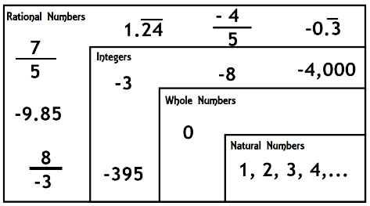

* Inequality is a comparison between two values. Students should connect the words to the symbols, for example, the symbol $<$ reads “is less than” and the symbol $>$ reads “is greater than.”
* It can be helpful for students to think about the placement of rational numbers on a number line using benchmark comparison values.
  + Examples of this could include the following questions: Between what two whole numbers does the rational number fall? Is it more than half or less than halfway to the next whole number?
* Within the grade 6 benchmarks, students are only expected to convert between forms of positive rational numbers. When working with negative rational numbers, students are only expected to determine their relationship based on their relative location to each other, as can be demonstrated on a number line. This benchmark connects to MA.7.NSO.2 where students will be expected to solve problems with all rational numbers including integers in the grade 6 accelerated course.
* Having students read the comparison relationships from right to left and from left to right can help students develop flexibility of thinking and fluency with using the inequality symbols.
* When comparing negative rational numbers, it is helpful to reason through the comparisons using real-world scenarios *(MTR.7.1).*
  + For example, if Jeff owes $12.47 and Mary owes $6.50, most students can quickly see and understand that $-12.47<-6.50$. Jeff has less money than Mary.
* Students should be given opportunities to order rational numbers by notating as a list (as is often done with data sets) and by notating using inequality symbols.
  + For example, when ordering from least to greatest, the set could be written as $–\frac{5}{8}, -0.33, 2, 5.8$ or as $–\frac{5}{8}<-0.33<2<5.8$.
* Instruction includes the use of technology to help define and explore rational numbers.

Common Misconceptions or Errors

* Students may think if a positive number is greater than a second positive number that the relationship will hold true given the negative or opposite of the given numbers.
  + For example, if given $6.75>6.71$, then a student may think that $–6.75>-6.71$. Using a number line (vertical or horizontal) can help students to see the relationship with whole numbers, meaning the greater value is always to the right (horizontal) or above (vertical).

This relationship also holds true with rational numbers. If students accurately plot the points, they can determine which value is larger by looking at the position.

* Students may think that rational numbers cannot be compared unless they are in the same form (i.e., only fractions can be compared to fractions). Instruction should showcase how to make comparisons using benchmark values for plotting numbers without converting between forms.

Strategies to Support Tiered Instruction

* Instruction includes using a physical or digital number line where students can plot the values and see that the further to the left they move on the number line, the lesser the number.
* When comparing positive numbers in different forms, students may think they can order them just by looking, or that they cannot be compared since they are in different forms. Reviewing converting between fractions, decimals, and percent will help students in the comparing process.
* Teacher provides explanation of negative numbers (perhaps starting with integers) in terms of currency to help bring real-world connection to the standard. Students should know they would rather have someone owe them $\$34$ rather than someone owing them $21. Similarly, they understand that if they owed someone $6.25 $(-6.25)$, that is less than owing them $11.84 $(-11.84)$. Then, using the number lines, students can begin to recognize patterns that will bridge their understanding from conceptual to procedural, as well as apply their understanding in real world situations.
* When plotting rational numbers, students should start by making assumptions and reasonable estimations.
  + For example, if a student is plotting $-4\frac{3}{5}$ on a number line, they need to know that $\frac{3}{5}$ is more than half. So, to graph this value, they should plot a point between $-4$ and $-5$, with the point closer to the $-5$. Then, the student can more precisely adjust the point if necessary if any other value is between $-4$ and $-5$.
* Instruction showcases how to make comparisons using benchmark values for plotting numbers without needing to convert between forms.

Instructional Tasks

*Instructional Task 1 (MTR.1.1, MTR.4.1, MTR.5.1)*

Provide students with an open number line and cards labeled with different rational numbers. Students may work together in groups or individually; if individually, be sure to provide opportunities for students to discuss with a partner and as a whole group.

Part A. Arrange the cards on the number line.

Part B. Discuss your rationale for the placement of rational numbers in your group or with a partner.

Part C. Compare your work and discuss whether you agree or disagree on rational number placement on the number line.

*Instructional Task 2 (MTR.6.1, MTR.7.1)*

Sharon was being paid to paint a mural on a wall in the gym. The mural was supposed to be at least 6.2 feet tall and 12.8 feet wide. When she measured her completed mural, the tape measure showed the height as $6\frac{1}{4}$ feet and the width as $12\frac{7}{8}$ feet. Did the dimensions of Sharon’s mural meet the given requirements? How do you know?

*Instructional Task 3 (MTR.2.1, MTR.4.1)*

Cameron wrote on a quiz that $\frac{2}{3}, -\frac{6}{8}$ and $\frac{1}{9}$ are all rational numbers because they are written as fractions and that $–6, 12\%$ and $4.333$ are not rational numbers because they are not written as fractions. Is Cameron’s answer correct? Explain your reasoning using a model to represent the situation.

Instructional Items

*Instructional Item 1*

Plot and label each of the following numbers on a number line: $3.4$, $\frac{2}{3}$, $2.7$, $7$, $\frac{3}{4}$ and $1$.

*Instructional Item 2*

Write the comparisons of $-\frac{1}{6}$ and $-\frac{1}{3}$ in more than one way using words and inequalities.

*Instructional Item 3*

Part A. Plot $-5$ and $5$ on a number line.

Part B. Write a comparison that describes the relationship.

\*The strategies, tasks and items included in the B1G-M are examples and should not be considered comprehensive.

### MA.6.NSO.1.2

Benchmark

MA.6.NSO.1.2 Given a mathematical or real-world context, represent quantities that have opposite direction using rational numbers. Compare them on a number line and explain the meaning of zero within its context.

*Example:* Jasmine is on a cruise and is going on a scuba diving excursion. Her elevations of 10

feet above sea level and 8 feet below sea level can be compared on a number line,

where 0 represents sea level.

Benchmark Clarifications:

*Clarification 1:* Instruction includes vertical and horizontal number lines, context referring to distances, temperatures and finances and using informal verbal comparisons, such as, lower, warmer or more in debt.

*Clarification 2:* Within this benchmark, the expectation is to compare positive and negative rational numbers when given in the same form.

Connecting Benchmarks/Horizontal Alignment

* MA.6.NSO.4.1, MA.6.NSO.4.2
* MA.6.AR.1.1, MA.6.AR.1.2
* MA.6.GR.1.1, MA.6.GR.1.2, MA.6.GR.1.3
* MA.7.NSO.2.1

Terms from the K-12 Glossary

* Integers
* Number Line
* Rational Number
* Whole Number

Vertical Alignment

|  |  |
| --- | --- |
| **Previous Benchmarks**   * This is the first introduction to the concept of numbers having opposites. | **Next Benchmarks**   * MA.7.NSO.1 |

Purpose and Instructional Strategies

In previous courses, students plotted, ordered and compared positive numbers. In grade 6 accelerated, students plot, order and compare on both sides of zero on the number line with all forms of rational numbers. This benchmark focuses on the comparison of quantities with opposite directions (one positive and one negative) and understanding what the zero represents within the provided context. Students will also use the concept of opposites when solving problems involving order of operations and absolute value. In future courses, students will plot, order and compare positive and negative rational numbers.

* A strong foundation in this skill can help students more efficiently solve problems involving absolute value, finding the distance between points on a coordinate plane, combining rational numbers as well as assessing the reasonableness of solutions.
* Within this benchmark, it is the expectation that students make informal verbal comparisons of rational numbers using “is greater than” or “is less than” or another comparison within context.
  + For example, when comparing the temperature in Chipley, Florida, which is 34°F, to Minneapolis, Minnesota, which is $-4°$ F, one could say that it is warmer in Florida than Minnesota or that it is colder in Minnesota than Florida.
* Students can describe the relative relationships between quantities and include the distance between the values in their description, as this is a way of connecting and reinforcing the MA.6.GR.1 standard *(MTR.2.1, MTR.7.1).*
  + For example, if a shark is $7.5$ meters below sea level and a cliff diver is standing on a cliff at a point that is $22$ meters from the surface of the water, the shark is $29.5$ meters below the cliff diver. The shark’s position can also be described as $–7.5$ meters from the surface of the water if the surface of the water represents 0.

Common Misconceptions or Errors

* Students may incorrectly assign double negatives when describing relationships that are below zero.
  + For example, they may say the temperature is $–3$ degrees below zero when they mean it is $–3$ degrees from zero or it is 3 degrees below zero. In this same context, it is important for students to understand that identifying a value as negative indicates the position as being lower or colder than the neutral position of 0.
* Instruction provides many opportunities for students to share verbal descriptions (in written and oral forms) to better develop this skill (*MTR.4.1, MTR.7.1*).
* Students may experience difficulty when trying to create a number line and determining the meaning of 0 within the context. Instruction showcases drawing a picture of the context first and then connecting it to the building of a number line.

Strategies to Support Tiered Instruction

* Instruction includes the use of a physical or digital number line to plot various values and to use their location on the number line to assist in comparing them. Instruction focuses on the generalization that the farther to the left a value is on the number line, the lesser the number.
* Teacher assists students with representing rational values in a real-world context, by first drawing a visual representation of the situation and labeling key features of the picture such as the “neutral” point of the visual (sea level, zero degrees, ground level, etc.), direction (above or below sea level, forward or backwards movement, etc.) and magnitude (the absolute value of the given quantity) of the given situation. Once a visual is drawn, the teacher or students create a corresponding horizontal or vertical number line to match the picture and the key features and then use the number line to write the correct rational number, paying close attention to the location of the point relative to zero.
  + For example, Jasmine is on a cruise and is going on a scuba diving excursion. Her elevations of 10 feet above sea level and 8 feet below sea level can be compared on a number line, where 0 represents sea level.

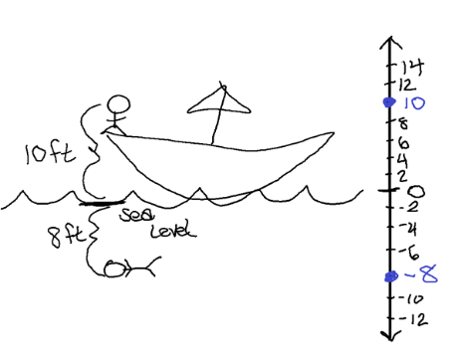

* Teacher provides opportunities for students to represent verbal descriptions of situations pictorially and on a number line. Students then restate the same situation using different vocabulary and check the reasonableness of the new situations by making connections back to the visual representation, number line, and meaning of zero in the context.
  + For example, on Saturday, Thomas’s football team lost 3 yards in their first drive while on Thursday, Derrek’s football team gained 5 yards in their first drive. The first drives for each team can be compared on a number line, where 0 represents the line of scrimmage for each play.

|  |  |
| --- | --- |
| **Picture** | **Meaning of Zero** |
| Diagram of word problem above. | The start of each first drive. |
| **Number Line** | **Additional Description** |
| Number line showing Thomas at negative 3 and Derrek at positive 5 and the line of scrimmage in between them at zero. | The first drive of Thomas’s football team can be represented by $-3$ and the first drive of Derrek’s team can be represented by $5.$ |

* Instruction includes providing students with opportunities to practice placing rational number cards on a provided number line. While placing the cards, students should share their thinking out loud while the teacher listens for reasonable estimations and assumptions for correct placement.
  + For example, if a student is placing a number card with $-4\frac{3}{5}$ on the number line, the student needs to know that $\frac{3}{5}$ is more than half, so to place the card, the student should be between $-4$ and $-5$, with the point closer to the $-5$. As more cards are added to the number line, the students may adjust the placement of other cards, if necessary, for more accurate estimates.
* Teacher and students co-create a list of common terms from contextual situations that may be used to describe positive or negative values.
  + Examples of this could include:

|  |  |
| --- | --- |
| **Positive** | **Negative** |
| Deposit  Gain  Above | Withdrawal  Loss  Below |

Instructional Tasks

*Instructional Task 1 (MTR.4.1, MTR.7.1)*

On Thursday, Calvin borrowed $46.68 from his mom to purchase a new video game. He mowed yards on the weekend to earn money to pay his mom back. After paying his mom back, Calvin had $12.32 left on Monday. What is the meaning of 0 in this situation? Compare the amounts of money that Calvin had on Thursday and Monday. Explain your reasoning including a number line in your justification.

*Instructional Task 2 (MTR.5.1)*

Part A. Given the inequality $7.2>-4.5$, describe how the numbers would be positioned relative to each other on a number line.

Part B. What role does 0 play in this context?

Part C. Using this reasoning, describe how any number $x$ and any number $y$ could be positioned relative to each other on a number line and the role played by 0.

Instructional Items

*Instructional Item* *1*

New Orleans, Louisiana has an altitude of about $-6\frac{1}{2}$ feet and Miami, Florida has an altitude of about $6\frac{3}{5}$ feet. Compare the two altitudes on a vertical number line.

*Instructional Item 1*

Students from Hope Middle School are traveling to Washington D.C. for their grade 8 field trip. When they left Florida, the temperature was 67℉. At their arrival in their hotel in Washington D.C., the temperature was $-15$ ℉, which is the coldest day on record in Washington D.C. On their second day in Washington D.C., the temperature was 24℉. Compare the three temperatures on a number line and explain where zero would be on the number line, as well as its relationship to the temperatures.

\*The strategies, tasks and items included in the B1G-M are examples and should not be considered comprehensive.

### MA.6.NSO.1.3

Benchmark

MA.6.NSO.1.3 Given a mathematical or real-world context, interpret the absolute value of a number as the distance from zero on a number line. Find the absolute value of rational numbers.

Benchmark Clarifications:

*Clarification 1:* Instruction includes the connection of absolute value to mirror images about zero and to opposites.

*Clarification 2:* Instruction includes vertical and horizontal number lines and context referring to distances, temperature and finances.

Connecting Benchmarks/Horizontal Alignment

* MA.6.NSO.1.4, MA.6.NSO.4.1, MA.6.NSO.4.2
* MA.6.AR.1.1, MA.6.AR.1.2
* MA.6.GR.1.1, MA.6.GR.1.2, MA.6.GR.1.3
* MA.7.NSO.2.1

Terms from the K-12 Glossary

* Absolute Value
* Integers
* Number Line
* Rational Number
* Whole Number

Vertical Alignment

|  |  |
| --- | --- |
| **Previous Benchmarks**   * This is the first introduction to the concept of absolute value. | **Next Benchmarks**   * MA.8.NSO.1.7 |

Purpose and Instructional Strategies

In previous courses, students plotted positive numbers on a number line and related addition of positive numbers to distance on a number line. In grade 6 accelerated, students determine the absolute values, both in the context of the distance from zero and determining the distance between two points on the coordinate plane with the same $x$- or $y$-coordinate. Students will also use the concept of opposites when solving problems involving order of operations and absolute value in grade 6 accelerated. In future courses, students will use the order of operations with rational numbers, including exponents and radicals to solve multi-step mathematical and real-world problems.

* Instruction includes developing the understanding that absolute value explains the magnitude of a real number without regard to its sign and is denoted by $\left|x\right|$ and reads “the absolute value of $x$.”
* Absolute value in real-life situations can help students understand the concept of absolute value.
* Distance is not depicted as a negative number; thus, absolute value context should be used to describe a distance in the opposite direction. Students can draw pictures or diagrams, including vertical or horizontal number lines, to mathematically demonstrate what is happening in a real-life situation *(MTR.2.1, MTR.7.1).*
* Using sentence frames can help students describe relationships and reasoning with absolute value *(MTR.4.1).*
* For example, when given the statement $|x|=6$, students may benefit from a frame such as: The distance from $x$ to 0 is \_\_\_\_\_, so $x$ can be located at \_\_\_\_\_ or \_\_\_\_\_.
* Instruction includes the use of technology to explore, interpret and define absolute value.

Common Misconceptions or Errors

Students may incorrectly state the absolute value of a negative number has a negative value. Students need to understand the total distance you traveled is not dependent on which direction you travel. To help address this misconception, instruction includes students talking about absolute value as distance and asking students questions such as:

* Would you describe how far you traveled with a negative number?
* If your parent drives a car in reverse, does the odometer show how far the car traveled by counting backwards?
* If you walk from your desk to the door backwards (your back is facing the door), did you walk a negative distance?
* You stand in line for a ride at an amusement park. You walk forward 10 feet in line, then the line makes a U-turn and you walk 30 feet. A U-turn happens in the line again and you travel an additional 16 feet before boarding the ride. How do you determine the distance you traveled whilst traveling in line?

Strategies to Support Tiered Instruction

* Instruction includes providing students with a sentence stem to interpret the meaning of the absolute value. Some students may require additional reading support.
  + For example, if given “If the temperature in Chicago, IL, is −7°, how many degrees below zero is the temperature?” the teacher can provide the sentence stem: “The absolute value of −7 is 7 units from zero, so the temperature is 7 degrees below zero.”
* Instruction includes providing error analysis problems for which the absolute value of a positive number is incorrectly given as its opposite, rather than its distance from zero. Teacher reinforces the absolute value as the distance from zero and provides opportunities for students to plot the value on a number line and record the number of units the point is from zero. Instruction begins with integers and moves toward rational numbers.
* Teacher co-creates a graphic organizer with the students while providing instruction on the definitions of “absolute value,” “opposite value,” and “negative number.” Instruction includes helping students to develop a definition in their own words, and identify key characteristics, examples, and non-examples of each term.
* Teacher provides students with flashcards to practice and reinforce academic vocabulary.
* Instruction includes students talking about absolute value as distance and asking students questions such as:
  + If your parent drives a car backwards, does the odometer show how far the car traveled by counting backwards?
  + If you walk from your desk to the door backwards (your back is facing the door), about how far would you walk?
  + You stand in line for a ride at an amusement park. You walk forward 10 feet in line, then the line makes a U-turn and you walk 30 feet. A U-turn happens in the line again and you travel an additional 16 feet before boarding the ride. Do you subtract the distance when you travel the opposite direction in line, or do you still add it because you are still traveling over a specific distance?
  + Do you describe how far you traveled with a negative number because a person was walking or driving backwards?

Instructional Tasks

*Instructional Task 1 (MTR.4.1, MTR.5.1)*

The absolute value of an unknown number is 11.2. Where could the unknown number be located on a number line? Explain how you know.

*Instructional Task 2 (MTR.7.1)*

The table below shows the change in rainfall amount from the last 5 years. Find the absolute value of each month and determine which month had the greatest change in rainfall.

|  |  |  |  |  |  |
| --- | --- | --- | --- | --- | --- |
| **Month** | **March** | **April** | **May** | **June** | **July** |
| Change in Rainfall Amount from 5-Year Average (inches) | 0.21 | -1.64 | -0.48 | 2.01 | -2.30 |

*Instructional Task 3 (MTR.3.1)*

Plot $4, -4$ and $0$ on the same number line.

Part A. Compare the distance of $4$ and $-4$ in relation to $0$.

Part B. Explain how this relates to the definition of absolute value.

Instructional Items

*Instructional Item 1*

What is the value of the expression $\left|-\frac{7}{8}\right|$?

*Instructional Item 2*

If the temperature in Chicago, IL is $-7°$, how many degrees below zero is the temperature?

*Instructional Item 3*

What is the value of the expression $-\left|12.75\right|$?

\*The strategies, tasks and items included in the B1G-M are examples and should not be considered

### MA.6.NSO.1.4

Benchmark

MA.6.NSO.1.4 Solve mathematical and real-world problems involving absolute value, including the comparison of absolute value.

*Example:* Michael has a lemonade stand which costs $10 to start up. If he makes $5 the first day,

he can determine whether he made a profit so far by comparing |-10| and |5|.

Benchmark Clarifications:

*Clarification 1:* Absolute value situations include distances, temperatures and finances.

*Clarification 2:* Problems involving calculations with absolute value are limited to two or fewer operations.

*Clarification 3:* Within this benchmark, the expectation is to use integers only.

Benchmark Clarifications:

Connecting Benchmarks/Horizontal Alignment

* MA.6.NSO.1.3, MA.6.NSO.4.1, MA.6.NSO.4.2
* MA.6.GR.1.1, MA.6.GR.1.2, MA.6.GR.1.3
* MA.7.NSO.2.1

Terms from the K-12 Glossary

* Absolute Value
* Integers
* Number Line
* Rational Number
* Whole Number

Vertical Alignment

|  |  |
| --- | --- |
| **Previous Benchmarks**   * This is the first introduction to the concept of absolute value. | **Next Benchmarks**   * MA.8.NSO.1.5, MA.8.NSO.1.7, MA.912.DP.1.4 |

Purpose and Instructional Strategies

In previous courses, students plotted positive numbers on a number line and related addition of positive numbers to distance on a number line. In grade 6 accelerated, students determine and compare absolute values. Students will also use the concept of opposites when solving problems involving order of operations and absolute value. In future courses, students will use the order of operations with rational numbers, including exponents and radicals to solve multi-step mathematical and real-world problems.

* All values within this benchmark are limited to integers. This extends within the course to MA.7.NSO.2.1 where students will be expected to solve mathematical problems using the order of operations with rational numbers including absolute values.
* Instruction includes making connections in absolute value problems to direction, distance, or speed. This benchmark connects to finding the distance between two points on a coordinate plane with the same $x$- or $y$-coordinate.
* Instruction within absolute value contexts are not limited to distances, temperature and finances. Other situations could arise from a predetermined amount, or zero point, and then measuring above or below that amount *(MTR.7.1).*
  + For example, Leah eats on average 1200 calories in a day. On Wednesday, her caloric intake was 400 calories different than her average. What are her possible caloric intakes on Wednesday?
* Students should progress from solving problems using a concrete number line to solving problems abstractly. Students should represent equations with a visual model to illustrate their thinking. This will allow students to solidify the abstract concept through a pictorial representation. When students understand both methods and how they connect, students are often able to think more flexibly and reason through challenging problems successfully *(MTR.2.1, MTR.5.1).*
* Instruction includes the use of technology, including calculators.

Common Misconceptions or Errors

* Students may incorrectly state the absolute value of a negative number has a negative value. Instruction includes opportunities for students to talk about absolute value as distance in real-world scenarios *(MTR.7.1).*
  + For example, the odometer on my car reads 92,500 miles when I leave my house to drive 89 miles to Grandma’s house. When I get to Grandma’s house, the odometer reads 92,589 miles. When I turn around and drive home, which is the opposite direction, will my odometer count backward and read 92,500 again when I get home, or will it read 92,678 miles?
* Students may incorrectly assume distance is only referring to physically traveling between locations, such as walking, biking or driving. However, if we plot two values on a number line, this can also represent distance because we are determining how far away two points or values are from each other *(MTR.3.1).*

Strategies to Support Tiered Instruction

* Teacher provides instruction to reinforce the concept of absolute value being the distance of a number from zero.
  + For example, students plot integer values that represent temperatures on a number line and then record the number of units from zero.
* Teacher provides instruction for utilizing the absolute value symbols within the order of operations and refers to them as grouping symbols.
  + For example, when evaluating $-\left|6\right|$, first apply the absolute value of $6$, then apply the factor of $-1$ to result in a solution of $-6$, so that

$-\left|6\right|=\left(-1\right)\left(\left|6\right|\right)$

$=\left(-1\right)\left(6\right)$

$=-6$.

* Instruction for comparing absolute values of integers includes the use of pictorial representations or number lines to model the comparison and the use of key features of the model to discuss the problem, using contextual language when provided.

Instructional Tasks

*Instructional Task 1 (MTR.2.1, MTR.7.1)*

On March 1, Mr. Lopez weighed 187 pounds. This was 12 pounds different than he weighed on January 1. On January 1, Mr. Lopez weighed 25 pounds different than the preceding October 1. What might Mr. Lopez have weighed on October 1? Explain why this question could have multiple answers.

Instructional Items

*Instructional Item 1*

The Philippine Trench is located 10,540 meters below sea level and the Tonga Trench is located 10,882 meters below sea level. Which trench has the greater depth and by how many meters?

*Instructional Item 2*

What is the value of the expression $7-|-3|$?

\*The strategies, tasks and items included in the B1G-M are examples and should not be considered

**MA.6.NSO.2** *Add, subtract, multiply and divide positive rational numbers.*

### MA.6.NSO.2.1

Benchmark

MA.6.NSO.2.1 Multiply and divide positive multi-digit numbers with decimals to the thousandths, including using a standard algorithm with procedural fluency.

Benchmark Clarifications:

*Clarification 1:* Multi-digit decimals are limited to no more than 5 total digits.

Connecting Benchmarks/Horizontal Alignment

* MA.6.NSO.3.3
* MA.6.AR.1.1, MA.6.AR.1.3
* MA.6.AR.2.4
* MA.6.AR.3
* MA.6.GR.2
* MA.6.DP.1.2, MA.6.DP.1.3
* MA.7.NSO.2.2

Terms from the K-12 Glossary

* Area Model
* Commutative Property of Multiplication
* Expression
* Dividend
* Divisor

Vertical Alignment

|  |  |
| --- | --- |
| **Previous Benchmarks**   * MA.5.NSO.2.1, MA.5.NSO.2.2, MA.5.NSO.2.4, MA.5.NSO.2.5 | **Next Benchmarks**   * MA.8.NSO.1.5, MA.8.NSO.1.7 |

Purpose and Instructional Strategies

In previous courses, students multiplied and divided multi-digit whole numbers and represented remainders as fractions. They also estimated and determined the product and quotient of multi-digit numbers with decimals to the hundredths and multiplied and divided the product and quotient of multi-digit numbers with decimals to the hundredths by one-tenth and one-hundredth with procedural reliability. In grade 6 accelerated, students multiply and divide positive rational numbers with procedural fluency, including dividing numerators by denominators to rewrite fractions as decimals. Students will also become fluent in all operations with positive and negative rational numbers. In future courses, students will use the order of operations with rational numbers, including exponents and radicals to solve multi-step mathematical and real-world problems.

* Instruction includes representing multiplication in various ways.
$3.102×1.1=3.4122$

$(3.102)(1.1)=3.4122$

$3.102(1.1)=3.4122$

$3.102∙1.1=3.4122$

* Students should continue demonstrating their understanding from previous courses that division can be represented as a fraction.
* A standard algorithm is a systematic method that students can use accurately, reliably and efficiently (no matter how many digits) depending on the content of the problem. It is not the intention to require students to use a standard algorithm all of the time. However, students are expected to become fluent with a standard algorithm by certain grade levels as stated within the benchmarks.
* Instruction includes a variety of methods and strategies to multiply and divide multi-digit numbers with decimals.
  + Area Models

$$3.102×1.1=3.4122$$

|  |  |  |  |  |
| --- | --- | --- | --- | --- |
|  | 3 | 0.1 | 0.00 | 0.002 |
| 1 | 3 | 0.1 | 0.00 | 0.002 |
| 0.1 | 0.3 | 0.01 | 0.000 | 0.0002 |

* + Partial Products

$$3.102$$

$$×1.1$$

0.3102

+ 3.1020

3.4122

* + Multiplying as if the factors are whole numbers and applying the decimal places to the final product based on the number of decimals represented in the factors *(MTR.3.1).*

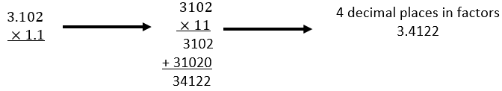

* Students should develop fluency with and without the use of a calculator when performing operations with positive decimals.

Common Misconceptions or Errors

* Students may incorrectly apply rules for adding or subtracting decimals to multiplication of decimals, believing place values must be aligned.
* Students may confuse the lining up of place values when multiplying or dividing vertically by omitting or forgetting to include zeros as placeholders in the partial products or quotients.

Strategies to Support Tiered Instruction

* Instruction includes the use of estimation to ensure the proper placement of the decimal point in the final product or quotient of decimals.
  + For example, if finding the product of and , students should estimate the product to be close to , by using and as friendly numbers, then apply the decimal to the actual product of and , which is . Based on the estimate, the decimal should be placed after to produce .
* Teacher encourages students with a firm understanding of multiplying and dividing fractions to convert decimal values into equivalent fraction forms and then perform the desired operation and convert the solution back to decimal form.
* Teacher provides graph paper to utilize while applying an algorithm for multiplying or dividing to keep numbers lined up and help students focus on place value.
* Instruction includes providing opportunities to reinforce place values with the use of base ten blocks or hundredths grids.

Instructional Tasks

*Instructional Task 1 (MTR.6.1)*

Carlos spent $20.76 on chips when his friends came over. Each bag of chips costs $3.46 and each bag has 3 servings. What is the maximum number of friends that Carlos can have over if each person can have a single serving of chips?

*Instructional Task 2 (MTR.7.1)*

Samantha has 6.75 bags of candy. A full bag of candy contains 13.125 ounces of candy. How many ounces of candy does Samantha have?

*Instructional Task 3 (MTR.4.1, MTR.5.1)*

Part A. Complete the table below using a calculator.

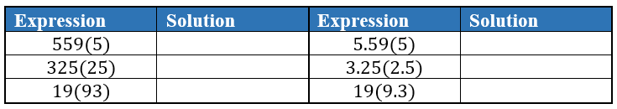

Part B. Talk with a partner about what you notice from the table in Part A.

Part C. How are the expressions without decimals related to the expressions with decimals? Is there a relationship between the decimal placements in the expressions and the solutions?

Part D. If $2368(421)=996,928$, what would you expect $2.368(4.21)$ be equal to?

Instructional Items

*Instructional Item 1*

Determine the product of 23.5 and 2.3.

*Instructional Item 2*

The expression $13.31÷0.125$ is equivalent to what number?

*Instructional Item 3*

Determine the quotient of 201.3 and 1.83.

*Instructional Item 4*

The expression $4.321×2.3$ is equivalent to what number?

\*The strategies, tasks and items included in the B1G-M are examples and should not be considered

### MA.6.NSO.2.2

Benchmark

MA.6.NSO.2.2 Extend previous understanding of multiplication and division to compute products and quotients of positive fractions by positive fractions, including mixed numbers, with procedural fluency.

Benchmark Clarifications:

*Clarification 1:* Instruction focuses on making connections between visual models, and the relationship between multiplication and division, reciprocals and algorithms.

Connecting Benchmarks/Horizontal Alignment

* MA.6.NSO.3.3
* MA.6.AR.1.1, MA.6.AR.1.3
* MA.6.GR.2
* MA.6.DP.1.2, MA.6.DP.1.3
* MA.7.NSO.2.2

Terms from the K-12 Glossary

* Area Model
* Commutative Property
* Dividend
* Divisor
* Expression

Vertical Alignment

|  |  |
| --- | --- |
| **Previous Benchmarks**   * MA.5.FR.2.2, MA.5.FR.2.4 | **Next Benchmarks**   * MA.8.NSO.1.7 |

Purpose and Instructional Strategies

In previous courses, students multiplied fractions by fractions with procedural reliability and explored how to divide a unit fraction by a whole number and a whole number by a unit fraction. In grade 6 accelerated, students become procedurally fluent with multiplication and division of positive fractions. The expectation is to utilize skills from the procedural reliability stage to become fluent with an efficient and accurate procedure, including a standard algorithm. Students will also become fluent in all operations with positive and negative rational numbers. In future courses, students will use the order of operations with rational numbers, including exponents and radicals to solve multi-step mathematical and real-world problems.

* Instruction includes using concrete and pictorial models, writing a numerical sentence that relates to the model and discovering the pattern or rules for multiplying and dividing fractions by fractions *(MTR.2.1, MTR.3.1, MTR.5.1).*
  + Area Model

|  |  |
| --- | --- |
| Using the area model to multiply 2 and a half times 3 and a half, 2 and a half squares are drawn vertically and 3 and a half squares are shown horizontally. When these are multiplied, the answer is 8 and three-fourths. | Using the area model when dividing 5 units by three-fourths, 5 is broken down into fourths with a total of 20 small squares. Then the 20 small squares are broken down into groups of three, to depict dividing by three-fourths. When adding up the total number of groups of 3, there are a total of 6 and two-thirds groups of 3. |

* + Linear Model

|  |  |
| --- | --- |
| Using a linear model of 2 and one-fourth times two-thirds is equal to 1 and a half. 2 and one-fourth is broken into groups of 3 on a number line. Two-thirds of the 9 spaces shown equals six spaces, which is 1 and a half. | Using a linear model, 6 and one-half divided by one and a half equals 4 and one-third. A coordinate point is placed on 6 and a half with markings shown for half spacing. It is divided into one and a half spaces, totaling 4 and one-third spaces. |

* + Bar Model

|  |  |
| --- | --- |
| Using a bar model, 4 and two-thirds times five-sevenths equals 3 and one-third. 4 and two-thirds is shown as 7 groups of two-thirds. Five of the seven groups equals three and one-third. | Using a bar model, 3 and three-fourths divided by 1 and a half equals 2 and a half. Three and three-fourths is divided into fourths, showing fifteen fourths. The fifteen fourths are divided into groups of 1 and a half, leaving a total of two and a half groups. |

* Instruction includes making connections to the distributive property when multiplying fractions.
  + For example, when multiplying $1\frac{1}{2}$ by $\frac{3}{4}$, it can be written as $\left(1+\frac{1}{2}\right)\frac{3}{4}$ to determine $\frac{9}{8}$ as the product.
* Instruction includes making connections to inverse operations when multiplying or dividing fractions.
  + For example, when determining $\frac{3}{4}÷\frac{5}{8}$, students can ask the question, what number multiplied by $\frac{5}{8}$ gives the value $\frac{3}{4}$?
* Instruction focuses on appropriate academic vocabulary, such as reciprocal. Avoid focusing on tricks such as “keep-change-flip.” Using academic language and procedures allows students to connect to future mathematics *(MTR.5.1).*
  + For example, $\frac{3}{4}÷\frac{5}{8}$ can be read as “How many five-eighths are in three-fourths?”
* Instruction includes providing opportunities for students to analyze their own and others’ calculation methods and discuss multiple strategies or ways of understanding with others *(MTR.4.1)*.
* Students should develop fluency with and without the use of a calculator when performing operations with positive fractions.

Common Misconceptions or Errors

* Students may forget that common denominators are not necessary for multiplying or dividing fractions.
* Students may incorrectly assume that multiplication results in a product that is larger than the two factors. Instruction continues with students assessing the reasonableness of their answers by determining if the product will be greater or less than the factors within the given context.
* Students may incorrectly assume that division results in a quotient that is smaller than the dividend. Instruction continues with students assessing the reasonableness of their answers by determining if the quotient will be greater or less than the dividend within the given context.

Strategies to Support Tiered Instruction

* Teacher encourages students with a firm understanding of multiplying and dividing decimals to convert fractional values to their equivalent decimal forms and then perform the desired operation and convert the solution back to fractional form.
* Instruction includes the use of fraction tiles, fraction towers, or similar manipulatives to make connections between physical representations and algebraic methods.
* Instruction includes the co-creation of a graphic organizer utilizing the mnemonic device Same, Inverse Operation, Reciprocal (S.I.R.) for dividing fractions, which encourages the use of correct mathematical terminology, and including examples of applying the mnemonic device when dividing fractions, whole numbers, and mixed numbers.
* Teacher provides students with flashcards to practice and reinforce academic vocabulary.
* Instead of multiplying by the reciprocal to divide fractions, an alternative method could include rewriting the fractions with a common denominator, dividing the numerators and then dividing the denominators.
  + For example, $\frac{5}{6}÷\frac{3}{2}$ is equivalent to $\frac{5}{6}÷\frac{9}{6}$ which is equivalent to $\frac{5/9}{1}$ which is equivalent to $\frac{5}{9}$.
* Instruction provides opportunities to assess the reasonableness of answers by determining if the product will be greater or less than the factors within the given context.
* Instruction provides opportunities to assess the reasonableness of answers by determining if the quotient will be greater or less than the dividend within the given context.

Instructional Tasks

*Instructional Task 1 (MTR.2.1, MTR.4.1)*

Jasmine wants to build a $2\frac{5}{6}$ meters long garden path paved with square stones that measure $\frac{1}{4}$ meter on each side. There will be no space between the stones.

Part A. Create a model that could be used to answer the following question: How many stones are needed for the path?

Part B. How many stones are needed for the path?

*Instructional Task 2 (MTR.3.1, MTR.6.1)*

A container at a juicing plant holds $6\frac{2}{3}$ tons of oranges. The plant can juice $1\frac{1}{2}$ tons of oranges per day. At this rate, how long will it take to empty the container?

*Instructional Task 3 (MTR.2.1)*

Explain using visual models why $\frac{4}{5}×\frac{2}{3}=\frac{8}{15}$.

Instructional Items

*Instructional Item 1*

What is the value of the expression $\frac{3}{5}÷\frac{5}{8}$?

Instructional Item 2

What is the value of the expression $8\frac{1}{10}÷\frac{5}{8}$?

\*The strategies, tasks and items included in the B1G-M are examples and should not be considered comprehensive.

### MA.6.NSO.2.3

Benchmark

MA.6.NSO.2.3 Solve multi-step real-world problems involving any of the four operations with positive multi-digit decimals or positive fractions, including mixed numbers.

Benchmark Clarifications:

*Clarification 1:* Within this benchmark, it is not the expectation to include both decimals and fractions within a single problem.

Connecting Benchmarks/Horizontal Alignment

* MA.6.AR.1.1
* MA.6.AR.2.4
* MA.6.AR.3.2, MA.6.AR.3.3, MA.6.AR.3.4, MA.6.AR.3.5
* MA.6.GR.2.2, MA.6.GR.2.3, MA.6.GR.2.4
* MA.6.DP.1.2, MA.6.DP.1.3, MA.6.DP.1.4, MA.6.DP.1.6
* MA.7.NSO.2.3

Terms from the K-12 Glossary

* Area Model
* Commutative Property of Multiplication
* Dividend
* Divisor
* Expression

Vertical Alignment

|  |  |
| --- | --- |
| **Previous Benchmarks**   * MA.5.AR.1.1, MA.5.AR.1.2, MA.5.AR.1.3 * MA.5.M..2.1 * MA.5.GR.2.1 | **Next Benchmarks**   * MA.8.NSO.1.6, MA.8.NSO.1.7 |

Purpose and Instructional Strategies

In previous courses, students solved multi-step real-world problems involving the four operations with whole numbers as well as addition, subtraction and multiplication for solving real-world problems with fractions and for solving problems with decimals involving money, area and perimeter. In grade 6 accelerated, students solve multi-step real-world problems with positive fractions and decimals. Students will also solve real-world problems involving any of the four operations with positive and negative rational numbers. In future courses, students will use the order of operations with rational numbers, including exponents and radicals to solve multi-step mathematical and real-world problems.

* This benchmark is the culmination of MA.6.NSO.2. It is built on the skills found in MA.6.NSO.2.1 and MA.6.NSO.2.2, so instruction provides practice of these skills within real-world contexts *(MTR.5.1, MTR.7.1).*
* Instruction includesengaging in questions such as:
  + What do you know from the problem?
  + What is the problem asking you to find?
  + Are you putting groups together? Taking groups apart? Or both?
  + Are the groups you are working with the same sizes or different sizes?
  + Can you create a visual model to help you understand or see patterns in your problem?
* Students should have experience using technology with decimals and fractions as they occur in the real world (*MTR.7.1*). This benchmark directly connects to MA.7.NSO.2.3 where students will be solving real-world problems with all rational numbers.
* Students should develop fluency with and without the use of a calculator when performing operations with positive rational numbers.

Common Misconceptions or Errors

* Students may incorrectly oversimplify a problem by mechanically circling the numbers, underlining the question, and boxing in keywords and then jumping to an answer, or procedure, without taking the time to comprehend the context or situation *(MTR.2.1, MTR.4.1, MTR.5.1, MTR.7.1).*
* Students may incorrectly apply rules for adding or subtracting decimals to multiplication of decimals, believing place values must be aligned.
* Students may confuse the lining up of place values when multiplying or dividing vertically by omitting or forgetting to include zeros as placeholders in the partial products or quotients.
* Students may forget that common denominators are not necessary for multiplying or dividing fractions.
* Students may incorrectly assume that multiplication results in a product that is larger than the two factors. Instruction continues with students assessing the reasonableness of their answers by determining if the product will be greater or less than the factors within the given context.
* Students may incorrectly assume that division results in a quotient that is smaller than the dividend. Instruction continues with students assessing the reasonableness of their answers by determining if the quotient will be greater or less than the dividend within the given context.

Strategies to Support Tiered Instruction

* Instruction includes using visual models to illustrate and make meaning of situations represented in word problems.
* Instruction includes the use of estimation to ensure the proper placement of the decimal point in the final product or quotient of decimals.
  + For example, if finding the product of and , students should estimate the product to be close to , by using and as friendly numbers, then apply the decimal to the actual product of and , which is . Based on the estimate, the decimal should be placed after to produce .
* Teacher encourages students with a firm understanding of multiplying and dividing fractions to convert decimal values into equivalent fractional forms and then perform the desired operation and convert the solution back to decimal form.
* Teacher encourages students with a firm understanding of multiplying and dividing decimals to convert fractional values into equivalent decimal forms and then perform the desired operation and convert the solution back to fractional form.
* Teacher provides opportunities for students to comprehend the context or situation by engaging in questions such as:
  + What do you know from the problem?
  + Can you create a visual model to help you understand or see patterns in your problem?
* Teacher provides graph paper to use while applying an algorithm for multiplying or dividing to keep numbers lined up and help students focus on place value.
* Instruction includes providing opportunities to reinforce place values with the use of base ten blocks or hundredths grids.
* Instruction includes the co-creation of a graphic organizer utilizing the mnemonic device S.I.R. (Same, Inverse Operation, Reciprocal) for dividing fractions, which encourages the use of correct mathematical terminology, and including examples of applying the mnemonic device when dividing fractions, whole numbers, and mixed numbers.
* Teacher provides students with flashcards to practice and reinforce academic vocabulary.
* Instead of multiplying by the reciprocal to divide fractions, an alternative method could include rewriting the fractions with a common denominator, dividing the numerators, and then dividing the denominators.
  + For example, $\frac{5}{6}÷\frac{3}{2}$ is equivalent to $\frac{5}{6}÷\frac{9}{6}$ which is equivalent to $\frac{5/9}{1}$ which is equivalent to $\frac{5}{9}$.
* Instruction includes the use of a three-read strategy. Students read the problem three different times, each with a different purpose.
  + First, read the problem with the purpose of answering the question: What is the problem, context, or story about?
  + Second, read the problem with the purpose of answering the question: What are we trying to find out?
  + Third, read the problem with the purpose of answering the question: What information is important in the problem?
* Instruction provides opportunities to assess the reasonableness of answers by determining if the product will be greater or less than the factors within the given context.
* Instruction provides opportunities to assess the reasonableness of answers by determining if the quotient will be greater or less than the dividend within the given context.

Instructional Tasks

*Instructional Task 1 (MTR.3.1, MTR.6.1)*

Janie is at the gas station. She has $53.25 and buys a sandwich that costs $7.68 and a drink for $0.97.

Part A. After she buys the sandwich and drink, how much money will Janie have left?

Part B. Janie wants to buy 10 gallons of gas with the remaining money. What is the highest price per gallon that she can afford? Use words or numbers to show your work.

*Instructional Task 2 (MTR.3.1, MTR.7.1)*

For the bake sale at school next week, Tamsynn plans to bake brownies.

Part A. If each batch makes 12 brownies, and uses 1 ½ cups of flour, how many brownies could she make if she has 18 cups of flour.

Part B. If she plans to sell each brownie for $1.25, how much money will she earn for the bake sale if she sells all of her brownies?

Part C. If her goal is to earn $200, how many more brownies should she make?

Instructional Items

*Instructional Item 1*

Candy comes in $3\frac{1}{2}$ pound bags. At a class party, the boys in the class ate $2\frac{1}{4}$ bags of candy and the girls in the class ate $1\frac{1}{3}$ bags. How many pounds of candy did the class eat?

*Instructional Item 2*

Tina’s SUV holds 18.5 gallons of gasoline. If she has 4.625 gallons in her car when she stops to fill it up. How much money will she spend to fill up her car if the current price for gas is $2.57 per gallon?

\*The strategies, tasks and items included in the B1G-M are examples and should not be considered comprehensive.

**MA.6.NSO.3** *Apply properties of operations to rewrite numbers in equivalent forms.*

### MA.6.NSO.3.1

Benchmark

MA.6.NSO.3.1 Given a mathematical or real-world context, find the greatest common factor and least common multiple of two whole numbers.

*Example:* Middleton Middle School’s band has an upcoming winter concert which will have several performances. The bandleader would like to divide the students into concert groups with the same number of flute players, the same number of clarinet players and the same number of violin players in each group. There are a total of 15 students who play the flute, 27 students who play the clarinet and 12 students who play the violin. How many separate groups can be formed?

*Example:* Adam works out every 8 days and Susan works out every 12 days. If both Adam and Susan work out today, how many days until they work out on the same day again?

Benchmark Clarifications:

*Clarification 1:* Within this benchmark, expectations include finding the greatest common factor within 1,000 and the least common multiple with factors to 25.

*Clarification 2:* Instruction includes finding the greatest common factor of the numerator and denominator of a fraction to simplify the fraction.

Connecting Benchmarks/Horizontal Alignment

* MA.6.NSO.3.2, MA.6.NSO.3.4
* MA.6.AR.1.4
* MA.6.AR.3.2, MA.6.AR.3.3, MA.6.AR.3.5
* MA.7.NSO.2.2

Terms from the K-12 Glossary

* Area Model
* Composite Number
* Dividend
* Divisor
* Factor
* Greatest Common Factor (GCF)
* Least Common Multiple (LCM)
* Prime Factorization
* Prime Number

Vertical Alignment

|  |  |
| --- | --- |
| **Previous Benchmarks**   * MA.4.AR.3.1 | **Next Benchmarks**   * MA.7.AR.3.3 * MA.7.AR.4.5 |

Purpose and Instructional Strategies

In previous courses, students determined factor pairs for whole numbers from 0 to 144 and determined if numbers are prime, composite, or neither. In grade 6 accelerated, students will determine the least common multiple and greatest common factor of two whole numbers. In future courses, students will use their understanding of factors, factorization and the distributive property to generate equivalent expressions and solve equations.

* Instruction includes a variety of methods and strategies to determine the least common multiple *(MTR.2.1, MTR.3.1, MTR.5.1).*
  + Multiple listing method

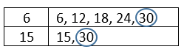

* + Factorization

Use Prime Factorization to find the LCM.

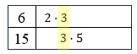

The LCM of 6 and 15 is 30 and is represented as $2×3×5$.

Discuss with students why 3 is listed only once. To use the strategy of prime factorization to find the LCM of two numbers, students must know what to do when a prime factor repeats.

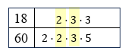

The LCM of 180 is represented as 3 .

To find the leastA table that shows how to determine the least common multiple of 14 and 15. Prime factors of 14 are 2 and 7. Prime factors of 15 are 3 and 5.

The LCM of 210 is represented as .

* + Using the Ladder Method (Successive Division)

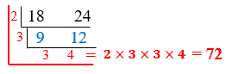

* Instruction includes a variety of methods and strategies to determine the greatest common factor *(MTR.2.1, MTR.3.1, MTR.5.1).*
  + T-charts

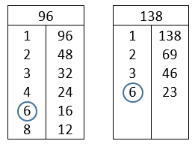

The greatest common factor of 96 and 138 is 6.

* + Factorization

GCF is represented as $3$.

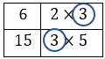

Using the Ladder Method for GCF

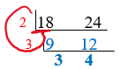

The GCF of 18 and 24 is $2×3=6$. A student may start with any factor that can evenly divide into the given numbers. A student may have started with 3 or 6.

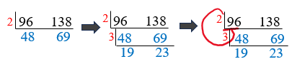

The GCF of 96 and 138 is $2×3=6$. A student may start with any factor that can evenly divide into the given numbers. Each “rung” of the ladder is created when the reduced numbers have a common factor.

* + The greatest common factor can be determined by dividing the numbers multiple times by common factors and then multiplying the common factors that were used as divisors.

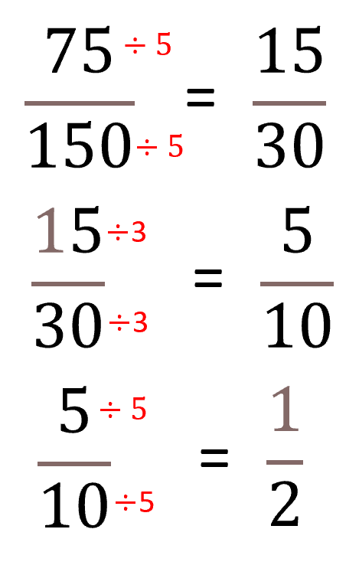

The greatest common factor of 75 and 150 can be found by multiplying $5×3×5=75$.

$\frac{75 ÷75}{150 ÷75}= \frac{1}{2}$

* Instruction includes the use of technology to explore, interpret and define greatest common factors and least common multiple.

Common Misconceptions or Errors

* Greatest common factor and least common multiple are often mixed up or confused by students. Stressing the academic vocabulary of what is a factor versus what is a multiple can help students keep the two straight in their minds.
* Students may incorrectly think that the greatest common factor of two numbers cannot be 1. However, if given two prime numbers, the greatest common factor will always be 1.
* Students may incorrectly think that if one of the numbers is prime, the greatest common factor must be 1. However, the greatest common factor is not 1 if one of the numbers is a prime number and that prime number is a factor of the second number.
* Students may incorrectly think the least common multiple has to be larger than both of the given numbers. Provide examples to showcase the least common multiple being the same as one of the given whole numbers.
  + For example, the LCM of 12 and 24 is 24.
* Students may incorrectly think the least common multiple can be found by multiplying the two numbers. Provide examples where this is not the case, such as the LCM of 4 and 6 is 12 not 24.

Strategies to Support Tiered Instruction

* Teacher shares their thinking when determining if a given situation requires finding the greatest common factor or the least common multiple. Steps include reading the given context out loud and thinking out loud about if the context requires the final answer to be greater than or equal to the given numbers (least common multiple) or less than the given numbers (greatest common factor).
* Teacher creates and posts an anchor chart with visual representations of factors and multiples and encourages students to utilize the anchor chart to assist in utilizing correct academic vocabulary when referring to factors and multiples.
  + Example:

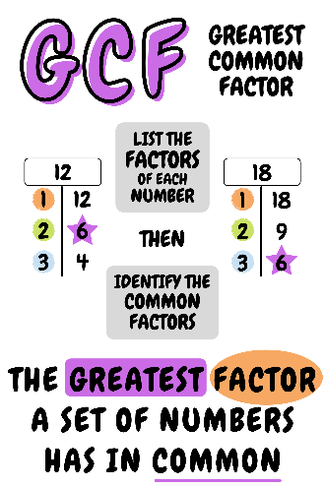 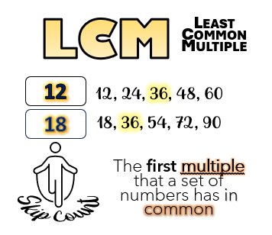

* Teacher provides students with flashcards to practice and reinforce academic vocabulary.
* Teacher provides instruction on the definitions of greatest common factor and least common multiple then co-creates a graphic organizer using student-created definitions, lists of key characteristics, examples, and non-examples of each term.
  + A non-example for the greatest common factor might include finding the least common factor, which would result in $1$.
  + A non-example for the least common multiple might include attempting to find the greatest common multiple, which cannot be determined because multiples are infinite.
* Teacher provides examples to showcase the least common multiple being the same as the larger of the given whole numbers or the same as the product of the two numbers.
  + For example, the least common multiple of 12 and 24 is 24.
  + For example, the least common multiple of 14 and 5 is 70.
* Teacher provides examples where this is not the case, such as the least common multiple of 4 and 6 is 12, not 6 or 24.
* Instruction includes the use of a graphic organizer to compare the multiples or factors of two numbers to help recognize common multiples and factors.

Instructional Tasks

*Instructional Task 1 (MTR.3.1, MTR.6.1)*

Parker reads a book every 12 days and Leah reads a book every 8 days.

Part A. If they both start a new book on Wednesday, how many days will it take for them to start another new book on the same day?

Part B. What day of the week will it be when they both start a new book on the same day?

*Instructional Task 2 (MTR.3.1, MTR.5.1, MTR.7.1)*

Mrs. Weinstein is packing school supplies for her new students. She has 24 glue sticks, 18 packs of colored pencils, and 32 cap erasers.

Part A. If each pack of school supplies should have an equal amount of materials, how many packs can she make?

Part B. If she plans to put her students in groups of 4 and give each group 2 packs of supplies, how many more of each supply would she need if she has 24 students in her class?

Instructional Items

*Instructional Item 1*

What is the greatest common factor of 85 and 187?

*Instructional Item 2*

What is the least common multiple of 18 and 12?

\*The strategies, tasks and items included in the B1G-M are examples and should not be considered comprehensive.

### MA.6.NSO.3.2

Benchmark

MA.6.NSO.3.2 Rewrite the sum of two composite whole numbers having a common factor, as a common factor multiplied by the sum of two whole numbers.

Benchmark Clarifications:

*Clarification 1:* Instruction includes using the distributive property to generate equivalent expressions.

Connecting Benchmarks/Horizontal Alignment

* MA.6.AR.1.4
* MA.6.NSO.3.1, MA.6.NSO.3.4
* MA.7.AR.1.2

Terms from the K-12 Glossary

* Area Model
* Composite Number
* Factor
* Greatest Common Factor (GCF)
* Prime Number
* Rectangular Array

Vertical Alignment

|  |  |
| --- | --- |
| **Previous Benchmarks**   * MA.4.AR.3.1 * MA.5.NSO.2.1, MA.5.NSO.2.2 | **Next Benchmarks**   * MA.7.NSO.1.1 * MA.8.AR.1.1, MA.8.AR.1.3 |

Purpose and Instructional Strategies

In previous courses, students determined factor pairs for whole numbers from 0 to 144 and determined if numbers are prime, composite, or neither. Students also multiplied and divided using products and divisors greater than 144. In grade 6 accelerated, students use their understanding of factor pairs to find common factor pairs between addends to generate equivalent expressions, including the use of the distributive property. In future courses, students generate equivalent expressions including the use of integer exponents as well as rewrite the sum of two algebraic expressions having a common monomial factor as a common factor multiplied by the sum of two algebraic expressions.

* This benchmark builds upon student understanding of the distributive property and supports the decomposition of numbers in earlier grades and extends to future learning in algebraic reasoning in future grade levels.
* Students should not use the multiplication symbol “ $×$” when rewriting composite numbers as a common factor multiplied by the sum of two whole numbers. In grade 3, students have seen the multiplication symbol “ $×$” when using the distributive property. Students should move away from this practice in grade 6 accelerated to writing the common factor directly outside the parentheses with an understanding that a number directly next to parentheses means you multiply *(MTR.3.1).*
  + For example, $24+12=6(4+2).$
* Instruction includes the use of manipulatives, models, drawings and equations to rewrite the sum.
* If two numbers have multiple common factors, there will be multiple equivalent common factors multiplied by the sum of two whole number possibilities *(MTR.2.1, MTR.5.1).*
  + For example, the equations below are equivalent:
$$42+96=2\left(21+48\right) 42+96=3\left(14+32\right) 42+96=6\left(7+16\right)$$

* Provide opportunities for students to identify the common factor and the factors to sum in the parenthesis. Given the common factor multiplied by the sum of two whole numbers, determine the two composite whole numbers to be summed.
* For this benchmark, all terms are numerical, not algebraic.
* Students should use their basic multiplication facts to do this benchmark and think through number relationships and patterns *(MTR.5.1).*

Common Misconceptions or Errors

* When working with the distributive property, some students may incorrectly multiply only the common factor by only one of the terms inside the parenthesis. Students need to make sure to multiply the common factor by both terms in the parentheses.
* Students may incorrectly think that they always must factor out the greatest common factor.
* Students must read the task or question carefully to determine if any common factor is allowable or if it must be the greatest common factor.

Strategies to Support Tiered Instruction

* Instruction includes the use of area models to visually represent an application of the distributive property.
  + Teacher provides review of prior knowledge of the distributive property using an area model. For example, the teacher can begin with the expression $5\left(2+3\right)$ and the area model below.

|  |  |  |
| --- | --- | --- |
|  | $$2$$ | $$3$$ |
| $$5$$ | ? | ? |

Then the teacher can co-creates the area model to demonstrate the distributive property.

$$5\left(2+3\right)=10+15$$

|  |  |  |
| --- | --- | --- |
|  | $$2$$ | $$3$$ |
| $$5$$ | 10 | 15 |

* + Teacher models using an area model to determine a common factor. For example, the teacher can begin with the expression $9+21$ and the area model below.

|  |  |  |
| --- | --- | --- |
|  | ? | ? |
| ? | $$9$$ | $$21$$ |

Then the teacher can co-creates the area model to determine a common factor.

$$9+21=3\left(3+7\right)$$

|  |  |  |
| --- | --- | --- |
|  | $$3$$ | 7 |
| $$3$$ | $$9$$ | $$21$$ |

* Instruction includes providing students with incomplete area models they must complete and use to write equivalent expressions.

Instructional Tasks

*Instructional Task 1 (MTR.3.1, MTR.4.1)*

Rewrite $121+66$ in the form $a(b + c)$ where $a$ is one of the common factors of 121 and 66 and $b$ and $c$ are whole numbers. Does your expression have the same value as $121+66$? Justify your thinking.

Instructional Items

*Instructional Item 1*

Rewrite the following numerical expression in an equivalent form using the distributive property: $24 + 36$.

*Instructional Item 2*

Rewrite $2(4 + 8)$ as a numerical expression.

\*The strategies, tasks and items included in the B1G-M are examples and should not be considered comprehensive.

### MA.6.NSO.3.3

Benchmark

MA.6.NSO.3.3 Evaluate positive rational numbers and integers with natural number exponents.

Benchmark Clarifications:

*Clarification 1:* Within this benchmark, expectations include using natural number exponents up to 5.

Connecting Benchmarks/Horizontal Alignment

* MA.6.NSO.2.1, MA.6.NSO.2.2
* MA.6.NSO.3.4
* MA.6.NSO.4.2
* MA.6.AR.1.3
* MA.6.GR.2.3
* MA.7.NSO.2.1

Terms from the K-12 Glossary

* Base (of an exponent)
* Expression
* Exponents
* Factors
* Integers
* Rational Number
* Natural Number

Vertical Alignment

|  |  |
| --- | --- |
| **Previous Benchmarks**   * MA.5.NSO.2.1, MA.5.NSO.2.4 * MA.5.FR.2.2 * MA.7.NSO.2.1 | **Next Benchmarks**   * MA.7.NSO.1.1 * MA.8.NSO.1.3 * MA.8.AR.1.1 |

Purpose and Instructional Strategies

In previous courses, students multiplied multi-digit whole numbers and fractions. In grade 6 accelerated, students evaluate positive rational numbers and integers with natural number exponents. In future courses, students will apply the Laws of Exponents with rational number bases and whole-number exponents.

* Instruction focuses on the connection to repeated multiplication.
* Instruction allows student flexibility in their solution *(MTR.2.1).*
  + For example, allow for both fraction and decimal response when the base is a fraction or a decimal.
* Instruction provides opportunities for students to continue to practice and apply multiplying fractions by fractions, decimals by decimals, and integers by integers *(MTR.5.1).*
* Instruction includes the use of technology to explore and evaluate positive rational numbers and integers with natural number exponents.
* The expectation of this benchmark is the application of exponents, not determining the value in expressions with multiple operations.
  + For example, ${(-12)}^{4}$ and ${\left(\frac{21}{5}\right)}^{3}$ would be appropriate, but ${1.258}^{3}-{12}^{2}$ or $\left({215}^{3}\right)({71}^{2})$ would not be appropriate.

Common Misconceptions or Errors

* Students may multiply the base by the exponent instead of multiplying the base by itself as many times as directed by the exponent. Instruction includes students using expanded form to represent multiplication.
  + For example, ${1.258}^{3}$ written in expanded form is $(1.258)(1.258)(1.258)$.
* Some students may incorrectly apply or use incorrect notation when exponents are applied to negative integers. If a negative integer has an exponent, the negative base must be in parentheses and the exponent is on the outside of the parentheses *(MTR.5.1)*.
  + For example, ${(-12)}^{4}=\left(-12\right)\left(-12\right)\left(-12\right)\left(-12\right) is not the same as {-12}^{4}=-\left(12\right)\left(12\right)\left(12\right)\left(12\right).$

Strategies to Support Tiered Instruction

* Instruction includes rewriting exponential expressions in expanded form to represent the multiplication before evaluating.
  + For example:
${\left(\frac{1}{4}\right)}^{3}=\frac{1}{4}∙\frac{1}{4}∙\frac{1}{4}=\frac{1∙1∙1}{4∙4∙4}=\frac{1}{64}$

${(-6)}^{3}=\left(-6\right)\left(-6\right)\left(-6\right)=36\left(-6\right)=-216$

${1.258}^{3}=(1.258)(1.258)(1.258)$

* Teacher creates and posts an anchor chart with visual representations of the base of an exponent, exponent, power, and factor. Teacher encourages students to utilize the anchor chart to assist in correct academic vocabulary when evaluating exponential expressions.
* Instruction includes the use of algebra tiles to represent and evaluate numerical exponential expressions.
* Teacher provides students with flashcards to practice and reinforce academic vocabulary.

Instructional Tasks

*Instructional Task 1 (MTR.4.1)*

Robin determines the volume of a cube with side lengths of 3.4 cm to be 10.2 cm3. Mickey says the volume is 39.304 cm3. Which person is correct and why?

*Instructional Task 2 (MTR.4.1)*

Sean told Parker that $-5^{3}={\left(-5\right)}^{3}$. Parker told Sean that he is incorrect. Is Sean correct or is Parker correct? How do you know?

*Instructional Task 3 (MTR.6.1)*

Determine if $8^{4}$ is equivalent to $4^{8}$. Explain your reasoning.

Instructional Items

*Instructional Item 1*

What is the value of the expression ${\left(\frac{1}{3}\right)}^{3}?$

*Instructional Item 2*

What is the value of the expression ${\left(-3\right)}^{4}$?

*Instructional Item 3*

What is the value of the expression ${0.1}^{3}$?

\*The strategies, tasks and items included in the B1G-M are examples and should not be considered comprehensive.

### MA.6.NSO.3.4

Benchmark

MA.6.NSO.3.4 Express composite whole numbers as a product of prime factors with natural number exponents.

Connecting Benchmarks/Horizontal Alignment

* MA.6.NSO.3.1, MA.6.NSO.3.2, MA.6.NSO.3.3

Terms from the K-12 Glossary

* Base (of an exponent)
* Composite Number
* Exponent
* Factors (of positive whole numbers)
* Natural Number
* Prime Factorization
* Prime Number
* Whole Number

Vertical Alignment

|  |  |
| --- | --- |
| **Previous Benchmarks**   * MA.4.AR.3.1 * MA.5.NSO.2.1, MA.5.NSO.2.2 | **Next Benchmarks**   * MA.7.NSO.1.1 * MA.8.NSO.1.3 * MA.8.AR.1.1 |

Purpose and Instructional Strategies

In previous courses, students determined factor pairs for whole numbers from 0 to 144 and determined if numbers are prime, composite, or neither. Students also multiplied and divided using products and divisors greater than 144. In grade 6 accelerated, students use prime factors and exponents to express whole numbers. In future courses, students will use their understanding of factors and factorization with simplifying exponents, discovering exponent rules and generating equivalent rational expressions.

* Instruction includes representing multiplication in various ways.
$2^{3}×3$

$2^{3}∙3$

${(2}^{3})(3)$

$2^{3}(3)$

* If the prime factorization has factors that occur more than once, it should be simplified where each factor is a unique term and exponents are used to denote a prime factor occurring more than once *(MTR.2.1).*
* If a composite number has more than three factors, the factor tree can be started in more than one way. Students should identify and compare factor trees to other classmates to see that regardless of which factors they used for the first branch pair on the factor tree it will result in the same prime factorization of the number.
* Instruction includes a variety of methods and strategies to determine the prime factorization *(MTR.2.1, MTR.4.1, MTR.5.1).*
  + Factor tree

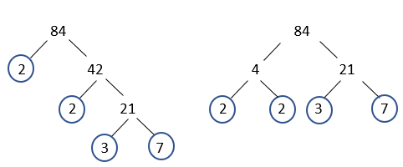

=

* + Successively dividing a number by prime numbers

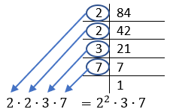

* The benchmark can be taught before 6.NSO.3.3 as a bridge between 6.NSO.3.1 and 6.NSO.3.3 and exponents.
* There is no limitation on the size of the whole number exponent for this benchmark.
* It is important to allow students to connect to the commutative property to understand that the prime factorization can be represented as $2^{6}·3^{3}$ or $3^{3}·2^{6}$*(MTR.2.1, MTR.5.1).*

Common Misconceptions or Errors

* Students may incorrectly think when creating branches on a factor tree, one of the branches of each factor pair has to have a prime number.
* Students may incorrectly think the prime factorization of a number will change if different factors are selected for constructing the prime factorization model.
* Students may incorrectly write the prime factorization from a factor tree because they do not take all of the factors into their solution.
* Students may incorrectly think 2 is a composite number because it is even. Have students list the factor pairs that produce a product of 2 for them to conclude that 2 must be prime because it has exactly 2 factors: 1 and itself.
* Students may incorrectly think most odd numbers, like 91, are prime. It can be helpful to, within problem contexts, incorporate divisibility rules, especially those for 2, 3, 5, 6, 9 and 10, to help students identify factors quickly.
* Students may confuse finding factors with finding multiples of a number. It is important to use the academic vocabulary of factor and multiple within the contexts of problems and tasks.

Strategies to Support Tiered Instruction

* Teacher identifies the first seven prime numbers as 2, 3, 5, 7, 11, 13, 17 and introduces the divisibility rules to utilize when finding prime factors of a given value.
* Instruction includes comparing two different factor trees for the same given number with a focus on recognizing that multiple different factor pairs can be used to produce the same final factorization.
  + For example, 48 can be represented by the factor trees below.

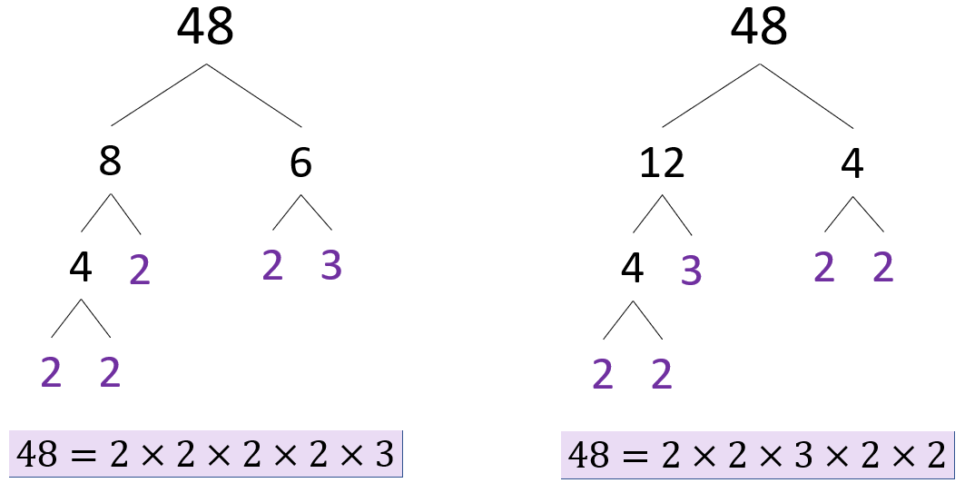

* Instruction includes the use of additional divisibility rules for $2$, $3$, $and 5$ to assist with determining factors of a given value.
* Teacher creates and posts an anchor chart with visual representations of factors and multiples and encourages students to utilize the anchor chart to assist in utilizing correct academic vocabulary when referring to factors and multiples.
* Teacher provides students with flashcards to practice and reinforce academic vocabulary.

Instructional Tasks

*Instructional Task 1 (MTR.2.1, MTR.3.1, MTR.4.1)*

Lizzie and Adam both factored 864. Their answers are shown below:

|  |  |
| --- | --- |
| Lizzie | Adam |
| $$864=2^{5}∙3^{3}$$ | $$864=2∙2∙3∙3∙2∙2∙3∙2$$ |

Who factored 864 as a product of primes correctly? If Lizzie or Adam are incorrect, describe the error they made. If they are both correct, describe which factored form is more efficient as a solution and justify your reasoning.

Instructional Items

*Instructional Item 1*

Determine all of the factors of 24. Rewrite 24 as a product of its prime factors using exponents.

*Instructional Item 2*

Determine all of the factors of 216. Rewrite 216 as a product of its prime factors using exponents.

\*The strategies, tasks and items included in the B1G-M are examples and should not be considered comprehensive.

### MA.6.NSO.3.5

Benchmark

**MA.6.NSO.3.5 Rewrite positive rational numbers in different but equivalent forms including fractions, terminating decimals and percentages.**

*Example:* The number $1\frac{5}{8}$ can be written equivalently as 1.625 or 162.5%.

Benchmark Clarifications:

*Clarification 1:* Rational numbers include decimal equivalence up to the thousandth place.

Connecting Benchmarks/Horizontal Alignment

* MA.6.NSO.1.1
* MA.6.AR.3.4, MA.6.AR.3.5
* MA.7.AR.3.1

Terms from the K-12 Glossary

* Dividend
* Divisor
* Rational Number

Vertical Alignment

|  |  |
| --- | --- |
| **Previous Benchmark**   * MA.4.FR.1.2 * MA.5.NSO.1.2 * MA.5.NSO.2.2 * MA.5.FR.1.1 | **Next Benchmarks**   * MA.7.NSO.1.2 |

Purpose and Instructional Strategies

In previous courses, students related the relationship between decimal values and fractions out of ten, one hundred or one thousand. Students also were taught that fractions show a division relationship. This understanding is being extended in grade 6 accelerated to re-write positive and negative rational numbers into equivalent forms, including terminating and repeating decimals. In future courses, students will generate equivalent forms of rational numbers.

* Instruction includes various methods and strategies to rewrite numbers into a percentage.
  + Finding equivalent fractions with denominators of 10, 100 or 1000 to determine the equivalent percentage.
  + Writing fractions and decimals as hundredths; the term percent can be substituted for the word hundredth.
  + Multiplying the decimal by 100.
* Percent means “per 100,” so a whole is out of 100, or a whole is 100%. If converting the inverse relationship from a percent to a decimal, students divide the percent by 100 to find the equivalent decimal. Students should be encouraged to look for and discover the pattern that occurs *(MTR.5.1).*
* Instruction includes various methods and strategies to rewrite numbers from fraction to decimal or from decimal to fraction *(MTR.3.1).*
  + Decimal grid models

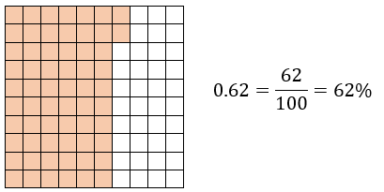

* + Dividing the numerator by the denominator.

If the fraction is a fraction greater than one or a mixed number, there will be a whole number in the decimal equivalent and the percent will be greater than 100. Students can convert mixed numbers to fractions greater than one and then divide to help them see the pattern of where the whole number falls in relation to the decimal *(MTR.5.1).*

* Instruction focuses on relating fractions, decimal and percent equivalence to familiar real-world situations, like scores and grades on tests or coupons and sales offered by stores *(MTR.5.1, MTR.7.1).*
* Use questioning to help students determine their solution’s reasonableness *(MTR.6.1).*
  + For example, is it reasonable for the percent to be more than 100? Is it reasonable for the percent to be less than 1?
* Instruction includes the understanding that percents are a number and are worth specific amounts in different contexts *(MTR.7.1).*
* Students should have practice with and without the use of technology to rewrite positive rational numbers in different but equivalent forms.

Common Misconceptions or Errors

* Students may incorrectly think that, when dividing, the larger value is divided by the smaller value. This is a common overgeneralization because most of their experience in elementary school is dividing larger values by smaller values.
* Students may misplace the decimal when converting from fraction to decimal form because they forget to place the decimal after the whole number in the dividend if the numbers do not divide evenly or do not place the decimal in the aligned place value of the quotient. It is helpful for some students to use graph paper when dividing with decimals to help students keep place values accurately aligned.
* Students may incorrectly think that the decimal value and the percent are exactly the same, not realizing that the percent is 100 times the decimal value.
* Students may incorrectly convert from fraction to decimal form because of their lack of place value knowledge. Instruction includes students using the expanded form of the numbers by adding a decimal and zeros in aligned place values until the decimal terminates. Practice includes multiple opportunities for students to work with fractions that require students to add zeros.
* Students may incorrectly move the decimal direction when converting between decimals and percentages because they do not understand what happens to the decimal when a number is multiplied or divided by a power of 10.

Strategies to Support Tiered Instruction

* Instruction includes the use of estimation when converting fractions to decimal form to ensure the proper placement of the decimal point in the final quotient.
* Instruction includes the use of a 100 frame to review place value for tenths, hundredths, and if needed, thousandths and the connections for decimal and fractional forms.
  + For example:

|  |  |  |
| --- | --- | --- |
| **Fraction** | **Model** | **Decimal** |
|  | A picture showing 30 cubes colored out of 100 to depict 3/10 or 0.3 | 0.3 |
|  | A picture showing 35 cubes colored out of 100 to depict 35/100 or 0.35. | 0.35 |

* Instruction includes providing multiple opportunities for students to work with fractions that require students to add zeros.

Instructional Tasks

*Instructional Task 1 (MTR.7.1)*

Kami told her mother that she answered 17 out of 25 questions correctly on her math test or 68%. Did Kami determine the correct percent score? Explain your reasoning.

*Instructional Task 2 (MTR.2.1, MTR.4.1, MTR.5.1)*

Complete the table to identify equivalent forms of each number. Explain how you approached your solutions.

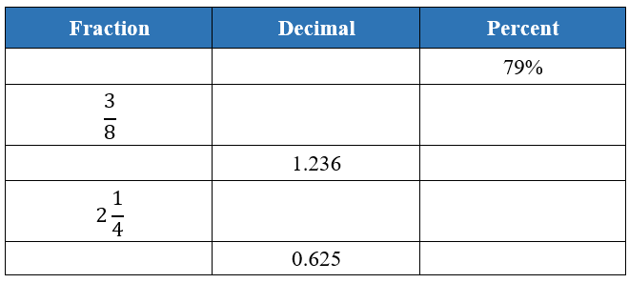

*Instructional Task 3 (MTR.2.1)*

Convert each of the following to an equivalent form to compare their values.

$$\frac{1}{5} 0.4 65\% 2\frac{3}{4} 5.75 \frac{9}{8} 123\%$$

Instructional Items

*Instructional Item 1*

How can $\frac{3}{4}$ be written as a decimal and as a percent?

*Instructional Item 2*

What is an equivalent fraction and decimal representation of 42%?

*Instructional Item 3*

Complete the following statement:

$4\frac{2}{5}$ can be written as the decimal \_\_\_\_\_\_\_ and is equivalent to \_\_\_\_\_\_ percent.

\*The strategies, tasks and items included in the B1G-M are examples and should not be considered comprehensive.

**MA.6.NSO.4** *Extend understanding of operations with integers.*

### MA.6.NSO.4.1

Benchmark

MA.6.NSO.4.1 Apply and extend previous understandings of operations with whole numbers to add and subtract integers with procedural fluency.

Benchmark Clarifications:

*Clarification 1:* Instruction begins with the use of manipulatives, models and number lines working towards becoming procedurally fluent by the end of grade 6.

*Clarification 2:* Instruction focuses on the inverse relationship between the operations of addition and subtraction. If $p$ and $q$ are integers, then $p-q=p+(-q)$ and $p+q=p-(-q)$.

Connecting Benchmarks/Horizontal Alignment

* MA.6.NSO.1
* MA.6.AR.1.3
* MA.6.AR.2.2
* MA.6.GR.1.2, MA.6.GR.1.3
* MA.7.NSO.2.2

Terms from the K-12 Glossary

* Equal Sign
* Equation
* Integers
* Number Line
* Whole Number

Vertical Alignment

|  |  |
| --- | --- |
| **Previous Benchmarks**   * MA.3.NSO.2.1 | **Next Benchmarks**   * MA.8.NSO.1.7 |

Purpose and Instructional Strategies

In previous courses, students added and subtracted whole numbers using models, including number lines and counters. These skills are extended in grade 6 accelerated to compare and perform operations with integers with procedural fluency as well as write and solve single-step equations using integers. Students also perform all operations with rational numbers in the form of expressions, equations and inequalities. In future courses, students will use the order of operations with rational numbers, including exponents and radicals to solve multi-step mathematical and real-world problems.

* It can be beneficial for students to learn to add and subtract integers using real-world contexts, such as, the movement of a football on a football field, above and below sea level, temperature; refer to Appendix A for more situations. Given a real-world context, develop a conceptual model to represent the situation. Students can describe the relationship mathematically as an expression.
* Explore opportunities with students to discover patterns or rules instead of being directly instructed and expected to memorize them. It is not expected or recommended that students start by generating equivalent expressions mathematically *(MTR.2.1, MTR.5.1, MTR.7.1).*
* Use models to help students identify patterns for adding and subtracting integers. Instruction includes opportunities to model adding and subtracting integers using tools such as algebra tiles, two-color counters and number lines. Students should relate the model to the expression *(MTR.5.1).*
  + Algebra Tiles

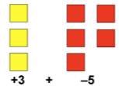

* + Two-Color Counters

A picture of 5 yellow two-color counters plus 3 red two-color counters to show the representation of positive 5 plus negative 3.

* + - For example, if a student is evaluating $5+(-3)$ using two-colored counters, a student can think, “I start with 5 yellows and 3 reds. A positive and a negative together make a zero pair. So, if I have 5 positive yellows and 3 negative reds, 3 of the paired chips will have a sum of zero, and I will have 2 yellow positives remaining, therefore my answer is $2$.”
  + Number Lines

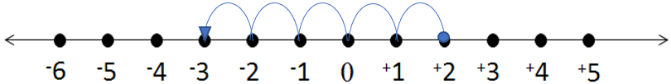

* + - For example, if a student is evaluating $2-5$ using a number line, a student can think, “I start at positive 2 and move 5 in the negative direction (to the left). I am now at $–3$.” Students can also use the commutative property to change the order to $\left(-5\right)+2$. The student can see that if they start at $-5$ and move 2 in the positive direction (right), they land on $–3$.
* When using algebra tiles or two-color counters, group the positive and negative values to create zero pairs, then the remaining tiles or counters show the resulting value.
* When combining integers on a number line, a negative symbol (“ $–$”) denotes the direction that will be traveled. If two negative symbols “ $-(-)$” (or subtracting a negative number) are present, the operators are showing to move in the opposite direction twice; the first negative symbol $(-)$ indicates moving to the left on the number line, whereas the second negative symbol $(-)$ indicates moving the opposite direction, or to the right, so it is the same as adding the second addend.
* Instruction includes understanding that subtracting a positive value is the same as adding a negative value, move the value left or decrease it on the number line. The commutative property can help students to see the relationship. Subtracting a negative value is the same as adding a positive value, moving the value to the right.
* Procedural fluency is developed with the combination of conceptual understanding and practice. Students should be encouraged to think through why a sum or difference would result in a positive or negative value instead of being encouraged to memorize a set of rules *(MTR.3.1).*
* The commutative property of addition allows for individuals to rearrange the order of the terms they are adding, regardless if they are positive or negative terms *(MTR.3.1).*
  + For example, $6-3$ can be rewritten as $6+(-3)$ in order to the commutative property to see that this is equivalent to $(-3)+6$.
* Use real-world contexts that model opposite relationships, like borrowing/earning money or falling/climbing, to help students conceptually reason through why a solution would be positive or negative *(MTR.6.1).*
* Instruction includes connecting understanding of the magnitudes of numbers to the absolute value of a number.
* Students should develop fluency with and without the use of a calculator when performing operations with integers.
* Instruction includes the use of models to demonstrate that the commutative and associative properties do not apply to subtraction. Demonstrate the correct use of the commutative and associative properties of addition by rewriting a subtraction expression as an addition expression before applying either property.
  + For example, $6-3≠3-6$, but $6-3=6+\left(-3\right)$ and $6-3=\left(-3\right)+6$.
  + For example, $\left(3-6\right)+5≠3-(6+5)$, but $\left(3-6\right)+5=3+\left(-6\right)+5$ and $\left(3-6\right)+5=3+(-6+5)$.

Common Misconceptions or Errors

* Some students may misunderstand when adding and subtracting integers, the sign of the “bigger number” is kept.
  + For example, in the expression $–8+4,$ the sum will be negative because $–8$ is the “bigger number.” Instead, it can be thought of as there are more negatives than positives being combined, so the result will be a negative value.
* Students may confuse zero for being a negative number because it is less than a whole. However, 0 is a neutral number; it is neither positive nor negative.
* Students may incorrectly believe that the number with the larger absolute value will always be the minuend (the first term in a subtraction expression) or that the positive number must always be the minuend. This may stem from an overgeneralization of the common pattern in elementary mathematics that “the larger number always goes first in subtraction.”

Strategies to Support Tiered Instruction

* Teacher provides opportunities for students to utilize two-color counters to represent addition and subtraction of integers. Use repeated addition to develop generalizations for multiplying integers and discuss the difference between generalized rules for addition and generalized rules for multiplication.
* Teacher provides opportunities for students to utilize two-color counters when evaluating the sum or difference of integers. Instruction includes having students write the expression, representing the expression with the two-color counters, finding the sum or difference, and then recording the solution.
* Teacher models identifying zero pairs using manipulatives such as two-color counters.

Instructional Tasks

*Instructional Task 1 (MTR.7.1)*

At 9:00 a.m. the temperature was $-5$ °F. By noon, the temperature had risen 14°F. On a number line, show how to find the temperature at noon. Explain.

*Instructional Task 2 (MTR.2.1)*

Jonah is a novice when it comes to scuba diving. His first dive was 12 feet deep, and his second dive was 3 feet deeper than the first. Describe the depth of Jonah’s second dive. Show your work on a vertical number line.

*Instructional Task 3 (MTR.2.1)*

At 6:00 p.m., the temperature was 11°C. By midnight, the temperature was $-3$ °C.

Part A. Using a visual model, show how to find the difference between the temperatures.

Part B. Write a numerical expression to represent the temperature change from 6:00 p.m. to midnight. Explain.

*Instructional Task 4 (MTR.2.1)*

Write $-3-6$ as an equivalent addition problem. How are $-3-6$ and the addition problem you wrote related? Explain using a visual model.

Instructional Items

*Instructional Item 1*

Evaluate $–5-8-(-2).$

*Instructional Item 2*

What is the value of the expression $9+\left(-12\right)$?

\*The strategies, tasks and items included in the B1G-M are examples and should not be considered comprehensive.

### MA.6.NSO.4.2

Benchmark

MA.6.NSO.4.2 Apply and extend previous understandings of operations with whole numbers to multiply and divide integers with procedural fluency.

Benchmark Clarifications:

*Clarification 1:* Instruction includes the use of models and number lines and the inverse relationship between multiplication and division, working towards becoming procedurally fluent by the end of grade 6.

*Clarification 2:* Instruction focuses on the understanding that integers can be divided, provided that the divisor is not zero, and every quotient of integers (with non-zero divisor) is a rational number. If $p$ and $q$ are integers where $q≠0$, then $-\left(\frac{p}{q}\right)=-\frac{p}{q}$, $-\left(\frac{p}{q}\right)=\frac{p}{-q}$ and $\frac{p}{q}=\frac{-p}{-q}$.

Connecting Benchmarks/Horizontal Alignment

* MA.6.NSO.1.1, MA.6.NSO.1.2, MA.6.NSO.1.3, MA.6.NSO.1.4 – This is all of NSO.1
* MA.6.NSO.3.3
* MA.6.AR.2.1, MA.6.AR.2.3
* MA.7.NSO.2.2
* MA.7.AR.2.1

Terms from the K-12 Glossary

* Dividend
* Divisor
* Expression
* Factor
* Integer
* Number Line

Vertical Alignment

|  |  |
| --- | --- |
| **Previous Benchmarks**   * MA.5.NSO.2.1, MA.5.NSO.2.2 | **Next Benchmarks**   * MA.7.AR.2.2 |

Purpose and Instructional Strategies

In previous courses, students have multiplied whole numbers and positive rational numbers. This is their first experience multiplying and dividing with negative numbers. In grade 6 accelerated, students will use these skills to write and solve one-step equations. Students will also continue to develop these skills by multiplying and dividing rational numbers in all forms and using them to solve equations and inequalities. In future courses, students will write and solve equations including rational numbers with two or more steps.

* Instruction includes making the connection to absolute value and the distance an integer is from zero (on a number line).
* Instruction includes extending the understanding of multiplying and dividing integers.
  + For example, $-6∙4$ can be thought of as “the opposite of 6 times 4.” Since 6 times 4 is 24, the opposite of 24 is –24.
* Instruction includes using algebra tiles or two-color counters to model multiplication and division of integers. Students flip the tiles over as directed by the negative value being “the opposite of.”
  + Algebra Tiles

|  |  |
| --- | --- |
|  |  |

* + Two-Color Counters

|  |  |
| --- | --- |
|  | A picture of 4 groups of 3 red two-color counters, equalling 12 red two-color counters, which is negative 12. |

* Use guided discussion for students to notice and record patterns. From analyzing the pattern, students should conclude that when two positive or two negative integers are multiplied or divided, the resulting product or quotient is positive. If a negative and a positive number are multiplied or divided, the resulting product or quotient is negative *(MTR.2.1, MTR.5.1).*
* Dividing a negative by a negative can be interpreted as was done when dividing a whole number by a whole number.
  + For example, $-8$ divided by $-4$ can be interpreted as “How many groups of -4 are in $-8$,” or as “What is the opposite of the size of the group that you get if you divide a group of $-8$ into $4$ parts?”.
* Division should be shown using the $÷$ symbol when written horizontally and a fraction bar when written vertically.
* If an integer divided by an integer result in a rational number quotient, the quotient can be written as a fraction or as a decimal *(MTR.3.1).*
* Multiplication and division with integers are inverse relationships resulting in related equations *(MTR.3.1, MTR.5.1).*
* Students should develop fluency with and without the use of a calculator when performing operations with integers.
* Instruction includes rewriting negative fractions using the division symbol and grouping symbols.
  + The teacher can refer to the negative sign as “the opposite of” to represent the entire quotient is the opposite of its positive value, which will be negative.
    - For example, $-\frac{50}{10}=-\left(50÷10\right)$ which is equivalent to $–(5)$, which is equivalent to $-5$.
  + The teacher can refer to the negative sign as multiplying by $-1$.
    - For example, $-\frac{50}{10}=-1\left(\frac{50}{10}\right)$ which is equivalent to $–1(50÷10)$, which is equivalent to $-1(5)$, which is equivalent to $-5$.
  + The teacher can make connections to the properties of operations (Appendix D).
    - For example, $-\frac{50}{10}=-1\left(\frac{50}{10}\right)$ which is equivalent to $–1(50÷10)$, which is equivalent to $(-50)÷10$, which is equivalent to $-5$.
    - For example, $-\frac{50}{10}=-1\left(\frac{50}{10}\right)$ which is equivalent to $–1(50÷10)$, which is equivalent to $50÷\left(-10\right)$, which is equivalent to $-5$.

Common Misconceptions or Errors

* Students may incorrectly apply rules to the multiplication and division of integers without experiencing models to provide concrete understanding. Using algebra tiles or two-colored counters, have students flip over the tiles every time they encounter a negative. This allows students to see a pattern and see negatives as “the opposite of” (*MTR.2.1, MTR.5.1*).
* Students may incorrectly believe the sign of the product or quotient is determined by the integer that is further from zero because they are confusing the pattern or rules for adding and subtracting integers with multiplying and dividing integers.
* Students may incorrectly conclude if an expression begins with a positive integer, the value of the expression is positive or if it begins with a negative integer, the value of the expression is negative.
* Students may incorrectly assume if division is written as a negative fraction, both the numerator and denominator are negative values. This can be addressed by modeling with algebra tiles or two-colored counters.
* Students may confuse zero for being a negative number because it is less than a whole number. However, 0 is a neutral number; it is neither positive nor negative.
* Students may say that a value divided by itself is zero because they subtract instead of divide. Students should remember that any number divided by itself is equal to 1.
* Students may make the common mistake of dividing the numbers but not remembering to pay attention to the negative sign. It may help students to write or highlight their negative signs in color to make them stand out visually.

Strategies to Support Tiered Instruction

* Teacher provides opportunities for students to utilize two-color counters to represent multiplication as repeated addition to develop generalizations for multiplying integers and discuss the difference between generalized rules for addition and generalized rules for multiplication.
* Teacher provides opportunities for students to utilize two-color counters when evaluating the product or quotient of integers. Instruction includes having students write the expression, representing the expression with the two-color counters, finding the product or quotient, and then recording the solution.
* Teacher provides instruction on the connections between dividends and divisors and numerators and denominators.
* Teacher provides algebra tiles or two-colored counters, to have students flip over the tiles every time they encounter a negative. This allows students to see a pattern and see negatives as “the opposite of.”
* Teacher models with algebra tiles or two-colored counters.
* Teacher models how to write or highlight their negative signs in color to make them stand out visually.

Instructional Tasks

*Instructional Task 1 (MTR.4.1)*

Camden is trying to understand why the product of a positive number and a negative number should be negative. How would you explain to Camden why $5(-4)$ is a negative number?

*Instructional Task 2 (MTR.6.1)*

Shannon noticed that $–2[5+(-3)]$ can be rewritten using the Distributive Property as:

$$-2∙5+\left(-2\right)∙\left(-3\right)$$

$=-10+$

$$=-4$$

\_\_\_\_\_\_

She was not sure what to put in the blank.

Part A. What number must go in the blank so the answer is $-4$?

Part B. What does this tell Shannon about the result of multiplying two negative numbers?

*Instructional Task 3 (MTR.7.1)*

Describe a real-world problem that can be solved by dividing $-12$ by 3. Then, find the quotient and explain what it means in the context of your problem.

Instructional Items

*Instructional Item 1*

Model one method for evaluating $–4×5$.

*Instructional Item 2*

What is the value of the expression $–72÷8$?

*Instructional Item 3*

Select all of the values that are equivalent.

* 1. 4

\*The strategies, tasks and items included in the B1G-M are examples and should not be considered comprehensive.

**MA.7.NSO.2** *Add, subtract, multiply and divide rational numbers.*

### MA.7.NSO.2.1

Benchmark

MA.7.NSO.2.1 Solve mathematical problems using multi-step order of operations with rational numbers including grouping symbols, whole-number exponents and absolute value.

Benchmark Clarifications:

*Clarification 1*: Multi-step expressions are limited to 6 or fewer steps.

Connecting Benchmarks/Horizontal Alignment

* MA.6.NSO.1.4
* MA.6.AR.1.3
* MA.7.NSO.1.1
* MA.7.AR.1
* MA.7.GR.1.1, MA.7.GR.1.2

Terms from the K-12 Glossary

* Absolute Value
* Exponent
* Order of Operations
* Rational Number

Vertical Alignment

|  |  |
| --- | --- |
| **Previous Benchmarks**   * MA.5.AR.2.2, MA.5.AR.2.3 | **Next Benchmarks**   * MA.7.NSO.1 * MA.8.NSO.1.5, MA.8.NSO.1.7 |

Purpose and Instructional Strategies

In previous courses, students used the order of operations to evaluate multi-step numerical expressions including parentheses. In grade 6 accelerated, students evaluate algebraic expressions using substitution and order of operations with integers, including use of absolute value and natural number exponents. Students also solve multi-step order of operations with rational numbers including grouping symbols, whole-number exponents and absolute value. In future courses, students will solve problems involving order of operations involving radicals.

* Number sense and properties of operations should be emphasized during instruction as this benchmark is the completion of operations with rational numbers.
* Remind students that subtraction is addition of an opposite and division is multiplication by a reciprocal when working with order of operations (*MTR.3.1*).
* Avoid mnemonics, such as PEMDAS, that do not account for other grouping symbols and do not exercise proper number sense that allows for calculating accurately in a different order.
* Instruction includes the use of technology to help emphasize the proper use of grouping symbols for order of operations.
* Students should have experience using technology with decimals and fractions as they occur in the real world. This experience will help to prepare students working with irrational numbers in grade 8.

Common Misconceptions or Errors

* Students may confuse when parentheses are used for grouping or multiplication.
* Some students may incorrectly apply the order of operations. In order to support students in moving beyond this misconception, be sure to review operations with rational numbers and order of operations.

Strategies to Support Tiered Instruction

* Instruction includes the use of colors to highlight each step of the process used to evaluate an expression.
* Teacher co-creates a graphic organizer for different grouping symbols and provides examples when the grouping symbols indicate operator symbols.
  + For example, students can be given the expressions below and discuss similarities and differences.

|  |  |  |
| --- | --- | --- |
| $$\left(\frac{4}{6}+9\right)+87$$ | $$\left(\frac{4}{6}+9\right)87$$ | $$\left(\frac{4}{6}+9\right)-87$$ |
| $$\left(\frac{4}{6}+9\right)\left(+87\right)$$ | $$\left(\frac{4}{6}+9\right)\left(87\right)$$ | $$\left(\frac{4}{6}+9\right)(-87)$$ |

* Instruction includes reviewing operations with rational numbers and order of operations.

Instructional Tasks

*Instructional Task 1 (MTR.4.1, MTR.5.1)*

Part A. Using the integers –6 to 6 at most once, fill in the boxes to create an expression with the lowest value.

$$\frac{\boxed{}}{\boxed{}}\left(\boxed{}-\frac{\boxed{}}{\boxed{}}\left|\boxed{}-\boxed{}\right|\right)$$

Part B. Compare your value with those in your group. Who has the lowest value? Explain why this value was less than the others.

*Instructional Task 2 (MTR.3.1, MTR.4.1)*

Part A. Evaluate the expression ${\left(\frac{\left|\frac{3}{4}\left(24\right)-21\right|}{2}\right)}^{4}$.

Part B. Compare your strategy with a partner.

Instructional Items

*Instructional Item 1*

What is the value of the expression $\frac{{\left(12-\left|8-5\right|\right)}^{3}}{36}$?

*Instructional Item 2*

What is the value of the expression $\frac{1}{2}\left(3^{2}-4\right)+\left|7-\frac{1}{6}\right|$?

*Instructional Item 3*

Evaluate the expression $18-3\left(4.12+7.6÷2\right)$.

\*The strategies, tasks and items included in the B1G-M are examples and should not be considered

### MA.7.NSO.2.2

Benchmark

MA.7.NSO.2.2 Add, subtract, multiply and divide rational numbers with procedural fluency.

Connecting Benchmarks/Horizontal Alignment

* MA.6.NSO.2.1, MA.6.NSO.2.2
* MA.6.NSO.4.1, MA.6.NSO.4.2
* MA.7.AR.1.1
* MA.7.AR.3.1, MA.7.AR.3.2
* MA.7.GR.1.1, MA.7.GR.1.2
* MA.7.DP.1.1, MA.7.DP.1.2, MA.7.DP.1.3

Terms from the K-12 Glossary

* Rational Number

Vertical Alignment

|  |  |
| --- | --- |
| **Previous Benchmarks**   * MA.5.NSO.2 * MA.5.FR.2.2, MA.5.FR.2.2 | **Next Benchmarks**   * MA.8.NSO.1.5, MA.8.NSO.1.7 |

Purpose and Instructional Strategies

In previous courses, students added, subtracted, and multiplied fractions, and performed operations with whole numbers and decimals. In grade 6 accelerated, students perform operations with integers, multiply and divide positive multi-digit numbers with decimals to the thousandths and compute products and quotients of positive fractions by positive fractions, including mixed numbers with procedural fluency. Students also perform all four operations with positive and negative rational numbers with procedural fluency. In future courses, students will expand to operations with rational numbers including exponents and radicals, and will perform operations with rational numbers expressed in scientific notation.

* This benchmark is the completion of arithmetic operations with rational numbers (*MTR.3.1*).
* Instruction includes the possibility that the division of two fractions can be written as a complex fraction. This connection will be important when students work with algebraic expressions in later grades.
* Students should develop fluency with and without the use of a calculator when performing operations with rational numbers.

Common Misconceptions or Errors

* Students may think the product of a fraction and another fraction is greater than either factor. Use manipulatives or models referenced in previous grade levels to support conceptual understanding *(MTR.2.1)*.
* Students may incorrectly believe that dividing by $\frac{1}{2}$ is the same as dividing by 2.
* Students may incorrectly solve complex fractions by multiplying the two fractions.

Strategies to Support Tiered Instruction

* Instruction includes the use of fraction tiles to represent operations with positive fractions while simultaneously recording the equivalent numerical expressions.
* Instruction includes the use of base ten blocks to represent operations with positive decimals while simultaneously recording the equivalent numerical expressions.
* Instruction includes the use of two-color counters to represent operations with positive and negative whole numbers while simultaneously recording the equivalent numerical expressions.
* Teacher co-creates a graphic organizer with students to review operations with positive fractions and operations with integers to assist when applying operations with rational numbers.

A graphic organizer showing the negative sign as multiplying by a negative one. The examples shown are fractions being used in multiplication and division problems.



* Instruction includes using manipulatives or models referenced in previous grade levels to support conceptual understanding.

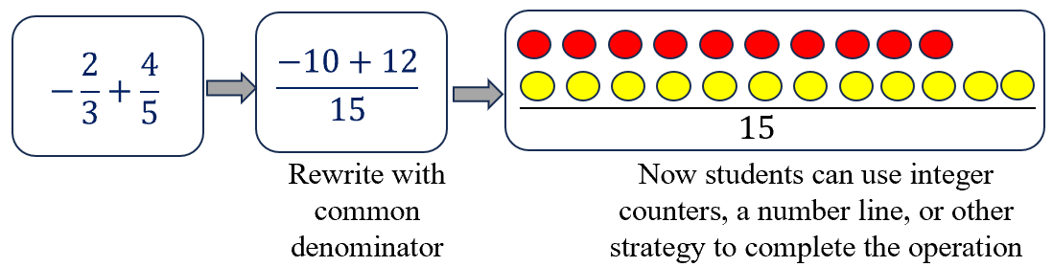

Instructional Tasks

*Instructional Task 1 (MTR.7.1)*

Daliah purchases eggs by the dozen for her two children. Each day, Zane eats $\frac{1}{4}$ carton and Amare eats $\frac{1}{6}$ carton. A carton of 12 eggs costs $1.65.

Part A. How much does Daliah spend on eggs for her two children in 30 days?

Part B. During one of her shopping trips, Daliah finds that her grocery store has started to sell cartons of 18 eggs for $2.25. If she begins to purchase these cartons, how much does Daliah spend on eggs for her two children in 30 days? After how many days will Daliah spend more than $50? Explain your reasoning.

*Instructional Task 2 (MTR.3.1)*

Part A. Given $a=-2\frac{3}{5}$ and $b=\frac{2}{3}$, calculate the following:

$a+b$

$a-b$

$a∙b$

$\frac{a}{b}$

Part B. Using the same expressions above, find the value of each if $a=2\frac{3}{5}$ and $b=-\frac{2}{3}$.

Part C. Compare and contrast the values of each expression from Part A and Part B.

Discuss with a partner any patterns or similarities in your answers.

Instructional Items

*Instructional Item 1*

Determine the product of $\frac{15}{6}$ and $-1.2$.

*Instructional Item 2*

What is the value of the expression $7.24-5.01-78.4$?

Instructional Item 3

What is the value of the expression $\frac{\frac{24}{5}}{\frac{1}{9}}$?

\*The strategies, tasks and items included in the B1G-M are examples and should not be considered

### MA.7.NSO.2.3

Benchmark

MA.7.NSO.2.3 Solve real-world problems involving any of the four operations with rational numbers.

Benchmark Clarifications:

Clarification 1: Instruction includes using one or more operations to solve problems.

Connecting Benchmarks/Horizontal Alignment

* MA.6.NSO.2.3
* MA.7.AR.3.1, MA.7.AR.3.2
* MA.7.DP.1.1, MA.7.DP.1.2, MA.7.DP.1.3

Terms from the K-12 Glossary

* Rational Number

Vertical Alignment

|  |  |
| --- | --- |
| **Previous Benchmarks**   * MA.5.AR.1.1, MA.5.AR.1.2, MA.5.AR.1.3 | **Next Benchmarks**   * MA.8.NSO.1.6, MA.8.NSO.1.7 |

Purpose and Instructional Strategies

In previous courses, students added, subtracted, and multiplied fractions, and performed operations with whole numbers and decimals. In grade 6 accelerated, students solve real-world problems involving any of the four operations with positive multi-digit decimals or positive fractions, including mixed numbers, with all rational numbers. In future courses, this extends to rational numbers including exponents and radicals.

* This benchmark applies the procedural fluency skills of the previous benchmark to real-world problems (*MTR.3.1*).
* Students should develop fluency with and without the use of a calculator when performing operations with rational numbers.
* Instruction includes the use of technology to help emphasize the proper use of grouping symbols for order of operations.
* Students should have experience using technology with decimals and fractions as they occur in the real world. This experience will help to prepare students to work with irrational numbers in future courses.
* Open-ended tasks with real-world contexts (*MTR.7.1*) will allow students to practice multiple pathways for solutions as well as to make comparisons with their peers (*MTR.4.1*) to refine their problem-solving methods.
* Instruction includes support in vocabulary development as related to the context of real-world problems.

Common Misconceptions or Errors

* Students may incorrectly perform operations with the numbers in the problem based on what has recently been taught, rather than what is most appropriate for a solution. To overcome this misconception, have students estimate or predict solutions prior to solving and then compare those predictions to their actual solution to see if it is reasonable *(MTR.6.1)*.
* Students may incorrectly oversimplify a problem by circling the numbers, underlining the question, boxing in keywords, and eliminating contextual information that is needed for the solution. This process can cause students to not be able to comprehend the context or the situation (*MTR.2.1*, *MTR.4.1*, *MTR.5.1*, *MTR.7.1*).

Strategies to Support Tiered Instruction

* Instruction includes the use of visual representations and manipulatives to represent the given situation and use the chosen representation to help find the solution.
* The teacher provides opportunities for students to comprehend the context or situation by engaging in questions like the ones below.
  + What do you know from the problem?
  + What is the problem asking you to find?
  + Can you create a visual model to help you understand or see patterns in your problem?
* Teacher co-creates a graphic organizer with students to review operations with positive fractions and operations with integers to assist when applying operations with rational numbers.

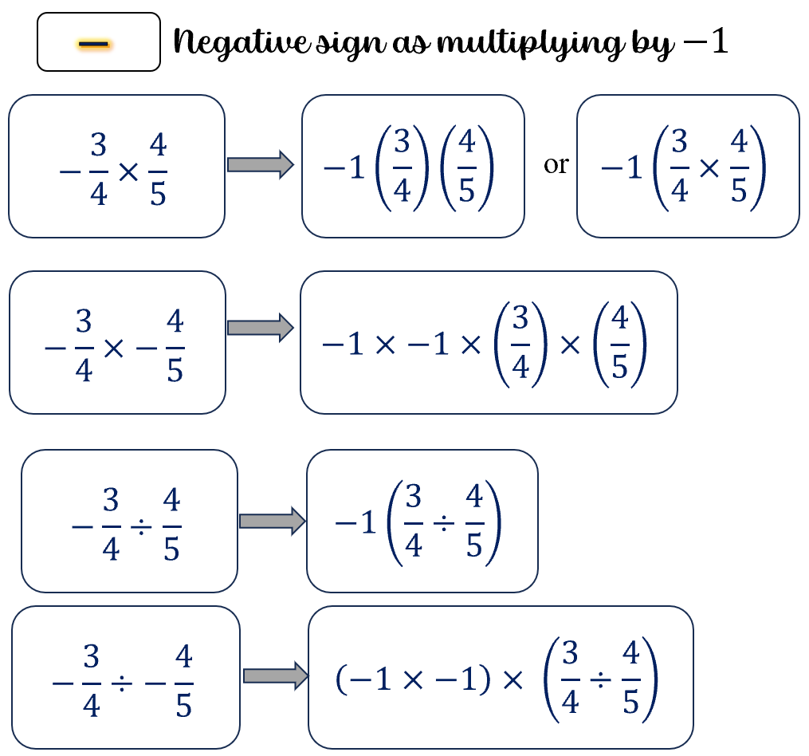

* Instruction includes the use of a three-read strategy. Students read the problem three different times, each with a different purpose. Laminating these questions on a printed card for students to utilize as a resource in and out of the classroom would be helpful.
  + First, read the problem with the purpose of answering the question: What is the problem, context, or story about?
  + Second, read the problem with the purpose of answering the question: What are we trying to find out?
  + Third, read the problem with the purpose of answering the question: What information is important in the problem?
* Instruction includes having students estimate or predict solutions prior to solving and then compare those predictions to their actual solution to see if it is reasonable.

Instructional Tasks

*Instructional Task 1 (MTR.7.1)*

All of the 7th grade homeroom classes collected recycling, with the top three classes splitting

the grand prize of $800 toward building their own gardens. Mr. Brogle’s class turned in 237

pounds of recycling, Mrs. Abiola’s class turned in 192 pounds and Mr. Wheeler’s class turned

in 179 pounds. How should these top three divide the money so that each class gets the same

fraction of the prize money as the fraction of recycling they collected?

*Instructional Task 2 (MTR.7.1)*

Kari and Natalia went to the Fun Warehouse with $20 each to spend. There is a $3 entry fee each and the menu of activities is shown below. What are some possible combinations of activities Kari and Natalia can enjoy before they each run out of money?

Go-Karts $9.75

Laser Tag $7.50

Inflatables $5.00

Mini-Bowling $2.25

Video Games $0.75

*Instructional Task 3 (MTR.4.1, MTR.7.1)*

Anjeanette is making cupcakes for her sister’s birthday. Among other ingredients, her recipe calls for 2 cups of flour, $\frac{1}{2}$ cup of butter and $\frac{3}{4}$ cup sugar in one batch. In the kitchen, she has 8 cups of flour, 2 cups of butter and 2 cups of sugar.

Part A. How many batches of cupcakes can Anjeanette make?

Part B. What should Anjeanette ask for if she wants to borrow from her neighbor to make one more batch?

Instructional Items

*Instructional Item 1*

Kari and Natalia went to the Fun Warehouse with $20 each to spend. They paid the $3 entry fee each and then decided they would both play laser tag and mini-bowling. If they finished the day with playing 4 video games each, how much money will be left?

Go-Karts $9.75

Laser Tag $7.50

Inflatables $5.00

Mini-Bowling $2.25

Video Games $0.75

\*The strategies, tasks and items included in the B1G-M are examples and should not be considered

# Algebraic Reasoning

**MA.6.AR.1** *Apply previous understanding of arithmetic expressions to algebraic expressions.*

### MA.6.AR.1.1

Benchmark

MA.6.AR.1.1 Given a mathematical or real-world context, translate written descriptions into algebraic expressions and translate algebraic expressions into written descriptions.

*Example:* The algebraic expression $7.2x-20$ can be used to describe the daily profit of a

company that makes $\$7.20$ per product sold with daily expenses of $\$20$.

Connecting Benchmarks/Horizontal Alignment

* MA.6.NSO.1.2, MA.6.NSO.1.3
* MA.6.NSO.2.1, MA.6.NSO.2.2, MA.6.NSO.2.3
* MA.6.AR.2.2, MA.6.AR.2.3
* MA.6.AR.3.5
* MA.6.GR.2.2, MA.6.GR.2.3

Terms from the K-12 Glossary

* Associative Property
* Absolute Value
* Coefficient
* Commutative Property of Addition
* Commutative Property of Multiplication
* Expression

Vertical Alignment

|  |  |
| --- | --- |
| **Previous Benchmarks**   * MA.5.AR.2.1, MA.5.AR.2.4 | **Next Benchmarks**   * MA.7.AR.2.2 |

Purpose and Instructional Strategies

Students are focusing on appropriate mathematical language when writing or reading expressions. In previous courses, students have had experience with unknown whole numbers within equations. Students in grade 6 accelerated extend this knowledge by focusing on using verbal and written descriptions using constants, variables and operating with algebraic expressions. In future courses, students use this knowledge when solving equations involving mathematical and real-world contexts.

* This continues to build in MA.6.AR.1.2 where students will focus on translating algebraic inequalities.
* Within this benchmark, instruction includes connections to the properties of operations, including the associative property, commutative property and distributive property. Students need to understand that subtraction and division do not comply with the commutative property, whereas addition and multiplication do. Students should have multiple experiences writing expressions *(MTR.2.1, MTR.5.1).*
* Instruction focuses on different ways to represent operations when translating written descriptions into algebraic expressions. For translating multiplication descriptions, students should understand that multiplication can be represented by putting a coefficient in front of a variable.
  + For instance, if students were translating “six times a number $n,$” they can write the algebraic expression as $6n$.
* For translating division descriptions, students should understand that division can be represented by using a fraction bar or fractions as coefficients in front of the variables *(MTR.2.1).*
  + For example, if students were translating “a third of a number $n$,” they can write the algebraic expression as $\frac{1}{3}n$ or $\frac{n}{3}$.
* Students are expected to identify the parts of an algebraic expression, including variables, coefficients, constants and the names of arithmetic operations (sum, difference, product and quotient).
* Variables are not limited to $x$; instruction includes using a variety of lowercase letters for their variables; however, $o$, $i$, and $l$ should be avoided as they too closely resemble zero and one.

Common Misconceptions or Errors

* Students may incorrectly assume that there is not a coefficient in front of a variable if there is not a number explicitly written to indicate a coefficient *(MTR.2.1).*
  + $x$ is the same as $1x$
* Students may incorrectly think that terms that are being combined using addition and subtraction have to be written in a specific order and not realize that the term being subtracted can come first in the form of a negative number *(MTR.2.1).*
  + $2x-3$ is the same as $-3+2x$
* Students may oversimplify a problem by using the process of circling the numbers, underlining the question, boxing in keywords, and trying to eliminate information without considering the context *(MTR.2.1, MTR.4.1, MTR.5.1, MTR.7.1)*

Instead, teachers and students should engage in questions such as:

* What do you know from the problem?
* What is the problem asking you to find?
* Are you putting groups together? Taking groups apart? Or both?
* Are the groups you are working with the same sizes or different sizes?
* Can you create a visual model to help you understand or see patterns in your problem?

Strategies to Support Tiered Instruction

* Instruction includes the use of pictorial representations, tape diagrams, or algebra tiles to represent the written situation before writing an expression.
* Instruction includes identifying unknowns, constants, negative values, and mathematical operations in a written description or algebraic expression.
* Instruction includes co-creating a graphic organizer that includes words used in written descriptions for each of the operations. The graphic organizer should continue to grow as new contexts are encountered.
* Teacher provides opportunities for students to comprehend the context or situation by engaging in questions such as:
  + What do you know from the problem?
  + What is the problem asking you to find?
  + Are you putting groups together? Taking groups apart? Or both?
  + Are the groups you are working with the same sizes or different sizes?
  + Can you create a visual model to help you understand or see patterns in your problem?

Instructional Tasks

*Instructional Task 1 (MTR.7.1)*

The amount of money Jazmine has left after going to the mall could be described by the algebraic expression $75-12.75s-9.50d$, where $s$ is the number of shirts purchased and $d$ is the number of dresses purchased.

Part A. Describe what each of the terms represents within the context.

Part B. What are the possible numbers of shirts and dresses Jazmine purchased?

*Instructional Task 2 (MTR.2.1)*

Some of the students at Kahlo Middle School like to ride their bikes to and from school. They always ride unless it rains. Let $d$ represent the distance, in miles, from a student’s home to the school. Write two different expressions that represent how far a student travels by bike in a four-week period if there is one rainy day each week.

Instructional Items

*Instructional Item 1*

Rewrite the algebraic expression as a written description: $10-\frac{6}{x}$.

*Instructional Item 2*

Write an expression to represent the phrase “9 plus the quotient of *w* and 4.”

*Instructional Item 3*

Write an expression to represent the phrase “7 fewer than the sum of 3 and *y.*”

\*The strategies, tasks and items included in the B1G-M are examples and should not be considered comprehensive.

### MA.6.AR.1.2

Benchmark

MA.6.AR.1.2 Translate a real-world written description into an algebraic inequality in the form of $x>a$, $x<a$, $x≥a$ or $x≤a$. Represent the inequality on a number line.

Example: Mrs. Anna told her class that they will get a pizza if the class has an average of at least 83 out of 100 correct questions on the semester exam. The inequality $g≥83$ can be used to represent the situation where students receive a pizza and the inequality

$g<83$ can be used to represent the situation where students do not receive a pizza.

Benchmark Clarifications:

*Clarification 1:* Variables may be on the left or right side of the inequality symbol.

Connecting Benchmarks/Horizontal Alignment

* MA.6.NSO.1.1, MA.6.NSO.1.2, MA.6.NSO.1.3
* MA.6.AR.2.1
* MA.7.AR.2.1

Terms from the K-12 Glossary

* Number Line

Vertical Alignment

|  |  |
| --- | --- |
| **Previous Benchmarks**   * MA.5.NSO.1.4 * MA.5.AR.2.1, MA.5.AR.2.4 | **Next Benchmarks**   * MA.8.AR.2.2 |

Purpose and Instructional Strategies

In previous courses, students plotted, ordered and compared multi-digit decimal numbers up to the thousandths using the greater than, less than, or equal to symbols. Students translated written real-world and mathematical situations into numerical expressions. In grade 6 accelerated, students plot, order and compare on both sides of zero on the number line with all forms of rational numbers. The algebraic inequalities include “is less than or equal to” ($≤$) and “is greater than or equal to” ($≥$). Students will also write and solve one-step inequalities in one variable and represent the solutions both algebraically and graphically. In future courses, solve two or more step linear inequalities and represent solutions algebraically and graphically.

* Instruction emphasizes the understanding of defining an algebraic inequality both numerically and graphically. Students should explore how “is greater than or equal to” and “is strictly greater than” are similar and different as well as “is less than or equal to” and “is strictly less than.” Students should use appropriate language when describing the algebraic inequality.
* The expectation of this benchmark includes translating from an algebraic inequality into a real-world written description.
* As students identify and write the inequality relationships, it is important to ask students about other values on the number line *(MTR.6.1, MTR.7.1).*
  + For example, when representing the inequality $x>1$ on the number line, students should compare numbers to 1 in order to determine whether to shade to the left or to the right of 1.
* Instruction includes inequalities where the variable is on the left and right side of the inequality symbol. This type of problem will create flexibility in their thinking to be able to apply in future applications of inequalities. Students should form equivalent statements to demonstrate their understanding of how inequalities are related. Students should use context to determine which situation is most appropriate for forming the inequality *(MTR.2.1).*
  + For example, $a>8$ can be written as $8<a$.
* Students should understand the solution set and its graphical representation on a number line. This also includes showcasing inclusive (closed circle) or non-inclusive (open circle), as well as shading to represent the solution set.
* A number line is a useful tool for modeling inequality situations.
  + For example, students can model on a vertical number line having to be at least 40 inches tall to ride a roller coaster.
* Instruction includes the understanding of how inequality relationships can be represented in real-world contexts from the beginning. It can be talked about in terms of character lives in a video game, or the amount of money to purchase apps or popular items. Allow students opportunities to identify their own inequality relationships as written descriptions and share with classmates to have them create the algebraic inequality and represent it on the number line *(MTR.1.1, MTR.4.1, MTR.5.1, MTR.7.1).*

Common Misconceptions or Errors

* Students may incorrectly think that the variable must always be written on the left-hand side of the inequality symbol. It is important that students be able to read and understand the context regardless of the side of the inequality that the variable is placed.
* Students may incorrectly shade the solution set of an inequality on a number line. Using verbal descriptions acknowledging the relationship between the number and the variable can support students in identifying the solution set. Students should test numbers on each side of the value to determine if they are true statements.
  + For example, if the relationship is $x>3$, have students replace the $x$ with $-5$ and $5$ to see which one creates a true statement.
* Students may not understand the difference between inclusive and non-inclusive solutions sets on a number line. Students can benefit from reasoning within a real-world context.

Strategies to Support Tiered Instruction

* Teacher provides inequalities with variables on the left or right side of the symbol and has students write two verbal comparisons for each statement.
  + For example, $x>15$ can be read as “ $x$ is greater than $15$” or as “ $15$ is less than $x$.”
  + For example, $k≤6$ can be read as “ $k$ is less than or equal to $6$” or as “ $6$ is greater than or equal to $y$.”
* Instruction includes the use of substitution to test various numbers to determine which set of numbers will make true statements and then to draw a ray in the appropriate direction. The same strategy holds true for reasoning with inclusive and non-inclusive solution sets and the difference in the solid or open point at the indicated value.
* Teacher provides students with flashcards to practice and reinforce academic vocabulary.
* Instruction includes creating a list of common terms from contextual situations that may be used to describe situations requiring an inequality symbol and add to as an interactive anchor chart as additional situations arise.
  + Examples include the table below.

|  |  |  |  |
| --- | --- | --- | --- |
| ($>$) | ($<$) | ($≥$) | ($≤$) |
| is greater than | is less than | is greater than or equal to  at least | is less than or equal to  at most  no more than |

* Teacher uses verbal descriptions to acknowledge the relationship between the number and the variable to support students in identifying the solution set. Students should test numbers on each side of the value to determine if they are true statements.
  + For example, if the relationship is $x>3$, have students replace the $x$ with $-5$ and $5$ to see which one creates a true statement.

Instructional Tasks

*Instructional Task 1 (MTR.4.1)*

The graph below describes the altitudes, measured in feet, at which civilian aircraft must provide everyone with supplemental oxygen, according to the U.S. Federal Aviation Regulation.

C:\Users\courtney.starling\AppData\Local\Microsoft\Windows\INetCache\Content.MSO\3109722D.tmp

Determine an inequality to represent the situation. How can this be written in another way?

*Instructional Task 2 (MTR.4.1)*

According to historical records, the highest price for diesel gas in Florida over the last twenty years was just under $4.88. Maria states that this is an inclusive relationship. Destiny says it is a non-inclusive relationship. Who is correct and why?

Instructional Items

*Instructional Item 1*

Graph $x≤ 5$ on a number line.

*Instructional Item 2*

According to Interstate Highway Standards, U.S. and state highway traffic lanes must be at least 12 feet wide. Write an inequality to represent the widths that traffic lanes can be.

*Instructional Item 3*

Bryce is allowed to play video games for no more than 6 hours over the weekend. Graph the inequality on a number line.

*Instructional Item 4*

A farmer is going to plant more than 30 acres of wheat this year. If $a$ represents the number of acres planted in wheat, write an inequality to describe all possible values of $a$.

*Instructional Item 5*

The recommended maximum depth for conventional scuba diving is 130 feet below the surface. If *d* represents the depth of a diver, write an inequality to describe all possible values of *d*.

\*The strategies, tasks and items included in the B1G-M are examples and should not be considered comprehensive.

### MA.6.AR.1.3

Benchmark

MA.6.AR.1.3 Evaluate algebraic expressions using substitution and order of operations.

Example: Evaluate the expression $2a^{2}-b^{5}$, where $a=-1$ and $b=15$.

Benchmark Clarifications:

*Clarification 1:* Within this benchmark, the expectation is to perform all operations with integers.

*Clarification 2:* Refer to Properties of Operations, Equality and Inequality (Appendix D).

Connecting Benchmarks/Horizontal Alignment

* MA.6.NSO.2.1, MA.6.NSO.2.2
* MA.6.NSO.3.3
* MA.6.NSO.4.1
* MA.6.AR.2.1
* MA.7.NSO.2.1
* MA.7.AR.1.1, MA.7.AR.1.2

Terms from the K-12 Glossary

* Base
* Coefficient
* Exponent
* Expression

Vertical Alignment

|  |  |
| --- | --- |
| **Previous Benchmarks**   * MA.5.AR.2.1, MA.5.AR.2.2, MA.5.AR.2.3 | **Next Benchmarks**   * MA.7.NSO.1.1 |

Purpose and Instructional Strategies

In previous courses, students translated written real-world and mathematical descriptions into numerical expressions, evaluated multi-step numerical expressions used order of operations involving combinations of the four arithmetic operations and parentheses with whole numbers, decimals and fractions. Students also determined and explained whether an equation involving any of the four operations is true or false. In grade 6 accelerated, students will use substitution to evaluate algebraic expressions, including exponents and rational coefficients. The values being substituted will also be integers. This benchmark extends to other benchmarks in this course, and in further courses where students will evaluate more complex numerical expressions with rational coefficients, apply laws of exponents and generate equivalent linear expressions.

* Substitution is the process in which a symbol or variable is replaced by a given value. In prior grades, students have found missing terms in equations and then substituted the value back in to check it they are correct.
  + For example, students may have seen something such as $2 + ? =10$ and decided that 8 is the value that should replace the $?$.
* This prior experience can be used to connect prior student understanding with new learning. In previous courses, instead of seeing a symbol like a question mark or a box for a missing value, we use letters called variables.
* An algebraic expression is built from constants (limited to integers), variables and operations whereas an equation is the statement of two equivalent expressions. This benchmark is specifically addressing substitution.
* Depending on the given expression, students may see opportunities to start generating equivalent expressions before substituting the value of the variable(s). This is a way a student can demonstrate flexible thinking and the understanding of patterns and structure in mathematical concepts *(MTR.5.1).*

Common Misconceptions or Errors

* + Students may incorrectly use the order of operations when generating equivalent expressions.
  + If more than one variable is present in a given expression, students may incorrectly substitute one value for all given variables or apply the wrong value to each of the variables. To address this misconception, students can use colors (pens, pencils, markers) to keep track of which variable and location correspond to each given value.
  + If students try to generate an equivalent expression before substituting integer values, they may try to combine unlike terms (constants with variables or unlike variable terms).
  + Students may substitute without using the correct operation of multiplication.
    - For example, $3c$, where *c* is 2; a student may write 32 instead of $3\left(2\right)$ or $3∙2$.

Strategies to Support Tiered Instruction

* Instruction includes building a foundation for the meaning of substitution by introducing algebraic expressions in a single variable with an exponent of 1 and representing the expression with algebra tiles. Then the variable tile can be replaced with the appropriate number of unit tiles to represent the provided value and the expression can be evaluated. The algebraic expression should be represented simultaneously to draw connections between the concrete and abstract representations. Use this foundation to build towards using algebraic strategies to evaluate expressions that cannot be represented with algebra tiles.
  + For example, when evaluating $3b+5$ when $b=-4$, students can represent this as shown below.

|  |  |
| --- | --- |
| **Algebra Tiles** | **Algebraic Representation** |
| *A picture of 3 green rods, representing 3b, and 5 yellow tiles, representing positive 5. This is the representation of the algebraic expression above. Then 4 red tiles are replaced in each of the 3 green tiles, showing the substitution of b equals negative 4. The yellow tiles remain the same.*  5 red tiles are matched to the 5 yellow tiles representing 5 zero pairs.  A picture showing the answer of 7 red tiles, which is negative 7. |  |

* Teacher provides opportunities for students to use different colored pencils to represent different variables and use the coordinating color to replace the variable with its assigned value before utilizing the order of operations to evaluate.
  + For example, if evaluating the expression $-5a^{2}+c$, where $a=-3$ and $c=-12$, the teacher can color coordinate as shown below.

$-5a^{2}+c$; $a=-3$ and $c=-12$

$$-5{\left(-3\right)}^{2}+(-12)$$

$$-5\left(9\right)+(-12)$$

$$-45+(-12)$$

$$-57$$

* Teacher models how students can use colors (pens, pencils, markers) to keep track of which variable and location correspond to each given value.

Instructional Tasks

*Instructional Task 1 (MTR.5.1)*

To compute the perimeter of a rectangle, you add the length, $l$, and width, $w$, and double this sum.

Part A. Write an expression for the perimeter of a rectangle.

Part B. Use the expression to ﬁnd the perimeter of a rectangle with a length of 13 feet and width of 9 feet.

*Instructional Task 2 (MTR.6.1)*

To determine the distance traveled by a car, you multiply the speed the car traveled by the amount of time the car was traveling at that speed. The scenario can be represented as $st$, where $s$ is speed, and $t$ is time. What is the distance traveled by a car that travels at an average speed of 65 miles per hour for 40 minutes?

Instructional Items

*Instructional Item 1*

If $x=5$, find $5x+12$.

*Instructional Item 2*

If $p=9$, find $\frac{2}{3}p-4$.

*Instructional Item 3*

Evaluate the expression $-3a^{2}+c,$ where $a=-2$ and $c=-9$.

\*The strategies, tasks and items included in the B1G-M are examples and should not be considered comprehensive.

### MA.6.AR.1.4

Benchmark

MA.6.AR.1.4 Apply the properties of operations to generate equivalent algebraic expressions with integer coefficients.

*Example:* The expression $5(3x+1)$ can be rewritten equivalently as $15x+5$.

Example: If the expression $2x+3x$ represents the profit the cheerleading team can make when selling the same number of cupcakes, sold for $2 each, and brownies, sold for $3 each. The expression $5x$ can express the total profit.

Benchmark Clarifications:

*Clarification 1:* Properties include associative, commutative and distributive.

*Clarification 2:* Refer to Properties of Operations, Equality and Inequality (Appendix D).

Connecting Benchmarks/Horizontal Alignment

* MA.6.NSO.3.1, MA.6.NSO.3.2
* MA.7.AR.1.1, MA.7.AR.1.2

Terms from the K-12 Glossary

* Coefficient
* Distributive Property
* Expression
* Integer

Vertical Alignment

|  |  |
| --- | --- |
| **Previous Benchmarks**   * MA.5.AR.2.2 | **Next Benchmarks**   * MA.8.AR.1.2 |

Purpose and Instructional Strategies

In previous courses, students evaluated multi-step numerical expressions using order of operations including parentheses, whole numbers, decimals and fractions. In grade 6 accelerated, variable terms are introduced to create algebraic expressions with integer coefficients. In future courses, rational number coefficients will be used in variable expressions.

* Instruction focuses on students using the properties of operations to generate equivalent algebraic expressions.
* Within this benchmark, all variables will have an exponent value of 1. Laws of exponents are introduced later on.
* Students should understand if values are equivalent, they are worth the same amount.
  + For example, a 1-dollar bill, 4 quarters, 10 dimes, 20 nickels, 2 half-dollars or 100 pennies have equal values and can be represented as $1b=4q$, $1b=10d$, $1b=20n$, $1b=2h$ or $1b=100p$, respectively.
* Instruction includes generating equivalent expressions and comparing with other students’ solutions. Discussion focuses around looking for similarities and relationships between students’ approaches (*MTR.4.1)*.
* Instruction includes the use of algebra tiles or other concrete representations to provide visual representation of the properties of operations.

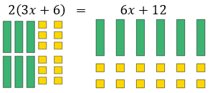

* Students should be encouraged to generate equivalent expressions in ways that are mathematically accurate and make sense to the individual. Students should be able to justify their process using properties of operations.
* Instruction includes having expressions with more than one variable as well as nested grouping symbols.
  + Expression with more than one variable: $-4x+3x-2y$
  + Nested grouping symbols: $-2\left[3\left(x-3\right)\right]$

Common Misconceptions or Errors

* + Students may incorrectly think there is only one right answer or equivalent value.
  + Students may incorrectly perform operations involving nested grouping symbols. Students can be taught or reminded that each grouping symbol is treated similarly to parentheses.

Strategies to Support Tiered Instruction

* Instruction includes providing students with algebra tiles and two different expressions. Students should represent the provided expressions with the algebra tiles and determine if the two expressions are equivalent or not by comparing the number of each tile.
* Teacher provides opportunities for students to use algebra tiles to represent various given expressions, manipulate the tiles to show the expression a different way, and then write the corresponding expression.
* Instruction includes building a foundation for the properties of operations by modeling the associative, commutative, and distributive properties with algebra tiles for numeric and algebraic expressions.
* Instruction includes providing students with two different expressions already represented with algebra tiles and then allowing the students to manipulate the algebra tiles to determine if they are equivalent. Students should be allowed to justify their reasoning for why the expressions are equivalent, or not.
* Teacher reminds students that each grouping symbol is treated similarly to parentheses.

Instructional Tasks

*Instructional Task 1 (MTR.2.1, MTR.5.1)*

Look at the following expressions.

$$3\left(7+\left(4\right)\left(5\right)+x\right)$$

$$3[\left(7+4)(5+x\right)]$$

$$2\left(7+4\left(5+x\right)\right)$$

Part A. Simplify the expressions shown above.

Part B. Can any grouping symbols be removed from the expressions without changing the value of the expression?

*Instructional Task 2 (MTR.2.1)*

How can you show the two expressions, $6(x+3)$ and $6\left(x\right)+6(3)$, are equivalent? Explain.

Instructional Items

*Instructional Item 1*

Tamika is selling chocolate candy bars for $2 and bags of popcorn for $5 at the school fair. She sells *y* candy bars and ($y-5$*)* bags of popcorn. The expression $2y+ 5(y-7)$ represents Tamika’s total sales. Rewrite the expression in a different but equivalent form.

*Instructional Item 1*

Trenton is practicing at home in hopes of making the middle school basketball team. He is working on his mid-range jump shot and 3-pointer. In a game, each mid-range shot is worth 2 points, and each 3-pointer is worth 3 points. Trenton made $s$ 3-pointers, and $(s+6$) mid-range shots yesterday. Write an expression that represents how many points Trenton scored during yesterday’s practice.

\*The strategies, tasks and items included in the B1G-M are examples and should not be considered comprehensive.

**MA.6.AR.2** *Develop an understanding for solving equations and inequalities. Write and solve one-step equations in one variable.*

### MA.6.AR.2.1

Benchmark

MA.6.AR.2.1 Given an equation or inequality and a specified set of integer values, determine which values make the equation or inequality true or false.

Example: Determine which of the following values makes the inequality $x+1<2$ true: $-4$, $-2$, 0, 1.

Benchmark Clarifications:

*Clarification 1:* Problems include the variable in multiple terms or on either side of the equal sign or inequality symbol.

Connecting Benchmarks/Horizontal Alignment

* MA.6.NSO.4.2
* MA.6.AR.1.2, MA.6.AR.1.3
* MA.7.AR.2.1

Terms from the K-12 Glossary

* Coefficient
* Distributive Property
* Equation
* Integer

Vertical Alignment

|  |  |
| --- | --- |
| **Previous Benchmarks**   * MA.5.AR.2.2, MA.5.AR.2.3 | **Next Benchmarks**   * MA.7.AR.2.2 |

Purpose and Instructional Strategies

In previous courses, students evaluated numerical expressions and simplified them on both sides of an equation to determine if the equation was true or false. In grade 6 accelerated, the skills are extended to evaluating expressions where students must substitute the given value of a variable. Students are also expected to use substitution with multiple variables within algebraic equations and inequalities to determine which of the given values make the mathematical statement true and which make it false. This skill extends within grade 6 accelerated and future courses where students learn to solve two-step equations and one-step inequalities to determine their rational number solutions.

* Within this benchmark, the substituted values are limited to integers.
* Instruction focuses on the understanding that solving an equation or inequality is a process of answering the question:
  + Which values from a specified set, if any, make the equation or inequality true?
* Instruction emphasizes the understanding of defining an algebraic inequality. Students should have practice with inequalities in the form of , , and . Students should explore how “is greater than or equal to” and “is strictly greater than” are similar and different as well as “is less than or equal to” and “is strictly less than.” Students should use academic language when describing an algebraic inequality *(MTR.4.1)*.
* Students should understand a variable can represent an unknown number or, depending on the context, any value in a specified set.
* Instruction includes using set notation to list numbers but not writing solutions in set notation as well as equations where the same variable is in more than one term or on both sides of the equation or inequality. Set notation does not require descending or ascending order.
  + Set notation: $\{-3, 0, 4, 11\}$ or $\{5, -3, 2, 0, 13\}$.
* For this benchmark, students are not expected to perform operations with negative rational numbers.

Common Misconceptions or Errors

* + Some students may incorrectly believe only one value can make an inequality true. Inequalities describe a relationship between expressions where more than one value can satisfy the statement.
  + If more than one operation is present, students may incorrectly think there is only one way to accurately evaluate it.
    - For example, if students are asked if the value of $x=8$ is true given the equation $2x-3(x-4)=4$, students could accurately solve using the order of operations and properties of operations in more than one way.

Strategies to Support Tiered Instruction

* Instruction includes the use of pictorial representations, tape diagrams, or algebra tiles to represent the equation or inequality, then replacing the variables with the possible solutions to test for the equation or inequality to be true.
  + For example, the following representations can be used to determine which of the values, 4, 5 or 6, make the equation $4x+5=25$ true.

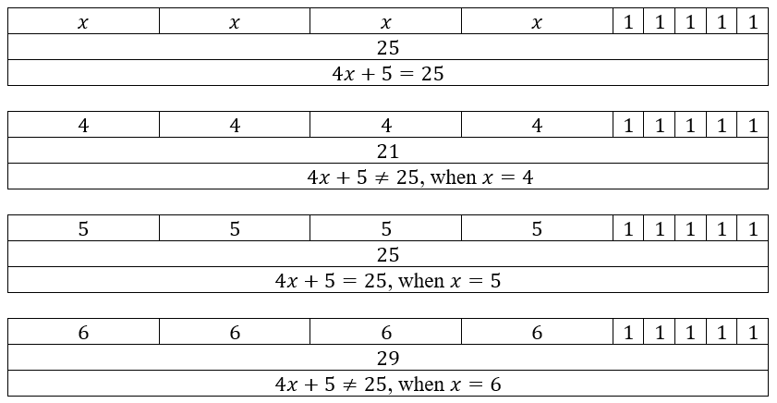

* Teacher provides instruction with a simple inequality statement and its graph, and then has students use substitution and the number line to test for possible solutions. Gradually remove the support of the number line and transition students to using only substitution to test for possible values to make the given inequalities true.

Instructional Tasks

*Instructional Task 1 (MTR.4.1)*

Explain what it means for a number to be a solution to an equation. Explain what it means for a number to be a solution to an inequality.

*Instructional Task 2* *(MTR.3.1, MTR.4.1, MTR.5.1)*

Provide students with a set of integer values.

Part A. Choose one of the integer values and create an equation that would make a true statement with your selected value.

Part B. Compare your equation with someone who chooses the same value and a different value. What do you notice?

Part C. Choose two of the integer values and create an inequality that would make a true statement with your selected values. Create another inequality that would make a true statement with one of your selected values but not the other.

Part D. Compare your inequality with someone who chose the same values and someone who chose different values. What do you notice?

*Enrichment Task 1* *(MTR.5.1, MTR.6.1)*

Which of the following values are solutions to the inequality $6a+2≤a-23$?

$5$

$\frac{21}{5}$

$4$

$4.2$

$-\frac{25}{7}$

Instructional Items

*Instructional Item 1*

Which of the following values makes the equation $2x+6=16$ true?

$-5$

$-2$

$2$

$5$

$11$

*Instructional Item 2*

Which of the following values makes the inequality $3x+4>28$ true?

$-5$

$-4$

$4$

$8$

$11$

\*The strategies, tasks and items included in the B1G-M are examples and should not be considered comprehensive.

### MA.6.AR.2.2

Benchmark

MA.6.AR.2.2 Write and solve one-step equations in one variable within a mathematical or real-world context using addition and subtraction, where all terms and solutions are integers.

*Example:* The equations $-35+x=17, 17=-35+x$ and $17-x=-35$ can represent the question “How many units to the right is 17 from -35 on the number line?”

Benchmark Clarifications:

*Clarification 1:* Instruction includes using manipulatives, drawings, number lines and inverse operations.

*Clarification 2:* Instruction includes equations in the forms $x+p=q$ and $p+x=q$, where $x$, $p$ and $q$ are any integer.

*Clarification 3:* Problems include equations where the variable may be on either side of the equal sign.

Connecting Benchmarks/Horizontal Alignment

* MA.6.NSO.4.1
* MA.6.AR.1.1

Terms from the K-12 Glossary

* Additive Inverse Property
* Addition Property of Equality
* Associative Property
* Commutative Property of Addition
* Equation
* Identity Property of Addition
* Integer
* Number Line

Vertical Alignment

|  |  |
| --- | --- |
| **Previous Benchmarks**   * MA.5.AR.1.1, MA.5.AR.2.1 * MA.5.AR.2.2, MA.5.AR.2.3, MA.5.AR.2.4 | **Next Benchmarks**   * MA.7.AR.2.2 |

Purpose and Instructional Strategies

In previous courses, students wrote and evaluated numerical expressions with positive rational numbers. Students also wrote equations to determine an unknown whole number. In grade 6 accelerated, students extend their understanding to solve one-step equations which include integers. Students will also write and solve one-step inequalities involving rational numbers. In future courses, students will write and solve two or more step equations and inequalities involving rational numbers.

* When students write equations to solve real-world and mathematical problems, they draw on meanings of operations that they are familiar with from previous courses’ work.
* Problem types include cases where students only create an equation, only solve an equation and problems where they create an equation and use it to solve the task. Equations include variables on the left or right side of the equal symbol.
* Use models or manipulatives, such as algebra tiles, bar diagrams, number lines and balances to conceptualize equations *(MTR.2.1)*.
  + Algebra Tiles

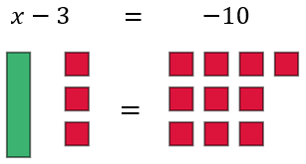

* + Bar Diagrams

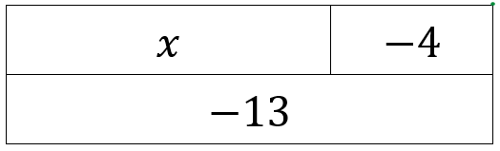

* + Number Lines

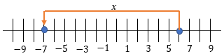

* + Balances

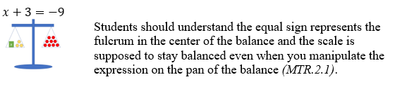

* As students physically manipulate a modeled equation concretely, they should record a pictorial representation and formally document the mathematical processes being done to the equation. Students should move from the physical models to visual representations of the models and then to solve the equations abstractly, without the visuals *(MTR.2.1, MTR.5.1)*.
* Instruction includes students identifying the properties of operations and properties of equality being used at each step toward finding the solution. Explaining informally the validation of their steps will introduce algebraic proofs in future mathematics *(MTR.5.1)*.
* Students should be encouraged to show flexibility in their thinking when writing equations.

Common Misconceptions or Errors

* Students may incorrectly apply an operation to a single side of an equation.
  + Students may incorrectly use the addition and subtraction properties of equality on the same side of the equal sign while solving an equation. To address this misconception, use manipulatives such as balances, algebra tiles, or bar diagrams to show the balance between the two sides of an equation *(MTR.2.1)*.

Strategies to Support Tiered Instruction

* Instruction includes identifying unknowns, constants, negative values, and mathematical operations in the provided context.
* Teacher provides opportunities for students to comprehend the context or situation by engaging in questions such as:
  + What do you know from the problem?
  + What is the problem asking you to find?
  + Are you putting groups together? Taking groups apart? Or both?
  + Are the groups you are working with the same sizes or different sizes?
  + Can you create a visual model to help you understand or see patterns in your problem?
* Teacher provides opportunities for students to use algebra tiles to co-solve provided equations with the teacher without the need of writing the equation first.
* Teacher provides opportunities for students to co-write an algebraic equation with the teacher without requiring students to solve the equation.
* Teacher models the use of manipulatives such as balances, algebra tiles, or bar diagrams to show the balance between the two sides of an equation.

Instructional Tasks

*Instructional Task 1 (MTR.2.1, MTR.4.1)*

Melvin wants to go to the school musical. The school auditorium has 1450 seats arranged in three sections. The left section has 425 seats, and the right section has 425 seats. Write an equation to find the number of seats in the center section and explain why you wrote the equation the way you did.

*Instructional Task 2 (MTR.6.1, MTR.7.1)*

To apply for college scholarships, Darcy is looking at the total goals she saved as the goalie of her high school soccer team. She saved 653 goals during her 4 years on the team. She saved 122 goals during her freshman year, 166 goals during her junior year, and 194 goals during her senior year. Write an equation to find the number of goals Darcy saved during her sophomore year and explain how you would solve the equation.

Instructional Items

*Instructional Item 1*

Given $n+11=4$, what is the value of $n$?

*Instructional Item 2*

Given $3=x-11$*,* what is the value of $x$?

*Instructional Item 3*

Dominic has some money in his wallet. His grandmother gives him $20 for a gift in his birthday card. He now has $36 in his wallet. Write an equation to represent the problem. How much money did he originally have in his wallet?

*Instructional Item 4*

The width of the rectangular tabletop is 3 feet shorter than its length. If the length of the tabletop is 8 feet, write and solve an equation to determine the width of the tabletop.

*\*The strategies, tasks and items included in the B1G-M are examples and should not be considered comprehensive.*

### MA.6.AR.2.3

Benchmark

MA.6.AR.2.3 Write and solve one-step equations in one variable within a mathematical or real-world context using multiplication and division, where all terms and solutions are integers.

Benchmark Clarifications:

*Clarification 1:* Instruction includes using manipulatives, drawings, number lines and inverse operations.

*Clarification 2:* Instruction includes equations in the forms $xp=q$, where $p≠0$, and $px=q$.

*Clarification 3:* Problems include equations where the variable may be on either side of the equal sign.

Connecting Benchmarks/Horizontal Alignment

* MA.6.NSO.4.2
* MA.6.AR.1.1
* MA.6.AR.3.4, MA.6.AR.3.5
* MA.6.GR.2.1, MA.6.GR.2.3, MA.6.GR.2.4

Terms from the K-12 Glossary

|  |
| --- |
| * Associative Property * Commutative Property of Multiplication * Division Property of Equality * Equation * Identity Property of Multiplication * Integer * Multiplicative Inverse (reciprocal) * Multiplication Property of Equality * Number Line * Substitution Property of Equality |

Vertical Alignment

|  |  |
| --- | --- |
| **Previous Benchmarks**   * MA.5.AR.1.1 * MA.5.AR.2.1, MA.5.AR.2.3, MA.5.AR.2.4 | **Next Benchmarks**   * MA.7.AR.2.2 |

Purpose and Instructional Strategies

In previous courses, students wrote and evaluated numerical expressions with positive rational numbers. Students also wrote equations to determine an unknown whole number. In grade 6 accelerated, students extend their understanding to solve one-step equations which include integers. In future courses, students write and solve one-step inequalities and two-step equations involving rational numbers.

* When students write equations to solve real-world and mathematical problems, they draw on meanings of operations that they are familiar with from previous courses’ work.
* Problem types include cases where students only create an equation, only solve an equation and problems where they create an equation and use it to solve the task. Equations include variables on the left or right side of the equal symbol.
* For multiplication, instruction includes the use of coefficients, parentheses and the raised dot symbol ($∙$).
* Use models or manipulatives, such as algebra tiles, bar diagrams and balances to conceptualize equations *(MTR.2.1)*. Build from these concrete models toward solving abstractly.
  + Algebra Tiles



* + Bar Diagrams

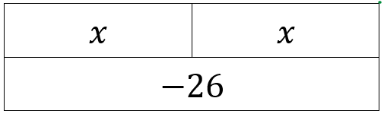

* + Balance

$$2x=-10$$

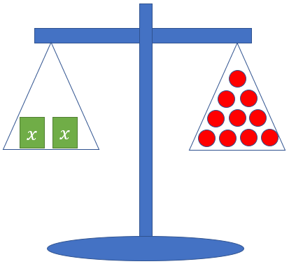

* As students physically manipulate a modeled equation concretely, they should record a pictorial representation and formally document the mathematical processes being done to the equation. Students should move from the physical models to visual representations of the models and then to solving the equations abstractly, without the *visuals (MTR.2.1, MTR.5.1)*.
* Instruction includes many contexts involving negative integers, including connections to ratio, rate and percentage problems in MA.6.AR.3.4 and MA.6.AR.3.5.
* Instruction can include students identifying the properties of operations and properties of equality being used at each step toward finding the solution. Explaining informally the validation of their steps will introduce algebraic proofs in future mathematics *(MTR.5.1)*.
* Students should be encouraged to show flexibility in their thinking when writing equations.

Common Misconceptions or Errors

* + Students may incorrectly apply an operation to a single side of an equation.
  + Students may incorrectly use the multiplication and division properties of equality on the same side of the equal sign while solving an equation. To address this misconception, use manipulatives such as algebra tiles, number lines or bar diagrams to show the balance between the two sides of an equation *(MTR.2.1)*.

Strategies to Support Tiered Instruction

* Instruction includes identifying unknowns, constants, negative values, and mathematical operations in the provided context.
* Teacher provides opportunities for students to comprehend the context or situation by engaging in questions such as:
  + What do you know from the problem?
  + What is the problem asking you to find?
  + Are you putting groups together? Taking groups apart? Or both?
  + Are the groups you are working with the same sizes or different sizes?
  + Can you create a visual model to help you understand or see patterns in your problem?
* Teacher provides opportunities for students to use algebra tiles to co-solve provided equations with the teacher without the need of writing the equation first.
* Teacher provides opportunities for students to co-write an algebraic equation with the teacher without requiring students to solve the equation.
* Teacher models the use of manipulatives such as algebra tiles, number lines or bar diagrams to show the balance between the two sides of an equation.

Instructional Tasks

*Instructional Task 1(MTR.4.1, MTR.7.1)*

A solar panel generates 200 watts of power each hour. A warehouse wants to generate 34,000 watts of power each hour.

Part A. Write an equation to find how many solar panels the warehouse will need on its roof to generate 34,000 watts of power each hour.

Part B. Explain why you wrote the equation the way you did. Could you write the equation in another way?

Part C. Find the solution to your equation.

Part D. What does the solution to your equation mean?

*Extension:*

If an apartment building wanted to install solar panels, and the residents use 25,250 watts of power each hour, would 120 solar panels be enough to power the building? If so, how many less would they need to still generate enough power? If not, how many more would they need to generate enough power?

Instructional Items

*Instructional Item 1*

An outlet mall has 4 identical lots that can hold a total of 1,388 cars. The equation

$4c=1388$ describes the number of cars that can fit into each lot. How many cars can fit into each lot?

*Instructional Item 2*

Given $\frac{x}{7}=56$, what is the value of $x$?

*\*The strategies, tasks and items included in the B1G-M are examples and should not be considered comprehensive*

### MA.6.AR.2.4

Benchmark

MA.6.AR.2.4 Determine the unknown decimal or fraction in an equation involving any of the four operations, relating three numbers, with the unknown in any position.

*Example:* Given the equation $\frac{9}{8}=x-\frac{1}{8}$, $x$ can be determined to be $\frac{10}{8}$ because $\frac{10}{8}$ is $\frac{1}{8}$ more than $\frac{9}{8}$.

Benchmark Clarifications:

*Clarification 1:* Instruction focuses on using algebraic reasoning, drawings, and mental math to determine unknowns.

*Clarification 2:* Problems include the unknown and different operations on either side of the equal sign. All terms and solutions are limited to positive rational numbers.

Connecting Benchmarks/Horizontal Alignment

* MA.6.NSO.2.1, MA.6.NSO.2.3
* MA.6.GR.1.2, MA.6.GR.1.3

Terms from the K-12 Glossary

* Dividend
* Divisor
* Equation
* Equal Sign
* Number Line

Vertical Alignment

|  |  |
| --- | --- |
| **Previous Benchmarks**   * MA.5.NSO.2.5 * MA.5.FR.2.1 * MA.5.AR.2.3 | **Next Benchmarks**   * MA.7.AR.2.2 |

Purpose and Instructional Strategies

In previous courses, students multiplied and divided decimals by one tenth and one hundredth, added and subtracted fractions with unlike denominators, and determined if equations were true. In grade 6 accelerated, students increase their computation with fractions and decimals as well as solve equations with integers. In future courses, students solve multi-step equations with rational numbers.

* Thinking through the lens of fact families can help students think flexibly about number relationships to determine the unknown value *(MTR.5.1)*.
* This benchmark allows for fractions in equations to include unlike denominators.
* The benchmark expects students to reason and use mental math to build their number sense. Students should not follow a specific set of steps to solve.
* Variables are not limited to $x$; instruction includes using a variety of lowercase letters for their variables; however, $o$, $i$ and $l$ should be avoided as they too closely resemble zero and one.

Common Misconceptions or Errors

* + Students may not see the connection to mental mathematics within the benchmark and may need to apply procedures when finding an unknown quantity.

Strategies to Support Tiered Instruction

* Instruction includes the use of fact family prompts of whole numbers to help guide students' reasoning with positive rational numbers.
  + For example, the connection can be made between determining the unknown in the equation $3×\boxed{}=15$ and in the equation $\frac{1}{3}×\boxed{}=\frac{1}{15}$.
* Teacher provides opportunities for students to identify the relationship between the provided numbers and then co-solve the equation to determine the unknown.

Instructional Tasks

*Instructional Task 1 (MTR.4.1)*

Given the equation $0.5=\frac{c}{0.15}$, describe a process or create a visual to explain how you can determine the value of $c$.

Instructional *Task 2 (MTR.4.1)*

If $\frac{2}{9}+g=\frac{8}{9}$, what value of g makes the equation true? Support your response with evidence.

*Instructional Task 3 (MTR.7.1)*

A solar panel can generate $\frac{8}{25}$ of a kilowatt of power. The average store needs to generate about 30 kilowatts of power.

Part A. Write an equation to determine how many solar panels a store needs on its roof.

Part B. How many solar panels does a store need?

Instructional Items

*Instructional Item 1*

Determine the value of $m$ in the equation $0.15m=0.60.$

*Instructional Item 2*

Given the equation $p-\frac{3}{5}=\frac{7}{10}$, what value of $p$ could be a solution to the equation?

*\*The strategies, tasks and items included in the B1G-M are examples and should not be considered comprehensive.*

**MA.6.AR.3** *Understand ratio and unit rate concepts and use them to solve problems.*

### MA.6.AR.3.1

Benchmark

MA.6.AR.3.1 Given a real-world context, write and interpret ratios to show the relative sizes of two quantities using appropriate notation: $\frac{a}{b}$, $a$ to $b$, or $a:b$ where $b≠0$.

Benchmark Clarifications:

*Clarification 1:* Instruction focuses on the understanding that a ratio can be described as a comparison of two quantities in either the same or different units.

*Clarification 2:* Instruction includes using manipulatives, drawings, models and words to interpret part-to-part ratios and part-to-whole ratios.

*Clarification 3:* The values of $a$ and $b$ are limited to whole numbers.

Connecting Benchmarks/Horizontal Alignment

* MA.6.NSO.2.1
* MA.7.AR.3.1

Terms from the K-12 Glossary

* N/A

Vertical Alignment

|  |  |
| --- | --- |
| **Previous Benchmarks**   * MA.4.FR.1.3 * MA.5.FR.1.1 | **Next Benchmarks**   * MA.7.AR.4.4 |

Purpose and Instructional Strategies

In previous courses, students identified and generated equivalent fractions, and in grade 5, students represented the division of two whole numbers as a fraction. This was a foundation for ratio relationships relating parts to wholes. In grade 6 accelerated, students work with ratios that can compare parts to whole or parts to parts. This extends within grade 6 accelerated, where students will use ratio comparisons in multi-step problems that may also involve percentages. In future courses, students will solve multi-step linear equations of any context.

* A ratio describes a multiplicative comparison that relates quantities within a given situation. Instruction emphasizes the understanding of the concept of a ratio and its similarities to a fraction and division.
* When working with ratios in context, the context should drive the form of the ratio.
  + For example, there are 42 students on a school bus. 12 students are girls, and the rest are boys. What is the ratio of girls to boys on the school bus? *It is not necessary to simplify this ratio since the unsimplified ratio, 12 to 30, is more descriptive of the actual number of students on the bus.*
* Allow student flexibility in accepting both simplified and non-simplified responses. This provides an opportunity for students to have discussions about why they have different responses and to connect various forms of a ratio to equivalent fractions *(MTR.4.1).*
* Instruction includes the use of manipulatives and models to represent ratios. Manipulatives and models include snap cubes, marbles, bar models, number lines or ratio tables to help visually represent the relationship. Students can also act out the ratio relationship in the classroom to help with visualization *(MTR.2.1).*
  + Bar Models

*The ratio of toy cars to toy airplanes in Andrew’s collection is 3:5.*

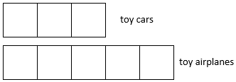

* + Number Lines

*The ratio of toy cars to toy airplanes in Andrew’s collection is 3:5.*

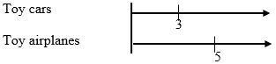

* + Ratio Tables

*The ratio of toy cars to toy airplanes in Andrew’s collection is 3:5.*

A horizontal table showing the toy cars to have 3 and the toy airplanes to have 5 and extra columns to show different ratios of the 2 items that are blank but appropriate ratios could be added.

* Students should be able to write ratio relationships in all three forms: fraction, using “to”, or with a colon (:) between two numbers. They are not expected to write it in all three forms for every problem.
* Instruction includes writing the ratio and interpreting its meaning in the provided real-world context *(MTR.5.1, MTR.7.1).*
* Ratios can compare quantities of any kind, including counts of people or objects, measurements of length, weight and time.
* Problem types include providing real-world context with written descriptions, charts and tables.
* In some cases, the context of a problem determines a specific ratio, as well as the order in which a ratio is written.
  + For example, there are 2 blue marbles and 5 red marbles. Write the ratio of red marbles to blue marbles.
    - Acceptable responses: $5:2, 5 to 2 or\frac{5}{2}.$
* In other cases, the context of a problem does not determine the order in which a ratio is written, and it may involve more than one ratio.
  + For example, there are 2 blue marbles and 5 red marbles. Write a ratio relationship.
    - Acceptable responses: $2:5, 5:2, 2 to 7, 7 to 2 , \frac{5}{7} or \frac{7}{5}$.

Common Misconceptions or Errors

* + Students may incorrectly reverse the order of a ratio when a question does specify the order. To address this misconception, students can color code or write the order of the description before assigning the numbers to the ratio.
  + Students may not recognize simplified forms of ratios. It is not required that students determine the simplified version of a ratio, but when comparing the ratios with other students and seeing different numbers, students should become more adept at seeing both ratios as representing the same relationship. The student should be reminded of the connection to equivalent fractions.

Strategies to Support Tiered Instruction

* Instruction includes using colored pencils to identify the units in each corresponding portion of a ratio and identifying the units before writing the numerical values.
  + For example, Leslie and Sabrina are both running for class president. If for every two votes Leslie receives, Sabrina receives five, describe the relationship between the number of votes Leslie receives to the number of votes Sabrina receives as a ratio.

Leslie’s votes to Sabrina’s votes

2 to 5, or 2:5, or $\frac{2}{5}$

* Instruction includes the use of two different counters to represent the provided ratio to allow for students to explore equivalent ratios by adding additional sets of counters or by dividing the existing counters into equal groups.
* Teacher reminds students of the connection between ratios and equivalent fractions.

Instructional Tasks

*Instructional Task 1 (MTR.4.1, MTR.7.1)*

To make the color purple, Jamal’s art teacher instructed him to mix equal parts of red paint and blue paint. To make a different shade of purple, the ratio of red paint to blue paint is 2:1. What does the ratio 2:1 mean? Would a ratio of 1:2 make the same color? Why or why not?

*Instructional Task 2 (MTR.4.1)*

Mr. Keen, a band teacher, wanted to know if certain types of instruments are more appealing to one grade level or another. So, he conducted a survey of his students’ preferences. The results are compiled in the chart below.

|  |  |  |
| --- | --- | --- |
| **Instruments** | **6th graders** | **7th graders** |
| Strings | 15 | 26 |
| Woodwind | 19 | 36 |
| Brass | 27 | 13 |
| Percussion | 39 | 25 |

Part A. What is the ratio of the number of 6th graders preferring woodwind instruments to the number of 7th graders preferring woodwind instruments?

Part B. What is the ratio of the number of 7th graders preferring percussion instruments to the total number of 7th graders surveyed?

Part C. What does the ratio of 27:40 represent? Does the ratio of 40 to 27 have the same meaning as 27:40? Why or why not?

Instructional Items

*Instructional Item 1*

Ana and Robbie both stayed after school for help on their math homework. Ana stayed for 15 minutes, and Robbie stayed for 50 minutes. Write a ratio to represent the relationship between the time that Ana stayed for help and the time that Robbie stayed for help.

*Instructional Item 2*

Leslie and Sabrina are both running for class president. If for every two votes Leslie receives, Sabrina receives five, describe the relationship between the number of votes Leslie receives to the number of votes Sabrina receives as a ratio.

*Instructional Item 3*

Miss Williams asked her class if they prefer doing their homework before school or after school. If the ratio of students who prefer doing homework before school to students who prefer doing homework after school is $\frac{7}{15}$, what does the ratio $\frac{7}{15}$ represent? Explain.

*\*The strategies, tasks and items included in the B1G-M are examples and should not be considered comprehensive.*

### MA.6.AR.3.2

Benchmark

MA.6.AR.3.2 Given a real-world context, determine a rate for a ratio of quantities with different units. Calculate and interpret the corresponding unit rate.

*Example:* Tamika can read 500 words in 3 minutes. Her reading rate can be described as $\frac{500 words}{3 minutes}$ which is equivalent to the unit rate of $166\frac{2}{3}$ words per minute.

Benchmark Clarifications:

*Clarification 1:* Instruction includes using manipulatives, drawings, models and words and making connections between ratios, rates and unit rates.

*Clarification 2:* Problems will not include conversions between customary and metric systems.

Connecting Benchmarks/Horizontal Alignment

* MA.6.NSO.2.1, MA.6.NSO.2.3
* MA.6.NSO.3.1

Terms from the K-12 Glossary

* Rate
* Unit Rate

Vertical Alignment

|  |  |
| --- | --- |
| **Previous Benchmarks**   * MA.5.FR.1.1 * MA.5.AR.1.2, MA.5.AR.1.3 | **Next Benchmarks**   * MA.7.AR.4.2 |

Purpose and Instructional Strategies

In previous courses, students represented the division of two whole numbers as a fraction. In doing this, students started to work with a ratio relationship that relates parts to wholes. In grade 6 accelerated, students extend this concept to include rates, which are ratios between quantities that are most often in different units. Students use ratio relationships to describe unit rates and percentage relationships and use the division of positive rational numbers to calculate unit rates from rates. In future courses, students learn that a unit rate is the same as a constant of proportionality in a proportional relationship between two variables.

* Instruction connects rate and unit rate to student understanding of equivalent fractions from mathematics in both numeric and picture or model forms. Students can use the models to represent the situations in different ways *(MTR.5.1).*
  + Allow student flexibility in accepting both simplified and non-simplified responses for rates unless the unit rate is the specified or expected form.

Common Misconceptions or Errors

* + Students may incorrectly identify what is being compared or the order of quantities being compared by the rate.
  + Students may have difficulty connecting a unit rate, which is represented by a single number, to a ratio or non-unit rate, which may be represented by two numbers.

Strategies to Support Tiered Instruction

* Instruction includes the use of manipulatives and models to represent the provided rates and then to use multiplicative reasoning to determine the rate of one unit. Manipulatives and models include snap cubes, marbles, bar models, number lines or rate tables to help visually represent the relationship.
* Instruction includes the use of manipulatives to allow for students to explore the meaning of a unit rate. The teacher should provide two different counters to represent a rate equivalent to a whole number unit rate and then co-model the division of the counters into equal groups to determine how many counters of one color are needed to represent a single counter of the other color.
  + For example: At the grocery store, you paid $9.00 for 3 pounds of apples. What is the unit price paid per pound of apples?

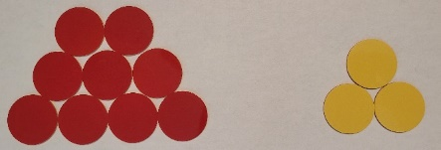

Instructional Tasks

*Instructional Task 1 (MTR.6.1, MTR.7.1)*

When buying ground beef for hamburgers, there are several packages from which to choose as shown in the table below.

|  |  |  |  |  |
| --- | --- | --- | --- | --- |
| **pounds of ground beef** | 1.5 | 2 | 3 | 3.75 |
| **cost** | $5.58 | $7.44 | $11.16 | $13.95 |

Part A. Predict how much it would cost for a pound of ground beef. Explain why your prediction is reasonable.

Part B. What is the unit cost of ground beef? Does the unit cost differ by the package size at this store?

*Instructional Task 2 (MTR.4.1)*

The Jones family is planning on expanding their garden so that they can plant more vegetables. The ratio of the area of the old garden to the area of the new garden is $4\frac{1}{4}:8\frac{3}{4}$. Convert this ratio to a unit rate and explain what it means in this context.

*Instructional Task 3 (MTR.2.1, MTR.4.1, MTR.5.1)*

Stephen is tracking the number of miles traveled to the number of minutes passed while traveling. He discovered that in 8 minutes he traveled 6 miles.

Part A. In your group, use the chart below to determine the rate and unit rate in miles per minute.

Part B. Which form would be most efficient for this context? Why?

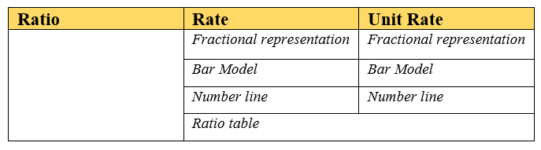

Instructional Items

*Instructional Item 1*

At the grocery store, you paid $9.87 for 3.3 pounds of apples. What is the unit price paid per pound of apples? (Round to the nearest cent.)

*Instructional Item 2*

Katelyn wants to buy one of the three cereals listed below. Determine which box is the best buy. Show and explain how you determined this.

* 16 ounces of Frosted Flurries for $3.50
* 12.4 ounces of Chocolate O’s for $2.42
* 11.5 ounces of Cinnamon Grahams for $2.35

*\*The strategies, tasks and items included in the B1G-M are examples and should not be considered comprehensive.*

### MA.6.AR.3.3

Benchmark

MA.6.AR.3.3 Extend previous understanding of fractions and numerical patterns to generate or complete a two- or three-column table to display equivalent part-to-part ratios and part-to-part-to-whole ratios.

*Example:* The table below expresses the relationship between the number of ounces of yellow and blue paints used to create a new color. Determine the ratios and complete the table.

|  |  |  |  |  |
| --- | --- | --- | --- | --- |
| **Yellow (part)** | 1.5 | 3 |  | 9 |
| **Blue (part)** | 2 | 4 |  |  |
| **New color (whole)** |  |  | 12 | 21 |

Benchmark Clarifications:

*Clarification 1:* Instruction includes using two-column tables (e.g., a relationship between two variables) and three-column tables (e.g., part-to-part-to-whole relationship) to generate conversion charts and mixture charts.

Connecting Benchmarks/Horizontal Alignment

* MA.6.NSO.2.1, MA.6.NSO.2.3
* MA.6.NSO.3.1
* MA.6.AR.2.2, MA.6.AR.2.3

Terms from the K-12 Glossary

* Rate
* Unit Rate

Vertical Alignment

|  |  |
| --- | --- |
| **Previous Benchmarks**   * MA.5.FR.1.1 * MA.5.FR.2.1, MA.5.FR.2.2 | **Next Benchmarks**   * MA.7.AR.3.2 * MA.7.AR.4.1, MA.7.AR.4.2, MA.7.AR.4.3, MA.7.AR.4.4 |

Purpose and Instructional Strategies

In previous courses, students developed an understanding of fraction concepts and operations, often in the context of the relationship that relates parts to wholes. In grade 6 accelerated, students use tables to display parts-to-parts and parts-to-whole relationships, as preparation for understanding a constant ratio relationship between two quantities. This extends in grade 6 accelerated and future courses, where students will achieve a more formal understanding of the constant of proportionality and proportional relationships, which can be represented by tables, equations and graphs. In future courses, students will work with linear relationships and expand their understanding of the constant of proportionality in proportional relationships to slope in linear relationships.

* Instruction includes discussion about how the patterns that students see in the tables can help them reason through various situations *(MTR.4.1, MTR.5.1).*
* Instruction includes the use of acting out scenarios, bar models, tables and number lines in order to see relationships and relevance to real-world application *(MTR.2.1).*
  + Bar Model

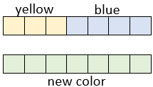

* + Tables

|  |  |  |
| --- | --- | --- |
| Yellow (part) | 3 |  |
| Blue (part) | 4 |  |
| New color (whole) | 7 |  |

* + Number Lines

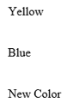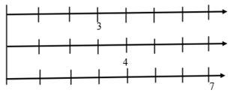

Common Misconceptions or Errors

* + Students may be looking for arithmetic or counting patterns within the table and not seeing multiplicative patterns between the ratio values.

Strategies to Support Tiered Instruction

* Instruction includes the use of whole number parts to allow for students to explore the various relationships in the tables before introducing positive rational values. Discussions include additive and multiplicative patterns amongst the rows and the columns of the table.
* Instruction includes the use of two different counters to represent the provided ratios with emphasis on the different colors representing the parts and the total number of counters representing the whole. Teacher allows for opportunities for the student to explore equivalent ratios by adding addition sets of counters or by dividing the existing counters into equal groups and recording the equivalent ratios in a two- or three-column table.
  + For example, students can use the counters to help complete the table to express the relationship between the number of students and the number of adults on a recent field trip.

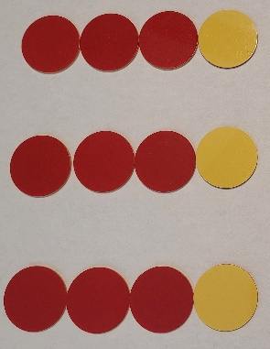

|  |  |  |  |  |
| --- | --- | --- | --- | --- |
| **Students**  **(Red Counters)** | 3 | 6 |  |  |
| **Adults**  **(Yellow Counters)** | 1 |  | 3 |  |
| **Total People**  **(Total Counters)** |  |  |  | 16 |

Instructional Tasks

*Instructional Task 1 (MTR.4.1, MTR.7.1)*

Jeremy is making punch for a party. The relationship between the cups of syrup and the cups of water he used to create the punch mixture is shown on the table below.

Part A. Complete the table. Explain the process you used to complete the table.

|  |  |  |
| --- | --- | --- |
| **syrup (cups)** | **water (cups)** | **punch (cups)** |
| $$1\frac{3}{4}$$ | 7 |  |
| 3 | 12 |  |
|  | 15 | $$18\frac{3}{4}$$ |
|  |  | 20 |

Part B. If Jeremy needs 30 cups of punch, how many cups of syrup are needed? How many cups of water are needed?

*Instructional Task 2 (MTR.3.1)*

Given the table below, determine the common ratio between the $x$- and $y$-values.

|  |  |
| --- | --- |
| $$x$$ | $$y$$ |
| 2 | 8 |
| 5 | 20 |
| 7 |  |
|  |  |

Part A. Using a common ratio, complete the table when *x* is 7.

Part B. Using a common ratio, determine an *x* and corresponding *y* value.

Instructional Items

*Instructional Item 1*

Shambria is making pies and part of the recipe she uses is described in the table below.

|  |  |  |
| --- | --- | --- |
| **Number of Pies** | **Cups of Sugar** | **Pounds of Apples** |
| 1 | 0.5 | 2.25 |
| 5 |  |  |

Using this recipe, complete the table to determine the amount of sugar and apples needed to bake 5 pies.

*Instructional Item 2*

The table below describes the same rate at which Drew hiked along the Appalachian Trail each day. Complete the table and determine how many miles he could hike in 2 hours.

|  |  |  |  |
| --- | --- | --- | --- |
| **time (hours)** | 5 |  | 2 |
| **distance (miles)** | 20 | 12 |  |

*\*The strategies, tasks and items included in the B1G-M are examples and should not be considered comprehensive.*

### MA.6.AR.3.4

Benchmark

MA.6.AR.3.4 Apply ratio relationships to solve mathematical and real-world problems involving percentages using the relationship between two quantities.

Example: Gerald is trying to gain muscle and needs to consume more protein every day. If he has a protein shake that contains 32 grams and the entire shake is 340 grams, what percentage of the entire shake is protein? What is the ratio between grams of protein and grams of non-protein?

Benchmark Clarifications:

*Clarification 1:* Instruction includes the comparison of $\frac{part}{whole}$ to $\frac{percent}{100}$ in order to determine the percent, the part or the whole.

Connecting Benchmarks/Horizontal Alignment

* MA.6.NSO.2.1, MA.6.NSO.2.3
* MA.6.NSO.3.1, MA.6.NSO.3.5
* MA.6.AR.2.3

Terms from the K-12 Glossary

* Rate

Vertical Alignment

|  |  |
| --- | --- |
| **Previous Benchmarks**   * MA.5.NSO.2.1, MA.5.NSO.2.2 * MA.5.FR.1.1 | **Next Benchmarks**   * MA.7.AR.3.1 |

Purpose and Instructional Strategies

In previous courses, students worked with creating equivalent fractions, as well as operations with whole numbers and fractions. In grade 6 accelerated, students use ratio relationships to solve problems involving percentages. This extends in grade 6 accelerated, where students will solve multi-step problems and proportional relationships involving percentages. In future courses, students will solve multi-step real-world percent problems by applying previous understanding of percentages and ratios.

* Students should understand that percent (%) represents a part to whole relationship.
* Instruction includes the connection to ratio relationships to determine the part, the whole or the percentage *(MTR.5.1).*
  + For example, when determining how much 40% is of 24, students should compare the ratio $\frac{x}{24}$ to the ratio $\frac{40}{100}$.
* Instruction does not include the use of proportions or cross multiplication to solve problems involving percentages.
* Instruction includes the use of models to represent percentages such as bar models, number lines or ratio tables to help visually represent the relationship *(MTR.2.1).*
  + Bar Models

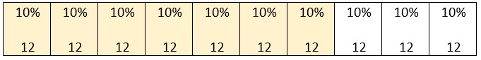

* + Number Lines

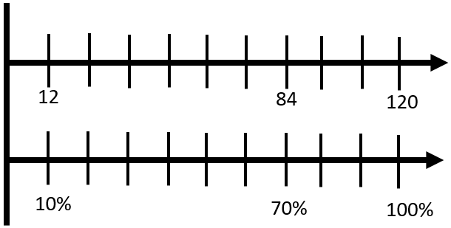

* + Ratio Tables

$$70\% of 120 = 84$$

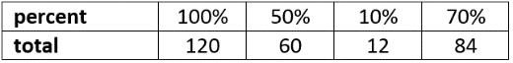

Common Misconceptions or Errors

* + Students may not understand the difference between an additive relationship and a multiplicative relationship.
  + Students may incorrectly set up ratios because of a misunderstanding of the part and the whole addressed in the situation.
  + Students may not recognize simplified forms of ratios in order to find equivalent ratios to determine the percentage, the whole or the part.

Strategies to Support Tiered Instruction

* Instruction includes finding an equivalent unit rate (either part or whole), then multiplying to find the desired equivalent ratio.
  + For example: Steve wants to determine how much a $15\%$ tip is if the bill is $80.00.

Use a visual representation to show 80 represents 100%

|  |  |
| --- | --- |
| **Part** | 80 |
| **Percent** | 100 |

Divide the ratio by 80

|  |  |  |
| --- | --- | --- |
| **Part** | 80 | 1 |
| **Percent** | 100 | 1.25 |

Multiply the resulting ratio by 15

|  |  |  |  |
| --- | --- | --- | --- |
| **Part** | 80 | 1 | 12 |
| **Percent** | 100 | 1.25 | 15 |

Using the equivalent ratios, 12 is 15% of 80, so the tip is $12.00.

Instructional Tasks

*Instructional Task 1 (MTR.4.1, MTR.6.1, MTR.7.1)*

Carlos predicts that his math homework will take him 60 of the total of 75 minutes he has available for homework tonight.

Part A. At this rate, how many minutes would Carlos spend on math homework out of a total of 100 available minutes?

Part B. What percentage of the available homework time does Carlos predict he will spend doing math? Explain how the answer to this question is related to the answer in Part A.

Instructional Items

*Instructional Item 1*

Find the percent equivalent to $\frac{60}{115}$. Round to the nearest tenth percent.

*Instructional Item 2*

15% of 80 is what value?

*Instructional Item 3*

Sami is keeping track of the amount of salt she consumes each day. According to the label on her macaroni and cheese box, one serving contains 470 mg of sodium (salt). If 470 mg is 20% of the recommended daily amount, how many milligrams of sodium are recommended for the whole day?

*\*The strategies, tasks and items included in the B1G-M are examples and should not be considered comprehensive.*

### MA.6.AR.3.5

Benchmark

MA.6.AR.3.5 Solve mathematical and real-world problems involving ratios, rates and unit rates, including comparisons, mixtures, ratios of lengths and conversions within the same measurement system.

Benchmark Clarifications:

*Clarification 1:* Instruction includes the use of tables, tape diagrams and number lines.

Connecting Benchmarks/Horizontal Alignment

* MA.6.NSO.1.1
* MA.6.NSO.2.1, MA.6.NSO.2.3
* MA.6.NSO.3.1, MA.6.NSO.3.5
* MA.6.AR.1.1
* MA.6.AR.2.3
* MA.7.AR.3.1, MA.7.AR.3.2

Terms from the K-12 Glossary

* Customary units
* Metric units
* Rate
* Unit Rate

Vertical Alignment

|  |  |
| --- | --- |
| **Previous Benchmarks**   * MA.5.M.1.1 * MA.5.FR.1.1 * MA.5.FR.2.1, MA.5.FR.2.2 * MA.5.AR.1.2, MA.5.AR.1.3 | **Next Benchmarks**   * MA.7.AR.3.3 |

Purpose and Instructional Strategies

In previous courses, students developed an understanding of fraction concepts and operations, often in the context of the relationship that relates parts to wholes. Students also learned how to convert measurements within the same measurement system. In grade 6 accelerated, students solve problems involving ratio relationships. Students will also solve problems involving proportional relationships. This benchmark is the culmination of the MA.6.AR.3 standard. It combines all of the concepts developed in the previous four benchmarks and applies them to a variety of mathematical and real-world contexts, including conversions of units within a measurement system. In future courses, students are expected to convert units across different measurement systems.

* Instruction includes a variety of problem types including comparison, mixtures, lengths and conversions. Students should work within the same measurement system, for example, standard measurement to standard measurement or metric system to metric system.
* It is not the expectation of this benchmark to solve problems using proportions; however, problem types will naturally start to build the foundation of proportions and proportional relationships.
* Instruction includes the use of bar models, tables and number lines to help students see relationships and relevance to real-world applications *(MTR.2.1).*
  + For example, 3 toy cars cost Mikela $5 at the local superstore. Mikela needs 18 toy cars. How much will it cost Mikela to buy the cars?
    - Bar Models

Visual representation of bar models. The first set depicts 3 units, with 6 in each unit, with a total of 18 toy cars.
The second set depicts 5 units with a "question mark" in each unit, with a total of unknown dollars.

* + - Number Lines

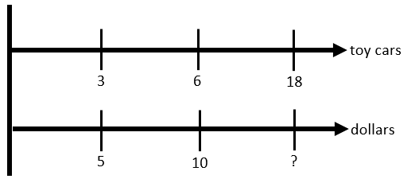

* + - Tables

|  |  |  |  |
| --- | --- | --- | --- |
| **Toy cars** | 3 | 6 | 18 |
| **dollars** | 5 | 10 | ? |

* + Discussion about why students used certain methods to solve specific problems can help students see the patterns for determining their own processes in the future *(MTR.2.1, MTR.5.1, MTR.7.1)*.
  + Instruction includes many opportunities for converting between units in the same measurement system.

Common Misconceptions or Errors

* + Some students may struggle to determine a process for solving problems in a real-world context. Instruction highlights strategies for students to build perseverance by modifying methods as needed and analyzing the problem in a way that makes sense *(MTR.1.1)*.

Strategies to Support Tiered Instruction

* Teacher provides opportunities for students to comprehend the context or situation by engaging in questions (writing questions on flashcards to reuse will be useful) such as:
  + What do you know from the problem?
  + What is the problem asking you to find?
  + Can you create a visual model to help you understand or see patterns in your problem?
* Instruction includes using colored pencils to identify the units in each corresponding portion of a ratio and identifying the units before writing the numerical values.
* Instruction includes the use of a three-read strategy. Students read the problem three different times, each with a different purpose.
  + First, read the problem with the purpose of answering the question: What is the problem, context, or story about?
  + Second, read the problem with the purpose of answering the question: What are we trying to find out?
  + Third, read the problem with the purpose of answering the question: What information is important in the problem?
* Instruction highlights strategies for students to build perseverance by modifying methods as needed and analyzing the problem in a way that makes sense.

Instructional Tasks

*Instructional Task 1 (MTR.7.1)*

On the first day of camp, Sara hiked 20 miles in 5 hours.

Part A. At this rate, how long would it take Sara to hike 12 miles? Show and explain how you determined this.

Part B. At this same rate, how many miles could Sara hike in 2 hours? Show and explain how you determined this.

*Instructional Task 2 (MTR.7.1)*

Chris and Jenny are comparing two similar punch recipes. Each recipe calls for cranberry juice and ginger ale, but in different amounts. The tables below show the amounts of cranberry juice and ginger ale for four different quantities of punch.

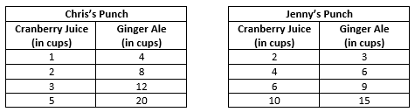

Part A. Is the ratio of the punch that is cranberry juice the same in each of Chris’s recipes given in his table? Explain how you determined your answer.

Part B. Is the ratio of the punch that is cranberry juice the same in each of Jenny’s recipes given in her table? Explain how you determined your answer.

Part C. Is the ratio of the punch that is cranberry juice the same in Chris’s recipes as it is in Jenny’s recipes? If not, whose punch has a greater concentration of cranberry juice? Explain how you determined your answer.

Instructional Items

*Instructional Item 1*

A recent study found that parking lots for offices should have a ratio of 6 spaces for every 1000 square feet of floor space. If a new office building has 19,000 square feet of floor space, how many spaces should there be in the parking lot?

*Instructional Item 2*

Jessica made 8 out of 24 free throws. Bob made 5 out of 20 free throws. Who has the highest free-throw ratio?

*\*The strategies, tasks and items included in the B1G-M are examples and should not be considered comprehensive.*

**MA.7.AR.1** *Rewrite algebraic expressions in equivalent forms.*

### MA.7.AR.1.1

Benchmark

MA.912.AR.1.1 Apply properties of operations to add and subtract linear expressions with rational coefficients.

*Example: $\left(7x-4\right)-\left(2-\frac{1}{2}x\right)$* is equivalent to $\frac{15}{2}x-6$.

Benchmark Clarifications:

*Clarification 1*: Instruction includes linear expressions in the form $ax±b$ or $b±ax$, where $a$ and $b$ are rational numbers.

*Clarification 2:* Refer to Properties of Operations, Equality and Inequality (Appendix D).

Connecting Benchmarks/Horizontal Alignment

* MA.6.AR.1.4
* MA.7.NSO.2.1, MA.7.NSO.2.2

Terms from the K-12 Glossary

* Coefficient
* Linear Expression
* Rational Number

Vertical Alignment

|  |  |
| --- | --- |
| **Previous Benchmarks**   * MA.5.AR.2.2 | **Next Benchmarks**   * MA.8.AR.1.2, MA.8.AR.1.3 |

Purpose and Instructional Strategies

In previous courses, students evaluated multi-step numerical expressions using order of operations including parentheses, whole numbers, decimals and fractions. In grade 6 accelerated, students generate equivalent algebraic expressions with integer coefficients. Students also perform operations (adding and subtracting) with linear expressions with rational coefficients and multiple variables. In future courses, students will multiply two linear expressions with rational coefficients as well as continuing to write equivalent expressions.

* Students extend their understanding of operations with rational numbers to linear expressions. This will be critical to solving equations and inequalities having more than one step. This is also an opportunity to build fluency within MA.7.NSO.2 (*MTR.3.1*).
* Use manipulatives such as algebra tiles to emphasize the difference between linear and constant terms for integers. Once clear and confident, the transition from manipulatives to the abstract to include rational numbers (*MTR.2.1*).
  + Algebra Tiles

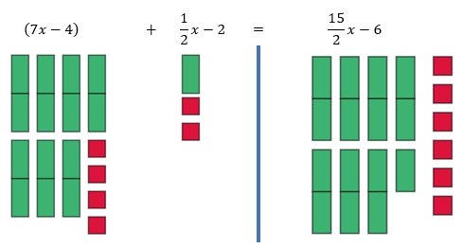

* Variables are not limited to $x$. Instruction includes using various lowercase letters for their variables; however, $o$, $i$ and $l$ should be avoided as they too closely resemble zero and one.
* Instruction includes students working within the same type of rational numbers when appropriate.
  + For example, if students are given fractions, the solution should be demonstrated in fractions and not be converted to decimals.

Common Misconceptions or Errors

* Students may incorrectly add and subtract terms that are unlike. To address this misconception, begin with a sorting activity to organize terms into groups before performing operations with those terms *(MTR.2.1)*. Have students verbalize the criteria for being considered like terms to ensure they are focused on the correct similarities.
* Students may incorrectly distribute the negative sign when subtracting a linear expression with more than one term.
  + For example, $3-(2x+7)$ may be incorrectly rewritten as $3-2x+7$. To address this misconception, use algebra tiles or other manipulatives to physically show the removal or subtraction of an expression.

Strategies to Support Tiered Instruction

* Teacher provides instruction to students that may incorrectly add and subtract unlike terms by giving students examples of like and unlike expressions and having students decide if they are equivalent. Give students the opportunity to explain why the expressions are equivalent or not equivalent.
* Teacher provides instruction on using the properties of operations to group like terms together.
* Instruction includes the use of different color highlighters or shapes to identify algebraic terms and constants and then combining like terms identified with the same color.
  + For example, the expression $3x+5+\frac{2}{3}x-6$ can be color-coded as $3x+5+\frac{2}{3}x-6$ to determine that $3x+\frac{2}{3}x+5-6=3\frac{2}{3}x-1$.
* Teacher includes a leading coefficient of $1$ in front of grouping symbols to help students recognize the implications of a negative sign in front of grouping symbols.
  + For example, could be written as or as $\frac{1}{3}+\left(-1\right)⋅\left(2x+\frac{7}{3}\right)$ to help remind students to distribute the negative one before performing the next operation.
* Teacher provides students with a visual picture to decide if expressions are equivalent.
  + For example, if $s$ represents the number of blue squares and $t$ represents the number of red triangles shown, students can write an expression to represent the display. Students could write the expression as $s+s+s+t+t$, and then rewrite with combining like terms as $3s+2t$.
* Instruction includes building a foundation for the properties of operations by modeling the associative, commutative, and distributive properties with algebra tiles for numeric and algebraic expressions and allowing the students to manipulate the algebra tiles as well.
* Instruction includes providing students with two different linear expressions already represented with algebra tiles and then allowing the students to add and subtract the algebra tiles to determine their sum or difference.
* Teacher co-creates a graphic organizer with students to review operations with positive fractions and operations with integers to assist when applying operations with rational numbers.
* Teacher provides a sorting activity to organize terms into groups before performing operations with those terms. Have students verbalize the criteria for being considered like terms to ensure they are focused on the correct similarities.
* Instruction includes using algebra tiles or other manipulatives to physically show the removal or subtraction of an expression.

Instructional Tasks

*Instructional Task 1 (MTR.4.1)*

Part A. Write three expressions that are equivalent to $\frac{3}{4}x-1$.

Part B. Compare the expressions from Part A with a partner.

* + How many are the same?
  + How many are different?
  + How many are correct?
  + If there are incorrect expressions, what were the errors? Explain your reasoning.

Instructional Items

*Instructional Item 1*

Write the following expression using the fewest possible terms.

$$\left(5x-1\right)-(0.06x-4+0.4x)$$

*Instructional Item 2*

Write the following expression using the fewest possible terms.

$$\left(4+\frac{2}{3}x\right)+\left(\frac{1}{6}x-3\right)$$

*Instructional Item 3*

Write the following expression using the fewest possible terms.

$$\left(2x-\frac{4}{5}-3z\right)-(-8x+2z)$$

\*The strategies, tasks and items included in the B1G-M are examples and should not be considered comprehensive.

### MA.7.AR.1.2

Benchmark

MA.7.AR.1.2 Determine whether two linear expressions are equivalent.

*Example:* Are the expressions $\frac{4}{3}(6-x)-3x$ and $8-\frac{5}{3}x$ equivalent?

Benchmark Clarifications:

*Clarification 1*: Instruction includes using properties of operations accurately and efficiently.

*Clarification 2:* Instruction includes linear expressions in any form with rational coefficients.

*Clarification 3:* Refer to Properties of Operations, Equality and Inequality (Appendix D).

Connecting Benchmarks/Horizontal Alignment

* MA.6.AR.1.4
* MA.7.NSO.2.1

Terms from the K-12 Glossary

* Linear Expression

Vertical Alignment

|  |  |
| --- | --- |
| **Previous Benchmarks**   * MA.5.AR.2.2 | **Next Benchmarks**   * MA.8.AR.1.1, MA.8.AR.1.3 |

Purpose and Instructional Strategies

In previous courses, students evaluated multi-step numerical expressions using order of operations including parentheses, whole numbers, decimals and fractions. In grade 6 accelerated, students generated equivalent algebraic expressions with integer coefficients. Students also add and subtract linear expressions with rational coefficients as well as determine whether two linear expressions are equivalent. In future courses, students will generate equivalent expressions including the use of integer exponents as well as rewrite the sum of two algebraic expressions having a common monomial factor as a common factor multiplied by the sum of two algebraic expressions.

* Emphasize properties of operations to determine equivalence. Use manipulatives such as algebra tiles to emphasize the difference between linear and constant terms.
  + Algebra tiles can also be used to model operations concretely (*MTR.2.1*).

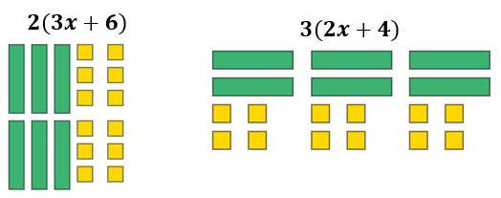

* + Area Model can be used to represent the distributive property of multiplication over addition before moving to the abstract (*MTR.2.1*).

$4\left(2x+3\right)=2(4x+6)$

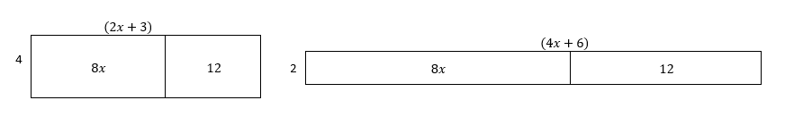

From these representations, students can showcase equivalency between the two different linear expressions.

* Instruction includes students working within the same type of rational numbers when appropriate.
  + For example, if students are given fractions, the solution should be demonstrated in fractions and not be converted to decimals.
* Multiple equivalent expressions should be given, not just the most simplified. Transforming one or both expressions may be needed to show equivalence (*MTR.3.1*).
  + For example, $\frac{1}{2}x is equivalent to\frac{1}{5}x+\frac{3}{10}x$ as well as $\frac{1}{10}x+\frac{1}{10}x+\frac{1}{10}x+\frac{1}{5}x$.

Common Misconceptions or Errors

* Students may incorrectly add and subtract terms that are unlike. To address this misconception, begin with a sorting activity to organize terms into groups before performing operations with those terms *(MTR.2.1)*. Have students verbalize the criteria for being considered like terms to ensure they are focused on the correct similarities.
* Students may incorrectly distribute the negative sign when subtracting a linear expression with more than one term.
  + For example, $\frac{1}{3}-(2x+\frac{7}{3})$ may be incorrectly rewritten as $\frac{1}{3}-2x+\frac{7}{3}$ and concludes that it is equivalent to $\frac{8}{3}-2x$.

Strategies to Support Tiered Instruction

* Teacher provides instruction to students that may incorrectly add and subtract unlike terms by giving students examples of like and unlike expressions and having students decide if they are equivalent. Give students the opportunity to explain why the expressions are equivalent or not equivalent.
* Teacher includes a leading coefficient of $1$ in front of grouping symbols to help students recognize the implications of a negative sign in front of grouping symbols.
  + For example, could be written as or as $\frac{1}{3}+\left(-1\right)⋅\left(2x+\frac{7}{3}\right)$ to help remind students to distribute the negative one before performing the next operation.
* Teacher provides instruction on using the properties of operations to group like terms together.
* Instruction includes the use of different color highlighters or shapes to identify algebraic terms and constants and then combining like terms identified with the same color.
  + For example, the expression $3x+5+\frac{2}{3}x-6$ can be color-coded as $3x+5+\frac{2}{3}x-6$ to determine that $3x+\frac{2}{3}x+5-6=3\frac{2}{3}x-1$.
* Teacher provides students with examples of linear expressions to explain whether two or more of the expressions are equivalent or not. Teacher co-creates examples of equivalent and non-equivalent linear expressions with students.
* Teacher co-creates a graphic organizer with students to review operations with rational numbers.
* Instruction includes providing students with two different linear expressions already represented with algebra tiles and then allowing the students to manipulate the algebra tiles to determine if they are equivalent. Students should be allowed to justify their reasoning for why the expressions are equivalent, or not.
* Teacher provides a sorting activity to organize terms into groups before performing operations with those terms. Have students verbalize the criteria for being considered like terms to ensure they are focused on the correct similarities.

Instructional Tasks

*Instructional Task 1 (MTR.4.1)*

Part A. Write three expressions that are equivalent to $\frac{4}{3}\left(6-x\right)+3\left(\frac{2}{3}x+1\right)$.

Part B. Compare those expressions with a partner. Think about the following questions to guide your conversation:

* How many are the same?
* How many are different?
* How many are correct?
* If there are incorrect expressions, what were the errors?

Instructional Items

*Instructional Item 1*

Match the following equivalent expressions.

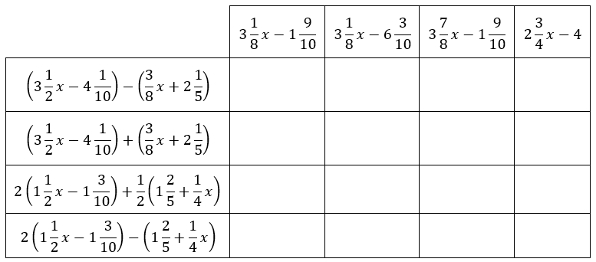

\*The strategies, tasks and items included in the B1G-M are examples and should not be considered comprehensive.

**MA.7.AR.2** *Write and solve equations and inequalities in one variable.*

### MA.7.AR.2.1

Benchmark

MA.7.AR.2.1 Write and solve one-step inequalities in one variable within a mathematical context and represent solutions algebraically or graphically.

Benchmark Clarifications:

*Clarification 1:* Instruction focuses on the properties of inequality.Refer to Properties of Operations, Equality and Inequality (Appendix D).

*Clarification 2:* Instruction includes inequalities in the forms $px>q$; $\frac{x}{p}>q$; $x±p>q$ and $p±x>q$, where $p$ and $q$ are specific rational numbers and any inequality symbol can be represented.

*Clarification 3:* Problems include inequalities where the variable may be on either side of the inequality symbol.

Connecting Benchmarks/Horizontal Alignment

* MA.6.AR.1.2
* MA.6.AR.2.1
* MA.7.NSO.2.1, MA.7.NSO.2.2, MA.7.NSO.2.3

Terms from the K-12 Glossary

* N/A

Vertical Alignment

|  |  |
| --- | --- |
| **Previous Benchmarks**   * MA.5.AR.2.3 | **Next Benchmarks**   * MA.8.AR.2.2 * MA.8.GR.1.3 |

Purpose and Instructional Strategies

In previous courses, students explain whether equations using any of the four operations is true or false. In grade 6 accelerated, students write and verify solutions in inequalities. Students also write and solve one-step inequalities in one variable (*MTR.5.1*). In future courses, students will solve two or more step linear inequalities in one variable.

* Instruction includes real-world scenarios to assist students with making sense of solving inequalities by checking the reasonableness of their answer.
* Instruction emphasizes properties of inequality with connections to the properties of equality (*MTR.5.1*).
* Instruction includes showing why the inequality symbol reverses when multiplying or dividing both sides of an inequality by a negative number.
  + For example, if the inequality $6>-7$ is multiplied by $-3$, it results in $-18>21$ which is a false statement. The inequality symbol must be reversed in order to keep a true statement. Since 6 is to the right of -7 on the number line and multiplying by a negative number reverses directions, $6(-3)$ will be to the left of $-7(-3)$ on the number line.
* Instruction includes cases where the variable is on the left side or the right side of the inequality.
* Variables are not limited to $x.$ Instruction includes using a variety of lowercase letters for their variables; however, $o$, $i$ and $l$ should be avoided as they too closely resemble zero and one.
* Instruction emphasizes the understanding of defining an algebraic inequality. Students should have practice with inequalities in the form of , , and . Students should explore how “is greater than or equal to” and “is strictly greater than” are similar and different as well as “is less than or equal to” and “is strictly less than.” Students should use academic language when describing an algebraic inequality.

Common Misconceptions or Errors

* Students may confuse when to use an open versus closed circle when graphing an inequality. Emphasize the inclusion $(≤$ and $≥)$ versus non-inclusion $(<$ and $>)$ of that value as a viable solution and provide problems that motivate reasoning with different ranges of possible values for the variable.
* Some students are unable to see the difference between the division property of equality and the division property of inequality.
* Students may mistakenly think that the direction the inequality symbol is pointing is always the direction they shade on the number line. To address this misconception, emphasize reading the inequality sentence aloud and use numerical examples to test for viable solutions *(MTR.6.1)*.

Strategies to Support Tiered Instruction

* Teacher provides instruction on when to use an open versus closed circle when graphing an inequality. Teacher encourages students to substitute their solution into their graphs and discuss whether their graph makes sense with the solution.
* Teacher provides a graphic organizer with examples and non-examples of the Division Property of Equality and the Division Property of Inequality.
* Teacher provides students with pre-drawn number lines for students to number as needed to graph solutions.
* Teacher provides students with instruction for similarities and differences of solving equations versus solving inequalities.
* Teacher emphasizes reading the inequality sentence aloud and use numerical examples to test for solutions.
* Instruction includes emphasizing the inclusion ( $≤$ and $≥$) versus non-inclusion ( $<$ and $>$) of that value as a solution and provide problems that motivate reasoning with different ranges of possible values for the variable.
  + For example, if the given inequality is $x+3>5$, students can test various numbers to determine if they are solutions. When students test $x=2$, students should realize that they get the inequality $5>5$ which is not a true statement, therefore $2$ is not a solution.

Instructional Tasks

*Instructional Task 1 (MTR.3.1, MTR.4.1)*

Determine if there is an error in each of the following. If there is an error, write the corrected solution. If there is not an error, indicate “No Error” next to the answer.

Example A: Three boxes hold at least 120 cookies total, which would be (3b) is greater than or equal to 120 and simplifies to b is less than or equal to 40.
Example B: (2,55) is less than (4.2 - x), which simplifies to x is less than (-1.65).
Example C: All the pencils in the classroom with an additional pack of 8 pencils is not enough for a class of 25 students, which would be (p + 8) is less than 25, which simplifies to p is less than 17.

*Instructional Task 2 (MTR.5.1, MTR.6.1)*

Using integers between $-5$ and $5$ no more than once, finish writing the inequality below, whose solutions are $x≥\frac{1}{2}$.

$$\underline{}x≤\underline{}$$

Instructional Items

*Instructional Item 1*

Solve the inequality and graph its solutions on a number line.

$$12<\frac{a}{4}$$

*Instructional Item 2*

What are the solutions to the inequality $4.2+z ≤-5.3$?

*Instructional Item 3*

Represent the solutions to the inequality $-0.125c>0.375$ on a number line.

\*The strategies, tasks and items included in the B1G-M are examples and should not be considered comprehensive.

**MA.7.AR.3** *Use percentages and proportional reasoning to solve problems.*

### MA.7.AR.3.1

Benchmark

MA.7.AR.3.1 Apply previous understanding of percentages and ratios to solve multi-step real-world percent problems.

*Example:* 23% of the junior population are taking an art class this year. What is the ratio of juniors taking an art class to juniors not taking an art class?

*Example:* The ratio of boys to girls in a class is $3:2$. What percentage of the students are boys in

the class?

Benchmark Clarifications:

*Clarification 1:* Instruction includes discounts, markups, simple interest, tax, tips, fees, percent increase, percent decrease and percent error.

Connecting Benchmarks/Horizontal Alignment

* MA.6.AR.3.2, MA.6.AR.3.4
* MA.7.NSO.2.1, MA.7.NSO.2.2, MA.7.NSO.2.3
* MA.7.DP.1.3
* MA.7.DP.2.2, MA.7.DP.2.3, MA.7.DP.2.4

Terms from the K-12 Glossary

* Percent of Change
* Percent Error
* Rate
* Simple Interest

Vertical Alignment

|  |  |
| --- | --- |
| **Previous Benchmarks**   * MA.5.FR.1.1 * MA.5.AR.1.2, MA.5.AR.1.3 | **Next Benchmarks**   * MA.7.AR.4.4, MA.7.AR.4.5 * MA.8.AR.2.1 |

Purpose and Instructional Strategies

In previous courses, students represented the division of two whole numbers as a fraction. In doing this, students started to work with a ratio relationship that relates parts to wholes. In grade 6 accelerated, students solved mathematical and real-world problems involving percentages, ratios, rates and unit rates. Students also solve multi-step real-world percent problems. In future courses, students solve multi-step linear equations given any context.

* Instruction includes discounts, markups, simple interest, tax, tips, fees, percent increase, percent decrease and percent error (*MTR.7.1*).
  + Markdown/discount is a percentage taken off the initial price. Instruction includes showing the connection between subtracting the calculated discount or taking the difference between 100% and the discount and multiplying that by the initial price.
    - For example, if there was a 15% discount on an item that costs $15.99, students could take 85% of $15.99 or take 15% of $15.99 and subtract that value from the initial price of $15.99.
  + Markup showcases adding a charge to the initial price. Markups are often shown in retail situations.
  + Simple interest refers to money you can earn by initially investing some money (the principal). The percentage of the principal (interest) is added to the principal, making your initial investment grow. The formula, $I=Prt$, represents $I$ =interest, $P$ =principal, $r$ =rate, and $t$ =time. When using simple interest, provide the formula as students should not be expected to memorize this.
  + Tax, tips and fees are an additional charge added to the initial price. Students can add the calculated tax, tip or fee to the initial price or add 1 to the tax, tip or fee to reach the final cost.
    - For example, if there was a 6% sales tax on clothing and a t-shirt costs $7.99. Students can add 100% to the 6% and multiply that value to $7.99 or students can find 6% of the $7.99 and add that to the initial value of the t-shirt.
  + Percent Increase/Percent Decrease asks students to look for a percentage instead of a dollar amount. Students should discover that they can use the formula below to help become more flexible in their thinking.
$$\frac{new price-initial price}{original price}×100$$

* Percent Error is a way to express the size of the error (or deviation) between two measurements.
$$\% error=\frac{\left|estimation-actual\right|}{actual}×100$$

* Use bar models to model percent increase and decrease problems.
  + For example, if you are finding percentages that are in multiples of 10%, your bar model may look like the model below.

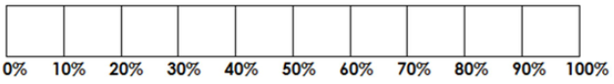

To showcase the percent increase, you would add additional boxes into the bar model. If you are showcasing a percent decrease, then you would cross out boxes for the decrease (*MTR.2.1*).

* Use bar models, double number lines, tables or other visual representations to model relationships between percentages and the part and whole amounts (*MTR.2.1*).
  + Double Number Line

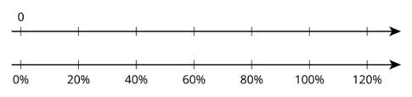

* + Table

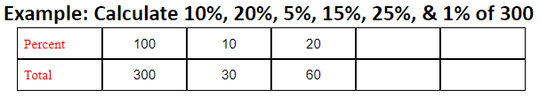

Instruction includes the use of patterns when using a table. In the example above, students can use the idea of 100% being 300 and using this knowledge to find other percentages. 10 is $\frac{1}{10}$ of 100, so students can divide by 10. To find 20%, students can multiply their solution from 10% by 2. The pattern can continue to relate common connections between percentages (*MTR.5.1*).

* Reinforce how percentages relate to fractions and decimals. Help students write equivalent ratios to represent problems using reasoning about the relationships between the quantities.
  + Instruction includes using proportional relationships and multiplicative reasoning to solve problems.

Common Misconceptions or Errors

* Students may incorrectly place the decimal point when calculating with percentages. If students have discovered the shortcut of moving the decimal point twice, instruction includes understanding of how a percent relates to fractions and decimals. Refer to MA.7.NSO.1.2 to emphasize equivalent forms.
* Students may forget to change the percent amount into decimal form (divide the percent by 100) when setting up an equation (*MTR.3.1*).
* Students may incorrectly believe all percentages must be between 1 and 100%. To address this misconception, provide examples of percentages below 1% and over 100%.
* Students may incorrectly believe a percent containing a decimal is already in decimal form.
  + For example, emphasize that 43.5% is 43.5 out of 100 and dividing by 100 will provide the decimal form.
* In multiple discount problems, students may incorrectly combine the discounts instead of working them sequentially (*MTR.5.1*).
  + For example, 25% off, then 10% off could incorrectly lead to 35% off rather than finding 25% off before calculating the additional 10% off.
* Students may incorrectly invert the part and the whole in the percent problem. To address this misconception, students should use bar models to help visualize and make sense of the problem *(MTR.2.1)*.

Strategies to Support Tiered Instruction

* Instruction includes the use of estimation to find the approximate solution before calculating the actual result to help with correct placement of the decimal point and reasonableness of the solution.
* Teacher provides opportunities for students to use a 100 frame to review place value for and the connections to decimal, fractional, and percentage forms.
* Teacher provides support for students in dividing by 100 to change percent into decimal form. Teacher supports by providing calculators, manipulatives and base ten blocks to multiply decimals.
* Instruction includes having students take different percentages of the same amount, such as 40% of 80, 4% of 80, 0.4% of 80, 0.04% of 80 and 400% of 80. Students can be given the flexibility to provide the answer as decimal or fraction and compare.
* Teacher provides support for students when solving multi-discount problems and combining the discounts. Instruction might begin with a single-step discount problem in a real-world context.
  + For example, the teacher can include local sale flyers with products that students are interested in buying. Have students explain how to apply the multi-discounts with a comparison of the difference in costs when combining the discounts incorrectly.
* Teacher provides opportunities for students to reason and think about multiple discount problems by providing prompts.
  + For example, “if a pair of jeans is 50% off with an additional 50% off, does that mean the jeans are 100% off, or free?” or “what if the jeans are 75% off with an additional 50% off, does that mean the jeans are 125% off and the store now owes you money to take them?”
* Teacher provides opportunities for students to comprehend the context or situation by engaging in questions (laminating these questions on a printed card for students to utilize as a resource in and out of the classroom would be helpful).
  + What do you know from the problem?
  + What is the problem asking you to find?
  + Can you create a visual model to help you understand or see patterns in your problem?
* Teacher provides support when solving multi-discount problems, by providing students with a table to keep track of the information in the problem.
* Instruction includes the use of a three-read strategy. Students read the problem three different times, each with a different purpose (laminating these questions on a printed card for students to utilize as a resource in and out of the classroom would be helpful).
  + First, read the problem with the purpose of answering the question: What is the problem, context, or story about?
  + Second, read the problem with the purpose of answering the question: What are we trying to find out?
  + Third, read the problem with the purpose of answering the question: What information is important in the problem?
* Teacher encourages the use of bar models to help visualize and make sense of the problem.
* Instruction includes understanding of how a percent relates to fractions and decimals if students have discovered the shortcut of moving the decimal point twice. Refer to MA.7.NSO.1.2 to emphasize equivalent forms.

Instructional Tasks

*Instructional Task 1 (MTR.4.1, MTR.7.1)*

SurfPro Shop and The Surfer Store both sold surfboards for $350. In February, SurfPro Shop wanted to increase their profits, so they increased the prices of their boards by 15%. When this increase failed to bring in more money, they decreased their price again by 10% in November. To beat their competitor who had increased prices, The Surfer Store decided to decrease their price of surfboards by 10% in March. However, when they started to lose money on the final pricing scheme, they increased the price of surfboards in November by 15%.

Part A. If no other changes were made after November, which store now has the better price for surfboards?

Part B. What is the difference between their prices?

Instructional Items

*Instructional Item 1*

A college’s intramural soccer team has 30 players, 60% of which are women. After 22 new players joined the team, the percentage of women was reduced to 50%. How many of the new players are women?

*Instructional Item 2*

Miguel takes out a loan that adds interest each year on the initial amount. What is the interest Miguel will pay on the loan if he borrowed $5,000 at an annual interest rate of 4.5% for 15 years? (Use the formula $I=Prt$, where $I$ is the interest, $P$ is the principal or initial investment, $r$ is the interest rate per year, and $t$ is the number of years.)

*Instructional Item 3*

Massimo lost his mathematics textbook. The school charges a lost book fee of 70% of the initial cost of the book. If Massimo received a notice that he owed the school $73.50 for the lost textbook, what was the initial cost?

\*The strategies, tasks and items included in the B1G-M are examples and should not be considered comprehensive.

### MA.7.AR.3.2

Benchmark

MA.7.AR.3.2 Apply previous understanding of ratios to solve real-world problems involving proportions.

*Example:* Scott is mowing lawns to earn money to buy a new gaming system and knows he needs to mow 35 lawns to earn enough money. If he can mow 4 lawns in 3 hours and 45 minutes, how long will it take him to mow 35 lawns? Assume that he can mow each lawn in the same amount of time.

*Example:* Ashley normally runs 10-kilometer races which is about 6.2 miles. She wants to start training for a half-marathon which is 13.1 miles. How many kilometers will she run in the half-marathon? How does that compare to her normal 10K race distance?

Connecting Benchmarks/Horizontal Alignment

* MA.6.AR.3.5
* MA.7.NSO.2.1, MA.7.NSO.2.2, MA.7.NSO.2.3
* MA.7.DP.1.3

Terms from the K-12 Glossary

* Constant of Proportionality
* Proportional Relationships

Vertical Alignment

|  |  |
| --- | --- |
| **Previous Benchmarks**   * MA.5.FR.1.1 * MA.5.AR.1.2, MA.5.AR.1.3 | **Next Benchmarks**   * MA.7.AR.4.4, MA.7.AR.4.5 * MA.8.AR.3.1 * MA.8.GR.2.4 |

Purpose and Instructional Strategies

In previous courses, students developed an understanding of fraction concepts and operations, often in the context of the relationship that relates parts to wholes. In grade 6 accelerated, students solved mathematical and real-world problems involving ratios, rates and unit rates, including comparisons, mixtures, ratios of lengths and conversions within the same measurement system. Students will also apply ratio reasoning to solve real-world problems involving proportions. In future courses, students will determine if a linear relationship is also a proportional relationship and will solve problems involving proportional relationships between similar triangles.

* Instruction includes making connections to comparing ratios from grade 6 as a comparison using the equal sign.
  + For example, if a student can complete 7 math problems in 30 minutes and one wants to determine how many math problems they can complete in 90 minutes, they can compare the two ratios $\frac{7}{30}$ and $\frac{p}{90}$ as the equation $\frac{7}{30}=\frac{p}{90}$ to determine the number of math problems.
* Instruction does not emphasize rules, like cross multiplying, when solving proportions.
* Instruction allows time for students to analyze real-world situations. Ratio and rate reasoning can be applied to many types of real-life problems, including rate and unit rate, scaling, unit pricing, and statistical analysis (*MTR.7.1*).

Common Misconceptions or Errors

* Students may not understand the difference between an additive relationship and a multiplicative relationship. To help address this misconception, instruction includes the understanding that proportions are multiplicative relationships.
* Students may incorrectly set up proportions with one of the ratios having incorrect numbers in the numerator and denominator.
* Students may not recognize simplified forms of ratios in order to find equivalent ratios.

Strategies to Support Tiered Instruction

* Teacher provides instruction focused on the understanding of multiplicative relationships between two quantities in a proportional relationship.

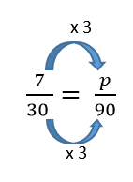

* Teacher provides instruction on color-coding and labeling the different units when setting up a proportional relationship to ensure corresponding units are placed in the corresponding positions within the proportion.
* For example, a student can complete 7 math problems in 30 minutes. How many math problems can they complete in 90 minutes?
$$\frac{7 problems}{30 minutes}=\frac{x problems}{90 minutes}$$

* Teacher co-creates visual models with students to visualize the multiplicative relationship between quantities.
  + For example, to solve the proportion, the corresponding numbers are tripled to find a missing value of 21.

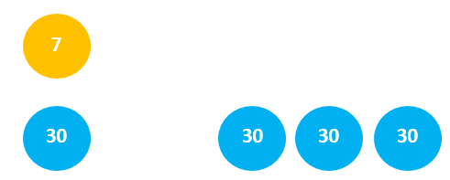

* Instruction includes the understanding that proportions are multiplicative relationships.

Instructional Tasks

*Instructional Task 1 (MTR.3.1)*

A recipe that makes 16 cookies calls for $\frac{1}{4}$ cup of sugar and $\frac{2}{3}$ cup of flour. Janelle wants to proportionally increase these amounts to get a new recipe using one cup of sugar.

[baking ingredients by johnny_automatic - Ready-To-Use Food And Drink Spot Illustrations by Susan Gaber 1982

Book as a whole is under copyright but contents are copyright-free

From archive.org](http://openclipart.org/people/johnny_automatic/johnny_automatic_baking_ingredients.svg)

Part A. Using the new recipe, how much flour will she need? Explain or show your work.

Part B. How many cookies can she make with the new recipe? Explain or show your work.

*Instructional Task 2 (MTR.6.1, MTR.7.1)*

In buying ground beef for hamburgers, there are several packages from which to choose, as shown in the table below.

|  |  |  |  |  |
| --- | --- | --- | --- | --- |
| **Pounds of Ground Beef** | 1.5 | 2 | 3 | 3.75 |
| **Cost** | $5.58 | $7.44 | $11.16 | $13.95 |

If Johannes needs 5 pounds of ground beef for his barbeque, what will he pay?

Instructional Items

*Instructional Item 1*

Anthony is writing the place cards for his best friend’s wedding reception. If he can write 12 place cards in 5 minutes, how long will it take him to complete the entire group of 180 place cards?

*Instructional Item 2*

Brody is working at a music store selling instruments. Brody is paid $4 for every instrument that is sold. If he sells 6 instruments a day, how many days does he need to work to have $120 to purchase a new pair of sneakers?

\*The strategies, tasks and items included in the B1G-M are examples and should not be considered comprehensive.

# Geometric Reasoning

**MA.6.GR.1** *Apply previous understanding of the coordinate plane to solve problems.*

### MA.6.GR.1.1

Benchmark

MA.6.GR.1.1 Extend previous understanding of the coordinate plane to plot rational number ordered pairs in all four quadrants and on both axes. Identify the x- or y-axis as the line of reflection when two ordered pairs have an opposite x- or y-coordinate.

Connecting Benchmarks/Horizontal Alignment

* MA.6.NSO.1.1, MA.6.NSO.1.2, MA.6.NSO.1.3, MA.6.NSO.1.4

Terms from the K-12 Glossary

* Axes (of a graph)
* Coordinate Plane
* Coordinate
* Origin
* Quadrant

Vertical Alignment

|  |  |
| --- | --- |
| **Previous Benchmarks**   * MA.5.GR.4.1 | **Next Benchmarks**   * MA.7. AR.4.3 * MA.8.GR.2.3 |

Purpose and Instructional Strategies

In previous courses, students plotted and labeled ordered pairs of whole numbers in the first quadrant. In grade 6 accelerated, students plot ordered pairs of rational numbers in all four quadrants. In future courses, students will apply their knowledge of plotting ordered pairs to the graphing of proportional relationships.

* Instruction includes making connections to opposites on a number line and absolute value, as well as to reflections across the $x$- and $y$-axes.
* Instruction includes using academic terminology, including calling ordered pairs a coordinate pair or coordinates.
* Instruction includes students plotting ordered pairs on coordinate planes with different scales.
  + For example, students can plot the ordered pair $\left(\frac{1}{2}, 3\right)$, where the $x$- and $y$-axis have a scale of 2 or a scale of 0.5.
* Instruction includes describing movement on the coordinate plane from the origin to the right, to the left, horizontally, vertically, or as a cardinal direction (north, east, south, west).

Common Misconceptions or Errors

* Students may switch the location of the $x$-coordinate and the $y$-coordinate in the ordered pair.
* Students may not recognize that a point on an axis has at least one coordinate of zero.
  + For example, the location of the point on the graph identified as $(3,0)$ may be incorrectly identified as $(3,3)$ or just 3.
* Students may not understand the numbering of the four quadrants (upper right in a counter-clockwise rotation) as well as which coordinate is positive and which coordinate is negative.
* Students may incorrectly label the scale of the axes.

Strategies to Support Tiered Instruction

* Teacher creates an anchor chart while students create their own graphic organizer to include key features of a coordinate plane. Features include the $x$-axis, $y$-axis, origin, quadrants, and an ordered pair.
* Instruction includes building connections to plotting points on number lines. On one sheet of tracing paper, label a horizontal number line as the -axis and plot the -value. On another sheet of tracing paper, label a vertical number line as the -axis and plot the -value. Overlap the two number lines with a point of intersection at the origin (. Place a third sheet of tracing paper on top of the two number lines, trace and label the - and -axis to produce a coordinate plane. The location of a new point should then be plotted in the appropriate quadrant to represent the horizontal and vertical locations of the two previously plotted points. This same strategy helps to draw connections to a point lying on an axis if one of the coordinates is zero.
* Teachers may provide instruction on using reasonable estimations when plotting rational coordinates on the coordinate plane.
  + For example, if a student is plotting $-4\frac{3}{5}$ for an $x$-value and $3$ for $y$-value, they need to know that $\frac{3}{5}$ is more than half, so to graph the $x$-value, they should plot a point between $-4$ and $-5$, with the point closer to the $-5$. Then the student can more precisely adjust the point if necessary (if any other value is between $-4$ and $-5$ they can adjust, but if not, they will see that their estimation will be a valid way to order.)
* When plotting rational coordinates, the teacher provides a coordinate plane with an appropriate scaling to match the fractional or decimal units so the points graphed will fall on the intersection of two minor grid lines.

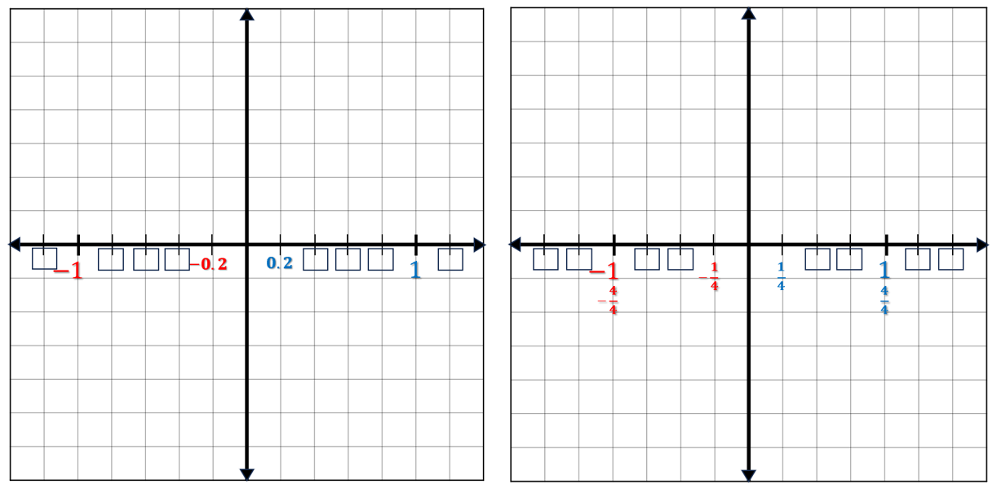

* + Another example, if a student is graphing the ordered pair $(-0.5, 2.25)$ the $x$- and $y$-axis could have a scale of $0.25$.

Instructional Tasks

*Instructional Task 1 (MTR.3.1)*

Part A. On graph paper, draw a coordinate grid. Label the axis and plot the ordered pairs below.

|  |  |
| --- | --- |
| $A\left(2 ,\frac{5}{2}\right)$ $B(-4, 5)$ $C(-4, -7)$ $D\left(\frac{3}{2}, -5\right)$ | $E(0, 0)$ $F(2, -8)$ $G(0, 0.6)$ $H(-4, -5)$ |

Part B. Which ordered pair(s) are located on an axis?

Part C. Which points are in quadrant III?

Part D. Which points are a reflection of each other and over which axis or axes are they reflected? Explain.

*Instructional Task 2 (MTR.4.1)*

Part A. Create a picture with fewer than 20 coordinates in the four quadrants. Write your coordinates on a separate piece of paper.

Part B. Trade your list of ordered pairs with a partner. Recreate your partner’s picture on a new sheet of graph paper.

Part C. Discuss differences and discuss possible errors you or your partner may have made when recreating each other’s pictures.

*Instructional Task 3 (MTR.4.1)*

Create an ordered pair given $x>0$ and $y>0$. Then determine which quadrant or axis each ordered pair described will lie. Explain your answer.

Part A. $\left(-x,y\right)$

Part B. $(-x,0)$

Part C $. (x,-y)$

Part D. $(0,y)$

Instructional Items

*Instructional Item 1*

What is the value of the $x$-coordinate of the ordered pair that reflects $\left(5\frac{1}{2}, -8\right)$ over the $y$- axis?

*Instructional Item 2*

Using the graph below, state the ordered pair that describes the point plotted in Quadrant II?

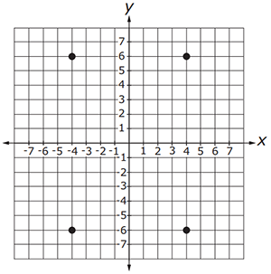

\*The strategies, tasks and items included in the B1G-M are examples and should not be considered comprehensive.

### MA.6.GR.1.2

Benchmark

MA.6.GR.1.2 Find distances between ordered pairs, limited to the same $x$-coordinate or the same $y$-coordinate, represented on the coordinate plane.

Connecting Benchmarks/Horizontal Alignment

* MA.6.NSO.1.2, MA.6.NSO.1.3, MA.6.NSO.1.4
* MA.6.NSO.4.1

Terms from the K-12 Glossary

* Axes (of a graph)
* Coordinate
* Coordinate Plane
* Origin
* Quadrant

Vertical Alignment

|  |  |
| --- | --- |
| **Previous Benchmarks**   * MA.5.GR.4.2 | **Next Benchmarks**   * MA.8.GR.1.2 |

Purpose and Instructional Strategies

Throughout the previous courses, students have used the number line to model subtraction as the distance between two points. In grade 6 accelerated, this connection has been extended to negative integers, and in this benchmark, it extends to the distance between ordered pairs of rational numbers in the four quadrants, if they share a coordinate. In future courses, students will find distances between any two ordered pairs using the Pythagorean Theorem.

* Instruction connects student understanding of MA.6.NSO.1 to the coordinate plane. Strategies include using absolute value to find the distance between two ordered pairs. Even though in grade 6, students are adding and subtracting integers, this benchmark focuses on using absolute value to explore addition and subtraction of rational numbers.
  + For example, the points $(4, 9)$ and $(4, -6)$ are plotted on a coordinate grid.

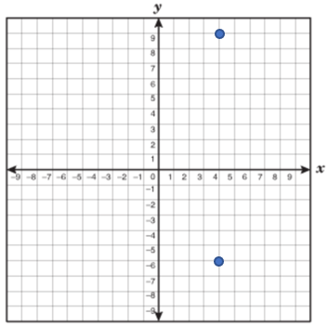

Students can use the absolute value of the first $y$-coordinate, $9$, and the second $y$-coordinate, $-6$, and add these numbers together to determine the distance is $15$.

* When using rational numbers, instruction is restricted to numbers within the same form.
  + For example, if students are working with fractions, the ordered pairs will not include decimals. If students are working with decimals, the ordered pairs will not include fractions. Students should not be penalized if they convert from one form to another when performing operations.
* Students should be given the opportunity to find the distance between the ordered pairs both on and off of a graph.

Common Misconceptions or Errors

* Students may have trouble finding the distance across either of the axes.
  + For example, find the distance between $(-4, 3)$ and $(5, 3)$. It may appear that the “difference” between $-4$ and $5$ is $1$. However, the distance from $-4$ to $0$ is $4$ units and from $0$ to $5$ is $5$ units. Therefore, the distance between the two points is $9$ units.
* Students may misunderstand that a point on an axis has at least one coordinate of zero.
  + For example, the points $(0, 8)$ and $(4, 0)$ are graphed on the coordinate plane.
  + Some students may incorrectly believe that the points represent $(8, 8)$ and $(4, 4)$ or just $(8)$ and $(4).$

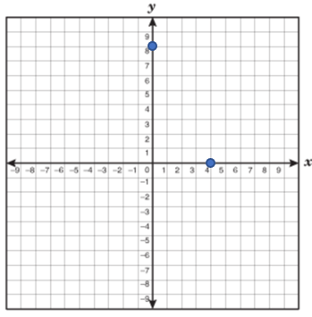

Strategies to Support Tiered Instruction

* Instruction includes using two notecards and covering empty portions of the coordinate plane to focus attention on the space between two provided points. Students can then count the number of spaces between the two points, paying attention to scaling.
* If points are not already placed on a coordinate plane, students may plot the points to create a visual representation of the distances created.
* Instruction includes building connections to plotting points on number lines. On one sheet of tracing paper, label a horizontal number line as the -axis and plot the -value. On another sheet of tracing paper, label a vertical number line as the -axis and plot the -value. Overlap the two number lines with a point of intersection at the origin (. Place a third sheet of tracing paper on top of the two number lines, trace and label the - and -axis to produce a coordinate plane. The location of a new point should then be plotted in the appropriate quadrant to represent the horizontal and vertical locations of the two previously plotted points. This same strategy helps to draw connections to a point lying on an axis if one of the coordinates is zero.
* Instruction includes creating connections back to finding distance on a number line. Lay a piece of tracing paper on top of the provided coordinate plane, trace the points, and draw a number line through the two points, paying close attention to the scaling. Once the number line is drawn, remove the tracing paper and find the distance between the two points on the number line.

Instructional Tasks

*Instructional Task 1 (MTR.6.1)*

On a coordinate plane, Perry is planning a future town by labeling different buildings. Each unit on the coordinate plane is equivalent to 0.5 miles.

|  |  |
| --- | --- |
| * Town Hall $(2 , 5)$* Fire Station $(-4, 5)$* Library $(-4, -7)$* Ice Cream Shop $(3, -5)$ | * Central Park $(0, 0)$* Grocery Store $(2, -8)$* Police Station $(0, 6)$* Gas Station $(-4, -5)$ |

Part A. What is the distance, in miles, from the Fire Station to the Library?

Part B. How far, in miles, would the mayor, located at Town Hall, have to walk to get to the grocery store?

Part C. Compare a walk from Central Park to the Police Station and a walk from the Gas Station to the Ice Cream Shop. Which one is further? ­

Part D. Using what you have learned, can you determine how far Perry would have to ride his bike, in miles, if he is starting at Central Park and going to the Ice Cream Shop and can only travel North, South, East or West.

*Instructional Task 2 (MTR.3.1)*

André is located at $(-5, 3)$, Boris is located at $(-1,3)$ and Carlos is located at $(-5, -2)$. Determine the distance between André and Boris. Then determine the distance between André and Carlos. Show your work.

Instructional Items

*Instructional Item 1*

The points $(0.4, -6)$ and $(1.9, -6)$ represent the location of two towns on a coordinate plane, where one unit is equal to one mile. What is the distance, in miles, between the two towns?

*Instructional Item 2*

If the distance between two points is 7 units and one of the points is located at $(-6, 3)$, what could be the coordinates of the other point?

*\*The strategies, tasks and items included in the B1G-M are examples and should not be considered comprehensive.*

### MA.6.GR.1.3

Benchmark

MA.6.GR.1.3 Solve mathematical and real-world problems by plotting points on a coordinate plane, including finding the perimeter or area of a rectangle.

Benchmark Clarifications:

*Clarification 1:* Instruction includes finding distances between points, computing dimensions of a rectangle or determining a fourth vertex of a rectangle.

*Clarification 2:* Problems involving rectangles are limited to cases where the sides are parallel to the axes.

Connecting Benchmarks/Horizontal Alignment

* MA.6.NSO.1.1, MA.6.NSO.1.2, MA.6.NSO.1.3, MA.6.NSO.1.4
* MA.6.NSO.4.1
* MA.6.AR.2.4
* MA.7.GR.1.1

Terms from the K-12 Glossary

* Area
* Axes (of a graph)
* Coordinate
* Coordinate Plane
* Origin
* Quadrant

Vertical Alignment

|  |  |
| --- | --- |
| **Previous Benchmarks**   * MA.5.GR.2.1 | **Next Benchmarks**   * MA.8.GR.1.2 * MA.912.GR.3.4 * MA.912.GR.4.4 |

Purpose and Instructional Strategies

In previous courses, students found the perimeter and area of rectangles using models and formulas. In grade 6 accelerated, students plot points on a coordinate plane and determine the perimeter or area. Students will also need to find the missing coordinate before determining the perimeter or area *(MTR.1.1, MTR.2.1).* In future courses, students will extend their knowledge to find the areas of other quadrilaterals on a coordinate plane.

* Students will be able to find the area and perimeter of rectangles only if their side lengths are parallel to the axes (*MTR.6.1*).
* Instruction connects student understanding of MA.6.NSO.1 to the coordinate plane. Strategies include using absolute value to find the distance between two ordered pairs. Even though in grade 6, students are adding and subtracting integers, this benchmark focuses on using absolute value to explore the addition and subtraction of rational numbers.
  + For example, the points $(4, 9)$ and $(4, -6)$ are plotted on a coordinate grid.



Students can use the absolute value of the first $y$-coordinate, $9$, and the second $y$-coordinate, $-6$, and add these numbers together to determine the distance is $15$.

* Instruction includes opportunities to find partial areas and partial perimeters in real-world context. When discussing area and perimeter, allow flexibility for students to use base and height or to use length and width.
  + For example, Nathanial is building a garden in his backyard. His uncle has made a map of the backyard with a grid on it to help them plan out where the garden should go; the length of each box on the grid is equivalent to one meter. Nathanial’s garden has corners at $(0, 9)$, $\left(8, 9\right), (0, 2)$ and $\left(8, 2\right).$ The $y$-axis represents the fence in his backyard. Find the perimeter to determine the amount of wood needed to create a barrier for the garden.

Common Misconceptions or Errors

* Students may switch the location of the $x$-coordinate and the $y$-coordinate in an ordered pair.
* Students may confuse perimeter (distance around a figure) with area (the total measure of the inside region of a closed two-dimensional figure).

Strategies to Support Tiered Instruction

* Instruction includes using two notecards and covering empty portions of the coordinate plane to focus attention on the space between two provided points. Students can then count the number of spaces between the two points, paying attention to scaling.
* If points are not already placed on a coordinate plane, students may plot the points to create a visual representation of the distances created.
* Instruction includes creating connections back to finding distance on a number line in order to determine the perimeter or area of a rectangle.
  + For example, the teacher can model finding the perimeter by laying a piece of tracing paper on top of the provided coordinate plane, trace the points, and draw a number line through the two points of one side of the rectangle, paying close attention to the scaling. Once the number line is down, remove the tracing paper and find the distance between the two points on the number line. Repeat this for all sides and then add the distances together to determine the perimeter.
  + For example, the teacher can model finding the area by laying a piece of tracing paper on top of the provided coordinate plane, trace the points, and draw a number line through the two points of the length (or base) of the rectangle, paying close attention to the scaling. Once the number line is down, remove the tracing paper and find the distance between the two points on the number line. Repeat this for the width (or height) and then multiply the length (or base) and width (or height) together to determine the area.
* Instruction includes the use of geometric software to help build upon the concepts of area and perimeter on a coordinate plane.

Instructional Tasks

*Instructional Task 1 (MTR.5.1, MTR.6.1)*

A square has a perimeter of 36 units. One vertex of the square is located at $\left(3, 5\right)$ on the coordinate grid.

Part A. What could be the $x$- and $y$-coordinates of another vertex of the square?

Part B. What is the area of the square?

*Instructional Task 2 (MTR.3.1, MTR.5.1)*

Sandy wants to find the area of a rectangular garden where one side is a side of her house. She graphed the garden on a coordinate plane so that three of the vertices are at: $(-3, -2), (4, -2)$ and $(4, 4).$

Part A. Find the coordinates of the fourth vertex so that the garden is a rectangle.

Part B. Find the area of the garden, showing your work.

Part C. If Sandy wants to enclose the garden, what is the length of fencing needed?

Instructional Items

*Instructional Item 1*

The corners of a rectangular swimming pool are located at $(-4,-3), (-4, -8), (6, -3)$ and $(6,-8)$. What is the perimeter of the swimming pool?

*Instructional Item 2*

A map of a park has corners located at $(-6,5), (-6, 12), (7, 5)$ and $(7,12)$. What is the area of the park as shown on the map?

\*The strategies, tasks and items included in the B1G-M are examples and should not be considered comprehensive.

**MA.6.GR.2** *Model and solve problems involving two-dimensional figures and three-dimensional figures.*

### MA.6.GR.2.1

Benchmark

MA.6.GR.2.1 Derive a formula for the area of a right triangle using a rectangle. Apply a formula to find the area of a triangle.

Benchmark Clarifications:

*Clarification 1:* Instruction focuses on the relationship between the area of a rectangle and the area of a right triangle.

*Clarification 2:* Within this benchmark, the expectation is to know from memory a formula for the area of a triangle.

Connecting Benchmarks/Horizontal Alignment

* MA.6.NSO.2.1, MA.6.NSO.2.2, MA.6.NSO.2.3
* MA.6.AR.2.3
* MA.7.GR.1.2

Terms from the K-12 Glossary

* Algorithm
* Area
* Rectangle
* Triangle

Vertical Alignment

|  |  |
| --- | --- |
| **Previous Benchmarks**   * MA.5.GR.2.1 | **Next Benchmarks**   * MA.912.GR.4.4 |

Purpose and Instructional Strategies

In previous courses, students found the area of a rectangle with fractional or decimal side lengths using visual models and formulas. In grade 6 accelerated, students will use this understanding of the area of a rectangle to derive the formula of the area of a triangle *(MTR.1.1, MTR.2.1).* Students will decompose composite figures into triangles and quadrilaterals to find area. In future courses, students will use mathematical and real-world problems involving the area of two-dimensional figures.

* Instruction includes developing the understanding that two copies of any right triangle with the same base and height will always form a rectangle. Therefore, the triangle will have an area of half of the rectangle, $A=\frac{1}{2}(base×height)$. This understanding can develop from seeing how a triangle is constructed when cutting a rectangular piece of paper diagonally in half.
  + Students should be flexible in their understanding of formulas to be able to use the equivalency of $\frac{1}{2}bh$ and $\frac{bh}{2}$.
  + Formulas can be a tool or strategy for geometric reasoning. Students require a solid understanding of two area concepts: (1) the area of a rectangle is $length×width$ or $base×height$, and (2) figures of the same size and shape (congruent) have the same area.
  + Instruction includes representing measurements for the area as square units, units squared or units2.
* Students should understand that any side of the triangle can be a base; however, the height can only be represented as a line segment drawn from a vertex perpendicular to the base. The terms height and altitude can be used interchangeably. Students should see the right-angle symbol, $⦜$ to indicate perpendicularity. ­
* Problem types include having students measure lengths using a ruler to determine the area.

Common Misconceptions or Errors

* Students may forget that multiplying by $\frac{1}{2}$ and dividing by 2 are the same operation.
* Students may neglect to apply the $\frac{1}{2}$ when finding the area of a triangle.
* Students may incorrectly identify a side measurement as the height of a triangle.
* Students may incorrectly measure with a ruler.

Strategies to Support Tiered Instruction

* Teacher models several problems solving them both ways (using a rectangle and using a formula). Then have the students solve them step by step with guidance. This will provide students with the opportunity to see that the two operations are identical.
* Teacher reinforces that a right triangle is half of a rectangle cut diagonally. Therefore, we must cut the area in half.
* Teacher models with geometric software so students can see that a right triangle is half of a rectangle, which is why we multiply by $\frac{1}{2}$.
* Teacher models the use of manipulatives that students can measure to better understand there is a difference between a side length and the height in non-right triangles.

Instructional Tasks

*Instructional Task 1 (MTR.2.1, MTR.4.1)*

Mrs. Lito asked her students to label a base $b$ and its corresponding height $h$ in the triangle shown.

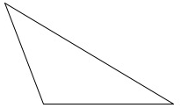

Three students drew the figures below.

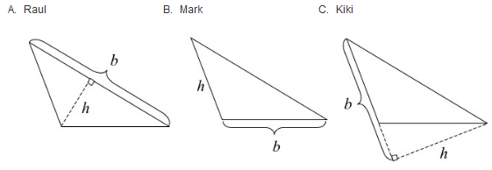

Part A. Which students, if any, have correctly identified a base and its corresponding height? Which ones have not? Explain what is incorrect.

Part B. There are three possible base-height pairs for this triangle. Sketch all three.

*Instructional Task 2 (MTR.5.1)*

Look at the triangles below.

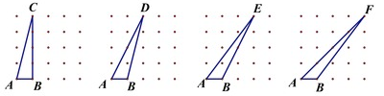

Determine and explain:

* + Which triangle has the greatest area?
  + Which triangle has the least area?
  + Do any of the triangles have the same area?
  + Are some areas impossible to compare?

Instructional Items

*Instructional Item 1*

Find the area of $ΔDEF$.

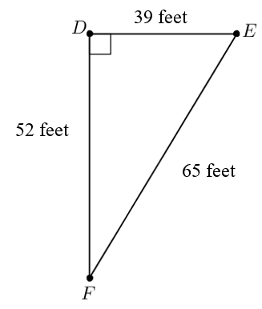

*Instructional Item 2*

Using the rectangle below, if a line was drawn from vertex J to vertex L, what is the area of $ΔJKL$?

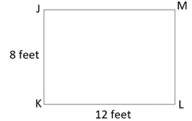

*\*The strategies, tasks and items included in the B1G-M are examples and should not be considered comprehensive.*

### MA.6.GR.2.2

Benchmark

MA.6.AR.2.2 Solve mathematical and real-world problems involving the area of quadrilaterals and composite figures by decomposing them into triangles or rectangles.

Benchmark Clarifications:

*Clarification 1:* Problem types include finding the area of composite shapes and determining missing dimensions.

*Clarification 2:* Within this benchmark, the expectation is to know from memory a formula for the area of a rectangle and triangle.

*Clarification 3:* Dimensions are limited to positive rational numbers.

Connecting Benchmarks/Horizontal Alignment

* MA.6.NSO.2.1, MA.6.NSO.2.2, MA.6.NSO.2.3
* MA.6.AR.1.1
* MA.7.GR.1.2

Terms from the K-12 Glossary

* Algorithm
* Area
* Rectangle
* Quadrilateral
* Triangle
* Composite Figure

Vertical Alignment

|  |  |
| --- | --- |
| **Previous Benchmarks**   * MA.5.GR.2.1 | **Next Benchmarks**   * MA.912.GR.4.4 |

Purpose and Instructional Strategies

In previous courses, students found the perimeter and area of rectangles with fractional or decimal sides. In grade 6 accelerated, students will apply the area of rectangles to find the areas of quadrilaterals and composite figures by decomposing composite figures into triangles and rectangles *(MTR.1.1, MTR.2.1).* Students will also extend this knowledge to decompose composite figures into triangles and quadrilaterals to find the area. In future courses, students will solve mathematical and real-world problems involving the area of two-dimensional figures.

* Instruction includes finding missing dimensions with quadrilaterals and composite figures *(MTR.1.1, MTR.5.1).*
* Instruction includes representing measurements for area as square units, units squared or units2.
* When using rational numbers, instruction is restricted to numbers within the same form.
  + For example, if students are working with fractions, the side lengths will not include decimals. If students are working with decimals, the side lengths will not include fractions. Students should not be penalized though if they convert from one form to another when performing operations.
* Students should look for opportunities to either decompose or compose shapes to enhance their geometric reasoning.
  + For example, in the diagram below, students can solve by decomposing or by composing.

|  |  |
| --- | --- |
| A trapezoid with the following measurements: 18 cm (parallel to 12 cm), 12 cm (parallel to 18 cm), 10 cm, and 7 cm (for the height). | Area = = 105 cm2  Area = = 105 cm2 |

* Problem types include having students measure lengths using a ruler to determine the area.
* Instruction includes problems where multiple decompositions are possible so students understand the various pathways to a solution (MTR.5.1). If students decompose composite figures using quadrilaterals other than rectangles, this directly connects to benchmark MA.7.GR.1.2.

Common Misconceptions or Errors

* Students may invert the perimeter and area formulas.
* Students may incorrectly label all sides of the figure.
* Students may incorrectly identify a side of a triangle as the height.
* Students may overlook an unlabeled side.
* Students may incorrectly decompose a figure into irregular shapes.

Strategies to Support Tiered Instruction

* Teacher relates the definitions of surface area and volume and co-creates an anchor chart to display in the room explaining each. Providing flashcards or cue cards with the formulas will help students in place of anchor charts when they are outside the classroom area.
* Teacher models the use of different color markers or pencils to match similar sides when decomposing figures. This will help students accurately label the sides of each shape.
* Use manipulatives or grid paper that students can measure to better understand there is a difference between a side length and the height in non-right triangles.
* Teacher models the use of manipulatives and geometric software to review the concept of perimeter or area.
* Teacher models the use of manipulative shapes to reinforce the sides of the pieces that make up a decomposed figure.

Instructional Tasks

*Instructional Task 1 (MTR.1.1, MTR.2.1, MTR.5.1)*

The diagram shows the dimensions, in feet, of the local playground. While playing with friends, Shona lost the key to her diary somewhere in the dirt. By composing or decomposing into rectangles, determine the maximum number of square feet that Shona may need to search to find the missing key? If she only searched one rectangular area, what is the least number of square feet Shona searched?

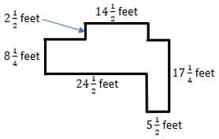

Instructional Items

*Instructional Item 1*

A pentagon is shown. What is the area, in square inches, of the pentagon? Image not to scale.

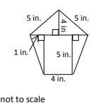

*Instructional Item 2*

Mr. Moretti wants to cover the walkway around his swimming pool with tile. Determine how many square feet of tile he will need to cover the shaded portion of the diagram.

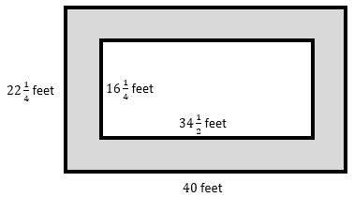

*\*The strategies, tasks and items included in the B1G-M are examples and should not be considered comprehensive.*

### MA.6.GR.2.3

Benchmark

**MA.6.GR.2.3 Solve mathematical and real-world problems involving the volume of right rectangular prisms with positive rational number edge lengths using a visual model and a formula.**

Benchmark Clarifications:

*Clarification 1:* Problem types include finding the volume or a missing dimension of a rectangular prism.

Connecting Benchmarks/Horizontal Alignment

* MA.6.NSO.2.1, MA.6.NSO.2.2, MA.6.NSO.2.3
* MA.6.NSO.3.3
* MA.6.AR.1.1
* MA.6.AR.2.3

Terms from the K-12 Glossary

* Algorithm
* Cube
* Rectangular prism

Vertical Alignment

|  |  |
| --- | --- |
| **Previous Benchmarks**   * MA.5.GR.3.3 | **Next Benchmarks**   * MA.7.GR.2.3 |

Purpose and Instructional Strategies

In previous courses, students found the volume of right rectangular prisms with whole-number edges. Students calculated the volume of right rectangular prisms (boxes) using whole-number edges with a unit cube of $1×1×1$. In grade 6 accelerated, students will use this understanding and apply it to rational-number edge lengths of rectangular prisms. In future courses, students will find the volume of right circular cylinders.

* Instruction includes exploring volume of right rectangular prisms using fractional unit cubes.
  + For example, the right rectangular prism has edges of $1\frac{1}{4}$ inches, 1 inch and $1\frac{1}{2}$ inches. The volume can be found by recognizing that the unit cube would be $\frac{1}{4}$ inch of all edges, changing the dimensions to $\frac{5}{4}$ inches, $\frac{4}{4}$ inches and $\frac{6}{4}$ inches. The volume is the number of unit cubes making up the prism ($5×4×6$), which is 120-unit cubes each with the volume of $\frac{1}{64}=\left(\frac{1}{4}×\frac{1}{4}×\frac{1}{4}\right)$. This can also be expressed as $\left(\frac{5}{4}×\frac{6}{4}×\frac{4}{4}\right)$ or $\left(\frac{120}{64}\right)$.
* “Know the formula” does not mean memorization of the formula. To “know” means to have an understanding of why the formula works and how the formula relates to the measure (volume) and the figure.
* Instruction includes measuring volume by filling rectangular prisms with blocks and looking at the relationship between the total volume and the area of the base. Through these experiences, students can derive the volume formula.
* When using rational numbers, instruction should stay within the same form. Students should not be penalized though if they convert from one form to another when performing operations.
  + For example, if students are working with fractions, the side lengths will not include decimals. If students are working with decimals, the side lengths will not include fractions.
* Instruction includes using the formula of $V=Bh$ as well as the formula $V=lwh.$ Students should know when and how to use each formula and be able to apply the formulas to real-world contexts.
  + When given a problem such as “The standard size of a construction brick is $2\frac{1}{4}$ inches by 8 inches by $3\frac{1}{2}$ inches. Find the volume of one brick.” There are three measurements given. Therefore, the formula, $V=lwh$, would be the most appropriate formula.
  + When given a problem such as “The floor of a cargo truck is $22\frac{1}{2}$ square feet. What is the volume of the storage space in cubic feet if the truck is $7\frac{1}{5}$ feet high?”, there are two measurements given with one being the area of a base. Therefore, the formula $V=Bh$ would be the most appropriate formula.
* Instruction includes representing measurements for volume as cubic units, units cubed or units3.
* Problem types include having students measure lengths using a ruler to determine the area.

Common Misconceptions or Errors

* Students may invert the formulas for surface area and volume.
* Students incorrectly identify the units for volume. For example, use square inches to represent volume instead of cubic inches.
* Students often confuse the vocabulary terms base, length, height, “B” (base area), when moving between two- and three-dimensional figures.

Strategies to Support Tiered Instruction

* Teacher reviews definitions of surface area and volume and co-creates an anchor chart to display in the room explaining each. Providing flashcards or cue cards with the formulas will help students in place of anchor charts when they are outside the classroom area.
* Teacher explains the difference between two-dimensional and three-dimensional shapes. When working with two-dimensional shapes, we label in units $²$, but when working with three-dimensional shapes, we label with units $³$.
* Teacher models the use of manipulatives, such as unit cubes, and geometric software to review the concept of area, perimeter, and volume.

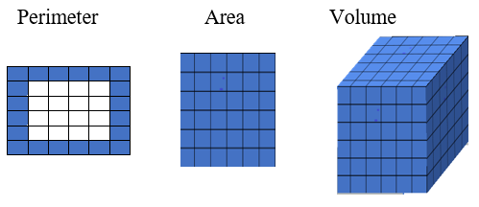

* Teacher breaks down formulas for the area of a rectangle and the volume of a rectangular prism to show when finding area, we are multiplying two sides, which is why we use units $²$, but with the rectangular prism, we are multiplying three sides, so we use units $³$ to label.

Instructional Tasks

*Instructional Task 1 (MTR.4.1, MTR.5.1)*

Imagine that the rectangular prism pictured below is packed full of smaller identical rectangular prisms. The length of each edge of the small prisms is a unit fraction.

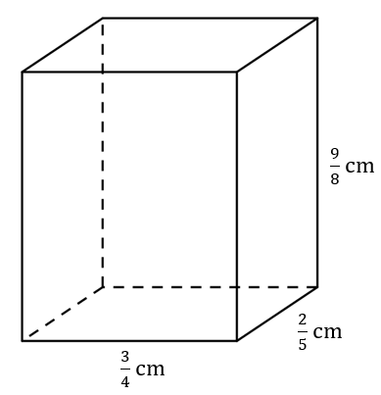

Part A. Give the dimensions of the small rectangular prisms that can be used to pack the larger rectangular prism.

Part B. How many of the small rectangular prisms would it take to completely fill the larger rectangular prism? Explain how you found your answer.

Part C. Explain how the number of the small rectangular prisms needed to fill the larger rectangular prism is related to the volume of the large rectangular prism.

Instructional Items

*Instructional Item 1*

A right rectangular prism has a length of $4\frac{1}{2}$ feet, a width of $6\frac{1}{2}$ feet and a height of 8 feet. What is the volume of the prism?

*Instructional Item 2*

Alex has 64 cubes, with dimensions in feet (ft), like the one shown.

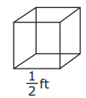

He uses all the cubes to fill a box shaped like a larger rectangular prism. There are no gaps between the cubes.

Part A. What is the volume, in cubic feet, of the larger rectangular prism?

Part B. What is a possible set of dimensions, in feet, of the larger rectangular prism?

*\*The strategies, tasks and items included in the B1G-M are examples and should not be considered comprehensive.*

### MA.6.GR.2.4

Benchmark

**MA.6.AR.2.4 Given a mathematical or real-world context, find the surface area of right rectangular prisms and right rectangular pyramids using the figure’s net.**

Benchmark Clarifications:

*Clarification 1:* Instruction focuses on representing a right rectangular prism and right rectangular pyramid with its net and on the connection between the surface area of a figure and its net.

*Clarification 2:* Within this benchmark, the expectation is to find the surface area when given a net or when given a three-dimensional figure.

*Clarification 3:* Problems involving right rectangular pyramids are limited to cases where the heights of triangles are given.

*Clarification 4:* Dimensions are limited to positive rational numbers.

Connecting Benchmarks/Horizontal Alignment

* MA.6.NSO.2.1, MA.6.NSO.2.2, MA.6.NSO.2.3
* MA.6.AR.2.3

Terms from the K-12 Glossary

* Area
* Net
* Rectangular Prism
* Rectangular Pyramid

Vertical Alignment

|  |  |
| --- | --- |
| **Previous Benchmarks**   * MA.5.GR.2.1 | **Next Benchmarks**   * MA.7.GR.2.2 |

Purpose and Instructional Strategies

In previous courses, students found the area of a rectangle with fractional or decimal sides. In grade 6 accelerated, students find the surface area of right rectangular prisms and right rectangular pyramids. In future courses, students will calculate the surface area of right circular cylinders.

* Instruction includes constructing models and nets of three-dimensional figures and describing them by the number of edges, vertices, and faces. Providing these opportunities will allow students to manipulate materials and connect to more abstract aspects of geometry.
* Instruction includes students using formulas and decomposition strategies to find the surface area of figures. Using the dimensions of the individual faces, students should calculate each rectangle or triangle area and add these values together to find the surface area of the figure.
* Instruction includes describing the types of faces needed to create a three-dimensional figure. Students can make and test conjectures by determining what is needed to create a specific three-dimensional figure.
* Students need to practice the language of the problems they are being asked to solve.
  + For instance, when being asked how much wrapping paper is needed to wrap a box, they know from experience that they are working with surface area. If they are being asked how many boxes will fit in a shipping container, then they are looking at volume.
* When using rational numbers, instruction should stay within the same form. Students should not be penalized though if they convert from one form to another when performing operations.
  + For example, if students are working with fractions, the side lengths will not include decimals. If students are working with decimals, the side lengths will not include fractions.
* Instruction includes representing measurements for surface area as square units, units squared or units2.
* Problem types include having students measure lengths using a ruler to determine the surface area.

Common Misconceptions or Errors

* Students may not be able to determine the different two-dimensional figures that make up the net of the three-dimensional figure.
* Students may invert the formulas for surface area and volume.
* Students may confuse rectangular prisms and right rectangular pyramids.

Strategies to Support Tiered Instruction

* Teacher provides nets of the three-dimensional figures and model color coding each similar shape. This will help students properly identify each shape to find the area to calculate surface area.
  + For example, a right rectangular prism can be modeled by the net shown below.

|  |  |  |
| --- | --- | --- |
|  |  |  |
|  |  |  |
|  |  |  |
|  |  |  |

* + For example, a right rectangular pyramid can be modeled by the net shown below.



* Teacher reviews definitions of surface area and volume and co-creates an anchor chart to display in the room explaining the differences between them. Teacher models the use of manipulatives and geometric software to review the concept of area and surface area.
* Teacher breaks down formulas for area of a rectangle and volume of a rectangular prism to show when finding area, we are multiplying two sides which is why we use units $²$, but with the rectangular prism, we are multiplying three sides, so we use units $³$ to label. Providing flashcards or cue cards with the formulas will help students in place of anchor charts when they are outside the classroom area.

Instructional Tasks

*Instructional Task 1 (MTR.6.1)*

The surface area of a rectangular prism is 115 square inches. The net of the prism is shown. What are the possible dimensions of the prism?

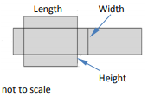

*Instructional Task 2 (MTR.2.1)*

A right rectangular pyramid has a surface area of $56{cm}^{2}$ and the height of each triangular side is 5cm. Draw the net of the figure described.

*Extension.* If the base of the pyramid is a square, what are the dimensions of the base?

Instructional Items

*Instructional Item 1*

Carl is making a box to ship a gift. The net of Carl’s box is shown. How much cardboard, in square inches, is required to make the box?

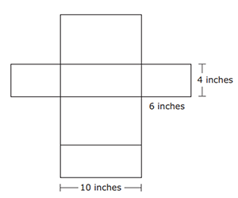

*Instructional Item 2*

Maxwell is making a replica of the Egyptian pyramids. The figures’ dimensions have a square base with a side length of $7.7$ cm and a slant height of 6.2 cm. Maxwell wants to cover the model with gold paper. How much paper, in square centimeters, is needed to cover the pyramid?

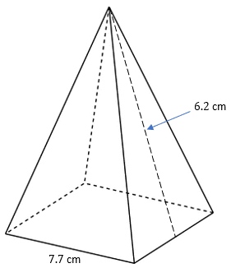

*\*The strategies, tasks and items included in the B1G-M are examples and should not be considered comprehensive.*

**MA.7.GR.1** *Solve problems involving two-dimensional figures, including circles.*

### MA.7.GR.1.1

Benchmark

MA.7.GR.1.1 Apply formulas to find the areas of trapezoids, parallelograms and rhombi.

Benchmark Clarifications:

*Clarification 1:* Instruction focuses on the connection from the areas of trapezoids, parallelograms and rhombi to the areas of rectangles or triangles.

*Clarification 2:* Within this benchmark, the expectation is not to memorize area formulas for trapezoids, parallelograms and rhombi.

Connecting Benchmarks/Horizontal Alignment

* MA.6.GR.2.1, MA.6.GR.2.2
* MA.7.NSO.2.1, MA.7.NSO.2.2, MA.7.NSO.2.3

Terms from the K-12 Glossary

* Area
* Parallelogram
* Rectangle
* Rhombus
* Triangle
* Trapezoid

Vertical Alignment

|  |  |
| --- | --- |
| **Previous Benchmarks**   * MA.5.GR.2.1 | **Next Benchmarks**   * MA.912.GR.3.3 * MA.912.GR.4.4 |

Purpose and Instructional Strategies

In previous courses, students find the area of a rectangle with fractional or decimal side lengths using visual models and formulas. In grade 6 accelerated, students solve problems involving the area of quadrilaterals and composite figures by decomposing them into triangles or rectangles. Students also apply formulas to find the areas of trapezoids, parallelograms, and rhombi. In future courses, students will extend this knowledge to solve mathematical and real-world problems involving the perimeter or area of any polygon using coordinate geometry and other tools.

* Instruction includes using students’ prior knowledge of finding the area of a rectangle to build the area formulas for trapezoids, parallelograms and rhombi. The use of grid paper can support students in counting the squares to verify the areas are accurate.
* Investigations and explore activities for students can include:
  + Draw or provide a cutout of a rhombus. Slice the rhombus vertically at a right angle. Slide the sliced-off portion to form a square so students can see the base and height of the square are the same as that of the rhombus (*MTR.5.1*).

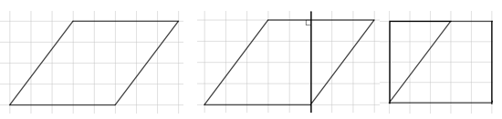

* + Draw or provide a cutout of a parallelogram. Slice the parallelogram vertically at a right angle. Slide the sliced off portion to form a rectangle so students can see the base and height of the rectangle are the same as that of the parallelogram (*MTR.5.1*).



* + Draw or provide a cutout of a trapezoid. Duplicate the trapezoid using tracing paper and rotate it to form a larger parallelogram formed with both figures. The base of the parallelogram then becomes the sum of the two bases of the original trapezoid while the height is the perpendicular height of the original trapezoid. The area is one-half of the area of this parallelogram since it contains two identical trapezoids (*MTR.5.1*).

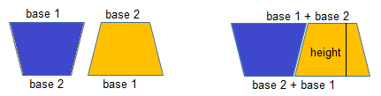

* Instruction includes the comparison of formulas between rectangles, trapezoids, parallelograms and rhombi.

Common Misconceptions or Errors

* Students may incorrectly identify a side length as a height rather than using the perpendicular distance between the bases. To address this misconception, use cutouts or measuring tools to show that these distances are not the same; consider using physical objects that are not square or rectangular to make sense of finding the correct height.
* Students may not properly locate the height or base(s) when using figures in various orientations. To address this misconception, provide multiple orientations of objects and figures. Note that parallelograms are like rectangles, in that any side can be considered a base, so there are two possible heights.

Strategies to Support Tiered Instruction

* Teacher models measuring the length and height of a given shape to demonstrate the difference between the dimensions.
* Instruction includes the use of manipulatives or geometric software to demonstrate the similarity of trapezoids, parallelograms and rhombi to square, rectangles, and triangles.
* Teacher co-creates a graphic organizer with images and formulas for trapezoids, parallelograms and rhombi and uses different colors to connect the dimensions of the figures to the variables within the formulas.
* Teacher uses cutouts or measuring tools to show that the length of the side of a figure is not necessarily the same as its height. Consider using physical objects that are not square or rectangular to make sense of finding the correct height.

Instructional Tasks

*Instructional Task 1 (MTR.5.1)*

Trace a parallelogram or a rhombus on a sheet of graph paper. Highlight (or color) each of the sides a different color. Slice your two-dimensional figure vertically from a vertex at a right angle to an opposite side, to create a right triangle. Move the sliced-off portion to form a rectangle.

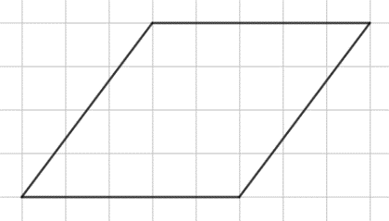

Part A. What are the length and width of the created rectangle?

Part B. Determine the formula for finding the area of your two-dimensional figure.

Part C. Compare your two-dimensional figure and formula with a partner. What do you notice?

*Instructional Task 2 (MTR.5.1)*

Duplicate the trapezoid given below using tracing paper and color the corresponding bases the same color. Cut out both trapezoids. Rotate one trapezoid 180o and line it up next to the other.

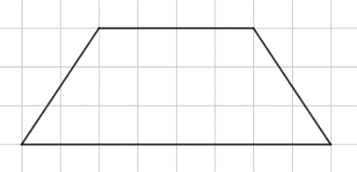

Part A. What figure has formed?

Part B. What is the formula for the figure’s area? Use this information to determine the formula for finding the area of a trapezoid.

Instructional Items

*Instructional Item 1*

A new park is being built in the shape of a trapezoid, as shown in the diagram below. The builders will cover the ground with a solid rubber surface to ensure the children playing have a safe and soft place to land when they jump or fall. How many square yards of rubber will be needed for this park?

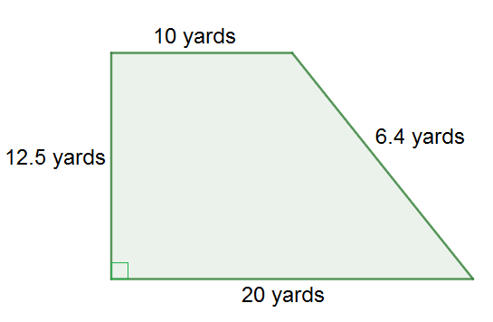

*Instructional Item 2*

Find the area of the figure below.

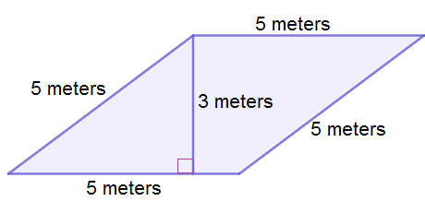

\*The strategies, tasks and items included in the B1G-M are examples and should not be considered comprehensive.

### MA.7.GR.1.2

Benchmark

MA.7.GR.1.2 Solve mathematical or real-world problems involving the area of polygons or composite figures by decomposing them into triangles or quadrilaterals.

Benchmark Clarifications:

*Clarification 1:* Within this benchmark, the expectation is not to find areas of figures on the coordinate plane or to find missing dimensions.

Connecting Benchmarks/Horizontal Alignment

* MA.7.NSO.2.1, MA.7.NSO.2.2, MA.7.NSO.2.3
* MA.6.GR.2.2

Terms from the K-12 Glossary

* Area
* Composite Figure
* Polygon
* Quadrilateral
* Triangle

Vertical Alignment

|  |  |
| --- | --- |
| **Previous Benchmarks**   * MA.5.GR.2.1 | **Next Benchmarks**   * MA.912.GR.3.4 * MA.912.GR.4.4 |

Purpose and Instructional Strategies

In previous courses, students found the area of a rectangle with fractional or decimal side lengths using visual models and formulas. In grade 6 accelerated, students solve problems involving the area of quadrilaterals and composite figures by decomposing them into triangles or rectangles. Students also solve problems involving the area of polygons or composite figures by decomposing them into triangles or quadrilaterals. In future courses, students will extend this knowledge to solve mathematical and real-world problems involving the perimeter or area of any polygon using coordinate geometry and other tools.

* Instruction includes problems where multiple decompositions are possible so students understand the various pathways to a solution (*MTR.5.1*). This is a direct extension of MA.6.GR.2.2 where students decompose composite figures by rectangles and triangles. Scaffolded instruction may include figures on grid paper to allow students to more easily count the total area. Select and order student solutions to be shared with the whole group (*MTR.4.1*), depicting various solution pathways.
* Instruction includes figures where an efficient method is to subtract a basic figure from a larger figure.
* Students should use grid paper to draw a polygon that is composed of triangles and quadrilaterals that can be exchanged with a partner or within a group to find the corresponding areas.

Common Misconceptions or Errors

* Students may neglect to add the areas of the decomposed figures to find the total area of the composite figure. Students may also incorrectly add one (or more) of the decomposed figures more than once. To address misconceptions, have students mark or color the figures as they add them to the total to keep track of their work *(MTR.3.1)*.
* Students may not decompose the figure into the most basic figures. To address this misconception, ask students if they can find the area of each of the pieces they have, or if they can break any of them down further to find a more familiar figure *(MTR.5.1)*.

Strategies to Support Tiered Instruction

* Instruction includes writing the area of each decomposed figure inside the original figure and placing a check next to each of the decomposed areas as they are added to determine the total area of the composite figure.
* Teacher provides geometric software for students to interact with composite figures to develop an understanding of how to decompose two-dimensional figures.
* Teacher provides paper cutouts of different composite figures for students to fold or cut into triangles or quadrilaterals to visually understand how to decompose the area.
* Instruction includes color-coding parallel bases or heights to assist in determining missing measurements of composite figures.
  + For example, given the figure below (assuming the two right triangles have the same side lengths as each other), students can highlight the parallel bases of the rectangle.

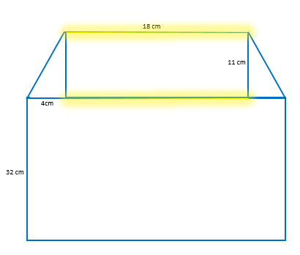

* Teacher has students mark or color the figures as they add them to the total to keep track of their work *(MTR.3.1)*.
* Teacher asks students if they can find the area of each of the pieces they have, or if they can break any of them down further to find a more familiar figure *(MTR.5.1)*.

Instructional Tasks

*Instructional Task 1 (MTR.6.1)*

After a recent storm, Evan has been offered two jobs to replace patio screens. The layouts for the screens needed at both locations are given below. The shaded part represents a stone layout that does not need to be screened.

Job #1

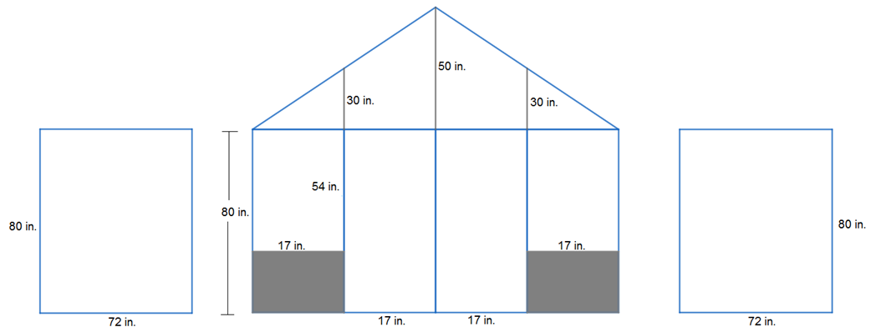

Job #2

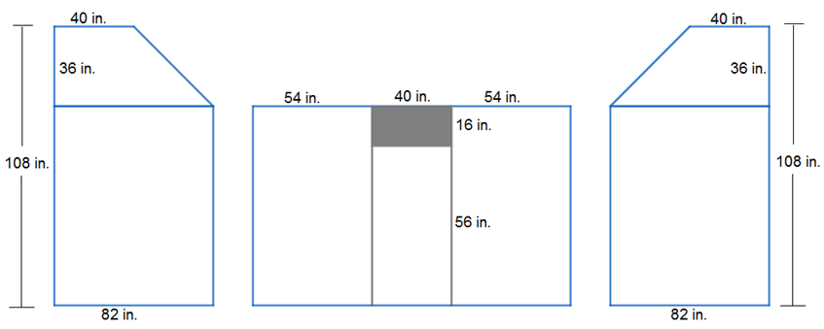

If Evan gets paid by the square inch and would like the highest-paying job, which job should he take? Justify your reasoning.

*Instructional Task 1 (MTR.3.1)*

Tyler and Samantha are building the set for a school play. The design shown below was cut out of wood and now needs to be covered in fabric. What is the total area of the wood that needs to be covered? Each square in the grid has a length of one foot. Justify your answer.

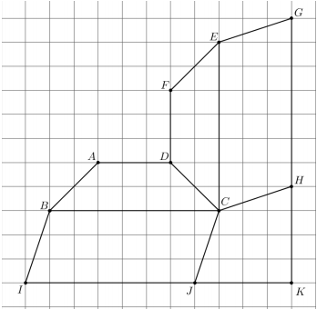

Instructional Items

*Instructional Item 1*

Find the area of the figure below. Note that the figure may not be drawn to scale.

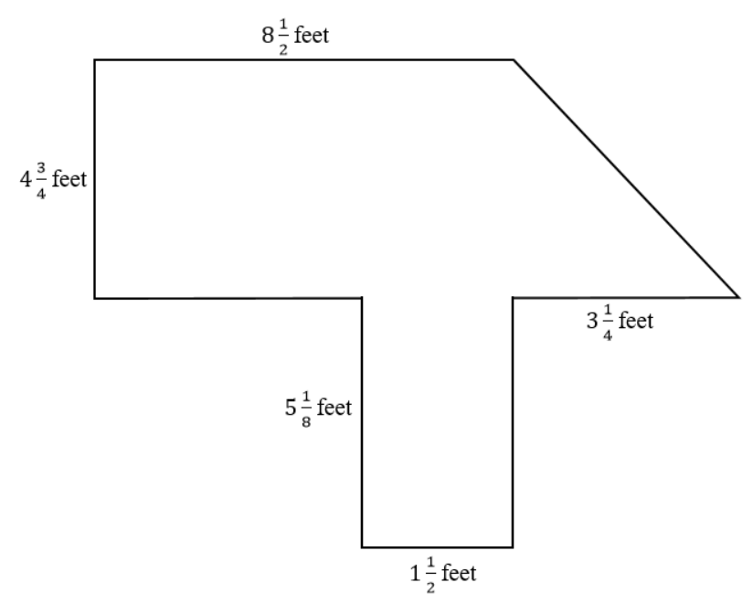

*Instructional Item 2*

Bena is building a kite based on the design shown below. Determine how much ripstop

nylon she will need to purchase for the sail material.

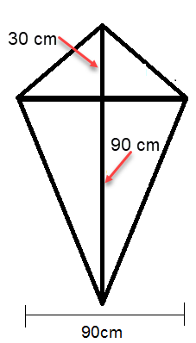

\*The strategies, tasks and items included in the B1G-M are examples and should not be considered comprehensive.

# Data Analysis & Probability

**MA.6.DP.1** *Develop an understanding of statistics and determine measures of center and measures of variability. Summarize statistical distributions graphically and numerically.*

### MA.6.DP.1.1

Benchmark

MA.6.DP.1.1 Recognize and formulate a statistical question that would generate numerical data.

*Example:* The question “How many minutes did you spend on mathematics homework last night?” can be used to generate numerical data in one variable.

Connecting Benchmarks/Horizontal Alignment

* MA.6.AR.1.1

Terms from the K-12 Glossary

* Data
* Statistical Question

Vertical Alignment

|  |  |
| --- | --- |
| **Previous Benchmarks**   * MA.5.DP.1.1, MA.5.DP.1.2 | **Next Benchmarks**   * MA.7.DP.1.5 |

Purpose and Instructional Strategies

In previous courses, students collected numerical and categorical data to construct tables and graphs. In grade 6 accelerated, students are formally introduced to statistics and begin formulating statistical questions for numerical data. In future courses, students will extend this when working with categorical data and then with bivariate data *(MTR.1.1, MTR.4.1).*

* Statistics are numerical data relating to a group of individuals; statistics is also the name for the science of collecting, analyzing and interpreting such data. It is a method for translating a real-world context into a collection of numbers. A statistical question anticipates an answer that varies from one individual to the next and is written to account for the variability in the data. Data are the numbers produced in response to a statistical question. Data are frequently collected from surveys or other sources (i.e., documents).
* Instruction focuses on statistical questions that generate numerical data. Once the data is gathered, it can be organized in a table or displayed in a graph.
* Instruction includes the understanding of a statistical question and a non-statistical question. A statistical question can be answered by collecting information that addresses differences in a population. A statistical question concerns some characteristic of a collection of individuals rather than of one specific individual.
  + For example, the question “How tall am I?” is not a statistical question because it is only about a single individual and there is only one response; however, “How tall are the students in my class?” is a statistical question since it can be answered by collecting information from many students and it is anticipated that this information will vary from one student to the next.

|  |  |
| --- | --- |
| **Examples of**  **Statistical Questions** | **Non-Examples of**  **Statistical Questions** |
| * What is the range of ages of students in my school? * How many pets are owned by each student in my grade level? * What is the average math test scores of the students in my class? * How many cupcakes of each type were made at the bakery in a week? * How many letters are in the names of each person in my class? * What is the median height of people in my class? | * + - How old am I?     - How many pets do my grandparents own?     - What is my sister’s math test score?     - What is Martha’s favorite type of cupcake?     - How many letters are in my name?     - What is my height? |

* For numerical data, statistical questions can result in a narrow or wide range of numerical values. To collect information, students design a statistical question that anticipates variability by providing a variety of possible anticipated responses that have numerical answers, such as 3 hours per week, 4 hours per week and so on. Be sure questions have specific numerical answers.
* Statistical questions address the following two aspects: population of interest and measurement of interest. These types of questions should be formulated to anticipate answers that vary.
* Instruction includes students recognizing that statistical questions exist to collect data that can be organized, analyzed and interpreted. This includes determining the measure of center and measure of variation.
  + For example, the statistical question “How much money does a household in Lake County generally spend on the internet in a year?” implies that one must gather numerical data on the cost of internet for households in Lake County to determine how much is generally spent.
* Instruction includes the understanding that statistical questions are not limited to data that can be gathered by students themselves but can also be found by researching or using existing data sets.
  + For example, the question “What was the temperature in Miami in the month of July?” can be considered a statistical question because the data had already been collected.

Common Misconceptions or Errors

* Students may believe that all the questions that they write are statistical questions. Students need to understand that a statistical question must have a range of numerical answers. They will need to have sample questions and practice writing their own.

Strategies to Support Tiered Instruction

* Teacher provides a list of examples of statistical questions and what qualifies them as statistical to assist students who incorrectly label non-statistical questions.
* Teacher provides instruction focused on patterns that make statistical questions and how to change non-statistical questions into statistical questions. Teachers work with students on examples to determine if each question is statistical or non-statistical. If the question is non-statistical, the teacher models how to convert it to a statistical question.
* Teacher provides a list and co-creates a graphic organizer that determines the pattern from statistical and non-statistical questions. Students will have an opportunity to explain why each one is either statistical or non-statistical.
  + Example of a graphic organizer is shown below.

|  |  |  |
| --- | --- | --- |
| **Question Type** | **Characteristics** | **Examples** |
| Statistical | A question that can be answered by collecting data. Often there will be variability in the data. | What is the average cost of a home in this neighborhood? |
| Non-statistical | A question that is typically not answered by collecting data or used to collect data. | When will you be home? |
| Data-gathering but non-statistical | Often a question that is on a survey. | Does your father work from home? |

* Teacher provides sample questions and models how to practice writing their own.

Instructional Tasks

*Instructional Task 1 (MTR.7.1)*

Write a statistical question that will require data that could be collected from your class to provide information to an advertising agency for teenagers to purchase clothing, shoes, backpacks or school supplies.

* 1. Design a table for data collection.
  2. Create a proposal to the advertising agency to recommend an item to advertise based on the data you collected from your statistical question. Include data to support your recommendation.

Instructional Items

*Instructional Item 1*

Amir collected data from his sixth-grade class at Liberty Middle School. He asked about the amount of time students spent playing video games. Write a statistical question associated with his data.

*Instructional Item 2*

Which of the questions below are statistical?

1. Are there typically more manatees in Tarpon Springs or in Blue Springs?
2. How many Instagram followers does Mr. Youmans have?
3. How many points did the basketball team score in its last game?
4. What is the range of photos students in Ms. Alvarez’s class have on their phone?
5. How many minutes a week do 8th graders at Bridgton Middle School spend watching TV?

\*The strategies, tasks and items included in the B1G-M are examples and should not be considered comprehensive.

### MA.6.DP.1.2

Benchmark

MA.6.DP.1.2 Given a numerical data set within a real-world context, find and interpret mean, median, mode and range.

*Example:* The data set {15, 0, 32, 24, 0, 17, 42, 0, 29, 120, 0, 20}, collected based on minutes spent on homework, has a mode of 0.

Benchmark Clarifications:

*Clarification 1:* Numerical data is limited to positive rational numbers.

Connecting Benchmarks/Horizontal Alignment

* MA.6.NSO.2.1, MA.6.NSO.2.2, MA.6.NSO.2.3
* MA.6.AR.2.2, MA.6.AR.2.3
* MA.7.DP.1.1, MA.7.DP.1.2

Terms from the K-12 Glossary

* Data
* Mean
* Median
* Mode
* Range

Vertical Alignment

|  |  |
| --- | --- |
| **Previous Benchmarks**   * MA.5.DP.1.2 | **Next Benchmarks**   * MA.8.DP.1.1 |

Purpose and Instructional Strategies

In previous courses, students interpreted numerical data, with whole-number values, represented with tables or line plots by determining the mean, median, mode and range. In grade 6 accelerated, students find and interpret mean, median, mode and range given a numerical data set with positive rational numbers. Students also continue building their knowledge while using measures of center and measures of variability to compare two populations. In future courses, students are introduced to numerical bivariate data and depict it with line graphs and lines of fit.

* Instruction includes using numerical data generated by statistical questions.
* Instruction includes the understanding that data sets can contain many numerical values that can be summarized by one number such as mean, median, mode or range.
* Instruction includes data sets that have more than one mode. Students should understand that a mode may not be descriptive of the data set as a whole.
* Instruction includes how to calculate and interpret the mean *(MTR.4.1).*
* Instruction focuses on statistical thinking that allows for meaningful discussion of interpreting data *(MTR.4.1).* Students should be asked:
  + What do the numbers tell us about the data set? Is it representative of the whole?
  + What kinds of variability might need to be considered in interpreting this data?
  + What happens when you do not know all the measures in your data set?
  + Can you find missing data elements?
* Instruction includes student understanding of the difference between measures of center (mean and median) and measures of variability (range).
* Instruction includes students knowing when a number represents the spread or variability of the data, or when the number describes the center of the data.
* Instruction includes multiple representations of a given data set such as tables, lists, sets and graphical representations.
* Instruction includes graphical representations both horizontally and vertically and focus on box plots, histograms, stem-and-leaf plots and line plots.
* Instruction includes interpreting the median as splitting the data into two halves (50% above and below the median).

Common Misconceptions or Errors

* Students may incorrectly believe that “average” only represents the mean of a data set. Statisticians prefer to use the term “mean” rather than “average” since the term “average” is often used to refer to “typical” or “in the middle”.
* Students may confuse mean, median, mode and range.
* Students may neglect to order the numbers in the data set from least to greatest when finding the median or range.

Strategies to Support Tiered Instruction

* Teacher discusses with students how the use of the word average in daily life may show a different meaning of the word each time, just as other mathematical words have different meanings in everyday life. This will help students to understand that “average” does not only represent the mean of a data set.
* Teacher provides instruction focused on measures of center, co-creating anchor chart or graphic organizer.
* Teacher provides examples visually that show the clear middle of a data set, but where the mean is not the same. This visual will help students understand that the middle of a data set does not indicate that the amount is the mean.
  + For example, the figure below shows a data set with a mean of 7 and a median of 4.

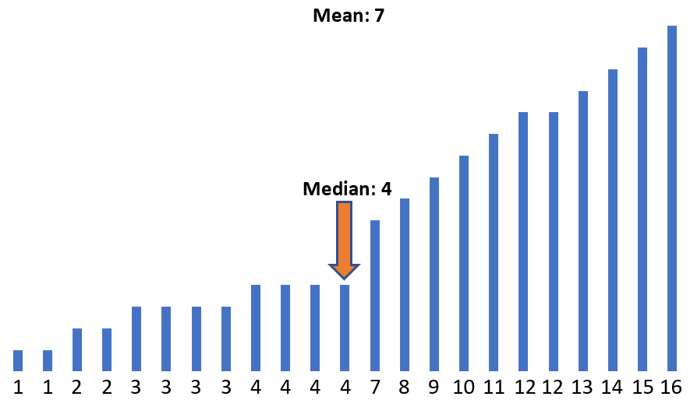

Instructional Tasks

*Instructional Task 1 (MTR.4.1, MTR.5.1)*

Salena has 15 students in her class. The mean shoe size is 8.5. She records the shoe sizes below, with one missing:

7.5, 10, 15, 6.5, 7, 9, 9.5, 6, 11, 8.5, 7, 12, 6, 6.5, \_\_\_

What shoe size is missing? Explain how she can find the missing shoe size.

*Instructional Task 2 (MTR.5.1)*

Brandi is in the Girl Scouts, and they are selling cookies. There are 11 girls in her troop. The median number of boxes of cookies sold by a girl scout is 26, and the range of the number of boxes sold is 30 boxes.

Part A. What is a possible set of boxes of cookies sold?

Part B. If the mean number of boxes of cookies sold is 22, describe some possible

characteristics of the data set.

Instructional Items

*Instructional Item 1*

Jonathan works for a sporting goods store. He is asked to report his sales of running shoes for each day of the week, in dollars. His numbers are given below.

{150.25, 122.85, 171.01, 118.48, 108.52, 130.15, 154.36}

Part A. What is the mean?

Part B. What is the median?

\*The strategies, tasks and items included in the B1G-M are examples and should not be considered comprehensive.

### MA.6.DP.1.3

Benchmark

MA.6.DP.1.3 Given a box plot within a real-world context, determine the minimum, the lower quartile, the median, the upper quartile and the maximum. Use this summary of the data to describe the spread and distribution of the data.

*Example:* The middle 50% of the population can be determined by finding the interval between the upper quartile and the lower quartile.

Benchmark Clarifications:

*Clarification 1:* Instruction includes describing range, interquartile range, halves and quarters of the data.

Connecting Benchmarks/Horizontal Alignment

* MA.6.NSO.2.1, MA.6.NSO.2.2, MA.6.NSO.2.3
* MA.7.DP.1.1, MA.7.DP.1.2

Terms from the K-12 Glossary

* Box Plot
* Data
* Interquartile Range (IQR)
* Median
* Quartiles
* Range (of a data set)

Vertical Alignment

|  |  |
| --- | --- |
| **Previous Benchmarks**   * MA.5.DP.1.1, MA.5.DP.1.2 | **Next Benchmarks**   * MA.8.DP.1.1 |

Purpose and Instructional Strategies

In previous courses, students collected and represented fraction and decimal data using tables, line graphs or line plots. They also interpreted whole-number data by determining the mean, median, mode or range. In grade 6 accelerated, students will be given a box plot in a real-world context to determine quartile values as well as describe the spread and distribution. Students will also use the measures of center and variability to make comparisons, interpret results and draw conclusions about two populations *(MTR 7.1).* In future courses, students learn how to interpret the main features of line graphs and lines of fit

* Instruction includes developing statistical questions that generate numerical data.
* Box plots represent only numerical data sets and display the data’s spread.
* Instruction focuses more on variation rather than measures of central tendency.
* Vocabulary instruction emphasizes qualitative descriptive words such as symmetrical and skewed.
* Instruction focuses on the advantages and disadvantages of box plots in relation to other graphical representations.
* Instruction relates to MA.6.DP.1.5 in which students will create box plots to represent sets of numerical data.
* Instruction includes horizontal and vertical representations of box plots *(MTR.2.1).*
* Instruction provides opportunities for students to use the following terms interchangeably *(MTR.4.1).*
  + lower quartile (LQ), quartile 1 (Q1) and the boundary for the lowest 25% of the data set
  + median and quartile 2 (Q2)
  + upper quartile (UQ), quartile 3 (Q3) and the boundary for the highest 25% of the data set
  + interquartile range (IQR) and the middle 50% of the data set

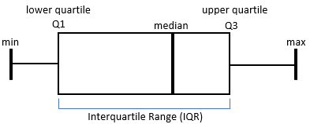

Common Misconceptions or Errors

* Students may have difficulty remembering what percentage of data is above or below the specific quartile (e.g., 25% below LQ, 50% below/above median, 25% above UQ, etc.)
* Students may have difficulty determining the median of an even set of data.
* Students may incorrectly believe the median always splits the box portion of a box plot in half.



Strategies to Support Tiered Instruction

* Teacher reviews vocabulary for students who have difficulty understanding what percentage of data is above or below the specific quartile. Students should be given opportunity to relate “quartile” to “quarter.” Teachers can ensure students understand that “quartile” means 25% and recognize the median as “middle” of the data.
* If there are an even number of total data points, teacher models how the median is found by finding the mean of the two middle data points. Teacher provides opportunity for students to practice this skill by gradually releasing them until they are proficient and gain understanding.
* Teacher co-creates s vocabulary guide or anchor chart with students who need additional support understanding the vocabulary for measures of center and variation.
  + Examples of guides and charts are shown below.

|  |  |  |
| --- | --- | --- |
| **Term** | **Definition** | **How it is found or calculated** |
| Mean |  |  |
| Median |  |  |
| Mode |  |  |
| Range |  |  |
| Interquartile Range (IQR) |  |  |
| Quartiles |  |  |

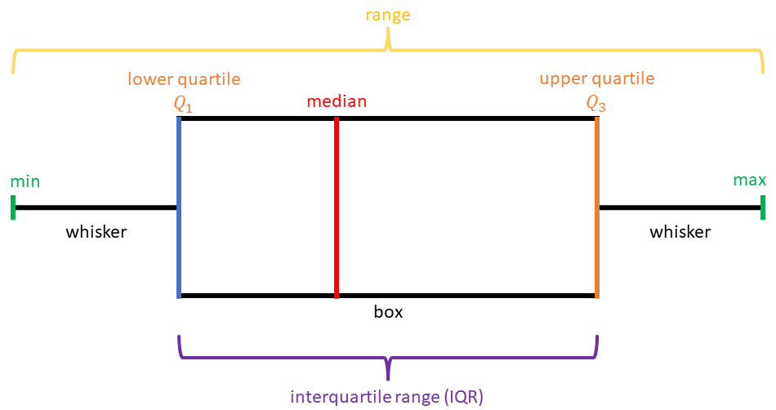

Instructional Tasks

*Instructional Task 1 (MTR.5.1)*

Use the data from the International Shark Attack File on the number of shark attacks in Florida, which is given in the table below, along with the corresponding box plot to answer the following questions.

**Shark Attacks in Florida (2009-2019)**

| **Year** | 2009 | 2010 | 2011 | 2012 | 2013 | 2014 | 2015 | 2016 | 2017 | 2018 | 2019 |
| --- | --- | --- | --- | --- | --- | --- | --- | --- | --- | --- | --- |
| **Number of Attacks** | 19 | 14 | 11 | 27 | 23 | 28 | 30 | 32 | 31 | 16 | 21 |

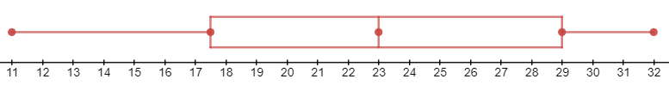

Part A. When did the greatest number of shark attacks occur? When did the lowest number of shark attacks occur? Why do you think this was the case?

Part B. What is the median number of shark attacks?

Part C. What percentage of attacks was below 30?

Instructional Items

*Instructional Item 1*

The box plot represents the AdvertiseHere company employees’ ages. State the lowest age, lower quartile age, median age, upper quartile age and highest age of the employees.

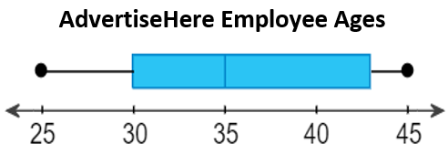

\*The strategies, tasks and items included in the B1G-M are examples and should not be considered comprehensive

### MA.6.DP.1.4

Benchmark

MA.6.DP.1.4 Given a histogram or line plot within a real-world context, qualitatively describe and interpret the spread and distribution of the data, including any symmetry, skewness, gaps, clusters, outliers and the range.

Benchmark Clarifications:

*Clarification 1:* Refer to K-12 Mathematics Glossary (Appendix

Connecting Benchmarks/Horizontal Alignment

* MA.6.NSO.2.3

Terms from the K-12 Glossary

* Cluster
* Data
* Histogram
* Line Plot
* Outlier
* Range

Vertical Alignment

|  |  |
| --- | --- |
| **Previous Benchmarks**   * MA.5.DP.1.1 | **Next Benchmarks**   * MA.7.DP.1.5 |

Purpose and Instructional Strategies

In previous courses, students interpreted numerical data from tables and line plots by determining the mean, median, mode and range. In grade 6 accelerated, students extend their understanding of data interpretation by describing qualitatively the symmetry, skewness, gaps, clusters and outliers of line plots and histograms. Additionally, students will expand from whole-number data sets to rational-number data sets and to include histograms as a graphical representation. In future courses, students compare two data sets to interpret and draw conclusions about populations.

* Instruction includes developing statistical questions that generate numerical data.
* Instruction includes the understanding that line plots are useful for highlighting clusters, gaps and outliers within a data set and show the shape of the distribution of a data set while displaying the individual data points. Likewise, students should understand that histograms are useful for highlighting clusters and gaps and showing the shape of the distribution of a data set without displaying the individual data points. Additionally, histograms help identify the shape and spread of the data set.
* Problem types include using a histogram’s or line plot’s symmetry, skewness, gap(s), cluster(s), outlier(s) or range to qualitatively describe the spread/distribution; qualitatively interpret the spread/distribution; or both qualitatively describe and interpret the spread/distribution.
* Instruction relates to MA.6.DP.1.5 in which students create histograms to represent sets of numerical data.
* When describing the distribution, students are not expected to use the term uniform. Instruction focuses on describing data as normal, skewed or bimodal.

|  |  |  |
| --- | --- | --- |
| **Normal** | **Skewed** | **Bimodal** |
| A normal distribution of data | A skewed distribution of data | A bimodal distribution of data |

* Within this benchmark, the expectation is not to identify skewness as positive, negative, left or right. Students are only expected to describe and interpret skewness within a data set generally. When describing the spread of the distribution, students should be able to interpret whether the data set has a narrow range (less spread), wide range (more spread) or contains an outlier (see glossary) *(MTR.4.1).*

Common Misconceptions or Errors

* Students may confuse bar graphs (categorical data) and histograms (numerical data).
* Students have difficulty understanding skewness and how that relates to data and its interpretation.

Strategies to Support Tiered Instruction

* Teacher displays histograms and line plots, side by side. Teacher co-creates a graphic organizer to compare and contrast the difference between the two, and what information can be interpreted from each one.
* Teacher facilitates discussion on symmetry, skewness, gaps, clusters, outliers, and range with students and provides additional examples for students to reference after instruction.
* Teacher displays a graph or other visual representation to show a real-world example that will assist students in seeing data that is skewed.
* For example, showing a dot plot of the number of Electoral Votes states have will show data that is skewed. Then conversations can be had about what it means that most of the data points are to the left, and which states have the most votes.

|  |  |  |  |  |  |
| --- | --- | --- | --- | --- | --- |
| **State** | **Electoral Votes** | **State** | **Electoral Votes** | **State** | **Electoral Votes** |
| Alabama | 9 | Kentucky | 8 | North Dakota | 9 |
| Alaska | 3 | Louisiana | 8 | Ohio | 18 |
| Arizona | 11 | Maine | 4 | Oklahoma | 7 |
| Arkansas | 6 | Maryland | 10 | Oregon | 7 |
| California | 55 | Massachusetts | 11 | Pennsylvania | 20 |
| Colorado | 9 | Michigan | 16 | Rhode Island | 4 |
| Connecticut | 7 | Minnesota | 10 | South Carolina | 9 |
| Delaware | 3 | Mississippi | 6 | South Dakota | 3 |
| District of Columbia | 3 | Missouri | 10 | Tennessee | 11 |
| Florida | 29 | Montana | 3 | Texas | 38 |
| Georgia | 16 | Nebraska | 5 | Utah | 6 |
| Hawaii | 4 | Nevada | 6 | Vermont | 3 |
| Idaho | 4 | New Hampshire | 4 | Virginia | 13 |
| Illinois | 20 | New Jersey | 14 | Washington | 12 |
| Indiana | 11 | New Mexico | 5 | West Virginia | 5 |
| Iowa | 6 | New York | 29 | Wisconsin | 10 |
| Kansas | 6 | North Carolina | 15 | Wyoming | 3 |

A line plot of the number of  Electoral Votes that states have.

Instructional Tasks

*Instructional Task 1 (MTR.4.1)*

Instructional strategies for this task.

1. Provide the histograms below to students, either individually or whole group
2. Have students examine the histogram for 2 minutes and record their observations.
3. Have students share with a partner their thinking.
4. Then as a whole group, create a cohesive description and interpretation of the histogram.

Number of Lakes

Depth (in feet)

Deepest Point in Florida Lakes

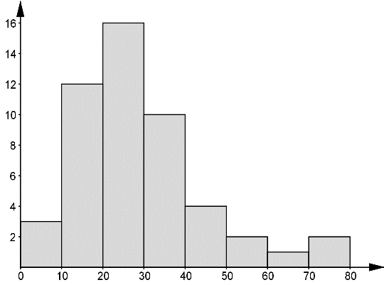

*Instructional Task 2 (MTR.4.1)*

The data set $\{3.25, 2.25, 0.5, 1.5, 1, 0.75, 4, 1, 2.25, 2, 1.5, 1.5, 0.75, 3, 4, 2\}$ is the result of LaKeesha taking a survey of her class to find out how many hours each student spent on their phone on Tuesday. Describe the distribution by stating its symmetry, its range, any outliers, any clusters and any gaps.

Instructional Items

*Instructional Item 1*

The line plot below shows the distribution of test scores in Mrs. Duncan’s math class.

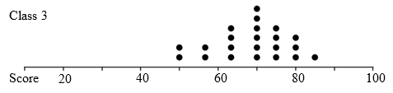

Part A. Describe the shape of the distribution. What does the shape of the distribution indicate about how students scored on the math test?

Part B. Describe the spread by using the range and explain what the shape means in terms of the student’s scores on the math test.

\*The strategies, tasks and items included in the B1G-M are examples and should not be considered comprehensive.

### MA.6.DP.1.5

Benchmark

MA.6.DP.1.5 Create box plots and histograms to represent sets of numerical data within real-world contexts.

*Example:* The numerical data set {15, 0, 32, 24, 0, 17, 42, 0, 29, 120, 0, 20}, collected based on minutes spent on homework, can be represented graphically using a box plot.

Benchmark Clarifications:

*Clarification 1:* Instruction includes collecting data and discussing ways to collect truthful data to construct graphical representations.

*Clarification 2:* Within this benchmark, it is the expectation to use appropriate titles, labels, scales and units when constructing graphical representations.

*Clarification 3:* Numerical data is limited to positive rational numbers.

Connecting Benchmarks/Horizontal Alignment

* MA.6.NSO.1.1
* MA.6.DP.1.3, MA.6.DP.1.4

Terms from the K-12 Glossary

* Box Plot
* Data
* Histogram

Vertical Alignment

|  |  |
| --- | --- |
| **Previous Benchmarks**   * MA.5.DP.1.1 | **Next Benchmarks**   * MA.7.DP.1.5 |

Purpose and Instructional Strategies

In previous courses, students collected and represented numerical data using tables, line graphs or line plots and interpreted this data by determining the mean, median, mode and range. In grade 6 accelerated, students add box plots and histograms to the types of data displays they are creating. In future courses, students are asked to choose and create an appropriate graphical representation of both numerical and categorical data, which includes bar graphs and circle graphs *(MTR.1.1, MTR.2.1, MTR.7.1).*

* Instruction includes developing statistical questions that generate numerical data.
* Instruction includes opportunities for students to collect their own data to create a graphical display. This increases student interest in analyzing the data *(MTR.1.1).*
* Scales can be represented using brackets, ranges, inclusive or exclusive endpoints.
  + For example, the numerical data set from the example is {15, 0, 32, 24, 0, 17, 42, 0, 29, 120, 0, 20}. A student has determined to use intervals of 0-20, 20-40, 40-60, 60-80, 80-100, 100-120.
    - Students could use brackets to represent inclusive endpoints and parentheses to represent exclusive endpoints. Students can write the intervals as [0-20); [20-40); [40-60); [60-80); [80-100); [100-120].
    - Since the data only contains whole numbers, students can write the intervals as 0-20, 21-40, 41-60, 61-80, 91-100, 101-120.
  + Parentheses represent exclusive endpoints.
* Given a set of data, allow students to choose to create either a histogram or box plot, ensuring both are being created. Then discuss the pros and cons for why one may be preferred over another. Practice this using data sets containing whole numbers as well as with data sets containing positive rational numbers. Students should be provided with different ways to organize the data in order to best create the graphical representation.
* Instruction allows for analysis of the truthfulness or reasonableness of the data set. Students should understand whether the data can be used to showcase real situations.
* Instruction includes the use of online tools to quickly show the difference in distributions when changing the size of the bins in a histogram.

Common Misconceptions or Errors

* Students may choose bin sizes that do not effectively show the distribution of the data.
  + For example, students gathered gas mileage (in miles per gallon) data for 50 cars as shown in the histograms below. Histogram A easily shows the gas mileage for the majority of cars, and a much smaller count being above 40 miles per gallon. Histogram B uses very small bins, which leads the consumer to believe that there is more variability in the data than truly exists.

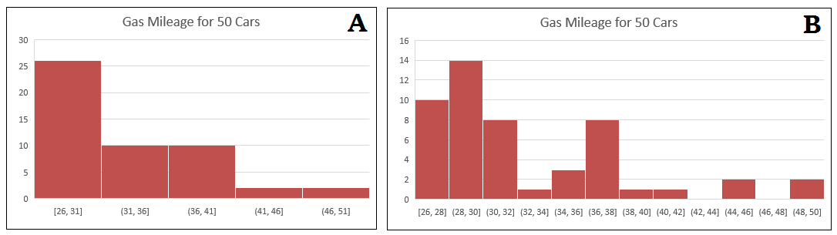



* Students may incorrectly include the same number in 2 bins. For example, if bins are 0-10, 10-20, 20-30, etc., they must decide whether 10 is included in the first bin or if numbers greater than 0, but less than 10 are included in the first bin.
* Students may incorrectly calculate the median given a data set with an even number of values.
* Students may incorrectly believe more data will create a larger box in a box plot.
* Students may neglect to order values from least to greatest when creating a box plot.
* Students may neglect to include titles and labels in the graphical representations.

Strategies to Support Tiered Instruction

* Teacher reviews the difference between histograms and bar graphs, creating an anchor chart with properties of a histogram for students to refer to.
* Teacher reinforces how scales are represented with specific endpoints. The endpoints they chose to use, or as defined in a problem, tell them if the point is included in the bin or not. Include notation of endpoints on the anchor chart to display in the classroom.
* If there are an even number of total data points, teacher models how the median is found by finding the mean of the two middle data points. Teachers provide opportunities for students to practice this skill by gradually releasing them until they are proficient and gain understanding.
* Teacher co-creates a vocabulary guide/anchor chart with students who need additional support understanding the vocabulary for measures of center and variation.
  + Examples of guides and charts are shown below.

|  |  |  |
| --- | --- | --- |
| **Term** | **Definition** | **How it is found or calculated** |
| Mean |  |  |
| Median |  |  |
| Mode |  |  |
| Range |  |  |
| Interquartile Range (IQR) |  |  |
| Quartiles |  |  |



Instructional Tasks

*Instructional Task 1 (MTR.3.1, MTR.7.1)*

Data from the International Shark Attack File on the number of shark attacks in Florida is given in the table below.

**Shark Attacks in Florida (2001-2013)**

| **Year** | 2001 | 2002 | 2003 | 2004 | 2005 | 2006 | 2007 | 2008 | 2009 | 2010 | 2011 | 2012 | 2013 |
| --- | --- | --- | --- | --- | --- | --- | --- | --- | --- | --- | --- | --- | --- |
| **Number of Attacks** | 34 | 29 | 29 | 12 | 17 | 21 | 31 | 28 | 19 | 14 | 11 | 27 | 23 |

Part A. Construct a box plot to summarize this data.

Part B. Identify and explain what each of the key numbers you used to make the box plot means in the context of the data.

Part C. Describe the distribution of the number of shark attacks in Florida between 2001 and 2013. Be sure to describe the spread and distribution of the data.

*Instructional Task 2 (MTR.4.1, MTR.7.1)*

Below are the 25 birth weights, in ounces, of all the Labrador Retriever puppies born at Kingston Kennels in the last six months.

|  |  |  |  |  |  |  |  |  |  |
| --- | --- | --- | --- | --- | --- | --- | --- | --- | --- |
| $$13.5$$ | $$14$$ | $$15.25$$ | $$15.7$$ | $$16$$ | $$16.1$$ | $$16.45$$ | $$16.9$$ | $$17.2$$ | $$17.25$$ |
| $$17.4$$ | $$17.5$$ | $$17.75$$ | $$17.75$$ | $$17.8$$ | $$18$$ | $$18$$ | $$18.5$$ | $$18.5$$ | $$18.55$$ |
| $$18.6$$ | $$18.85$$ | $$18.9$$ | $$19.2$$ | $$20$$ |  |  |  |  |  |

Part A. Use a box plot or histogram to summarize these birth weights and explain how you chose which type of graph to use.

Part B. Describe the distribution of birth weights for puppies born at Kingston Kennels in the last six months. Be sure to describe the spread and distribution of the data.

Part C. What is a typical birth weight for puppies born at Kingston Kennels in the last six months? Explain why you chose this value.

Instructional Items

*Instructional Item 1*

Every year a local basketball team plays 82 games. During the past two decades, the number of wins each year was:

42, 54, 51, 72, 67, 61, 43, 38, 53, 57, 41, 68, 54, 52, 47, 60, 46, 53, 73, 65

Make a histogram to summarize the data.

*Instructional Item 2*

The average precipitation in inches for each month in Orlando, FL is listed below. ([*US Climate Data*](https://www.usclimatedata.com/climate/orlando/florida/united-states/usfl1021)accessed December 13,2022*)*

|  |  |  |  |  |  |
| --- | --- | --- | --- | --- | --- |
| **Jan.** | **Feb.** | **Mar.** | **Apr.** | **May** | **Jun.** |
| 2.74 | 2.83 | 2.79 | 2.49 | 3.30 | 8.74 |

|  |  |  |  |  |  |
| --- | --- | --- | --- | --- | --- |
| **Jul.** | **Aug.** | **Sep.** | **Oct.** | **Nov.** | **Dec.** |
| 7.10 | 7.82 | 6.02 | 3.29 | 2.42 | 2.63 |

Make a box plot to summarize the data.

\*The strategies, tasks and items included in the B1G-M are examples and should not be considered comprehensive.

### MA.6.DP.1.6

Benchmark

MA.6.DP.1.6 Given a real-world scenario, determine and describe how changes in data values impact measures of center and variation.

Benchmark Clarifications:

*Clarification 1:* Instruction includes choosing the measure of center or measure of variation depending on the scenario.

*Clarification 2:* The measures of center are limited to mean and median. The measures of variation are limited to range and interquartile range.

*Clarification 3:* Numerical data is limited to positive rational numbers.

Connecting Benchmarks/Horizontal Alignment

* MA.6.NSO.2.3
* MA.6.AR.1.2
* MA.6.AR.2.3
* MA.7.DP.1.1, MA.7.DP.1.2

Terms from the K-12 Glossary

* Data
* Interquartile Range
* Mean
* Measures of Center
* Measures of Variability
* Median
* Range (of a data set)

Vertical Alignment

|  |  |
| --- | --- |
| **Previous Benchmarks**   * MA.5.DP.1.2 | **Next Benchmarks**   * MA.8.DP.1.1 * MA.912.DP.1.1 |

Purpose and Instructional Strategies

In previous courses, students interpreted numerical data by determining the mean, median, mode and range when the data involved whole-number values and was represented with tables or line plots. In grade 6 accelerated, student understanding is extended to determine the measures of center and variation when the data points are positive rational numbers. Students are also expected to use their understanding of arithmetic to describe how the addition or removal of data values will impact the measures of center and variation within real-world scenarios. Students will also determine an appropriate measure of center or measure of variation to summarize data and use them to make comparisons when given two numerical or graphical representations of data. In future courses, students are introduced to numerical bivariate data and depict it with line graphs and lines of fit. Students will also select an appropriate method to represent both univariate and bivariate numerical data and interpret the different components in the display.

* Instruction includes student understanding that the choice between using the median or the mean as the measure of center or using the interquartile range or range as the measure of variation depends on the purpose.
  + For example, in some cases it is important to include the influence of outliers in the description of a population and the mean might be preferable as the measure of center and the range might be preferable as the measure of variation. If the influence of outliers is meant to be ignored, the median and interquartile range may be more preferable.
* Students should be provided with data sets and asked to find the measures of center and of variability. Students should explore and look for patterns when a data value is removed, or a new data value is added that meets the following conditions *(MTR.5.1)*:
  + The value is larger than the measure of the center.
  + The value is equal to the measure of the center.
  + The value is less than the measure of the center.
  + The value is greater or less than any value of the original data set.
  + The value is within the range of the original data set.
* Instruction includes the use of technology to help with connecting the measures of center and variation to the visual representation on a box plot. This can help students understand what the value of the median, range and interquartile range represent within a context. If a value is added or removed from a data set, students can create a second box plot based on the new data set to help determine and describe the impact of the change *(MTR.2.1)*.

Common Misconceptions or Errors

* Students may incorrectly categorize the data measures (mean, median, range, interquartile range) as measures of center or measures of variability. It can be helpful to frequently refer back to the purpose of a type of measure and how it relates to the center of the data or the variation of the data.
* Students may incorrectly try to determine the change by calculating the mean, median, range or interquartile range for the changed data set instead of calculating for both the initial and the changed sets before comparing.

Strategies to Support Tiered Instruction

* Instruction includes having students calculate the measures of center (mean and median) or the measures of variation (range and interquartile range) for the initial data sets and changed data sets before comparing the impact of an outlier or an additional data point.
* Instruction includes co-creating a graphic organizer for measures of center (mean and median) and measures of variation (range and interquartile range), and include the generalized impact of outliers on each.

Instructional Tasks

*Instructional Task 1 (MTR.5.1, MTR.6.1, MTR.7.1)*

Mr. Biggs and his students shared the number of hours they played video games last week and Mr. Biggs recorded it in the table below.

|  |  |  |  |  |  |  |  |
| --- | --- | --- | --- | --- | --- | --- | --- |
| 2.5 | 12 | 0 | 28 | 6.75 | 21.25 | 1.2 | 16 |
| 7.33 | 1.5 | 4 | 15 | 7 | 2.5 | 16 | 0 |

Part A. Find a measure of center and variability to represent this scenario. Explain why you chose these measures.

Part B. Mr. Biggs removed the 4 from the data set since this represented the number of hours that he played video games. Describe the impact this removal has on the measures of center and measures of variability of the data set.

Part C. Mario is a new student in Mr. Biggs’s class. If the number of hours Mario played video games caused the measure of center to increase, how long could Mario have played video games last week? Explain your reasoning.

Instructional Items

*Instructional Item 1*

Christian took his temperature, in degrees Fahrenheit ($℉$), every day for a week. His temperatures are shown in the table below:

|  |  |
| --- | --- |
| **Day** | **Temperature ($℉$)** |
| Sunday | 98.7 |
| Monday | 99.1 |
| Tuesday | 98.2 |
| Wednesday | 97.9 |
| Thursday | 98.1 |
| Friday | 98.8 |
| Saturday | 99.2 |
| Sunday |  |

Part A. Which measure of center and variation could be used to summarize the data? Explain your choice.

Part B. He took his temperature on the following Sunday, and it was 103.2 $℉$. How does this impact the measures of center and variation?

\*The strategies, tasks and items included in the B1G-M are examples and should not be considered comprehensive.

**MA.7.DP.1** *Represent and interpret numerical and categorical data.*

### MA.7.DP.1.1

Benchmark

MA.7.DP.1.1 Determine an appropriate measure of center or measure of variation to summarize numerical data, represented numerically or graphically, taking into consideration the context and any outliers.

Benchmark Clarifications:

*Clarification 1:* Instruction includes recognizing whether a measure of center or measure of variation is appropriate and can be justified based on the given context or the statistical purpose.

*Clarification 2:* Graphical representations are limited to histograms, line plots, box plots and stem-and-leaf plots.

*Clarification 3:* The measure of center is limited to mean and median. The measure of variation is limited to range and interquartile range.

Connecting Benchmarks/Horizontal Alignment

* MA.6.DP.1.2, MA.6.DP.1.6
* MA.7.NSO.2.2, MA.7.NSO.2.3

Terms from the K-12 Glossary

* Box Plot
* Data
* Histogram
* Interquartile Range (IQR)
* Line Plot
* Mean
* Measures of Center
* Measures of Variability
* Median
* Outlier
* Quartiles
* Range (of data set)
* Stem-and-Leaf Plot

Vertical Alignment

|  |  |
| --- | --- |
| **Previous Benchmarks**   * MA.5.DP.1.2 | **Next Benchmarks**   * MA.8.DP.1.1 * MA.912.DP.1.1 |

Purpose and Instructional Strategies

In previous courses, students interpreted numerical data by determining the mean, median, mode and range when the data involved whole-number values and was represented with tables or line plots. Student understanding was also extended to determine the measures of center and variation when the data points are positive rational numbers. In grade 6 accelerated, students are expected to use their understanding of arithmetic to describe how the addition or removal of data values will impact the measures of center and variation within real-world scenarios. Students also will determine an appropriate measure of center or measure of variation to summarize data and use them to make comparisons when given two numerical or graphical representations of data. In future courses, students are introduced to numerical bivariate data and depict it with line graphs and lines of fit. Students will also select an appropriate method to represent both univariate and bivariate numerical data and interpret the different components in the display.

* The difference between range and interquartile range is just as important as, and very similar to, the difference between mean and median. In both cases, the difference has to do with whether or not one thinks outliers should be ignored (*MTR.1.1*, *MTR.6.1*).
  + Outliers should be mostly ignored if a researcher is more interested in only the “typical” members of a population, as might be the case in politics or advertising. In these cases, the median is often the best choice as a measure of center, and the IQR is often the best choice as a measure of variation. These measures are little affected by outliers.
  + Outliers should not be ignored if a researcher is concerned about the risks associated with “extreme” cases or concerned with the effects that outliers have on the average, as is the case in the insurance industry or in medical trials. In these cases, the mean is often a better choice than the median as a measure of center, and the range is better than the IQR as a measure of variation.
  + All four of these measures are widely used in data analysis.
  + The choice between using the median or the mean as the measure of center or using the interquartile range or range as the measure of variation directly connects to benchmark MA.6.DP.1.6.
* Instruction focuses on identifying outliers qualitatively rather than quantitatively. To determine quantitatively if a data point is an outlier, a teacher may use the following definition. A data value is considered to be an outlier if it lies 1.5 times the IQR below Q1, $\left(Q1-\left(1.5∙IQR\right)\right),$ or above Q3, $\left(Q3+\left(1.5∙IQR\right)\right)$.
* For example, the table below showcases a five-number summary of a data set.

This table shows the minimum value of 29, the quartile 1 value of 37, the median value of 43, the quartile value 3 of 49 and the maximum value of 82.

Within the data set, the IQR is 12. To calculate if a value is an outlier, start with finding $1.5∙12$, which is 18. From there, a data value is considered an outlier if it is less than $37-18$, or 19. It is also considered an outlier if it is greater than $49+18$, or 67.

The maximum value in this data set is an outlier within the data set, though there could be additional values when you see the entire data set.

* Instruction includes cases where students are able to gather their own data for analysis (*MTR.7.1*).
* Instruction includes activities that require students to match graphs and explanations, or measures of center/variation and explanations prior to interpreting graphs based upon the appropriate measures of center or spread calculated (*MTR.2.1*, *MTR.4.1*).

Common Misconceptions or Errors

* Some students may incorrectly calculate the measures of center and variation.
* Students may incorrectly believe all graphical displays are symmetrical. To address this misconception, students should use graphs of various shapes, including those with outliers, which will show this to be false. Start with small data sets related to familiar contexts to discuss how the data should be represented and to show how extreme values can alter the measures.
* Students may incorrectly identify data points as outliers.

Strategies to Support Tiered Instruction

* Instruction includes opportunities for students to calculate the measures of center or the measures of variation for the initial and the changed data sets before comparing the impact of an outlier or an additional data point.
* Teacher provides examples of several visual displays or graphs to discuss the shapes of each one. Opportunities should be provided for students to see the various shapes with and without outliers so they can see that not all graphical displays are symmetrical.
* Teacher provides instruction on the definition of an outlier and interpretation on when to consider outliers (refer to the Instructional Strategies). Teacher provides examples of how outliers can be displayed within different types of data displays.
* Instruction includes co-creating a graphic organizer for measures of center and measures of variation and including the generalized impact of outliers on each.
  + For example:

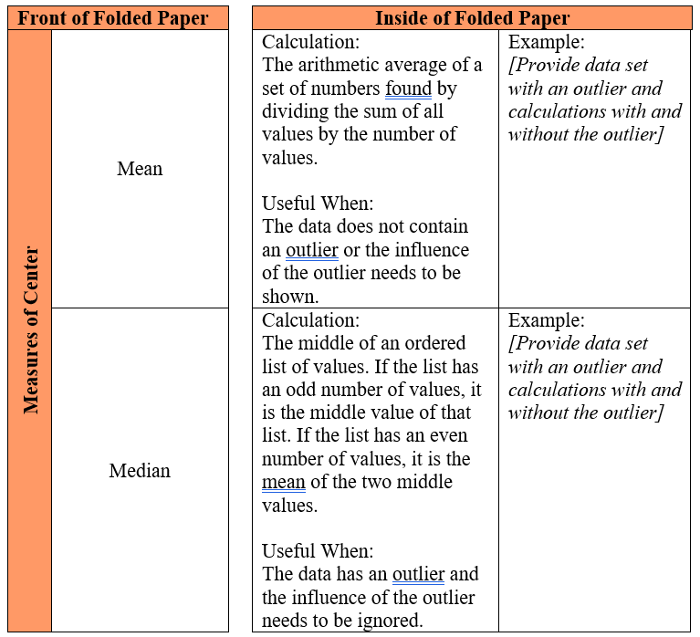

Instructional Tasks

*Instructional Task 1 (MTR.7.1)*

**Teacher Background Information**

Unlike many elections for public office where a person is elected strictly based on the results of a popular vote (i.e., the candidate who earns the most votes in the election wins), in the United States, the election for President of the United States is determined by a process called the Electoral College. According to the National Archives, the process was established in the United States Constitution “as a compromise between election of the President by a vote in Congress and election of the President by a popular vote of qualified citizens.” ([*Archives - electoral college*](http://www.archives.gov/federal-register/electoral-college/about.html) accessed July 1, 2021).

Each state receives an allocation of electoral votes in the process, and this allocation is determined by the number of members in the state’s delegation to the U.S. Congress. This number is the sum of the number of U.S. Senators that represent the state (always 2, per the Constitution) and the number of Representatives that represent the state in the U.S. House of Representatives (a number that is directly related to the state’s population of qualified citizens as determined by the US Census). Therefore, the larger a state’s population of qualified citizens, the more electoral votes it has. Note: the District of Columbia (which is not a state) is granted 3 electoral votes in the process through the 23rd Amendment to the Constitution.

**Task**

The following table shows the allocation of electoral votes for each state and the District of Columbia for the 2012, 2016 and 2020 presidential elections. ([*Archives - electoral college*](http://www.archives.gov/federal-register/electoral-college/allocation.html) accessed July 1, 2021).

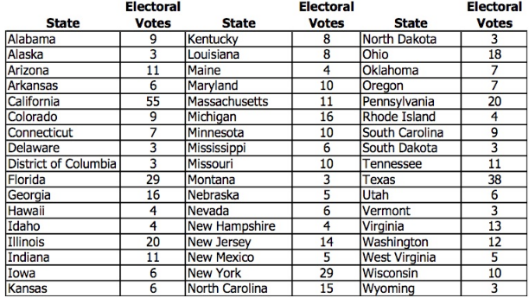

Part A. Which state has the most electoral votes? How many votes does it have?

Part B. Based on the given information, which state has the second highest population of qualified citizens?

Part C. Here is a line plot of the distribution.

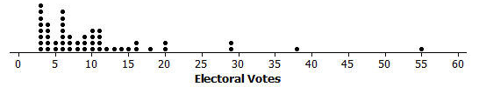

1. What is the shape of this distribution: symmetric or skewed?
2. Imagine that someone you are speaking with is unfamiliar with these shape terms. Describe clearly and in the context of this data set what the shape description you have chosen means in terms of the distribution.

Part D. Does the line plot lead you to think that any states are outliers in terms of their number of electoral votes? Explain your reasoning, and if you do believe that there are outlier values, identify the corresponding states.

Part E. What measure of center (mean or median) would you recommend for describing this data set? Why did you choose this measure?

Part F. Determine the value of the median for this data set (electoral votes).

Instructional Items

*Instructional Item 1*

The household incomes of 15 families in a local neighborhood were recorded to the nearest $1,000 in the table below.

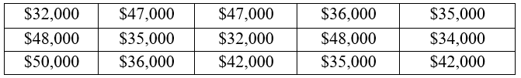

Determine the most appropriate measure of center to describe this data set. What is the value of that measure?

*Instructional Item 2*

The household incomes of 15 families in a local neighborhood were recorded to the nearest $1,000 in the table below.



At the end of the month, a new family is moving in whose household income is $475,000. Determine the most appropriate measure of center to describe this data set. What is the value of that measure? Justify your choice.

\*The strategies, tasks and items included in the B1G-M are examples and should not be considered comprehensive.

### MA.7.DP.1.2

Benchmark

MA.7.DP.1.2 Given two numerical or graphical representations of data, use the measure(s) of center and measure(s) of variability to make comparisons, interpret results and draw conclusions about the two populations.

Benchmark Clarifications:

*Clarification 1:* Graphical representations are limited to histograms, line plots, box plots and stem-and-leaf plots.

*Clarification 2:* The measure of center is limited to mean and median. The measure of variation is limited to range and interquartile range.

Connecting Benchmarks/Horizontal Alignment

* MA.6.DP.1.2
* MA.7.DP.1.1
* MA.7.NSO.2.2, MA.7.NSO.2.3

Terms from the K-12 Glossary

* Box Plot
* Data
* Histogram
* Interquartile Range (IQR)
* Line Plot
* Mean
* Measures of Center
* Measures of Variability
* Median
* Range (of data set)
* Stem-and-Leaf Plot

Vertical Alignment

|  |  |
| --- | --- |
| **Previous Benchmarks**   * MA.5.DP.1.2 | **Next Benchmarks**   * MA.8.DP.1.1 |

Purpose and Instructional Strategies

In previous courses, students interpreted numerical data, with whole-number values, represented with tables or line plots by determining the mean, median, mode and range. In grade 6 accelerated, students will calculate and interpret mean, median, mode and range. They use those calculations to make comparisons, interpret results and draw conclusions about two populations. In future courses, students will learn how to interpret the main features of line graphs and lines of fit.

* Instruction includes cases where students need to calculate measures of center and variation in order to interpret them.
* Instruction includes having students collect their own data for analysis. Students make connections to data they are interested in. (*MTR.1.1*, *MTR.7.1*).
* Students should not be expected to classify differences between data sets as “significant” or “not significant.”
* Data representations can be shown as a two-sided stem-and-leaf plot and multiple box plots on the same scale.
* Data representations should include titles, labels and a key as appropriate.

Common Misconceptions or Errors

* Some students may incorrectly believe a histogram with greater variability in the heights of the bars indicates greater variability of the data set.
* Students may not recognize when to use a stem-and-leaf plot or may not be able to read a two-sided stem-and-leaf plot.
* Students may not be able to explain their choice of the most appropriate measures of center and variability based on the given data.
* Students may think that the presence of one or more outliers leads to an automatic choice (median, IQR) for the measures of center and variation.

Strategies to Support Tiered Instruction

* Instruction includes explaining the difference between variability in the heights of the bars of histograms, and the actual variability of the data set.
* Teacher provides instruction on how to use different types of data displays to show two sets of data at the same time. Teachers co-create an anchor chart explaining the different parts of each display with explanations on when and how to use each of them.
  + For example, the teacher can provide students with a two-sided stem-and-leaf plot with the “stem” in the middle and “leaves” on either side, each displaying the two data sets.

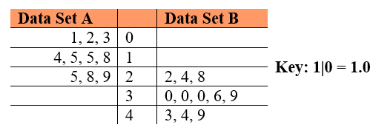

* + For example, the teacher can provide students with two line plots or two box plots on the same number line. Plots can be given in different colors to show the different data sets.
* Teacher provides instruction on which measure of center and variation should be used, making sure to include what to do when an outlier is present.
* Teacher facilitates discussion on the different measures of center and variability and how to know when to use each one. Use a graphic organizer to compare the different measures of center and variability to assist students in deciding when to use them.
* Instruction includes co-creating an anchor chart with different data displays containing visual representations and explanations of when and how to use them.

Instructional Tasks

*Instructional Task 1 (MTR.1.1, MTR.7.1)*

A group of students in the book club are debating whether high school juniors or seniors spend more time on homework. A random sampling of juniors and seniors at the local high school were surveyed about the average amount of time they spent per night on homework. The results are listed in the table below.

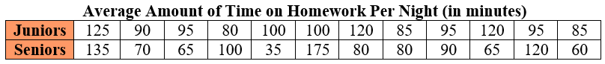

Part A. Calculate and compare the measures of center for the data sets.

Part B. Calculate and compare the variability in each distribution.

Part C. Does the data support juniors or seniors spending more time on homework? Explain your reasoning.

Instructional Items

*Instructional Item 1*

High schools around the state of Florida were asked what percentage of students in their graduating class would be attending a state college and what percentage would be attending a community college. The results are provided in the graph below.

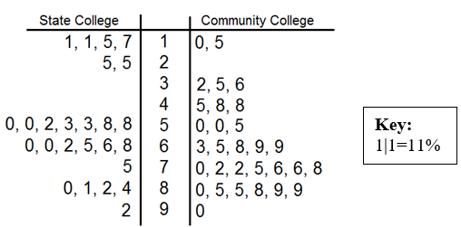

Is a student more likely to go to a state or community college? Which choice has more variability?

\*The strategies, tasks and items included in the B1G-M are examples and should not be considered comprehensive.

### MA.7.DP.1.3

Benchmark

MA.7.DP.1.3 Given categorical data from a random sample, use proportional relationships to make predictions about a population.

*Example:* O’Neill’s Pillow Store made 600 pillows yesterday and found that 6 were defective. If they plan to make 4,300 pillows this week, predict approximately how many pillows will be defective.

*Example:* A school district polled 400 people to determine if it was a good idea to not have school on Friday. 30% of people responded that it was not a good idea to have school on Friday. Predict the approximate percentage of people who think it would be a good idea to have school on Friday from a population of 6,228 people.

Connecting Benchmarks/Horizontal Alignment

* MA.6.AR.3.4
* MA.6.DP.1.3, MA.6.DP.1.4
* MA.7.NSO.2.2, MA.7.NSO.2.3
* MA.7.AR.3.1, MA.7.AR.3.2

Terms from the K-12 Glossary

* Categorical Data
* Population (in Data Analysis)
* Proportional Relationships
* Random Sampling

Vertical Alignment

|  |  |
| --- | --- |
| **Previous Benchmarks**   * MA.6.AR.3.4 * MA.6.DP.1.3, MA.6.DP.1.4 * MA.7.NSO.2.2, MA.7.NSO.2.3 * MA.7.AR.3.1, MA.7.AR.3.2 | **Next Benchmarks**   * MA.7.AR.4.5 * MA.8.DP.1.1 * MA.912.DP.1.4 |

Purpose and Instructional Strategies

In previous courses, students worked with creating equivalent fractions, as well as operations with whole numbers and fractions. In grade 6 accelerated, students describe data using measures of center and variation. Students also use samples to compare measures of center and variation in data sets, as well as use samples to make a generalization about the population from which the sample was taken. In future courses, students will use bivariate data to study proportional and linear relationships and make predictions with lines of fit. Students will also estimate a population total, mean or percentage using data from a sample survey and develop a margin of error through the use of simulation.

* Instruction includes helping students understand that since there is always variability in collecting samples. These generalizations, or predictions, can only be estimates of what we expect to see from the greater population.
* Use real-world scenarios to explain that random sampling is needed when we need to find information about a population that is too large or too difficult to measure completely (*MTR.7.1*).
  + As in the second example for this benchmark, the school district polled 400 people because it would be difficult, and perhaps costly, to poll all 6,228 people efficiently. Therefore, we can analyze a sample that is representative of the population to get an idea of what may be happening with the larger group.
* Students have done more precise work with proportional relationships in MA.7.AR.4, but in this benchmark, students will use the same proportional reasoning to make predictions or find estimates of what may be happening in a population that is too large or cumbersome for us to measure completely.
* Instruction includes having students make predictions about what the population measures will be, based on the sample (*MTR.6.1*).
* Instruction uses manipulatives or simulations to have students collect their own set of data (*MTR.2.1*).
* As in the first example for this benchmark about defective pillows, students can pull a random sample from a bag of chips that have been strategically marked D for defective or have no marking for no defects. They can use their proportion of defective chips to predict how many might be in the entire bag. Comparisons can be made across the different groups in the room to see how close the estimates were to the actual values (*MTR.4.1*).

Common Misconceptions or Errors

* Students may mistake part to total as part to part, which would give an incorrect ratio when setting up their proportion. To address this misconception, use percentages or counts out of 100 to help illustrate this more clearly.
* Students may not understand what random sampling is or why it is important. To address this misconception, allow students to collect random samples and make comparisons across groups to show they are not exact, but representative, of the larger population.

Strategies to Support Tiered Instruction

* Teacher provides instruction focused on color-coding and labeling the different categories based on the sample and the population when setting up a proportional relationship to ensure corresponding parts are placed in the corresponding positions within the proportion.
* For example, based on a random sample of 150 people, 23 people stated that they preferred to go grocery shopping on Saturday morning. If one wants to make a prediction on how many people, out of a town of 4500 people, who prefer to go shopping on Saturday morning, the proportion below can be used.

$$\frac{23 Saturday shoppers}{150 shoppers}=\frac{x Saturday shoppers}{4500 shoppers}$$

Students can also make the connection to multiplicative relationships between shoppers and Saturday shoppers as shown below.

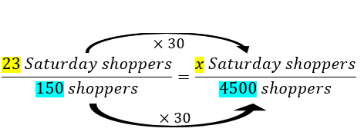

* Teacher uses percentages to help illustrate the difference between part to part and part to total more clearly. Use percentages or counts out of 100 to help illustrate this more clearly.
* Instruction includes providing students with an example of random sampling and biased sampling in a context that is relevant to students.
  + For example, Branden at Sunshine Middle School wants to predict if pizza should be served at the Fall Festival and Johnny suggests sampling 20 students in his 7th grade class. Amanda suggests it would be better to sample 20 random students from all grade levels at Sunshine Middle School. Since Branden wants to ensure that the sampling is not biased, he chooses Amanda’s plan since the prediction is for the whole school and not just for one class at the school.
* Instruction includes the use of problems with percentages or counts of 100.
  + For example, Mr. Smith surveyed students at his school last year to determine which candy bar they preferred. His results are shown in the pie chart below. Students can discuss how they can use this information to make a prediction about how many students prefer a certain candy bar this school year.
* Teacher allows students to collect random samples and make comparisons across groups to show they are not exact, but representative of the larger population.

Instructional Tasks

*Instructional Task 1 (MTR.4.1, MTR.5.1)*

A random sample of the 1,200 students at Moorsville Middle School was asked which type of movie they prefer. The results are compiled in the table below:

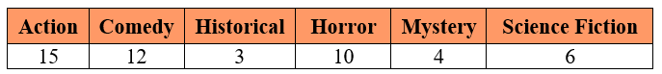

Part A. Use the data to estimate the total number of students at Moorsville Middle school who prefer horror movies.

Part B. Use the data to estimate the total number of students at Moorsville Middle school who prefer either mystery or science fiction movies.

Part C. Suppose another random sample of students was drawn. Would you expect the results to be the same? Explain why or why not.

*Instructional Task 2 (MTR.4.1, MTR.7.1)*

A constitutional amendment is on the ballot in Florida, and it needs **at least 60%** of the vote to pass. The editor of a local newspaper wants to publish a prediction of whether or not the amendment will pass. She hires ten pollsters to each ask 100 randomly selected voters if they will vote yes.

Poll Number       Yes Vote 
1                                51               
2                                68 
3                                58
4                                43 
5                                65
6                                56
7                                45
8                                59
9                                71
10                              63

Should the newspaper’s prediction be that the amendment *will pass* or that it *will not pass*? Explain your reasoning.

Instructional Items

*Instructional Item 1*

A research group is trying to determine how many alligators are in a particular area. They tagged 30 alligators and released them. Later, they counted 12 alligators who were tagged out of the 150 they saw. What can the research group estimate is the total population of alligators in that area?

*Instructional Item 2*

The local grocery store is going to donate milk and cookies to an upcoming middle school event. They surveyed 150 students in the school to determine which type of milk they preferred and recorded the results below.

Table showing results of the 150 students surveyed: cow's milk 82 students, soy milk 25 students, and almond milk 43 students.

If there are 950 students in the school, how much soy milk should the store plan to donate?

* the salaries of all 250 people at a mid-sized company
* the distribution of colors in a bag of colored candies
* the number of siblings that students in the 7th grade class have

\*The strategies, tasks and items included in the B1G-M are examples and should not be considered comprehensive.

**MA.7.DP.2** *Develop an understanding of probability. Find and compare experimental and theoretical probabilities.*

### MA.7.DP.2.1

Benchmark

MA.7.DP.2.1 Determine the sample space for a simple experiment.

Benchmark Clarifications:

*Clarification 1:* Simple experiments include tossing a fair coin, rolling a fair die, picking a card randomly from a deck, picking marbles randomly from a bag and spinning a fair spinner.

Connecting Benchmarks/Horizontal Alignment

* MA.7.NSO.2.2
* MA.7.DP.2.3, MA.7.DP.2.4

Terms from the K-12 Glossary

* Event
* Sample Space

Vertical Alignment

|  |  |
| --- | --- |
| **Previous Benchmarks**   * This is the first introduction to the concept of probability. | **Next Benchmarks**   * MA.8.DP.2.1, MA.8.DP.2.2, MA.8.DP.2.3 |

Purpose and Instructional Strategies

In grade 6 accelerated, students determine the sample space for a simple experiment. In future courses, students will find the sample space for a repeated experiment.

* For mastery of this benchmark, an experiment is an action that can have more than one outcome. Experiments tend to have randomness, or uncertainty, in their outcomes.
  + For example, an experiment can be the action of tossing a coin. Possible outcomes would be whether the coin lands on heads or lands on tails.
* For mastery of this benchmark, simple experiments are restricted to those listed in *Clarification 1*.
  + Tossing a coin

Coins are not limited to those with heads or tails.

* + Rolling a die

Dice are not limited to 6-sided dice.

* + Picking a card from a deck

Card decks are not limited to a standard 52-card deck.

* + Picking a marble from a bag

Picking a marble from a bag is not limited to colors. Picking a tile, slip of paper or other objects from a bag are acceptable for this benchmark.

* + Spinning a spinner

Spinning a spinner is not limited to colors.

* Students should experience experiments before discussing the theoretical concept of probability.
* Students should informally explore the idea of likelihood, fairness and chance while building the meaning of a probability value. In this benchmark, all experiments are fair, meaning that all of the individual outcomes are equally likely.
  + For example, if the experiment is to draw a marble from a bag, then each marble is equally likely to be chosen.
* Have students practice making models to represent sample spaces to gain understanding on how probabilities are determined. Use familiar tools, including virtual manipulatives such as a coin, fair die, deck of cards and fair spinner *(MTR.2.1)*.
* For simple experiments, a sample space will typically be represented by a list of outcomes, such as Heads, Tails or by a written description, such as “The sides of a 20-sided die.” Providing opportunities for students to match situations and sample spaces will assist with building their ability to visualize the sample space for any given experiment.
  + For example, the experiment of drawing a marble from a bag containing 2 red marbles and 1 blue marble has the sample space that can be written as {red, red, blue} or as {r, r, b}.

Common Misconceptions or Errors

* Students may incorrectly list more outcomes than the experiment merits. To address this misconception, ensure students can explain the experiment in their own words to then verify what is listed in their sample space.

Strategies to Support Tiered Instruction

* Teacher provides examples of situations and has students decide on the sample space necessary.
* Teacher co-creates a graphic organizer with different examples of sample spaces with the use of virtual manipulatives.
* Teacher co-creates a graphic organizer of a T-chart to list the experiment and the sample space necessary for the examples provided.
* Teacher co-creates models with students to represent sample spaces using a coin, fair die, fair spinner or deck of cards.
* Teacher ensures students can explain the experiment in their own words to then verify what is listed in their sample space.

Instructional Tasks

*Instructional Task 1 (MTR.4.1)*

List all of the possible outcomes for each experiment.

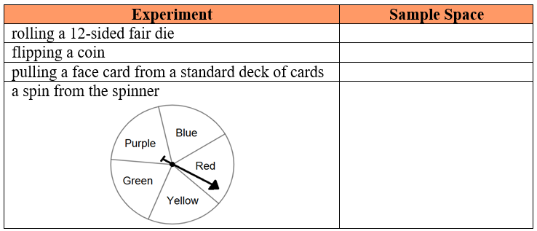

Compare your list with a partner and identify any differences. Allow each partner time to discuss their reasoning until an agreement is reached on the correct sample space.

Instructional Items

*Instructional Item 1*

Letter cards for the word “probability” are placed into a bag. List the sample space for choosing a card from this bag.

*Instructional Item 2*

There are 10 blue, 5 green and 7 white marbles in a jar. List the sample space for the simple

experiment of choosing a marble from the jar.

\*The strategies, tasks and items included in the B1G-M are examples and should not be considered comprehensive.

### MA.7.DP.2.2

Benchmark

MA.7.DP.2.2 Given the probability of a chance event, interpret the likelihood of it occurring. Compare the probabilities of chance events.

Benchmark Clarifications:

*Clarification 1:* Instruction includes representing probability as a fraction, percentage or decimal between 0 and 1 with probabilities close to 1 corresponding to highly likely events and probabilities close to 0 corresponding to highly unlikely events.

*Clarification 2:* Instruction includes $P(event)$ notation.

*Clarification 3:* Instruction includes representing probability as a fraction, percentage or decimal.

Connecting Benchmarks/Horizontal Alignment

* MA.6.NSO.3.5
* MA.7.NSO.1.2
* MA.7.AR.3.1

Terms from the K-12 Glossary

* Event
* Theoretical Probability

Vertical Alignment

|  |  |
| --- | --- |
| **Previous Benchmarks**   * This is the first introduction to the concept of probability. | **Next Benchmarks**   * MA.8.DP.2.2, MA.8.DP.2.3 |

Purpose and Instructional Strategies

In grade 6 accelerated, students represent rational numbers in different but equivalent forms including fractions, decimals, and percentages. Students also interpret the probability of a chance event and the likelihood of it occurring. In future courses, students will solve problems involving probabilities related to single or repeated experiments, including making predictions based on theoretical probability.

* An event is a set of outcomes.
  + For example, if the experiment is to roll a six-sided die, possible events could be:
    - “Rolling a 3 or a 4;”
    - “Rolling an even number;” or
    - “Not rolling a 2.”
* Instruction includes the understanding that some events can have a probability of 1 or 0. Students should understand that if an event has a probability of zero, the event is impossible or will not occur. If an event has a probability of one, the event is certain or must occur.
  + For example, in the experiment of rolling a 6-sided die, the event of rolling a 1, 2, 3, 4, 5 or 6 would have a probability of 1.
  + For example, when rolling a 6-sided fair die, the event of rolling a 7 would have a probability of 0.
* Instruction includes having students use probabilities of 1, 0.5 and 0 as benchmark probabilities to interpret the likelihood of other events.
  + For example, if a student wants to interpret the likelihood represented by the probability of 80%, they can compare 80% to the benchmark probabilities of 50% and 100%.
* If an event has a probability of 0.5, it can be interpreted that it has the same likelihood as its opposite.
  + For example, in the experiment of picking a card from a standard 52-card deck, the event of picking a red card has a probability of 0.5, which can be interpreted as having the same likelihood as the opposite event, which is picking a black card.

Common Misconceptions or Errors

* Students may incorrectly assume that an event is only possible in an experiment and interchange the meaning of an event and an experiment.
* Students may confuse the mathematical meaning of a word like “event” with the everyday meaning.
* Students may incorrectly convert forms of probability between fractions and percentages. To address this misconception, scaffold with more familiar values initially to facilitate the interpretation.
* Students may incorrectly interpret a value with a negative sign as a possible probability.
  + For example, $-\frac{1}{2}$ cannot represent a probability since negative values are less than 0.

Strategies to Support Tiered Instruction

* Teacher creates and posts an anchor chart with visual representations of probability terms to assist students in correct academic vocabulary when solving real-world problems.
* Teacher provides opportunities for students to use a 100 frame to review place value for and the connections to decimal, fractional and percentage forms of probabilities.
* Instruction includes the use of a 100 frame to review place value for tenths, hundredths, and if needed, thousandths and the connections for decimal and fractional forms of probabilities.
* When students incorrectly convert from one form to another (i.e., fraction to percentage), the teacher scaffolds with more familiar values initially to facilitate the interpretation.

Instructional Tasks

*Instructional Task 1 (MTR.1.1)*

Determine which of the following could represent the probability of an event. For those that can, provide a possible event that would fit the probability given.

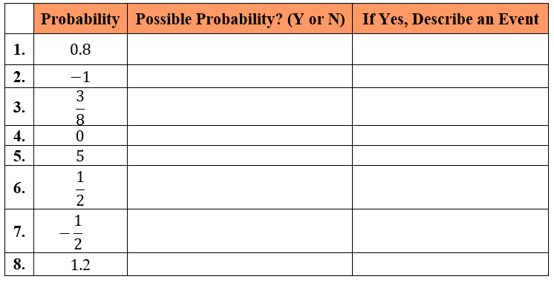

Instructional Items

*Instructional Item 1*

In each scenario, a probability is given. Describe each event as likely, unlikely or neither.

1. The probability of a hurricane being within 100 miles of a location in two days is 40%.
2. The probability of a thunderstorm being located within 5 miles of your house sometime tomorrow is $\frac{9}{10}$.
3. The probability of a given baseball player getting at least three hits in the game today is 0.08.

\*The strategies, tasks and items included in the B1G-M are examples and should not be considered comprehensive.

### MA.7.DP.2.3

Benchmark

MA.7.DP.2.3 Find the theoretical probability of an event related to a simple experiment.

Benchmark Clarifications:

*Clarification 1:* Instruction includes representing probability as a fraction, percentage or decimal.

*Clarification 2:* Simple experiments include tossing a fair coin, rolling a fair die, picking a card randomly from a deck, picking marbles randomly from a bag and spinning a fair spinner.

Connecting Benchmarks/Horizontal Alignment

* MA.6.NSO.3.5
* MA7.AR.3.1
* MA.7.DP.2.1

Terms from the K-12 Glossary

* Event
* Theoretical Probability

Vertical Alignment

|  |  |
| --- | --- |
| **Previous Benchmarks**   * This is the first introduction to the concept of probability. | **Next Benchmarks**   * MA.8.DP.2.3 |

Purpose and Instructional Strategies

In grade 6 accelerated, students represent rational numbers in different but equivalent forms including fractions, decimals, and percentages. Students are introduced to probability and will find the theoretical probability of an event related to a simple experiment. In future courses, students will find the theoretical probability of an event related to a repeated experiment.

* Instruction builds on finding sample spaces from MA.7.DP.2.1. Have students discuss their understanding of the words “theoretical” and “probability” to build toward a formal definition of theoretical probability.
* When finding theoretical probability, have students work from their sample space. Doing so will lead to the understanding that since experiments for this benchmark are fair, the probability of an event is equivalent to $\frac{number of outcomes in the event}{number of outcomes in the sample space}$.
  + For example, if rolling a fair 6-sided die, the sample space is {1, 2, 3, 4, 5, 6,}. If one wants to find $P(rolling an odd number)$, students can circle all of the odd numbers from the sample space to determine the probability as $\frac{3}{6}$, or 0.5.
* While the benchmark does focus on fair experiments, instruction could include spinners with unequal sections, making the connection to angle measures and to circle graphs.
* Instruction focuses on the simple experiments listed in *Clarification 2*.
  + For example, when tossing a coin with one yellow side and one red side, $P(landing on blue)=0$.
  + For example, when rolling a 10-sided die, $P(not rolling a multiple of 3)=0.7$.
  + For example, when picking a card from a deck that contains each of the letters of the alphabet, $P(picking a consonant)=\frac{21}{26}$.
  + For example, when picking a tile from a bag that contains a set of chess pieces, $P(picking a pawn)=50\%$.
  + For example, when spinning a spinner that contains 5 sections where two of the sections are green and the remaining sections are red, white and blue, $P(landing on a color from the American flag)=\frac{3}{5}$.

Common Misconceptions or Errors

* Students may incorrectly convert forms of probability between fractions and percentages. To address this misconception, scaffold with more familiar values initially to facilitate the interpretation.
* Students may incorrectly count outcomes when one outcome appears more than once in the sample space.
  + For example, if the sample space is {red, red, blue} and one wants to find $P(red)$, a student may incorrectly state $\frac{1}{2}$ or $\frac{1}{3}$ instead of $\frac{2}{3}$.

Strategies to Support Tiered Instruction

* Teacher provides instruction in converting between fractions and percentages, by using more familiar values.
  + For example, $\frac{1}{2}=50\%, \frac{1}{4}=25\%, \frac{1}{3}≈33.3\%$, etc.
* Teacher co-creates a T-chart (like the one below) to list the experiment and the sample space necessary for the examples provided.

*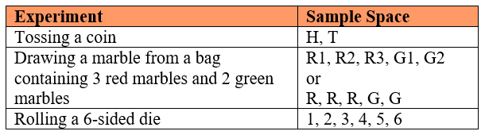*

Instructional Tasks

*Instructional Task 1 (MTR.4.1, MTR.7.1)*

Look at the shirt you are wearing today and determine how many buttons it has. Then complete the following table using tally marks for all the members of your class.

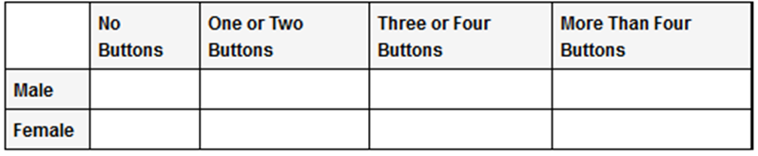

Suppose each student writes his or her name on an index card, and one card is selected randomly.

Part A. What is the probability that the student whose card is selected is wearing a shirt with no buttons?

Part B. What is the probability that the student whose card is selected is female and is wearing a shirt with two or fewer buttons?

*Instructional Task 2 (MTR.4.1, MTR.5.1)*

There is only one question on the next quiz, and it will be true or false.

Part A. If a student randomly answers the question, what is the probability of earning a score of 100%?

Part B. What is the probability of earning a 50%?

Instructional Items

*Instructional Item 1*

What is the probability of choosing a 9 from a standard deck of 52 cards?

*Instructional Item 2*

There are 7 red, 5 blue and 12 green marbles in a bag.

Part A. What is the probability of choosing a red marble?

Part B. What is the probability of not choosing a green marble?

Part C. What is the probability of choosing a yellow marble?

Part D. What is the probability of choosing a red or blue marble?

\*The strategies, tasks and items included in the B1G-M are examples and should not be considered comprehensive.

### MA.7.DP.2.4

Benchmark

MA.7.DP.2.4 Use a simulation of a simple experiment to find experimental probabilities and compare them to theoretical probabilities.

*Example:* Investigate whether a coin is fair by tossing it 1,000 times and comparing the percentage of heads to the theoretical probability 0.5.

Benchmark Clarifications:

*Clarification 1:* Instruction includes representing probability as a fraction, percentage or decimal.

*Clarification 2:* Instruction includes recognizing that experimental probabilities may differ from theoretical probabilities due to random variation. As the number of repetitions increases experimental probabilities will typically better approximate the theoretical probabilities.

*Clarification 3:* Experiments include tossing a fair coin, rolling a fair die, picking a card randomly from a deck, picking marbles randomly from a bag and spinning a fair spinner.

Connecting Benchmarks/Horizontal Alignment

* MA.6.NSO.1.1
* MA.6.NSO.3.5
* MA.7.NSO.1.2
* MA.7.DP.2.1, MA.7.DP.2.3

Terms from the K-12 Glossary

* Event
* Experimental Probability
* Simulation
* Theoretical Probability

Vertical Alignment

|  |  |
| --- | --- |
| **Previous Benchmarks**   * MA.4.AR.1.3 * MA.4.FR.2.4 | **Next Benchmarks**   * MA.8.DP.2.1, MA.8.DP.2.2, MA.8.DP.2.3 |

Purpose and Instructional Strategies

In previous courses, students multiplied fractions by a whole number. In grade 6 accelerated, students use a simulation of a simple experiment to find experimental probabilities and compare them to theoretical probabilities. They also plot, order and compare rational numbers in addition to rewriting positive rational numbers in different but equivalent forms. In future courses, students will solve real-world problems involving probabilities related to single or repeated experiments and will include making predictions based on theoretical probability.

* Instruction includes opportunities for students to run various numbers of trials to discover that the increased repetition of the experiment will bring the experimental probability closer to the theoretical. Use virtual simulations to quickly show higher and higher volumes of repetition that would be difficult to create with physical manipulatives *(MTR.5.1)*.
* Remind students that chance and each repetition in the simulation has the same probability distribution for the possible events unless an option/possible outcome is removed.
  + For example, if you flip a coin and it lands on heads, the next flip does not rely on the first outcome and still can be either heads or tails.
* Instruction focuses on the simple experiments listed in *Clarification 3*.
* For example, students can roll a 6-sided die 30 times to determine the experimental probability of “not rolling a 2.” Students can then compare their experimental probability to the theoretical probability of “not rolling a 2,” which is $\frac{5}{6}$.

Common Misconceptions or Errors

* Students may incorrectly assume the theoretical and experimental probabilities of the same experiment will always be the same. To address this misconception, provide multiple opportunities for students to experience simulations of different situations, with physical or virtual manipulatives, in order to find and compare the experimental and theoretical probabilities.
* Students may incorrectly expect to see every possible outcome occur during a simulation. While all may occur in a simulation, it is not certain to happen. Students may inadvertently let their own experience with an experiment affect their response.
  + For example, during an experiment if a student never draws an ace from a standard deck of cards, they could incorrectly assume it could never happen.

Strategies to Support Tiered Instruction

* Teacher reviews the root words theoretical (theory) and experimental (experiment) and discusses the difference between theoretical probability and experimental probability. Teacher provides a graphic organizer to keep as a reference for root words.
  + For example, experimental probabilities are from simulations whereas theoretical probabilities are from calculations.
* Teacher provides opportunities to see a variety of outcomes.
  + For example, open a deck of cards and draw 5 random cards. After looking at the 5 cards, discuss all the possible cards that could have been drawn but were not. This will help students see that not all possible outcomes will occur when an experiment is done.
* Teacher provides multiple examples for students to discuss if a probability in the example is theoretical or experimental. After each answer, students discuss how they know it is theoretical or experimental.
  + For example, if one tosses a fair coin, the theoretical probability of landing on heads is 0.5. If one tosses a fair coin 14 times and it lands on hands 9 times, the experimental probability of landing on heads is $\frac{9}{14}$ based on the simulation.
* Teacher provides multiple opportunities for students to experience simulations of different situations, with physical or virtual manipulatives, in order to find and compare the experimental and theoretical probabilities.

Instructional Tasks

*Instructional Task 1 (MTR.4.1)*

Each set of partners has been given a bag containing 5 red, 5 green, 5 yellow and 10 brown candies.

Part A. Determine the theoretical probability for selecting one red candy at random from the bag. Do the same for blue, yellow and brown.

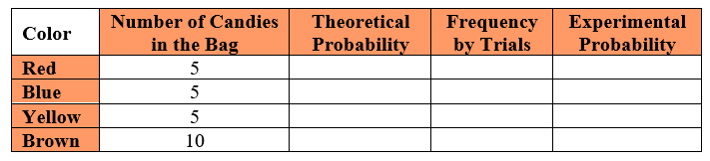

Part B. Experimental Trials: Select one candy from the bag, record its color in the table below and return it to the bag. Repeat this process for a total of 20 trials.

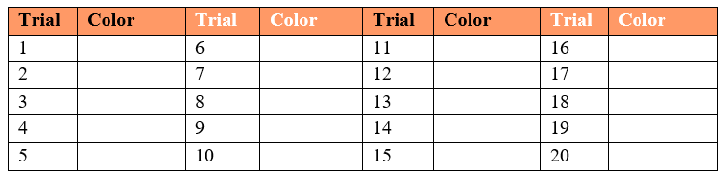

Part C. In the original table, record the total frequency of each color based on your 20 trials. Then calculate the experimental probability for each. How do the theoretical and experimental probabilities compare?

Part D. Collect the data from 2 other sets of partners and combine your total frequencies. Complete the table below based on those 60 trials. How do the theoretical and experimental probabilities compare? How does that compare to your original calculations using 20 trials?



Part E. Collect all of the class data to calculate new total frequencies and complete the table below.



Part F.

* + How do the theoretical and experimental probabilities compare?
  + How does that compare to the calculations using 20 trials and 60 trials?
  + What conclusions can you make about theoretical and experimental probabilities based on this information?

Instructional Items

*Instructional Item 1*

A bag contains green marbles and purple marbles. If a marble is randomly selected from the

bag, the probability that it is green is 0.6 and the probability that it is purple is 0.4. Dylan

draws a marble from the bag, notes its color, and returns it to the bag. He does this 50 times.

Approximately, how many times would you expect Dylan to draw a green marble?

\*The strategies, tasks and items included in the B1G-M are examples and should not be considered comprehensive.

# Appendix A. Summary of Changes

The purpose of this table is to provide a summary of changes from the latest version of the B1G-M. For questions or feedback on the B1G-M, please direct them to [BESTMath@fldoe.org](mailto:BESTMath@fldoe.org).

| **Benchmark** | **B1G-M Component** | **Change Made** |
| --- | --- | --- |
| Table | Accelerated Areas of Emphasis | Last column "Relationships" is misspelled. |
| MA.6.NSO.1.1 | Connecting Benchmarks/Horizontal Alignment | Removed MA.6.AR.3.1, MA.6.GR.1.2 |
| MA.6.NSO.1.1 | Vertical Alignment/Previous Benchmarks | Added MA.6.4.FR.1.4 |
| MA.6.NSO.1.1 | Vertical Alignment/Next Benchmarks | Removed MA.8.NSO.1.1 |
| MA.6.NSO.1.1 | Purpose and Instructional Strategies | 6th bullet @ the 1st open bullet, the example was UPDATED using names of individuals and removing confusing wording: "For example, if Jeff owes $12.47 and Mary owes $6.50, most students can quickly see and understand that Jeff has less money than Mary." |
| MA.6.NSO.1.1 | Common Misconceptions or Errors | added a comma after points |
| MA.6.NSO.1.1 | Strategies to Support Tiered Instruction | changed "over" to "rather than" |
| MA.6.NSO.1.1 | Instructional Tasks | changed "individual" to individually" twice in the introductory paragraph |
| MA.6.NSO.1.2 | Common Misconceptions or Errors | In 3rd bullet changed "connect" to "connecting" |
| MA.6.NSO.1.2 | Strategies to Support Tiered Instruction | changed "on" to "on Saturday" and added "on Thursday" after "while" |
| MA.6.NSO.1.2 | Strategies to Support Tiered Instruction | Updated pictures 1 & 2 |
| MA.6.NSO.1.2 | Instructional Tasks | REWORDED Instructional Task 1 with clarifying language: "On Thursday, Calvin borrowed $46.68 from his mom to purchase a new video game. He mowed yards on the weekend to earn money to pay his mom back. After paying his mom back, Calvin had 412/32 left on Monday...";ADDED a negative to 4.5 |
| MA.6.NSO.1.2 | Instructional Items | Item 2 Changes are "grade 8" REPLACED "eighth grade" and after "on the number line" REPLACED "and" with "as well as". |
| MA.6.NSO.1.3 | Connecting Benchmarks/Horizontal Alignment | Added MA.6.NSO.1.4 |
| MA.6.NSO.1.3 | Purpose and Instructional Strategies | removed "For example" and capitalized "Distance"; added "thus" after "number;" |
| MA.6.NSO.1.3 | Common Misconceptions or Errors | ADDED an open bullet at the beginning that deals with the subsequent bullets: "Would you describe how far you traveled with a negative number?"; CLARIFIED the car will drive in reverse, not backwards; REWORDED the example on walking to a door from the desk and back: "If you walk from your desk to the door backwards (your back is facing the door), did you walk a negative distance?"; EDITED the amusement park question: "...before boarding the ride. How do you determine the distance you traveled while traveling in line? REMOVED the last open bullet. |
| MA.6.NSO.1.3 | Strategies to Support Tiered Instruction | REMOVED "students" in bullet 2. |
| MA.6.NSO.1.3 | Instructional Tasks | REWORDED instructional task 2 for clarification purposes: "The table below shows the change in rainfall amount from the last 5 years…"; REWORDED Task 3 to be listed as a “task” not item, then changed the question stem and parts A and B accordingly: Part A reads "Compare the distance of 4 and -4 in relation to 0." and Part B reads "Explain how this relates to the definition of absolute value." |
| MA.6.NSO.1.4 | Connecting Benchmarks/Horizontal Alignment | ADDED MA.6.NSO.1.3 |
| MA.6.NSO.1.4 | Purpose and Instructional Strategies | REMOVED "and" and ADDED a comma after 'direction' in bullet 2. |
| MA.6.NSO.1.4 | Common Misconceptions or Errors | CHANGED "physical" to "physically" in bullet 2. |
| MA.6.NSO.1.4 | Instructional Items | Instructional Item 1 changed "higher altitude" to "greater depth" |
| MA.6.NSO.2.1 | Connecting Benchmarks/Horizontal Alignment | ADDED MA.6.AR.1.3 and REMOVED MA.6.DP.1.4 |
| MA.6.NSO.2.1 | Purpose and Instructional Strategies | EDITED the Area Model table with appropriate zeros. |
| MA.6.NSO.2.1 | Strategies to Support Tiered Instruction | REWORDED the 2nd solid bullet point for clarification: "Teacher encourages students with a firm understanding of multiplying and dividing fractions to convert decimal values into equivalent fractional forms and then perform the desired operation and convert the solution back to decimal form." |
| MA.6.NSO.2.2 | Connecting Benchmarks/Horizontal Alignment | ADDED MA.6.AR.1.3 and REMOVED MA.6.AR.3 AND MA.6.DP.1.4 |
| MA.6.NSO.2.2 | Purpose and Instructional Strategies | In Bullet 3's open bullet: "Students can ask the question, what number multiplied by 5/8 gives the value 3/4?" |
| MA.6.NSO.2.2 | Common Misconceptions or Errors | EDITED 2nd ("Students may incorrectly assume that multiplication…") and 3rd bullet points for grammar:( "Students may incorrectly…") |
| MA.6.NSO.2.2 | Strategies to Support Tiered Instruction | EDITED 1st bullet point for grammar and clarification: ("Teacher encourages students with a firm understanding for multiplying and dividing decimals to convert fractional values to their equivalent decimal forms and then perform the desired operation and convert the solution back to fractional form."); EDITED 5th bullet point for clarification: "...with a common denominator, dividing the numerators and then dividing the denominators." |
| MA.6.NSO.2.3 | Connecting Benchmarks/Horizontal Alignment | ADDED MA.6.GR.2.3 and MA.6.GR.2.4 |
| MA.6.NSO.2.3 | Purpose and Instructional Strategies | 1st bullet and in front of 'real-world contexts" REMOVED "the" |
| MA.6.NSO.2.3 | Common Misconceptions or Errors | EDITED for grammar only, bullets 5 ("Students may incorrectly assume that…" AND sixth bullet ("Students may incorrectly assume that division…") |
| MA.6.NSO.2.3 | Strategies to Support Tiered Instruction | EDITED bullets 3, 4, 6, AND 10 for grammar and consistency in wording throughout the document. Bullet 3: "Teacher encourages students with a firm understanding of multiplying and dividing fractions to convert decimal values into equivalent fractional forms and then perform the desired operation and convert the solution back to decimal form." Bullet 4: Teacher encourages students with a firm understanding of multiplying and dividing decimals to convert fractional values into equivalent decimal forms and then perform the desired operation and convert the solution..." Bullet 6: "...provides graph paper to use while..." Bullet 10: "...with a common denominator, dividing the numerators, and then dividing the denominators." |
| MA.6.NSO.3.1 | Connecting Benchmarks/Horizontal Alignment | REMOVED MA.6.NSO.2.2, MA.6.NSO.2.3, MA.6.AR.3.4 and ADDED MA.6.NSO.3.2, MA.6.NSO.3.4 |
| MA.6.NSO.3.1 | Glossary | removed "rectangular array" |
| MA.6.NSO.3.1 | Purpose and Instructional Strategies | **Factorization LCM and visual CHANGED**; 1st bullet and then 2nd open bullet wording: "Use Prime Factorization to find the LCM. [image] The LCM of 6 and 15 is 30 and is represented as 2 x 3 x 5. Discuss with students why 3 is listed only once. To use the strategy of prime factorization to find the LCM of two numbers, students must know what to do when a prime factor repeats. [image] The LCM of 180 is represented as 2 x 2 x 3 x 3 x 5. [image] The LCM of 210 is represented as 2 x 3 x 5 x 7. 1st bullet and then 3rd open bullet, ADD "Using the Ladder Method (Successive Division) [ADD Ladder Method image]. 2nd bullet and then 2nd OPEN bullet under Factorization and 1st image: "Using the Ladder Method for GCF. [image] The GCF of 18 and 24 is 2 x 3 = 6. A student may start with any factor that can evenly divide into the given numbers. A student may have started with 3 or 6. [image with 3 steps of Ladder Method] The GCF of 96 and 138 is 2 x 3 = 6. A student may start with any factor that can evenly divide into the given numbers. Each 'rung' of the ladder is created when the reduced numbers have a common factor." End of last bullet: REPLACE the word “factors” with "multiple". |
| MA.6.NSO.3.1 | Instructional Tasks | Task 1 ADDED clarifying wording to part A: "If they both start a new book on Wednesday, how many days will it take for them to start another new book on the same day?". |
| MA.6.NSO.3.1 | Instructional Items | CHANGED the values to meet the benchmark and intent on both items: "Instructional Item 1 What is the greatest common factor of 85 and 187? Instructional Item 2 What is the least common multiple of 18 and 12?" |
| MA.6.NSO.3.2 | Connecting Benchmarks/Horizontal Alignment | ADDED MA.6.NSO.3.1 AND MA.6.NSO.3.4 |
| MA.6.NSO.3.2 | Purpose and Instructional Strategies | EDITED grammar and formatting for bullets 2 ("Students should not use the multiplication…") AND 5 ("…and the factors to sum in the parenthesis. Given the common factor multiplied by the sum of two whole numbers, determine…") |
| MA.6.NSO.3.2 | Common Misconceptions or Errors | CLARIFIED wording to meet the intent of the benchmark in bullet 2: "Students may incorrectly think that they always must factor out the greatest common factor." CHANGED to 3 total bullets. |
| MA.6.NSO.3.2 | Strategies to Support Tiered Instruction | 1st open bullet (2nd sentence) and 2nd open bullet (2nd sentence), change "co-constructs" to "co-creates". |
| MA.6.NSO.3.2 | Instructional Tasks | EDITED to clarify it is one of the Greatest Common Factor: "Rewrite…is one of the common factors of 211 and 66…" |
| MA.6.NSO.3.3 | Connecting Benchmarks/Horizontal Alignment | ADDED MA.6.NSO.3.4 |
| MA.6.NSO.3.3 | Glossary | ADDED NATURAL NUMBERS |
| MA.6.NSO.3.3 | Purpose and Instructional Strategies | EDITED the last bullet point for grammar: "The expectation of this benchmark is the application of exponents, not determining the value in expressions with multiple operations." |
| MA.6.NSO.3.3 | Common Misconceptions or Errors | last bullet - removed "number" |
| MA.6.NSO.3.3 | Strategies to Support Tiered Instruction | 2nd bullet, 1st sentence, place a "period" after "factor" and change the next sentence to: "Teacher encourages…" 3rd bullet, remove "exponent" and replace with "algebra" tiles. |
| MA.6.NSO.3.3 | Instructional Items | Item 2 was CHANGED to (-3) raised to the power of 4. |
| MA.6.NSO.3.4 | Connecting Benchmarks/Horizontal Alignment | REMOVED "DIRECT CONNECTIONS TO BENCHMARKS ..." |
| MA.6.NSO.3.4 | Connecting Benchmarks/Horizontal Alignment | ADDED MA.6.NSO.3.1, MA.6.NSO.3.2, MA.6.NSO.3.3 |
| MA.6.NSO.3.4 | Common Misconceptions or Errors | REMOVED 2nd sentence in 5th bullet: "If students believe…" and REMOVED entire open bullet: "For example, 91 ends in" |
| MA.6.NSO.3.4 | Strategies to Support Tiered Instruction | changed "five" to seven and add "2" and "17" in the list of prime numbers in order from least to greatest |
| MA.6.NSO.3.4 | Strategies to Support Tiered Instruction | removed the last bullet and open bullet. |
| MA.6.NSO.3.5 | Connecting Benchmarks/Horizontal Alignment | REMOVED MA.6.NSO.2.1 and ADDED MA.6.AR.3.5 |
| MA.6.NSO.3.5 | Purpose and Instructional Strategies | ADDED to introductory paragraph: "forms, including terminating and repeating decimals." next to last bullet changed "percentages" to "percents" and added "different" |
| MA.6.NSO.3.5 | Instructional Items | EDITED Instructional Item 3, to change the order of the information to include: "…can be written as the decimal \_\_\_\_\_\_ and is equivalent to \_\_\_\_\_ percent." |
| MA.6.NSO.4.1 | Purpose and Instructional Strategies | EDITED grammar in the first paragraph: REMOVED "worth with" and REPLACE with "perform" and bullet 1 to REMOVED "start" and REPLACED "learning" with "learn"; Also REMOVED "from the" and REPLACED with "Given a"; Also REMOVED "from the situation" and capitalize "Students" |
| MA.6.NSO.4.1 | Purpose and Instructional Strategies | Bullet 3, under open bullet 2 @ 2-colored counters example: REMOVED "sum" and ADDED a comma after "So" |
| MA.6.NSO.4.1 | Purpose and Instructional Strategies | Bullet 3, under open bullet 3 @ number line changed "landing" to "they land" |
| MA.6.NSO.4.1 | Purpose and Instructional Strategies | Bullet 4 REMOVED "sum" |
| MA.6.NSO.4.1 | Purpose and Instructional Strategies | Bullet 5 REMOVED "switch to" and REPLACED with "move in" and removed "of movement" |
| MA.6.NSO.4.2 | Connecting Benchmarks/Horizontal Alignment | ADDED benchmarks MA.6.NSO.1.1, MA.6.NSO.1.4, noted "This is all of NSO.1" |
| MA.6.NSO.4.2 | Purpose and Instructional Strategies | HIGHLIGHT the first bullet and open bullet underneath first bullet for clarification |
| MA.6.NSO.4.2 | Common Misconceptions or Errors | EDITED bullet 4 to ADDED "two-" in front of "colored counters." |
| MA.6.NSO.4.2 | Common Misconceptions or Errors | EDITED bullet 6: "Students may say that a value divided by itself is zero because they subtract instead of divide. Students should remember that any number..." |
| MA.6.NSO.4.2 | Strategies to Support Tiered Instruction | EDITED bullet 5 for consistency: ADD "two-" in front of colored counters. |
| MA.7.NSO.2.1 | Connecting Benchmarks/Horizontal Alignment | ADDED MA.7.NSO.1.1 |
| MA.7.NSO.2.1 | Vertical Alignment/Next Benchmarks | ADDED MA.8.AR.1.1 |
| MA.7.NSO.2.1 | Strategies to Support Tiered Instruction | LAST BULLET - REMOVED "With the completion of operations with rational numbers" and capitalize "Students". |
| MA.7.NSO.2.2 | Strategies to Support Tiered Instruction | last 2 bullets - added visual |
| MA.7.NSO.2.3 | Purpose and Instructional Strategies | 4th BULLET - REMOVED "With the completion of operations with rational numbers" and capitalize "Students" and in the 6th bullet REMOVE "when necessary". |
| MA.7.NSO.2.3 | Strategies to Support Tiered Instruction | 3rd bullet added visual |
| MA.6.AR.1.1 | Purpose and Instructional Strategies | Introductory paragraph - "Students in grade 6 accelerated extend…" next to the last bullet - REMOVED "and", added a comma after coefficients and added "arithmetic" in front of operations |
| MA.6.AR.1.1 | Common Misconceptions or Errors | REWORDED the 3rd bullet point for clarification: "Students may oversimplify a problem by using the process of circling…words, and trying to eliminate information without considering the context. (MTR.2.1…); Instead, teachers and students…" |
| MA.6.AR.1.1 | Instructional Tasks | Instructional Task 1, Part B, add a "?" at the end. |
| MA.6.AR.1.1 | Instructional Items | RENUMBERED instructional item 3 to reflect it is #3 and re-worded this item: "…fewer than the sum of 3 and y." |
| MA.6.AR.1.2 | Connecting Benchmarks/Horizontal Alignment | ADDED MA.6.NSO.1.1 AND REMOVED MA.6.DP.1.6 |
| MA.6.AR.1.2 | Purpose and Instructional Strategies | Word changes in bullet 4 ("…symbol. This type of problem will create…"), bullet 5 ("…on a number line. This also includes showcasing…"), AND bullet 7 ("…includes the understanding of how…") |
| MA.6.AR.1.2 | Instructional Items | Add words to Instructional Item 3: "…video games for no more than…" |
| MA.6.AR.1.3 | Connecting Benchmarks/Horizontal Alignment | ADDED MA.6.NSO.2.1, MA.6.NSO.2.2 AND REMOVED MA.6.NSO.4.2 |
| MA.6.AR.1.3 | Purpose and Instructional Strategies | EDITED 3rd solid bullet to define that constants were limited to integers, reading as: "built from constants (limited to integers)..."; EDITED 4th bullet for grammar ("This is a way a student can demonstrate...") |
| MA.6.AR.1.3 | Strategies to Support Tiered Instruction | 3rd bullet - removed "integer" and added "(limited to integers)" |
| MA.6.AR.1.3 | Common Misconceptions or Errors | EDITED 1st bullet ADD after incorrectly: "use the order of operations when generating equivalent expressions." REMOVED "using the order of operations". |
| MA.6.AR.1.3 | Common Misconceptions or Errors | ADDED a fourth bullet point and 1st open bullet example: "Students may substitute without using the correct operation of multiplication. For example, 3*c*, where c is 2; a student may write 32 instead of 3(2) or 3 x 2." |
| MA.6.AR.1.4 | Purpose and Instructional Strategies | REPLACED "whole number" with "integer" in the first paragraph and ADDED "of" in front of "algebra tiles" in bullet 5. |
| MA.6.AR.1.4 | Common Misconceptions or Errors | EDITED for grammar: The first bullet reads as: "Students may incorrectly think there is only one right answer or equivalent value." DELETED 2nd sentence in the first bullet for consistency/clarification. |
| MA.6.AR.1.4 | Strategies to Support Tiered Instruction | EDITED for grammar bullet three: DELETED the "s" at the end of "distributive"; Bullet three, DELETED "and allowing the students…as well." |
| MA.6.AR.2.1 | Connecting Benchmarks/Horizontal Alignment | REMOVED MA.6.NSO.4.1 |
| MA.6.AR.2.1 | Purpose and Instructional Strategies | Introductory paragraph (1st sentence), REMOVED "as well as" and CHANGED to "and"; ADDED "them" after "simplified" and DELETED "numerical expressions”. |
| MA.6.AR.2.1 | Purpose and Instructional Strategies | EDITED for consistency in wording and grammar; For paragraph 1: "In grade 5, students evaluated numerical expressions and simplified them on both sides of an equation to determine if they were true or false…The substituted values in grade 6 are limited to integers. In grade 7 students learn..." |
| MA.6.AR.2.1 | Common Misconceptions or Errors | DELETED conflicting language in bullet one ("…between expressions where more than one value can satisfy the statement.") and in bullet two ("…may incorrectly think there is only one way to accurately evaluate it. For example, if students are asked if the value of *x = 8* is true given the equation *2x - 3(x-4) = 4,*") |
| MA.6.AR.2.1 | Strategies to Support Tiered Instruction | EDITED to add comma after 4, removed duplicated value of "5" and replace with "6". |
| MA.6.AR.2.1 | Instructional Tasks | Task 2, part B, CHANGE "choose" to "chooses" |
| MA.6.AR.2.1 | Enrichment Tasks | ADDED a negative to choice e: "*-25/7*" |
| MA.6.AR.2.2 | Purpose and Instructional Strategies | next to last bullet DELETED "can" and add an -s to include: "includes". DELETED "provide an introduction to" and REPLACE with "introduce" |
| MA.6.AR.2.2 | Instructional Items | EDITED for grammar in Instructional Item 4 to change "table top" to "tabletop" in 3 places. |
| MA.6.AR.2.3 | Purpose and Instructional Strategies | next to last bullet - DELETED "provide an introduction to" and REPLACE with "introduce" |
| MA.6.AR.2.4 | Connecting Benchmarks/Horizontal Alignment | REMOVED MA.6.NSO.2.2 |
| MA.6.AR.2.4 | Common Misconceptions or Errors | EDITED for grammar: DELETE "instead" and REPLACED with "may need to"; DELETED "try to" and DELETED "rules and" |
| MA.6.AR.3.1 | Connecting Benchmarks/Horizontal Alignment | REMOVED MA.6.NSO.2.2 AND MA.6.NSO.3.5 |
| MA.6.AR.3.1 | Instructional Tasks | Task 2 Part C changed "represent the same concept" to "have the same meaning as 27:40?" |
| MA.6.AR.3.2 | Connecting Benchmarks/Horizontal Alignment | removed MA.6.NSO.2.2 AND ADDED MA.6.NSO.3.1 |
| MA.6.AR.3.2 | Common Misconceptions or Errors | EDITED for grammar by changing the 2nd bullet to "represent" instead of "represented". |
| MA.6.AR.3.2 | Instructional Tasks | EDITED Task 1 for grammar: "When buying ground beef…"; Added "ground" in front of beef for Part A. Deleted "the" in front of ground beef for Part B. |
| MA.6.AR.3.2 | Instructional Items | Item 1 - ADDED to the end of the question "(round to the nearest cent)" |
| MA.6.AR.3.3 | Connecting Benchmarks/Horizontal Alignment | removed MA.6.NSO.2.2 ADDED MA.6.NSO.3.1 |
| MA.6.AR.3.3 | Vertical Alignment/Next Benchmarks | removed MA.5.AR.3.2 |
| MA.6.AR.3.3 | Instructional Tasks | EDITED table in instructional task 1 for value formatting; EDITED table in task 2 to include additional rows; ADDED two parts to instructional task 2, "Part A. Using a common ratio, complete the table when *x* is 7. Part B. Using a common ratio, determine an *x* and corresponding *y* value." |
| MA.6.AR.3.3 | Instructional Items | EDITED grammar for clarification for Item 1: "Using this recipe, complete the table to determine the amount…" and end with a period. |
| MA.6.AR.3.4 | Connecting Benchmarks/Horizontal Alignment | REMOVED MA.6.NSO.2.2 ADDED MA.6.NSO.3.1 |
| MA.6.AR.3.4 | Purpose and Instructional Strategies | 2ND BULLET - removed "the" |
| MA.6.AR.3.5 | Connecting Benchmarks/Horizontal Alignment | ADDED MA.6.NSO.1.1 and MA.6.NSO.3.1; DELETED MA.6.NSO.2.2 |
| MA.6.AR.3.5 | Vertical Alignment/Next Benchmarks | ADDED MA.5.M.1.1 and MA.5.FR.2.2 |
| MA.6.AR.3.5 | Purpose and Instructional Strategies | ADDED clarifying language about previous learning to the introduction, insert this sentence after sentence 1: Students also learned how to convert measurements within the same measurement system." REPLACED image of table with an actual table and changed "toy airplanes" to "dollars"; in the last bullet point DELETED phrase for clarification: "including conversions of areas and volumes and conversions that are commonly used in the science classroom." |
| MA.6.AR.3.5 | Common Misconceptions or Errors | REWORDED the 1st bullet point for grammar and clarification: "…for solving problems in a real-world context…as needed and analyzing the problem…" |
| MA.7.AR.1.1 | Connecting Benchmarks/Horizontal Alignment | Added MA.7.NSO.2.1, Removed MA.7.NSO.2.3 |
| MA.7.AR.1.1 | Purpose and Instructional Strategies | Introductory paragraph, 3rd sentence: ADD "and multiple variables" after "with rational coefficients" |
| MA.7.AR.1.1 | Instructional Item 3 | Changed *3x* to *3z* in the first set of parentheses and in the second set of parentheses placed a "*z*" to the right of "*2*" like this: "*2z*" |
| MA.7.AR.2.1 | Connecting Benchmarks/Horizontal Alignment | CHANGED to MA.7.NSO.2.1, MA.7.NSO.2.2, MA.7.NSO.2.3 |
| MA.7.AR.3.1 | Connecting Benchmarks/Horizontal Alignment | CHANGED to MA.7.NSO.2.1, MA.7.NSO.2.2, MA.7.NSO.2.3 |
| MA.7.AR.3.1 | Purpose and Instructional Strategies | Introductory paragraph: CHANGED "of" to "given" |
| MA.7.AR.3.2 | Connecting Benchmarks/Horizontal Alignment | CHANGED to MA.7.NSO.2.1, MA.7.NSO.2.2, MA.7.NSO.2.3 |
| MA.7.AR.3.2 | Strategies to Support Tiered Instruction | Bullet 3: CHANGED "co-constructs" to "co-creates" |
| MA.6.GR.1.1 | Connecting Benchmarks/Horizontal Alignment | Added MA.6.NSO.1.3 |
| MA.6.GR.1.1 | Purpose and Instructional Strategies | EDITED introductory paragraph for grammar and consistency: "…first quadrant. In grade 6, students plot ordered pairs…students will apply their knowledge of plotting order pairs..."; " |
| MA.6.GR.1.1 | Purpose and Instructional Strategies | In bullet 2, CLARIFIED coordinate pairs are also called coordinates: "calling ordered pairs a coordinate pair or coordinates. |
| MA.6.GR.1.1 | Purpose and Instructional Strategies | CLARIFIED again in bullet 3: "plotting ordered pairs on coordinate planes with different scales. OPEN bullet added for the example. |
| MA.6.GR.1.1 | Purpose and Instructional Strategies | ADDED a 4th bullet point about cardinal directions: "Instruction includes describing movement on the coordinate plane from the origin to the right, to the left, horizontally, vertically, or as a cardinal direction (north, east, south, west)." |
| MA.6.GR.1.1 | Common Misconceptions or Errors | CLARIFIED 2nd bullet to DELETE "misunderstood" and REPLACED with "not recognize" and 2nd bullet point, 1st open bullet: "For example, the location of the point on the graph...may be incorrectly identified as..." (NOTE: DELETED "the location".) |
| MA.6.GR.1.1 | Common Misconceptions or Errors | 3rd bullet point- changed "misunderstand" to "not recognize" |
| MA.6.GR.1.1 | Common Misconceptions or Errors | ADDED a 4th bullet point: "Students may incorrectly label the scale of the axes." |
| MA.6.GR.1.1 | Strategies to Support Tiered Instruction | Bullet 4, open bullet DELETED "For" and replace with "Another". **ADDED image to illustrate fractional parts.** |
| MA.6.GR.1.1 | Instructional Tasks 1 | ADDED at Part D: "...over which axis or axes are they reflected? Explain." |
| MA.6.GR.1.1 | Instructional Tasks 3 | REWORDED task 3 to clarify expectations and added parts: Instructional Task 3 "Create an ordered pair, given *x* > *0* and *y* > *0*. Then determine which quadrant or axis each ordered pair described will lie..."; Part A. *(-x, y)*; Part B. *(-x, 0)*; Part C. *(x, -y)*; Part D. *(0, y)* |
| MA.6.GR.1.2 | Connecting Benchmarks/Horizontal Alignment | Removed MA.6.NSO.1.1 |
| MA.6.GR.1.2 | Purpose and Instructional Strategies | 2nd bullet: REMOVED 2nd sentence; ADDED a sentence at the end of the 2nd open bullet point: "Students should not be penalized if they convert from one form to another when performing operations." |
| MA.6.GR.1.2 | Common Misconceptions or Errors | Moved 3rd bullet point under 2nd bullet point as the 2nd open bullet example. |
| MA.6.GR.1.2 | Strategies to Support Tiered Instruction | In bullet 4 the last sentence, it should read: "Once the number line is drawn…" |
| MA.6.GR.1.2 | Instructional Tasks 1 and Item 1 | changed "grid" to "plane" |
| MA.6.GR.1.3 | Purpose and Instructional Strategies | In the introductory paragraph, 2nd sentence: REMOVED "determining" and CHANGE to "determine"; EDITED 3rd bullet to read: " ...allow flexibility for students to use..." EDITED 2nd open bullet (which is under the 3rd bullet) to read: "...where the garden should go; the length of each box...Nathanial's garden...backyard. Find the perimeter to determine the amount of wood needed to create a barrier for the garden." |
| MA.6.GR.1.3 | Common Misconceptions or Errors | EDITED 1st bullet to read: "…y-coordinate in an ordered pair." 2nd bullet: DELETE "the difference between". |
| MA.6.GR.1.3 | Strategies to Support Tiered Instruction | DELETED "to" after "the distance between" in both open bullets |
| MA.6.GR.2.1 | Connecting Benchmarks/Horizontal Alignment | ADDED MA.6.NSO.2.2 and MA.6.NSO.2.3 |
| MA.6.GR.2.1 | Purpose and Instructional Strategies | EDITED in the introductory paragraph, 2nd sentence: "...students will use models...to derive the formula of the area of a triangle. Students will decompose ...and quadrilaterals to find area." EDITED 1st bullet to read: "...any right triangle with the same base and height will always form a rectangle. Therefore, the triangle will have an area..." DELETED "show" in the 2nd bullet. In the last bullet, an apostrophe was added to students. |
| MA.6.GR.2.1 | Common Misconceptions or Errors | ADDED a 4th bullet point to read: "Students may incorrectly measure with a ruler." |
| MA.6.GR.2.1 | Strategies to Support Tiered Instruction | EDITED 1st bullet to read: "(…using a rectangle and using a formula). Then have the students...step by step with guidance. This will provide…" EDITED 2nd bullet to read: "…half of a rectangle cut diagonally. Therefore…" |
| MA.6.GR.2.2 | Terms from the K-12 Glossary | ADDED "Composite Figure" |
| MA.6.GR.2.2 | Purpose and Instructional Strategies | EDITED first paragraph 2nd sentence: CHANGED "finding" to "find" and 3rd sentence DELETED "in order to". 3rd bullet: MOVED statement about penalizing students to the end of the first open bullet. |
| MA.6.GR.2.2 | Common Misconceptions or Errors | ADDED two bullet points at the end of this section; Bullet 4 reads: "Students may overlook an unlabeled side." Bullet 5 reads: "Students may incorrectly decompose a figure into irregular shapes." |
| MA.6.GR.2.2 | Strategies to Support Tiered Instruction | REPLACED "reviews" with "relates" in the first bullet point; CHANGED "student" to "students" in 2nd bullet; 3rd bullet ADDED "or grid paper" after 'Use manipulatives…'; DELETED modeling statement, which was the 6th bullet. |
| MA.6.GR.2.3 | Connecting Benchmarks/Horizontal Alignment | REMOVED MA.6.NSO.3.5; ADDED MA.6.NSO.3.3 |
| MA.6.GR.2.3 | Purpose and Instructional Strategies | In the 1st bullet, DELETED "the" in front for "right rectangular prisms". 4th bullet, ADDED "m" to the end of 'for' to make it read "form". |
| MA.6.GR.2.3 | Common Misconceptions or Errors | ADDED a 3rd bullet to read: "Students often confuse the vocabulary terms base, length, height, "B" (base area), when moving between two- and three-dimensional figures. |
| MA.6.GR.2.3 | Strategies to Support Tiered Instruction | 1st bullet, DELETED comma after "and volume". CLARIFIED 3rd bullet to read: "manipulatives, such as unit cubes, and ...concept of area, perimeter and volume." |
| MA.6.GR.2.3 | Instructional Tasks 1 | Included the word "rectangular" in front of all prisms |
| MA.6.GR.2.4 | Connecting Benchmarks/Horizontal Alignment | REMOVED benchmark MA.6.NSO.3.5 |
| MA.6.GR.2.4 | Purpose and Instructional Strategies | CLARIFIED language in the introductory paragraph 2nd sentence: ADDED "right rectangular" in front of pyramids and in the 3rd sentence ADDED "will" in front of "calculate"; In the 1st bullet, 2nd sentence: DELETED "the symbolic and". 3rd bullet, 2nd sentence: DELETED the -s in "figures". In the 1st open bullet under bullet 4, ADDED "is" in front of "needed". |
| MA.6.GR.2.4 | Common Misconceptions or Errors | EDITED 1st bullet to read: "…determine the different two-dimensional figures that make up the net of the three-dimensional figure." ADDED bullet 3: "Students may confuse rectangular prisms and right rectangular pyramids." |
| MA.6.GR.2.4 | Strategies to Support Tiered Instruction | ADDED 2 nets (one is a square pyramid and the other is a rectangular pyramid) to the 2nd open bullet. |
| MA.6.GR.2.4 | Instructional Item 1 | EDITED item 1 to read: "Carl is making a box to ship a gift…How much cardboard, in square inches, is required to make the box?" |
| MA.7.GR.1.1 | Connecting Benchmarks/Horizontal Alignment | REMOVED MA.7.NSO.2 and ADDED MA.7.NSO.2.1, MA.7.NSO.2.2, MA.7.NSO.2.3 |
| MA.7.GR.1.1 | Purpose and Instructional Strategies | 2nd bullet- REMOVED "patty paper" |
| MA.7.GR.1.1 | Instructional Tasks 2 | REMOVED "patty paper or" |
| MA.7.GR.1.2 | Connecting Benchmarks/Horizontal Alignment | REMOVED MA.7.NSO.2 and ADDED MA.7.NSO.2.1, MA.7.NSO.2.2, MA.7.NSO.2.3 |
| MA.7.GR.1.2 | Strategies to Support Tiered Instruction | 4th bullet REMOVED "determine" and CHANGED to "determining" |
| MA.6.DP.1.1 | Purpose and Instructional Strategies | Introductory paragraph: DELETED the -s in "students" in the 1st sentence; 2nd sentence CHANGED "statistical" to "statistics" and ADD "and begin" and DELETED "information and". In the first open bullet and 1st sentence, DELETED "there" and REPLACED with "it"; DELETED "gathering" and REPLACED with "collecting". DELETED bullet 4 and open bullet that follows. CHANGED titles for the table to read as: "Examples of Statistical Questions" & "Non-Examples of Statistical Questions". In the bullet directly underneath the table, in the 2nd sentence, DELETED "this"; DELETED "survey" and REPLACED with "statistical". **NEW bullet 5,** DELETED "well written"; the remainder should read as follows: "Statistical questions address the following...interest and measurement of interest. These types of questions should be formulated to anticipate answers that vary." **NEW bullet 6** should read: "Instruction includes students recognizing that statistical questions exist to collect data that can be organized, analyzed and interpreted. This includes determining measure of center and measure of variation." **Bullet 6 under open bullet**, DELETED "or on average", as well as commas in front of and after it. **NEW bullet 7 should read:** "...to data that can be gathered by students themselves but can also be found by researching or using existing data sets." **Bullet 7 under open bullet,** DELETE "are the ten largest cities in Florida". It should read: "...What was the temperature in Miami in the month of July?" can be considered a statistical question because the data had already been collected." |
| MA.6.DP.1.1 | Common Misconceptions or Errors | Removed 2nd bullet point |
| MA.6.DP.1.1 | Strategies to Support Tiered Instruction | REMOVED 2nd bullet and open bullet. **NEW bullet 2**, in the last sentence, ADDED "the" in front of teacher and DELETED "they can" and continue with: "to convert it to a statistical question." **NEW bullet 3,** DELETED "co-construct" and REPLACED with "co-creates"; DELETED "and" after "graphic organizer" & REPLACED with "that"; also DELETED 1st two open bullets and keep the "Example of a graphic organizer is shown below" as the only open bullet under NEW bullet 3. In the table, DELETED the 2nd example under all columns. CHANGED "other" to "Non-statistical" and ADDED a NEW 3rd example under all columns: 1st column in the table: "Data-gathering but non-statistical"; 2nd column in the table: "Often a question that is on a survey" 3rd column in the table: "Does your father work from home?" |
| MA.6.DP.1.2 | Connecting Benchmarks/Horizontal Alignment | ADDED benchmarks MA.6.NSO.2.1 and MA.6.NSO.2.2; REMOVED benchmark MA.6.NSO.3.5 |
| MA.6.DP.1.2 | Purpose and Instructional Strategies | Introductory paragraph, 2nd sentence: ADDED an "a" in front of numerical data. Bullet 1 should read: "Instruction includes using numerical data generated by statistical questions." 3rd bullet ADDED "as a whole" at the end of the sentence. 4th bullet should read: "Instruction includes how to calculate and interpret the mean. (MTR.4.1)" In Bullet 5 @ the 1st open bullet A at the end: "Is it representative of the whole?" Bullet 6 ADDED "(mean and median)" after measures of center and ADDD "(range)" after measures of variability. Bullet 8 DELETED "The data set can be represented in" and REPLACED with "Instruction includes multiple representations of a given data set such as..." Bullet 9 should read: "Instruction includes graphical representations both horizontally..." Bullet 10 is ADDED: "Instruction includes interpreting the median as splitting the data into two halves (50% above and below the median)." |
| MA.6.DP.1.2 | Common Misconceptions or Errors | 1st bullet DELETED 2nd sentence about "average" and ADDED "Statisticians prefer to use the term "mean" rather than "average" since the term "average" is often used to refer to "typical" or "in the middle." 2nd bullet should read: "…confuse mean, median, mode and range." |
| MA.6.DP.1.2 | Strategies to Support Tiered Instruction | Bullet 3, 1st sentence: CHANGED "average" to "mean" and in the 2nd sentence change to: "...the middle of data set does not indicate that the amount is the mean." |
| MA.6.DP.1.2 | Item 1 | EDITED the question stem and data set to read: "…store. He is asked to report his sales of running shoes for each day of the week, in dollars." |
| MA.6.DP.1.3 | Connecting Benchmarks/Horizontal Alignment | ADDED benchmarks MA.6.NSO.2.1, MA.6.NSO.2.2; REMOVED MA.6.NSO.3.5 |
| MA.6.DP.1.3 | Purpose and Instructional Strategies | Bullet 5 ADDED "the advantages and disadvantages of" after "Instruction focuses on"; DELETED "plots' benefits and disadvantages" and CHANGED to "plots". |
| MA.6.DP.1.3 | Common Misconceptions or Errors | ADDED a 3rd bullet point: "Students may incorrectly believe the median always splits the box portion of the box plot in half." |
| MA.6.DP.1.3 | Strategies to Support Tiered Instruction | DELETED "co-constructs" and REPLACED with "co-creates". |
| MA.6.DP.1.3 | Instructional Item 1 | ADDED at the end of the sentence to read: "…of the employees." |
| MA.6.DP.1.4 | Connecting Benchmarks/Horizontal Alignment | REMOVED benchmark MA.6.NSO.3.5 |
| MA.6.DP.1.4 | Purpose and Instructional Strategies | 6th bullet-added "see glossary" after "outlier" |
| MA.6.DP.1.4 | Strategies to Support Tiered Instruction | 1st bullet, CHANGED 2nd sentence: "Teacher co-creates a graphic organizer to compare and contrast the difference…" EDITS 2nd bullet: DELETED ", providing instruction when needed. Teacher", DELETED comma after "with students" and ADDED "and" before "provides". EDITS 3rd bullet MOVE "in" in front of "students" to after "students". EDITS 1st open bullet: DELETED "is" after "conversations can be had about what" and REPLACED with "it". |
| MA.6.DP.1.4 | Instructional Task 1 | ADDED "Instructional strategies for this task:" and numbered 1-4: "1. Provide the histograms below to students, either individually or whole group. 2. Have students examine the histogram for 2 minutes and record their observations. 3. Have students share with a partner their thinking. 4. Then as a whole group, create a cohesive..." |
| MA.6.DP.1.5 | Connecting Benchmarks/Horizontal Alignment | ADDED benchmarks MA.6.NSO.1.1, MA.6.DP.1.3, and MA.6.DP.1.4; REMOVED benchmarks MA.6.NSO.2.3 and MA.6.NSO.3.5 |
| MA.6.DP.1.5 | Purpose and Instructional Strategies | In the introductory paragraph, sentence 2: DELETED "include" and REPLACE with "add". 1st open bullet, DELETED the last sentence. In the 1st square bullet ADDED: "Students could use brackets to represent inclusive endpoints and parentheses to represent exclusive endpoints" and in the next sentence CHANGED "should" to "can". ADDED a 2nd square bullet: "Since the data only contains whole numbers, students can write the intervals as 1-20, 21-40, 41-60, 61-80, 91-100, 101-120." |
| MA.6.DP.1.5 | Strategies to Support Tiered Instruction | In Bullet 4 DELETED "co-construct" and REPLACED with "co-creates". |
| MA.6.DP.1.6 | Purpose and Instructional Strategies | ADDED wording at the beginning of the last bullet: "Instruction includes the use of technology to help with connecting measures…plot. This can…" |
| MA.6.DP.1.6 | Strategies to Support Tiered Instruction | 3rd bullet ADDED wording: "initial data sets and changed data…" |
| MA.6.DP.1.6 | Instructional Task 1 | Introductory paragraph, REPLACED "on" with "in". Part B ADDED "that" after "hours". |
| MA.6.DP.1.6 | Instructional Item 1 | EDITED Part A: DELETED "If he took his temperature on the Sunday of the next week and it was 103.2 degrees F," and capitalized "Which" and CHANGED "measures" to "measure". INSERTED a NEW sentence at the beginning of Part B: "He took his temperature on the following Sunday, and it was 103.2 [degree sign] *F*. |
| MA.7.DP.1.1 | Purpose and Instructional Strategies | In the introductory paragraph & the last sentence, DELETED the comma after "data". DELETED the 2nd bullet and open bullet included in the 2nd bullet. |
| MA.7.DP.1.1 | Instructional Task 1 | ADDED a comma after "Therefore," in the Teacher Background Information's 2nd to last sentence. |
| MA.7.DP.1.2 | Purpose and Instructional Strategies | Introductory paragraph ADDED "will" after "students" in the 2nd sentence. |
| MA.7.DP.1.2 | Purpose and Instructional Strategies | 2nd bullet CHANGED 2nd sentence to read: "Students make connections to data they are interested in." |
| MA.7.DP.1.2 | Strategies to Support Tiered Instruction | 2nd bullet, 1st sentence CHANGED "type" to "types"; CHANGED "co-constructs" to "co-creates". |
| MA.7.DP.1.3 | Connecting Benchmarks/Horizontal Alignment | ADDED MA.7.AR.3.1 |
| MA.7.DP.1.3 | Purpose and Instructional Strategies | 2nd bullet, open bullet, 1st sentence, ADDED "example for this" in front of "benchmark" and DELETED "example" after "benchmark" |
| MA.7.DP.1.3 | Purpose and Instructional Strategies | 3rd bullet, 1st sentence, ADDED "in this benchmark, students" after "but" and DELETED "here we" |
| MA.7.DP.1.3 | Purpose and Instructional Strategies | 6th bullet, 1st sentence, ADDED "example for this" after "As in the first" and DELETED "example" after "benchmark" and ADDED "about" after "benchmark" |
| MA.7.DP.1.3 | Strategies to Support Tiered Instruction | 3rd bullet, open bullet, 2nd sentence, CHANGED "sampling" to "to sample". |
| MA.7.DP.1.3 | Strategies to Support Tiered Instruction | 4th bullet, open bullet, 1st sentence, ADDED "to determine" after "last year" |
| MA.7.DP.2.1 | Connecting Benchmarks/Horizontal Alignment | ADDED MA.7.DP.2.3, MA.7.DP.2.4 |
| MA.7.DP.2.1 | Purpose and Instructional Strategies | 6th bullet, last open bullet CHANGED "bad" to "bag" |
| MA.7.DP.2.2 | Connecting Benchmarks/Horizontal Alignment | ADDED MA.7.AR.3.1 |
| MA.7.DP.2.2 | Purpose and Instructional Strategies | 4th bullet, CHANGED "is" to "it" |
| MA.7.DP.2.2 | Common Misconceptions or Errors | 1st bullet, DELETED "invert" and REPLACED with "incorrectly assume that an event is only possible in an experiment and interchange" |
| MA.7.DP.2.3 | Connecting Benchmarks/Horizontal Alignment | ADDED MA.7.AR.3.1 and MA.7.DP.2.1 |
| MA.7.DP.2.3 | Vertical Alignment/Next Benchmarks | REMOVED MA.8.DP.2.1, MA.8.DP.2.2 |
| MA.7.DP.2.3 | Purpose and Instructional Strategies | Introductory paragraph, 2nd sentence: DELETED "also" and REPLACED with "are introduced to probability and will" |
| MA.7.DP.2.3 | Purpose and Instructional Strategies | 1st open bullet located @ the 4th bullet CHANGED phrasing to "…coin with one yellow side and one red side,..." |
| MA.7.DP.2.3 | Instructional Task 1 | Introductory paragraph, 2nd sentence: ADDED "using tally marks" after "table" |
| MA.7.DP.2.4 | Connecting Benchmarks/Horizontal Alignment | REMOVED MA.7.AR.3.1; ADD MA.6.NSO.1.1, MA.6.NSO.3.5, MA.7.DP.2.1, MA.7.DP.2.3 |
| MA.7.DP.2.4 | Purpose and Instructional Strategies | In the introductory paragraph, INSERTED after 2nd sentence: "They also plot, order and compare rational numbers in addition to rewriting positive rational numbers in different but equivalent forms. Last sentence, DELETED "comma" and "including" and REPLACED with "and will include" |
| MA.7.DP.2.4 | Purpose and Instructional Strategies | 2nd bullet, DELETED "chance has no memory and" and INSERTED at the end of the sentence "unless an option/possible outcome is removed" |
| MA.7.DP.2.4 | Purpose and Instructional Strategies | 3rd bullet @ the open bullet DELETED extra space in front of "not rolling a 2." |
| MA.7.DP.2.4 | Common Misconceptions or Errors | Open bullet: DELETED "this does not indicate" and REPLACED with "they could incorrectly assume..." |