# Grade 5 B.E.S.T. Instructional Guide for Mathematics

The B.E.S.T. Instructional Guide for Mathematics (B1G-M) is intended to assist educators with planning for student learning and instruction aligned to Florida’s Benchmarks for Excellent Student Thinking (B.E.S.T.) Standards. This guide is designed to aid high-quality instruction through the identification of components that support the learning and teaching of the B.E.S.T. Mathematics Standards and Benchmarks. The B1G-M includes an analysis of information related to the B.E.S.T. Standards for Mathematics within this specific mathematics course, the instructional emphasis and aligned resources. This document is posted on the [B.E.S.T. Standards for Mathematics webpage](https://www.fldoe.org/academics/standards/subject-areas/math-science/mathematics/bestmath.stml) of the Florida Department of Education’s website and will continue to undergo edits as needed.

## Structural Framework and Intentional Design of the B.E.S.T. Standards for Mathematics

Florida’s B.E.S.T. Standards for Mathematics were built on the following.

* The coding scheme for the standards and benchmarks was changed to be consistent with other content areas. The new coding scheme is structured as follows:

Content.Grade.Level.Strand.Standard.Benchmark.

* Strands were streamlined to be more consistent throughout.
* The standards and benchmarks were written to be clear and concise to ensure that they are easily understood by all stakeholders.
* The benchmarks were written to allow teachers to meet students’ individual skills, knowledge and ability.
* The benchmarks were written to allow students the flexibility to solve problems using a method or strategy that is accurate, generalizable and efficient depending on the content (i.e., the numbers, expressions or equations).
* The benchmarks were written to allow for student discovery (i.e., exploring) of strategies rather than the teaching, naming and assessing of each strategy individually.
* The benchmarks were written to support multiple pathways for success in career and college for students.
* The benchmarks should not be taught in isolation but should be combined purposefully.
* The benchmarks may be addressed at multiple points throughout the year, with the intention of gaining mastery by the end of the year.
* Appropriate progression of content within and across strands was developed for each grade level and across grade levels.
* There is an intentional balance of conceptual understanding and procedural fluency with the application of accurate real-world context intertwined within mathematical concepts for relevance.
* The use of other content areas, like science and the arts, within real-world problems should be accurate, relevant, authentic and reflect grade-level appropriateness.

## Components of the B.E.S.T. Instructional Guide for Mathematics

The following table is an example of the layout for each benchmark and includes the defining attributes for each component. It is important to note that instruction should not be limited to the possible connecting benchmarks, related terms, strategies or examples provided. To do so would strip the intention of an educator meeting students’ individual skills, knowledge and abilities.

Benchmark

focal point for instruction within lesson or task

This section includes the benchmark as identified in the [B.E.S.T. Standards for Mathematics](https://www.cpalms.org/uploads/docs/standards/BEST/MA/MathBESTStandardsFinal.pdf). The benchmark, also referred to as the Benchmark of Focus, is the focal point for student learning and instruction. The benchmark, and its related example(s) and clarification(s), can also be found in the course description. The 9-12 benchmarks may be included in multiple courses; select the example(s) or clarification(s) as appropriate for the identified course.

Connecting Benchmarks/Horizontal Alignment

in other standards within the grade level or course

This section includes a list of connecting benchmarks that relate horizontally to the Benchmark of Focus. Horizontal alignment is the intentional progression of content within a grade level or course linking skills within and across strands. Connecting benchmarks are benchmarks that either make a mathematical connection or include prerequisite skills. The information included in this section is not a comprehensive list, and educators are encouraged to find other connecting benchmarks. Additionally, this list will not include benchmarks from the same standard since benchmarks within the same standard already have an inherent connection.

Terms from the K-12 Glossary

This section includes terms from Appendix C: K-12 Glossary, found within the B.E.S.T. Standards for Mathematics document, which are relevant to the identified Benchmark of Focus. The terms included in this section should not be viewed as a comprehensive vocabulary list, but instead should be considered during instruction or act as a reference for educators.

Vertical Alignment

across grade levels or courses

This section includes a list of related benchmarks that connect vertically to the Benchmark of Focus. Vertical alignment is the intentional progression of content from one year to the next, spanning across multiple grade levels. Benchmarks listed in this section make mathematical connections from prior grade levels or courses in future grade levels or courses within and across strands. If the Benchmark of Focus is a new concept or skill, it may not have any previous benchmarks listed. Likewise, if the Benchmark of Focus is a mathematical skill or concept that is finalized in learning and does not have any direct connection to future grade levels or courses, it may not have any future benchmarks listed. The information included in this section is not a comprehensive list, and educators are encouraged to find other benchmarks within a vertical progression.

Purpose and Instructional Strategies

This section includes further narrative for instruction of the benchmark and vertical alignment. Additionally, this section may also include the following:

* explanations and details for the benchmark;
* vocabulary not provided within Appendix C;
* possible instructional strategies and teaching methods; and
* strategies to embed potentially related Mathematical Thinking and Reasoning Standards (MTRs).

Common Misconceptions or Errors

This section will include common student misconceptions or errors and may include strategies to address the identified misconception or error. Recognition of these misconceptions and errors enables educators to identify them in the classroom and make efforts to correct the misconception or error. This corrective effort in the classroom can also be a form of formative assessment within instruction.

**Strategies** to Support Tiered Instruction

The instructional strategies in this section address the common misconceptions and errors listed within the above section that can be a barrier to successfully learning the benchmark. All instruction and intervention at Tiers 2 and 3 are intended to support students to be successful with Tier 1 instruction. Strategies that support tiered instruction are intended to assist teachers in planning across any tier of support and should not be considered exclusive or inclusive of other instructional strategies that may support student learning with the B.E.S.T. Mathematics Standards. For more information about tiered instruction, please see the Effective Tiered Instruction for Mathematics: ALL Means ALL document.

Instructional Tasks

demonstrate the depth of the benchmark and the connection to the related benchmarks

This section will include example instructional tasks, which may be open-ended and are intended to demonstrate the depth of the benchmark. Some instructional tasks include integration of the Mathematical Thinking and Reasoning Standards (MTRs) and related benchmark(s). Enrichment tasks may be included to make connections to benchmarks in later grade levels or courses. Tasks may require extended time, additional materials and collaboration.

Instructional Items

demonstrate the focus of the benchmark

This section will include example instructional items which may be used as evidence to demonstrate the students’ understanding of the benchmark. Items may highlight one or more parts of the benchmark.

*The strategies, tasks and items included in the B1G-M are examples and should not be considered comprehensive.

# Mathematical Thinking and Reasoning Standards

MTRs: Because Math Matters

Florida students are expected to engage with mathematics through the Mathematical Thinking and Reasoning Standards (MTRs) by utilizing their language as a self-monitoring tool in the classroom, promoting deeper learning and understanding of mathematics. The MTRs are standards which should be used as a lens when planning for student learning and instruction of the B.E.S.T. Standards for Mathematics.

## Structural Framework and Intentional Design of the Mathematical Thinking and Reasoning Standards

The Mathematical Thinking and Reasoning Standards (MTRs) are built on the following.

* The MTRs have the same coding scheme as the standards and benchmarks; however, they are written at the standard level because there are no benchmarks.
* In order to fulfill Florida’s unique coding scheme, the 5th place (benchmark) will always be a “1” for the MTRs.
* The B.E.S.T. Standards for Mathematics should be taught through the lens of the MTRs.
* At least one of the MTRs should be authentically and appropriately embedded throughout every lesson based on the expectation of the benchmark(s).
* The bulleted language of the MTRs were written for students to use as self-monitoring tools during daily instruction.
* The clarifications of the MTRs were written for teachers to use as a guide to inform their instructional practices.
* The MTRs ensure that students stay engaged, persevere in tasks, share their thinking, balance conceptual understanding and procedures, assess their solutions, make connections to previous learning and extended knowledge, and apply mathematical concepts to real-world applications.
* The MTRs should not stand alone as a separate focus for instruction but should be combined purposefully.
* The MTRs will be addressed at multiple points throughout the year, with the intention of gaining mastery of mathematical skills by the end of the year and building upon these skills as they continue in their K-12 education.

MA.K12.MTR.1.1 Actively participate in effortful learning both individually and collectively.

Mathematicians who participate in effortful learning both individually and with others:

* Analyze the problem in a way that makes sense given the task.
* Ask questions that will help with solving the task.
* Build perseverance by modifying methods as needed while solving a challenging task.
* Stay engaged and maintain a positive mindset when working to solve tasks.
* Help and support each other when attempting a new method or approach.

Clarifications:

Teachers who encourage students to participate actively in effortful learning both individually and with others:

* Cultivate a community of growth mindset learners.
* Foster perseverance in students by choosing tasks that are challenging.
* Develop students’ ability to analyze and problem solve.
* Recognize students’ effort when solving challenging problems.

MA.K12.MTR.2.1 Demonstrate understanding by representing problems in multiple ways.

Mathematicians who demonstrate understanding by representing problems in multiple ways:

* Build understanding through modeling and using manipulatives.
* Represent solutions to problems in multiple ways using objects, drawings, tables, graphs and equations.
* Progress from modeling problems with objects and drawings to using algorithms and equations.
* Express connections between concepts and representations.
* Choose a representation based on the given context or purpose.

Clarifications:

Teachers who encourage students to demonstrate understanding by representing problems in multiple ways:

* Help students make connections between concepts and representations.
* Provide opportunities for students to use manipulatives when investigating concepts.
* Guide students from concrete to pictorial to abstract representations as understanding progresses.
* Show students that various representations can have different purposes and can be useful in different situations.

MA.K12.MTR. 3.1 Complete tasks with mathematical fluency.

Mathematicians who complete tasks with mathematical fluency:

* Select efficient and appropriate methods for solving problems within the given context.
* Maintain flexibility and accuracy while performing procedures and mental calculations.
* Complete tasks accurately and with confidence.
* Adapt procedures to apply them to a new context.
* Use feedback to improve efficiency when performing calculations.

Clarifications:

Teachers who encourage students to complete tasks with mathematical fluency:

* Provide students with the flexibility to solve problems by selecting a procedure that allows them to solve efficiently and accurately.
* Offer multiple opportunities for students to practice efficient and generalizable methods.
* Provide opportunities for students to reflect on the method they used and determine if a more efficient method could have been used.

MA.K12.MTR.4.1 Engage in discussions that reflect on the mathematical thinking of self and others.

Mathematicians who engage in discussions that reflect on the mathematical thinking of self and others:

* Communicate mathematical ideas, vocabulary and methods effectively.
* Analyze the mathematical thinking of others.
* Compare the efficiency of a method to those expressed by others.
* Recognize errors and suggest how to correctly solve the task.
* Justify results by explaining methods and processes.
* Construct possible arguments based on evidence.

Clarifications:

Teachers who encourage students to engage in discussions that reflect on the mathematical thinking of self and others:

* Establish a culture in which students ask questions of the teacher and their peers, and error is an opportunity for learning.
* Create opportunities for students to discuss their thinking with peers.
* Select, sequence and present student work to advance and deepen understanding of correct and increasingly efficient methods.
* Develop students’ ability to justify methods and compare their responses to the responses of their peers.

MA.K12.MTR.5.1 Use patterns and structure to help understand and connect mathematical concepts.

Mathematicians who use patterns and structure to help understand and connect mathematical concepts:

* Focus on relevant details within a problem.
* Create plans and procedures to logically order events, steps or ideas to solve problems.
* Decompose a complex problem into manageable parts.
* Relate previously learned concepts to new concepts.
* Look for similarities among problems.
* Connect solutions of problems to more complicated large-scale situations.

Clarifications:

Teachers who encourage students to use patterns and structure to help understand and connect mathematical concepts:

* Help students recognize the patterns in the world around them and connect these patterns to mathematical concepts.
* Support students to develop generalizations based on the similarities found among problems.
* Provide opportunities for students to create plans and procedures to solve problems.
* Develop students’ ability to construct relationships between their current understanding and more sophisticated ways of thinking.

MA.K12.MTR.6.1 Assess the reasonableness of solutions.

Mathematicians who assess the reasonableness of solutions:

* Estimate to discover possible solutions.
* Use benchmark quantities to determine if a solution makes sense.
* Check calculations when solving problems.
* Verify possible solutions by explaining the methods used.
* Evaluate results based on the given context.

Clarifications:

Teachers who encourage students to assess the reasonableness of solutions:

* Have students estimate or predict solutions prior to solving.
* Prompt students to continually ask, “Does this solution make sense? How do you know?”
* Reinforce that students check their work as they progress within and after a task.
* Strengthen students’ ability to verify solutions through justifications.

MA.K12.MTR.7.1 Apply mathematics to real-world contexts.

Mathematicians who apply mathematics to real-world contexts:

* Connect mathematical concepts to everyday experiences.
* Use models and methods to understand, represent and solve problems.
* Perform investigations to gather data or determine if a method is appropriate.
* Redesign models and methods to improve accuracy or efficiency.

Clarifications:

Teachers who encourage students to apply mathematics to real-world contexts:

* Provide opportunities for students to create models, both concrete and abstract, and perform investigations.
* Challenge students to question the accuracy of their models and methods.
* Support students as they validate conclusions by comparing them to the given situation.
* Indicate how various concepts can be applied to other disciplines.

## Examples of Teacher and Student Moves for the MTRs

Below are examples that demonstrate the embedding of the MTRs within the mathematics classroom. The provided teacher and student moves are examples of how some MTRs could be incorporated into student learning and instruction. The information included in this table is not a comprehensive list, and educators are encouraged to incorporate other teacher and student moves that support the MTRs.

| **MTR** | **Student Moves** | **Teacher Moves** |
| --- | --- | --- |
| MA.K12.MTR.1.1  *Actively participate in effortful learning both individually and collectively.* | * Students engage in the task through individual analysis, student-to-teacher interaction and student-to-student interaction. * Students ask task-appropriate questions to self, the teacher and to other students. *(MTR.4.1)* * Students have a positive productive struggle exhibiting growth mindset, even when making a mistake. * Students stay engaged in the task to a purposeful conclusion while modifying methods, when necessary, in solving a problem through self-analysis and perseverance. | * Teacher provides flexible options (i.e., differentiated, challenging tasks that allow students to actively pursue a solution both individually and in groups) so that all students have the opportunity to access and engage with instruction, as well as demonstrate their learning. * Teacher creates a physical environment that supports a growth mindset and will ensure positive student engagement and collaboration. * Teacher provides constructive, encouraging feedback to students that recognizes their efforts and the value of analysis and revision. * Teacher provides appropriate time for student processing, productive struggle and reflection. * Teacher uses data and questions to focus students on their thinking; help students determine their sources of struggle and to build understanding. * Teacher encourages students to ask appropriate questions of other students and of the teacher including questions that examine accuracy. *(MTR.4.1)* |
| MA.K12.MTR.2.1  *Demonstrate understanding by representing problems in multiple ways.* | * Students represent problems concretely using objects, models and manipulatives. * Students represent problems pictorially using drawings, models, tables and graphs. * Students represent problems abstractly using numerical or algebraic expressions and equations. * Students make connections and select among different representations and methods for the same problem, as appropriate to different situations or context. *(MTR.3.1)* | * Teacher provides students with objects, models, manipulatives, appropriate technology and real-world situations. *(MTR.7.1)* * Teacher encourages students to use drawings, models, tables, expressions, equations and graphs to represent problems and solutions. * Teacher questions students about making connections between different representations and methods and challenges students to choose one that is most appropriate to the context. *(MTR.3.1)* * Teacher encourages students to explain their different representations and methods to each other. *(MTR.4.1)* * Teacher provides opportunities for students to choose appropriate methods and to use mathematical technology. |
| MA.K12.MTR.3.1  *Complete tasks with mathematical fluency.* | * Students complete tasks with flexibility, efficiency and accuracy. * Students use feedback from peers and teachers to reflect on and revise methods used. * Students build confidence through practice in a variety of contexts and problems. *(MTR.1.1)* | * Teacher provides tasks and opportunities to explore and share different methods to solve problems. *(MTR.1.1)* * Teacher provides opportunities for students to choose methods and reflect (i.e., through error analysis, revision, summarizing methods or writing) on the efficiency and accuracy of the method(s) chosen. * Teacher asks questions and gives feedback to focus student thinking to build efficiency of accurate methods. * Teacher offers multiple opportunities to practice generalizable methods. |
| MA.K12.MTR.4.1  *Engage in discussions that reflect on the mathematical thinking of self and others.* | * Students use content specific language to communicate and justify mathematical ideas and chosen methods. * Students use discussions and reflections to recognize errors and revise their thinking. * Students use discussions to analyze the mathematical thinking of others. * Students identify errors within their own work and then determine possible reasons and potential corrections. * When working in small groups, students recognize errors of their peers and offer suggestions. | * Teacher provides students with opportunities (through open-ended tasks, questions and class structure) to make sense of their thinking. *(MTR.1.1)* * Teacher uses precise mathematical language, both written and abstract, and encourages students to revise their language through discussion. * Teacher creates opportunities for students to discuss and reflect on their choice of methods, their errors and revisions and their justifications. * Teachers select, sequence and present student work to elicit discussion about different methods and representations. *(MTR.2.1, MTR.3.1)* |
| MA.K12.MTR.5.1 *Use patterns and structure to help understand and connect mathematical concepts.* | * Students identify relevant details in a problem in order to create plans and decompose problems into manageable parts. * Students find similarities and common structures, or patterns, between problems in order to solve related and more complex problems using prior knowledge. | * Teacher asks questions to help students construct relationships between familiar and unfamiliar problems and to transfer this relationship to solve other problems. *(MTR.1.1)* * Teacher provides students opportunities to connect prior and current understanding to new concepts. * Teacher provides opportunities for students to discuss and develop generalizations about a mathematical concept. *(MTR.3.1, MTR.4.1)* * Teacher allows students to develop an appropriate sequence of steps in solving problems. * Teacher provides opportunities for students to reflect during problem solving to make connections to problems in other contexts, noticing structure and making improvements to their process. |
| MA.K12.MTR.6.1 *Assess the reasonableness of solutions.* | * Students estimate a solution, including using benchmark quantities in place of the original numbers in a problem. * Students monitor calculations, procedures and intermediate results during the process of solving problems. * Students verify and check if solutions are viable, or reasonable, within the context or situation. *(MTR.7.1)* * Students reflect on the accuracy of their estimations and their solutions. | * Teacher provides opportunities for students to estimate or predict solutions prior to solving. * Teacher encourages students to compare results to estimations and revise if necessary for future situations. *(MTR.5.1)* * Teacher prompts students to self-monitor by continually asking, “Does this solution or intermediate result make sense? How do you know?” * Teacher encourages students to provide explanations and justifications for results to self and others. *(MTR.4.1)* |
| MA.K12.MTR.7.1 *Apply mathematics to real-world contexts.* | * Student Students connect mathematical concepts to everyday experiences. * Students use mathematical models and methods to understand, represent and solve real-world problems. * Students investigate, research and gather data to determine if a mathematical model is appropriate for a given situation from the world around them. * Students re-design models and methods to improve accuracy or efficiency. | * Teacher provides real-world context to help students build understanding of abstract mathematical ideas. * Teacher encourages students to assess the validity and accuracy of mathematical models and situations in real-world context, and to revise those models if necessary. * Teacher provides opportunities for students to investigate, research and gather data to determine if a mathematical model is appropriate for a given situation from the world around them. * Teacher provides opportunities for students to apply concepts to other content areas. |

# Grade 5 Areas of Emphasis

In Grade 5, instructional time will emphasize five areas:

(1) multiplying and dividing multi-digit whole numbers, including using a standard algorithm;

(2) adding and subtracting fractions and decimals with procedural fluency, developing an understanding of multiplication and division of fractions and decimals;

(3) developing an understanding of the coordinate plane and plotting pairs of numbers in the first quadrant;

(4) extending geometric reasoning to include volume; and

(5) extending understanding of data to include the mean.

The purpose of the areas of emphasis is not to guide specific units of learning and instruction, but rather provide insight on major mathematical topics that will be covered within this mathematics course. In addition to its purpose, the areas of emphasis are built on the following.

* Supports the intentional horizontal progression within the strands and across the strands in this grade level or course.
* Student learning and instruction should not focus on the stated areas of emphasis as individual units.
* Areas of emphasis are addressed within standards and benchmarks throughout the course so that students are making connections throughout the school year.
* Some benchmarks can be organized within more than one area.
* Supports the communication of the major mathematical topics to all stakeholders.
* Benchmarks within the areas of emphasis should not be taught within the order in which they appear. To do so would strip the progression of mathematical ideas and miss the opportunity to enhance horizontal progressions within the grade level or course.

The table below shows how the benchmarks within this mathematics course are embedded within the areas of emphasis.

| **Number Sense and Operations** | Multiplying and dividing multi-digit whole numbers | Adding and subtracting fractions and decimals, multiplication and division of fractions and decimals | Developing understanding of the coordinate plane | Extending geometric reasoning to include volume | Extending understanding of data to include mean |
| --- | --- | --- | --- | --- | --- |
| MA.5.NSO.1.1 |  | X |  |  |  |
| MA.5.NSO.1.2 |  | X |  |  |  |
| MA.5.NSO.1.3 |  | X |  |  |  |
| MA.5.NSO.1.4 |  | X |  |  |  |
| MA.5.NSO.1.5 |  | X |  |  |  |
| MA.5.NSO.2.1 | X |  |  |  |  |
| MA.5.NSO.2.2 | X |  |  |  |  |
| MA.5.NSO.2.3 |  | X |  |  |  |
| MA.5.NSO.2.4 |  | X |  |  |  |
| MA.5.NSO.2.5 |  | X |  |  |  |

|  |  |  |  |  |  |
| --- | --- | --- | --- | --- | --- |
| **Fractions** | Multiplying and dividing multi-digit whole numbers | Adding and subtracting fractions and decimals, multiplication and division of fractions and decimals | Developing understanding of the coordinate plane | Extending geometric reasoning to include volume | Extending understanding of data to include mean |
| MA.5.FR.1.1 |  | X |  |  |  |
| MA.5.FR.2.1 |  | X |  |  |  |
| MA.5.FR.2.2 |  | X |  |  |  |
| MA.5.FR.2.3 |  | X |  |  |  |
| MA.5.FR.2.4 |  | X |  |  |  |

|  |  |  |  |  |  |
| --- | --- | --- | --- | --- | --- |
| **Algebraic Reasoning** | Multiplying and dividing multi-digit whole numbers | Adding and subtracting fractions and decimals, multiplication and division of fractions and decimals | Developing understanding of the coordinate plane | Extending geometric reasoning to include volume | Extending understanding of data to include mean |
| MA.5.AR.1.1 | X |  |  |  |  |
| MA.5.AR.1.2 |  | X |  |  |  |
| MA.5.AR.1.3 |  | X |  |  |  |
| MA.5.AR.2.1 | X | X |  |  |  |
| MA.5.AR.2.2 | X | X |  |  |  |
| MA.5.AR.2.3 | X |  |  |  |  |
| MA.5.AR.2.4 | X |  |  |  |  |
| MA.5.AR.3.1 | X |  |  |  |  |
| MA.5.AR.3.2 | X |  |  |  |  |

|  |  |  |  |  |  |
| --- | --- | --- | --- | --- | --- |
| **Measurement** | Multiplying and dividing multi-digit whole numbers | Adding and subtracting fractions and decimals, multiplication and division of fractions and decimals | Developing understanding of the coordinate plane | Extending geometric reasoning to include volume | Extending understanding of data to include mean |
| MA.5.M.1.1 | X | X |  | X |  |
| MA.5.M.2.1 | X | X |  | X |  |

|  |  |  |  |  |  |
| --- | --- | --- | --- | --- | --- |
| **Geometric Reasoning** | Multiplying and dividing multi-digit whole numbers | Adding and subtracting fractions and decimals, multiplication and division of fractions and decimals | Developing understanding of the coordinate plane | Extending geometric reasoning to include volume | Extending understanding of data to include mean |
| MA.5.GR.1.1 |  |  |  | X |  |
| MA.5.GR.1.2 |  |  |  | X |  |
| MA.5.GR.2.1 |  | X |  | X |  |
| MA.5.GR.3.1 |  |  |  | X |  |
| MA.5.GR.3.2 |  |  |  | X |  |
| MA.5.GR.3.3 |  |  |  | X |  |
| MA.5.GR.4.1 |  |  | X |  |  |
| MA.5.GR.4.2 |  |  | X |  |  |

|  |  |  |  |  |  |
| --- | --- | --- | --- | --- | --- |
| **Data Analysis & Probability** | Operations with Integers, Positive Decimals and Positive Fractions | Ratios, Rates and Percentages | Expressions and Equations | Area and Volume of Geometric Figures and the Coordinate Plane | Statistical Thinking |
| MA.5.DP.1.1 |  | X |  |  | X |
| MA.5.DP.1.2 |  | X |  |  | X |

## Number Sense and Operations

**MA.5.NSO.1** *Understand the place value of multi-digit numbers with decimals to the thousandths place.*

### MA.5.NSO.1.1

Benchmark

MA.5.NSO.1.1 Express how the value of a digit in a multi-digit number with decimals to the thousandths changes if the digit moves one or more places to the left or right.

Connecting Benchmarks/Horizontal Alignment

* MA.5.NSO.2.4, MA.5.NSO.2.5
* MA.5.AR.2.1, MA.5.AR.2.2, MA.5.AR.2.3
* MA.5.M.1.1
* MA.5.M.2.1

Terms from the K-12 Glossary

* Whole Number

Vertical Alignment

|  |  |
| --- | --- |
| **Previous Benchmarks**   * MA.4.NSO.1.1 | **Next Benchmarks**   * MA.6.NSO.2.1 |

Purpose and Instructional Strategies Integers

The purpose of this benchmark is for students to reason about the magnitude of digits in a number. This benchmark extends the understanding from Grade 4 (MA.4.NSO.1.1), where students expressed their understanding that in multi-digit whole numbers, a digit in one place represents *10 times* what it represents in the place to its right and $\frac{1}{10}$ *of* what it represents in the place to its left. All of this work forms the foundation for arithmeticand algorithms with decimals which is completed in Grade 6 (MA.6.NSO.2.1).

* To help students understand the meaning of the 10 times and $\frac{1}{10}$ *of* relationship, students can use base ten manipulatives or bundle simple classroom objects (e.g., paper clips, pretzel sticks). Students should name numbers and use verbal descriptions to explain the relationship between numbers (e.g., “6 is 10 times greater than 6 tenths, and 6 tenths is $\frac{1}{10}$ of 6”). In addition to physical manipulatives, place value charts help students understand the relationship between digits in different place values *(MTR.2.1)*.
* Instruction includes helping students understand that *one-tenth of* can also be expressed as “ten times less.” It also includes students knowing that as “ten times more” is the same as multiplying by 10, and " $\frac{1}{10}$ of” a number is the same as dividing the number by 10.

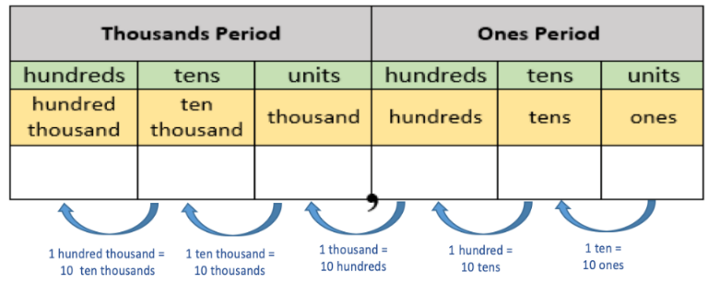

* The image below shows the 10 times and $\frac{1}{10}$ of relationships by place value. For example, if the number 7,777,777 were filled in the spaces below, it would be true that each digit 7 is *ten times greater* than the digit 7 to its right and *one-tenth the value of* (or *ten times less*) the digit 7 to its left.

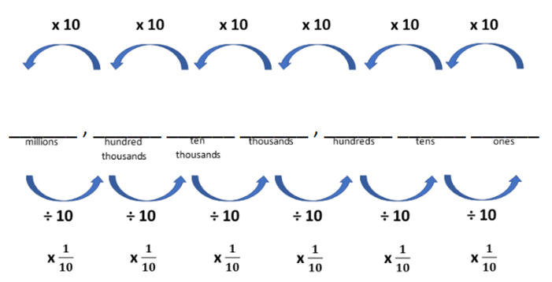

* Instruction of this benchmark should also connect students’ multiplication and division work with decimal numbers. For example, students who understand $35×2=70$ can reason that $3.5×2=7$ because $3.5$ is $\frac{1}{10}$ of $35$, therefore its product with 2 will be $\frac{1}{10}$ of $70$*(MTR.5.1)*.
* Instruction builds on the patterns of multiplying by 10 and $\frac{1}{10}$, and extends to multiplying by values such as 100 and $\frac{1}{100}$ that will cause the digits to shift more than one place to the left and right as students multiply numbers with more digits. (MTR.5.1)

Common Misconceptions or Errors

* Students who use either rule “move the decimal point” or “shift the digits” without understanding when multiplying by a power of ten can easily make errors. Students need to understand that from either point of view, the position of the decimal point marks the transition between the ones and the tenths place. Instruction includes the language that the “digits shift” relative to the position of the decimal point as long as there is an accompanying explanation. An instructional strategy that helps students see this is by putting digits on sticky notes or cards and showing how the values shift (or the decimal point moves) when multiplying by a power of ten.
* Students may not understand that when the digit moves to the left that it has increased a place value which is the same thing as multiplying by 10 and when the digit moves to the right that is has decreased a place value, which is the same thing as dividing by 10. It is important to have math discourse throughout instruction about why this is happening.
* Students may not understand that the value of a digit is 10 times the value of the digit to its right only if the digits are the same.
* Students may misunderstand what “ $\frac{1}{10}$ of” a number represents. Teachers can connect “ $\frac{1}{10}$ of” to “ten times less” or “dividing by 10” to help students connect $\frac{1}{10}$ of a number to 10 times greater.

Strategies to Support Tiered Instruction

* Instruction includes opportunities to use a place value chart and manipulatives, such as place value blocks, to demonstrate how the value of a digit changes if the digit moves one place to the left or right. Instruction includes math discourse throughout instruction about why this is happening.
  + For example, the 5 in 543 is 10 times greater than the 5 in 156. Students write 543 and 156 in a place value chart like the one shown below and compare the value of the 5’s (500 and 50) using the place value charts and equations. The teacher explains that the 5 in the hundreds place represents the value 500, which is 10 times greater than the value 50 represented by the 5 in the tens place. Use a place value chart to show this relationship while writing the equation to reinforce this relationship. The teacher explains that the 5 in the tens place represents the value 50, which is 10 times less than the value 500 represented by the 5 in the hundreds place. Use a place value chart to show this relationship while writing the equation to reinforce this relationship and repeat with other sets of numbers that have one digit in common such as 3,904 and 5,321.

A table with text on it


* + For example, $10×1=10$ and $10×10=100$. The teacher begins with a unit cube and explains to students that “we are going to model $10×1=10$ using our place-value blocks.” Students count out 10 unit cubes and exchange them for a tens rod. The teacher explains that the tens rod represents the value 10, which is 10 times greater than the value 1 represented by the unit cube. Write the equation $10×1=10$ to reinforce this relationship and repeat this process to model $10×10=100$. Then, students exchange a hundreds flat for 10 ten rods to model .The teacher explains that the value represented by a tens rod is 10 times less than the value represented by the hundreds flat and use a place value chart to show this relationship while writing the equation To reinforce this relationship repeat this process to model .

**Place value chart. 

**

* Instruction includes the use of place value charts and models such as place value disks to demonstrate how the value of a digit changes if the digit moves one place to the left or right. Explicit instruction includes using place value understanding to make the connections between the concepts of “ $\frac{1}{10}$ of,” “ten times less” and “dividing by 10.” Place value charts are used to demonstrate that the decimal point marks the transition between the ones place and the tenths place.
  + For example, students multiply 4 by 10, then record 4 and the product of 40 in a place value chart. This process is repeated by multiplying 40 by 10 while asking students to explain what happens to the digit 4 each time it is multiplied by 10. Next, the teacher explains that multiplying by $\frac{1}{10}$ is the same as dividing by 10. Students multiply 400 by $\frac{1}{10}$ and record the product in their place value chart. This process is repeated, multiplying 40 and 4 by $\frac{1}{10}$. The teacher asks students to explain how the value of the 4 changed when being multiplied by 10 and .

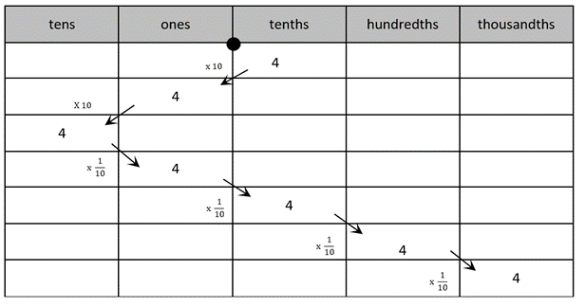

* + For example, instruction includes using a familiar context such as money, asking students to explain the value of each digit in $33.33. Next, students represent 33.33 in a place value chart using place value disks. Then, students compare the value of the whole numbers (3 dollars and 30 dollars) and compare 0.3 and 0.03 (30 cents and 3 cents). The teacher asks, “How does the value of the three in the hundredths place compare to the value of the three in the tenths place?” and explains that the three in the hundredths place is $\frac{1}{10}$ the value of the three in the tenths place and that multiplying by $\frac{1}{10}$ is the same as dividing by 10.

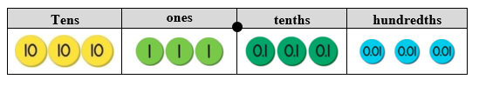

Instructional Tasks

*Instructional Task 1 (MTR.7.1)*

At the Sunshine Candy Store, saltwater taffy costs $0.18 per piece.

Part A. How much would 10 pieces of candy cost?

Part B. How much would 100 pieces of candy cost?

Part C. How much would 1000 pieces of candy cost?

Part D. At the same store, you can buy 100 chocolate coins for $89.00. How much does each chocolate coin cost? Explain how you know.

Instructional Task 2

Leah wrote the following expressions on her paper:

$7.4 ×100$ and $7.4 × \frac{1}{100}$

Part A. Explain how the value of the 7 in 7.4 changes when it is multiplied by 100. Why does this happen? Part B. Explain how the value of the 7 in 7.4 changes when it is multiplied by $\frac{1}{100}$. Why does this happen?

Instructional Items

*Instructional Item 1*

Which statement correctly compares 0.034 and 34?

1. 0.034 is 10 times the value of 34.
2. 0.034 is $\frac{1}{10}$ the value of 34.
3. 0.034 is $\frac{1}{100}$ the value of 34.
4. 0.034 is $\frac{1}{1000}$ the value of 34.

*Instructional Item 2*

What number is 100 times the value of 45.03?

*Instructional Item 3*

0.03 is $\frac{1}{100}$ the value of which number?

1. 0.003
2. 0.3
3. 3
4. 300

*Instructional Item 4*

Part A: Write the number 369 in the place value chart below.

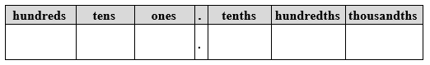

Part B: Select if the statements below are true or false.

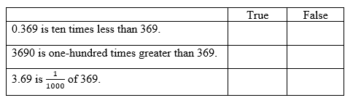

*Instructional Item 5*

Fill in the blanks.

Part A: When 963 is multiplied by $\frac{1}{100}$, the value of the 9 changes from 9 _______ to 9 ________ because the digits shift _______ places to the _______.

Part B: When 963 is multiplied by 100 the value of the 9 changes from 9 _______ to 9 ________ because the digits shift _______ places to the _______.

*The strategies, tasks and items included in the B1G-M are examples and should not be considered comprehensive.

### MA.5.NSO.1.2

Benchmark

MA.5.NSO.1.2 Read and write multi-digit numbers with decimals to the thousandths using standard form, word form and expanded form.

*Example:* The number sixty-seven and three hundredths written in standard form is $67.03$ and in expanded form is $60+7+0.03$ or $(6×10)+(7×1)+\left(3×\frac{1}{100}\right)$.

Connecting Benchmarks/Horizontal Alignment

* MA.5.NSO.2.4, MA.5.NSO.2.5
* MA.5.AR.2.1, MA.5.AR.2.2, MA.5.AR.2.3
* MA.5.M.2.1

Terms from the K-12 Glossary

Vertical Alignment

|  |  |
| --- | --- |
| **Previous Benchmarks**  MA.4.NSO.1.2 | **Next Benchmarks**  MA.6.AR.1.1 |

Purpose and Instructional Strategies

The purpose of this benchmark is for students to read numbers appropriately and to write numbers in all forms. Utilizing place value, students are expected to understand the value of tenths, hundredths, and thousandths, extending from their work to read and write whole numbers in any form in Grade 4 (MA.4.NSO.1.2). Writing numbers in expanded form can help students see the relationship between decimals and fractions *(MTR.5.1)*. Translating from written form to symbolic form builds the foundation for moving from written to algebraic form in Grade 6 (MA.6.AR.1.1).

* Representing numbers in flexible ways will help students name, order, compare and operate with decimals *(MTR.3.1)*.
* During instruction, teachers should relate all three forms using place value charts and base ten manipulatives (e.g., blocks, disks) *(MTR.3.1, MTR.4.1, MTR.5.1)*.
* Instruction includes explanation of the word “*and”* when reading decimals and writing decimals in word form. Students should understand that the word “*and”* represents the decimal point in the number and separates the whole number and decimal number digits.

Common Misconceptions or Errors

* Students may incorrectly read and write from expanded form if one of the digits is 0, like in the number 67.03 as used in the benchmark example. A common mistake that students make is to name the number as 67.3 because they do not see that 3 is the value of hundredths.
* Students may use the word *and* in parts of numbers where a decimal point is not placed. For example, in the number 1,894.07, the student should read “one thousand eight hundred ninety-four *and* 7 hundredths.” Students should not read the word *and* elsewhere in the number.

Strategies to Support Tiered Instruction

* Instruction includes the use of place value understanding, models such as place value disks and decimal fractions to read and write multi-digit numbers with decimals to the thousandths using standard form, word form and expanded form when one of the digits in the decimal place values is 0.
  + For example, write 2.054 in standard form, word form and expanded form using a place value chart.

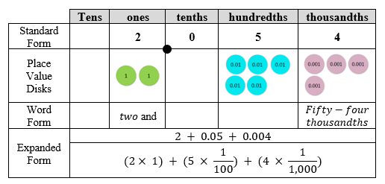

* + For example, the teacher uses decimal fractions and a place value chart to help students read 2.054, modeling how to write the decimal portion of the number as a fraction, $\frac{54}{1,000}$ and explaining that doing so helps us to read the decimal correctly. Also, the teacher explains that the word “and” is used for a portion of a number, decimal or fraction. Next, the teacher and students write 2.054 as 2 $\frac{54}{1,000}$ and read the number as “two and fifty-four thousandths.”
  + For example, write 6.03 in standard form, word form and expanded form using a place value chart.

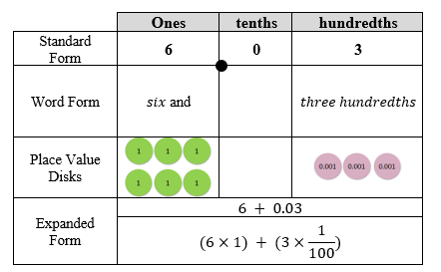

* + For example, the teacher uses decimal fractions and a place value chart to help students read 6.03, while modeling how to write the decimal portion of the number as a fraction, $\frac{3}{100}$ and explaining that doing so helps us to read the decimal correctly. Also, the teacher explains that the word “and” is used for a portion of a number, decimal or fraction. Next, write 6.03 as $6\frac{3}{100}$ and read the number as “six and three hundredths.”
* Opportunities for enrichment include presenting problems with decimals in different notations.
  + For example, students can be asked to solve the problem: Thirty-one and fifty-three tenths minus (2 x10) + (5x1) + (4x 1/10) + (9x 1/100). Students would need to identify the numbers in word form and expanded form, rewrite the numbers in standard form and solve.

Instructional Tasks

*Instructional Task 1*

Use the number cards below to write a number in standard, word and expanded form. You can use the cards in any order to make your number, but it must have a digit other than zero in the thousandths place.

Cards with numbers and decimals 


*Instructional Task 2*

Micah says that the expanded form of 3.627 is

Jayden says that the expanded form of 3.627 is $\left(3 ×1\right)+\left(6 × \frac{1}{10}\right)+\left(2 × \frac{1}{100}\right)+\left(7 × \frac{1}{1,000}\right)$.

Their teacher explains that they are both correct. Explain why this is the case.

Instructional Items

*Instructional Item 1*

Which shows the number below in word form?

$$\left(7 ×100\right)+\left(2×1\right)+\left(5×\frac{1}{10}\right)+\left(9×\frac{1}{1,000}\right)$$

1. Seventy-two and fifty-nine thousandths
2. Seven hundred two and fifty-nine hundredths
3. Seven hundred two and five hundred nine thousandths
4. Seventy-two and five hundred nine thousandths

*Instructional Item 2*

Write eight thousand and 2 hundredths in standard form.

*Instructional Item 3*

Which of the following correctly represents 9.023? Select all that apply.

1. Nine and twenty-three hundredths
$9+0.02+0.003$

2. Nine and twenty-three thousandths
3. 9 + 0.2 + 0.03

$\left(9 ×1\right)+\left(2 × \frac{1}{100}\right)+\left(3 × \frac{1}{1,000}\right)$

*The strategies, tasks and items included in the B1G-M are examples and should not be considered comprehensive.

### MA.5.NSO.1.3

Benchmark

MA.5.NSO.1.3 Compose and decompose multi-digit numbers with decimals to the thousandths in multiple ways using the values of the digits in each place. Demonstrate the compositions or decompositions using objects, drawings and expressions or equations.

*Example:* The number $20.107$ can be expressed as $2 tens + 1 tenth+7 thousandths$ or as

20 *ones* + 107 *thousandths.*

Connecting Benchmarks/Horizontal Alignment

* MA.5.NSO.2.4
* MA.5.NSO.2.5
* MA.5.AR.2.1
* MA.5.AR.2.2
* MA.5.AR.2.3
* MA.5.M.2.1

Terms from the K-12 Glossary

Expression

Vertical Alignment

|  |  |
| --- | --- |
| **Previous Benchmarks**   * MA.4.FR.2.1 | **Next Benchmarks**   * MA.6.NSO.3.2 |

Purpose and Instructional Strategies Integers

The purpose of this benchmark is for students to use place value relationships to compose and decompose multi-digit numbers with decimals. While students have composed and decomposed whole numbers in Grade 3 (MA.3.NSO.1.2) and fractions in Grade 4 (MA.4.FR.2.1), naming multi-digit decimals in flexible ways in Grade 5 helps students with decimal comparisons and operations (addition, subtraction, multiplication and division). Flexible representations of multi-digit numbers with decimals also reinforces the understanding of how the value of digits change if they move one or more places left or right (MA.5.NSO.1.1). Composing and decomposing numbers also helps build the foundation for further work with the distributive property in Grade 6 (MA.6.NSO.3.2).

* Instruction may include multiple representations using base ten models *(MTR.2.1)*. During instruction, teachers can emphasize that the value of a base ten block (or another concrete model) is flexible (e.g., one flat could be 1 ten, one, tenth, hundredth, and so forth). Using base ten models flexibly helps students think about how numbers can be composed and decomposed in different ways.
  + For example, the image below shows 2.1. This representation shows that 2.1 can also be composed as 21 *tenths* or 210 *hundredths*. Thinking about 2.1 as 210 *hundredths* may help subtracting $2.1 – 0.04$ easier for students because they can think about the expression as, 210 *hundredths* minus 4 *hundredths,* or 206 *hundredths*.

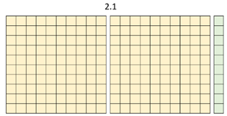

* Representing multi-digit numbers with decimals flexibly can help students reason through multiplication and division as well. For example, students may prefer to multiply $1.2 × 4$ as 12 *tenths $× 4$* to use more familiar numbers *(MTR.2.1, MTR.5.1)*.
* Students may name their representations in different forms (e.g., word, expanded) during classroom discussion. While students are representing multi-digit numbers with decimals in different ways, teachers may invite all answers and have students compare them *(MTR.4.1)*.

Common Misconceptions or Errors

* Students may assume that the value of base ten blocks are fixed based on their previous experiences with whole numbers (e.g., units are ones, rods are tens, flats are hundreds). During instruction, teachers may name a base ten block for each example so students can relate the other blocks. (For example, “Show 2.4. Allow 1 rod to represent 1 tenth.”)

Strategies to Support Tiered Instruction

* Instruction includes opportunities to decompose multi-digit numbers with decimals to the hundredths in multiple ways. Instruction includes the use of place-value blocks to represent decimals where one flat represents one whole, one rod represents one tenth and one unit represents one hundredth. During instruction, the teacher names a place-value block for each example, so students relate the other blocks. A chart may be used to organize students’ thinking. The teacher may ask students to identify the different ways to name the values (grouping the hundredths into tenths and the tenths into the ones, e.g., 2 *ones* and 34 *hundredths* or 20 *tenths* and 34 *hundredths*, etc.)
  + For example, decompose 2.34 in multiple ways using ones, tenths and hundredths.

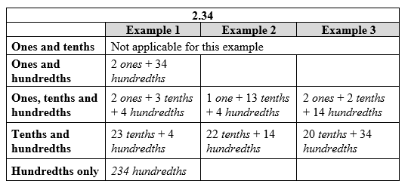

* + For example, show 3.5. Allow one rod to represent one-tenth. Then, decompose 3.5 in multiple ways using ones, tenths and hundredths.

place value chart


Instructional Tasks

*Instructional Task 1 (MTR.2.1)*

Using place-value blocks, represent 1.36 in two different ways. Allow one flat to represent 1 whole.

*Instructional Task 2 (MTR.3.1)*

How many tenths are equivalent to 13.2? How do you know?

Instructional Items

*Instructional Item 1*

Select all the ways to name $14.09$.

1. 1,409 *hundredths*
2. 1 *ten* + 409 *hundredths*
3. 1 *ten* + 4 *ones* + 9 *tenths*
4. 140 *tenths* + 9 *hundredths*
5. 1,409 *tenths*

*Instructional Item 2*

What number is composed of $7 ones, 18 tenths,$ and $59 thousanths$?

*The strategies, tasks and items included in the B1G-M are examples and should not be considered comprehensive.

### MA.5.NSO.1.4

Benchmark

MA.5.NSO.1.4 Plot, order and compare multi-digit numbers with decimals up to the thousandths.

*Example:* The numbers 4.891, 4.918 and 4.198 can be arranged in ascending order as 4.198, 4.891 and 4.918.

*Example: $0.15<0.2$* because $fifteen hundredths$ is less than $twenty hundredths$, which is the same as $two tenths$.

Benchmark Clarifications:

*Clarification 1:* When comparing numbers, instruction includes using an appropriately scaled number line and using place values of digits.

*Clarification 2:* Scaled number lines must be provided and can be a representation of any range of numbers.

*Clarification 3:* Within this benchmark, the expectation is to use symbols ($<$, $>$ or $=$).

Connecting Benchmarks/Horizontal Alignment

* MA.5.NSO.2.4
* MA.5.NSO.2.5
* MA.5.AR.2.1
* MA.5.AR.2.2
* MA.5.AR.2.3

Terms from the K-12 Glossary

* Equal sign
* Number line

Vertical Alignment

|  |  |
| --- | --- |
| **Previous Benchmarks**   * MA.4.NSO.1.3 * MA.4.NSO.1.5 | **Next Benchmarks**   * MA.6.NSO.1.1 |

Purpose and Instructional Strategies Integers

The purpose of this benchmark is for students to use place value understanding to plot, order and compare multi-digit numbers with decimals to the thousandths. In Grade 4 (MA.4.NSO.1.5), decimals were plotted to the hundredths, and in Grade 6 (MA.6.NSO.1.1) rational numbers, including negative numbers, will be plotted.

* During instruction, students may apply understanding of flexible representations from MA.5.NSO.1.3 to help them reason while plotting, ordering and comparing.
* Instruction includes showing students how to represent decimals on scaled number lines. Students may use place value understanding to make comparisons.
* Instruction expects students to justify their arguments when plotting, comparing and ordering decimals *(MTR.4.1)*.

Common Misconceptions or Errors

* Students may be confused when comparing numbers that have the same number of digits (but different values).
  + For example, when comparing 2.459 and 13.24, a student may not consider the magnitude of the numbers and only look at their digits. That student may claim that 2.459 is greater than 13.24 because the digit 2 is greater than the digit 1 (though they are comparing 2 and 10).
* Students may compare the place values from right to left because many algorithms add and subtract from right to left. Emphasize that the greatest place value is on the left, so they should compare from the largest to smallest place. Students may find it helpful to model the numbers using place-value blocks or a place-value chart to visualize decimal place comparisons.

Strategies to Support Tiered Instruction

* Instruction includes the use of place value charts, number lines and relational symbols to compare numbers to the thousandths that have the same number of digits but different values. It is imperative for students to develop a conceptual understanding of rounding, such as what the benchmarks are, using place value understanding to round numbers without instruction of mnemonics, rhymes or songs.
  + For example, when comparing 7.468 and 23.15, students record 7.468 and 23.15 in a place value chart. The teacher asks students to compare these numbers, beginning with the greatest place value and explains that the number 23.15 has 2 *tens* and the number 7.468 does not have any *tens* so $7.468 <23.15$ and $23.15>7.468$ even though both numbers have the same number of digits. Also, students plot 7.468 and 23.15 on a number line to compare the magnitude of the numbers.

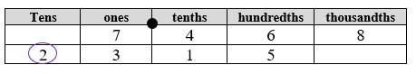

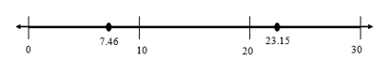

* + For example, when comparing 12.3 and 9.57 students record 12.3 and 9.57 in a place value chart. The teacher asks students to compare these numbers, beginning with the greatest place value while explaining that the number 12.3 has one *ten* and the number 9.57 does not have any *tens* so $9.57 <12.3$ and $12.3>9.57$ even though both numbers have the same number of digits. Also, students plot 12.3 and 9.57 on a number line to compare the magnitude of the numbers.

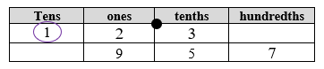

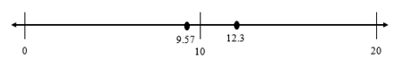

Instructional Tasks

*Instructional Task 1 (MTR.3.1)*

Part A. Plot the numbers 1.519, 1.9, 1.409 and 1.59 on the number line below.

Part B. Choose two values from the list and compare them using $>$, $<$ or $=$.

Part C. Choose a number between 1.519 and 1.59 and plot it on the number line.

Part D. Use evidence from your number line to justify which number is greatest.

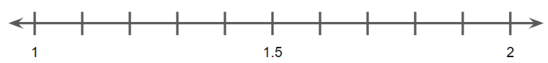

Instructional Items

*Instructional Item 1*

Select all the statements that are true.

$13.049 < 13.49$

$13.049 < 13.05$

$2.999 > 28.99$

$1.28 < 1.31$

$5.800 = 5.8$

*Instructional Item 2*

Order 2.592, 2.59 and 2.399 in ascending order.

*Instructional Item 3*

Use the number line to answer Parts A, B and C below.

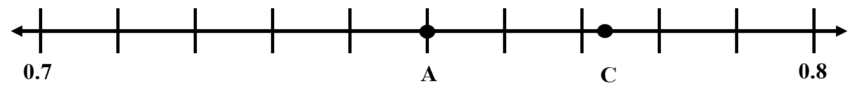

Part A: What value does Point A represent?

Part B: Which value does Point C represent? Circle your answer.

1. 0.77
2. 0.772
3. 0.779
4. 0.78

Part C: Plot Point B between Points A and C. What is the value of Point B?

*The strategies, tasks and items included in the B1G-M are examples and should not be considered comprehensive.

### MA.5.NSO.1.5

Benchmark

MA.5.NSO.1.5 Round multi-digit numbers with decimals to the thousandths to the nearest hundredth, tenth or whole number.

*Example:* The number 18.507 rounded to the nearest tenth is 18.5 and to the nearest hundredth is 18.51.

Connecting Benchmarks/Horizontal Alignment

* MA.5.NSO.2.4, MA.5.NSO.2.5
* MA.5.AR.2.1, MA.5.AR.2.2, MA.5.AR.2.3

Terms from the K-12 Glossary

* Whole Number

Vertical Alignment

|  |  |
| --- | --- |
| **Previous Benchmarks**   * MA.4.NSO.1.4 | **Next Benchmarks**   * MA.6.NSO.2.3 * MA.8.NSO.1.4 |

Purpose and Instructional Strategies

The purpose of this benchmark is for students to think about the magnitude of multi-digit numbers with decimals to round them to the nearest hundredth, tenth or whole number. In Grade 5, the expectations for rounding are to the nearest hundredth and to digits other than the leading digit, e.g., round 29.834 to the nearest hundredth. Students have experience rounding whole numbers to the nearest 10, 100 or 1,000. from Grade 4 (MA.4.NSO.1.4). Rounding skills continue to be important in later grades as students solve real-world problems with fractions and decimals (MA.6.NSO.2.3) and work with scientific notation (MA.8.NSO.1.4).

* Instruction develops some efficient rules for rounding fluently by building from the basic strategy of – “Is 29.834 closer to 20 or 30?” Number lines are effective tools for this type of thinking and help students relate the placement of numbers to benchmarks for rounding *(MTR.3.1, MTR.5.1)*.
* The expectation is that students have a deep understanding of place value and number sense in order to develop and use an algorithm or procedure for rounding. Additionally, students should explain and reason about their answers when they round and have numerous experiences using a number line and a place value chart as tools to support their work with rounding.

Common Misconceptions or Errors

* Students may confuse the place value to which they are rounding a number.
  + For example, when rounding 29.834 to the nearest tenth, they may have difficulty determining that 29.834 is between 29.8 and 29.9. The reliance on mnemonics, songs or rhymes during instruction can often confuse students further because they may lack the conceptual understanding for rounding decimals.

Strategies to Support Tiered Instruction

* Instruction includes using number lines and place value understanding to round multi-digit numbers with decimals to the nearest tenth or whole number.
  + For example, students round 16.32 to the nearest tenth using a number line and place value understanding. The teacher explains that the endpoints of the number line will be represented using tenths, because we are rounding to the nearest tenth. The teacher explains that there are three tenths in the number 16.32 and one more tenth would be four tenths. The teacher represents these endpoints on the number line as sixteen and three-tenths (16.3) and sixteen and four-tenths (16.4) while reminding students that 16.3 is equivalent to 16.30 and 16.4 is equivalent to 16.40. Additionally, the teacher explains that the mid-point on the number line can be labeled as sixteen and three-tenths, five-hundredths or sixteen and 35 hundredths (16.35). This midpoint is halfway between 16.3 and 16.4. The teacher asks students to plot 16.32 on the number line and discuss if it is closer to 16.3 or 16.4, explaining that 16.32 rounds to 16.3 because it is less than the midpoint of 16.35 and closer to 16.3 on the number line.

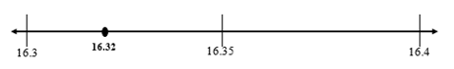

* + For example, students round 6.8 to the nearest whole number using a number line and place value understanding. The teacher explains that the endpoints of our number line will be represented using ones, because we are rounding to the nearest whole number. Also, the teacher explains that there are six ones in the number 6.8 and one more one would be seven ones. The teacher represents these endpoints on the number line as six ones (6) and seven ones (7). The midpoint on the number line is labeled as 6 ones and 5 tenths (6.5). This midpoint is halfway between 6 and 7. The teacher asks students to plot 6.8 on the number line and discuss if it is closer to six or seven, explaining that 6.8 rounds to seven because it is eight-tenths away from six and only two-tenths away from seven. It is also more than the midpoint of 6.5.

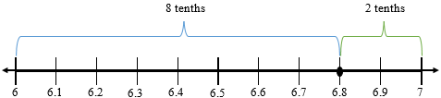

Instructional Tasks

*Instructional Task 1 (MTR.3.1, MTR.6.1)*

Part A. Identify between which two whole numbers 29.834 lies on a number line.

Part B. Round 29.834 to the nearest whole number.

*Instructional Task 2 (MTR.3.1, MTR.6.1)*

Part A. Identify between which two *tenths* 29.834 lies on a number line.

Part B. Round 29.834 to the nearest *tenth*.

*Instructional Task 3 (MTR.3.1, MTR.6.1)*

Part A. Identify between which two *hundredths* 29.834 lies on a number line.

Part B. Round 29.834 to the nearest *hundredth.*

*Instructional Task 4*

Explain how you would use a number line to round a number to the nearest tenth.

Instructional Items

*Instructional Item 1*

Which of the following are true about the number 104.029?

1. 104.029 rounded to the nearest whole number is 4.
2. 104.029 rounded to the nearest whole number is 104.
3. 104.029 rounded to the nearest $tenth$ is 104.2.
4. 104.029 rounded to the nearest $hundredth$ is 104.02.
5. 104.029 rounded to the nearest $hundredth$ is 104.03.

*Instructional Item 2*

For the number shown below, select all the values for the missing digit that would round the number to 47.64 when rounding to the nearest hundredth.

47.63 with blank in thousanths place

1. 2
2. 4
3. 5
4. 6
5. 8

*Instructional Item 3*

Which of the following numbers rounds to 84.5 when rounded to the nearest tenth?

1. 84.42
2. 84.437
3. 84.526
4. 84.55

*The strategies, tasks and items included in the B1G-M are examples and should not be considered comprehensive.

**MA.5.NSO.2** *Add, subtract, multiply and divide positive rational numbers.*

### MA.5.NSO.2.1

Benchmark

MA.5.NSO.2.1 Multiply multi-digit whole numbers including using a standard algorithm with procedural fluency.

Connecting Benchmarks/Horizontal Alignment

* MA.5.FR.2.2
* MA.5.AR.1.1
* MA.5.M.1.1
* MA.5.GR.3

Terms from the K-12 Glossary

* Area model
* Distributive Property
* Equation
* Expression
* Natural number
* Whole Number

Vertical Alignment

|  |  |
| --- | --- |
| **Previous Benchmarks**   * MA.4.NSO.2.1, MA.4.NSO.2.2 | **Next Benchmarks**   * + MA.6.NSO.2.1 |

Purpose and Instructional Strategies

The purpose of this benchmark is for students to demonstrate procedural fluency while multiplying multi-digit whole numbers. To demonstrate procedural fluency, students may choosea standard algorithm that works best for them. A standard algorithm accurate, efficient, and *generalizable*. Generalizable means that the algorithm always follows the same procedural steps no matter how many digits are involved *MTR.3.1).* In Grade 4, students had experience multiplying two-digit by three-digit numbers using a method of their choice with procedural reliability (MA.4.NSO.2.2) and multiplying two-digit by two-digit numbers using a standard algorithm (MA.4.NSO.2.3). In Grade 6, students will multiply and divide multi-digit numbers including decimals with fluency (MA.6.NSO.2.1).

* There is no limit on the number of digits in factors for whole-number multiplication in Grade 5.
* When students use a standard algorithm, they should be able to justify why it works conceptually. Teachers can expect students to demonstrate how their algorithm works, for example, by comparing it to another method for multiplication *(MTR.6.1)*.
* Instruction includes helping students understand what each partial product in a standard algorithm represents.
  + For example, when using the below standard algorithm to find the product of 376 and 218, students can use their understanding of place value and multiplication to write an equation for each partial product.

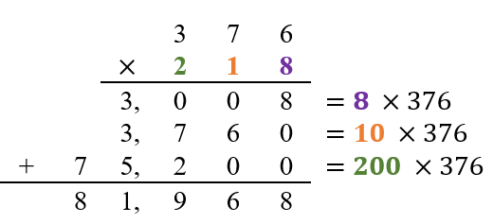

* Along with using a standard algorithm, students should estimate reasonable solutions *before* solving. Estimation helps students anticipate possible answers and evaluate whether their solutions make sense after solving.
* This benchmark supports students as they solve multi-step real-world problems involving combinations of operations with whole numbers *(MA.5.AR.1.1).*

Common Misconceptions or Errors

* Students may make computational errors while using standard algorithms when they are unable to reason why their algorithms work. In addition, they may struggle to determine where or why that computational mistake occurred because they did not estimate reasonable values for intermediate outcomes as well as for the final outcome. During instruction, teachers may expect students to justify their work while using their chosen algorithms and engage in error analysis activities to connect their understanding to the algorithm.

Strategies to Support Tiered Instruction

* Instruction includes estimating reasonable values for partial products as well as final products.
  + For example, students make reasonable estimates for the partial products and final product for $513×32$. Before using an algorithm, students can make estimates for partial products and the final product to make sure that they are using the algorithm correctly and the answer is reasonable. First, students will estimate the first partial product by rounding 513 to the nearest hundred, 500, and multiplying by 2. When using an algorithm to solve the first partial product, the answer should be approximately 1,000. Next, students can estimate the second partial product by rounding 513 to 500 and multiplying by 30. When using an algorithm to solve the second partial product, it should be approximately 15,000. Finally, students can add the estimates for the partial products to find an estimate for the final product.

An image depicting 500 multiplied by 32. The numbers are in uniform columns maintaining place value. It also uses 30 instead of 32 to show an estimated result.

* + For example, students make reasonable estimates for the partial products and the final product for $41×23$. First, students will estimate the first partial product by rounding 41 to 40 and multiplying by 3. When using an algorithm to determine the first partial product, it should be approximately 120. Next, students will estimate the second partial product by rounding 41 to 40 and multiplying by 20. When using an algorithm to determine the second partial product, it should be approximately 800. Finally, students can add the estimates for the partial products to find an estimate for the final product.

An image depicting 40 multiplied by 23. The numbers are in uniform columns maintaining place value. 40 has been rounded from 41. An estimated product is calculated.

* Instruction includes explaining and justifying mathematical reasoning while using a multiplication algorithm. Instruction includes determining if an algorithm was used correctly by analyzing any errors made and reviewing the reasonableness of solutions.
  + For example, students use an algorithm to determine $513×32$ and explain their thinking using place value understanding. Begin by multiplying 2 ones times 3 ones; students should recognize this equals 6 ones. Students can write the 6 ones under the line, in the ones place. Next, multiply 2 ones times 1 ten, which students should recognize this equals 2 tens. They can write the 2 tens under the line in the tens place. Then, multiply 2 ones times 5 hundreds, which equals 10 hundreds. Write the 10 hundreds under the line in the thousands and hundreds place because 10 hundred is the same as 1 thousand. Students should see that this gives the first partial product of 1,026. Now multiply the 3 ones by the 3 tens from 32; this equals 9 tens or 90. Record 90 below the first partial product of 1,026. Next, multiply the 1 ten by 3 tens, which equal 3 hundreds, and write the 3 in the hundreds place of the second partial product. Then, multiply the 5 hundreds times 3 tens, which equals 15 thousands. Students can write the 15 in the ten thousands and thousands place of our second partial product, noticing that the second partial product is 15,390. Finally, add the partial products to find the product of 16,416.

An image depicting 513 multiplied by 32. The numbers are in uniform columns maintaining place value. 

For example, have students use an algorithm to determine $41×23$ and explain their thinking using place value understanding. Explicit instruction could include “Begin by multiplying 3 ones times 1 one. This equals 3 ones. We will write the 3 ones under the line, in the ones place. Next, we will multiply 3 ones times 4 tens. This equals 12 tens. We will write the 12 tens under the line in the hundreds and tens place because 12 tens is the same as 1 hundred 2 tens. This gives us our first partial product of 123. Now we will multiply the 1 one by the 2 tens from 23. This equals 2 tens or 20. We will record 20 below our first partial product of 123. Next, we will multiply 2 tens times 4 tens, which equal 8 hundreds. We will write the 8 in the hundreds place of our second partial product. Our second partial product is 820. Finally, we add our partial products to get 943.”

An image depicting 41 multiplied by 23. The numbers are in uniform columns maintaining place value. 

* + For example, students solve $41×23$ using an area model and place value understanding and explain how each partial product is calculated and what it represents as they multiply using the area model. Then, students explain how the final product is calculated using the partial products from the area model.

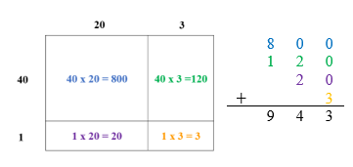

Instructional Tasks

*Instructional Task 1 (MTR.7.1)*

Maggie has three dogs. She buys a box containing 175 bags of dog food. Each bag weighs 64 ounces.

Part A. What is the total weight of the bags of dog food in ounces?

Part B. Maggie has a storage cart to transport the box that holds up to 750 pounds. Will the storage cart be able to hold the box? Explain.

*Instructional Task 2*

Select six cards from the set of cards below.



Part A. Use your cards to create a four-digit number and a two-digit number. Find the product of your four-digit and two-digit numbers.

Part B. Use your cards to create a three-digit number and another three-digit number. Find the product of your three-digit numbers.

Part C. How are your two products similar? How are they different?

Instructional Items

*Instructional Item 1*

What is the product of $1,834 ×23$?

*Instructional Item 2*

What is the product of 427 $×165$?

*The strategies, tasks and items included in the B1G-M are examples and should not be considered comprehensive.

### MA.5.NSO.2.2

Benchmark

MA.5.NSO.2.2 Divide multi-digit whole numbers, up to five digits by two digits, including using a standard algorithm with procedural fluency. Represent remainders as fractions.

*Example:* The quotient $27÷7$ gives $3$ with remainder $6$ which can be expressed as $3\frac{6}{7}$.

Benchmark Clarifications:

*Clarification 1:* Within this benchmark, the expectation is not to use simplest form for fractions.

Connecting Benchmarks/Horizontal Alignment

* MA.5.FR.2.4
* MA.5.AR.1.1, MA.5.AR.1.3
* MA.5.M.1.1
* MA.5.GR.3.3

Terms from the K-12 Glossary

* Dividend
* Divisor
* Equation
* Expression
* Whole Number

Vertical Alignment

|  |  |
| --- | --- |
| **Previous Benchmarks**   * MA.4.NSO.2.4 | **Next Benchmarks**   * + MA.6.NSO.2.1 |

Purpose and Instructional Strategies Integers

The purpose of this benchmark is for students to demonstrate procedural fluency while dividing multi-digit whole numbers with up to 5-digit dividends and 2-digit divisors. To demonstrate procedural fluency, students may choose a standard algorithm that works best for them and demonstrates their procedural fluency. A standard algorithm accurate, efficient, and *generalizable*. Generalizable means that the algorithm always follows the same procedural steps regardless of the magnitude of the number *(MTR.3.1).* In Grade 4, students had experience dividing four-digit by one-digit numbers using a method of their choice with procedural reliability (MA.4.NSO.2.4). In Grade 6, students will multiply and divide multi-digit numbers including decimals with fluency (MA.6.NSO.2.1).

* When students use a standard algorithm, they should be able to justify why it works conceptually. Teachers can expect students to demonstrate how their algorithm works, for example, by comparing it to another method for division *(MTR.6.1)*.
* When used efficiently, partial quotients is a suitable procedure for dividing multi-digit numbers. It can often be more reliable and efficient for students than the long division algorithm. Students can demonstrate fluency by skillfully using partial quotients, and should be able to understand the full long division algorithm.
  + For example, students can use place value understanding, estimation and partial quotients to solve Students can begin by determining that the product $2,000 ×15$ gets them close to their dividend of 34,681 and continue by subtracting groups of 15 based upon place value and multiples of 15.

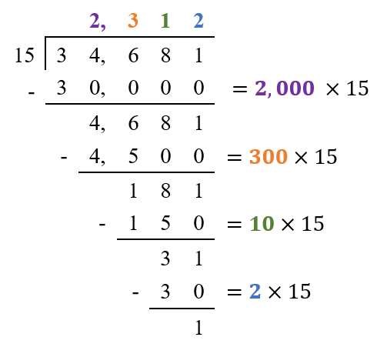

* In this benchmark, students are to represent remainders as fractions. In the benchmark example, the quotient of $27÷7$ is represented as $3\frac{6}{7}$. Students should gain understanding that this quotient means that there are 3 full groups of 7 in 27, and the remainder of 6 represents $\frac{6}{7}$ of another group. Students are not expected to have mastery of converting between forms (fraction, decimal, percentage) until Grade 6 but students should start to gain familiarity that fractions and decimals are numbers and can be equivalent (i.e., a remainder of ½ is the same as 0.5). Writing remainders as fractions or decimals is acceptable. Similarly, students should be able to understand that a remainder of zero means that whole groups have been filled without any of the dividend remaining *(MTR.5.1, MTR.7.1)*.
* Along with using a standard algorithm, students should estimate reasonable solutions before solving. Estimation helps students anticipate possible answers and evaluate whether their solutions make sense after solving.
* This benchmark supports students as they solve multi-step real-world problems involving combinations of operations with whole numbers (MA.5.AR.1.1). In a real-world problem, students should interpret remainders depending on its context.

Common Misconceptions or Errors

* Students may make computational errors while using standard algorithms when they are unable to reason why their algorithms work. In addition, they may struggle to determine where or why that computational mistake occurred because they did not estimate reasonable values for intermediate outcomes as well as for the final outcome. During instruction, teachers can expect students to justify their work while using their chosen algorithms and engage in error analysis activities to connect their understanding to the algorithm.

Strategies to Support Tiered Instruction

* Instruction includes estimating reasonable values for quotients when dividing by two-digit divisors.
  + For example, students make reasonable estimates for the quotient of $496÷24$. Before using an algorithm, students can estimate the quotient to make sure that they are using the algorithm correctly and the answer is reasonable. Students can use multiples of 24 and their understanding of multiplication and division to estimate the quotient. Students may want their estimate to be as close to 496 as possible. So, knowing that $24×2=48$, they can state that $24×20=480$. A reasonable estimate for the quotient would be 20 because 480 is close to 496.”
  + For example, students make reasonable estimates for the quotient of $94÷13$. Explicit instruction could include stating, “Before using an algorithm, we will estimate the quotient to make sure that we are using the algorithm correctly and our answer is reasonable. The divisor of 13 is close to 10 and the dividend of 94 is close to 90. So, we can use $90÷10=9$ to estimate that our quotient should be close to 9.”
* Instruction includes explaining and justifying mathematical reasoning while using a division algorithm to divide by two-digit divisors. Instruction also includes determining if an algorithm was used correctly by analyzing any errors made and reviewing the reasonableness of solutions.
  + For example, the teacher connects place value with the partial quotients model to determine $496÷24$. Students should not just view the digits as individual numbers but connect individual digits with the value of that number (e.g., 496 is $400+90+6$). Instruction includes stating, “In this problem we are finding how many groups of 24 are in 496. We will subtract groups of 24 until we cannot subtract any more groups. The total number of groups that we can subtract is the quotient. We can subtract 10 groups of 24 two times, so the quotient is 20. We have a remainder of 16. The quotient is represented as 20 $\frac{16}{24}$ because we have 20 full groups of 24 in 496 and the remainder of 16 represents $\frac{16}{24}$ of another group.”

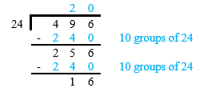

* + For example, connect place value with the partial quotients model to determine $94÷13$. Students should not just view the digits as individual numbers but connect individual digits with the value of that number (e.g., 94 is $90+4$). Instruction includes stating, “In this problem we are finding how many groups of 13 are in 94. We will subtract groups of 13 until we cannot subtract any more groups. The total number of groups that we can subtract is the quotient. We can subtract 7 groups of 13, so the quotient is 7. We have a remainder of 3. The quotient is represented as 7 $\frac{3}{13}$ because we have 7 full groups of 13 in 94 and the remainder of 3 represents $\frac{3}{13}$ of another group.”

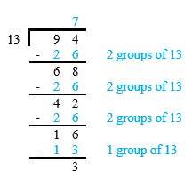

* + For example, students use an algorithm to solve $496÷24$ and explain their thinking using place value understanding. Instruction includes stating, “In this problem we are finding how many groups of 24 are in 496. We will begin by dividing our largest place value first. Recognizing that the 4 represents 400, if you divide 400 by 24 the result will be less than 100, so the quotient will not have any whole hundreds. Remember that 496 is the same as $49 tens 6 ones$, so we will see how many groups of 24 are in $49$ $tens$. We can also think of this as $___ ×24=49 tens$. There are 20 groups of 24 in $49 tens$, that’s 2 times 10 groups, so we can place a 2 in the *tens* place of the quotient. Next, we will subtract $49 tens – 48 tens$ (20 groups of 24 equals $48$ $tens$) to find a difference of $1 ten$. We can combine this $1 ten$ with the $6 ones$ remaining in 496. We now have $16 ones$ remaining from our original dividend of 496, this is not enough to make a group of 24. We have a remainder of 16. The quotient is represented as $20\frac{16}{24}$ because we have 20 full groups of 24 in 496 and the remainder of 16 represents $\frac{16}{24}$ of another group. Our quotient of $20\frac{16}{24}$ is close to our estimate of 20, this helps us determine that our answer is reasonable.”

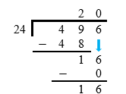

* + For example, students use an algorithm to solve $94÷13$ and explain their thinking using place-value blocks and place value understanding. Instruction includes stating, “In this problem we are finding how many groups of 13 are in 94. We will begin by dividing our largest place value first. How many groups of 13 are in $9 tens$? Recognizing that the 9 represents 90, if you divide 90 by 13 the result will be less than 10, so the quotient will not have any whole tens. Remember that 94 is the same as $9 tens 4 ones$ and $94 ones$, so we will see how many groups of 13 are in $94 ones$. We can also think of this as $___×13=94$. There are 7 groups of 13 in $94 ones$. Next, we will subtract to find our remainder of 3. Our quotient is represented as $7\frac{3}{13}$ because we have 7 full groups of 13 in 94 and the remainder of 3 represents $\frac{3}{13}$ of another group. Our quotient of $7\frac{3}{13}$ is close to our estimate of 9, this helps us determine that our answer is reasonable.”

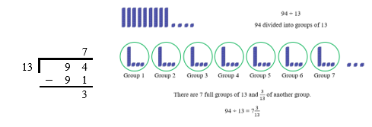

* Instruction includes the use of place value columns to support place value understanding when using a division algorithm.
  + Example:

An image showing two long division problems. One where 94 being divided by 13 and another 496 being divided by 24. The numbers are in uniform columns maintaining place value. 

Instructional Tasks

*Instructional Task 1 (MTR.7.1)*

The Magnolia Outreach organization is donating 6,924 pounds of rice to families in need. They pour all the rice into 15-pound containers.

Part A. How many containers will they fill completely if they use all the rice?

Part B. How many containers will they need for all the rice?

Part C. Will the Magnolia Outreach organization completely fill all of the containers needed for all of the rice? If not, will the partially filled container be more or less than half-full? Explain how you know.

*Instructional Task 2*

Natalie says that 5,978 is not divisible by 24. When two numbers are divisible, they have a whole-number quotient with no remainder. Is Natalie correct? Why or why not?

Instructional Items

*Instructional Item 1*

What is the quotient of $498÷72$?

*Instructional Item 2*

Part A. What is the quotient of 65 $,106÷34$?

Part B. Write the remainder of 65, $106÷34$ as a fraction.

*Instructional Item 3*

What is the quotient of $9,253÷46$?

1. 20 $\frac{5}{46}$
2. 21 $\frac{7}{46}$
3. 201 $\frac{3}{46}$
4. 201 $\frac{7}{26}$

*The strategies, tasks and items included in the B1G-M are examples and should not be considered comprehensive.

### MA.5.NSO.2.3

Benchmark

MA.5.NSO.2.3 Add and subtract multi-digit numbers with decimals to the thousandths, including using a standard algorithm with procedural fluency.

Connecting Benchmarks/Horizontal Alignment

* MA.5.NSO.1.5
* MA.5.AR.2.1, MA.5.AR.2.2, MA.5.AR.2.3
* MA.5.M.2.1
* MA.5.GR.2.1

Terms from the K-12 Glossary

* Distributive Property
* Equation
* Expression

Vertical Alignment

|  |  |
| --- | --- |
| **Previous Benchmarks**   * MA.4.NSO.2.6, MA.4.NSO.2.7 | **Next Benchmarks**   * + MA.6.NSO.2.3 |

Purpose and Instructional Strategies

The purpose of this benchmark is for students to add and subtract multi-digit numbers with decimals to the thousandths with procedural fluency. In Grade 4 (MA.4.NSO.2.7), students explored the addition and subtraction of multi-digit numbers with decimals to hundredths using money and manipulatives based on place value. In Grade 6, students add and subtract positive fractions with procedural fluency.

* To demonstrate procedural fluency, students may choose a standard algorithm that works best for them and demonstrates their procedural fluency. A standard algorithm is a method that is efficient and accurate *(MTR.3.1)*. A standard algorithm is also generalizable meaning that it works no matter how many digits are involved.
* Instruction includes explaining that the purpose of lining up the decimals points to add or subtract decimals is align corresponding place values. Due to the fixed denominator associated with each place value, such as $\frac{1}{10}$ or $\frac{1}{100}$, the process of adding or subtracting the digits in a specific column is the same as adding or subtracting fractions with like denominators.
* When students use a standard algorithm, they should be able to justify why it works conceptually. Teachers can expect students to demonstrate how their algorithm works, for example, by comparing it to another method for addition and subtraction *(MTR.6.1)*.
* Instruction makes the connection to decimal and fraction equivalence when solving addition and subtraction equations involving different numbers of decimal places.
  + For example, when solving students can use their understanding of decimal and fraction equivalence to write 7.5 as 7.50 because *seven and five tenths* is equivalent to *seven and fifty hundredths.*
* Along with using a standard algorithm, students should estimate reasonable solutions before solving. Estimation helps students anticipate possible answers and evaluate whether their solutions make sense after solving.

Common Misconceptions or Errors

* A common error that students may make is to not add or subtract like place values, especially in an example such as $30.1+2.74$. Instruction should relate decimals to methods used for whole numbers. When adding whole numbers, ones were added to ones, tens to tens, hundreds to hundreds, and so forth. When adding decimal numbers, like place values are combined, too. Like place values are subtracted, just as with whole numbers.
* Students can make computational errors while using standard algorithms when they are unable to reason why their algorithms work. In addition, they may struggle to determine where or why that computational mistake occurred because they did not estimate reasonable values for intermediate outcomes as well as for the final outcome. During instruction, teachers can expect students to justify their work while using their chosen algorithms and engage in error analysis activities to connect their understanding to the algorithm.

Strategies to Support Tiered Instruction

* Instruction includes estimating reasonable values for sums and differences when adding and subtracting decimals to the hundredths.
  + For example, students make reasonable estimates for the sum of $6.32+2.84$. Instruction includes stating, “Before using an algorithm, we will estimate the sum to make sure that we are using this algorithm correctly and our answer is reasonable. I will use my understanding of rounding decimals to estimate my sum. The addend of 6.32 rounds to 6 when rounded to the nearest whole number and the addend 2.84 rounds to 3 when rounded to the nearest whole number. A reasonable estimate for my sum would be 9 because $6+3=9.$”
  + For example, students make reasonable estimates for the difference of $7.9-4.25$. Instruction includes stating, “Before using an algorithm, we will estimate the difference to make sure that we are using this algorithm correctly and our answer is reasonable. I will use my understanding of rounding decimals to estimate my difference. The minuend of 7.9 rounds to 8 when rounded to the nearest whole number and the subtrahend 4.25 rounds to 4 when rounded to the nearest whole number. A reasonable estimate for my difference would be 4 because $8-4=4.$”
* Instruction includes explaining and justifying mathematical reasoning while using an algorithm to add and subtract decimals to the hundredths. Instruction also includes determining if an algorithm was used correctly by analyzing any errors made and reviewing the reasonableness of solutions.
  + For example, students use a standard algorithm to determine $6.32 +2.84$ and explain their thinking using a place value understanding. Instruction includes stating, “Begin by lining up the decimal points and place values for each addend. Next, add in the hundredths place. $2 hundredths plus 4 hundredths$ $are 6 hundredths$. Because the total number of $hundredths$ is less than $10 hundredths$ it is not necessary to regroup. Next, add in the tenths place. $3 tenths plus 8 tenths are 11 tenths$. Because I have more than $10 tenths$ it is necessary to regroup the $10 tenths$ to make one whole. After composing a group of 10 tenths there is 1 tenth remaining. Finally, add $6 ones$ plus $2 ones$ and the 1 whole that was regrouped from the tenths place. The sum is 9.16. Our sum of 9.16 is close to our estimate of 9, this helps us determine that our answer is reasonable.”

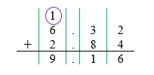

* + For example, students use a standard algorithm to determine $7.9 -4.25$ and explain their thinking using place value understanding. The teacher reminds students that 7.9 is equivalent to 7.90 and uses a decimal grid to show the equivalency of 0.9 and 0.90 if needed. Instruction includes stating, “Begin by lining up the decimal points and place values. Next, subtract 4.25 starting in the $hundredths$ place. There are not enough $hundredths$ to subtract $5 hundredths$ from $0 hundredths$. It is necessary to decompose one tenth into $10 hundredths$. Now there are $10 hundredths$, and there is enough to subtract $5 hundredths$. $10 hundredths-5 hundredths = 5 hundredths$. Then, subtract the $tenths$: $8 tenths-2 tenths = 6 tenths$. Finally, subtract the $ones$: $7 ones-4 ones = 3 ones$. The difference is 3.65. Our difference of 3.65 is close to our estimate of 4, this helps us determine that our answer is reasonable.”

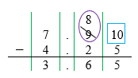

* + For example, students use a standard algorithm to determine $1.9+2.3$ and explain their thinking using place value understanding. Instruction includes stating, “Begin by lining up the decimal points and place values for each addend. Next, add in $tenths$ place. $9 tenths plus 3 tenths are 12 tenths$. Because I have more than $10 tenths$ it is necessary to regroup the $10 tenths$ to make one whole. After composing a group of $10 tenths$ there are $2 tenths$ remaining. Finally, add $1 one$ plus $2 ones$ and the 1 whole that was regrouped from the $tenths$ place. The sum is 4.2. Our sum of 4.2 is close to our estimate of 4, this helps us determine that our answer is reasonable.”

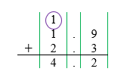

* + For example, students use a standard algorithm to determine $5.2-3.8$ and explain their thinking using place value disks and their understanding of place value. Instruction includes stating, “Begin by lining up the decimal points and place values. Next, subtract 3.8 starting in the $tenths$ place. There are not enough $tenths$ to subtract $8 tenths$ from $2 tenths$. It is necessary to decompose one whole into $10 tenths$. Now there are a total of $12 tenths$, and there are enough to subtract $8 tenths$. $12 tenths – 8 tenths = 4 tenths$. Finally, subtract the $ones$: $4 ones – 3 ones = 1 one$. The difference is 1.4. Our difference of 1.4 is close to our estimate of 1, this helps us determine that our answer is reasonable.”

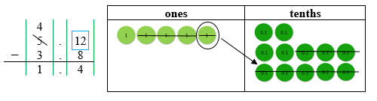

* Instruction includes the use of place value columns to support place value understanding when using an algorithm to add and subtract decimals.

Instructional Tasks

*Instructional Task 1 (MTR.3.1)*

Use a standard algorithm to find the difference of *eight hundred two and forty-six* thousandths and *three hundred and nine tenths*. Explain how you used your algorithm to subtract.

*Instructional Task 2*

A school is packing textbooks into a shipping container. The table below shows the total weight of the textbooks for five different subject areas.

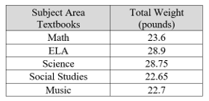

If the weight limit of the shipping container is 75 pounds, which combination of subject area textbooks will fit in the shipping container?

1. Math, Science and Music
2. ELA, Science and Social Studies
3. Math, ELA and Science
4. Math, Science and Social Studies

Instructional Items

*Instructional Item 1*

Find the sum and difference of $8.72$ and $3.032$.

*Instructional Item 2*

An equation is shown. What is the missing value in the equation?

$9.732 + =11.6$

*The strategies, tasks and items included in the B1G-M are examples and should not be considered comprehensive.

### MA.5.NSO.2.4

Benchmark

MA.5.NSO.2.4 Explore the multiplication and division of multi-digit numbers with decimals to the hundredths using estimation, rounding and place value.

*Example:* The quotient of 23 and 0.42 can be estimated as a little bigger than 46 because 0.42 is less than one-half and 23 times 2 is 46.

Benchmark Clarifications:

*Clarification 1*: Estimating quotients builds the foundation for division using a standard algorithm.

*Clarification 2:* Instruction includes the use of models based on place value and the properties of operations.

Connecting Benchmarks/Horizontal Alignment

* MA.5.NSO.1
* MA.5.FR.2.3
* MA.5.AR.2.2, MA.5.AR.2.3
* MA.5.M.1.1
* MA.5.M.2.1
* MA.5.GR.2.1

Terms from the K-12 Glossary

* Equation
* Expression

Vertical Alignment

|  |  |
| --- | --- |
| **Previous Benchmarks**   * MA.4.NSO.2.7 | **Next Benchmarks**   * MA.6.NSO.2.1 |

Purpose and Instructional Strategies

The purpose of this benchmark is for students to explore multiplication and division of multi-digit numbers with decimals using estimation, rounding, place value, and exploring the relationship between multiplication and division. This benchmark connects to the work students did in Grade 4 with addition and subtraction of decimals (MA.4.NSO.2.7). Students achieve procedural fluency with multiplying and dividing multi-digit numbers with decimals in Grade 6 (MA.6.NSO.2.1)

* Instruction of this benchmark focuses on number sense to help students develop procedural reliability while multiplying and dividing multi-digit numbers with decimals.
* Students should have practice solving multiplication and division equations with decimals using strategies based on place value and the properties of operations.
* During instruction, students should explore how the products and quotients of whole numbers relate to decimals.
  + For example, if students know the product of $8×7$ and the quotient of $56÷4$, then they can reason through $0.08×7$ or $5.6÷0.4$ through place value relationships. Classroom discussions should allow students to explore these patterns and use them to estimate products and quotients *(MTR.4.1, MTR.6.1)*.
* Instruction includes dividing decimals as if all of the numbers were whole numbers and then using estimation to place the decimal point.
  + For example, to solve a reasonable estimate of 12 could be found by determining how many groups of 3 *tenths* can be formed from the 36 *tenths* in 3.69. Dividing 3.69 by 0.3 as if they are whole numbers would result in a quotient of 123. The estimate of 12 would be used to place the decimal after the 2 in 123 resulting in a quotient of 12.3 for $3.69 ÷0.3.$
* Instruction makes the connection between multiplication of fractions and decimals to help students reason about the magnitude of their products and determine correct placement of the decimal point.
  + For example, can be written as to make connections to multiplying fractions and help students understand why their product results in a decimal to the thousandths. For this problem, $\frac{4}{10} × \frac{13}{100}= \frac{52}{1,000}$ so $0.4 ×0.13$ = 0.052.
* Teachers may connect what students know about place value and fractions.
  + For example, because students know that multiplying a number by one-fourth will result in a product that is less, multiplying a number by 0.25 (its decimal equivalent) will also result in a lesser product. In division, dividing a number by one-fourth and 0.25 will result in a greater quotient. Continued work in this benchmark will help students to generalize patterns in multiplication and division of whole numbers and fractions *(MTR.5.1)*.
* Models that help students explore the multiplication and division of multi-digit numbers with decimals include base ten representations (e.g., blocks) and place value mats.

Common Misconceptions or Errors

* Students may not understand the reasoning behind the placement of the decimal point in the product or quotient. Modeling and exploring the relationships between place-value will help students gain understanding.
* Students may confuse that multiplication always results in a larger product, and that division always results in a smaller quotient. Through classroom discussion, estimation and modeling, classroom work should address this misconception.

Strategies to Support Tiered Instruction

* Instruction includes opportunities to predict and explain the relative size of the product of two decimals. Students use models to check their prediction and solve. The teacher guides students to connect that multiplying a given number by a number less than one will result in a smaller number, and that multiplying a given number by a number greater than one will result in a larger number.
  + For example, students solve the following problem $0.2×0.5$. Students should reason about the size of the decimals and connect it back to their fraction understanding and think about the multiplication sign signaling “groups of.” This expression could be interpreted as 0.2 “of” 0.5. This will help with the misconception of multiplying equals a larger product.

The picture below illustrates the product of 0.2 and 0.5. If the entire square is 1 unit, the gray region represents 0.5 units, and the red region represents 0.2 units. The overlap in purple contains 10 small squares, each of which represents 0.01 units. Therefore, the overlap portion contains $10×0.01=0.10$ units. The overlap portions show a 0.2 by 0.5 rectangle, so the number of units it contains is the product 0.2 and 0.5.

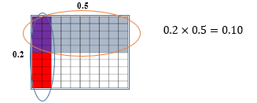

* Instruction includes opportunities to predict and explain the relative size of the quotient of a decimal and a whole number or two decimals. Students use models based on place value to check their prediction and solve. The teacher guides students to connect their quotients to the number of groups or size of the groups based on the magnitude of the divisor and dividend.
  + For example, students may use a decimal grid to solve $2 ÷0.4$ by using the following model:

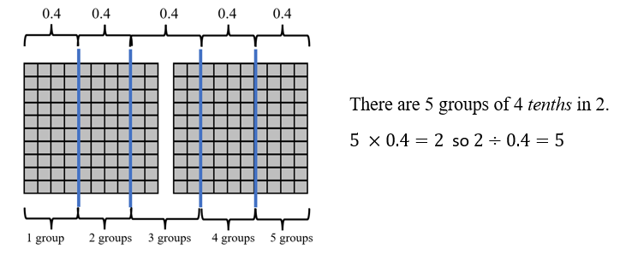

* + For example, students may use a decimal grid to solve 0.4 $÷8$ by using the following model:

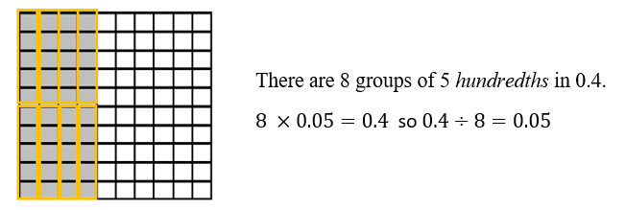

* + For example, students may use a decimal grid to solve 0.54 $÷0.09$ by using the following model:

Two groups of one hundred unit blocks. The blocks are in rows of ten. 
54 of those blocks are highlighted. Those 54 blocks are then highlighted in groups of nine. There are 6 groups of nine blocks.

Instructional Tasks

*Instructional Task 1 (MTR.4.1)*

What is the same about the products of these expressions? What is different? Explain.

$$14 ×5 0.14×0.05$$

*Instructional Task 2 (MTR.4.1)*

What is the same about the quotients of these expressions? What is different? Explain.

$$50÷25 50÷0.25$$

*Instructional Task 3 (MTR.5.1)*

How can you use $2×12=24$ to help you find the product of $2×1.2$? Explain.

Instructional Items

*Instructional Item 1*

Raul reasons that the product of $82×0.56$ will be greater than 41 and less than 82. Explain whether or not his conclusion is reasonable.

*Instructional Item 2*

What is the quotient of $66.25 ÷5$?

*Instructional Item 3*

What is the product of $4.6 × 0.8$?

*Instructional Item 4*

What is the quotient of 16.32 $÷0.16$?

*Instructional Item 5*

Which of the following equations has a missing value of 4.8? Select all that apply.

$1.6 ×3=$

$11.52 ÷2.4=$

$0.04 ×12=$

$0.96 ÷2=$

$16.8 ÷3.5=$

1. _____
2. _____
3. _____
4. ______
5. ______

*The strategies, tasks and items included in the B1G-M are examples and should not be considered comprehensive.

### MA.5.NSO.2.5

Benchmark

MA.5.NSO.2.5 Multiply and divide a multi-digit number with decimals to the tenths by one-tenth and one-hundredth with procedural reliability.

*Example:* The number $12.3$ divided by $0.01$ can be thought of as $?×0.01=12.3$ to determine the quotient is $1,230$.

Benchmark Clarifications:

*Clarification 1:* Instruction focuses on the place value of the digit when multiplying or dividing.

Connecting Benchmarks/Horizontal Alignment

* MA.5.NSO.1.1, MA.5.NSO.1.2, MA.5.NSO.1.3, MA.5.NSO.1.4
* MA.5.FR.2.3
* MA.5.AR.2.2, MA.5.AR.2.3
* MA.5.M.1.1
* MA.5.M.2.1
* MA.5.GR.2.1

Terms from the K-12 Glossary

* Dividend
* Divisor
* Equation
* Expression

Vertical Alignment

|  |  |
| --- | --- |
| **Previous Benchmarks**   * MA.4.NSO.2.6 | **Next Benchmarks**   * MA.6.NSO.2.1 |

Purpose and Instructional Strategies

The purpose of this benchmark is for students to multiply multi-digit numbers with decimals to the tenths by 0.1 and by 0.01 with procedural reliability. Procedural reliability refers to the ability for students to develop an accurate, reliable method that aligns with a student’s understanding and learning style. Procedural fluency of multiplying and dividing multi-digit whole numbers with decimals is not expected until Grade 6 (MA.6.NSO.2.1).

* When multiplying and dividing, students should continue to use the number sense strategies built in MA.5.NSO.2.4 (estimation, rounding and exploring place value relationships). Using these strategies will help students predict reasonable solutions and determine whether their solutions make sense after solving.
* During instruction, students should see the relationship between multiplying and dividing multi-digit numbers with decimals to multiplying and dividing by whole numbers. Students extend their understanding to generalize patterns that exist when multiplying or dividing by 10 or 100 *(MTR.5.1)*.
* Instruction includes the language that the “digits shift” relative to the position of the decimal point as long as there is an accompanying explanation. An instructional strategy that helps students see this is by putting digits on sticky notes or cards and showing how the values shift (or the decimal point moves) when multiplying by a power of ten.
  + For example, a teacher may show one card with a 3 and another with a 5, and place them on the left and right of a decimal point on a blank place value chart. The teacher may then ask students to multiply by ten and shift both digits one place left to show the equation $3.5×10=35$. They may ask students to multiply by $\frac{1}{10}$ and show that $3.5×\frac{1}{10}=0.35$. Instruction emphasizes that the decimal point indicates the transition from the ones to the tenths place and that the digits shift when multiplying or dividing by 0.1 or 0.01.*(MTR.2.1, MTR.4.1,MTR.5.1)*.

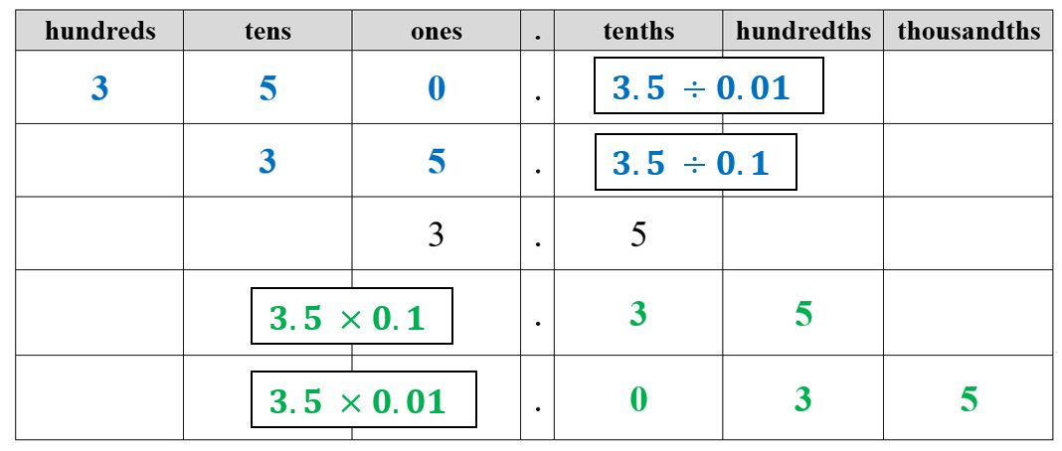

Common Misconceptions or Errors

* Students may confuse that multiplication always results in a larger product, and that division always results in a smaller quotient. Through classroom discussion, estimation and modeling, classroom work should address this misconception.

Strategies to Support Tiered Instruction

* Instruction includes the use of a place value chart to demonstrate how the value of a digit changes if the digit moves one place to the left or right. Instruction includes using place value understanding to make the connections between $\frac{1}{10}$ of, ten times less and dividing by 10. Also, the place value chart can be used to demonstrate that the decimal point marks the transition between the ones place and the tenths place.
  + For example, students multiply 4 by 10, then record 4 and the product of 40 in a place value chart. This process is repeated by multiplying 40 by 10. The teacher asks students to explain what happens to the digit 4 each time it is multiplied by 10. Next, the teacher explains that multiplying by $\frac{1}{10}$ is the same as dividing by 10. Students multiply 400 by $\frac{1}{10}$ and record the product in their place value chart. The process is repeated, multiplying 40 and 4 by $\frac{1}{10}$. Students explain how the value of the 4 changed when being multiplied by 10 and $\frac{1}{10}$.

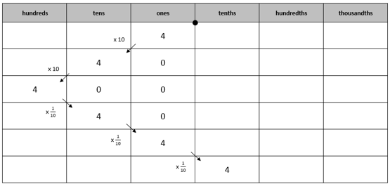

* Instruction includes opportunities to use models such as place value disks to demonstrate how the value of a digit changes if the digit moves one place to the left or right. A place value chart can be used with the models to support place value understanding and demonstrate that the decimal point marks the transition between the ones place and the tenths place. Instruction includes using place value understanding to make connections between $\frac{1}{10}$ of, ten times less and dividing by 10.
  + For example, the teacher uses a familiar context such as money, asking students to explain the value of each digit in $33.33. Then, students represent 33.33 in a place value chart using place value disks. Students compare the value of the whole numbers, (3 dollars and 30 dollars), then move to comparing 0.3 and 0.03 (30 cents and 3 cents). The teacher asks, “How does the value of the three in the hundredths place compared to the value of the three in the tenths place?” and explains that the three in the hundredths place is $\frac{1}{10}$ the value of the three in the tenths place and that multiplying by $\frac{1}{10}$ is the same as dividing by 10.

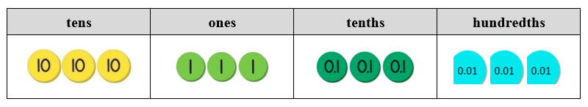

Instructional Tasks

*Instructional Task 1 (MTR.7.1)*

Part A. What is $\frac{1}{10}$ times 15?

Part B. How many dimes are in $1.50?

Part C. Write a division equation to represent how many dimes are in $1.50.

Part D. Write a related multiplication equation to represent how many dimes are in $1.50.

*Instructional Task 2 (MTR.7.1)*

Part A. What is $\frac{1}{100}$ times 60?

Part B. How many pennies are in $0.60?

Part C. Write a division equation to represent how many pennies are in $0.60.

Part D. Write a related multiplication equation to represent how many pennies are in $0.60.

Instructional Items

*Instructional Item 1*

Which compares the products of $7.8×0.1$ and $7.8×10$ correctly?

* 1. The product of $7.8×0.1$ is 100 times less than the product of $7.8×10$.
  2. The product of $7.8×0.1$ is 10 times less than the product of $7.8×10$.
  3. The product of $7.8×0.1$ is 100 times more than the product of $7.8×10$.
  4. The product of $7.8×0.1$ is 10 times more than the product of $7.8×10$.

*Instructional Item 2*

What is the quotient of $2.7÷0.01$.

*Instructional Item 3*

What is the quotient of $56.3÷0.1$.

*Instructional Item 4*

In the table below, match each equation to the correct product or quotient.

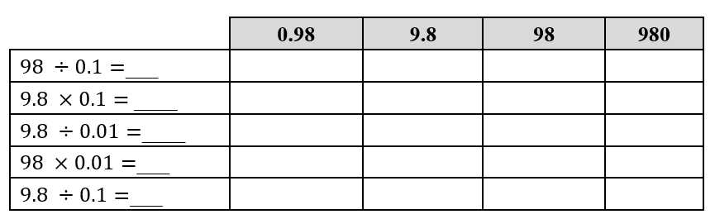

*The strategies, tasks and items included in the B1G-M are examples and should not be considered comprehensive.

## Fractions

**MA.5.FR.1***Interpret a fraction as an answer to a division problem.*

### MA.5.FR.1.1

Benchmark

MA.5.FR.1.1 Given a mathematical or real-world problem, represent the division of two whole numbers as a fraction.

*Example:* At Shawn’s birthday party, a two-gallon container of lemonade is shared equally among 20 friends. Each friend will have $\frac{2}{20}$ of a gallon of lemonade which is equivalent to one-tenth of a gallon which is a little more than 12 ounces.

Benchmark Clarifications:

*Clarification 1:* Instruction includes making a connection between fractions and division by understanding that fractions can also represent division of a numerator by a denominator.

*Clarification 2:* Within this benchmark, the expectation is not to simplify or use lowest terms.

*Clarification 3:* Fractions can include fractions greater than one.

Connecting Benchmarks/Horizontal Alignment

* MA.5.NSO.2.2
* MA.5.AR.1.1
* MA.5.GR.3.3
* MA.5.DP.1.2

Terms from the K-12 Glossary

* Dividend
* Divisor
* Expression
* Equation

Vertical Alignment

|  |  |
| --- | --- |
| **Previous Benchmarks**   * MA.4.NSO.2.4 | **Next Benchmarks**   * MA.6.NSO.2.2 |

Purpose and Instructional Strategies

The purpose of this benchmark is for students to understand that a division expression can be written as a fraction by explaining their thinking when working with fractions in various contexts. This builds on the understanding developed in Grade 4 that remainders are fractions (MA.4.NSO.2.4) and prepares students for the division of fractions in Grade 6 (MA.6.NSO.2.2).

* When students read $\frac{5}{8}$ as “ $five-eighths$,” they should be taught that $\frac{5}{8}$ can also be interpreted as “5 divided by 8,” where 5 represents the numerator and 8 represents the denominator of the fraction ( $\frac{5}{8}=5÷8)$ and refers to 5 wholes divided into 8 equal parts.
* Teachers can activate students’ prior knowledge of fractions as division by using fractions that represent whole numbers (e.g., $\frac{24}{6}$). Familiar division expressions help build students’ understanding of the relationship between fractions and division *(MTR.5.1)*.
* During instruction, provide examples accompanied by area and number line models.
* When solving mathematical or real-world problems involving division of whole numbers and interpreting the quotient in the context of the problem, students will be able to represent the division of two whole numbers as a mixed number, where the remainder is the fractional part’s numerator and the size of a group is its denominator (for example, $17÷3$ equals 5 $\frac{2}{3}$ which is the number of size 3 groups you can make from 17 objects including the fractional group). Students should demonstrate their understanding by explaining or illustrating solutions using visual fraction models or equations.
* Instruction includes building upon students’ prior knowledge from Grade 4 regarding dividing multi-digit whole numbers and representing their remainders as fractions.

An image showing the equation of two hundred sixty six divided by five equals fifty three and two fifths.

Common Misconceptions or Errors

* Students may believe that the fraction bar represents subtraction in lieu of understanding that the fraction bar represents division.
* Students may have the misconception that division always results in a smaller number.
* Students may have the misconception that dividends must always be greater than divisors and, thus, reorder them when representing a division expression as a fraction. Show students examples of fractions with greater numerators and greater denominators to create a division equation.

Strategies to Support Tiered Instruction

* Instruction includes making the connection to models and tools previously used to understand division as equal groups or sharing, but now as a fraction in a real-world context.
  + For example, “Eight friends share four brownies” can be represented as $\frac{4}{8}$. This means that $4÷8$ can be represented using the model below. A visual model of four whole brownies is divided into 8 equal parts. Each part represents $\frac{1}{2}$ of the brownie.

**An image of four uniform squares with each square divided in half.**

* + - Connecting the real-world application to the model helps students understand how the fraction represents division
* Instruction includes making the connection to models and tools previously used to understand division as equal groups or sharing, but now as a fraction in a real-world context.
  + For example, “Marcos has 8 toy cars that he wants to put into 4 boxes equally. How many cars can go in each box?” $8÷4$ can be shown using a model of 8 wholes divided into 4 groups. The quotient would be the total number of pieces in each group. The model below would show that $8÷4=2$. This can also be expressed as .

**An image of four rectangles containing two dots each.**

* Instruction includes examples of fractions with greater numerators and greater denominators to create a division equation.
* Instruction includes using the 3-Read Protocol to break down the problem. First read the problem to understand the context, possibly without the numbers. Then, read to understand the mathematics. Finally, read to create a plan for solving the problem.

Instructional Tasks

*Instructional Task 1 (MTR.7.1)*

Create a real-world division problem that results in an answer equivalent to $\frac{3}{10}$.

*Instructional Task 2 (MTR.3.1)*

Write a fraction greater than one and a mixed number that are equivalent to $10÷3.$

*Instructional Task 3 (MTR.7.1)*

Monica has a ribbon that is 8 feet long. She wants to make 12 bows for her friends. How long will each piece of the ribbon be? Express your answer in both feet and inches.

*Instructional Task 4 (MTR.7.1)*

Albert baked 18 fudge brownies for his video game club members. He wants to share the brownies with the 5 club members. How many brownies will each club member get?

*Instructional Task 5*

Albert baked 18 fudge brownies for his video game club members. He wants to share the brownies with the 5 club members. How many brownies will each club member get?

*Instructional Task 5*

Use a number cube to roll one digit to fill in the blank in the word problem.

Then solve the problem using a strategy of your choice.

Reroll the number cube and repeat.

Ping had _____ chocolate candy bars. If he wants to eat the same amount of chocolate every day for the next two weeks, how much of the candy bars can he eat each day?

*Instructional Task 6*

Ms. Starling made 60 cookies for her class of 20 students.

Part A. If all her students are present, how many cookies would each student receive if they each were given an equal amount of whole cookies?

Part B. If 2 students were absent, how many whole cookies would be left over if all students received equal amounts of whole cookies?

Part C. If 2 students were absent, how many whole cookies and what fractional number of a cookie would each student receive if the 60 cookies were divided evenly among the students?

Part D. If 2 new students came to the class, how many whole cookies would each student receive and how many whole cookies would be left over?

Part E. If 19 students gave half a cookie to their teacher, how many cookies would Ms. Starling have?

Instructional Items

*Instructional Item 1*

Which expression is equivalent to $\frac{7}{12}$?

$7-12$

$7÷12$

$12-7$

$12÷7$

*Instructional Item 2*

Amanda has 12 pepperoni slices that need to be distributed equally among 5 mini pizzas. How many pepperoni slices will go on each mini pizza?

$\frac{5}{12}$

$2\frac{2}{5}$

$7$

$60$

*Instructional Item 3*

Select all the numbers that represent the quotient of 12 ÷ 7.

$\frac{7}{12}$

$\frac{12}{7}$

$1\frac{5}{7}$

$1\frac{7}{5}$

$1\frac{5}{12}$

*Instructional Item 4*

Heath had a box with 6 small pizzas. If he wants to eat the same amount of pizza each day for 2 weeks, how much pizza will he eat each day?

*Instructional Item 5*

Dawn has 30 packs of colored paper. Each pack has 4 colors. If she wanted to sort the paper by color into equal piles, how much paper should be in each pile? Select all the correct answers.

$\frac{4}{30}$

$\frac{30}{4}$

$7\frac{2}{4}$

$7\frac{2}{30}$

$7\frac{1}{2}$

*The strategies, tasks and items included in the B1G-M are examples and should not be considered comprehensive.

**MA.5.FR.2***Perform operations with fractions.*

### MA.5.FR.2.1

Benchmark

MA.5.FR.2.1 Add and subtract fractions with unlike denominators, including mixed numbers and fractions greater than 1, with procedural reliability.

*Example:* The sum of $\frac{1}{12}$ and $\frac{1}{24}$ can be determined as $\frac{1}{8},\frac{3}{24}$, $\frac{6}{48}$ or $\frac{36}{288}$ by using different common denominators or equivalent fractions.

Benchmark Clarifications:

*Clarification 1:* Instruction includes the use of estimation, manipulatives, drawings or the properties of operations.

*Clarification 2:* Instruction builds on the understanding from previous Grades of factors up to 12 and their multiples.

Connecting Benchmarks/Horizontal Alignment

* MA.5.NSO.2.3
* MA.5.AR.1.2
* MA.5.GR.2.1

Terms from the K-12 Glossary

* Associative Property

Commutative Property

Vertical Alignment

|  |  |
| --- | --- |
| **Previous Benchmarks**   * MA.4.FR.1.3 * MA.4.FR.2.1, MA.4.FR.2.2 | **Next Benchmarks**   * MA.6.NSO.2.3 |

Purpose and Instructional Strategies

The purpose of this benchmark is for students to understand that when adding or subtracting fractions with unlike denominators, equivalent fractions are generated to rewrite the fractions with like denominators, with which students have experience from Grade 4 (MA.4.FR.2.2). Procedural fluency will be achieved in Grade 6 (MA.6.NSO.2.3).

* During instruction, have students begin with expressions with two fractions that require the rewriting of one of the fractions (where one denominator is a multiple of the other, like $1\frac{1}{2}+3\frac{1}{6}$ or $\frac{3}{4}+\frac{5}{8}$) and progress to expressions where both fractions must be rewritten (where denominators are not multiples of one another, like $\frac{4}{5}+\frac{2}{3}$ or $1\frac{1}{2}+9\frac{2}{3}$). In doing so, students can explore how both fractions need like denominators to make addition and subtraction easier. Once students have stronger conceptual understanding, expressions requiring adding or subtracting 3 or more numbers should be included in instruction.
* Instruction includes multiplying fractions equal to one to create equivalent fractions. Equivalent fractions allow for efficient addition and subtraction of fractions with unlike denominators because the size of the units (in this case, fractional parts) are the same. For example, when adding , the addend is multiplied by to create the equivalent fraction $\frac{9}{12}$. The new expression, $\frac{9}{12}+1\frac{5}{12}$, is equivalent and has like denominators for adding efficiently.
* It is important for students to practice problems that include various fraction models as students may find that a circular model might not be the best model when adding or subtracting fractions because of the difficulty in partitioning the pieces so they are equal. Using rectangular models may be easier for students to represent fractions and manipulate for addition and subtraction *(MTR.2.1)*.
* When students use an algorithm to add or subtract fractions, encourage students’ use of flexible strategies.
  + For example, students can use a partial sums strategy when adding $1\frac{2}{3}+4\frac{4}{5}$ by adding the whole numbers $1+4$ together first before adding the fractional parts and regrouping when necessary.
* Mental computations and estimation strategies should be used to determine the reasonableness of solutions.
  + For example, when adding $1\frac{2}{3}+4\frac{4}{5}$, students could reason that the sum will be greater than 6 because the sum of the whole numbers is 5 and the sum of the fractional parts in the mixed numbers will be greater than 1. Keep in mind that estimation is about getting reasonable solutions and not about getting exact solutions, therefore allowing for flexible estimation strategies and expect students to justify them.
* Although not required, instruction may include students using equivalent fractions to simplify answers.

Common Misconceptions or Errors

* Students can carry misconceptions from Grade 4 about adding and subtracting fractions and understanding why the denominator remains the same. Emphasize the use of area and number line models, and present expressions in numeral-word form to help understand that the denominator is the unit.
  + For example, “ $5 eighths + 9 eighths$ is equal to how many $eighths$?”
* Students often try to use different models when adding, subtracting or comparing fractions.
  + For example, they may use a circle for thirds and a rectangle for fourths, when comparing fractions with thirds and fourths.
* Remind students that the representations need to be from the same whole models with the same shape and same size. In a real-world problem, this often looks like same units.
  + For example, “Trey has $1\frac{3}{4}$ cups of water and Rachel has $2\frac{5}{6}$ cups of water. How many cups of water do they have?”

Strategies to Support Tiered Instruction

* Instruction includes concrete models and drawings that help solidify understanding that when adding and subtracting with unlike denominators, the value of the fractional parts remains the same.
  + For example, students create a model for each of the fractions in the problem

$\frac{2}{3}-\frac{1}{4}$.

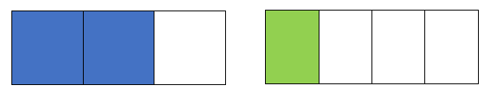

It is important for students to draw these two models the same size. Once the models are created, students will then need to be able to make all the pieces within each model the same size to be able to subtract. They then divide each piece of the $\frac{2}{3}$ model into fourths. They then divide each piece of the $\frac{1}{4}$ model into thirds. Now both models are divided in to 12 pieces and the subtraction problem can be represented as $\frac{8}{12}-\frac{3}{12}$. It is important to note that the area of the models did not change. Just because the fraction changed, the value of the fraction did not change.

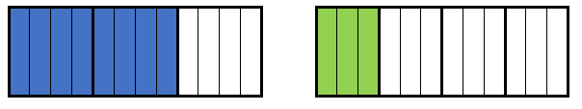

Now, students can subtract the same size pieces. So $\frac{2}{3}-\frac{1}{4}=\frac{5}{12}$.

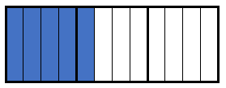

* Instruction includes concrete models and drawings that help solidify understanding that when adding and subtracting with unlike denominators, students are adding and subtracting pieces of the whole.
  + For example, the teacher emphasizes the use of area and number line models and presents expressions in numeral-word form to help understand that one over the denominator is the unit.
  + For example, “ $3 twelfths + 6 twelfths$ are equal to how many $twelfths$?” The denominator is 12 so one unit is equal to 1 twelfth.

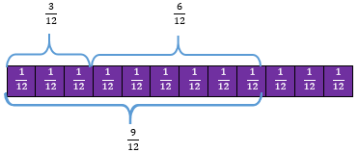

fraction addition equation

Instructional Tasks

*Instructional Task 1(MTR.2.1)*

Write an expression for the visual model below. Then find the sum.

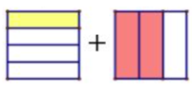

*Instructional Task 2 (MTR.2.1)*

Use a visual fraction model to find the value of the expression $\frac{3}{5}+\frac{4}{15}$.

*Instructional Task 3 (MTR.3.1)*

Find the value of the expression $3\frac{5}{6}+\frac{3}{8}$.

*Instructional Task 4 (MTR.3.1)*

Find the differences $\frac{5}{7}-\frac{2}{3}$ and $2\frac{1}{4}-\frac{4}{6}$.

Instructional Items

*Instructional Item 1*

Find the sum $\frac{5}{8}+\frac{7}{16}$.

$1\frac{2}{16}$

$\frac{12}{16}$

$1\frac{1}{16}$

$\frac{12}{24}$

*Instructional Item 2*

Find the difference $2\frac{1}{4}-\frac{3}{8}$.

$1\frac{2}{4}$

$1\frac{5}{8}$

$1\frac{7}{8}$

$2\frac{2}{8}$

Instructional Item 3

Represent the sum of $\frac{3}{4}+\frac{2}{3}$ on the number line.

Instructional Item 4

Find the sum of the expression below. Represent your answer in simplest form.

$5\frac{3}{4}+2\frac{1}{2}$

*The strategies, tasks and items included in the B1G-M are examples and should not be considered comprehensive.

### MA.5.FR.2.2

Benchmark

MA.5.FR.2.2 Extend previous understanding of multiplication to multiply a fraction by a fraction, including mixed numbers and fractions greater than 1, with procedural reliability.

Benchmark Clarifications:

*Clarification 1:* Instruction includes the use of manipulatives, drawings or the properties of operations.

*Clarification 2:* Denominators limited to whole numbers up to 20.

Connecting Benchmarks/Horizontal Alignment

* MA.5.NSO.2.1, MA.5.NSO.2.4
* MA.5.AR.1.2
* MA.5.GR.2.1

Terms from the K-12 Glossary

* Area Model

Distributive Property

Vertical Alignment

|  |  |
| --- | --- |
| **Previous Benchmarks**   * MA.4.FR.2.4 | **Next Benchmarks**   * MA.6.NSO.2.2 |

Purpose and Instructional Strategies

The purpose of this benchmark is for students to learn strategies to multiply two fractions. This continues the work from Grade 4 where students multiplied a whole number times a fraction and a fraction times a whole number (MA.4.FR.2.4). Procedural fluency will be achieved in Grade 6 (MA.6.NSO.2.2).

* During instruction, students are expected to multiply fractions less than one, fractions greater than one and mixed numbers efficiently and accurately.
* Visual fraction models (area models, tape diagrams, number lines) should be used and created by students *(MTR.2.1)*. Visual fraction models should show how a fraction is partitioned into parts that are the same as the product of the denominators.

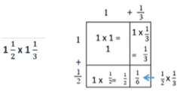

* When exploring an algorithm to multiply fractions ($\frac{a}{b}×\frac{c}{d}=\frac{a×c}{b×d}$), make connections to an accompanying area model. This will help students understand the algorithm conceptually and use it more accurately.
* Instruction includes students using equivalent fractions to simplify answers; however, putting answers in simplest form is not a priority.

Common Misconceptions or Errors

* Students may believe that multiplication always results in a larger number. Using models when multiplying with fractions will enable students to generalize about multiplication algorithms that are based on conceptual understanding (*MTR.5.1*).
* Students can have difficulty with word problems when determining which operation to use, and the stress of working with fractions makes this happen more often.
  + For example, “Mark has $\frac{3}{4}$ yards of rope and he gives a third of the rope to a friend. How much rope does Mark have left?” expects students to first find $\frac{1}{3}$ of $\frac{3}{4},$ or multiply $\frac{1}{3}$ x $\frac{3}{4}$, and then to find the difference to find how much Mark has left. On the other hand, “Mark has $\frac{3}{4}$ yards of rope and gives $\frac{1}{3}$ yard of rope to a friend. How much rope does Mark have left?” only requires finding the difference $\frac{3}{4}$- $\frac{1}{3}.$

Strategies to Support Tiered Instruction

* Instruction involves real-world examples and models which allow students to see that multiplication does not always result in a larger number.
  + For example, the teacher provides the problem: “Tau has $\frac{1}{4}$ of the lasagna pan leftover from the party in the refrigerator. He eats one half of the leftovers for dinner. How much of the lasagna did he eat for dinner?” This can be written as or “of”

An image showing two equal rectangles divided into four equal parts. the first rectangle has one fourth highlighted. The second rectangle has a fourth highlighted and then that fourth divided in half.

When students think about what is left in the refrigerator now, they must think in terms of the whole pan of lasagna. Tau didn’t eat half the pan; he ate half of the portion that was left. So how much of the whole pan did he eat?

An image of a rectangle divided into eigth equal parts. One eighth is highlighted.

Instructional Tasks

*Instructional Task 1 (MTR.4.1, MTR.7.1)*

Part A. Maritza has $4\frac{1}{2}$ cups of cream cheese. She uses $\frac{3}{4}$ of the cream cheese for a banana pudding recipe. After she uses it for the recipe, how much cream cheese will Maritza have left?

Part B. To find out how much cream cheese she used, Maritza multiplied $4\frac{1}{2}×\frac{3}{4}$ as $\left(4×\frac{3}{4}\right)+\left(\frac{1}{2}×\frac{3}{4}\right).$ Will this method work? Why or why not?

Part C. What additional step is required to find how much cream cheese she has left?

*Instructional Task 2*

Find the product, using manipulatives or the area model if needed.

$$7\frac{1}{7} x× 2\frac{2}{5}$$

|  |  |
| --- | --- |
|  |  |
|  |  |

*Instructional Task 3*

Six friends went strawberry picking. Each friend took $\frac{2}{3}$ pounds of strawberries home.

Part A. How many pounds of strawberries did they pick in total?

Part B. The next day, the friends gave $\frac{1}{3}$ of the total strawberries to their teacher. How many pounds of strawberries did their teacher receive?

*Instructional Task 4*

Use a number line to find the product.

$$9 × \frac{3}{4}$$

*Instructional Task 5*

Mario draws a rectangle with a length of $5\frac{1}{5}$ inches.

The width of the rectangle is one-half its length.

Part A. Draw Mario’s rectangle and label the dimensions.

Part B. What is the perimeter of Mario’s rectangle in inches?

Part C. What is the area of the rectangle in square inches?

*Instructional Task 6*

Jenna drew a rectangle that was $\frac{3}{5}$ inch long and $\frac{1}{2}$ inch wide. Create a model or use an equation to answer the questions.

Part A. What equation could you use to find the area of the rectangle?

Part B. What is the area of the rectangle in square inches?

Part C. What equation could you use to find the perimeter of the rectangle?

Part D. What is the perimeter of the rectangle in inches?

Instructional Items

*Instructional Item 1*

What is the product of $\frac{1}{5}×6\frac{1}{2}$?

$\frac{6}{10}$

$\frac{12}{5}$

$6\frac{7}{10}$

$1\frac{3}{10}$

*Instructional Item 2*

Select all the solutions equivalent to the product of $\frac{4}{5}×\frac{3}{4}$.

$\frac{12}{20}$

$\frac{3}{5}$

$\frac{7}{20}$

$\frac{7}{9}$

$\frac{6}{10}$

*Instructional Item 3*

Find the product. Express your answer in simplest form.

$$5×2\frac{3}{7}$$

*Instructional Item 4*

Use the model to solve the equation.

An image showing six equivalent circles and each one divided into five equal parts.

*The strategies, tasks and items included in the B1G-M are examples and should not be considered comprehensive.

### MA.5.FR.2.3

Benchmark

MA.5.FR.2.3 When multiplying a given number by a fraction less than 1 or a fraction greater than 1, predict and explain the relative size of the product to the given number without calculating.

Benchmark Clarifications:

*Clarification 1:* Instruction focuses on the connection to decimals, estimation and assessing the reasonableness of an answer.

Connecting Benchmarks/Horizontal Alignment

* MA.5.NSO.2.4, MA.5.NSO.2.5
* MA.5.GR.2.1

Terms from the K-12 Glossary

Equation

Vertical Alignment

|  |  |
| --- | --- |
| **Previous Benchmarks**   * MA.4.FR.2.4 | **Next Benchmarks**   * MA.6.NSO.2.2, MA.6.FR.NOS.2.3 |

Purpose and Instructional Strategies

The purpose of this benchmark is for students to examine how numbers change when multiplying by fractions *(MTR.2.1)*. Students previously multiplied fractions less than one by whole numbers in Grade 4 (MA.4.FR.2.4). Work with this benchmark will help prepare students to multiply and divide fractions and decimals with procedural fluency in Grade 6 (MA.6.NSO.2.2).

* It is important for students to have experiences examining:
  + when multiplying by a fraction greater than 1, the product increases in size.
  + multiplying by a fraction equal to 1, the product stays the same size; and
  + when multiplying by a fraction less the 1, the product decreases in size.
* Throughout instruction, encourage students to use models or drawings to assist them with a visual of the relative size. Models to consider when multiplying fractions to assist with finding relative size without calculating include, but are not limited to, area models (rectangles), linear models (fraction strips/bars and number lines) and set models (counters).
* Instruction includes examples with equivalent fractions and decimals *(MTR.2.1)*.
* Instruction includes multiplying fractions equal to one to create equivalent fractions. Equivalent fractions allow for efficient addition and subtraction of fractions with unlike denominators because the size of the units (in this case, fractional parts) are the same. For example, when adding , the addend is multiplied by to create the equivalent fraction $\frac{9}{12}$. The new expression, $\frac{9}{12}+1\frac{5}{12}$, is equivalent and has like denominators for adding efficiently.

Should explain and justify how they used the model or drawing to arrive at the solution and justify reasonableness of their answers *(MTR.4.1)*.

Common Misconceptions or Errors

* Students may believe that multiplication always results in a larger number. This is why it is imperative to include models during instruction when multiplying fractions. Students will observe that multiplying by a fraction less than one will result in a lesser product, but when multiplying by a fraction greater than one will result in a greater product.

Strategies to Support Tiered Instruction

* Instruction includes opportunities to predict and explain the relative size of the product of a given number by a fraction less than one or a fraction greater than one. Students use models to check their prediction and solve. The teacher guides students to connect that multiplying a given number by a fraction less than one will result in a smaller number and that multiplying a given number by a fraction greater than one will result in a larger number.

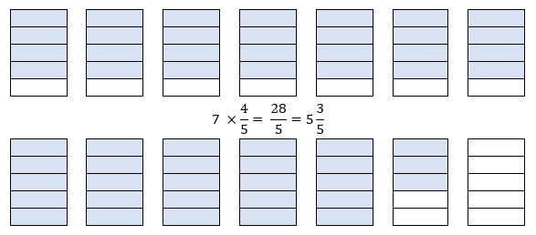

* + For example, the teacher displays the problem $7×\frac{4}{5}$ and asks students to predict if the product will be greater than, equal to, or less than 7 (it will be less than 7). Students use a visual model to represent the problem to determine $7 ×\frac{4}{5}= \frac{28}{5}$. This is repeated with additional examples using fractions both greater than, equal to, and less than one.
* Instruction includes providing hands-on opportunities to predict and explain the relative size of the product of a given number by a fraction less than one or a fraction greater than one. Students use fraction strips/bars or counters to check their prediction and solve, connecting that multiplying a given number by a fraction less than one will result in a smaller number and that multiplying a given number by a fraction greater than one will result in a larger number.
* For example, the teacher displays the problem $4×\frac{3}{8}= ___$. Then, the teacher asks students to predict if the product will be greater than, equal to, or less than 4 (it will be less than 4).
  + Using fraction bars or fraction strips, the teacher models solving this problem with explicit instruction and guided questioning. Students explain how to use fraction bars or fraction strips as a model to solve this problem. This is repeated with additional examples using fractions both greater than, equal to, and less than one.

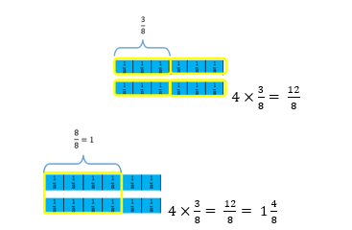

Instructional Tasks

*Instructional Item 1 (MTR.7.1)*

Derrick is playing a computer game where he must multiply a number by a factor that increases the number’s size each time. Select all of the factors that he could multiply by to continue to increase the size of his number? Explain how you determined your answers.

$\frac{3}{4}$

$\frac{4}{3}$

$1\frac{1}{9}$

$1.01$

$\frac{5}{2}$

$\frac{8}{9}$

$\frac{99}{100}$

$\frac{2}{2}$

*Instructional Task 2*

Using estimation instead of solving, determine which factors below would result in a lesser product when multiplied by $\frac{5}{6}$.

$\frac{5}{3}$

$\frac{3}{5}$

$\frac{6}{6}$

$\frac{99}{100}$

$\frac{100}{99}$

*Instructional Task 3*

Quinn works at a photo store. She uses a computer program to change the sizes of rectangular photos by typing a factor into the program. The program then multiplies the factor by the area of the original photo. Factors can make the original photo’s area larger, smaller, or stay the same size.

Explain how each factor below will affect the size of the photo after it is multiplied by the photo’s original area.

Part A. 0.50

Part B. 1.25

Part C. 1.00

Instructional Items

*Instructional Item 1*

Which of the following expressions will have a product greater than 4?



$4 ×\frac{8}{8}$

$\frac{3}{4}×4$

$4×\frac{99}{100}$

$\frac{101}{100}×4$

*Instructional Item 2*

Fill in the blank. The product of the expression $\frac{63}{65}×20$ will be _____________ 20.

* 1. less than
  2. equal to
  3. greater than
  4. half of

*Instructional Item 3*

Without calculating, explain whether the product of $78×\frac{9}{10}$ will be greater than or less than 78.

*The strategies, tasks and items included in the B1G-M are examples and should not be considered comprehensive.

### MA.5.FR.2.4

Benchmark

MA.5.FR.2.4 Extend previous understanding of division to explore the division of a unit fraction by a whole number and a whole number by a unit fraction.

Benchmark Clarifications:

*Clarification 1:* Instruction includes the use of manipulatives, drawings or the properties of operations.

*Clarification 2:* Refer to Situations Involving Operations with Numbers (Appendix A).

Connecting Benchmarks/Horizontal Alignment

* MA.5.NSO.2.2
* MA.5.AR.1.3

Terms from the K-12 Glossary

* Dividend
* Divisor
* Equation
* Whole number

Vertical Alignment

|  |  |
| --- | --- |
| **Previous Benchmarks**   * MA.4.FR.2.4 | **Next Benchmarks**   * MA.6.NSO.2.2, MA.6.NSO.2.3 |

Purpose and Instructional Strategies

The purpose of this benchmark is for students to experience division with whole number divisors and unit fraction dividends (fractions with a numerator of 1) and with unit fraction divisors and whole number dividends. This work prepares for division of fractions in Grade 6 (MA.6.NSO.2.2) in the same way that in Grade 4 (MA.4.FR.2.4) students were prepared for multiplication of fractions.

* Instruction should include the use of manipulatives, area models, number lines, and emphasizing the properties of operations (e.g., through fact families) for students to see the relationship between multiplication and division *(MTR.2.1)*.
* Throughout instruction, students should have practice with both types of division: a unit fraction that is divided by a non-zero whole number and a whole number that is divided by a unit fraction.
* Students should be exposed to all situation types for division (refer to Situations Involving Operations with Numbers (Appendix A).
* The expectation of this benchmark is not for students to use an algorithm (e.g., multiplicative inverse) to divide by a fraction.
* Instruction includes students using equivalent fractions to simplify answers; however, putting answers in simplest form is not a priority.

Common Misconceptions or Errors

* Students may believe that division always results in a smaller number, which is true when dividing a fraction by a whole number, but not when dividing a whole number by a fraction. Using models will help students develop the understanding needed for computation with fractions.

Strategies to Support Tiered Instruction

* Instruction includes making the connection to models and tools previously used to understand division as equal groups or sharing. The teacher uses models to develop the understanding needed for computation with fractions.
* For example, $8÷\frac{1}{4}$ can be shown using a model of 8 wholes divided into parts of size $\frac{1}{4}$. The quotient would be the total number of $\frac{1}{4}$ pieces. The model below would show that .

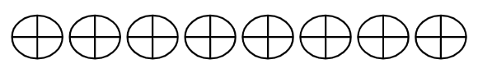

* + For example, $\frac{1}{4}÷8$ can be represented using the model below. One-fourth is divided into 8 equal parts, each part is $\frac{1}{32}$ of the whole.

Fraction visual


* Instruction includes real-world situations to interact with the content. The teacher provides students with a division expression with a real-world context and provides items to represent the situation to allow connections to be made.
  + For example, the teacher provides students with the following situation: “The teacher brought in 8 brownies to split between the class. She cut the brownies into pieces of size $\frac{1}{4}$ so there would be enough for the whole class. How many $\frac{1}{4}$ pieces will there be?” The teacher provides students with images of eight brownies (or models to represent them) and has them divide or cut them into $\frac{1}{4}$ pieces to determine how many pieces they will have (32 pieces).
* For example,the teacher provides students with the following situation: “The teacher baked a pan of brownies. All but $\frac{1}{4}$ of the pan was eaten. She brought in the remaining $\frac{1}{4}$ and divided it into 8 equal pieces for her co-teachers. What fraction of the whole pan will each person get?”The teacher provides students with an image of a pan of brownies with $\frac{1}{4}$ left (or model to represent it). The students divide the $\frac{1}{4}$ portion into 8 equal pieces. The teacher then connects the remaining part of the brownies to the whole pan so that students can make the connection to the total number of the smaller pieces representing $\frac{1}{32}$ of the whole.

Instructional Tasks

*Instructional Task 1 (MTR.5.1, MTR.7.1)*

Part A. Emily has 2 feet of ribbon to make friendship bracelets. Use models and equations to answer the questions below.

1. How many friendship bracelets can she make if each bracelet uses 2 feet of ribbon?
2. How many friendship bracelets can she make if each bracelet uses 1 foot of ribbon?
3. How many friendship bracelets can she make if each bracelet uses 1 half foot of ribbon?
4. How many friendship bracelets can she make if each bracelet uses 1 third foot of ribbon?
5. How many friendship bracelets can she make if each bracelet uses 1 fifth foot of ribbon?

Part B. Do you see any patterns in the models and equations you have written? Explain.

*Instructional Task 2*

Students will need one number cube to create division expressions and find their quotients.

Part A. Students will roll a number cube twice. The first roll will indicate the whole-number dividend of the expression. The second roll will indicate the denominator of the divisor. The numerator of the divisor will always be 1 so that remains a unit fraction.

* For example, if a student rolls a 2 and then a 6, their expression would be $2÷\frac{1}{6}$.

Part B. Students will find the quotient of the whole number and unit fraction. Then they should write an equation to match.

Part C. Students will swap the dividend and divisor, and then find the quotient of the new expression. Then they should write an equation to match.

Part D. Students should compare the quotients, describing what is similar and what is different.

*Instructional Task 3*

Part A. Use a visual model to find the quotient of $8÷\frac{1}{9}$.

Part B. Use a visual model to find the quotient of $\frac{1}{9}÷8$.

*Instructional Task 4*

Will $\frac{1}{3}÷8$ have the same quotient as $8÷\frac{1}{3}$? Use properties of operations to justify your answer.

Instructional Items

*Instructional Item 1*

What is the quotient of $\frac{1}{3}÷5$?

$\frac{1}{15}$

$15$

$\frac{5}{3}$

$\frac{3}{5}$

*Instructional Item 2*

How many one-fourths are in 8 wholes?

1. 4
2. 8
3. 16
4. 32

*Instructional Item 3*

Write a division equation to match the area model displayed.

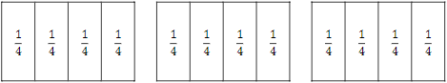

*Instructional Item 4*

Write a division equation to match the number line displayed.

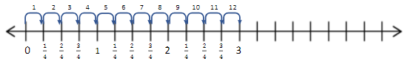

*The strategies, tasks and items included in the B1G-M are examples and should not be considered comprehensive.

## Algebraic Reasoning

**MA.5.AR.1***Solve problems involving the four operations with whole numbers and fractions.*

### MA.5.AR.1.1

Benchmark

MA.5.AR.1.1 Solve multi-step real-world problems involving any combination of the four operations with whole numbers, including problems in which remainders must be interpreted within the context.

Benchmark Clarifications:

*Clarification 1*: Depending on the context, the solution of a division problem with a remainder may bethe whole number part of the quotient, the whole number part of the quotient with the remainder, the whole number part of the quotient plus 1, or the remainder.

Connecting Benchmarks/Horizontal Alignment

* MA.5.NSO.2.1, MA.5.NSO.2.2
* MA.5.FR.1.1
* MA.5.GR.3.3
* MA.5.GR.4.2
* MA.5.DP.1.2

Terms from the K-12 Glossary

* Dividend
* Divisor
* Equation
* Whole number

Vertical Alignment

|  |  |
| --- | --- |
| **Previous Benchmarks**   * MA.3.AR.1.2 * MA.4.AR.1.1 | **Next Benchmarks**   * MA.6.NSO.2.3 |

Purpose and Instructional Strategies

The purpose of this benchmark is for students to solve multistep word problems with whole numbers and whole-number answers involving any combination of the four operations. Work in this benchmark continues instruction from Grade 4 where students interpreted remainders in division situations (MA.4.AR.1.1) *(MTR.7.1*) and prepares for solving multi-step word problems involving fractions and decimals in Grade 6 (MA.6.NSO.2.3).

* To allow for an effective transition into algebraic concepts in Grade 6 (MA.6.AR.1.1), it is important for students to have opportunities to connect mathematical statements and number sentences or equations.
* During instruction, teachers can allow students an opportunity to practice with word problems that require multiplication or division which can be solved by using drawings and equations, especially as the students are making sense of the context within the problem *(MTR.5.1)*.
* Teachers may have students practice with representing an unknown number in a word problem with a variable by scaffolding from the use of only an unknown box.
* Offer word problems to students with the numbers covered up or replaced with symbols or icons and ensure to ask students to write the equation or the number sentence to show the problem type situation *(MTR.6.1)*.
* Interpreting number pairs on a coordinate graph can provide students opportunities to solve multi-step real-world problems with the four operations (MA.5.GR.4.2).

Common Misconceptions or Errors

* Students may apply a procedure that results in remainders that are expressed as $r$ for ALL situations, even for those in which the result does not make sense.
  + For example, when a student is asked to solve the following problem: “There are 34 students in a class bowling tournament. They plan to have 3 students in each bowling lane. How many bowling lanes will they need so that everyone can participate?” the student response is “11 $r$ 1 bowling lanes,” without any further understanding of how many bowling lanes are needed and how the students may be divided among the last 1 or 2 lanes. To assist students with this misconception, pose the question “What does the quotient mean?”
  + It is essential to guide students in tackling real-world problems that may provide a quotient with a remainder, where interpretation may be necessary. Teachers can create environments where students relate remainders back to the contexts of the problems. For example, prompt students to consider whether it is plausible to have half of a person/object or if the problem is seeking complete groups. Remind students that interpreting remainders is contingent upon the problem's context and the specific information the problem aims to reveal. Encourage critical thinking and application of mathematical concepts in practical scenarios.

Strategies to Support Tiered Instruction

|  |  |  |  |  |  |  |  |  |
| --- | --- | --- | --- | --- | --- | --- | --- | --- |
| * Instruction includes opportunities to engage in guided practice completing multi-step word problems with any combination of the four operations, including problems with remainders. Students use drawings and models to understand how to interpret the remainder in situations in which they will need to drop the remainder as their solution.   + For example, the teacher displays and reads the following problem aloud: “There are 58 fourth grade students and 45 fifth grade students going on a class field trip. They plan to have 20 students in each van. How many vans will they need so that everyone can participate?”Students use models or drawings to represent the problem and write an equation to represent the problem. The teacher uses guided questioning to encourage students to identify that they will need to add one to the quotient as their solution. If students state that they will need $5r3$ vans, the teacher refers to the models to prompt students that a sixth van is needed for the remaining three students. If students state that they will need 3 more vans since the remainder is 3, the teacher reminds students through guided questioning that the remainder of 3 represents 3 remaining students and only 1 more van is needed (i.e., “add 1 to the quotient”). This is repeated with similar multistep real-world problems, asking students to explain what the quotient means in problems involving remainders.  |  |  | | --- | --- | | **An image of lines which represent ten students and dots in which each dot represent a single student. The lines and dots are grouped together with twenty students in each group. There are three dots not in a group.** | **The same image that was just described. The five groups represent five vans that are needed. The three dots are grouped showing a need for a sixth van.** | | They will need 6 vans so everyone can participate on the trip. | They will need 6 vans so everyone can participate on the trip. $$v=van$$ |  * Instruction includes opportunities to engage in practice with explicit instruction completing multi-step word problems with any combination of the four operations, including problems with remainders. Students use manipulatives to understand how to interpret the remainder in situations in which they will need to drop the remainder as their solution.   + For example, the teacher displays and reads the following problem aloud: “There are 18 red markers and 26 black markers on the art table. Ms. Williams is cleaning up and can put 10 markers in each box. How many boxes will she need so all the markers will be put away into a box??” The teacher uses manipulatives (e.g., place-value blocks) to represent the problem, having students write an equation to represent the problem. The teacher uses guided questioning to encourage students to identify that they will need to add 1 to the quotient as their solution. If students state that she will need 4 $r4$ boxes, the teacher refers to the models to prompt students that a fifth box is needed for the remaining four markers. If students state that they will need 4 more boxes since the remainder is 4, the teacher reminds students through guided questioning that the remainder of 4 represents 4 remaining markers and only 1 more box is needed (i.e., “add 1 to the quotient”). This is repeated with similar multistep real-world problems, asking students to explain what the quotient means in problems involving remainders.  |  |  | | --- | --- | | **An image of lines which represent ten unit blocks and dots in which each dot represent a single unit block. The lines and dots are grouped together with ten blocks in each group. There are four blocks not in a group.** | **The same image that was just described. The four groups represent four boxes that are needed. The four blocks are grouped showing a need for a fifth box.** | |  | Ms. Williams will need 5 boxes. $$b=box$$ | |

Instructional Tasks

*Instructional Task 1 (MTR.6.1)*

There are 128 girls in the Girl Scouts Troop 1653 and 154 girls in the Girl Scouts Troop 1764. Both Troops are going on a camping trip. Each bus can hold 36 girls. How many buses are needed to get all the girls to the camping site?

*Instructional Task 2*

Every year, Alex receives a monthly budget for buying video games. The price of video games has been increasing each year.

|  |  |
| --- | --- |
| Year | Video Game Prices |
| 2020 | $21 |
| 2021 | $42 |
| 2022 | $54 |
| 2023 | $63 |

* + 1. In 2020, Alex’s monthly budget for video games was $70. How many video games could he buy with one month’s budget?
    2. If Alex’s budget remained $70 per month, how many video games could he buy in 2023?
    3. In 2022, Alex’s monthly budget increased to $80 a month. How much did Alex’s monthly budget increase between 2020 and 2022?
    4. How much more did a video game cost in 2020 than it did in 2023?
    5. What would Alex’s monthly allowance need to be in 2023 in order for him to be able to buy as many video games as he could in 2020?

*Instructional Task 3*

Jennifer and her classmates picked 200 apples. They enjoyed snacking on 119 of the apples and then shared the remaining apples equally among nine baskets. Unfortunately, on their way to the bus, Jennifer accidentally knocked over one basket, resulting in the loss of those apples. How many apples were placed in the bus?

*Instructional Task 4(MTR.7.1)*

Nancy has 478 one-dollar bills that she wants to divide equally between her 7 friends.

1. How much money will each person receive? How much money will Nancy have left over?
2. Nancy exchanged the remaining one-dollar bills for nickels. If she divides the coins equally between her 7 friends, how much money will each friend get? How many nickels, if any, will remain?

Instructional Items

*Instructional Item 1*

A shoe store orders 17 cases each containing 142 pairs of sneakers and 12 cases each containing 89 pairs of sandals. How many more pairs of sneakers did the store order?

*Instructional Item 2 (MTR.3.1)*

For a fundraiser to replace the seats in the auditorium, Stanley raised $342 last month and $780 this month. He wants to buy as many seats to place in the auditorium at school as possible. Each seat costs $11. How many seats can Stanley buy?

*Instructional Item 3*

Augusta had $2,385. She spent $729 on a new computer. She wants to spend the rest of her money on different computer accessories. Each accessory cost $65. What is the maximum number of accessories Augusta can buy?

* + 1. 25 accessories
    2. 26 accessories
    3. 27 accessories
    4. 28 accessories

*The strategies, tasks and items included in the B1G-M are examples and should not be considered comprehensive.

### MA.5.AR.1.2

Benchmark

MA.5.AR.1.2 Solve real-world problems involving the addition, subtraction or multiplication of fractions, including mixed numbers and fractions greater than 1.

*Example:* Shanice had a sleepover, and her mom is making French toast in the morning. If her mom had $2\frac{1}{4}$ loaves of bread and used $1\frac{1}{2}$ loaves for the French toast, how much bread does she have left?

Benchmark Clarifications:

*Clarification 1*: Instruction includes the use of visual models and equations to represent the problem.

Connecting Benchmarks/Horizontal Alignment

* MA.5.FR.2.1, MA.5.FR.2.2
* MA.5.M.1.1
* MA.5.GR.2.1
* MA.5.DP.1.1

Terms from the K-12 Glossary

* Equation

Vertical Alignment

|  |  |
| --- | --- |
| **Previous Benchmarks**   * MA.4.AR.1.2, MA.4.AR.1.3 | **Next Benchmarks**   * MA. 6.NSO.2.3 |

Purpose and Instructional Strategies

The purpose of this benchmark is to continue the work from Grade 4 where students began solving real-world problems with fractions and prepares them for Grade 6 (MA.6.NSO.2.3) where they will solve real-world fraction problems using all four operations with fractions *(MTR.7.1)*.

* Students need to develop an understanding that when adding or subtracting fractions, the fractions must refer to the same whole.
* During instruction, teachers can provide opportunities for students to practice solving problems using models or drawings to add, subtract or multiply with fractions. Begin with students modeling with whole numbers, have them explain how they used the model or drawing to arrive at the solution, then scaffold using the same methodology using fraction models. Instruction allows students to continue building an understanding of fraction operations through modeling and the use of manipulatives.
* Students are encouraged to express problem-solving solutions through various means, such as objects, illustrations, tables, graphs, and equations (MTR.2.1). When tackling fraction-related challenges, it is advisable to employ diverse models, including but not confined to area models (rectangles), linear models (fraction strips/bars and number lines), and set models (counters). There should be student progression from solving problems with physical manipulatives and illustrations to the utilization of algorithms and equations. Students should articulate the relationships between different concepts and representations, while also selecting the most suitable representation based on the specific context or purpose of the question.
* Please note that it is not expected for students to always find least common multiples or make fractions greater than 1 into mixed numbers, but it is expected that students know and understand equivalent fractions, including naming fractions greater than 1 as mixed numbers to add, subtract or multiply.
* It is important that teachers have students rename the fractions with a common denominator when solving addition and subtraction fraction problems, in lieu of using tricks, shortcuts, or mnemonics, to ensure students build a conceptual understanding.

Common Misconceptions or Errors

* When solving real-world problems, students can often confuse contexts that require subtraction and multiplication of fractions.
  + For example, “Mark has $¾$ yards of rope and he gives half of the rope to a friend. How much rope does Mark have left?” expects students to find $½$ of $¾$, or multiply $½×¾$ to find the product that represents how much is given to the friend. On the other hand, “Mark has $¾$ yards of rope and gives $½$ yard of rope to a friend. How much rope does Mark have left?” expects students to take $½$ yard from $¾$ yard or subtract $¾-½$ to find the difference. Encourage students to look for the units in the problem (e.g., $½$ yard versus $½$ of the whole rope) to determine the appropriate operation.
* Students may believe that multiplication always results in a larger number. Using models when multiplying with fractions will enable students to generalize about multiplication algorithms that are based on conceptual understanding (*MTR.5.1*). Encourage students to use their number sense when determining the size of a product (connecting to MA.5.FR.2.3). The teacher can ask students what they know about multiplying fractions to determine how the numbers in the problem are related.
* Students can have difficulty with word problems when determining which operation to use, and the stress of working with fractions makes this happen more often. Students need to apply what they already know about operations with fractions to create action plans to solve multi-step real-world problems involving fractions.
  + For example, “Mark has $\frac{3}{4}$ yards of rope and he gives a third of the rope to a friend. How much rope does Mark have left?” expects students to first find $\frac{1}{3}$ of $\frac{3}{4},$ or multiply $\frac{1}{3}×\frac{3}{4}$, and then to find the difference to find how much Mark has left. On the other hand, “Mark has $\frac{3}{4}$ yards of rope and gives $\frac{1}{3}$ yard of rope to a friend. How much rope does Mark have left?” only requires finding the difference $\frac{3}{4}-\frac{1}{3}$.
  + With guiding questions, teachers can ask students what operation will be needed to solve the problem. Prompt students to indicate what the first action step will be before they solve. If students struggle to find the first step of the problem, encourage them to create a visual model while rereading.

Strategies to Support Tiered Instruction

* Instruction includes opportunities to identify the appropriate operation to use in a real-world problem that requires addition, subtraction, or multiplication of fractions. The teacher guides students to identify the units in the problem for clarification on which operation is appropriate.
  + For example, the teacher displays and reads the following two problems:
    - “Gina has $\frac{7}{8}$ of a bar of chocolate left and gives half of what she has to her friend Sarah. How much of a whole chocolate bar does she have left?”
    - “Gina has $\frac{7}{8}$ of a bar of chocolate left and she gives $\frac{1}{2}$ of the original bar of chocolate to her friend Sarah. How much of her chocolate bar does she have left?” (See illustration below)

The teacher uses questioning and prompting to have students identify what operations must be used to solve each problem. The teacher asks students to share what they notice about each problem (e.g., the similarities and the differences), placing emphasis on the units (e.g., “half of the amount of chocolate that Gina has in the first problem vs. $\frac{1}{2}$ of the whole chocolate bar*”* in the second problem). The teacher guides students to identify that in the first problem, they will need to multiply $\frac{7}{8}×\frac{1}{2}$ and in the second problem, they will need to subtract $\frac{7}{8}-\frac{1}{2}$ to solve. Students solve using models.

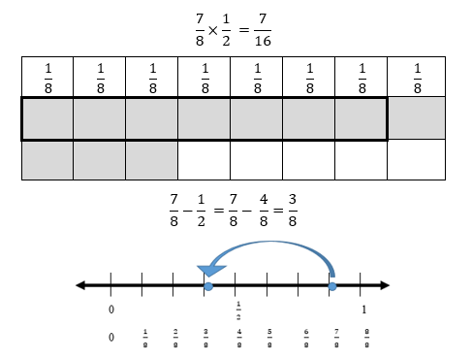

* + For example, the teacher displays and reads the following problem: “Tia has $\frac{3}{8}$ yards of ribbon and she gives half of the ribbon to a friend. How much ribbon does Tia have left?” The teacher uses questioning and prompting to have students identify what operation must be used to solve the problem. The teacher asks students, “Did Tia give half of the ribbon or half a yard of ribbon to her friend?” Emphasis is placed on the units (e.g., half of the whole ribbon vs. $\frac{1}{2}$ yard of ribbon) while guiding students to identify that they will need to multiply $\frac{3}{8}×\frac{1}{2}$ to solve. Students solve using the area model and counters. The cells with both color counters indicate the numerator in the solution. This is repeated with similar word problems, using frequent guiding questions to support student understanding.

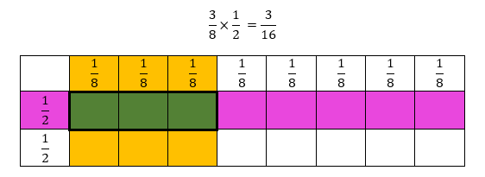

* Instruction includes opportunities to use models when solving problems that involve multiplication of fractions to increase understanding that multiplication does not always result in a larger number. The use of models when multiplying with fractions will enable students to generalize about multiplication algorithms that are based on conceptual understanding.
  + For example, the teacher displays and reads aloud the following problem: “Rosalind spent $\frac{2}{3}$ of an hour helping in the garden. Her sister spent $\frac{1}{2}$ the amount of time as Rosalind did helping in the garden. How much time did Rosalind’s sister spend helping in the garden?” Students solve the problem using an area model. The teacher uses questioning to help students draw a model to represent the problem. This is repeated with similar word problems involving multiplication of fractions.

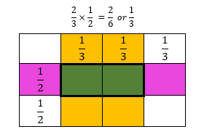

* + For example, the teacher displays and reads aloud the following problem: “Astrid spent $\frac{7}{8}$ of an hour reading her book. Elliot spent $\frac{1}{3}$ the amount of time as Astrid did reading. How much time did Elliot spend reading?” Students solve using the area model and counters. The cells with both color counters indicate the numerator in the solution. The teacher uses questioning to help students draw a model to represent the problem. This is repeated with similar word problems involving multiplication of fractions, using frequent guiding questions to support student understanding.

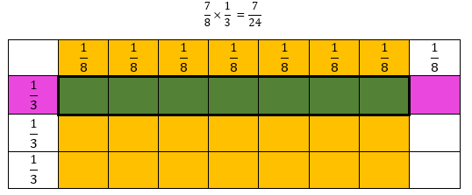

Instructional Tasks

*Instructional Task 1 (MTR.7.1)*

Rachel wants to bake her two favorite brownie recipes. One recipe needs $1\frac{1}{2}$ cups of flour and the other recipe needs $\frac{3}{4}$ cups of flour. How much flour does Rachel need to bake her two favorite brownie recipes?

*Instructional Task 2 (MTR.7.1)*

Shawn finished a 100-meter race in $\frac{3}{8}$ of one minute. The winner of the race finished in $\frac{1}{3}$ of Shawn’s time. How long did it take for the winner of the race to finish?

*Instructional Task 3*

Megan has a collection of 80 stickers, and $\frac{1}{5}$ of them feature cars, while $\frac{1}{4}$ of the stickers have animals. The remaining stickers display various types of shapes. How many stickers in Megan’s collection feature shapes?

*Instructional Task 3*

Megan has a collection of 80 stickers, and $\frac{1}{5}$ of them feature cars, while $\frac{1}{4}$ of the stickers have animals. The remaining stickers display various types of shapes. How many stickers in Megan’s collection feature shapes?

*Instructional Task 4 (MTR.7.1)*

Some of the problems below can be solved by multiplying $\frac{1}{4}$ $×\frac{3}{5}$, while others require a different operation to solve. Select the situations that can be solved using the expression $\frac{1}{4}×\frac{3}{5}$. For the other situations, indicate what operation is needed to solve, then solve.

1. One-fourth of the students in Gary’s fifth-grade class are boys. Three-fifths of the boys wear a blue shirt. What fraction of Gary’s class are boys wearing blue shirts?
2. A rectangular field is divided into two sections. One section is $\frac{1}{4}$ of the total area, and the other section is $\frac{3}{5}$ of the total area. What fraction of the field is left unoccupied?
3. There is $\frac{1}{4}$ box of chocolates left over after a party. If George eats another $\frac{3}{5}$ of the original box of chocolates, what fraction of the original box is left over?
4. A factory produces two types of products. One product is $\frac{1}{4}$ of the factory's total production, and the other product is is $\frac{3}{5}$ of the factory’s total production. What fraction of the total production is made up of these products combined?
5. A recipe calls for $\frac{1}{4}$ cup of sugar. Mary wants to make of the recipe. How much sugar, in cups, should Mary use in her scaled-down version of the recipe?
6. In a deck of cards, of the cards are spades, and of the spades are face cards (jack, queen, king). What fraction of the deck is a face card that is also a spade?
7. At the picnic, of the attendees brought sandwiches, and of those who brought sandwiches also brought drinks. What fraction of the attendees brought both sandwiches and drinks?

Instructional Items

*Instructional Item 1*

Monica has 2 $\frac{3}{4}$ cups of berries. She uses $\frac{5}{8}$ cups of berries to make a smoothie. She then uses $\frac{1}{2}$ cup for a fruit salad. After she makes her smoothie and fruit salad, how many cups of berries will Monica have left?

*Instructional Item 2*

Michelle paints a wall that is 6 $\frac{1}{4}$ feet high and 62 $\frac{3}{4}$ feet long. How many square feet does he paint?

* + 1. 372square feet
    2. 392 $\frac{1}{2}$ square feet
    3. 392 $\frac{3}{16}$ square feet
    4. 393 $\frac{3}{4}$ square feet

*The strategies, tasks and items included in the B1G-M are examples and should not be considered comprehensive.

### MA.5.AR.1.3

Benchmark

MA.5.AR.1.3 Solve real-world problems involving division of a unit fraction by a whole number and a whole number by a unit fraction.

*Example:* A property has a total of $\frac{1}{2}$ acre and needs to be divided equally among 3 sisters. Each sister will receive $\frac{1}{6}$ of an acre.

*Example:* Kiki has 10 candy bars and plans to give $\frac{1}{4}$ of a candy bar to her classmates at school. How many classmates will receive a piece of a candy bar.

Benchmark Clarifications:

*Clarification 1*: Instruction includes the use of visual models and equations to represent the problem.

Connecting Benchmarks/Horizontal Alignment

* MA.5.NSO.2.2
* MA.5.FR.2.4

Terms from the K-12 Glossary

* Dividend
* Divisor
* Equation
* Whole Number

Vertical Alignment

|  |  |
| --- | --- |
| **Previous Benchmarks**   * MA.4.AR.1.3 | **Next Benchmarks**   * MA.6.NSO.2.3 |

Purpose and Instructional Strategies

The purpose of this benchmark is to connect division of fraction concepts to real-world scenarios *(MTR.7.1)*. This work builds on the multiplication of fractions by whole numbers in Grade 4 (MA.4.AR.1.3) and prepares them for solving real-world fraction problems using all four operations with fractions in Grade 6 (MA.6.NSO.2.3). Additionally, students divide a unit fraction by a non-zero whole number (MA.5.FR.2.4) using division concepts learned in (5.NSO.2.2).

* During instruction, it is important for students to have opportunities to extend their understanding of the meaning of fractions, how many unit fractions are in a whole, and their understanding of division of fractions as involving equal groups or shares and the number of objects in each.
* Students should use visual fraction models and reasoning to solve word problems involving division of fractions.
  + For example, to assist students with solving the problem, “The elephant eats 4 pounds of peanuts a day. His trainer gives him $\frac{1}{5}$ pound at a time. How many times a day does the elephant eat peanuts?” use the following diagram to show how $4÷\frac{1}{5}$ can be visualized to assist students with solving.

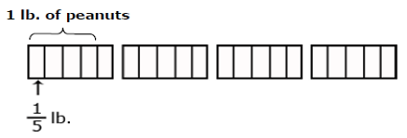

* The expectation of this benchmark is not for students to use a specific algorithm multiplicative inverse for dividing fractions. Instead, it is encouraged for students to enhance their understanding by drawing and labeling diagrams. Teachers should present real-world scenarios where it is inherent for students to divide a unit fraction by a non-zero whole number or a whole number by a unit fraction *(MTR.7.1)*.
* Instruction includes allowing students to visualize and practice using patterns and structure to divide unit fractions by non-zero whole numbers (*MTR.5.1*).
* Instruction includes students using equivalent fractions to simplify answers; however, putting answers in simplest form is not a priority.

Common Misconceptions or Errors

* Students may believe that division always results in a smaller number, which is true when dividing a fraction by a whole number, but not when dividing a whole number by a fraction. Using models will help students develop the understanding needed for computation with fractions.

Strategies to Support Tiered Instruction

* Instruction includes opportunities to engage in teacher-directed practice using visual representations to solve real-world problems involving division of a unit fraction by a whole number or a whole number by a unit fraction. The teacher directs students on how to use models or equations based on real-world situations. Through questioning, the teacher guides students to explain what each fractional portion represents in the problems used during instruction and practice.
  + For example, the teacher displays and reads aloud the following problem: “Julio has 6 packages of cookies. He is making gift bags for people at school. Each bag will contain $\frac{1}{3}$ of a package of cookies. How many gift bags can he make?”

Using models, the teacher solves the problem with guided questioning, having students explain how to use models to solve this question. The teacher guides students to create an equation to represent the problem. This is repeated with multiple real-world examples that involve division of a unit fraction by a whole number or a whole number by a unit fraction. If a student struggles to draw a picture of the problem, guide them along by asking what item in the question is being divided, and into how many/what size parts. Encourage and remind students to use pictures or objects.

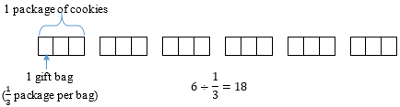

* Teacher provides opportunities to use hands-on models and manipulatives to solve real-world problems involving division of a unit fraction by a whole number or a whole number by a unit fraction. Students explain how each model represents the real-world situation. The teacher directs students how to use models or equations based on real-world examples and through questioning, guide students to explain what each fractional portion represents in the problems used during instruction and practice.
  + For example, the teacher displays and reads aloud the following problem: “Shelton made some lemonade. The pitcher of lemonade holds 8 cups. If each of the glasses that he uses can hold $\frac{1}{2}$ cup, how many servings of lemonade can he share?” Using fraction bars or fraction strips, the teacher models solving the problem with explicit instruction and guided questioning. Students explain how to use fraction bars or fraction strips as a model to solve this question and use an equation to represent the problem. This is repeated with multiple real-world problems that involve multiplication of a whole number by a fraction or a fraction by a whole number.

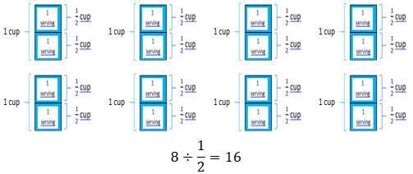

Instructional Tasks

*Instructional Task 1 (MTR.6.1, MTR.7.1)*

Sonya has $\frac{1}{2}$ gallon of chocolate chip ice cream. She wants to share her ice cream with 6 friends. How much ice cream will each friend get?

*Instructional Task 2 (MTR.6.1, MTR.7.1)*

A string that is 8 feet long is cut into pieces that are each $\frac{1}{8}$ feet long. How many pieces are there? Explain your work and draw a picture to support your reasoning.

*Instructional Task 3*

Jenna is painting her room. She needs $\frac{2}{3}$ gallon to paint the whole room. What fraction of a gallon will she need for each of her $4$ walls if she uses the same amount of paint on each? Explain your work and draw a picture to support your reasoning.

*Instructional Task 4*

Solve the following problems. Which of the following problems involves finding the result of ?

1. Amy buys three feet of rope and cuts it into pieces, each measuring foot. How many pieces of rope does she have?
2. Jen bakes three dozen cookies. During a party, half of the cookies are eaten. How many cookies are eaten at the party?
3. A gardener plants three rows of flowers in a garden. To ensure equal spacing, each row is separated by $\frac{1}{2}$ foot. How much space is there between the rows of flowers?
4. Mike shares s a 3-liter bottle of juice equally among his friends. Each friend receives $\frac{1}{2}$ liter of juice. To how many friends can Mike give juice?

Instructional Items

*Instructional Item 1*

Betty has 12 sheets of tissue paper to add to her holiday gift bags. Each gift bag needs $\frac{1}{3}$ sheet of tissue paper. How many holiday gift bags can Betty fill?

*Instructional Item 2*

Mr. Smith has a rectangular table with an area of 15 square feet and another square table with an area of 9 square feet. He plans to cover both tables with tiles, where each tile has an area of $\frac{1}{3}$ square foot. How many tiles does he need to completely cover both tables without any gaps or overlaps?

*Instructional Item 3 (MTR.5.1, MTR.6.1)*

What is the quotient of $\frac{1}{7}$ and 9?

$\frac{7}{9}$

$2\frac{2}{7}$

$\frac{1}{63}$

1. 63

*The strategies, tasks and items included in the B1G-M are examples and should not be considered comprehensive.

**MA.5.AR.2***Demonstrate an understanding of equality, the order of operations and equivalent numerical expressions.*

### MA.5.AR.2.1

Benchmark

MA.5.AR.2.1 Translate written real-world and mathematical descriptions into numerical expressions and numerical expressions into written mathematical descriptions.

*Example:* The expression $4.5 + (3×2)$ in word form is $four and five tenths$ plus the quantity $3$ times $2$.

Benchmark Clarifications:

*Clarification 1:* Expressions are limited to any combination of arithmetic operations, including parentheses, with whole numbers, decimals and fractions.

*Clarification 2:* Within this benchmark, the expectation is not to include exponents or nested grouping symbols.

Connecting Benchmarks/Horizontal Alignment

* MA.5.NSO.1
* MA.5.NSO.2.1, MA.5.NSO.2.2
* MA.5.NSO.2.3
* MA.5.AR.3.1
* MA.5.M.1.1

Terms from the K-12 Glossary

* Expression

Vertical Alignment

|  |  |
| --- | --- |
| **Previous Benchmarks**   * MA.4.AR.2.2 | **Next Benchmarks**   * MA.6.AR.1.1 |

Purpose and Instructional Strategies

* The purpose of this benchmark is for students to translate between numerical and written mathematical expressions. This builds from previous work where students wrote equations with unknowns in any position of the equation in Grade 4 (MA.4.AR.2.2). Algebraic expressions are a major theme in Grade 6 starting with MA.6.AR.1.1. Students continue to deepen their understanding of operations with whole numbers (MA.5.NSO.2.1/2.2).
* During instruction, teachers should model how to translate numerical expressions into words using correct vocabulary. This includes naming fractions and decimals correctly. Students should use diverse vocabulary to describe expressions.
  + For example, in the expression $4.5+(3×2)$ could be read in multiple ways to show its operations. Students should explore them and find connections between their meanings *(MTR.1.1, MTR.3.1, MTR.4.1, MTR.5.1)*.
    - *4 and five tenths plus the quantity 3 times 2*
    - *4 and 5 tenths plus the product of 3 and 2*
    - *The sum of 4 and 5 tenths and the quantity 3 times 2*
    - *The sum of 4 and 5 tenths and the product of 3 and 2*
* The expectation of this benchmark is to not use exponents or nested grouping symbols. Nested grouping symbols, such as braces and brackets, refer to grouping symbols within one another in an expression, like in . Explain to students that parentheses make the expression clearer, but they are not necessary when multiplication comes before addition, as seen in the example.
* Instruction of this benchmark helps students understand the order of operations, the expectation of MA.5.AR.2.2.

Teachers can encourage and motivate students to utilize properties to rewrite expressions. Instruction includes a review of the distributive, associative, and commutative properties of addition and multiplication. Reinforce the concept that the distributive property involves the distribution of multiplication over addition, while the commutative property entails a change in the order of the terms

Common Misconceptions or Errors

* Students can misrepresent decimal and fraction numbers in words. This benchmark helps students practice naming numbers according to place value.
* Some students can confuse the difference between what is expected in the expressions $5\left(9+3\right)$ and $5+\left(9+3\right).$ Students need practice naming the former as multiplication (e.g., 5 times the sum of 9 and 3) and understanding that in that expression, both $5$ and $9+3$ are factors.
* Students may have confusion with parentheses. Misplacement or omission of parentheses can lead to incorrect interpretations of expressions. Students might forget to use parentheses where necessary or include unnecessary ones, altering the meaning of the expression.
* Additional misinterpretations include misunderstanding the order of operations, where a student mistakenly performs an operation over another (e.g. addition before multiplication with no parentheses present).

Strategies to Support Tiered Instruction

* Instruction includes opportunities to name fractions and decimals correctly according to place value. The teacher provides students a place value chart to support correctly naming decimals. Students use appropriate terminology for naming fractions.
  + For example, write 8.601 in standard form and word form in a place value chart.

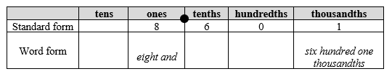

* + For example, students write 10.36 in standard form and word form in a place value chart.

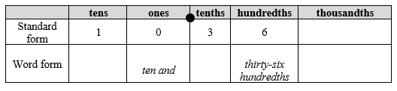

* + For example, students write 2.47 in standard form and word form in a place value chart using place value disks. Place value disks can be used as a visual representation in addition to the place value chart.

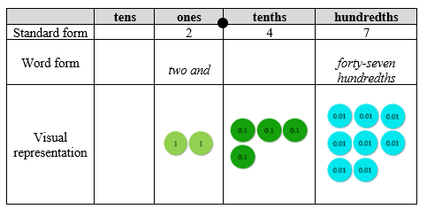

* + For example, students write $\frac{5}{12}$ in word form (*five twelfths*).
  + For example, students write $2\frac{7}{8}$ in word form (*two and seven eighths*).

This is repeated with additional fractions and decimals.

* Instruction includes opportunities to correctly translate numerical expressions into words using appropriate vocabulary.
  + For example, the teacher has students read aloud the following expression and write in word form. Next, the teacher models one way of reading aloud and has students provide alternate ways while using guiding questioning to facilitate the conversation about the multiple ways the expression can be read aloud to show its operations (*MTR.2.1*)
 $$18.49-(27÷3)$$

   - Eighteen and forty-nine hundredths minus the quotient of twenty-seven divided by three.
    - 18 and 49 hundredths minus the quantity 27 divided by 3.
    - The difference between 18 and 49 hundredths and the quotient of 27 divided by 3.
    - The difference between 18 and 49 hundredths and the quantity 27 divided by 3.

Instructional Tasks

*Instructional Task 1 (MTR.4.1)*

Nadia sees the numerical expression $6.5+\frac{1}{2}\left(4-2\right)$. She translates the expression as, “ $6 and five tenths plus 1 half times 4, minus 2$.”

Part A: Is her translation correct? Explain.

Part B: Evaluate the expression.

*Instructional Task 2 (MTR.3.1)*

Translate the written mathematical description below into a numerical expression:

*Divide the difference between 20 and 5 by the sum of 4 and 1.*

*Instructional Task 3*

Melissa spends time each evening designing bracelets for her friends. The number of minutes she spends can be represented by the variable $b$. Use the variable to complete the following tasks.

1. Write an algebraic expression to represent the number of minutes Melissa’s friend Gabriella spends designing bracelets in an evening if she designs 45 minutes more that evening than Melissa.
2. Write an algebraic expression to represent the number of minutes Melissa will spend designing bracelets at home in 9 weeks.

*Instructional Task 4*

Below is a model that represents .

addition model

1. Draw a model that represents $6×(6+4)$.
2. How much times greater is the value of $6×\left(6+4\right)$ than $6+4$?

*Instructional Task 5*

Alexis is booking a vacation rental for $50 per night.

Part A. Write an expression to determine the total cost of renting the vacation home for *n* nights.

Part B. What would be the total cost for a 10-night stay?

*Instructional Task 6*

Jordan is reserving a conference room for $75 per hour.

Part A. Write an expression to calculate the total cost of renting the conference room for *h* hours.

Part B. What would be the total cost to rent the conference room for 9 hours each on three days?

Instructional Items

*Instructional Item 1*

Translate the numerical expression below into a written mathematical description.

$$2(53.8+4-22.9)$$

*Instructional Item 2*

Translate the written mathematical description into a numerical expression.

*“One half the difference of 6 and 8 hundredths and 2”*

*Instructional Item 3*

Which numerical expression is equivalent to the written expression?

4 times the quantity 97 plus 156

$\left(4×97\right)+156$

$4×97+156$

$4×(97+156)$

$2×(4×97+156)$

*The strategies, tasks and items included in the B1G-M are examples and should not be considered comprehensive.

### MA.5.AR.2.2

Benchmark

MA.5.AR.2.2 Evaluate multi-step numerical expressions using order of operations.

Example: Patti says the expression $12÷2×3$ is equivalent to $18$ because she works each operation from left to right. Gladys says the expression $12÷2×3$ is equivalent to $2$ because first multiplies $2×3$ then divides $6$ into $12$. David says that Patti is correctly using order of operations and suggests that if parentheses were added, it would give more clarity.

Benchmark Clarifications:

*Clarification 1:* Multi-step expressions are limited to any combination of arithmetic operations, including parentheses, with whole numbers, decimals and fractions.

*Clarification 2:* Within this benchmark, the expectation is not to include exponents or nested grouping symbols.

*Clarification 3:* Decimals are limited to hundredths. Expressions cannot include division of a fraction by a fraction.

Connecting Benchmarks/Horizontal Alignment

* MA.5.NSO.1
* MA.5.NSO.2.3 MA.5.NSO.2.4, MA.5.NSO.2.5
* MA.5.FR.1.1
* MA.5.FR.2.1

Terms from the K-12 Glossary

* Expression

Vertical Alignment

|  |  |
| --- | --- |
| **Previous Benchmarks**   * MA.4.AR.2.1, MA.4.AR.2.2 | **Next Benchmarks**   * MA.6.NSO.2.3 * MA.6.AR.1.3 |

Purpose and Instructional Strategies

The purpose of this benchmark is for students to use the order of operations to evaluate numerical expressions. In Grade 4, students had experience with numerical expressions involving all four operations (MA.4.AR.2.1/2.2), but the focus was not on order of operations. Students evaluate numerical expressions using whole-number computation skills, including multiplying and dividing multi-digit whole numbers (MA.5.NSO.2.1 and MA.5.NSO.2.2). In Grade 6, students will be evaluating algebraic expressions using substitution and these expressions can include negative numbers (MA.6.AR.1.3).

* Begin instruction by exposing student to expressions that have two operations without any grouping symbols, before introducing expressions with multiple operations. Use the same digits, with the operations in a different order, and have students evaluate the expressions, then discuss why the value of the expression is different.
  + For example, have students evaluate $6×3+7$ and $6+3×7$.
* In Grade 5, students should learn to first work to simplify within any parentheses if present in the expression. Within the parentheses, the order of operations is followed. Next, while reading left to right, perform any multiplication and division in the order in which it appears. Finally, while reading from left to right, perform addition and subtraction in the order in which it appears.
* During instruction, students should be expected to explain how they used the order of operations to evaluate expressions and share with others. To address misconceptions around the order of operations, instruction should include reasoning and error analysis tasks for students to complete *(MTR.3.1, MTR.4.1, MTR.5.1)*.

Common Misconceptions or Errors

* When students learn mnemonics like PEMDAS to perform the order of operations, they may confuse that multiplication must always be performed before division, and likewise addition before subtraction. Students should have experience solving expressions with multiple instances of procedural operations and their inverse, such as addition and subtraction, so they learn how to solve them left to right.
  + For example, when given the expression $6-\left(3×2\right)+4$, guide students to follow the order of operations and simplify the parentheses first. Next, students should recognize that subtraction and addition are the remaining operations, and the expression should be solved reading left to right.
* Students may understand the order in which to perform operations, but they may have difficulty keeping track of the numbers they have already operated with.

Strategies to Support Tiered Instruction

* Instruction includes opportunities to solve expressions with multiple instances of procedural operations and their inverse, explicitly teaching the order of operations with an emphasis on the left to right order to solving multiplication and division, and addition and subtraction. Students use models or drawings as they solve.
  + For example, the teacher displays the following problem: $62-8×4+3-(18÷9)$. The teacher reviews the order of operations, reminding students that they must work to simplify within the parentheses first. The teacher then prompts students to multiply and divide from left to right next. Then, students are prompted to add and subtract from left to right and reminded that adding and subtracting fall within the same step. So, they will need to subtract $62-32$ to get 30 and then add $30+3$. The teacher repeats with additional expressions containing multiplication, division, addition, and subtraction in a variety of orders.

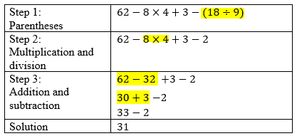

* Instruction includes manipulatives to practice solving expressions with multiple instances of procedural operations and their inverse, such as addition and subtraction, so they learn how to solve them left to right. Instruction also includes explicitly teaching the order of operations with an emphasis on the left to right order to solving multiplication and division, and addition and subtraction. Students use manipulatives as they solve.
  + For example, display the following problem: $5-10÷5+(2×3)$. The teacher reviews the order of operations, reminding students that they must work to simplify within the parentheses first. The teacher prompts students to multiply and divide from left to right next. Then, prompts students to add and subtract from left to right. Finally, the teacher reminds students that adding and subtracting falls within the same step, so they will need to subtract $5-2$ before they add $+6$. This is repeated with additional expressions containing multiplication, division, addition, and subtraction in a variety of orders.

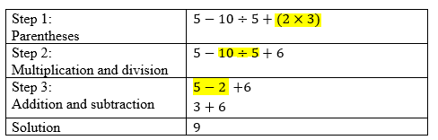

* Instruction includes students using highlighters to keep track of the order of operations and the steps they have completed as they evaluate an expression, as shown above in the table. Another way to keep track of the steps is to have students write the expression in a triangle as seen below and color code each step and its value. Students make sure they have completed all the calculations by tracking each part of the expression down to the solution.

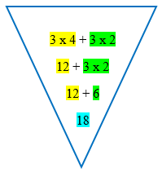

Instructional Tasks

*Instructional Task 1 (MTR.4.1)*

The two equations below are very similar. Are both equations true? Why or why not?

Equation One: $4×6+3×2+4=34$

Equation Two: $4×(6+3×2+4)=64$

*Instructional Task 2 (MTR.5.1)*

Part A. Insert one set of parentheses around two numbers in the expression below. Then evaluate the expression.

$$40÷5×2+6$$

Part B. Now insert one set of parentheses around a different pair of numbers. Then evaluate this expression.

$$40÷5×2+6$$

*Instructional Task 3*

Solve the following expression.

$$\left(40.2+13.05\right)×6-175÷5$$

*Instructional Task 4*

Evaluate the following numerical expressions and determine if the parentheses can be removed without changing the value of the expression. Explain your thinking.

$3×6+2×4-5$

$3×(6+2×4)-5$

$3×(6+2)×4-5$

$(3×6)+2×(4-5)$

$3×(6+2)×(4-5)$

Instructional Items

*Instructional Item 1*

What is the value of the numerical expression below:

$$(2.45+3.05)÷(7.15-2.15)$$

*Instructional Item 2*

A numerical expression is evaluated as shown.

$$\frac{1}{2}×(3×5+1)-2$$

In which step does the first mistake appear?

1. Step 1: $\frac{1}{2}×(15+1)-2$
2. Step 2: $\frac{1}{2}×14$
3. Step 3: $\frac{14}{2}$
4. Step 4: 7

Instructional Item 3

Evaluate.

a. $235+472÷4-2×90$

b. $(235+472)÷4-2×90$

*The strategies, tasks and items included in the B1G-M are examples and should not be considered comprehensive.

### MA.5.AR.2.3

Benchmark

MA.5.AR.2.3 Determine and explain whether an equation involving any of the four operations is true or false.

*Example:* The equation $2.5+\left(6×2\right)=16-1.5$ can be determined to be true because the expression on both sides of the equal sign are equivalent to $14.5$.

Benchmark Clarifications:

*Clarification 1:* Problem types include equations that include parenthesis but not nested parentheses.

*Clarification 2:* Instruction focuses on the connection between properties of equality and order of operations.

Connecting Benchmarks/Horizontal Alignment

* MA.5.NSO.1.2/1.3
* MA.5.NSO.2.1, MA.5.NSO.2.3, MA.5.NSO.2.5
* MA.5.FR.2.4
* MA.5.AR.2.1, MA.5.AR.2.2
* MA.5.NSO.2.3, MA.5.NSO.2.5

Terms from the K-12 Glossary

* Equal Sign
* Equation
* Expression

Vertical Alignment

|  |  |
| --- | --- |
| **Previous Benchmarks**   * MA.4.AR.2.1 | **Next Benchmarks**   * MA.6.AR.2.1 |

Purpose and Instructional Strategies

The purpose of this benchmark is to determine if students can connect their understanding of using the four operations reliably or fluently *(MTR.3.1)* to the concept of the meaning of the equal sign. Students have evaluated whether equations are true or false since Grade 2. In Grade 5, additional expectations include non-whole numbers and parentheses. In Grade 6, students extend this work to involve negative numbers and inequalities (MA.6.AR.2.1).

* Students will use their understanding of order of operations (MA.5.AR.2.2) to simplify expressions on each side of an equation *(MTR.5.1)*.
* Students will determine if the expression on the left of the equal sign is equivalent to the expression to the right of the equal sign. If these expressions are equivalent, then the equation is true.
* Students may use comparative relational thinking, instead of solving, in order to determine if the equation is true or false *(MTR.2.1, MTR.3.1, MTR.5.1)*.

Common Misconceptions or Errors

* Some students may not understand that the equal sign is a relational symbol showing expressions on both sides that are the same. While justifying whether equations are true or false, students should explain what makes the equation true.

Strategies to Support Tiered Instruction

* Instruction includes opportunities to explore the meaning of the equal sign. The teacher provides explicit clarification that the equal sign means “the same as” rather than “the answer is” along with multiple examples for students to evaluate equations as true or false using the four operations with the answers on both the left and right side of the equation. Instruction begins by using single numbers on either side of the equal sign to build understanding using the same equations written in different ways to reinforce the concept.
  + For example, the teacher shows the following equations, asking students if they are true or false statements. Students explain why each equation is true or false. This is repeated with additional true and false equations using the four operations.

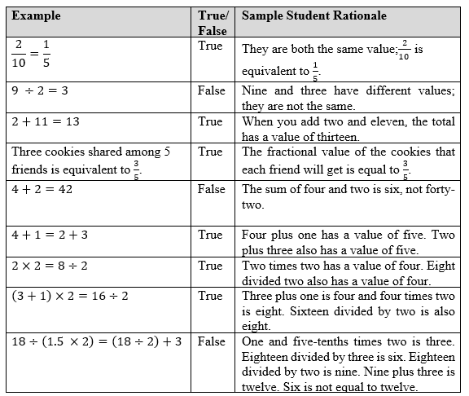

* + For example, the teacher shows the following equations having students use counters, drawings, or base-ten blocks on a t-chart to represent the equation. The teacher asks students if they are true or false statements and to explain what makes equations true. This is repeated with additional true and false equations using the four operations.

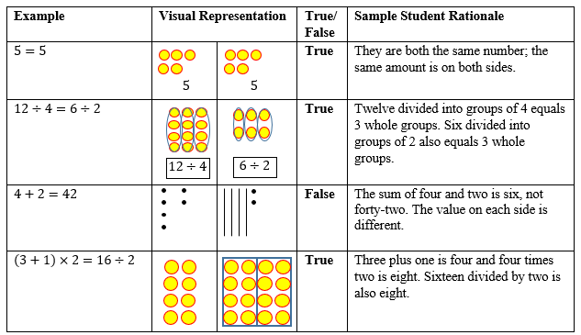

* Instruction includes opportunities for students to organize and structure their algebraic tasks. Teachers should encourage students to label and annotate expressions on both sides of the equation prior to solving. This structured approach enables students to identify occasions where they can apply the properties of operations and the order of operations for problem-solving. Encourage students to contemplate the operations required to solve the expressions on both sides of the equation (*MTR.1.1*).

Instructional Tasks

*Instructional Task 1 (MTR.2.1)*

Using the numbers below, create an equation that is true.

$$( ___ × ___ ) - ____ = ____ - ____$$

$12$, $6.2$, $5.2$, $0.4$, $3.$ 8

*Instructional Task 2*

Part A. Determine if the following equation is true or false.

$$\left(3×4\right)+2=\left(24÷2\right)+(9-7)$$

Part B. Determine if the models and steps shown correctly represent the expressions on both sides of the equation in Part A.

*Instructional Task 3*

Use each operation symbol $(+, -, ×, ÷)$ once in the equation below to make it true.

9 ___ (7___4) ___6___2=34

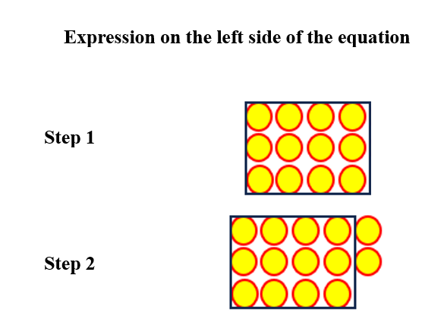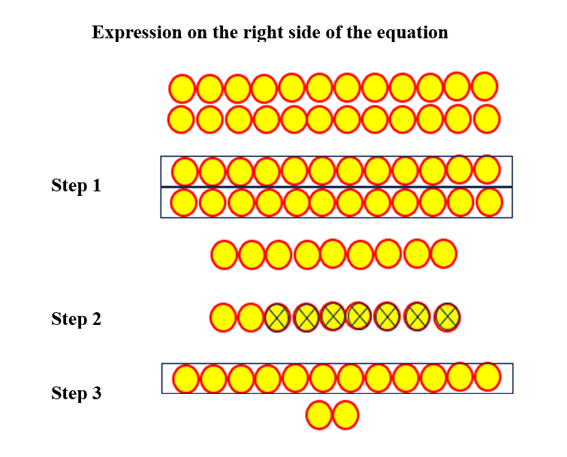

Instructional Items

*Instructional Item 1*

Which best explains the equation below?

$$13.8-6+3=4×1.2$$

1. This equation is true because both sides of the equation are equal to 4.8.
2. This equation is true because both sides of the equation are equal to 10.8.
3. This equation is false because both sides of the equation are equal to 4.8.
4. This equation is false because both sides of the equation are unequal.

*Instructional Item 2*

Is the below equation true or false? Explain how you know.

$$352÷(12-4)×4=176$$

*Instructional Item 3*

For what value of *x* is the below equation true? Explain.

$$3×\left(2.5×2\right)-1.5= 16-x$$

1. The value of *x* is 2.5 because it makes both expressions equal 13.5.
2. The value of *x* is 13.5 because it is found when following the order of operations.
3. The value of *x* is 16 because it is value on the right side of the equal sign.
4. The value of *x* is 29.5 because 16 + 13.5 is 29.5.

*The strategies, tasks and items included in the B1G-M are examples and should not be considered comprehensive.

### MA.5.AR.2.4

Benchmark

MA.5.AR.2.4 Given a mathematical or real-world context, write an equation involving any of the four operations to determine the unknown whole number with the unknown in any position.

Example: The equation $250-\left(5×s\right)=15$ can be used to represent that $5$ sheets of paper are given to $s$ students from a pack of paper containing $250$ sheets with $15$ sheets left over.

Benchmark Clarifications:

*Clarification 1:* Instruction extends the development of algebraic thinking where the unknown letter is recognized as a variable.

*Clarification 2:* Problems include the unknown and different operations on either side of the equal sign.

Connecting Benchmarks/Horizontal Alignment

* MA.5.NSO.2.1, MA.5.NSO.2.2
* MA.5.AR.1.1

MA.5.AR.3.1Terms from the K-12 Glossary

* Equal Sign
* Equation
* Expression
* Whole Number

Vertical Alignment

|  |  |
| --- | --- |
| **Previous Benchmarks**   * MA.4.AR.2.2 | **Next Benchmarks**   * MA.6.AR.1.4 * MA.6.AR.2 |

Purpose and Instructional Strategies

The purpose of this benchmark is for students to write equations that determine unknown whole numbers from mathematical and real-world contexts. In Grade 4, students wrote equations from mathematical and real-world contexts to determine unknown whole numbers (represented by letter symbols) (MA.4.AR.2.2). The extension in Grade 5 is that factors are not limited to within 12 and equations may use parentheses, implying students may have to use the order of operations to solve. In Grade 6, students extend this work to include integers and positive fractions and decimals (MA.6.AR.2.2/2.3/2.4).

* Instruction focuses on helping students translate mathematical and real-world contexts to equations. Instructional emphasis should be placed on students’ comprehension of the contexts to then translate to equations more easily. An instructional strategy that helps students translate from context to symbolic equations is to first present contexts with some or all their numerical information omitted. In a mathematical context, this may look like showing a data display with some numerical information covered. In a real-world context, this may look like a word problem with quantities covered. This allows students to comprehend what the problem is trying to find and allows students to think deeper about what operations will be required to do so. It can also help students estimate reasonable solution ranges. Once students can predict an equation (or equations) to solve the problem, then the teacher can reveal all numerical information and allow students to solve *(MTR.5.1)*.
* In each context, students may provide many examples of equations that can be used to solve. During instruction, teachers can have students compare their equations and evaluate whether they can be used to solve *(MTR.4.1)*.
* During instruction, students can engage in discussions to justify how their equations match the mathematical and real-world contexts through checking solutions (*MTR.2.1*) Students may substitute their solution for their letter symbol and use the order of operations to check that it makes the equation true. Students are expected to explain how they can use algebraic equations to solve real-world solutions.

Common Misconceptions or Errors

* When students have trouble comprehending contexts, they tend to just grab numbers from a given context and begin computing without justifying their arguments. Emphasis of instruction should be on the comprehension of problems through classroom discussion, sharing strategies, estimating reasonable solutions, and justifying equations and solutions (*MTR.2.1*).
* Students may overlook the fact that solving equations involves the application of inverse operations and the reverse order of operations. It is essential to revisit the concepts of the order of operations, the reverse order of operations, and the significance of inverse operations within the context of equations with students.

Strategies to Support Tiered Instruction

* Instruction focuses on the comprehension of problems through classroom discussion, sharing strategies, estimating reasonable solutions, and justifying equations and solutions.
* Instruction includes opportunities to connect real-world situations to write equations using any of the four operations to determine an unknown whole number with the unknown in any position. Students apply the order of operations to solve for the unknown. The teacher emphasizes the inverse relationships between addition and subtraction, and multiplication and division as applicable to help students solve for the unknown, while reinforcing conceptual understanding by having students use drawings, models and equations to solve real world problems.
  + For example, the teacher displays and reads the following problem aloud: “Renaldo read the same number of pages of his book each day for 8 days. He needs to read a total of 315 pages, and still needs to read 155 pages to meet his goal. How many pages did he read on each of the 8 days so far?” Students are provided manipulatives, such as counters or base-ten blocks, to model the problem or to use a drawing, such as a bar model, to solve and to write an equation. Through prompting and questioning, students explain their models, justify their solutions, and check their solution, repeating with multiple examples of real-world problems.

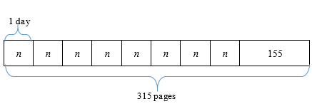

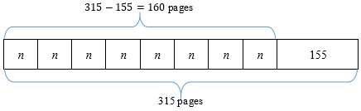

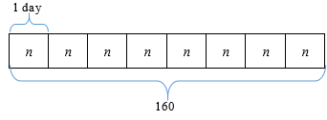

* + For example, Elijah reads 25 pages of a novel per day for 7 days. The entire novel is 230 pages, how many pages does he have left to read? Students are provided manipulatives, such as counters or base-ten blocks, to model the problem or to use a drawing, such as a bar model, to solve and to write an equation. Through prompting and questioning, students explain their models, justify their solutions, and check their solution, repeating with multiple examples of real-world problems.

$$25×7+p=230$$

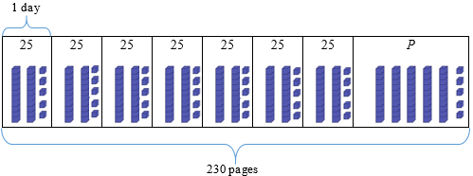

$$25×7+p=230$$

$$175+p=230$$

$$230-175=p$$

$$230-175=55$$

$$p=55$$

Instructional Tasks

*Instructional Task 1 (MTR.7.1)*

To celebrate reaching their monthly reading goal, Dr. Ocasio’s class has a cookie party. Dr. Ocasio buys a box of 96 cookies. She plans to give the same number to each of the 21 students in her class. She wants 12 cookies remaining to bring home for her children. What is the greatest number of cookies each of Dr. Ocasio’s students can receive?

Part A. Write an equation that can be used to solve. Use a letter to represent the unknown number.

Part B. What is the greatest number of cookies each of Dr. Ocasio’s students can receive?

Part C. Prove that your answer is correct by showing how your equation is true.

*Instructional Task 2*

To celebrate the success of their science project, Mr. Anderson's class has a candy celebration. Mr. Anderson buys a bag of 120 candies. He plans to give the same number to each of the 18 students in his class. He wants 15 candies remaining to distribute later. What is the greatest number of candies each of Mr. Anderson's students can receive?

Part A: Write an equation that can be used to solve. Use a letter to represent the unknown number.

Part B: What is the greatest number of candies each of Mr. Anderson's students can receive?

Part C: Prove that your answer is correct by showing how your equation is true.

*Instructional Task 3*

Translate the written description to an equation. Then, find the value of *n.*

“The sum of 44 and 8 is equal to the product of 6 and an unknown number, *n*”

*Instructional Task 4*

Mario’s family goes to the movie theater. They buy two adult tickets for $13 each and three children’s tickets for $9 each. They also spend some money on popcorn. Altogether, they spent $57.

Part. A. Write an equation that can be used to find the cost of the popcorn. Use *p* to represent the unknown value.

Part B. What is the cost of the popcorn?

Part C. Check your answer using a strategy of your choice.

Instructional Items

*Instructional Item 1*

Which of the equations can be used to solve the problem below?

To celebrate reaching their monthly reading goal, Dr. Ocasio’s class has a cookie party. Dr. Ocasio buys a box of 96 cookies. She plans to give the same number to each of the 21 students in her class. She wants 12 remaining to bring home for her children. What is the greatest number of cookies each of Dr. Ocasio’s students can receive?



$96 – 21 – 12 =c$

$96-\left(21×c\right)=12$

$12+c=96-21$

$21×c+12=96$

*Instructional Item 2*

Students at Maple Middle School are fundraising for a field trip, and they need to collect a total of $800. Currently, they have $250 from a bake sale. They plan to sell raffle tickets for $5 each to raise more funds. Write an equation to represent the situation, solve for the variable which represents the number of raffle tickets they need to sell to reach their goal, and explain the steps to find the value of $t.$

*The strategies, tasks and items included in the B1G-M are examples and should not be considered comprehensive.

**MA.5.AR.3***Analyze patterns and relationships between inputs and outputs.*

### MA.5.AR.3.1

Benchmark

MA.5.AR.3.1 Given a numerical pattern, identify and write a rule that can describe the pattern as an expression.

Example: The given pattern $6, 8, 10, 12…$ can be described using the expression $4+2x$, where $x=1, 2, 3, 4…$; the expression $6+2x$, where $x=0, 1, 2, 3…$ or the expression $2x$, where $x=3, 4, 5, 6$.

Benchmark Clarifications:

*Clarification 1:* Rules are limited to one or two operations using whole numbers.

Connecting Benchmarks/Horizontal Alignment

* MA.5.AR.2.1, MA.5.AR.2.4

Terms from the K-12 Glossary

* Expression

Vertical Alignment

|  |  |
| --- | --- |
| **Previous Benchmarks**   * MA.4.AR.3.2 | **Next Benchmarks**  MA.6.AR.3.3 |

Purpose and Instructional Strategies

The purpose of this benchmark is for students to identify and write an expression that shows the rule for a given pattern. Students have been identifying and generating patterns since Grade 3. In Grade 5, the expectation builds on student knowledge of translating numerical expressions into written mathematical descriptions and extends to students writing a rule as an expression that may have 1 or 2 operations. In Grade 6, the focus is on patterns involving ratios (MA.6.AR.3.3).

* The rules for given patterns are limited to one or two operations using whole numbers.
* Vocabulary (e.g., coefficient, terms, variables) should be interwoven into the instruction of this benchmark. These terms are introduced in Grade 5, but not expected to be mastered until Grade 6.
* Students should understand that determining a rule for patterns helps them determine the value of future terms in the pattern *(MTR.2.1, MTR.5.1)*.
* Instruction includes showing students multiple ways to express multiplication. Grade 5 is the first time students may see multiplication expressed in these ways.
  + For example, students will need to build understanding of reasoning with multiplication expressions such as $8x$ or $8\left(2\right).$
* During instruction, teachers can have students compare their rules and justify them using properties of operations.
  + For example, have students determine why the rule for the pattern in the benchmark example could be $6+2x$ or $2x+6$*(MTR.5.1, MTR.6.1)*.
* Instruction of this benchmark should be paired with MA.5.AR.3.2. The combination of determining rules and completing tables is important for students to begin understanding ratios and functions in the middle grades *(MTR.5.1)*.
* Instruction includes recognizing patterns that arise from geometrical figures with different lengths and their perimeter or area.
  + For example, a pattern can arise from the following sequence of rectangles: 1 unit by 1 unit, 1 unit by 2 units, 1 unit by 3 units, 1 unit by 4 units. Students can describe the pattern of the perimeter or of the area.

Common Misconceptions or Errors

* Students may focus on a rule that works for a single input and its corresponding output. Remind students that the rule must work for all terms in a table.
  + For example, students may determine a rule based on the change in only the first two terms. During instruction, teachers should emphasize that a rule must work for the change in any two terms in a pattern.

Strategies to Support Tiered Instruction

* Instruction includes opportunities to determine a rule given a numerical expression. After determining the rule, teachers provide guidance to support students as they work to describe the pattern as an expression. Special attention should be given to ensure that the rule is based on changes in all terms within the pattern (not just the first two terms).
  + For example, the teacher provides students with the first four terms of a pattern:

$$3, 8, 13, 18…$$

The teacher guides students to notice what pattern they see between the four terms (each number is five greater than the previous number). If students have difficulty, a number line or hundreds chart may be used to support finding the pattern. Students should identify that the rule is to add five. Based on this rule, the teacher guides students to represent the pattern as an expression (e.g., $3+5x$, where $x=0, 1, 2, 3…$) having students use the expression to check for accuracy with each of the terms in the pattern and identify the next two terms in the pattern ().

* + For example, the teacher provides students with the first four terms of a pattern.

$$6, 10, 14, 18…$$

The teacher guides students to notice what patterns they see between the four terms (each number is five greater than the previous number). A number line or hundreds chart is used to support finding the pattern. Students identify that the rule is to add four. Based on this rule, the teacher guides students to represent the pattern as an expression (e.g., $6+4x$, where $x=0, 1, 2, 3…$) having students use the expression to check for accuracy with each of the terms in the pattern and identify the next two terms in the pattern ($…22, 26…$).

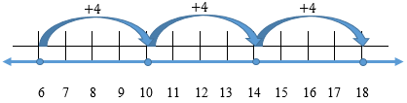

Instructional Tasks

*Instructional Task 1 (MTR.5.1)*

The first four terms of a pattern are below.

$$9, 13, 17, 21, …$$

Part A. Write a mathematical description for a rule that matches these terms where $x=0, 1, 2, 3,…$

Part B. Write an expression that describes your rule.

Part C. Use your answer from Part B to determine the value of the 16th term.

*Instructional Task 2*

Write an expression to describe the rule for the pattern where $x=1, 2, 3, 4,…$ $5, 7, 9, 11,$

Instructional Items

*Instructional Item 1*

Write an expression that can be a rule for the terms shown below where $x = 1, 2, 3, 4, …$

$$2, 7, 12, 17, …$$

*Instructional Item 2*

Use the pattern to answer the questions.

$$8, 16, 24, 32,…$$

Part A. Identify and write the rule to describe the pattern where $x=0, 1, 2, 3,…$

Part B. Identify and write the rule to describe the pattern where $x=1, 2, 3, 4,…$

*The strategies, tasks and items included in the B1G-M are examples and should not be considered comprehensive.

### MA.5.AR.3.2

Benchmark

MA.5.AR.3.2 Given a rule for a numerical pattern, use a two-column table to record the inputs and outputs.

Example: The expression $6+2x$, where $x$ represents any whole number, can be represented in a two-column table as shown below.

|  |  |  |  |  |
| --- | --- | --- | --- | --- |
| Input $(x)$ | 0 | 1 | 2 | 3 |
| Output | 6 | 8 | 10 | 12 |

Benchmark Clarifications:

*Clarification 1:* Instruction builds a foundation for proportional and linear relationships in later grades.

*Clarification 2:* Rules are limited to one or two operations using whole numbers.

Connecting Benchmarks/Horizontal Alignment

* MA.5.GR.4.2
* MA.5.DP.1.1

Terms from the K-12 Glossary

* Equation
* Whole number

Vertical Alignment

|  |  |
| --- | --- |
| **Previous Benchmarks**   * MA.4.AR.3.2 | **Next Benchmarks**   * MA.6.AR.3.3 |

Purpose and Instructional Strategies

The purpose of this benchmark is to relate patterns to a two-column table for students to record inputs and outputs. It is related to MA.5.AR.3.1 where students determine rules from given patterns. This is the first grade in which students record inputs and outputs two-column tables, and this work helps build the foundation for proportional relationships (MA.6.AR.3.3 and MA.7.AR.4) in middle school and functional relationships starting in Grade 8.

* Instruction of this benchmark should be paired with MA.5.AR.3.1. Organizing patterns into input and output tables lays the foundation for students to explore proportional and linear relationships in later grades *(MTR.5.1)*.
* During instruction, teachers can relate the idea of “inputs” and “outputs” on a two-column table to a machine. The input is the term number, and the output is the corresponding term’s value. Students are to find what the machine does to determine the output. Outputs can be generated from a given rule and set of inputs (*MTR.7.1*).
* Instruction should make connections between representing the information in a two-column table and as ordered pairs on a coordinate plane (MA.5.GR.4.2).
* Using tables to represent input/output tables prepares students to collect and represent data in line graphs (MA.5.DP.1.1).
* Instruction includes showing students multiple ways to express multiplication. Grade 5 is the first time students may see multiplication expressed in these ways.
  + For example, students will need to build understanding of reasoning with multiplication expressions such as $8x$ or $8\left(2\right)$.

Common Misconceptions or Errors

* Students may make computational errors when calculating the output for a given rule and input.
* When noting values in a two-column table, students may confuse input and output values.
  + For example, some students may incorrectly identify the equations in the output column as the actual outputs. It's important to highlight that the numeric outputs in the tables represent the solutions to the provided equations.
  + The substitution of numeric inputs into a rule helps to determine the corresponding outputs. An input/output table serves as a tool for organizing inputs and their respective outputs.

Strategies to Support Tiered Instruction

* Instruction includes opportunities to record each step when calculating the output for a given rule and input.
  + For example, for the rule $8 +3x$ students record the steps to calculate the output using an input of 5 and the order of operations.

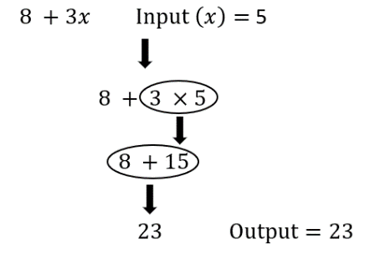

* Instruction includes using highlighters when recording inputs and outputs in a two-column table. Students highlight the “inputs” label in the table and all corresponding inputs using one color. Then, students highlight the “outputs” label in the table and all corresponding outputs using a different color.

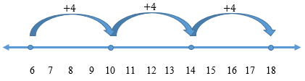

Instructional Tasks

*Instructional Task 1 (MTR.5.1)*

The Math Machine makes two-column tables when the user tells it a rule. Jacob tells the Math Machine to create a table using the rule “ $10+2x.$” Unfortunately, the machine is malfunctioning and only some of the table is correct.

Part A: Identify which values are incorrect and complete the table correctly.

|  |  |  |  |  |
| --- | --- | --- | --- | --- |
| Input (*x*) | 0 | 1 | 2 | 3 |
| Output | 12 | 12 | 22 | 32 |

Part B: Extend your table to show the outputs for $x=10, 11$ and $12$.

*Instructional Task 2*

Vince collects baseball cards that come in packages of 3. Complete the table below to show how many baseball cards Vince would have for each number of packages he buys.

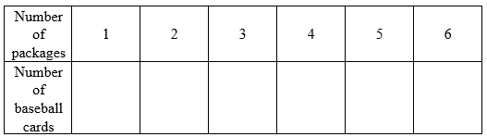

* + 1. Use the data in the table to form ordered pairs in which the input (*x*) is the number of packages, and the output (*y*) is the related number of baseball cards Vince has.
    2. Graph the ordered pairs on the coordinate grid below.

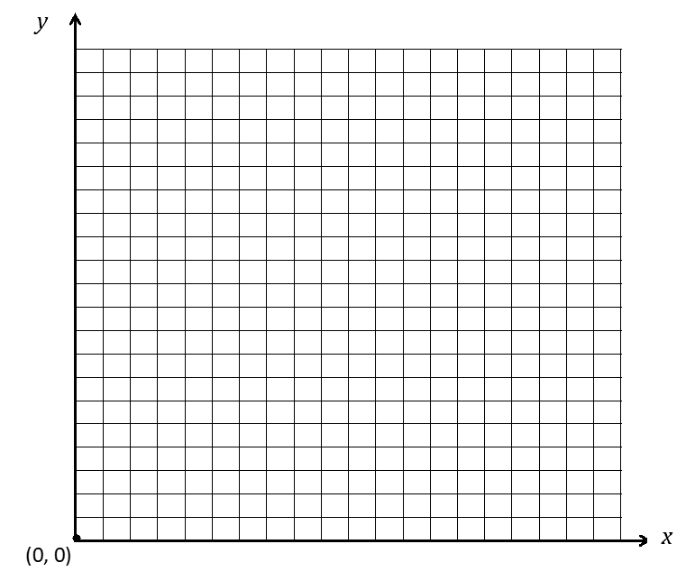

Instructional Items

*Instructional Item 1*

What is the missing value in the two-column table below?

Rule: $40-3x$

|  |  |  |  |  |
| --- | --- | --- | --- | --- |
| Input (*x*) | 0 | 1 | 2 | 3 |
| Output | ? | 37 | 34 | 31 |

*Instructional Item 2*

If each table in the U-shape arrangement can seat 4 people, what is the minimum number of tables required to accommodate a banquet for 40 people? 60 people? 180 people? Create a two-column table to record the inputs and outputs.

*The strategies, tasks and items included in the B1G-M are examples and should not be considered comprehensive.

## Measurement

**MA.5.M.1***Convert measurement units to solve multi-step problems.*

### MA.5.M.1.1

Benchmark

MA.5.M.1.1 Solve multi-step real-world problems that involve converting measurement units to equivalent measurements within a single system of measurement.

Example: There are 60 minutes in 1 hour, 24 hours in 1 day and 7 days in 1 week. So, there are $60×24×7$ minutes in one week which is equivalent to 10,080 minutes.

Benchmark Clarifications:

*Clarification 1:* Within the benchmark, the expectation is not to memorize the conversions.

*Clarification 2:* Conversions include length, time, volume and capacity represented as whole numbers, fractions and decimals.

Connecting Benchmarks/Horizontal Alignment

* MA.5.NSO.1.1
* MA.5.NSO.2.1
* MA.5.NSO.2.2
* MA.5.NSO.2.4
* MA.5.NSO.2.5
* MA.5.AR.1.2
* MA.5.AR.2.1
* MA.5.M.2.1
* MA.5.GR.1.1
* MA.5.GR.2.1
* MA.5.GR.3.3

Terms from the K-12 Glossary

* Equation
* Factor
* Whole number

Vertical Alignment

|  |  |
| --- | --- |
| **Previous Benchmarks**   * MA.4.M.1.2 | **Next Benchmarks**  MA.6.AR.3.5 |

Purpose and Instructional Strategies

The purpose of this benchmark is for students to be able to understand the relationship between units of measure through problem solving. This benchmark builds on Grade 4 concepts of converting measurement units (MA.4.M.1.2), where students acquired an understanding of conversion rules (e.g. multiply to change a larger unit to a smaller unit and divide to change a smaller unit to a larger unit.) This foundational concept is applicable to the conversion of any unit of measure. Additionally, in Grade 6 (MA.6.AR.3.5), students further enhance their understanding and establish connections between measurement conversion and the broader context of ratios and rates. During Grade 5, students utilize ratio reasoning to perform unit conversions. The application of ratio reasoning relies on procedures learned through the multiplication and division of fractions, skills that prove valuable in the context of measurement conversion.

* Instruction allows students to convert measurements flexibly.
  + For example, when finding the number of inches in 2 yards, students may start with inches, feet or yards when calculating. Classroom discussion should compare those conversions to explore their similarities and differences *(MTR.2.1, MTR.4.1)*.
* For students to have a better understanding of the relationships between units, it is important for teachers to allow students to have practice with tools during instruction. This will show students how the number of units relates to the size of the unit.
  + For example, for students to discover converting inches to yards, teachers can have them use 12-inch rulers and yardsticks. This will allow students to see that three of the 12-inch rulers are equivalent to one yardstick ($3×12 inches=36 inches$; $36 inches = 1 yard$), so that students understand that there are 12 inches in 1 foot and 3 feet in 1 yard. Using this knowledge, students will be able to determine whether to multiply or divide when making conversions *(MTR.2.1)*.
* When moving into real-world problem solving, it is important to begin with problems that allow for renaming the units to represent the solution before using problems that require renaming to find the solution *(MTR.7.1)*.
* During instruction, teachers can integrate the relationship between metric units to support student understanding of the place value system. Students utilize their understanding of the patterns of multiplying and dividing with zeros when working with metric conversions. For students to build understanding of metric units, students can list units in order from greatest to least and practice conversion in relation to the place value position.
* For students to have a better understanding of measurement conversions and proportional relationships, allow students to have exposure to attributes of items being measured. Students should develop a foundation of the relative size of each unit and should have practice converting from a small unit to a larger unit and from a large unit to a smaller unit.

Common Misconceptions or Errors

* Students confuse renaming units of measurement with the renaming that they do with whole numbers and place value.
  + For example, when subtracting 6 inches from 3 feet, they get 2 feet 4 inches because they think of subtracting 6 inches from 30 inches. Students need to pay attention to the unit of measurement which dictates the renaming (inches in this example) and the number to use (12 inches in a foot instead of 10 inches in a foot).
* Students confuse renaming units of measurements when converting mixed customary measures because, unlike metric measurement, the customary measurements are not expressed using the base-ten system
  + For example, when adding 3 feet 5 inches to 4 feet 9 inches, they get 7 feet 14 inches. Students may not understand that 14 inches can be converted into 1 foot 2 inches, for an overall answer of 8 feet 2 inches.
* Students may not know which operation to use when converting measurements. During instruction, teachers can use manipulatives and a real-world approach so that students make connections to units. For example, teachers can use containers that equal cups, pints, quarts, and gallons when giving explicit instruction on units of liquid capacity. Real- world application allows students to have a deeper understanding of the relative size of units that may be abstract.
* A common mistake that students may make when encountering word problems is when problems contain information in different units. Students should convert different units to one common unit before calculating.

Strategies to Support Tiered Instruction

* Instruction includes opportunities to measure often and provide feedback. Use error and reasoning analysis activities to address common measurement difficulties.
* Instruction includes providing students with a variety of objects. Ask students which tool they would use to measure each object. Discussions would include asking which attribute of the object is to be measured.
  + For example, objects could include a banana (where length or weight could be measured), water in a container (where temperature, volume or weight could be measured).
* Instruction includes deciding which operation to use when converting from smaller units to larger units (e.g., ounces to pounds) and when converting from larger units to smaller units (e.g., pounds to ounces). Instruction should also include estimating reasonable solutions.
  + For example, the teacher models a think aloud for which numbers to use based on the units of measurement and record the relationships on a chart.
    - How many minutes are in 1 week?
    - There are 60 minutes in 1 hour, 24 hours in 1 day and 7 days in 1 week. So, there are $60×24×7$ minutes in one week which is equivalent to 10,080 minutes.

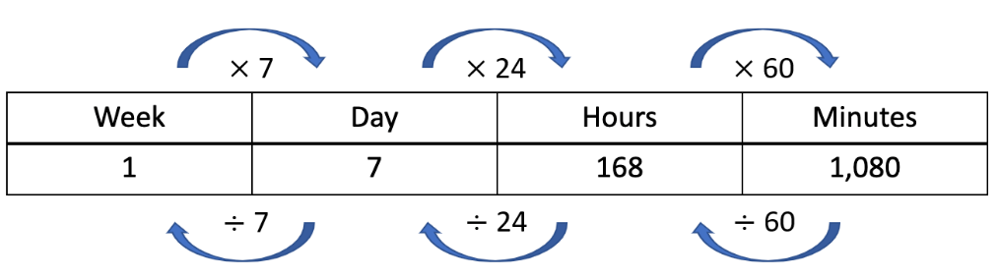

* Instruction includes using a bar model or tape diagram to show the relationship between the units.
* Instruction includes opportunities to connect conversions of metric units to place value positions. Instruction includes utilizing place value mats when computing metric conversions to connect understanding of the relationship between the metric units. Students who struggle with multiplying and dividing across decimal place values should be provided with opportunities.
* Instruction includes opportunities to connect conversions of time to fractional parts such as halves and quarters. Instruction allows students to visualize parts of a clock in connection to real-world time application.

Instructional Tasks

*Instructional Task 1 (MTR.6.1, MTR.7.1)*

Zevah is helping her mom plan her sister’s surprise birthday party.

Part A. The recipe to make one bowl of punch is shown below. How many cups of punch will they be able to serve at the party if they only make one bowl of punch and there is no punch leftover in the bowl?

| **Liquid** | **Fluid Ounces** |
| --- | --- |
| Pineapple Juice | 32 oz |
| Fruit Punch | 64 oz |
| Ginger Ale | 76 oz |

Part B. At the party, Zevah wants each balloon to have a string that is 250 centimeters long. The string she wants to buy comes in rolls of 30 meters. How many rolls of string does Zevah need to buy if she plans to have 36 balloons at the party?

*Instructional Task 2*

Jake ordered 3 miles of fencing to make a pasture for his cows. What are two other equivalent measures you can use to describe the same length of fencing he ordered?

*Instructional Task 3*

The dimensions of an aquarium are listed below.

Length: 6 in.

Width: 2 ft.

Height: 9 in.

Part A. If the dimensions were doubled, which expressions would you use to find the volume of the new aquarium?

$2×9×6×10$

$11×8×12$

$12×48×18$

$12+48+18$

Part B. How many times larger is the volume of the new aquarium compared to the original one?

*Instructional Task 4 (MTR.7.1)*

Beachside Bakery is making a large cake for an event. The recipe calls for $2\frac{1}{2}$ quarts of baking flour. The baker has only a measuring cup that holds 1 cup of flour at a time. How many times will he need to fill the measuring cup to make sure he uses the correct amount of flour for the recipe?

Instructional Items

*Instructional Item 1*

Michael is measuring fabric for the costumes of a school play. He needs 11.5 meters of fabric. He has 280 centimeters of fabric. How many more centimeters of fabric does he need?

*Instructional Item 2*

A recipe requires 24 ounces of milk. Edwin has only a $\frac{1}{2}$ cup measuring cup. How many measuring cups of milk will Edwin need?

1. 6
2. 12
3. 18
4. 24

*Instructional Item 3*

Jake brought a half-gallon bottle of apple juice to a picnic. David brought a six-pack of 12-ounce cans of apple juice. Who brought more apple juice to the picnic?

*The strategies, tasks and items included in the B1G-M are examples and should not be considered comprehensive.

**MA.5.M.2***Solve problems involving money.*

### MA.5.M.2.1

Benchmark

MA.5.M.2.1 Solve multi-step real-world problems involving money using decimal notation.

*Example:* Don is at the store and wants to buy soda. Which option would be cheaper: buying one 24-ounce can of soda for $1.39 or buying two 12-ounce cans of soda for 69¢ each?

Connecting Benchmarks/Horizontal Alignment

* MA.5.NSO.1.1, MA.5.NSO.1.2, MA.5.NSO.1.3
* MA.5.NSO.2.3, MA.5.NSO.2.4, MA.5.NSO.2.5
* MA.5.AR.2.1, MA.5.AR.2.4
* MA.5.M.1.1

Terms from the K-12 Glossary

Vertical Alignment

|  |  |
| --- | --- |
| **Previous Benchmarks**   * MA.4.M.2.2 | **Next Benchmarks**   * MA.6.NSO.2.3 |

Purpose and Instructional Strategies

The purpose of this benchmark is for students to apply understanding of multi-step real-world problems, measurement conversions, and decimal operations to solve problems involving money *(MTR.7.1)*. This benchmark connects to previous work in Grade 4 where students added and subtracted money in real world situations (MA.4.M.2.2). Money contexts continue to be important throughout the later grades. In Grade 6, students are expected to fluently use decimal operations to solve equations with variables (MA.6.NSO.2.3).

* During instruction, teachers should provide strategies for helping students build mathematical literacy, increasing comprehension and problem-solving skills so that students can identify important information in a word problem before completing numerical calculations. Students should be encouraged to estimate a solution and model a problem using manipulatives, pictures and/or equations before computing *(MTR.2.1)*.
* In this benchmark, money is expressed as decimal numbers, so decimal operations can be used to solve problems involving money. Instruction allows students to make computations flexibly using various strategies *(MTR.2.1)*

Common Misconceptions or Errors

* Students can misinterpret multi-step word problems and only complete one of the steps. Encourage students to estimate reasonable solutions and justify models to solve before computing.
* Students may get confused when reading word problems. Teachers should encourage students to draw and label diagrams with monetary value as a visual aid.

Strategies to Support Tiered Instruction

* Instruction includes encouraging students to estimate reasonable solutions and justify models before performing computations of a multi-step word problem.
  + Teachers have the opportunity to observe student behaviors as evidence that students are checking for reasonableness while exhibiting proficiency with mathematical thinking and reasoning standards. When assessing for reasonableness students should actively estimate to discover and explore possible solutions to problems. Students should use benchmark quantities to determine if a solution makes sense. Students should also check calculations during and after calculations when solving a problem and they verify possible solutions by explaining the methodology used. When assessing reasonableness, students can analyze results of a problem based on the given context before computation (*MTR.6.1*).
* Instruction includes using visual models, such as bar models or tape diagrams, to help to visualize the problem.
  + For example, which is a better deal, buying one 24oz. can for $1.39 or two 12 oz. cans for $0.69 each?

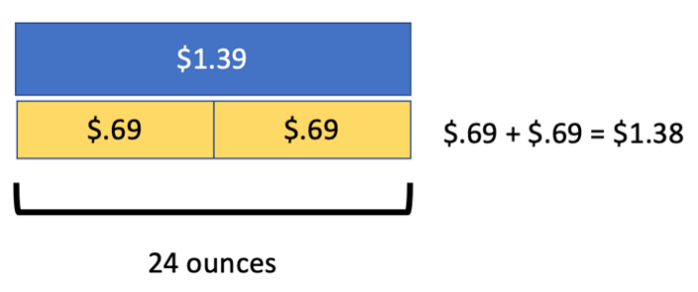

* Instruction includes visualizing word problems. The Three-Reads Protocol is a strategy that can be used to help students conceptualize what the question is asking. Students draw pictures or models to represent what is happening in the word problem. These pictures and models can be used to help students write equations for the problem they are solving.
* Instruction includes breaking down word problems into smaller parts. Students use a highlighter to emphasize the important information in the word problem and paraphrase the word problem so the teacher can determine if the student understands what the question is asking.
  + The teacher encourages and guides students to think backwards when completing word problems. Identify what the problem is asking and create action steps to solve the problem. For example, why do you subtract when a question asks you to find how much change will be given back after a purchase? Students should have an understanding that change back is the difference between the amount of money given and the cost of an item.
  + The teacher encourages students to utilize peer discourse to identify important information when solving word problems. Have students read word problems to a partner and explain to each other what steps are needed to solve the problem (*MTR.4.1*).

Instructional Tasks

*Instructional Task 1 (MTR.7.1)*

Jordan was saving his money to buy a remote control motorcycle. He saved $37.81 from his allowance and received two checks worth $10.00 each for his birthday. Jordan also has a half dollar coin collection with 30 coins in it. If the motorcycle costs $72.29, does Jordan have enough money to buy the motorcycle?

*Instructional Task 2*

A restaurant owner is buying ice. She needs 60 pounds. Should she buy the 20-pound bags of ice for $4.78 or the 10-pound bags of ice for $2.75 each?

*Instructional Task 3*

Maria is a college student managing her monthly budget. This month, she has a part-time job that pays her $12.65 per hour, and she worked 20 hours. Additionally, she received $50 as a birthday gift from her grandparents. On the spending side, she had to pay $29.95 for a textbook, $94.10 for groceries, and $15.50 for transportation.

Can you help Maria calculate her total earnings for the month and determine if she has enough money to cover her expenses? If there is any money left, how much does she have saved or, if she is short, how much does she need to cover her expenses?

*Instructional Task 4*

Lily and Jake decided to start a small business selling handmade candles. They invested $350.25 in purchasing materials and equipment. After creating and selling the candles, they earned a total revenue of $625.80. However, they incurred additional costs for packaging and transportation, amounting to $89.50.

Determine the amount of money made by Lily and Jake. Write your answer in decimal notation.

Instructional Items

*Instructional Item 1*

Pecans and almonds each cost $6.80 per pound. Kendall buys 1.5 pounds of pecans and 2.5 pounds of almonds. What is the total cost of Kendall’s purchase?

*Instructional Item 2*

A table below shows the costs of items at a candy store.

|  |  |
| --- | --- |
| **Item** | **Cost** |
| Chocolate bar | $2.99 each |
| Candy rope | $0.45 per ounce |
| Peanut butter cups | $1.50 each |
| Bubble gum | $0.29 per ounce |

Wayne has $10 to spend. Select all the purchases that Wayne has enough money to make.

1. 3 chocolate bars
2. 25 ounces of candy rope
3. 2 chocolate bars and 3 peanut butter cups
4. 3 peanut butter cups and 5 ounces of bubble gum
5. 24 ounces of bubble gum and 2 ounces of candy rope

*Instructional Item 3*

Ronald goes to dinner with some friends and pays the bill. Each person orders a meal that costs $14.95. Ronald gave the server a $11.96 tip. The total bill, including the tip, was $71.76. How many friends did Ronald pay for?

*The strategies, tasks and items included in the B1G-M are examples and should not be considered comprehensive.

## Geometric Reasoning

**MA.5.GR.1***Classify two-dimensional figures and three-dimensional figures based on defining attributes.*

### MA.5.GR.1.1

Benchmark

MA.5.GR.1.1 Classify triangles or quadrilaterals into different categories based on shared defining attributes. Explain why a triangle or quadrilateral would or would not belong to a category.

Benchmark Clarifications:

*Clarification 1:* Triangles include scalene, isosceles, equilateral, acute, obtuse and right; quadrilaterals include parallelograms, rhombi, rectangles, squares and trapezoids.

Connecting Benchmarks/Horizontal Alignment

* There are no direct connections outside of this standard; however, teachers are encouraged to find possible indirect connections.

Terms from the K-12 Glossary

* Acute Triangle
* Equilateral Triangle
* Isosceles Triangle
* Obtuse Triangle
* Parallelograms
* Quadrilateral
* Rectangle
* Rhombus
* Right Triangle
* Scalene Triangle
* Square
* Trapezoid
* Triangle

Vertical Alignment

|  |  |
| --- | --- |
| **Previous Benchmarks**   * MA.4.GR.1.1 | **Next Benchmarks**  MA.912.GR.3.2 |

Purpose and Instructional Strategies

The purpose of this benchmark is for students to understand that shapes can be classified by their attributes and these attributes may place them in multiple categories. Attributes of figures refer to its traits (such as angle classifications, numbers of sides, side lengths). Students have previous experience describing attributes of figures since Kindergarten. In Grade 3, students identified and drew quadrilaterals based on their attributes (MA.3.GR.1.2). In Grade 4, students explored angle classifications and measures in two-dimensional figures (MA.4.GR.1.1). This past work built the understanding required for students to classify triangles and quadrilaterals in Grade 5. Classification of geometric figures will return in high school geometry (MA.912.GR.3.2) using another Grade 5 concept, the coordinate plane.

* The work in Grade 5 will help students to understand that triangles can be defined by two different attributes that students can measure: the length of their sides (3 congruent sides, 2 congruent sides, or 0 congruent sides) and the size of their angle measures (3 acute angles, 2 acute angles and a right angle, or 2 acute angles and an obtuse angle).
* During instruction, it is important for students to have practice with classifying figures in multiple ways so they can better understand the relationship between attributes of the geometric figures. In addition, students should practice this concept by using graphic organizers such as flow charts, T-charts and Venn diagrams *(MTR.2.1)*.
* This benchmark requires a strong understanding and use of geometry vocabulary. Allow students to use math discourse throughout instruction to compare the attributes of geometric figures.
  + For example, pose questions such as, “Why is a square always a rhombus?” and “Why is a rhombus not always a square?” Lesson activities may require students to justify their thinking when making mathematical arguments about geometric figures *(MTR.4.1)*.

Common Misconceptions or Errors

* Students may think that when describing and classifying geometric shapes and placing them in subcategories, the last subcategory is the only classification that can be used.
* Students may think that a geometric figure can only be classified in one way.
  + For example, a square (a shape with 4 congruent sides and 4 congruent angles) can also be a parallelogram because it contains 2 pairs of sides that are congruent and parallel.

Strategies to Support Tiered Instruction

* Instruction includes providing a graphic organizer and having students place triangles and/or quadrilaterals into all the subcategories they belong to. Students then identify all the ways the figure could be classified.
  + For example, students are provided with a graphic organizer like the one shown below to help them classify figures into subcategories. The name of the figure, an example, and the definition are provided. Students then identify which other categories the figure would also fit. For example, a parallelogram is a quadrilateral containing two pairs of parallel sides. A rectangle, rhombus, and square all also have two pairs of parallel sides so they would also fit in this subcategory. The teacher refers to the glossary, included with the standards, for several examples to provide students.

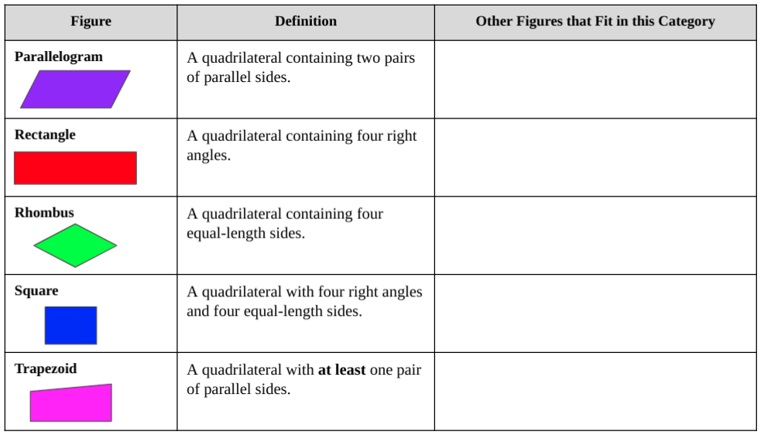

* Instruction includes providing a graphic organizer and having students use sticky notes with specific attributes on them to help them classify figures.
  + For example, students are provided with a graphic organizer like the one shown below with an example of the figure filled in for them to refer to and yellow sticky notes that have “4 equal sides” written on them. Students determine which figures contain this attribute and place the sticky note under those figures (square and rhombus). The teacher then provides green sticky notes with “two pairs of parallel sides” written on them. Students place the sticky note under each figure that has that attribute (parallelogram, rhombus, rectangle, and square). Students would continue to add different color sticky notes with attributes that say, “One pair of parallel sides” and “four right angles”. Students are able to see that some figures have several sticky notes and which figures have the same sticky notes. Students will then name all the ways a figure can be classified based on the attributes they have.

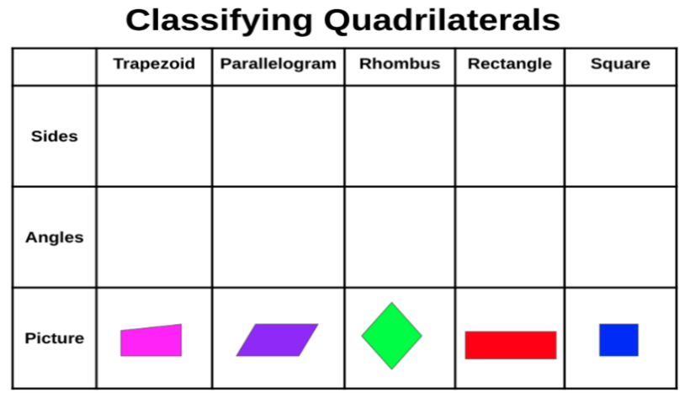

* Instruction may include providing a variety of graphic organizers that allow students to build physical and cognitive connections.
  + For example, have students create or provide them with a template to complete a double-bubble graphic organizer; then allow them to compare and contrast assorted examples.

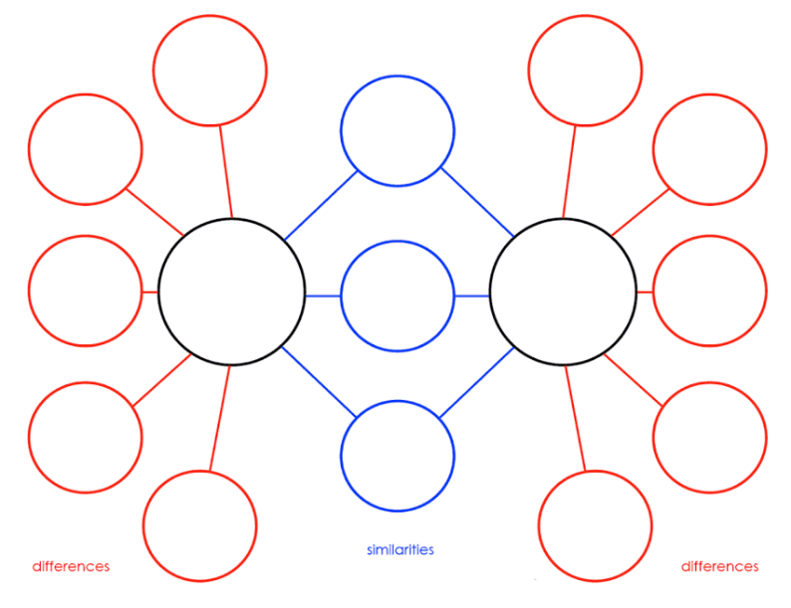

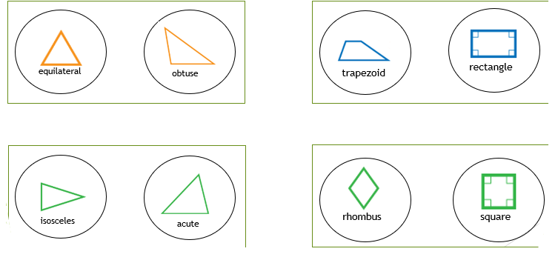

Instructional Tasks

*Instructional Task 1 (MTR.3.1, MTR.4.1)*

Part A. Roll a number cube twice and write a statement based on the key below.

**Number Cube Key**

1 – Equilateral

2 – Acute

3 – Right

4 – Obtuse

5 – Isosceles

6 – Scalene

Part B. Write a statement that reads, “A(n) ___________ (roll 1) triangle is ______________ (**always**, **sometimes** or **never**) a(n) ____________ triangle (roll 2).” Complete your statement by determining whether the category of triangle from roll 1 is always, sometimes, or never the category of triangle from roll 2. Complete this process three more times for a total of four statements.

Part C. Choose one of the statements that you said is sometimes true. Give an example of when the statement is true and when the statement is not true using picture models or words. If none of your statements are sometimes true, then create one to give an example.

*Instructional Task 2*

Classify each of the angles.

List the attributes of each angle.

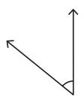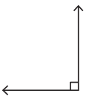An angle measuring one hundred eighty degrees.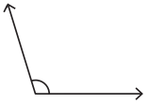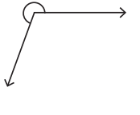

*Instructional Task 3*

Draw a quadrilateral that does not share any defining attributes with a square, except for 4 straight sides and 4 vertices.

Identify what shape you drew and explain how you decided on that shape.

*Instructional Task 4*

Create a graphic organizer to compare and contrast two different types of triangles.

* Identify all the similarities.
* Identify all the differences.
* Repeat with a new set.

Create a graphic organizer to compare and contrast two different types of quadrilaterals.

* Identify all the similarities.
* Identify all the differences.
* Repeat with a new set.

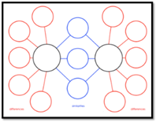

*Instructional Task 5*

Part A. Draw a rhombus that is NOT a square.

Part B. Draw a rhombus that is also a square.

Part C. Compare the attributes of both figures to describe how they are similar and different. Your attributes should be at least the figures’ side lengths and its angle measures.

Instructional Items

*Instructional Item 1*

Choose all the shapes that can **always** be classified as parallelograms.

* 1. Trapezoid
  2. Rectangle
  3. Rhombus
  4. Square
  5. Equilateral Triangle

*Instructional Item 2*

What type of triangle is shown?



1. Equilateral Triangle
2. Isosceles Triangle
3. Obtuse Triangle
4. Scalene Triangle

*Instructional Item 3*

Which shape is an obtuse triangle?

1.  b.  c. 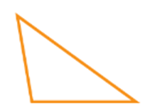 d. 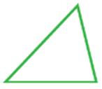

*Instructional Item 6*

Using the table, identify the angles of the triangles by putting an X in the corresponding column.

*Instructional Item 4*

The figure below has equal side lengths. Classify the figure, selecting all that apply.

1. Quadrilateral
2. Rectangle
3. Rhombus
4. Square
5. Trapezoid

*Instructional Item 5*

Which shape is a rhombus?

a. b.  c.  d. 

*Instructional Item 6*

* Using the table, identify the angles of the triangles by putting an X in the corresponding column.

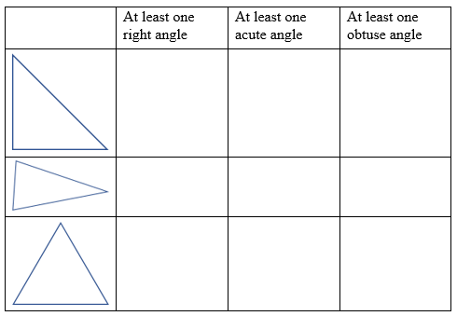

*The strategies, tasks and items included in the B1G-M are examples and should not be considered comprehensive.

### MA.5.GR.1.2

Benchmark

MA.5.GR.1.2 Identify and classify three-dimensional figures into categories based on their defining attributes. Figures are limited to right pyramids, right prisms, right circular cylinders, right circular cones and spheres.

Benchmark Clarifications:

*Clarification 1:* Defining attributes include the number and shape of faces, number and shape of bases, whether or not there is an apex, curved or straight edges and curved surfaces or flat faces.

Connecting Benchmarks/Horizontal Alignment

* There are no direct connections outside of this standard; however, teachers are encouraged to find possible indirect connections.

Terms from the K-12 Glossary

* Cone
* Cylinders
* Edge
* Prisms
* Pyramids
* Sphere

Vertical Alignment

|  |  |
| --- | --- |
| **Previous Benchmarks**   * MA.4.GR.1.1 | **Next Benchmarks**  MA.6.GR.2.4 |

Purpose and Instructional Strategies

The purpose of this benchmark is to begin formal categorization of three-dimensional figures based on attributes of their faces, edges and vertices. Three-dimensional figures were identified informally in Kindergarten and Grade 1. The work in Grade 5 prepares students for more detailed work with three-dimensional figures, including finding volumes and surface areas using formulas and nets in Grade 6 (MA.6.GR.2.4).

* Instruction includes having students use language they have already learned and apply it to a larger variety of figures including prisms and pyramids with any number of sides.

Instruction includes explaining that a cone has one flat base, a cylinder has two flat bases and a sphere does not have any flat bases, but each of these figures has a curved surface.

Common Misconceptions or Errors

* Students may believe that the orientation of a figure changes the three-dimensional shape.

Strategies to Support Tiered Instruction

* Instruction may include teacher providing a graphic organizer that contains three-dimensional figure names and definitions from the glossary. Students match images of the figures in different orientations to their definitions.
  + For example, the teacher may provide students with a graphic organizer like the one shown below and a set of three-dimensional figure picture cards. Students match the image to the defining attributes listed.

|  |  |  |  |  |  |
| --- | --- | --- | --- | --- | --- |
| **Figure** | **Pyramid (right, regular)** | **Prism (right)** | **Circular Cylinder (right)** | **Circular Cone** | **Sphere** |
| Defining Attributes | A figure containing a polygonal base and triangular faces. The triangular faces have the same size and shape and they connect the sides of the base to a common point called the apex. | A figure with two parallel bases that are the same shape and size. The bases are connected by rectangular faces that are perpendicular to the bases. A box with identical polygons on each end. | A figure containing two congruent, parallel, circular bases whose edges are connected by a perpendicular curved surface. | A three-dimensional figure with a circular base and an apex that is connected to the base by a collection of line segments that form a curved surface. | A three-dimensional figure with all points equidistant from a point called the center. |
| Examples |  |  |  |  |  |

Example Figure Cards

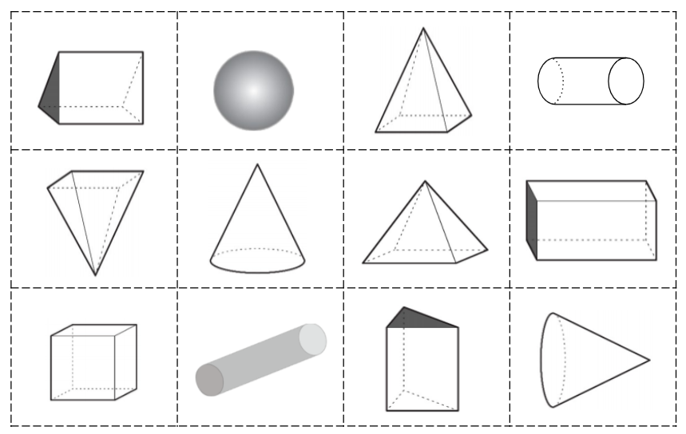

* Instruction may include providing three-dimensional figures made of plastic or wood and having students identify the shapes that make up their base or bases and faces. Students then look at the definition for each figure and classify it based on the attributes they identified.
  + For example, the teacher may provide the students with a triangular prism like the one shown below. The students then identify the two bases as triangles and the faces connecting them as rectangles. The teacher may provide students with the definitions for three-dimensional figures and have them determine which classification the three-dimensional figure fits in.

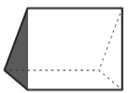

Instructional Tasks

*Instructional Task 1 (MTR.4.1)*

Categorize the three-dimensional figures below into the table.

|  |  |  |  |
| --- | --- | --- | --- |
| **Contains circular faces** | **Contains rectangular faces** | **May contain a rectangular face** | **Contains no faces** |
|  |  |  |  |

* Right pyramids
* Spheres
* Right circular cylinders
* Right prisms
* Right circular cones

*Instructional Task 2*

Complete the following table.

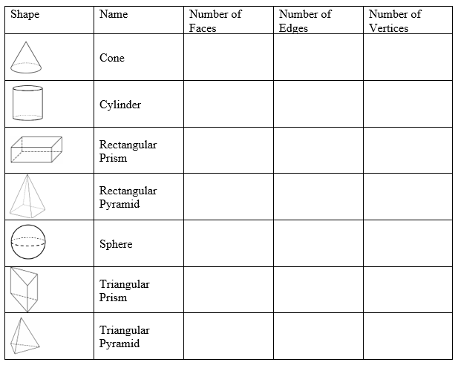

*Instructional Task 3*

For this task, students will need access to 3-D manipulatives or 3-D model cards.

Select a 3-D shape and create a classification chart like the one displayed.

Identify the 3-D figure.

Repeat with another 3-D figure.

2 column table for 3-D figure attributes.
Under column 1 attributes:
Apex, Curved Edges, Straight Edges, No Bases, One Base, Two Base, Curved Surface and Flat Face.
Column two blank for answers

*Instructional Task 4*

List the shapes that make up the attributes of the 3-D figure.

Identify the quantity of bases and faces for each 3-D figure.

Repeat with another 3-D figure.

Example:

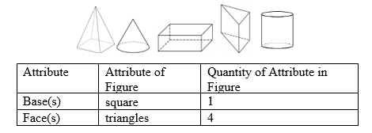

Instructional Items

*Instructional Item 1*

Select all the figures that contain an apex.

1. Right pyramids
2. Spheres
3. Right circular cylinders
4. Right prisms
5. Right circular cones

*Instructional Item 2*

Fill in the blank to identify the attribute.

A drawing of a cone and a pyramid with a question mark



*Instructional Item 3*

Select all the figures that do not contain an apex.

1. Right circular cylinder
2. Right circular cone
3. Right prism
4. Right pyramid
5. Sphere

*Instructional Item 4*

Select all the true statements.

1. A 3-D figure has three dimensions: length, width, and height.
2. All 3-D figures have flat faces.
3. 3-D figures are, also, called flat shapes.
4. 3-D figures are, also, called solids.
5. 3-D figures have volume.

*Instructional Item 5*

Name two three-dimensional figures with curved edges.

*The strategies, tasks and items included in the B1G-M are examples and should not be considered comprehensive.

**MA.5.GR.2***Find the perimeter and area of rectangles with fractional or decimal side lengths.*

### MA.5.GR.2.1

Benchmark

MA.5.GR.2.1 Find the perimeter and area of a rectangle with fractional or decimal side lengths using visual models and formulas..

Benchmark Clarifications:

*Clarification 1:* Instruction includes finding the area of a rectangle with fractional side lengths by tiling it with squares having unit fraction side lengths and showing that the area is the same as would be found by multiplying the side lengths.

*Clarification 2:* Responses include the appropriate units in word form.

Connecting Benchmarks/Horizontal Alignment

* MA.5.NSO.2.3
* MA.5.NSO.2.4
* MA.5.NSO.2.5
* MA.5.FR.2.1
* MA.5.FR.2.2
* MA.5.FR.2.3
* MA.5.AR.1.2
* MA.5.M.1.1

Terms from the K-12 Glossary

* Area Model
* Equation
* Perimeter

Vertical Alignment

|  |  |
| --- | --- |
| **Previous Benchmarks**   * MA.3.GR.2.3 * MA.4.GR.2.1 | **Next Benchmarks**   * MA.6.GR.1.3 |

Purpose and Instructional Strategies

The purpose of this benchmark is for students to understand how to work with fractional and decimal sums and products when calculating perimeter and area. This benchmark connects to previous work where students found areas and perimeters with whole number side lengths in Grade 4 (MA.4.GR.2.1) and prepares for future work of finding area and perimeter on a coordinate plane in Grade 6 (MA.6.GR.1.3).

* During instruction, teachers may encourage students to use models or drawings to assist them with finding the perimeter and area of a rectangle and have them explain how they used the model or drawing to arrive at the solution getting them to understand that multiplying fractional side lengths to find the area is the same as tiling a rectangle with unit squares of the appropriate unit fraction side lengths *(MTR.5.1)*.
* This benchmark provides a natural real-world context and a visual model for the multiplication of fractions and decimals. When finding the area, teachers can begin with students modeling multiplication with whole numbers and progress into the fractional and decimal parts, such as area models using rectangles or squares, fraction strips/bars and sets of counters.
  + For example, ask questions such as, “What does $2×3$ mean?” Then, follow with questions for multiplication with fractions, such as, “What does $\frac{3}{4}×\frac{1}{3}$ mean?” “What does $\frac{3}{4}×7$ mean?” ( $7$ sets of $\frac{3}{4}$) and “What does $7×\frac{3}{4}$ mean?” ( $\frac{3}{4}$ of a set of $7$) *(MTR.2.1, MTR.3.1, MTR.5.1)*.
* Instruction includes providing students with access to the FAST Grade 5 reference sheet throughout instruction so they can practice using the tool to solve real-world volume problems.

Common Misconceptions or Errors

* Students may believe that multiplication always results in a larger number. Working with an area provides them with concrete situations where this is not true.
  + For example, a city block that is $\frac{1}{10}$ mile by $\frac{1}{10}$ mile has an area of $\frac{1}{100}$ of a square mile.
* Students may have difficulty connecting visual models to the symbolic representation using equations. Use concrete visuals to represent problems.

Strategies to Support Tiered Instruction

* Instruction provides opportunities to use concrete visuals to represent problems. Instruction includes providing a rectangle to divide into fractional parts. The teacher provides students with fractional dimensions to divide the figure into to find the area of part of the whole figure. Before calculating the area, students explain if the area will be greater or less than one of the dimensions and explain how they know.
  + For example, the teacher provides students with a blank rectangle and has students divide into fractional parts as shown below. The teacher uses prompts like those shown to help guide the students. After dividing the figure, the students use two different colors to shade the fractional parts and label each side with the shaded dimensions ( $\frac{6}{8}$ or $\frac{4}{6}$).

|  |  |
| --- | --- |
| Divide the figure vertically into eights.  Divide the figure horizontally into sixths.  Shade $\frac{6}{8}$ vertically and $\frac{4}{6}$ horizontally. The area of $\frac{6}{8}×\frac{4}{6}$ is where the 2 shaded sections overlap.  Is the shaded area greater or less than $\frac{6}{8}$? How do you know? | A rectangle divided into forty eight equal parts with eight columns and six rows. Columns one through six, from row one down to row four are colored red. Columns seven and eight from row one down to row four are colored green. Rows five and six from column one over to column six are colored blue. The last four parts that includes rows five and six  and columns seven and eight are white. |

* Instruction includes providing fractional area models printed on transparency sheets. Models include equal size wholes divided into thirds, fourths, fifths, sixths, eighths, tenths, and twelfths. Students use two transparencies to show the area of given dimensions.
  + For example, the teacher asks students to find the area of a figure with side lengths of $\frac{3}{4}$ inch and $\frac{4}{10}$ inch. Students model $\frac{3}{4}×\frac{4}{10}$ by shading $\frac{3}{4}$ of one fraction model and $\frac{4}{10}$ of another fraction model. The teacher has students explain if the area will be greater or less than $\frac{3}{4}$ and how they know. The students then overlap the two figures and determine the fractional parts that overlap as being the area.

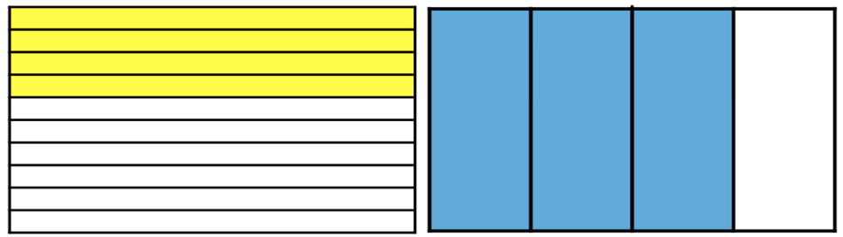

Image showing $\frac{4}{10}$ overlapping $\frac{3}{4}$, $\frac{12}{40}$ is overlapping.

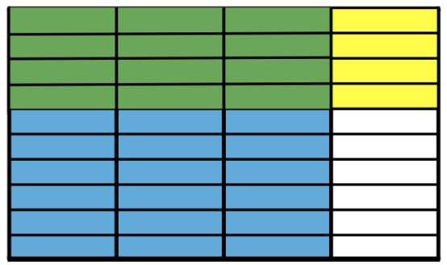

Instructional Tasks

*Instructional Task 1 (MTR.3.1)*

Margaret draws a rectangle with a length of 5.2 inches. The width of her rectangle is one-half its length.

Part A. Draw Margaret’s rectangle and show its dimensions.

Part B. What is the perimeter of her rectangle in inches?

Part C. What is the area of her rectangle in square inches?

*Instructional Task 2*

A diagram of a soccer field is shown.

1. Roll a 6-sided die three times to find the length of the field.
2. Roll a 6-sided die two times to find the width of the field.
3. Using the measurements created, find the area of the field in square feet.
4. Use the same measurements to find the perimeter of the field.
5. Repeat.

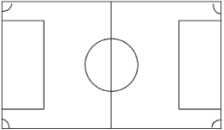

*Instructional Task 3*

Jenna drew a rectangle that was $\frac{3}{5}$ inch long and $\frac{1}{2}$ inch wide.

Part A. Shade the diagram to show the rectangle that Jenna drew.

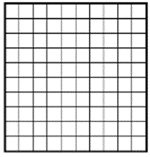

Part B. What equation could you use to find the area of the rectangle?

Part C. What is the area of the rectangle in square inches?

Part D. What equation could you use to find the perimeter of the rectangle?

Part E. What is the perimeter of the rectangle in inches?

*Instructional Task 4*

Use what you know about the attributes of two-dimensional figures to solve the problems below.

Part A. A rhombus has a perimeter of 5.6 centimeters. What is the length of its sides?

Part B. A square has an area of 49 square feet. What is the length of its sides?

Part C. An equilateral triangle has a perimeter of 0.36 feet. What is the length of its sides?

Instructional Items

*Instructional Item 1*

What is the area of the square below?

A square with a side labeled 0.7 inches



*Instructional Item 2*

Which of the following rectangles has a perimeter of 24 inches and an area of 32 inches?

a. 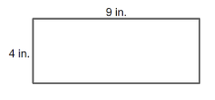

b.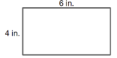

c. 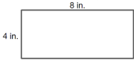

*Instructional Item 3*

Find the area of the figure. Find the perimeter of the same figure.

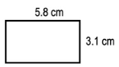

*Instructional Item 4*

A rectangle is 1.4 centimeters long and 0.9 centimeters wide.

What is the perimeter of the rectangle?

What is the area of the rectangle?

*The strategies, tasks and items included in the B1G-M are examples and should not be considered comprehensive.

**MA.5.GR.3***Solve problems involving the volume of right rectangular prisms.*

### MA.5.GR.3.1

Benchmark

MA.5.GR.3.1 Explore volume as an attribute of three-dimensional figures by packing them with unit cubes without gaps. Find the volume of a right rectangular prism with whole-number side lengths by counting unit cubes.

Benchmark Clarifications:

*Clarification 1:* Instruction emphasizes the conceptual understanding that volume is an attribute that can be measured for a three-dimensional figure. The measurement unit for volume is the volume of a unit cube, which is a cube with edge length of 1 unit.

Connecting Benchmarks/Horizontal Alignment

* MA.5.NSO.2.1

Terms from the K-12 Glossary

* Composite Figure
* Rectangular Prism

Vertical Alignment

|  |  |
| --- | --- |
| **Previous Benchmarks**   * MA.3.GR.2.1 | **Next Benchmarks**   * MA.6.GR.2.3 |

Purpose and Instructional Strategies

This benchmark introduces volume to students. To introduce the topic, Grade 5 focuses on calculating volume of right rectangular prisms. Students’ prior experiences with volume were restricted to liquid volume (also called capacity). Understanding of volume of right rectangular prisms extends from the understanding of area beginning in Grade 3 (MA.3.GR.2.1), with the idea that one layer (such as the bottom of cube) can be built up by adding more layers of unit cubes. In Grade 6, (MA.6.GR.2.3) students solve volume problems involving rectangular prisms with fraction and decimal side lengths.

* As students develop their understanding of volume, they recognize that a 1unit cube is the standard unit for measuring volume. A unit cube has a length of 1 unit, a width of 1 unit and a height of 1 unit and is referred to as one cubic *unit*. The volume of a three-dimensional figure refers to the number of cubic units that can be placed in it without gaps or overlaps. This cubic unit is written with an exponent of 3 (e.g., ${in}^{3}$, $3^{3}$). Students connect this notation to their understanding of the powers of 10 in our place value system *(MTR.5.1)*.

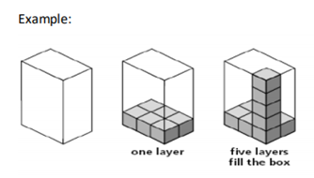

Common Misconceptions or Errors

* Students may incorrectly fill figures to find volume with cubes. Students need to ensure there is no empty space included and that unit cubes are equally sized and packed tightly in without overlaps.

Strategies to Support Tiered Instruction

* Instruction may include providing unit cubes and having students build rectangular prisms with specific dimensions and then calculating the volume.
  + For example, the teacher provides students with unit cubes and the following dimensions: length is 8 units, width is 4 units, and height is 5 units. Students stack equally sized unit cubes and ensure that the cubes are packed tightly with no gaps or overlaps to create a solid three-dimensional figure. Students begin building the figure as shown below, continuing to fill it in until it is complete. Students calculate the volume by multiplying $8 × 4 × 5$ and then decompose the figure and count the cubes to determine if their calculation is correct.

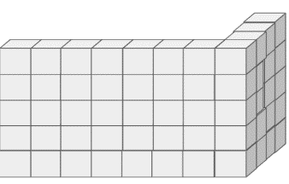

* Instruction may include providing rectangular prisms filled with cubes. Some are filled correctly with no gaps or overlaps, and others have the cubes filling the rectangular prism, but with gaps left between them. Students identify which are stacked correctly to find volume and which are not stacked correctly and record the dimensions of the number of cubes for the height, length, and width, counting the total to determine the volume.

Instructional Tasks

*Instructional Task 1 (MTR.6.1)*

Molly is putting her cube-shaped blocks into their storage container after she finishes playing with her sister. The storage container is shaped like a right rectangular prism, and she has a total of 120 blocks. The bottom layer of her storage container holds exactly 6 rows of 4 blocks each with no gaps or overlaps. The storage container holds exactly 6 layers of blocks with no gaps or overlaps.

Part A. Will all of Molly’s blocks fit in the storage container? Explain how you know using drawings and equations.

Part B. If there is enough room, determine how many more blocks Molly could fit in the storage container. If there is not enough room, determine how many blocks will not fit be able to fit in the storage container.

*Instructional Task 2*

The Breakfast Cereal Company is designing a new box.

The boxes must be in the shape of a right rectangular prism and measure 144 cubic centimeters.

What are some possible package designs the company could use?

Draw models and write equations to their volumes for all the boxes you design.

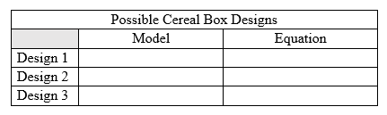

*Instructional Task 3*

Ving is putting 900 cube-shaped blocks into a box. The box is a right rectangular prism. The bottom layer of the box holds exactly 8 rows of 12 blocks each with no gaps or overlaps. The box holds exactly 11 layers of blocks with no gaps or overlaps.

a. Will all of Ving’s blocks fit into the box? Use drawings and equations to justify your answer.

b. If there is enough room, find out how many more blocks Ving could fit into the box. If there is not enough room, find out how many blocks will not fit into the box.

*Instructional Task 4*

Select all the rectangular prism sheds that have a volume of 1,792 cubic feet.

1. 8 feet x 16 feet x 14 feet
2. 4 feet x 16 feet x 28 feet
3. 8 feet x 8 feet x 28 feet
4. 4 feet x 20 feet x 22 feet

Instructional Items

*Instructional Item 1*

What is the volume of the right rectangular prism?

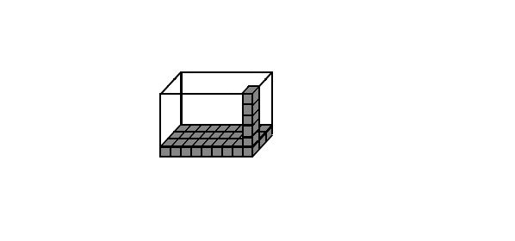

*Instructional Item 2*

Select True or False for each statement in the table.

Put an X in the column with the correct answer.

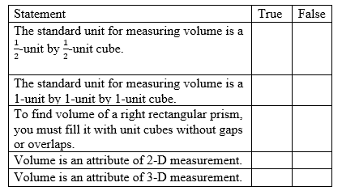

*Instructional Item 3*

Write a formula you can use to find the volume of the right rectangular prism; then solve to find the volume of the prism.

Volume = ______ X ______ X ______ X ______ = ______ cubic units

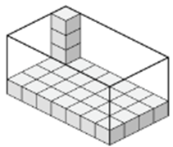

*Instructional Item 4*

Which scenario describes a person using volume to solve a real-life math problem.

1. Alex is going to fill a planter box with soil. How much soil does he need to buy?
2. Ben is going to cover the floor with carpet. How much carpet does he need to buy?
3. Cass is going to put a border around a bulletin board. How much border does she need?
4. Deb is going to put a fence around her garden. How much fence does she need to buy?

*The strategies, tasks and items included in the B1G-M are examples and should not be considered comprehensive.

### MA.5.GR.3.2

Benchmark

MA.5.GR.3.2 Find the volume of a right rectangular prism with whole-number side lengths using a visual model and a formula.

Benchmark Clarifications:

*Clarification 1:* Instruction includes finding the volume of right rectangular prisms by packing the figure with unit cubes, using a visual model or applying a multiplication formula.

*Clarification 2:* Right rectangular prisms cannot exceed two-digit edge lengths and responses include the appropriate units in word form.

Connecting Benchmarks/Horizontal Alignment

* MA.5.NSO.2.1

Terms from the K-12 Glossary

* Composite Figure
* Rectangular Prism
* Volume

Vertical Alignment

|  |  |
| --- | --- |
| **Previous Benchmarks**   * MA.3.GR.2.2 | **Next Benchmarks**   * MA.6.GR.2.3 |

Purpose and Instructional Strategies

The purpose of this benchmark is for students to make connections between packing a right rectangular prism with unit cubes to determine its volume and developing and applying a multiplication formula to calculate it more efficiently. Students have developed experience with area since Grade 3 (MA.3.GR.2.2). For volume, side lengths are limited to whole numbers in Grade 5, and problems extend to fraction and decimal side lengths in Grade 6 (MA.6.GR.2.3).

* Instruction may support making connections between the exploration expected of MA.5.GR.3.1 and what is happening mathematically when calculating volume *(MTR.2.1)*.
* Instruction may begin by connecting the measurement of a right rectangular prism to the calculation of a rectangle’s area. The bottom layer of the prism is packed with a number of rows with a number of cubes in each, like area of a rectangle is calculated with unit squares. From there, the third dimension (height) of the prism is calculated by the number of layers stacked atop one another.
* Having students explore how volume is calculated helps students see the patterns and develop a multiplication formula that will help them make sense of the two most common volume formulas, $V=B×h$ (where $B$ represents the area of the rectangular prism’s base) and $V=l×w×h$. If students understand conceptually what the formulas mean, they are more likely to use them effectively and efficiently *(MTR.5.1)*.
* When students use a multiplication formula, it is important for them to see that it is a matter of choice which dimensions of rectangular prisms are named length, width and height. This will help students understand that when calculating the volume of a rectangular prism, the three dimensions are multiplied together and that the order of factors does not matter (commutative property of multiplication).
* Instruction includes providing students with access to the FAST Grade 5 reference sheet throughout instruction so they can practice using the tool to solve real-world volume problems.

Common Misconceptions or Errors

* Students may confuse the difference between *b* in the area formula and in the volume formula . When building understanding of the volume formula for right rectangular prisms, teachers and students should include a visual model to justify their calculations.
* Students may make computational errors when calculating volume. Encourage them to estimate reasonable solutions before calculating and justify their solutions after. Instruction can also encourage students to find efficient ways to use the formula.
  + For example, when calculating the volume of a rectangular prism using the formula $V=45×12×2$, students may find calculating easier if they multiply $45×2 (90)$ first, instead of $45×12$. During class discussions, teachers should encourage students to share their strategies so they can build efficiency.

Strategies to Support Tiered Instruction

* Instruction may include the use of visual models to justify calculations when using the volume formula for right rectangular prisms.
* Instruction may include differentiating between base in the area formula, $Area=b×h$ and base in the volume formula $Volume=B×h$. The teacher provides students with models of two-dimensional figures, and three-dimensional figures, and has them identify which formula they will use and what the base in each image is.
  + For example, the students highlight the lines included in the base measurement for each figure. Then, they use the base to calculate the area or volume. The teacher provides students with a set of models like the one shown below asking which image they would use the area formula for and which image they would use the volume formula for. Students then highlight the measurements used for the base in the formula. For the first figure, students would use volume and the formula $B×h$ with $B=16× 4$. For the second figure, students would find area and use the formula $b×h$ with $b=16$.

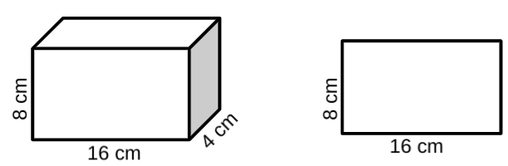

* Instruction may include providing models of two-dimensional and three-dimensional figures with the area and volume formula labeled and color-coded with the measurements.
  + For example, the teacher provides students with the following set of visual models and has students explain the difference in the base measurement in each formula. Students calculate the area or volume of each figure using the formula.

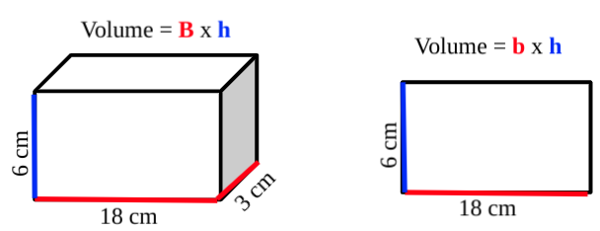

* Instruction may include providing a graphic organizer that requires students to estimate the volume of real-world examples provided and then solve using any strategy they would like.
  + For example, the teacher provides students with a graphic organizer similar to the one shown below. Students use it to find the volume of the given example and then compare their strategy to others.

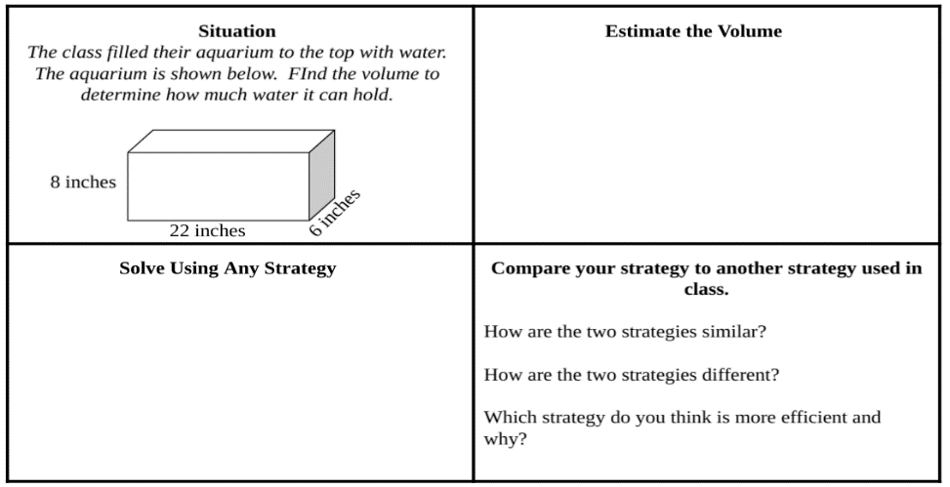

* Instruction may include finding efficient ways to use the formula.
  + For example, when calculating the volume of a rectangular prism using the formula $V=45×12×2$, students may find calculating easier if they multiply $45×2$ (which equals 90) first, instead of $45×12$. During class discussions, teachers may encourage students to share their strategies so they can build efficiency.
* Instruction may include providing worked examples of volume and having students determine which strategy is the better strategy to use and why.
  + For example, the teacher may provide students with the following image and two examples of how students solved for volume. Student A solved the area of the base first using the Distributive Property to help with the multiplication. Student B used the Associative Property of Multiplication and multiplied first. Students discuss both strategies and explain which would be easier and why.

A rectangular object with a square object in the middle and a square object in the middle



Instructional Tasks

*Instructional Task 1 (MTR.2.1)*

The Great Graham Cracker Company is looking for a new package design for next year’s boxes. The boxes must be a right rectangular prism and measure 144 cubic centimeters.

Part A. What are three package designs the company could use? Draw models and write equations to show their volumes.

Part B. Dr. Cruz, the company’s founder, wants the height of the package to be exactly 8 centimeters. What are two package designs that the company can use? Draw models and write equations to show their volumes.

*Instructional Task 2*

Students will need number cubes, graph paper, and unit cubes to complete this introductory volume activity.

1. Students will roll three number cubes. One roll will represent the length, one will represent the height, and one will represent the width of a right rectangular prism in inches.

2. Students will fold the paper, using the dimensions rolled, to create a right rectangular prism with an open top.

3. Students will fill the open prism with unit cubes, with no gaps or overlaps.

4. Students will find the volume of the rectangular prism created.

5. Students will repeat the task with new dimensions.

*Instructional Task 3*

How many different combinations of length, width, and height measurements can you create with a volume of 136 centimeters³?

Complete a table of all the combinations you can prove.

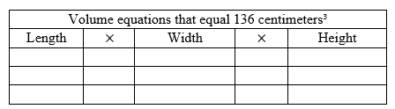

*Instructional Task 4*

Students will need unit cubes for this activity.

Working with a partner, students will compete to find the volume of a figure.

1. Both partners have 1 minute to build a right rectangular prism.
2. Once they build their prism, each partner must find the volume.
3. Once both partners have the volume of their own prism, the partners will compete to see who can find the volume of the other’s prism first.
4. The creator of the prism must verify if their partner has a correct answer: if yes the round is over, if not the round continues until the correct volume is found.
5. Repeat.

Instructional Items

*Instructional Item 1*

Which of the following equations can be used to calculate the volume of the rectangular prism below?

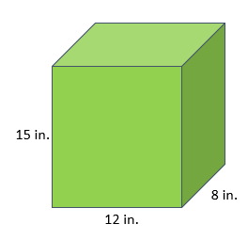

$V=96 ×15$

$V=15×8×12$

$V=15×20$

$V=27×8$

$V=23×12$

*Instructional Item 2*

A bedroom shaped like a rectangular prism is 15 feet wide, 32 feet long and measures 10 feet from the floor to the ceiling. What is the volume of the room, in cubic feet?57 cubic ft.

1. 150 cubic ft.
2. 4,500 cubic ft.
3. 4,800 cubic ft.

*Instructional Item 3*

Kelly is filling a box shaped like a right rectangular prism with 1-inch cubes without any gaps or overlaps. She started filling the box but did not finish. Using the cubes, she already put into the box, find the volume of the box.

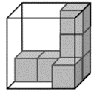

1. 6 cubic inches
2. 8 cubic inches
3. 16 cubic inches
4. 18 cubic inches

*Instructional Item 4*

Write an equation you can use to find the volume of the right rectangular prism.

Volume = $×$________ ________ = ________ cubic units

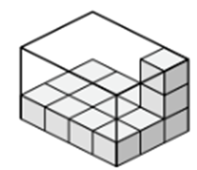

*The strategies, tasks and items included in the B1G-M are examples and should not be considered comprehensive.

### MA.5.GR.3.3

Benchmark

MA.5.GR.3.3 Solve real-world problems involving the volume of right rectangular prisms, including problems with an unknown edge length, with whole-number edge lengths using a visual model or a formula. Write an equation with a variable for the unknown to represent the problem.

*Example:* A hydroponic box, which is a rectangular prism, is used to grow a garden in wastewater rather than soil. It has a base of 2 feet by 3 feet. If the volume of the box is 12 cubic feet, what would be the depth of the box?.

Benchmark Clarifications:

*Clarification 1:* Instruction progresses from right rectangular prisms to composite figures composed of right rectangular prisms.

*Clarification 2:* When finding the volume of composite figures composed of right rectangular prisms, recognize volume as additive by adding the volume of non-overlapping parts.

*Clarification 3:* Responses include the appropriate units in word form.

Connecting Benchmarks/Horizontal Alignment

* MA.5.NSO.2.1, MA.5.NOS.2.2
* MA.5.FR.1.1
* MA.5.AR.1.1
* MA.5.M.1.1

Terms from the K-12 Glossary

* Composite Figure
* Rectangular Prism

Vertical Alignment

|  |  |
| --- | --- |
| **Previous Benchmarks**   * MA.4.GR.2.1 | **Next Benchmarks**   * MA.6.GR.2.3 |

Purpose and Instructional Strategies

The purpose of this benchmark is to solve real-world problems involving right rectangular prisms using a visual model or a formula. The real-world problems can require students to find an unknown side length or find the volume of a composite figure (*MTR.7.1*), if the figure can be decomposed into smaller right rectangular prisms. Students are expected to write an equation with a variable for the unknown to represent the problem. Similar expectations for area were developed in Grade 4 (MA.4.GR.2.1) and this work will be extended to include fraction and decimal side lengths in Grade 6 (MA.6.GR.2.3).

* Instruction of this benchmark can be combined with MA.5.GR.3.2 as students develop and apply understanding of calculating volume of right rectangular prisms using visual models and formulas (*MTR.2.1*).
* While finding volume, teachers may have students communicate and justify their decisions while solving problems (*MTR.4.1*).
* Instruction includes problems with the unknown side length being a fraction (MA.5.FR.1.1).
  + For example, if a box has a base of $5 inches×3 inches$, and a volume of 20 cubic inches, what is the length of its missing side?
* During instruction teachers may encourage students’ flexibility to use different equations for the same problem.
  + For example, to find the height of a rectangular prism with volume 120 and base dimensions 3 and 10, students can use the any of the follow equations: $120=3×10×h$ or $120=30h$ or $120÷30=h$.
* Instruction includes providing students with access to the FAST Grade 5 reference sheet throughout instruction so they can practice using the tool to solve real-world volume problems.

Common Misconceptions or Errors

* Students may confuse the difference between b in the area formula and in the volume formula . When building understanding of the volume formula for right rectangular prisms, teachers and students should include a visual model to use to justify their calculations.
* Students may make computational errors when calculating volume. Encourage them to estimate reasonable solutions before calculating and justify their solutions after. Instruction can also encourage students to find efficient ways to use the formula.
  + For example, when calculating the volume of a rectangular prism using the formula, , students may find calculating easier if they first multiply (which equals 90), instead of . During class discussions, teachers should encourage students to share their strategies so they can build efficiency.

Strategies to Support Tiered Instruction

* Instruction includes the use of visual models to justify calculations when using the volume formula for right rectangular prisms.
* Instruction includes differentiating between base in the area formula, $Area=b×h$ and base in the volume formula, $Volume=B×h$. Teacher provides students with models of two-dimensional figures, and three-dimensional figures, and has them identify which formula they will use and what the base in each image is. Students highlight the lines included in the base measurement for each figure and use the base to calculate the area or volume.
  + For example, the teacher provides students with a set of models like the one shown below. The teacher asks students which image they would use the area formula for and which image they would use the volume formula for. Students then highlight the measurements used for the base in the formula. For the first figure, students would use volume and the formula $B×h$ with $B=16×4$. For the second figure, students would find area and use the formula $b×h$ with $b=16$.



* Instruction includes providing models of two-dimensional and three-dimensional figures with the area and volume formula labeled and color-coded with the measurements.
  + For example, the teacher provides students with the following set of models and has students explain the difference in the base measurement in each formula. Students calculate the area or volume of each figure using the formula.



* Instruction includes providing a graphic organizer that requires students to estimate the volume of real-world examples provided and then solve using any strategy they would like. Students then compare their strategy to the strategies used by other students.
  + For example, the teacher provides students with a graphic organizer similar to the one shown below. Students use it to find the volume of the given example and then compare their strategy to others.

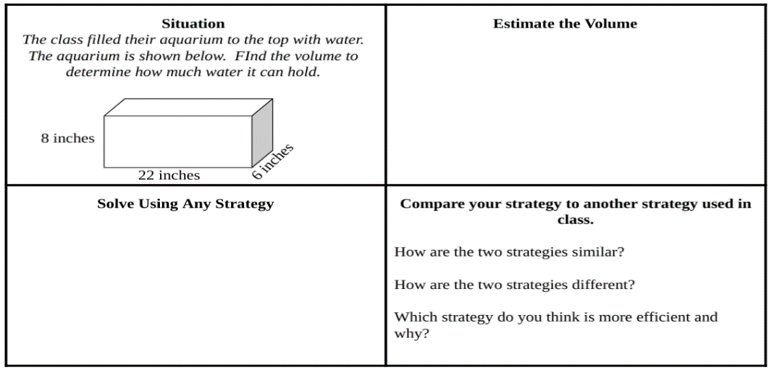

* Instruction includes estimating reasonable solutions before calculating and justifying solutions after. Instruction can also encourage students to find efficient ways to use the formula.
  + For example, when calculating the volume of a rectangular prism using the formula, , students may find calculating easier if they first multiply (which equals 90), instead of . During class discussions, teachers should encourage students to share their strategies so they can build efficiency.
* Instruction includes providing worked examples of volume and having students determine which strategy is the better strategy to use and why.
  + For example, the teacher provides students with the following image and two examples of how students solved for volume. Student A solved the area of the base first using the Distributive Property to help with the multiplication. Student B used the Associative Property of Multiplication and multiplied $20×5$ first. Students discuss both strategies and explain which would be easier and why.

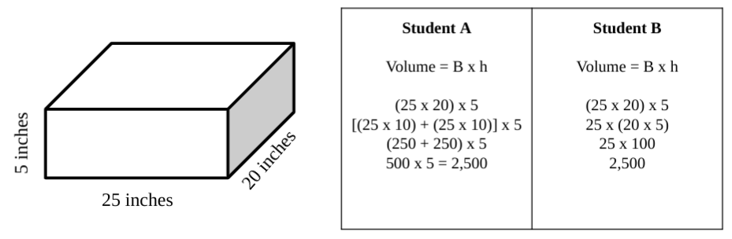

Instruction includes using the 3-Read Protocol to break down the problem. First read the problem to understand the context, possibly without numbers. Then, read to understand the mathematics. Finally, read to create a plan for solving the problem.

Instructional Tasks

*Instructional Task 1 (MTR.6.1)*

The Great Graham Cracker Company places packages of their graham crackers into a larger box for shipping to area grocery stores. Each package of graham crackers is a right rectangular prism that measures 18 cubic inches. The base of each package of graham crackers measures 2 inches by 3 inches. Packages are placed upright into the shipping box.

Part A. If the larger shipping box is a cube with edges that are each 30 inches, how many layers of graham cracker packages can the shipping box hold? Show your thinking using a visual model and equation(s).

Part B. Will the packages reach the top of the shipping box? If not, what will be the length of the gap from the top of the package to the top of the shipping box?

Part C. How many graham cracker packages will fit in the shipping box?

*Instructional Task 2*

The volume of Kara’s swimming pool is 256 cubic feet.

What are the possible dimensions of her pool?

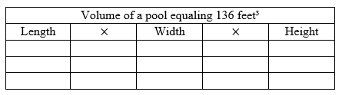

*Instructional Task 3*

Select all the possible dimensions of an aquarium with a volume of 216 cubic feet.

1. Length-3 feet, width-9 feet, height-8 feet
2. Length-4 feet, width-9 feet, height-6 feet
3. Length-4 feet, width-9 feet, height 16 feet
4. Length-3 feet, width-8 feet, height-8 feet
5. Length-6 feet, width-3 feet, height-12 feet

*Instructional Task 4*

The chart below shows a variety of containers for different items.

Some dimensions are missing in the chart below.

Find the missing dimensions for each.

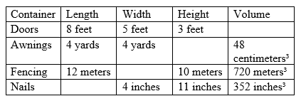

*Instructional Task 5*

For a holiday event, Flamingo Elementary School is creating a snowman out of three stacked boxes shaped like cubes. When stacked, the snowman will be a composite three-dimensional figure.

* The edge length of the bottom box is 13 inches.
* The edge length of the middle box is 2 inches less than the bottom box.
* The edge length of the top box is 2 inches less than the middle box.

Part A. Draw a model to show the composite figure.

Part B. What is the total volume of the snowman?

Part C. Explain why the snowman is considered a composite three-dimensional figure.

Instructional Items

*Instructional Item 1*

Select all of the following that could be the dimensions of the base of a rectangular box with height of 16 inches and volume of 128 cubic inches.

1. 2 inches x 4 inches
2. 3 inches x 3 inches
3. 1 inch x 8 inches
4. 4 inches x 2 inches
5. 56 inches x 56 inches

*Instructional Item 2*

Mia is measuring the inside of her desk.

The area of the base is 88 square centimeters.

The height is 16 centimeters.

What is the volume of the inside of the desk, in cubic centimeters?

*Instructional Item 3*

A flower box for roses is in the shape of a rectangular prism.

The box is 6 inches tall, 9 inches wide, and has a volume of 918 cubic inches.

What is the length of the box, in inches?

*Instructional Item 4*

Mark stores his fishing lures in a cube-shaped box.

The cube has a volume of 64 cubic inches.

What are the lengths of the edges of the cube?

*Instructional Item 5*

The figure below is a composite right rectangular prism.

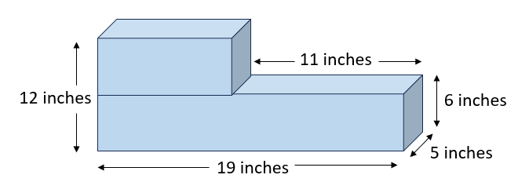

Find the volume of the composite figure, in cubic inches.

*The strategies, tasks and items included in the B1G-M are examples and should not be considered comprehensive.

**MA.5.GR.4***Plot points and represent problems on the coordinate plane.*

### MA.5.GR.4.1

Benchmark

MA.5.GR.4.1 Identify the origin and axes in the coordinate system. Plot and label ordered pairs in the first quadrant of the coordinate plane.

Benchmark Clarifications:

*Clarification 1:* Instruction includes the connection between two-column tables and coordinates on a coordinate plane.

*Clarification 2:* Instruction focuses on the connection of the number line to the $x$- and $y$-axis. *Clarification 3:* Coordinate planes include axes scaled by whole numbers. Ordered pairs contain only whole numbers.

Connecting Benchmarks/Horizontal Alignment

* MA.5.AR.3.2
* MA.5.DP.1.1

Terms from the K-12 Glossary

* Coordinate Plane (first quadrant)
* Origin
* $x$-axis
* $y$-axis

Vertical Alignment

|  |  |
| --- | --- |
| **Previous Benchmarks**   * MA.4.NSO.1.3 | **Next Benchmarks**   * MA.6.GR.1 |

Purpose and Instructional Strategies

The purpose of this benchmark is for students to extend their thinking from Grade 4 (MA.4.NSO.1.3) about horizontal and vertical number lines to plot and label whole number ordered pairs on a coordinate plane. In addition, students will make a connection between a two-column table and the ordered pairs represented on the coordinate plane. In Grade 6 (MA.6.GR.1.1), students plot rational number pairs in all four quadrants of the coordinate plane.

* Instruction includes relating the coordinate plane as the intersection of two axes – a horizontal number line called the $x$-axis and a vertical number line called the $y$-axis. The number lines that form the axes are perpendicular and meet at the origin, labeled by the ordered pair $(0, 0)$ (*MTR.5.1*).
* When students learn to plot ordered pairs represented in a two-column table, they should understand that the ordered pair $(x, y)$ represents how far to travel from the origin along the $x$- and $y$-axes.
  + For example, students should understand that in the ordered pair $(2, 4)$, the point travels along the $x$-axis 2 whole units to the right, and then vertically (parallel to the $y$-axis) 4 units up (*MTR.5.1*).

Common Misconceptions or Errors

* Students can confuse the $x$- and $y$-values in an ordered pair and move vertically along the -axis before moving horizontally along the $x$-axis.
  + For example, they may mean to plot and label the ordered pair $(2, 4)$, but plot and label $(4, 2)$ instead. To assist students with this misconception, have students practice with creating directions for their student peers to follow to allow them to gain a better understanding of the direction and distance on the coordinate plane.
* Some students may not understand what an $x$- or $y$-coordinate value of 0 represents. During instruction, students should justify why ordered pairs with a 0 will plot on the -axis or -axis.

Strategies to Support Tiered Instruction

* Instruction includes the teacher providing coordinate points to graph in quadrant 1 of the coordinate plane along with two small objects. The students explain how they move the object along the -axis and then up the -axis to the location provided. The teacher then provides the points reversed to graph and has students explain the difference in how they move the second object compared to the first.
  + For example, the teacher provides students with a coordinate plane like the one shown below. The teacher provides a set of coordinate points such as $\left(8,2\right)$. Students take turns moving an object, such as a two-colored counter, and explain the location of the point using the $x$- and $y$-axis in their explanation. The teacher then provides the points in reverse, $\left(2,8\right)$. The next student will move a second object and explain the location of the point as well as the difference between the two locations.

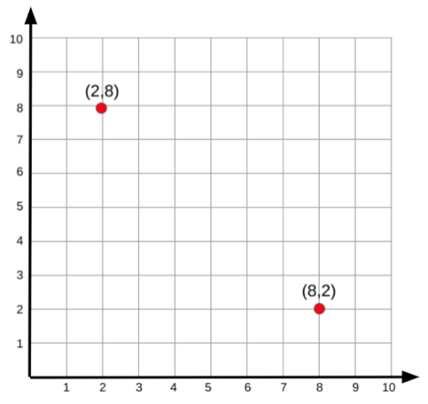

* Instruction includes the teacher providing a set of cards that have coordinate points on them, some with 0 as the location on the -axis, some with 0 as the location on the -axis, others with no 0 in the coordinates. Students sort the cards into three categories: points located on the $x$-axis, points located on the $y$-axis and neither. Students will justify their reasoning by explaining how the 0, or lack of a 0, in each set of points helped them.
  + For example, the teacher provides cards with the following points on them:

Students sort the points into three categories as shown below.

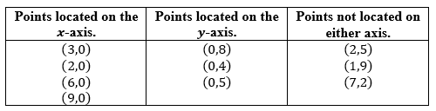

* Instruction includes the teacher creating a giant coordinate plane on the floor with painters' tape or outside with sidewalk chalk. The teacher or a student will then create directions for their peers to follow. The teacher or student will provide a set of coordinate points, including those with 0 as the $x$- or $y$-coordinate. Another student will physically move to the location, describing as they move, which axis they are moving on and counting the spaces until they reach their final location.
  + For example, the teacher or a student tells a student to move to the location of $\left(4,6\right)$ on the coordinate plane. The student says, “I begin at the origin which is $\left(0,0\right)$ and move 1, 2, 3, 4 spaces to the right on the $x$-axis. I then move 1, 2, 3, 4, 5, 6 spaces up on the $y$-axis to my final location of $\left(4,6\right)$.”
* For example: The teacher provides a student with the location $\left(5,0\right)$. The student will move along the $x$-axis 5 spaces and stop. The teacher provides another student with the location $\left(0,5\right)$. That student moves up the $y$-axis 5 spaces and stop. The teacher will then have the students explain how their location ended up on the $x$- or $y$-axis as well as the relationship between those located on the $y$-axis and those located on the $y$-axis.

Instructional Tasks

*Instructional Task 1 (MTR.3.1)*

Part A. A point has coordinates $(3, 5)$. If you were to graph this point on a coordinate plane, what does the 3 tell you to do?

Part B. Consider the same point with coordinates $(3, 5)$. What does the 5 tell you to do?

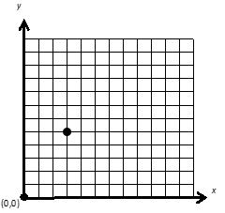

Part C. The point above has coordinates $(3, 5)$. Which of these is the $x$-coordinate? Which of these is the $y$-coordinate?

*Instructional Task 2*

Use the coordinate plane below to answer the questions.

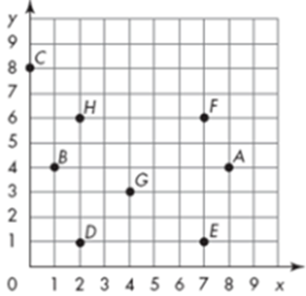

Billy is walking around town.

1. His house is at (7,1). What letter represents Billy’s house?
2. He is meeting his friends at the skate park. To get to the skate part, he moves 5 left and 5 up. What letter represents the skate park?
3. On his way to the skate park, he walked through the gas station parking lot. What letter represents the gas station?
4. After the skate park, Billy went to the store to get a drink. He moved 1 left and 2 down. What letter represents the school?
5. After the store, Billy went to the football field. He moved 6 right and 2 up. What letter represents the football field?
6. He goes to a friend’s house for lunch. His friend lives close to the football field. Which letter is closest to the football field?
7. After lunch, Billy goes to the movies with his friends. He moves 8 left and 4 up. What letter represents the movie theater?
8. On his way home, Billy stops to visit his gramma. Her house is at (4,3). What letter represents gramma’s house? How does Billy have to move from the movie theater to get to gramma’s house?
9. Finally, Billy goes home. How does he move to go home?

*Instructional Task 3*

Roll 2 number cubes to create an ordered pair.

Fill in the table using the numbers generated with the number cubes.

Variation 1:

Start from the origin (0,0) for each roll.

Variation 2:

With each roll, start at the last coordinate rolled and find the new coordinate.

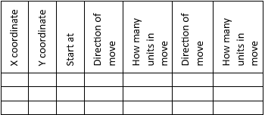

*Instructional Task 4*

Using the coordinate plane below, create an assortment of triangles and rectangles.

1. Identify the shape created.
2. Identify the ordered pairs for each vertex of the shape.

Instructional Items

*Instructional Item 1*

What ordered pair represents the origin of a coordinate plane?

$(0, 0)$

$(1, 0)$

$(0, 1)$

$(1, 1)$

*Instructional Item 2*

A point has coordinates $(1, 6)$. If you were to plot this point on a coordinate plane, what does the 1 tell you to do?

* 1. From the origin, move along the $x$-axis 1 unit up.
  2. From the origin, move along the $y$-axis 1 unit up.
  3. From the origin, move along the $x$-axis 1 unit right.
  4. From the origin, move along the $y$-axis 1 unit right.

*Instructional Item 3*

A point has the coordinates (4, 6).

To get to the coordinate,

* Where do you start?
* How do you move?
* How many units do you move?
* Do you move again? If yes, which direction and how many units?

*Instructional Item 4*

Joerg is plotting a square on the coordinate plane below.

Which four ordered pairs would he identify in his square?

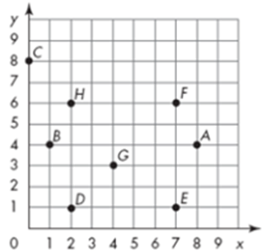

*The strategies, tasks and items included in the B1G-M are examples and should not be considered comprehensive.

### MA.5.GR.4.2

Benchmark

MA.5.GR.4.2 Represent mathematical and real-world problems by plotting points in the first quadrant of the coordinate plane and interpret coordinate values of points in the context of the situation.

*Example:* For Kevin’s science fair project, he is growing plants with different soils. He plotted the point $(5, 7$) for one of his plants to indicate that the plant grew $7$ inches by the end of week $5$.

Benchmark Clarifications:

*Clarification 1:* Coordinate planes include axes scaled by whole numbers. Ordered pairs contain only whole numbers.

Connecting Benchmarks/Horizontal Alignment

* MA.5.AR.1.1
* MA.5.AR.3.2
* MA.5.DP.1.1

Terms from the K-12 Glossary

* Coordinate Plane (first quadrant)
* Origin
* $x$-axis
* $y$-axis

Vertical Alignment

|  |  |
| --- | --- |
| **Previous Benchmarks**  MA.4.NSO.1.3 | **Next Benchmarks**   * MA.6.GR.1 |

Purpose and Instructional Strategies

The purpose of this benchmark is for students to interpret coordinate values plotted in mathematical and real-world contexts. Students have been plotting and interpreting numbers on a number line since Kindergarten. Students’ first experience with interpreting points plotted on a coordinate plane is in Grade 5, which leads to the foundational understanding needed throughout middle school.

* An example of interpreting coordinate values of points in a mathematical context could be identifying points of a rectangle plotted on the coordinate plane.
* An example of interpreting coordinate values of points in a real-world context could look like the example in the benchmark description. In this real-world example, students would interpret that each axis represents a variable describing a situation. The $x$-axis represents number of weeks and the $y$-axis represents plants’ heights in inches.
* During instruction, teachers should provide plenty of opportunities for students to both plot and interpret ordered pairs on a coordinate plane. Teachers may connect the expectations of this benchmark with MA.5.GR.4.1 by having students represent the points plotted on two-column tables as well *(MTR.4.1, MTR.7.1)*.
* In real-world contexts teachers may allow students the flexibility to decide which variable is represented by $x$ and which is represented by $y$. Students may be encouraged to explain their preference.
* During instruction, students should be given the flexibility to decide how to scale their graphs for a given real-world context. Students may be encouraged to explain their preference.

Common Misconceptions or Errors

* Students can confuse the $x$- and $y$-values in an ordered pair and move vertically along the -axis before moving horizontally along the $x$-axis.
  + For example, they may mean to plot and label the ordered pair $(2, 4)$, but plot and label $(4, 2)$ instead.
* Some students may not understand what an $x$- or $y$-coordinate value of 0 represents. During instruction, students should justify why ordered pairs with a 0 will plot on the -axis or -axis.

Strategies to Support Tiered Instruction

* Instruction includes the teacher providing coordinate points to graph in quadrant 1 of the coordinate plane along with two small objects. The students explain how they move the object along the -axis and then up the -axis to the location provided. The teacher then provides the points reversed to graph and has students explain the difference in how they move the second object compared to the first.
  + For example, the teacher may provide students with a coordinate plane like the one shown below. The teacher provides a set of coordinate points such as $\left(8, 2\right)$. Students take turns moving an object, such as a two-colored counter, and explain the location of the point using the $x$- and $y$-axis in their explanation. The teacher will then provide the points in reverse, $\left(2,8\right)$. Students will move a second object and explain the location of the point as well as the difference between the two locations.

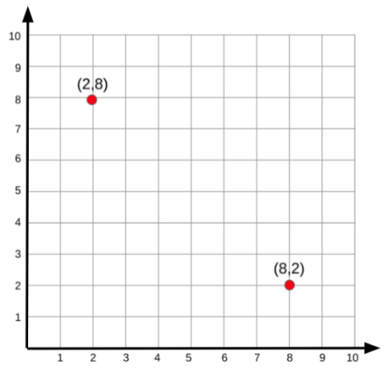

* Instruction includes the teacher providing a set of cards that have coordinate points on them, some with 0 as the location on the -axis, some with 0 as the location on the -axis, others with no 0 in the coordinates. Students sort the cards into three categories: points located on the $x$-axis, points located on the $y$-axis and neither. Students justify their reasoning by explaining how the 0, or lack of a 0, in each set of points helped them.
  + For example, the teacher provides cards with the following points on them:

Students sort the points into three categories as shown below.

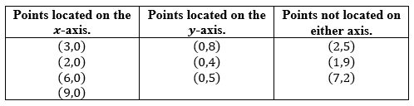

* Instruction includes the teacher creating a giant coordinate plane on the floor with painters' tape or outside with sidewalk chalk. The teacher or a student will then create directions for their peers to follow. The teacher or student provides a set of coordinate points, including those with 0 as the $x$- or $y$-coordinate. Another student physically moves to the location, describing as they move, which axis they are moving on and counting the spaces until they reach their final location.
  + For example, the teacher or a student tells another student to move to the location of $\left(4,6\right)$ on the coordinate plane. The student says, “I begin at the origin which is $\left(0,0\right)$ and move 1, 2, 3, 4 spaces to the right on the $x$-axis. I then move 1, 2, 3, 4, 5, 6 spaces up on the $y$-axis to my final location of $\left(4,6\right)$.”
  + For example, the teacher provides a student with the location $\left(5,0\right)$. The student moves along the $x$-axis 5 spaces and stop. The teacher provides another student with the location $\left(0,5\right)$. That student moves up the $y$-axis 5 spaces and stop. The teacher then has students explain how their location ended up on the $x$- or $y$-axis as well as the relationship between those located on the $y$-axis and those located on the $y$-axis.
* Instruction includes using the 3-Read Protocol to break down the problem. First read the problem to understand the context, possibly without the numbers. Then, read to understand the mathematics. Finally, read to create a plan for solving the problem.

Instructional Tasks

*Instructional Task 1 (MTR.7.1)*

Lukas can make four bracelets per hour and he will work for five hours. Make a two-column table where the first column contains the numbers 1, 2, 3, 4, 5 indicating the number of hours worked, and the second column shows how many total bracelets he has made in that many hours.

Plot points on the coordinate plane to represent your table, where the $x$*-*coordinate represents the number of hours worked and the $y$-coordinate represents the number of bracelets made.

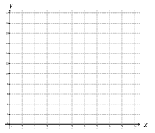

*Instructional Task 2*

Using the rule $x×2=y$, find the next five ordered pairs.

Make sure to label both the x- and y-axis.

Mark and label all the ordered pairs on the coordinate grid.

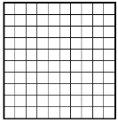

Rule: $x×2=y$

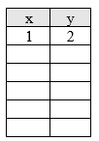

*Instructional Task 3*

Pat is planning the set up for his new playroom.

He is using a coordinate grid.

He has a rectangular table that he has begun to mark on the coordinate grid.

He has plotted (10,4), (12,4), and (10,8).

What is the final coordinate pair for his table?

He has a miniature train track that is 12 units long and 5 units wide.

* What are the coordinate pairs for the only space he would put the miniature train track?
* Label the points on the coordinate grid.

He has a 2-unit by 2-unit shelf he wants to put in a corner.

* List the coordinate pairs for all the possible locations.
* Mark the points and label them on the coordinate grid.

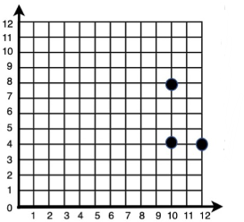

*Instructional Task 4*

Label the x- and y- axis.

Mel is growing a tomato plant.

Her measurements are in the table below.

* Plot the ordered pairs for the growth of the plant.
* Based on the pattern of growth, predict the next two ordered pairs.



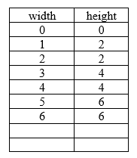

Instructional Items

*Instructional Item 1*

The map below shows the location of several places in a town.

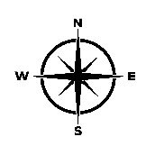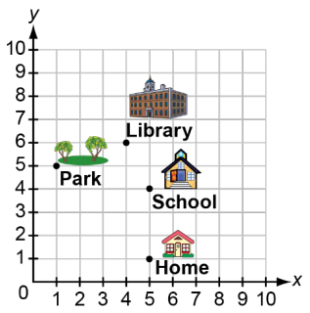

The fire department is 2 blocks north of the library. What ordered pair represents the location of the fire department?

1. (4, 2)
2. (2, 4)
3. (4, 8)
4. (8. 4)

*Instructional Item 2*

Deanna is plotting a square on the coordinate plane below.

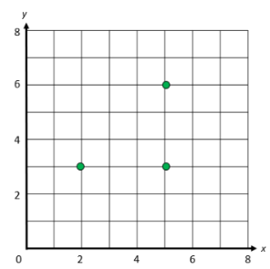

What ordered pair would represent the fourth vertex?

* 1. (6, 2)
  2. (2, 6)
  3. (2, 0)
  4. (0, 2)

*Instructional Item 3*

* If the Rule is x + 3 = y, fill in the missing numbers on the table.
* Plot all the ordered pairs onto the coordinate grid.

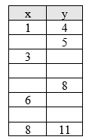

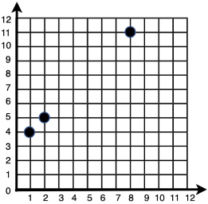

*Instructional Item 4*

Mr. Kelsey is planning to build a fence.

He is using a coordinate grid to determine how many posts he needs to buy.

* + Use the rule to find the ordered pairs.
  + Mark all the points on the coordinate grid.
  + How many posts does Mr. Kelsey need to buy?

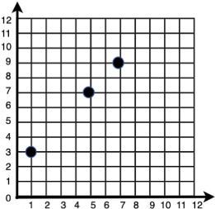

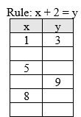

*The strategies, tasks and items included in the B1G-M are examples and should not be considered comprehensive.

## Data Analysis & Probability

**MA.5.DP.1***Collect, represent and interpret data and find the mean, mode, median or range of a data set.*

### MA.5.DP.1.1

Benchmark

MA.5.DP.1.1 Collect and represent numerical data, including fractional and decimal values, using tables, line graphs or line plots.

*Example:* Gloria is keeping track of her money every week. She starts with $\$10.00$, after one week she has $\$7.50$, after two weeks she has $\$12.00$ and after three weeks she has $\$6.25$. Represent the amount of money she has using a line graph.

Benchmark Clarifications:

*Clarification 1:* Within this benchmark, the expectation is for an estimation of fractional and decimal heights on line graphs.

*Clarification 2:* Decimal values are limited to hundredths. Denominators are limited to 1, 2, 3 and 4. Fractions can be greater than one.

Connecting Benchmarks/Horizontal Alignment

* MA.5.NSO.1.4
* MA.5.AR.1.2
* MA.5.GR.4.1, MA.5.GR.4.2

Terms from the K-12 Glossary

* Line Graphs
* Line Plots .4.DP.1.1

Vertical Alignment

|  |  |
| --- | --- |
| **Previous Benchmarks**   * MA.4.DP.1.1 | **Next Benchmarks**   * MA.6.DP.1.1, MA.6.DP.1.2, MA.6.DP.1.5 |

Purpose and Instructional Strategies

The purpose of this benchmark is to collect and display authentic numerical data in tables, line graphs or line plots, including fractional and decimal values. Students have represented whole number and fractional values using tables, stem-and-leaf plots and line plots in Grade 4 (MA.4.DP.1.1). In Grade 6, this work will extend to box plots and histograms (MA.6.DP.1.5).

* Instruction with line graphs should develop the understanding that values in this graph often represent data that changes over time.
* Instruction should include identifying the meaning of the points presented on the $x$-axis and $y$-axis with both axes being labeled correctly.

Common Misconceptions or Errors

* For line plots, students may misread a number line and have difficulty because they use whole-number names when counting fractional parts on a number line instead of the fraction name.

Strategies to Support Tiered Instruction

* Instruction includes opportunities to use concrete models and draw number lines to connect learning with fraction understanding. Students plot fourths on the number line, paying particular attention to what each tick mark and the “distance” between each tick mark represents.
  + Example:

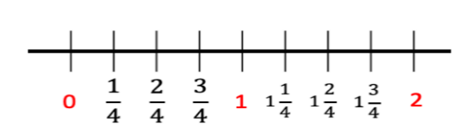

* + For example, utilizing fraction strips or tiles, students will be able to connect fractional parts to the measurement on a number line.

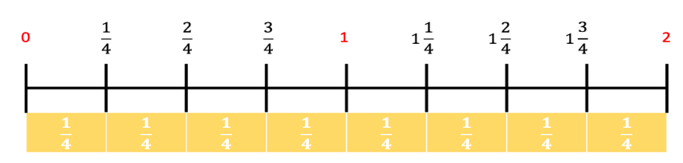

* Instruction includes providing the data set on index cards or sticky notes. Students then move the data set in order from least to greatest. For numbers that repeat, students stack the numbers on top of each other. This helps with understanding if there is no mode, or more than one mode.
  + Example:

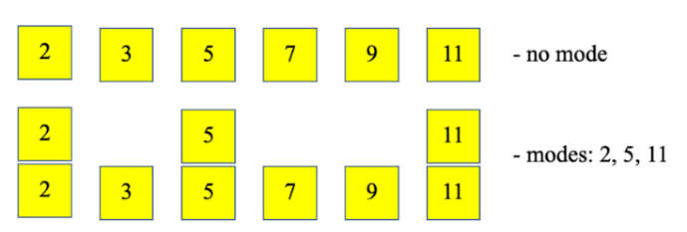

* Instruction includes opportunities to find the range on a line plot. Students subtract the least value on the line plot with an X from the greatest value with an X.
  + Example:

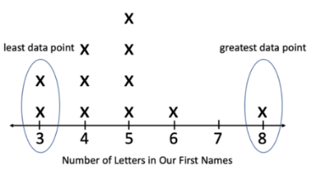

* Instruction includes showing how to cover up the data points in the middle of the line plot so that only the first and last data points are shown. This allows students to focus on the values that will be used to calculate the range.
  + Example:

|  |  |  |
| --- | --- | --- |
| line plot |  | line plot with yellow card covering some of the points |
| Range = |  |  |

Instructional Tasks

*Instructional Task 1 (MTR.3.1)*

Claire recorded the daily low temperatures in her city for the past ten days. The data she collected is below. Use her data to create a line plot to show the daily low temperatures.

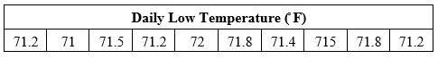

*Instructional Task 2*

A local bakery recorded the total amount of flour, in pounds, that was used for cakes each day for one week in the table.

table with days and flour in pounds


Part A. Use the template below to create a line graph for the data shown in the table. Include a title, axis labels, and determine appropriate intervals.

Part B. Create a question for the data set shown.

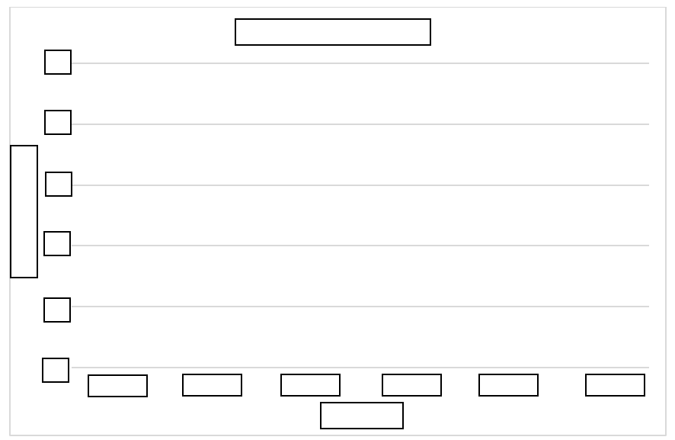

Instructional Items

*Instructional Item 1*

A line graph is shown.

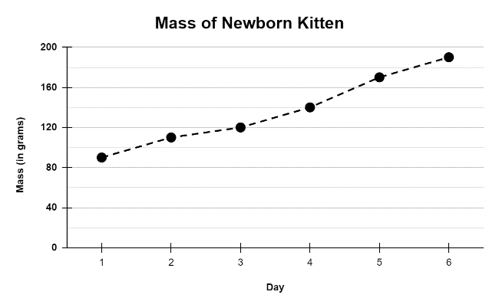

Part A. What is the approximate change in the kitten’s mass, in grams, between Days 3 and 4?

Part B. What is the approximate change in the kitten’s mass, in grams, between Days 2 and 5?

*Instructional Item 2*

Avery has a several baskets of oranges. She weighs each basket of oranges and makes a line plot to display the weight of the baskets in pounds.

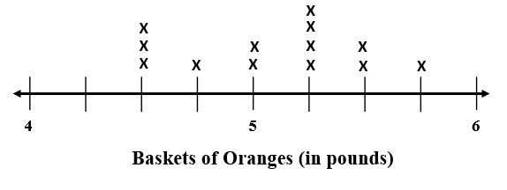

Which statements about the data displayed on Avery’s line plot are true? Select all that apply.

1. The heaviest basket of oranges weighs 5.25 pounds.
2. Avery weighed a total of 10 baskets of oranges.
3. The lightest basket of oranges weighs 4.5 pounds.
4. The combined weight of the 3 baskets with the heaviest weight is 16.75 pounds.
5. Most of the baskets weigh less than 5.5 pounds.

*Instructional Item 2*

Josh recorded the rainfall for 14 days during the month of December. The rainfall data is represented in the line plot shown.

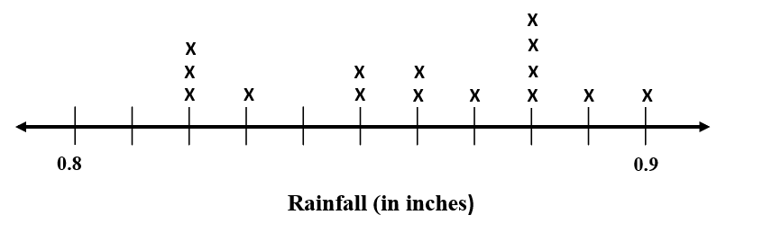

Part A. What is the least amount of rainfall, in inches, recorded?

Part B. What is the greatest amount of rainfall, in inches, recorded?

Part C. What amount of measured rainfall was recorded the most?

*The strategies, tasks and items included in the B1G-M are examples and should not be considered comprehensive.

### MA.5.DP.1.2

Benchmark

MA.5.DP.1.2 Interpret numerical data, with whole-number values, represented with tables or line plots by determining the mean, mode, median or range.

*Example:* Rain was collected and measured daily to the nearest inch for the past week. The recorded amounts are $1, 0, 3, 1, 0, 0$ and $1$. The range is $3$ inches, the modes are 0 and $1$ inches, and the mean value can be determined as $\frac{(1+0+3+1+0+0+1)}{7}$, which is equivalent to $\frac{6}{7}$ of an inch. This mean would be the same if it rained $\frac{6}{7}$ of an inch each day.

Benchmark Clarifications:

*Clarification 1:* Instruction includes interpreting the mean in real-world problems as a leveling out, a balance point or an equal share.

Connecting Benchmarks/Horizontal Alignment

* MA.5.FR.1.1
* MA.5.AR.1.1

Terms from the K-12 Glossary

* Line Plots
* Mean
* Median
* Mode
* Range

Vertical Alignment

|  |  |
| --- | --- |
| **Previous Benchmarks**   * MA.4.DP.1.2 | **Next Benchmarks**   * MA.6.DP.1.2, MA.6.DP.1. |

Purpose and Instructional Strategies

The purpose of this benchmark is to interpret numerical data by using the mean, mode, median and range. This work builds on the previous understanding of mode, median, and range in Grade 4 (MA.4.DP.1.2). In Grade 6, a focus will be on comparing the advantages and disadvantages of the mean and median.

* When finding median and mode, it is important for students to organize their data, putting it in order from least to greatest.
* With the data organized, students can determine:
  + range by subtracting the least value from the greatest value in the set.
  + mode by finding the value that occurs most often.
  + median by finding the value in middle of the set.
  + mean by finding the average of the set of numbers.
* Instruction includes interpreting mean as leveling out and balance point.
  + For example, 6 friends brought their favorite erasers to school. The number of erasers that each friend brought to school is shown in the table.

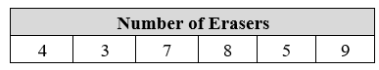

The stacks of cubes on the left represent the erasers that each student brought. The cubes can be moved from the taller stacks and added to the shorter stacks to level them out and ensure that each stack has the same number of cubes. The stacks of cubes on the right represent the process of leveling out.

A graph of different colored cubes



* + The mean for the eraser data set is 6. If the students combined all of their erasers and shared them equally, each student would have 6 erasers.
  + The mean is also the balance point, which means that the total distance from the mean to the data points above the mean is equal to the total distance from the mean to the data points below the mean. The image below shows the distance of the data points above and below the mean of 6 for the eraser data set.

line plot that show the mean


Common Misconceptions or Errors

* Students may confuse the mean and median of a data set. During instruction, teachers should provide students with examples where the median and mean of a data set are not close in value.

Strategies to Support Tiered Instruction

* Instruction includes examples where the mean and the median are not close in value and uses a data set to explain the difference between mean and median.
  + For example, the data set shown has a median of 4 and a mean of 7. The teacher uses the data to model how the mean is calculated and how the median is found.

line plot


* Instruction includes writing the data on index cards or sticky notes. Students can then easily arrange the data in order from least to greatest. This will assist in finding the median of the data set.
  + For example, students use the data shown to explain the difference between mean (which is 7) and median (which is 4) and to model how the mean is calculated and how the median is found.

cards with various numbers


Instructional Tasks

*Instructional Task 1 (MTR.7.1)*

Bobbie is a fifth grader who competes in the 100-meter hurdles. She recorded her times for each meet this season to the nearest second.

chart with times recorded


Part A. What is the mean time, in seconds, of Bobbie’s 100-meter hurdles?

Part B. What is the median time, in seconds, of Bobbie’s 100-meter hurdles?

Part C. What is the mode time, in seconds, of Bobbie’s 100-meter hurdles?

Part D. If you were Bobbie, which of these results would you report to your friend?

*Instructional Task 2*

Create a table using the data below.

Andrew has a 400-acre piece of land.

He monitors the deer population on the land.

In 2015 he counted 100 deer, 125 in 2016, 250 in 2017, and 150 in 2018.In 2019 he counted 200, 225 in 2020, 350 in 2021, and 250 in 2022.

Part A. What patterns do you see in the population of deer as years increase?

Part B. What predictions can you make about deer populations in 2023-2026?

Part C. Find the mean, median, mode, and range of the deer population from 2015-2022.

*Instructional Task 3*

Diego is collecting boxes for a science experiment. The volume of the boxes, in cubic inches, is shown in the table below.



Part A. Find the mean, median, mode and range for the data set.

Part B. How will the mean, median, and mode for the data set change if Diego adds two more boxes that have a volume of 72 cubic inches?

Instructional Items

*Instructional Item 1*

There was a pie-eating contest at the county fair. The line plot below shows the number of pies each of the 10 contestants ate. Use the line plot to determine the mean, mode, median and range of the data.

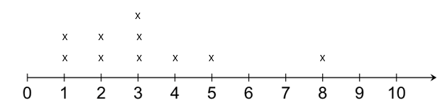

*Instructional Item 2*

Ada was given a Smart Watch as a gift.

She used the watch to monitor how much time she spent walking during the day.

She recorded her total minutes each day for eleven days.

Walking Minutes Recorded by Smart Watch Daily

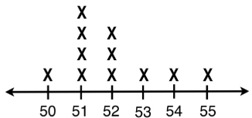

Minutes

Use the data set above to find the following.

Mean _________

Median _________

Mode _________

Range _________

*Instructional Item 3*

Sam was collecting water in a rain gauge as part of a science experiment.

He collected water for eight days, the data is below.

Create a line plot of the data, including appropriate labels.

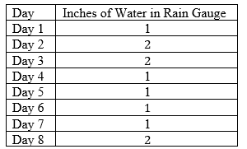

*Instructional Item 4*

The line plot shows the number of minutes Teia read each day for the past 10 days.

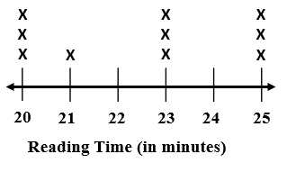

Part A. What is the mean of the data set?

Part B. Which statement correctly describes the data set?

1. The mode for the data set is 23.
2. The difference of the range and median is 18.
3. The range of the data set is greater than the median.
4. The difference of the range and median is 23.

*The strategies, tasks and items included in the B1G-M are examples and should not be considered comprehensive.

Appendix A. Summary of Changes

The purpose of this table is to provide a summary of changes from for the latest version of the B1G-M. For questions or feedback on the B1G-M, please direct them to [BESTMath@fldoe.org](mailto:BESTMath@fldoe.org).

| **Benchmark** | **B1G-M Component** | **Change Made** |
| --- | --- | --- |
| MA.5.FR.1.1 | Purpose and Instructional Strategies | Build On Prior Knowledge, when dividing a whole number up to four digits by a one-digit whole number, represent remainders as fractional parts of a divisor.  Example 266 ÷ 5 = 53 $\frac{2}{\begin{aligned}5 \\ \end{aligned}}$ |
| MA.5.FR.1.1 | Strategies to Support Tiered Instruction | Instruction includes using the 3-Read Protocol to break down the problem. First read the problem to understand the context, possibly without the numbers. Then, read to understand the mathematics. Finally, read to create a plan for solving the problem. |
| MA.5.GR.1.1 | Strategies to Support Tiered Instruction | Include an example using a double-bubble format for struggling students to make physical and cognitive connections.  C:\Users\deubelc\AppData\Local\Microsoft\Windows\INetCache\Content.MSO\189793BB.tmp |
| MA.5.GR.1.1 | Strategies to Support Tiered Instruction | Instruction includes providing a variety of graphic organizers that allow students to build physical and cognitive connections.   * For example, have students create or provide them with a template to complete a double-bubble graphic organizer; then allow them to compare and contrast assorted examples   C:\Users\deubelc\AppData\Local\Microsoft\Windows\INetCache\Content.MSO\48A30C8E.tmp C:\Users\deubelc\AppData\Local\Microsoft\Windows\INetCache\Content.MSO\D4FB7CC.tmp |
| MA.5.GR.1.1 | Instructional Items | Instructional Item 2  What type of triangle is shown?  C:\Users\deubelc\AppData\Local\Microsoft\Windows\INetCache\Content.MSO\4B06FBD8.tmp   1. Equilateral Triangle 2. Isosceles Triangle 3. Obtuse Triangle 4. Scalene Triangle |
| MA.5.GR.1.1 | Instructional Items | *Instructional Item 3*  Which shape is an obtuse triangle?   1. C:\Users\deubelc\AppData\Local\Microsoft\Windows\INetCache\Content.MSO\DBD1AE3.tmp B. C:\Users\deubelc\AppData\Local\Microsoft\Windows\INetCache\Content.MSO\4E41B9E9.tmp   C. C:\Users\deubelc\AppData\Local\Microsoft\Windows\INetCache\Content.MSO\E244DCDF.tmp D. C:\Users\deubelc\AppData\Local\Microsoft\Windows\INetCache\Content.MSO\78B75945.tmp |
| MA.5.GR.1.1 | Instructional Items | *Instructional Item 4*  What type of quadrilateral is shown?  C:\Users\deubelc\AppData\Local\Microsoft\Windows\INetCache\Content.MSO\DCAC2217.tmp   1. Rectangle 2. Rhombus 3. Square 4. Trapezoid |
| MA.5.GR.1.1 | Instructional Items | *Instructional Item 5*  Which shape is a rhombus?   1. C:\Users\deubelc\AppData\Local\Microsoft\Windows\INetCache\Content.MSO\B265801A.tmp     B.    C:\Users\deubelc\AppData\Local\Microsoft\Windows\INetCache\Content.MSO\9AD44F38.tmp   C. C:\Users\deubelc\AppData\Local\Microsoft\Windows\INetCache\Content.MSO\DEF9D206.tmp     D. C:\Users\deubelc\AppData\Local\Microsoft\Windows\INetCache\Content.MSO\75CF3404.tmp |
| MA.5.M.1.1 | Connecting Benchmarks/Horizontal Alignment | Added: MA.5.NSO.2.2 |
| MA.5.M.1.1 | Purpose and Instructional Strategies | Students build understanding of conversion principles—multiply to change a larger unit to a smaller unit and divide to change a smaller unit to a larger unit. This concept can be applied to any unit of measure being converted. |
| MA.5.M.1.1 | Purpose and Instructional Strategies | The purpose of this benchmark is for students to be able to understand the relationship between units of measure through problem solving. This benchmark builds on Grade 4 concepts of converting measurement units (MA.4.M.1.2), where students acquire an understanding of conversion rules (e.g. multiply to change a larger unit to a smaller unit and divide to change a smaller unit to a larger unit.) This foundational concept is applicable to the conversion of any unit of measure. Additionally, in Grade 6 (MA.6.AR.3.5), students further enhance their understanding and establish connections between measurement conversion and the broader context of ratios and rates. During Grade 5, students utilize ratio reasoning to perform unit conversions. The application of ratio reasoning relies on procedures learned through the multiplication and division of fractions, skills that prove valuable in the context of measurement conversion. |
| MA.5.M.1.1 | Purpose and Instructional Strategies | For students to have a better understanding of measurement conversions and proportional relationships, allow students to have exposure to attributes of items being measured. Students should develop a foundation of the relative size of each unit and should have practice converting from a small unit to a larger unit and from a large unit to a smaller unit. |
| MA.5.M.1.1 | Purpose and Instructional Strategies | During instruction, teachers can integrate the relationship between metric units to support student understanding of the place value system. Students utilize their understanding of the patterns of multiplying and dividing with zeros when working with metric conversions. For students to build understanding of metric units, students can list units in order from greatest to least and practice conversion in relation to the place value position. |
| MA.5.M.1.1 | Common Misconceptions or Errors | Students confuse renaming units of measurements when converting mixed measures.  For example, when adding 3 feet 5 inches to 4 feet 9 inches, they get 7 feet 14 inches. Students may not understand that 14 inches can be converted into 1 foot 2 inches, for an overall answer of 8 feet 2 inches. |
| MA.5.M.1.1 | Common Misconceptions or Errors | Students may not know which operation to use when converting measurements. During instruction, teachers can use manipulatives and a real-world approach so that students make connections to units. For example, teachers can use containers that equal cups, pints, quarts, and gallons when giving explicit instruction on units of liquid capacity. Real- world application allows students to have a deeper understanding of the relative size of units that may be abstract. |
| MA.5.M.1.1 | Common Misconceptions or Errors | A common mistake that students may make when encountering word problems is when problems contain information in different units. Students should convert different units to one common unit before calculating. |
| MA.5.M.1.1 | Strategies to Support Tiered Instruction | * Instruction includes opportunities to measure often and provide feedback. Use error and reasoning analysis activities to address common measurement difficulties. * Instruction includes providing students with a variety of objects. Ask students which tool they would use to measure each object. Discussions would include asking which attribute of the object is to be measured.   + For example, objects could include a banana (where length or weight could be measured), water in a container (where temperature, volume or weight could be measured). |
| MA.5.M.1.1 | Strategies to Support Tiered Instruction | Instruction includes opportunities to connect conversions of metric units to place value positions. Instruction includes utilizing place value mats when computing metric conversions to connect understanding of the relationship between the metric units. Students who struggle with multiplying and dividing across decimal place values should be provided with opportunities. |
| MA.5.M.1.1 | Strategies to Support Tiered Instruction | Instruction includes opportunities to connect conversions of time to fractional parts such as halves and quarters. Instruction allows students to visualize parts of a clock in connection to real-world time application, |
| MA.5.M.1.1 | Instructional Tasks | *Instructional Task 2*  Jake ordered 3 miles of fencing to make a pasture for his cows. What are two other equivalent measures you can use to describe the same length of fencing he ordered? |
| MA.5.M.1.1 | Instructional Tasks | *Instructional Task 4 (MTR.7.1)*  Use a thermometer to measure the temperature to the nearest 0.1 degree Fahrenheit at 8:30 a.m., 11:00 a.m. and 1:30 p.m. every day for one week. Record each temperature in a table. |
| MA.5.M.1.1 | Instructional Items | *Instructional Item 3*  Jake brought a half-gallon bottle of apple juice to a picnic. David brought a six-pack of 12-ounce cans of apple juice. Who brought more apple juice to the picnic? |
| MA.5.M.1.1 | Instructional Tasks | *Instructional Task 3*  The dimensions of an aquarium are listed below. If the dimensions were doubled, which expressions would you use to find the volume of the new aquarium?  Length: 6 in.  Width: 2 ft.  Height: 9 in.   * + 1. 2 x 9 x 6 x 10     2. 11 x 8 x 12     3. 12 x 48 x 18     4. 12 + 48 + 18 |
| MA.5.M.1.1 | Instructional Item | *Instructional Item 4*  A pencil is shown. Using the ruler provided, what is the length of the pencil to the nearest inch?  pencil and ruler  Using the ruler provided, what is the length of the pencil to the nearest $\frac{1}{8}$ inch? |
| MA.5.M.2.1 | Purpose and Instructional Strategies | In Grade 6, students are expected to fluently use decimal operations to solve equations with variables (MA.6.NSO.2.3). |
| MA.5.M.2.1 | Purpose and Instructional Strategies | During instruction, teachers should provide strategies for helping students build mathematical literacy, increasing comprehension and problem-solving skills so that students can identify important information in a word problem before completing numerical calculations. |
| MA.5.M.2.1 | Purpose and Instructional Strategies | In this benchmark, money is expressed as decimal numbers, so decimal operations can be used to solve problems involving money. Instruction allows students to make computations flexibly using various strategies *(MTR.2.1)* |
| MA.5.M.2.1 | Common Misconceptions or Errors | Students may get confused when reading word problems. Teachers should encourage students to draw and label diagrams with monetary value as a visual aid. |
| MA.5.M.2.1 | Strategies to Support Tiered Instruction | Teachers have the opportunity to observe student behaviors as evidence that students are checking for reasonableness while exhibiting proficiency with mathematical thinking and reasoning standards. When assessing for reasonableness students should actively estimate to discover and explore possible solutions to problems. Students should use benchmark quantities to determine if a solution makes sense. Students should also check calculations during and after calculations when solving a problem and they verify possible solutions by explaining the methodology used. When assessing reasonableness, students can analyze results of a problem based on the given context before computation (*MTR.6.1*). |
| MA.5.M.2.1 | Strategies to Support Tiered Instruction | The teacher encourages and guides students to think backwards when completing word problems. Identify what the problem is asking and create action steps to solve the problem. For example, why do you subtract when a question asks you to find how much change will be given back after a purchase? Students should have an understanding that change back is the difference between the amount of money given and the cost of an item.  The teacher encourages students to utilize peer discourse to identify important information when solving word problems. Have students read word problems to a partner and explain to each other what steps are needed to solve the problem (*MTR.4.1*). |
| MA.5.M.2.1 | Instructional Tasks | *Instructional Task 2*  A restaurant owner is buying ice. She needs 60 pounds. Should she buy the 20-pound bags of ice for $4.78 or the 10-pound bags of ice for $2.75 each? |
| MA.5.M.2.1 | Instructional Item | *Instructional Item 3*  Ronald goes to dinner with some friends and pays the bill. Each person orders a meal that cost $14.95. Ronald gave the server a $11.96 tip. The total bill, including the tip, was $71.76. How many friends did Ronald pay for? |
| MA.5.M.2.1 | Instructional Tasks | *Instructional Task 3*  Maria is a college student managing her monthly budget. This month, she has a part-time job that pays her $12 per hour, and she worked 20 hours. Additionally, she received $50 as a birthday gift from her grandparents. On the spending side, she had to pay $30 for a textbook, $25 for groceries, and $15 for transportation.  Can you help Maria calculate her total earnings for the month and determine if she has enough money to cover her expenses? If there is any money left, how much does she have saved or, if she is short, how much does she need to cover her expenses? |
| MA.5.M.2.1 | Instructional Tasks | *Instructional Task 4*  Lily and Jake decided to start a small business selling handmade candles. They invested $350.25 in purchasing materials and equipment. After creating and selling the candles, they earned a total revenue of $625.80. However, they incurred additional costs for packaging and transportation, amounting to $89.50.  Determine the amount of money made by Lily and Jake. Write your answer in decimal notation. |
| MA.5.AR.1.1 | Common Misconceptions or Errors | It is essential to guide students in tackling real-world problems that may provide a quotient with a remainder, where interpretation may be necessary. Foster a mindset that extends beyond the literal content of the word problem. For example, prompt students to consider whether it is plausible to have half of a person/object or if the problem is seeking complete groups. Remind students that interpreting remainders is contingent upon the problem's context and the specific information the problem aims to reveal. Encourage critical thinking and application of mathematical concepts in practical scenarios. |
| MA.5.AR.1.1 | Instructional Tasks | *Instructional Task 2*  Every year, Alex receives a monthly budget for buying video games. The price of video games has been increasing each year.  table with year and video grame prices   * + 1. In 2020, Alex’s monthly budget for video games was $70. How many video games can he buy with one month’s budget?     2. If Alex’s budget remains the same, $70 a month, how many video games could he buy in 2023?     3. In 2022, Alex’s monthly budget increased to $80 a month. How much did Alex’s monthly budget increase between 2020 and 2022?     4. How much more did a video game cost in 2020 than it did in 2023?     5. What would Alex’s monthly allowance need to be in 2023 in order for him to be able to buy as many video games as he could in 2020? |
| MA.5.AR.1.1 | Instructional Tasks | *Instructional Task 3*  Jennifer and her classmates picked 200 apples. They enjoyed snacking on 120 of the apples and then shared the remaining apples equally among nine baskets. Unfortunately, on their way to the bus, Jennifer accidentally knocked over one basket, resulting in the loss of those apples. How many apples were placed in the bus? |
| MA.5.AR.1.1 | Instructional Tasks | *Instructional Task 4(MTR.7.1)*  Nancy has 478 one-dollar bills that she wants to divide equally between her 7 friends.   1. How much money will each person receive? How much money will Nancy have left over? 2. Nancy exchanged the remaining one-dollar bills for nickels. If she divides the coins equally between her 7 friends, how much money will each friend get? |
| MA.5.AR.1.1 | Instructional Items | *Instructional Item 2 (MTR.3.1)*  Stanley saved $342 last month and $780 this month. He wants to buy as many chairs to place in the auditorium at school as possible. Each chair costs $11. How many chairs can Stanley buy? |
| MA.5.AR.1.1 | Instructional Items | *Instructional Item 3*  Agusta had $2,385. She spent $729 on a new computer. She wants to spend the rest of her money on different computer accessories. Each accessory cost $65. What is the maximum number of accessories Augusta can buy?   * + 25 accessories   + 26 accessories   + 27 accessories   + 28 accessories |
| MA.5.AR.1.2 | Purpose and Instructional Strategies | Instruction allows students to build understanding fractions through modeling and the use of manipulatives.  Students are encouraged to express problem-solving solutions through various means, such as objects, illustrations, tables, graphs, and equations (MTR.2.1). When tackling fraction-related challenges, it is advisable to employ diverse models, including but not confined to area models (rectangles), linear models (fraction strips/bars and number lines), and set models (counters).  There should be student progression from solving problems with tangible objects and illustrations to the utilization of algorithms and equations. Students should articulate the relationships between different concepts and representations, while also selecting the most suitable representation based on the specific context or purpose of the question. |
| MA.5.AR.1.2 | Common Misconceptions or Errors | Encourage students to use their number sense when determining the size of a product. The teacher should ask students what they know about multiplying fractions to determine how the numbers in the problem are related. |
| MA.5.AR.1.2 | Common Misconceptions or Errors | Students need to apply what they already know about operations with fractions to create action plans to solve multi-step real-world problems involving fractions. |
| MA.5.AR.1.2 | Common Misconceptions or Errors | With guiding questions, ask students what operation will be needed to solve the problem. Prompt students to tell you what the first action step will be before they solve. If students struggle to find the first step of the problem, encourage them to create a visual model while rereading. |
| MA.5.AR.1.2 | Instructional Tasks | *Instructional Task 3 (MTR.7.1)*  Megan has a collection of 80 stickers, and $\frac{1}{5}$ of them feature cars, while $\frac{1}{4}$ of the stickers have animals. The remaining stickers display various types of shapes. How many stickers in Megan’s collection feature shapes? |
| MA.5.AR.1.2 | Instructional Tasks | *Instructional Task 4 (MTR.7.1)*  Some of the problems below can be solved by multiplying $\frac{1}{4}$ $×\frac{3}{5}$ while others need a different operation. Select the situations where multiplication is the operation needed to solve. If a scenario does not require multiplication, tell what operation is needed to solve, then solve.   1. One-fourth of the students in Gary’s fifth-grade class are boys. Three-fifths of the boys wear a blue shirt. What fraction of Gary’s class are boys wearing blue shirts? 2. A rectangular field is divided into two sections. One section is of the total area, and the other section is of the total area. What fraction of the field is left unoccupied? 3. There is $\frac{1}{4}$ of a box of chocolates left over. If George eats another $\frac{3}{5}$ of the original box of chocolates, what fraction of the original box is left over? 4. A factory produces two types of products. Once product constitutes $\frac{1}{4}$ of the total production, and the other product constitutes $\frac{3}{5}$ of the total production. What fraction of the total production is made up of these products combined? 5. A recipe calls for cup of sugar. Mary wants to make of the recipe. How much sugar, in cups, should Mary use in her scaled-down version of the recipe? 6. In a deck of cards, of the cards are spades, and of the spades are face cards (jack, queen, king). What fraction of the deck is a face card that is also a spade? 7. At the picnic, of the attendees brought sandwiches, and of those who brought sandwiches also brought drinks. What fraction of the attendees brought both sandwiches and drinks? |
| MA.5.AR.1.2 | Instructional Items | *Instructional Item 2*  Michelle paints a wall that is 6 $\frac{1}{4}$ feet high and 62 $\frac{3}{4}$ feet long. How many square feet does he paint?   * + 1. 372square feet     2. 392square feet     3. 392square feet     4. 393square feet |
| MA.5.AR.1.3 | Purpose and Instructional Strategies | This work builds on the multiplication of fractions by whole numbers in grade 4 (MA.4.AR.1.3) and prepares them for solving real-world fraction problems using all four operations with fractions in grade 6 (MA.6.NSO.2.3). Additionally, students divide a unit fraction by a non-zero whole number (MA.5.FR.2.4) using division concepts learned in (5.NSO.2.2). |
| MA.5.AR.1.3 | Purpose and Instructional Strategies | The expectation of this benchmark is not for students to use a specific algorithm like the multiplicative inverse for dividing fractions. Instead, it is encouraged for students to enhance their understanding by drawing and labeling diagrams. Teachers should present real-world scenarios (MTR.7.1) where it is inherent for students to divide a unit fraction by a non-zero whole number or a whole number by a unit fraction. |
| MA.5.AR.1.3 | Purpose and Instructional Strategies | Instruction includes allowing students to visualize and practice using patterns and structure to divide unit fractions by non-zero whole numbers (*MTR.5.1*). |
| MA.5.AR.1.3 | Strategies to Support Tiered Instruction | If a student struggles to draw a picture of the problem, guide them along by asking what item in the question is being divided, and into how many/what size parts. Encourage and remind students to use pictures or objects. |
| MA.5.AR.1.3 | Instructional Tasks | *Instructional Task 2 (MTR.6.1, MTR.7.1)*  A string that is 8 feet long is cut into pieces that are $\frac{1}{8}$ feet long. How many pieces are there? |
| MA.5.AR.1.3 | Instructional Tasks | *Instructional Task 3*  Jenna is painting her room. She needs $\frac{2}{3}$ of a gallon to paint the whole room. What fraction of a gallon will she need for each of her $4$ walls if she uses the same amount of paint on each? Explain your work and draw a picture to support your reasoning. |
| MA.5.AR.1.3 | Instructional Tasks | *Instructional Task 4*  Solve the following problems. Which of the following problems involves finding the result of ?   1. Amy buys three feet of rope and cuts it into pieces, each measuring foot. How many pieces of rope does she have? 2. Jen bakes three dozen cookies. During a party, half of the cookies are eaten. How many cookies are eaten at the party? 3. A gardener plants three rows of flowers in a garden. To ensure equal spacing, each row is separated by foot. How much space is there between the rows of flowers? 4. Mike divides a 3-liter bottle of juice equally among his friends. Each friend receives $\frac{1}{2}$ liter of juice. How many friends does Mike have? |
| MA.5.AR.1.3 | Instructional Item | *Instructional Item 3 (MTR.5.1, MTR.6.1)*  Use operation symbols to make the equation true.  fractions in equation |
| MA.5.AR.1.3 | Instructional Item | *Instructional Item 2*  Mr. Smith has a rectangular table with an area of 15 square feet and another square table with an area of 9 square feet. He plans to cover both tables with tiles, where each tile has an area of $\frac{1}{3}$ square foot. How many tiles does he need to completely cover both tables without any gaps or overlaps? |
| MA.5.AR.2.1 | Connecting Benchmarks/ Horizontal Alignment | * MA.5.NSO.2.1, MA.5.NSO.2.2 |
| MA.5.AR.2.1 | Purpose and Instructional Strategies | Students continue to deepen their understanding of operations with whole numbers (MA.5.NSO.2.1/2.2). |
| MA.5.AR.2.1 | Purpose and Instructional Strategies | * 4 and five tenths plus the quantity 3 times 2 * 4 and 5 tenths plus the product of 3 and 2 * The sum of 4 and 5 tenths and the quantity 3 times 2 * The sum of 4 and 5 tenths and the product of 3 and 2 |
| MA.5.AR.2.1 | Purpose and Instructional Strategies | The expectation of this benchmark is to not use exponents or nested grouping symbols. Nested grouping symbols, such as braces and brackets, refer to grouping symbols within one another in an expression, like in . Explain to students that parentheses make the expression clearer, but they are not necessary when multiplication comes before addition, as seen in the example. |
| MA.5.AR.2.1 | Purpose and Instructional Strategies | Encourage and motivate students to utilize properties to rewrite expressions. Instruction includes a review of the Distributive, Associative, and Commutative Properties of Addition and Multiplication. Reinforce the concept that the Distributive Property involves the distribution of multiplication over addition, while the Commutative Property entails a change in the order of the elements. |
| MA.5.AR.2.1 | Common Misconceptions or Errors | Students may have confusion with parentheses. Misplacement or omission of parentheses can lead to incorrect interpretations of expressions. Students might forget to use parentheses where necessary or include unnecessary ones, altering the meaning of the expression.  Additional misinterpretations include misunderstanding the order of operations, where a student mistakenly performs an operation over another (e.g. addition before multiplication with no parentheses present). |
| MA.5.AR.2.1 | Strategies to Support Tiered Instruction | All italics in equation editor was removed from the charts and replaced with regular Times New Roman italics. |
| MA.5.AR.2.1 | Strategies to Support Tiered Instruction | Place value disks can be used as a visual representation in addition to the place value chart. |
| MA.5.AR.2.1 | Strategies to Support Tiered Instruction | *Italics writing was removed and replaced.*   * For example, students write $\frac{5}{12}$ in word form (five twelfths). * For example, students write $2\frac{7}{8}$ in word form (two and seven eighths). |
| MA.5.AR.2.1 | Strategies to Support Tiered Instruction | *Removed. Paragraph is also written under Comon Misconceptions or Errors*  For example, the teacher models how to translate the expression 5(9 + 3) into words (e.g., 5 times the sum of 9 and 3) and explains that in this expression, both 5 and 9 + 3 are factors. |
| MA.5.AR.2.1 | Instructional Items | *Instructional Item 3*  Which numerical expression is equivalent to the written expression?  4 times the quantity 97 plus 156   1. (4 x 97) + 156 2. 4 x 97 + 156 3. 4 x (97 + 156) 4. 2 x (4 x 97 + 156) |
| MA.5.AR.2.1 | Instructional Tasks | *Instructional Tasks 3*  Melissa spends time each evening designing bracelets for her friends. The number of minutes she spends can be represented by the variable *b*. Use the variable to complete the following tasks.   1. Write an algebraic expression to represent the number of minutes Melissa’s friend Gabriella spends designing bracelets in an evening if she designs 45 minutes more that evening than Melissa. 2. Write an algebraic expression to represent the number of minutes Melissa will spend designing bracelets at home in 9 weeks. |
| MA.5.AR.2.1 | Instructional Tasks | *Instructional Task 4*  Below is a model that represents .     1. Draw a model that represents . 2. How much times greater is the value of $6×\left(6+4\right)$ than $6+4$? |
| MA.5.AR.2.2 | Purpose and Instructional Strategies | Students evaluate numerical expressions using whole-number computation skills, including multiplying and dividing multi-digit whole numbers (MA.5.NSO.2.1/2.2). |
| MA.5.AR.2.2 | Common Misconceptions or Errors | For example, when given the expression 6- (3 x 2) + 4, guide students to follow the order of operations and simplify the parentheses first. Next, students should recognize that subtraction and addition are the remaining operations, and the expression should be solved reading left to right. |
| MA.5.AR.2.2 | Common Misconceptions or Errors | Students may understand the order in which to perform operations, but they may have difficulty keeping track of the numbers they have already operated with. |
| MA.5.AR.2.2 | Common Misconceptions or Errors | * Instruction includes students using highlighters to keep track of the order of operations and the steps they have completed as they evaluate an expression, as shown above in the table. Another way to keep track of the steps is to have students write the expression in a triangle as seen below and color code each step and its value. Students make sure they have completed all the calculations by tracking each part of the expression down to the solution.     3 x 4 + 3 x 2  12 + 3 x 2  12 + 6  18 |
| MA.5.AR.2.2 | Instructional Tasks | *Instructional Task 3*  Solve the following expression. $$\left(40.2+13.05\right)×6-175÷5$$ |
| MA.5.AR.2.2 | Instructional Tasks | Instructional Task 4Evaluate the following numerical expressions and determine if the parentheses can be removed without changing the value of the expression. $3×6+2×4-5$ $3×(6+2×4)-5$ $3×(6+2)×4-5$ $(3×6)+2×(4-5)$ $3×(6+2)×(4-5)$ |
| MA.5.AR.2.2 | Instructional Items | Instructional Item 3  Evaluate.  a. $135+472÷4-31×90$ b. $(135+472)÷4-31×90$ |
| MA.5.AR.2.3 | Connecting Benchmarks/Horizontal Alignment | * MA.5.NSO.1.2/1.3 * MA.5.NSO.2.1, MA.5.NSO.2.3, MA.5.NSO.2.5 * MA.5.FR.2.4 * MA.5.AR.2.1/2.2 * MA.5.NSO.2.3/2.5 |
| MA.5.AR.2.3 | Instructional Items | *Instructional Item 2*  Use the operation signs once in the expression below to make the number sentence true.  9 ___ (7___4) ___6___2=34 |
| MA.5.AR.2.3 | Instructional Items | *Instructional Item 3*  Place the parentheses in the appropriate place to make the equation true. $$352÷12-4×4=176$$ |
| MA.5.AR.2.3 | Instructional Tasks | *Numbers given were changed to make a true equation possible.*  *Instructional Task 1 (MTR.2.1)*  Using the numbers below, create an equation that is true. $$( ___ × ___ ) - ____ = ____ - ____$$ $12$, $6.2$, $5.2$, $0.4$, $3.$ 8 |
| MA.5.AR.2.3 | Connecting Benchmark/Horizontal Alignment | * MA.5.AR.2.2 |
| MA.5.AR.2.3 | Strategies to Support Tiered Instruction | Instruction includes opportunities for students to organize and structure their algebraic tasks. Teachers should encourage students to label and annotate expressions on both side of the equation prior to solving. This structured approach enables students to identify occasions where they can apply the properties of operations and the order of operations for problem-solving. Encourage students to contemplate the operations required to solve the expressions on both sides of the equation (*MTR.1.1*). |
| MA.5.AR.2.3 | Instructional Tasks | *Instructional Task 2*  Part A. Determine if the following equation is true or false. $$\left(3×4\right)+2=\left(24÷2\right)+(9-7)$$ Part B. Determine if the models and steps shown correctly represent the expressions on both sides of the equation in Part A.  counterscounters |
| MA.5.NSO.1.1 | Terms from the K-12 glossary | Added: Whole Number |
| MA.5.NSO.1.1 | Vertical Alignment/Previous Benchmarks | Deleted weblink. |
| MA.5.NSO.1.1 | Purpose and Instructional Strategies | Changed “This” to “the” at the beginning of first paragraph, first sentence. First paragraph, second sentence, capitalize “Grade 4”. First paragraph, last sentence, capitalize “Grade 6”. |
| MA.5.NSO.1.1 | Purpose and Instructional Strategies | First bullet should begin “To help”. ADD “10 times” after “the meaning of the” AND Change “simply bundle” to “bundle simple”. Last sentence in this bulet Change “places” at the end of the sentence to “place values”. |
| MA.5.NSO.1.1 | Purpose and Instructional Strategies | ADD NEW 2nd bullet to read “Instruction includes helping students understand that *one-tenth of* can also be expressed as “ten times less.” It also includes students knowing that as “ten times more” is the same as multiplying by 10, and " $\frac{1}{10}$ of” a number is the same as dividing the number by 10. |
| MA.5.NSO.1.1 | Purpose and Instructional Strategies | place value chart |
| MA.5.NSO.1.1 | Purpose and Instructional Strategies | ADD NEW 3rd bullet to read “The image below shows the 10 times and $\frac{1}{10}$ of relationships by place value. For example, if the number 7,777,777 were filled in the spaces below, it would be true that each digit 7 is *ten times greater* than the digit 7 to its right and *one-tenth the value of* (or *ten times less*) the digit 7 to its left.” |
| MA.5.NSO.1.1 | Purpose and Instructional Strategies | Re-worded bullet 4 to read: “Instruction of this benchmark should also connect students’ multiplication and division work with decimal numbers…” |
| MA.5.NSO.1.1 | Purpose and Instructional Strategies | ADD bullet 5: “Instruction builds on the patterns of multiplying by 10 and $\frac{1}{10}$, and extends to multiplying by values such as 100 and $\frac{1}{100}$ that will cause the digits to shift more than one place to the left and right as students multiply numbers with more digits. (MTR.5.1)” |
| MA.5.NSO.1.1 | Common Misconceptions or Errors | ADD for 1st bullet: “Students who use either rule “move the decimal point” or “shift the digits” without understanding when multiplying by a power of ten can easily make errors. Students need to understand that from either point of view, the position of the decimal point marks the transition between the ones and the tenths place. Instruction includes the language that the “digits shift” relative to the position of the decimal point as long as there is an accompanying explanation. An instructional strategy that helps students see this is by putting digits on sticky notes or cards and showing how the values shift (or the decimal point moves) when multiplying by a power of ten.” |
| MA.5.NSO.1.1 | Common Misconceptions or Errors | ADD for 2nd bullet: “ |
| MA.5.NSO.1.1 | Strategies to Support Tiered Instruction | Instruction includes opportunities to use a place value chart and manipulatives such as base-ten blocks to demonstrate how the value of a digit changes if the digit moves one place to the left or right. Have math discourse throughout instruction about why this is happening.   * For example, the 5 in 543 is 10 times greater than the 5 in 156. Students write 543 and 156 in a place value chart like the one shown below and compare the value of the 5’s (500 and 50) using the place value charts and equations. The teacher explains that the 5 in the hundreds place represents the value 500, which is 10 times greater than the value 50 represented by the 5 in the tens place. Use a place value chart to show this relationship while writing the equation to reinforce this relationship. The teacher explains that the 5 in the tens place represents the value 50, which is 10 times less than the value 500 represented by the 5 in the hundreds place. Use a place value chart to show this relationship while writing the equation to reinforce this relationship and repeat with other sets of numbers that have one digit in common such as 3,904 and 5,321.   See table in BIG-M |
| MA.5.NSO.1.1 | Strategies to Support Tiered Instruction | * For example, $10×1=10$ and $10×10=100$. The teacher begins with a ones cube and explains to students that “we are going to model $10×1=10$ using our base-ten blocks.” Students count out 10 ones cubes and exchange them for a ten rod. The teacher explains that the tens rod represents the value 10, which is 10 times greater than the value 1 represented by the ones cube. Write the equation $10×1=10$ to reinforce this relationship and repeat this process to model $10×10=100$. Then, students exchange a hundreds flat for 10 ten rods to model .The teacher explains that the value represented by a tens rod is 10 times less than the value represented by the hundreds flat and use a place value chart to show this relationship while writing the equation $100÷10=10.$ To reinforce this relationship repeat this process to model $10÷10=1$. |
| MA.5.NSO.1.1 | Instructional Task | *Instructional Task 2*  Leah wrote the following expressions on her paper: $7.4 ×100$ and $7.4 × \frac{1}{100}$ Part A Explain how the value of the 7 in 7.4 changes when it is multiplied by 100. Why does this happen?  Part B Explain how the value of the 7 in 7.4 changes when it is multiplied by $\frac{1}{100}$. Why does this happen? |
| MA.5.NSO.1.1 | Instructional Item | *Instructional Item 3*  0.03 is $\frac{1}{100}$ the value of which number?   1. 0.003 2. 0.3 3. 3 4. 300 |
| MA.5.NSO.1.2 | Purpose and Instructional Strategies | Instruction includes explanation of the word *and* when reading decimals and writing decimals in word form. Students should understand that the word *and* represents the decimal point in the number and separates the portions of the number that are greater than and less than 1. |
| MA.5.NSO.1.2 | Strategies to Support Tiered Instruction | Opportunities for enrichment include presenting problems with decimals in different notations.   * For example, students can be asked to solve the problem Thirty-one and fifty-three tens minus (2 x10) + (5x1) + (4x 1/10) + (9x 1/100). Students would need to identify the numbers in word form and expanded form, rewrite the numbers in standard form and solve. |
| MA.5.NSO.1.2 | Instructional Task | *Instructional Task 2*  Micah says that the expanded form of 3.627 is $3+0.6+ 0.02+0.007.$ Jayden says that the expanded form of 3.627 is $\left(3 ×1\right)+\left(6 × \frac{1}{10}\right)+\left(2 × \frac{1}{100}\right)+\left(7 × \frac{1}{1,000}\right)$.  Their teacher explains that they are both correct. Explain why this is the case. |
| 5.MA.NSO.1.2 | Instructional Item | *Instructional Item 3*  Which of the following correctly represents 9.023? Select all that apply.   1. *Nine and twenty-three hundredths* 2. *Nine and twenty-three thousandths $9+0.2+0.03$ $\left(9 ×1\right)+\left(2 × \frac{1}{100}\right)+\left(3 × \frac{1}{1,000}\right)$* |
| MA.5.NSO.1.3 | Instructional Item | *Instructional Item 2*  What number is composed of $7 ones, 18 tenths,$ and $59 thousanths$? |
| MA.5.AR.2.4 | Purpose and Instructional Strategies | (MA.6.AR.2.2/2.3/2.4). |
| MA.5.AR.2.4 | Purpose and Instructional Strategies | Students are expected to explain how they can use algebraic equations to solve real-world solutions. |
| MA.5.AR.2.4 | Common Misconceptions or Errors | Students might overlook the fact that solving equations involves the application of inverse operations and the reverse order of operations. It is essential to revisit the concepts of the order of operations, the reverse order of operations, and the significance of inverse operations within the context of equations with students. |
| MA.5.AR.2.4 | Instructional Items | *Instructional Item 2*  Students at Maple Middle School are fundraising for a field trip, and they need to collect a total of $800. Currently, they have $250 from a bake sale. They plan to sell raffle tickets for $5 each to raise more funds. Write an equation to represent the situation, solve for the variable which represents the number of raffle tickets they need to sell to reach their goal, and explain the steps to find the value of $t.$ nso |
| MA.5.AR.2.4 | Instructional Tasks | *Instructional Task 2*  To celebrate the success of their science project, Mr. Anderson's class has a candy celebration. Mr. Anderson buys a bag of 120 candies. He plans to give the same number to each of the 18 students in his class. He wants 15 candies remaining to distribute later. What is the greatest number of candies each of Mr. Anderson's students can receive?  **Part A:** Write an equation that can be used to solve. Use a letter to represent the unknown number.  **Part B:** What is the greatest number of candies each of Mr. Anderson's students can receive?  **Part C:** Prove that your answer is correct by showing how your equation is true. |
| MA.5.AR.2.4 | Instructional Tasks | *Instructional Task 3*  Solve for $x$ in each equation. $3x-5=16$ $12=4x(9-x)$ $13+x)÷3=6$ |
| MA.5.AR.3.1 | Purpose and Instructional Strategies | In Grade 5, the expectation builds on student knowledge of translating numerical expressions into written mathematical descriptions and extends to students writing a rule as an expression that may have 1 or 2 operations. |
| MA.5.AR.3.1 | Common Misconceptions or Errors | Students may focus on a rule that works for a single input and its corresponding output. Remind students that the rule must work for all terms in a table. |
| MA.5.AR.3.1 | Common Misconceptions or Errors | Students may be unfamiliar with the use of parentheses to show multiplication.   * For example, the variable *x* can be any number. The expression 8*x* has different values depending on what *x* is. For example, if *x*=2, the 8 *x* = 8(2) = 8 x 2= 16. If *x*=7, then 8 *x* = 8(7) = 8 x 7= 56. |
| MA.5.AR.3.1 | Instructional Tasks | *Instructional Task 2*  Write an expression that can be a rule for the terms shown below. $$2, 5, 10, 17, 26, …$$ |
| MA.5.AR.3.1 | Instructional Items | *Instructional Item 2*  Alexis is booking a vacation rental for $50 per night. Write an expression to determine the total cost of renting the vacation home for n nights. What would be the total cost for a 10-night stay? |
| MA.5.AR.3.1 | Instructional Items | *Instructional Item 3*  Jordan is reserving a conference room for $75 per hour. Write an expression to calculate the total cost of renting the conference room for h hours. What would be the total cost for a three day 9-hour reservation? |
| MA.5.AR.3.2 | Connecting Benchmarks/Horizontal Alignment | Added: MA.5.DP.1.1 |
| MA.5.AR.3.2 | Purpose and Instructional Strategies | Outputs can be generated from a given rule and set of inputs (*MTR.7.1*). |
| MA.5.AR.3.2 | Purpose and Instructional Strategies | Using tables to represent input/output tables prepares students to collect and represent data in line graphs (MA.5.DP.1.1). |
| MA.5.AR.3.2 | Common Misconceptions or Errors | When noting values in a two-column table, students may confuse input and output values.   1. For example, some students may incorrectly identify the equations in the output column as the actual outputs. It's important to highlight that the numeric outputs in the tables represent the solutions to the provided equations. 2. The substitution of numeric inputs into a rule helps to determine the corresponding outputs. An input/output table serves as a tool for organizing inputs and their respective outputs. |
| MA.5.AR.3.2 | Instructional Tasks | *Instructional Task 2*  Vince collects baseball cards that come in packages of 3. Complete the table below to show how many baseball cards Vince would have for each number of packages he buys.  table   1. Use the data in the table to form ordered pairs in which the input (*x*) is the number of packages, and the output (*y*) is the related number of baseball cards Vince has. 2. Graph the ordered pairs on the coordinate grid below.   blank coordinate plane |
| MA.5.AR.3.2 | Instructional Items | *Instructional Item 2*  If each table in the U-shape arrangement can seat 4 people, what is the minimum number of tables required to accommodate a banquet for 40 people? 60 people? 180 people? Create a two-column table to record the inputs and outputs. |
| MA.5.NSO.1.4 | Instructional Items | *Instructional Item 2*  Order 2.592, 2.59 and 2.399 from least to greatest. |
| MA.5.NSO.1.4 | Instructional Items | *Instructional Item 3*  Use the number line to complete the questions below.  number line  Part A: What value does Point A represent?  Part B: Which value does Point C represent?   1. 0.77 2. 0.772 3. 0.779 4. 0.78   Part C: Plot Point B between Points A and C. What is the value of Point B? |
| MA.5.NSO.1.4 | Common Misconceptions or Errors | Removed the language of “benchmarks” from this section.   * Students may confuse the place value to which they are rounding a number.   + For example, when rounding 29.834 to the nearest tenth, they may have difficulty determining that 29.834 is between 29.8 and 29.9. The reliance on mnemonics, songs or rhymes during instruction can often confuse students further because they may lack the conceptual understanding for rounding decimals. |
|  |  | Students may compare the place values from right to left because you add and subtract from right to left. Emphasize that the greatest place value is on the left, so they should compare from the largest to smallest place. Students may find it helpful to model the numbers using base-10 blocks or a place-value chart to visualize decimal place comparisons. |
| MA.5.NSO.1.5 | Instructional Items | *Instructional Item 2*  For the number shown below, select all of the values for the missing digit that would cause 47.63 to round to 47.64 when round to the nearest hundredth.  47.63   1. 2 2. 4 3. 5 4. 6 5. 8 |
| MA.5.NSO.1.5 | Instructional Items | *Instructional Item 3*  Which of the following numbers rounds to 84.5 when rounded to the nearest tenth?   1. 84.42 2. 84.437 3. 84.526 4. 84.55 |
| MA.5.NSO.2.1 | Purpose and Instructional Strategies | Added:  A standard algorithm is also generalizable meaning that it works no matter how many digits are involved. |
| MA.5.NSO.2.1 | Purpose and Instructional Strategies | Instruction includes helping students understand what each partial product in a standard algorithm represents.   * + For example, when using a standard algorithm to find the product of 376 and 218 students can use their understanding of place value and multiplication to write an equation for each partial product.   + addition equation |
| MA.5.NSO.2.1 | Instructional Tasks | *Instructional Task 2*  Select six cards from the set of cards below.  various number cards    Part A. Use your cards to create a four-digit number and a two-digit number. Find the product of your four-digit and two-digit numbers.  Part B. Use your cards to create a three-digit number and another three-digit number. Find the product of your three-digit numbers.  Part C. How are your two products similar? How are they different? |
| MA.5.NSO.2.1 | Instructional Items | *Instructional Item 2*  What is the product of 427 $×165$? |
| MA.5.NSO.2.2 | Purpose and Instructional Strategies | Added:  A standard algorithm is also generalizable meaning that it works no matter how many digits are involved. |
| MA.5.NSO.2.2 | Purpose and Instructional Strategies | When used efficiently, partial quotients is a suitable procedure for dividing multi-digit numbers. It can often be more reliable and efficient for students than the long division algorithm. Students can demonstrate fluency by skillfully using partial quotients and should be able to understand the full long division algorithm.  For example, students can use place value understanding, estimation, and partial quotients to solve Students can begin by determining that the product $2,000 ×15$ gets them close to their dividend of 34,681 and continue by subtracting groups of 15 based place value and multiples of 15.  division equation |
| MA.5.NSO.2.2 | Instructional Task | *Instructional Task 1 (MTR.7.1)*  The Magnolia Outreach organization is donating 6,924 pounds of rice to families in need. They pour all the rice into 15-pound containers.  Part A. How many containers will they fill completely if they use all the rice?  Part B. How many containers will they need for all of the rice?  Part C. Will the Magnolia Outreach organization completely fill all of the containers needed for all of the rice? If not, will the partially filled container be more or less than half-full? Explain how you know. |
| MA.5.NSO.2.2 | Instructional Tasks | *Instructional Task 2*  Natalie says that 5,978 is not divisible by 24 a whole number of times. Is Natalie correct? Why or why not? |
| MA.5.NSO.2.2 | Instructional Items | *Instructional Item 2*  Part A. What is the quotient of 65 $,106÷34$?  Part B. Write the remainder of 65, $106÷34$ as a fraction. |
| MA.5.NSO.2.2 | Instructional Items | *Instructional Item 3*  What is the quotient of ?   1. 20 2. 21 3. 201 4. 201 |
| MA.5.NSO.2.3 | Purpose and Instructional Strategies | Added:  A standard algorithm is also generalizable meaning that it works no matter how many digits are involved. |
| MA.5.NSO.2.3 | Purpose and Instructional Strategies | Instruction includes explaining that lining up the decimals points to add or subtract decimals also lines up the corresponding place values. Due to the fixed denominator associated with each place value, such as $\frac{1}{10}$ or $\frac{1}{100}$, the process of adding or subtracting the digits in a specific column is the same as adding or subtracting fractions with like denominators. |
| MA.5.NSO.2.3 | Purpose and Instructional Strategies | Instruction makes the connection to decimal and fraction equivalence when solving addition and subtraction equations involving different numbers of decimal places.   * For example, when solving students can use their understanding of decimal and fraction equivalence to write 7.5 as 7.50 because *seven and five tenths* is equivalent to *seven and fifty hundredths.* |
| MA.5.NSO.2.3 | Common Misconceptions or Errors | A common error that students make is to not add or subtract like place values, especially in an example such as $30.1+2.74$. Instruction should relate decimals to methods used for whole numbers. When adding whole numbers, ones were added to ones, tens to tens, hundreds to hundreds, and so forth. When adding decimal numbers, place values are combined, too. Like place values are subtracted, just as with whole numbers. |
| MA.5.NSO.2.3 | Instructional Tasks | *Instructional Task 2*  A school is packing textbooks into a shipping container. The table below shows the total weights of the textbooks for five different subject areas.  table with textbooks and weights recorded  If the weight limit of the shipping container is 75 pounds, which combination of subject area textbooks will fit in the shipping container?   1. Math, Science and Music 2. ELA, Science and Social Studies 3. Math, ELA and Science 4. Math, Science and Social Studies |
| MA.5.NSO.2.3 | Instructional Items | *Instructional Item 2*  An equation is shown. What is the missing value in the equation? $9.732 + =11.6$ |
| MA.5.NSO.2.4 | Purpose and Instructional Strategies | Students should have practice solving multiplication and division equations with decimals using strategies based on place value and the properties of operations. |
| MA.5.NSO.2.5 | Purpose and Instructional Strategies | Removed: Does not align with NSO.2.5  Instruction also includes using the language “moving the decimal point” as long as there is an explanation about what happens to a number when multiplying and dividing by 0.1 and 0.01. Moving the decimal point does not change its meaning; it always indicates the transition from the ones to the tenths place. From either point of view, when the change is made it is important to emphasize the digits have new place values.  And replaced with:  Instruction emphasizes that the decimal point indicates the transition from the ones to the tenths place and that the digits shift when multiplying or dividing by 0.1 or 0.01  place value chart. |
| MA.5.NSO.2.5 | Instructional Tasks | *Instructional Task 1 (MTR.7.1)*  Part A. What is times 15?  Part B. How many dimes are in $1.50?  Part C. Write a division equation to represent how many dimes are in $1.50.  Part D. Write a related multiplication equation to represent how many dimes are in $1.50. |
| MA.5.NSO.2.5 | Instructional Tasks | *Instructional Task 2 (MTR.7.1)*  Part A. What is $\frac{1}{100}$ times 60?  Part B. How many pennies are in $0.60?  Part C. Write a division equation to represent how many pennies are in $0.60.  Part D. Write a related multiplication equation to represent how many pennies are in $0.60. |
| MA.5.NSO.2.5 | Instructional Items | *Instructional Item 2*  What is the quotient of $2.7 ÷0.01$. |
| MA.5.NSO.2.5 | Instructional Items | *Instructional Item 3*  What is the quotient of $56.3 ÷0.1$. |
| MA.5.NSO.2.5 | Instructional Items | *Instructional Item 4*  In the table below, match each equation to the correct product or quotient.  table with equations, products, and quotients |
| MA.5.FR.1.1 | Instructional Item | *Instructional Item 3*  Select all the correct answers to 12 ÷ 7.   1. 1 2. 1 3. 1 |
| MA.5.FR.1.1 | Instructional Item | *Instructional Item 4*  Heath had a box with 6 small pizzas. If he wants to eat the same amount of pizza every day for 2 weeks, how much pizza can he eat each day so that the 6 small pizzas will last the entire 2 weeks? |
| MA.5.FR.1.1 | Instructional Item | *Instructional Item 5*  Dawn has 30 packs of colored paper. Each pack has 4 colors. If she wanted to sort the paper by color into equal piles, how much paper should be in each pile? Select all the correct answers.   1. 7 2. 7 3. 7 |
| MA.5.NSO.2.4 | Purpose and Instructional Strategies | Instruction includes dividing decimals as if all of the numbers were whole numbers and then using estimation to place the decimal point.   * + For example, to solve a reasonable estimate of 12 could be found by determining how many groups of 3 *tenths* can be formed from the 36 *tenths* in 3.69. Dividing 3.69 by 0.3 as if they are whole numbers would result in a quotient of 123. The estimate of 12 would be used to place the decimal after the 2 in 123 resulting in a quotient of 12.3 for $3.69 ÷0.3.$ |
| MA.5.NSO.2.4 | Purpose and Instructional Strategies | Instruction makes the connection between multiplication of fractions and decimals to help students reason about the magnitude of their products and determine correct placement of the decimal point.   * + For example, can be written as to make connections to multiplying fractions and help students understand why their product results in a decimal to the thousandths. For this problem, $\frac{4}{10} × \frac{13}{100}= \frac{52}{1,000}$ so $0.4 ×0.13$ = 0.052 |
| MA.5.NSO.2.4 | Strategies to Support Tiered Instruction | Instruction includes opportunities to predict and explain the relative size of the quotient of a decimal and a whole number or two decimals. Students use models based on place value to check their prediction and solve. The teacher guides students to connect their quotients to the number of groups or size of the groups based on the magnitude of the divisor and dividend.   * For example, students can use a decimal grid to solve $2 ÷0.4$ by using the following model:   **decimal grid**   * For example, students can use a decimal grid to solve 0.4 $÷8$ by using the following model:   decimal grid   * For example, students can use a decimal grid to solve 0.54 $÷0.09$ by using the following model:   decimal grid |
| MA.5.NSO.2.4 | Instructional Items | *Instructional Item 2*  What is the quotient of $66.25 ÷5$? |
| MA.5.NSO.2.4 | Instructional Items | *Instructional Item 3*  What is the product of $4.6 × 0.8$? |
| MA.5.NSO.2.4 | Instructional Items | *Instructional Item 4*  What is the quotient of 3.68 $÷0.16$? |
| MA.5.NSO.2.4 | Instructional Items | *Instructional Item 5*  Which of the following equations has a missing value of 4.8? Select all that apply.   1. _____ 2. _____ 3. _____ 4. ______   ______ |
| MA.5.FR.2.1 | Instructional Items | *Instructional Item 3*  Divide the number line below into equal sections so that you can locate and label the point .  Shape  Divide the same number line with a different color so that you can locate and label the point $\frac{2}{5}$. |
| MA.5.FR.2.1 | Instructional Items | *Instructional Item 4*  Solve, making sure to provide a solution in the simplest form for the mixed number.  5 $\frac{3}{4}$ +2 $\frac{1}{2}$ |
| MA.5.FR.2.2 | Instructional Task | *Instructional Task 2*  Solve the following equation, use manipulatives or the area model if needed.  7 x 2  4 boxes |
| MA.5.FR.2.2 | Instructional Task | *Instructional Task 3*  Complete the equations.  xfraction multiplication equation builder |
| MA.5.FR.2.2 | Instructional Task | *Instructional Task 4*  Use the bar model (tape diagram) to solve the mathematical problem.  Ms. Starling made 60 cookies for her class of 20 students.   1. If all her students are present, how many cookies would each student receive if they each were given an equal amount of whole cookies? 2. If 2 students were absent, how many whole cookies would be left over if all students received equal amounts of whole cookies? 3. If 2 students were absent, how many whole cookies and what fractional number of a cookie would each student receive if the 60 cookies were divided evenly among the students? 4. If 2 new students came to the class, how many whole cookies would each student receive and how many whole cookies would be left over? 5. If 19 students gave half a cookie to their teacher, how many cookies would Ms. Starling have? |
| MA.5.FR.2.2 | Instructional Task | *Instructional Task 5*  Use a number line to solve the mathematical problem.  9 x $\frac{3}{4}$ |
| MA.5.FR.2.2 | Instructional Task | *Instructional Task 6*  Using a strategy of your choice, solve how many $\frac{2}{5}$ are in $\frac{12}{5}$? |
| MA.5.FR.2.2 | Instructional Items | *Instructional Item 2*  Select all the solutions equivalent to the product of 5 x   1. 3 2. 5 |
| MA.5.FR.2.2 | Instructional Items | *Instructional Item 3*  Six friends went strawberry picking. Each friend took $\frac{2}{3}$ of a pound of strawberries home. How many pounds of strawberries did they pick in total? |
| MA.5.FR.2.2 | Instructional Items | *Instructional Item 4*  Solve, making sure to provide a solution in the simplest form for the mixed number.  5 $\frac{3}{4}$ x 2 $\frac{3}{7}$ |
| MA.5.FR.2.3 | Instructional Task | *Instructional Task 2*  Use the model to solve the equation.  fraction circles  4 x |
| MA.5.FR.2.3 | Instructional Task | *Instructional Task 3*  Use the model to solve the equation.  fraction tiles  3 x |
| MA.5.GR.2.1 | Instructional Task | *Instructional Task 3*  Mario draws a rectangle with a length of 5.2 inches.  The width of the rectangle is one-half of the length.  Part A. Draw Mario’s rectangle and label the dimensions.  Part B. What is the perimeter of Mario’s rectangle in inches?  Part C. What is the area of the rectangle in square inches? |
| MA.5.GR.2.1 | Instructional Task | *Instructional Task 4*  Jenna drew a rectangle that was $\frac{3}{5}$ of an inch on one side and $\frac{1}{2}$ of an inch on the other side.  Part A. Shade the diagram to show the rectangle that Jenna drew.  A grid of squares  Part B. What equation could you use to find the area of the rectangle?  Part C. What is the area of the rectangle in square inches?  Part D. What equation could you use to find the perimeter of the rectangle?  Part E. What is the perimeter of the rectangle in inches? |
| MA.5.GR.3.1 | Instructional Tasks | *Instructional Task 2*  The Breakfast Cereal Company is designing a new box.  The boxes must be in the shape of a right rectangular prism and measure 144 cubic centimeters.  What are some possible package designs the company could use?  Draw models and write equations to their volumes for all the boxes you design.    Possible Cereal Box Designs  table with models and equations |
| MA.5.GR.3.1 | Instructional Tasks | *Instructional Task 3*  Ving is putting 900 cube-shaped blocks into a box. The box is a right rectangular prism. The bottom layer of the box holds exactly 8 rows of 12 blocks each with no gaps or overlaps. The box holds exactly 11 layers of blocks with no gaps or overlaps.   1. Will all of Ving’s blocks fit into the box? Use drawings and equations to justify your answer. 2. If there is enough room, find out how many more blocks Ving could fit into the box. If there is not enough room, find out how many blocks will not fit into the box. |
| MA.5.GR.3.1 | Instructional Tasks | *Instructional Task 4*  Select all the rectangular prism sheds that have a volume of 1,792 cubic feet.   1. 8 feet x 16 feet x 14 feet 2. 4 feet x 16 feet x 28 feet 3. 8 feet x 8 feet x 28 feet   4 feet x 20 feet x 22 feet |
| MA.5.GR.3.1 | Instructional Items | *Instructional Item 2*  Select True or False for each statement in the table.  Put an X in the column with the correct answer.  table with true and false statements |
| MA.5.GR.3.1 | Instructional Items | *Instructional Item 3*  Write a formula you can use to find the volume of the right rectangular prism; then solve to find the volume of the prism.    Volume = ______ X ______ X ______ X ______ = ______ cubic units    rectangular prism with cubes to represent volume |
| MA.5.GR.3.1 | Instructional Item | *Instructional Item 4*  Which scenario describes a person using volume to solve a real-life math problem.   1. Alex is going to fill a planter box with soil. How much soil does he need to buy? 2. Ben is going to cover the floor with carpet. How much carpet does he need to buy? 3. Cass is going to put a border around a bulletin board. How much border does she need?   Deb is going to put a fence around her garden. How much fence does she need to buy? |
| MA.5.GR.3.2 | Instructional Tasks | *Instructional Task 2*  Students will need dice, graph paper, and unit cubes to complete this activity.  1. Students will roll three dice. One will be the length, one will be the height, and one will be the width of the prism in inches.  2. Fold the paper, using the dimensions rolled, to create a rectangular prism with an open top.  3. Fill the open prism with unit cubes, with no gaps or overlaps.  4. Find the volume of the rectangular prism created.  5. Repeat the task with new dimensions. |
| MA.5.GR.3.2 | Instructional Tasks | *Instructional Task 3*  How many different combinations of length, width, and height can you create with a volume of 136 centimeters³?  Complete a table of all the combinations you can prove.  table with volume formula |
| MA.5.GR.3.2 | Instructional Tasks | *Instructional Task 4*  Students will need unit cubes for this activity.  Working with a partner, students will compete to find the volume of a figure.   1. Both partners have 1 minute to build a 3-D figure. 2. Once they build their 3-D figure, each partner must find the volume of their figure. 3. Once both partners have the volume of their own figure, the partners will compete to see who can find the volume of the other’s figure first. 4. The creator of the 3-D figure must verify if their partner has a correct answer: if yes the round is over, if no the round continues until the correct volume is found. 5. Repeat. |
| MA.5.GR.3.2 | Instructional Items | *Instructional Item 3*  Kelly is filling a box with 1-inch cubes without any gaps or overlaps. She started filling the box but did not finish. Using the cubes she already put into the box, find the volume of the box.   1. 6 cubic inches 2. 8 cubic inches 3. 16 cubic inches 4. 18 cubic inches   rectangular prism with cubes representing volume |
| MA.5.GR.3.2 | Instructional Items | *Instructional Item 4*  Write a formula you can use to find the volume of the right rectangular prism.  Volume = ________ X ________ = ________ cubic units  rectangular prism with cubes representing volume |
| MA.5.GR.3.3 | Strategies to Support Tiered Instruction | Instruction includes using the 3-Read Protocol to break down the problem. First read the problem to understand the context, possibly without the numbers. Then, read to understand the mathematics. Finally, read to create a plan for solving the problem. |
| MA.5.GR.3.3 | Instructional Tasks | *Instructional Task 2*  The volume of Kara’s swimming pool is 256 cubic feet.  What are the possible dimensions of her pool?  table with volume formula |
| MA.5.GR.3.3 | Instructional Tasks | *Instructional Task 3*  Select all the possible dimensions of an aquarium with a volume of 216 cubic feet.   1. Length-3 feet, width-9 feet, height-8 feet 2. Length-4 feet, width-9 feet, height-6 feet 3. Length-4 feet, width-9 feet, height 16 feet 4. Length-3 feet, width-8 feet, height-8 feet   Length-6 feet, width-3 feet, height-12 feet |
| MA.5.GR.3.3 | Instructional Tasks | *Instructional Task 4*  The chart below shows a variety of containers for different items.  Some dimensions are missing in the chart below.  Find the missing dimensions for each.  table with dimensions |
| MA.5.GR.3.3 | Instructional Items | *Instructional Item 2*  Mia is measuring the inside of her desk.  The base is 88 centimeters².  The height is 16 centimeters².  What is the volume of the inside of the desk, in cubic centimeters? |
| MA.5.GR.3.3 | Instructional Items | *Instructional Item 3*  A flower box for roses is in the shape of a rectangular prism.  The box is 6 inches tall, 9 inches wide, and has a volume of 918 cubic inches.  What is the length of the box in inches? |
| MA.5.GR.3.3 | Instructional Items | *Instructional Item 4*  Mark stores his fishing lures in a cube-shaped box.  The cube has a volume of 64 cubic inches.  What is the length of the edges of the cube? |
| MA.5.GR.4.1 | Instructional Tasks | *Instructional Task 2*  Use the coordinate plane below to answer the questions.  coordinate plane with points A-H marked  Billy is walking around town.   1. His house is at (7,1). What letter represents Billy’s house? 2. He is meeting his friends at the skate park. To get to the skate part, he moves 5 left and 5 up. What letter represents the skate park? 3. On his way to the skate park, he walked through the gas station parking lot. What letter represents the gas station? 4. After the skate park, Billy went to the store to get a drink. He moved 1 left and 2 down. What letter represents the school? 5. After the store, Billy went to the football field. He moved 6 right and 2 up. What letter represents the football field? 6. He goes to a friend’s house for lunch. His friend lives close to the football field. Which letter is closest to the football field? 7. After lunch, Billy goes to the movies with his friends. He moves 8 left and 4 up. What letter represents the movie theater? 8. On his way home, Billy stops to visit his gramma. Her house is at (4,3). What letter represents gramma’s house? How does Billy have to move from the movie theater to get to gramma’s house?   Finally, Billy goes home. How does he move to go home? |
| MA.5.GR.4.1 | Instructional Tasks | *Instructional Task 3*  Roll 2 dice to create an ordered pair.  Fill in the table using the numbers generated with the dice.  Variation 1: Start from the origin (0,0) for each roll.  Variation 2: With each roll, start at the last coordinate rolled and find the new coordinate.  Table |
| MA.5.GR.4.1 | Instructional Tasks | *Instructional Task 4*  Using the coordinate plane below, create an assortment of triangles and rectangles.   1. Identify the shape created. 2. Identify the ordered pairs for each vertex of the shape.   Coordinate plane with points A-H |
| MA.5.GR.4.1 | Instructional Items | *Instructional Item 3*  A point has the coordinates (4, 6).  To get to the coordinate,  Where do you start?  How do you move?  How many units do you move?  Do you move again? If yes, which direction and how many units? |
| MA.5.GR.4.1 | Instructional Items | *Instructional Item 4*  Joerg is plotting a square on the coordinate plane below.  Which four ordered pairs would he identify in his square?  Coordinate plane with points A-H |
| MA.5.GR.4.2 | Strategies to Support Tiered Instruction | Instruction includes using the 3-Read Protocol to break down the problem. First read the problem to understand the context, possibly without the numbers. Then, read to understand the mathematics. Finally, read to create a plan for solving the problem. |
| MA.5.GR.4.2 | Instructional Tasks | *Instructional Task 2*  Using the rule $x×2=y$, find the next five ordered pairs.  Make sure to label both the $x-axis$ and $y-axis.$ Mark and label all the ordered pairs on the coordinate grid.  coordinate plane with one point  Rule:  X, Y chart |
| MA.5.GR.4.2 | Instructional Tasks | *Instructional Task 3*  Pat is planning the set up for his new playroom.  He is using a coordinate grid.  He has a rectangular table that he has begun to mark on the coordinate grid.  He has plotted (10,4), (12,4), and (10,8).  What is the final coordinate pair for his table?  He has a miniature train track that is 12 units long and 5 units wide.  What are the coordinate pairs for the only space he would put the miniature train track?  Label the points on the coordinate grid.  He has a 2-unit by 2-unit shelf he wants to put in a corner.  List the coordinate pairs for all the possible locations.  Mark the points and label them on the coordinate grid.  coordinate plane with 3 points |
| MA.5.GR.4.2 | Instructional Tasks | *Instructional Task 4*  Label the x- and y- axis.  Mel is growing a tomato plant.  Her measurements are in the table below.  Plot the ordered pairs for the growth of the plant.  Based on the pattern of growth, predict the next two ordered pairs.  blank coordinate plane  chart with width and height |
| MA.5.GR.4.2 | Instructional Items | *Instructional Item 3*  If the Rule is $x+3=y$, fill in the missing numbers on the table.  Plot all the ordered pairs onto the coordinate grid.  x, y chart  A graph of a graph with points |
| MA.5.GR.4.2 | Instructional Items | *Instructional Item 4*  Mr. Kelsey is planning to build a fence.  He is using a coordinate grid to determine how many posts he needs to buy.  Use the rule to find the ordered pairs.  Mark all the points on the coordinate grid.  How many posts does Mr. Kelsey need to buy?  A graph with dots and lines  Rule:  X Y table |
| MA.5.GR.1.1 | Instructional Tasks | *Instructional Task 2*  Classify each of the angles.  List the attributes of each angle.  Angle Angle line  angle angle |
| MA.5.GR.1.1 | Instructional Tasks | *Instructional Task 3*  Draw a quadrilateral that does not share any defining attributes with a square, except for 4 straight sides and 4 vertices. Identify what shape you drew and explain how you decided on that shape. |
| MA.5.GR.1.1 | Instructional Tasks | *Instructional Task 4*  Create a graphic organizer to compare and contrast two different types of triangles. Identify all the similarities. Identify all the differences. Repeat with a new set of triangles.  Create a graphic organizer to compare and contrast two different quadrilaterals. Identify all the similarities. Identify all the differences. Repeat with a new set of quadrilaterals.  graphic organizer |
| MA.GR.1.1 | Instructional Items | *Instructional Item 6*  Using the table, identify the angels of the triangles by putting an X in the corresponding column.  View table in BIG-M |
| MA.5.GR.1.2 | Instructional Tasks | *Instructional Task 2*  Complete the following table.  View table in BIG-M |
| MA.5.GR.1.2 | Instructional Tasks | *Instructional Task 3*  Select a 3-D shape and create a classification chart like the one displayed. Identify the 3-D shape. Repeat with another 3D shape.  table with attributes |
| MA.5.GR.1.2 | Instructional Tasks | *Instructional Task 4*  List the shapes that make up the attributes of the 3-D shapes.  Identify the quantities of bases and faces for each 3-D shape.  Repeat will all 3-D shapes pictured.  3-dimensional shape3-dimensional shape3-dimensional shape3-dimensional shape3-dimensional shape  chart wiht 3-dimensional shapes and attributes |
| MA.5.GR.1.2 | Instructional Items | *Instructional Item 2*  Fill in the blank to identify the attribute.  3-dimensional shapes with vertices marked |
| MA.5.GR.1.2 | Instructional Items | *Instructional Item 3*  Select all the shapes that do not contain an apex.   1. Right circular cylinder 2. Right circular cone 3. Right prism 4. Right pyramid 5. Sphere |
| MA.5.GR.1.2 | Instructional Items | *Instructional Item 4*  Select all the true statements.   1. A 3-D figure has three dimensions: length, width, and height. 2. All 3-D figures have flat faces. 3. 3-D figures are, also, called flat shapes. 4. 3-D figures are, also, called solids.   3-D figures have volume. |
| MA.5.GR.2.1 | Instructional Tasks | *Instructional Task 2*  A diagram of a soccer field is shown.  1. Roll a 6-sided die three times to find the length of the field.  2. Roll a 6-sided die two times to find the width of the field.  3. Using the measurements created, find the area of the field in square feet.  4. Use the same measurements to find the perimeter of the field.  5. Repeat.  soccer field diagram |
| MA.5.GR.2.1 | Instructional Items | *Instructional Item 2*  Which of the following rectangles has a perimeter of 24 inches and an area of 24 inches?  a. rectangle with measurements  b.rectangle with measurements  c. rectangle with measurements |
| MA.5.GR.2.1 | Instructional Items | *Instructional Item 3*  Find the area of the shape. Find the perimeter of the same shape.  rectangle with measurements |
| MA.5.GR.2.1 | Instructional Items | *Instructional Item 4*  A rectangle is 14 centimeters long and 9 centimeters wide.  What is the perimeter of the rectangle?  What is the area of the rectangle? |
| MA.5.FR.2.3 | Instructional Items | *Instructional Item 3*  Select all of the fractions that are less than one. $\frac{2}{3}$ $\frac{3}{3}$ $\frac{4}{3}$ $\frac{4}{5}$ $\frac{5}{4}$ |
| MA.5.FR.2.3 | Instructional Items | *Instructional Item 4*  Erick was packing a present.  He put the gift into a box to wrap.  The box can hold 2 pounds but when he weighed the box it was $\frac{1}{4}$ capacity.  Predict the weight of the gift in the box.  How much did the gift in the box weigh? |
| MA.5.DP.1.1 | Instructional Tasks | *Instructional Task 1*  Claire recorded the daily low temperatures in her city for the past ten days. The data she collected is below. Use her data to create a line plot to show the daily low temperatures.  table with temperatures |
| MA.5.DP.1.1 | Instructional Tasks | *Instructional Task 2*  A local bakery recorded the total amount of flour, in pounds, that was used for cakes each day for one week in the table.  table with flour measurements  Part A. Use the template below to create a line graph for the data shown in the table. Include a title, axis labels, and determine appropriate intervals.  Part B. Create a question for the data set shown.  blank line plot |
| MA.5.FR.2.4 | Instructional Item | *Instructional Item 3*  Write an equation to match the area model displayed.  fraction tiles |
| MA.5.FR.2.4 | Instructional Item | *Instructional Item 4*  Write an equation to match the number line displayed.  number line with fractions |
| MA.5.FR.2.4 | Instructional Item | *Instructional Item 5*  Will $\frac{1}{3}$ ÷8 have the same quotient as 8÷ $\frac{1}{3}$?  Why or why not?  Justify your answer. |
| MA.5.FR.2.4 | Instructional Tasks | *Instructional Task 3*  If $\frac{1}{3}$ of the 36 apples picked are put into a bag, how many apples are in the bag?  Are there any apples left over?  What if there were 31 apples?  Are there any apples left over?  What if there were 28 apples?  Are there any apples left over? |
| MA.5.FR.2.4 | Instructional Tasks | *Instructional Task 4*  Britt has to read a book for school.  The book is 396 pages long.  He has a week to finish reading the book.  How many pages does he need to read each day to finish on time? |
| MA.5.DP.1.2 | Instructional Items | *Instructional Item 2*  Ada was given a Smartwatch as a gift.  She used the watch to monitor how much time she spent walked during the day.  She recorded her total minutes each day for eleven days.  Walking Minutes Recorded by  Smartwatch Daily  line plot  Minutes  Use the data set above to find the following.  Mean _________  Median _________  Mode _________  Range _________ |
| MA.5.NSO.1.1 | Terms from the K-12 Glossary | Added: Whole Number |
| MA.5.NSO.1.3 | Terms from the K-12 Glossary | Added: Expression |
| MA.5.NSO.1.4 | Terms from the K-12 Glossary | Added:  Equal sign  Number line |
| MA.5.NSO.1.5 | Terms from the K-12 Glossary | Added Whole Number |
| MA.5.NSO.2.1 | Terms from the K-12 Glossary | Added:  Area model  Distributive Property  Natural Number |
| MA.5.NSO.2.2 | Terms from the K-12 Glossary | Added:  Dividend  Divisor |
| MA.5.NSO.2.3 | Terms from the K-12 Glossary | Added:  Distributive Property |
| MA.5.NSO.2.5 | Terms from the K-12 Glossary | Added:  Dividend  Divisor |
| MA.5.FR.1.1 | Terms from the K-12 Glossary | Added:  Dividend  Divisor  Expression  Equation |
| MA.5.FR.2.1 | Terms from the K-12 Glossary | Added:  Associative Property  Commutative Property |
| MA.5.FR.2.1 | Terms from the K-12 Glossary | Added:  Area Model  Distributive Property |
| MA.5.FR.2.3 | Terms from the K-12 Glossary | Added:  Equation |
| MA.5.FR.2.4 | Terms from the K-12 Glossary | Added:  Dividend  Divisor  Equation  Whole Number |
| MA.5.AR.1.1 | Terms from the K-12 Glossary | Added:  Whole Number |
| MA.5.AR.1.2 | Terms from the K-12 Glossary | Added:  Equation |
| MA.5.AR.1.3 | Terms from the K-12 Glossary | Added:  Dividend  Divisor  Equation  Whole Number |
| MA.5.AR.2.2 | Terms from the K-12 Glossary | Removed:  Order of Operation (not in K-12 Glossary) |
| MA.5.AR.3.1 | Terms from the K-12 Glossary | Removed:  Coefficient (not in K-12 Glossary) |
| MA.5.3.2 | Terms from the K-12 Glossary | Added:  Equation  Whole Number |
| MA.5.M.1.1 | Terms from the K-12 Glossary | Added:  Equation  Factor  Whole Number |
| MA.5.GR.2.1 | Terms from the K-12 Glossary | Added:  Equation |
| MA.5.GR.3.1 | Terms from the K-12 Glossary | Added:  Composite Figure  Rectangular Prism |
| MA.5.GR.3.2 | Terms from the K-12 Glossary | Added:  Composite Figure  Volume |
| MA.5.DP.1.2 | Instructional Item | *Instructional Item 3*  Sam was collecting water in a rain gauge as part of a science experiment.  He collected water for eight days; the data is below.  Create a line plot of the data, including appropriate labels.  table with rain in inches |
| MA.5.DP.1.2 | Instructional Tasks | *Instructional Task 2*  Create a table using the data below.  Andrew has a 400-acre piece of land.  He monitors the deer population on the land.  In 2015 he counted 100 deer, 125 in 2016, 250 in 2017, and 150 in 2018.  In 2019 he counted 200, 225 in 2020, 350 in 2021, and 250 in 2022.  What patterns do you see in the data?  What predictions can you make about 2023-2026?  Find the mean, median, mode, and range of the data set. |