Celebrate Literacy Week, Florida!
January 26-30, 2026
District Plan Submission Instructions

The Just Read, Florida! Office invites each school district to submit one comprehensive plan outlining districtwide activities for Celebrate Literacy Week, Florida! 2026. This submission will represent all participating schools within the district.

Instructions

- Complete One District Plan
- Each district should submit a single plan that summarizes the literacy activities taking place across all schools.
- Each district should coordinate with the charter schools it sponsors.
- Activity Descriptions
- Provide a brief description of the districtwide or represented school activities.
- Include details such as the target audience (e.g., elementary, secondary), focus of the activity and how it promotes literacy engagement.
- Do not include URL links or graphics in the submission.
- Do not list specific names of guest readers or other individuals. Instead, identify any community or partner involvement in general terms (e.g., “local officials,” “community volunteers,” “business partners”).
- Alignment to Theme
- Indicate how the district’s activities align with the statewide theme — Read, White and Blue: Celebrating 250 Chapters of America.
- Submission
- Submit one plan per district as a word document to JustRead@fldoe.org by January 9, 2026.

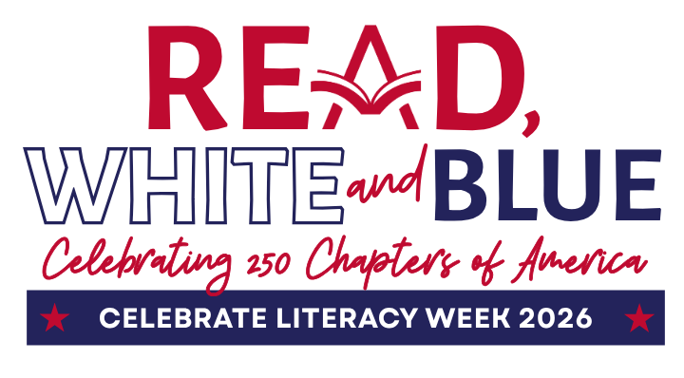
Celebrate Literacy Week, Florida!

January 26-30, 2026

District:
Monday,
January 26th
Tuesday,
January 27th
Wednesday,
January 28th
Thursday,
January 29th
Friday,
January 30th

