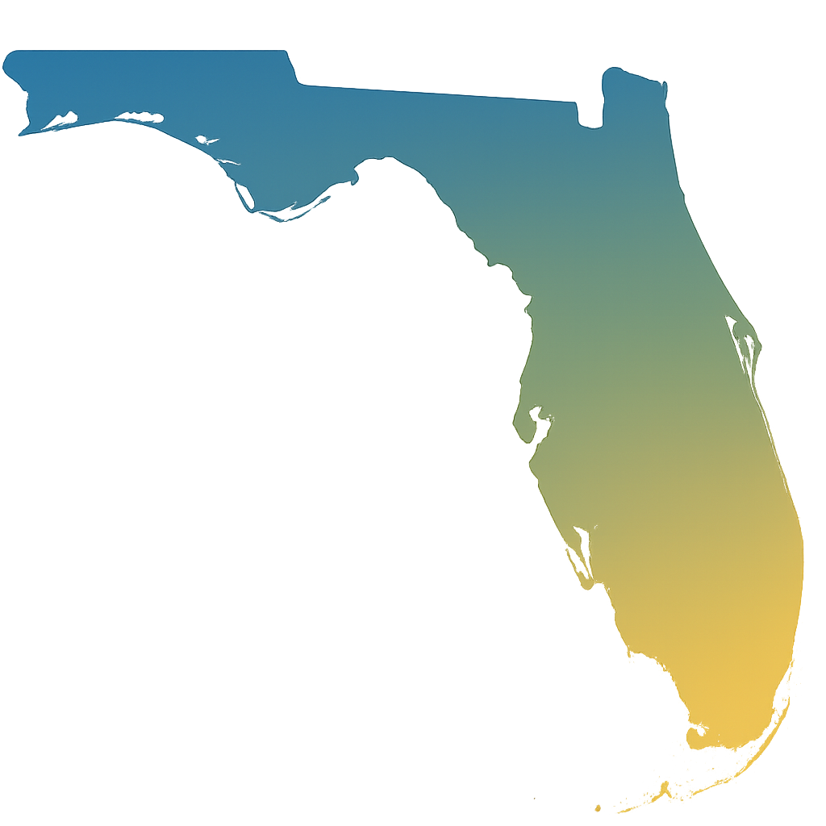

**Civics Literacy Directors**

Lauren Kappler – [Lauren.Kappler@fldoe.org](mailto:Lauren.Kappler@fldoe.org)

Traci Mulitsa – [Traci.Mulitsa@fldoe.org](mailto:Traci.Mulitsa@fldoe.org)

**Civics Literacy Coaches**

Carly Branning – [Carly.Branning@fldoe.org](mailto:Carly.Branning@fldoe.org)

Conner Albert – [Conner.Albert@fldoe.org](mailto:Conner.Albert@fldoe.org)

Jennifer Halter – [Jennifer.Halter@fldoe.org](mailto:Jennifer.Halter@fldoe.org)

Katelyn Rodd – [Katelyn.Rodd@fldoe.org](mailto:Katelyn.Rodd@fldoe.org)

Robin Siegers – [Robin.Siegers@fldoe.org](mailto:Robin.Siegers@fldoe.org)

Rosita Salazar – [Rosita.Salazar@fldoe.org](mailto:Rosita.Salazar@fldoe.org)

Stephanie Mathieu – [Stephanie.Mathieu@fldoe.org](mailto:Stephanie.Mathieu@fldoe.org)