CAREER CRUISER | Making a Postsecondary Credential Goal

Step 4 | Make a Personalized Career and Academic Plan (PCAP)
Driving Question | What recognized postsecondary credential do I want to get to reach my career goals?
Goal | Prioritize a recognized postsecondary credential aligned with the student’s career goal.
Standard | Describe which credentials are relevant to their career pathway. (CR.2.2)

FOR TEACHERS

Timeframe | 1 to 3 roughly hour-long lessons.
Materials | Internet and digital device access.
Xello | Xello, Florida’s official K-12 public school career planning and work-based learning coordination system, has tools you can use on this topic! On each ‘Major’ profile page you can favorite the major by pressing the heart icon on the page. Then, you can view your full list of favorited majors by clicking the heart icon by your profile picture at the top right.
Overview | Beginning  - Students should be reminded of what they learned through Career Cruiser Step 3 about credentials, including the information, data and experiences most relevant for decision making.  Middle  - Students will consider multiple relevant factors and select a recognized postsecondary credential to pursue.  End  - Have students discuss with a partner what training options there are for your career goal and which you intend to pursue.  Extension  - Have students research whether their postsecondary training goal can “stack” or articulate credit to other programs.

FOR STUDENTS

Learn
Credentials Matter
On average, the more education you have, the more likely you are to be employed and earn more.
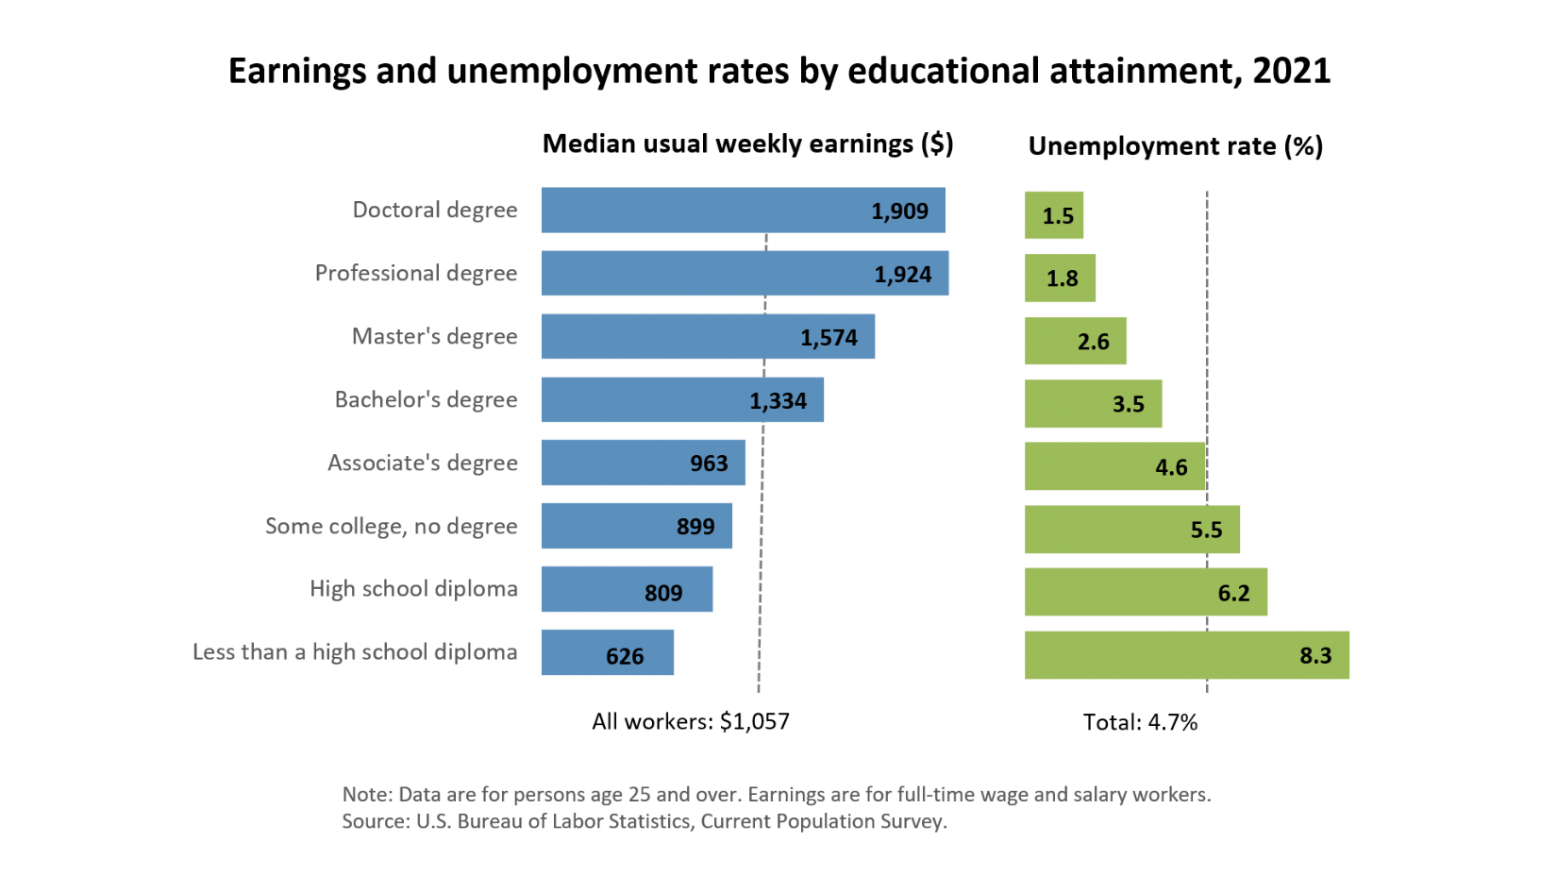
See the latest data on this topic: https://www.bls.gov/emp/chart-unemployment-earnings-education.htm.
Making decisions about what credential is right for you is a complex topic that should weigh multiple factors. Below are just a few items to consider.
- What are the requirements of the career I am interested in? Different occupations have different educational requirements and you should do research specific to your career goal.
- Can I “stack” credentials to continue my education later? Some credentials allow you to “stack” or transfer credits to other, higher credentials. For instance, associate’s degrees often transfer credits to bachelor’s degrees. So, if you get a two year associate’s degree, it often only takes 2 years to finish your bachelor’s degree (rather than the 4 years it can take to start and finish a bachelor’s degree).
- How many years are you willing to be in school? Many credentials take years to achieve. Making it through this process takes commitment and a clear vision on building the career you want.
- How much could the credential cost? Typically, the longer the credential takes to earn, the more it can cost to earn the credential, though this varies widely depending on the postsecondary training provider and how much the cost is offset by scholarships, grants, and work study earnings.

Do
Research Credentials Related to Your Career Goal
- Go to the U.S. Dept. of Labor’s Get My Future website at: https://www.careeronestop.org/GetMyFuture/Toolkit/Occupation-Profile.aspx.
- Search for your prioritized career and your location (local city, state or ZIP code).
- Open the page for your prioritized career and scroll down to the “How much education do you need?” section.
- Click on the “Find local training” button.
Reflect
Program Name: What “Program Name” is most commonly listed on GetMyFuture for your prioritized career?
Program Length: How many years are listed in GetMyFuture to complete the program you listed above?
Research: Some careers are very specific in what credentials they require, while others have employees from a variety of backgrounds. Search online to determine what is most commonly listed as a required credential. List that here.
Make a Credential Goal: What credential are you choosing as a postsecondary training goal?

