2021-24 American Rescue Plan
Elementary and Secondary School Emergency Relief Fund
Local Educational Agency ARP ESSER Plan,
Application and Assurances

[FLVS 48C]

Purpose
Florida must subgrant not less than 90 percent of its total ARP ESSER allocation to local educational agencies (LEAs) (including charter schools that are LEAs) to help meet a wide range of needs arising from the coronavirus pandemic, including reopening schools safely, sustaining their safe operation, and addressing students’ social, emotional, mental health, and academic needs resulting from the pandemic. The State must allocate these funds to LEAs on the basis of their respective shares of funds received under Title I, Part A of the Elementary and Secondary Education Act of 1965 (ESEA) in fiscal year (FY) 2020.

The purpose of this document is to guide districts to plan for the continued implementation of reopening and recovery through the utilization of the 2021-24 ARP ESSER and to assure federal requirements are met. Florida utilized the 2020-21 District Reopening Plan and the Spring 2021 Education Plan to respond to and mitigate the impact of the emergency and to promote the health, safety, and welfare of persons connected with Florida’s educational system.

The Department recognizes that the safe return to in-person instruction must be accompanied by a focus on meeting students’ academic, social, emotional, and mental health needs, and by addressing the opportunity gaps that existed before – and were exacerbated by – the pandemic. In this document, districts will describe how they will support the development of high-quality plans for the use of ARP ESSER funds to achieve these objectives for the following student groups: students from low-income families, from each racial or ethnic background, by gender, English Language Learners, students with disabilities, experiencing homelessness, in foster care, migratory students and other student groups.

Directions
Districts shall submit its ARP ESSER application to the Office of Grants Management via ShareFile on or before November 12, 2021. ShareFile access has been established for the ARP ESSER Lump Sum program for each LEA. The complete application shall include:

- LEA ARP ESSER Plan, Application and Assurances utilizing this template;
- DOE 100A Project Application Form; and
- DOE 101 Budget Narrative Form.

Each LEA developed and made publicly available on the LEA’s website a plan for the safe return of in-person learning in the Fall of 2020. This was before the enactment of the ARP Act. This plan must be updated to address the requirements of the U.S. Department of Education’s Interim Final Rule, 88 FR 21195. The requirements of the Interim Final Rule are summarized in Appendix A. Each LEA shall seek public comment on the updated plan and take such comments into account prior to the submission of the final plan to the Department. Updated plans must comply with state law, including any applicable executive order, any agency emergency action, or any agency regulation or rule. No later than 60 days from receipt of its DOE 200, Project Award Notice, each LEA shall email its updated final plan to recoveryplan@fldoe.org. The subject line of the email must include district name and Plan for the Safe Return of In-person Instruction. Upon the Department’s approval, the LEA shall post this plan on the LEA’s website within 90 days of the award.

Part I: Implementation Plan

The LEA will submit an implementation plan, outlining planned activities for each of the following uses of funds under section 2001(e) of the ARP Act. The description must be adequate to ascertain that the proposed use of funds is necessary to prevent, prepare for, or respond to the COVID-19 pandemic, including its impact on the social, emotional, mental health, and academic needs of students.
Activities should be numbered consecutively. If the LEA does not plan any activities for one or more authorized uses, please indicate that there are no planned activities. School district LEAs shall include the activities identified for charter schools within the LEA, aggregated at the district/LEA level.

Activity 1: Addressing Learning Loss (at least 20% of total allocation). Of the total amount allocated to an LEA, the LEA must reserve at least 20 percent of funds to address learning loss through the implementation of evidence-based interventions such as summer learning or summer enrichment, extended day, comprehensive afterschool programs, or extended school year programs, and ensure that those interventions respond to students’ social, emotional, and academic needs and address the disproportionate impact of COVID-19 on underrepresented student subgroups (each major racial and ethnic group, children from low-income families, children with disabilities, English learners, gender, migrant students, students experiencing homelessness, and children and youth in foster care).

- Intervention Teachers
To respond to COVID-19 and address the exponential increase in both tier 2 and tier 3 students, 6 new intervention teachers were hired (5 elementary intervention teachers and 1 middle school math intervention teacher). The data below represents the growth in tier 2 and 3 students from SY 2020 to SY 2022.

ELA | Tier 2 |  | Tier 3
 | One Grade Level Below |  | Two Grade Levels below |  | Three or More Grade levels Below
 | 2019-2020 | 2021-2022 | 2019-2020 | 2021-2022 | 2019-2020 | 2021-2022
Elementary(3-5) | 116 | 580 | 41 | 176 | 17 | 56
Middle | 84 | 171 | 43 | 97 | 58 | 217
Math | Tier 2 |  | Tier 3
 | One Grade Level Below |  | Two Grade Levels below |  | Three or More Grade levels Below
 | 2019-2020 | 2021-2022 | 2019-2020 | 2021-2022 | 2019-2020 | 2021-2022
Elementary(3-5) | 215 | 1131 | 45 | 231 | 18 | 87
Middle | 77 | 237 | 33 | 130 | 49 | 160

These six intervention teacher salaries and benefits will be funded by ARP ESSER through the end of fiscal year 2024.

- REWARDS® Teacher Intervention Materials:
The Middle School will use REWARDS® Secondary. It is both an evidence-based and research-validated program. REWARDS (Reading Excellence: Word Attack & Rate Development Strategies) is a specialized reading program that uses direct instruction to teach students highly transferable word attack and decoding strategies for multisyllabic words, and builds fluency, comprehension, and automaticity. REWARDS is designed as a six-week intensive course with daily lessons of 50-60 minutes each, and uses the model of "I do, we do, you do" to deliver explicit, teacher-led instruction. With explicit, systemic, teacher-led instruction, this intervention gives students new skills to unlock grade-level content-area text.
Teachers receive both print and online materials aimed at making implementation simple. The Teacher’s Set includes:
• Teacher’s Guide (print and eBook)
• Two classroom instructional charts
• Online Teacher Resources (illustrated content-area vocabulary displays, assessment materials, video vignettes on high-quality direct instruction and more)
ARP ESSER funds will be used to purchase the Full-time Middle School 3 teacher sets.
- Achieve 3000
Achieve 3000 for Literacy ensures all students, especially the most vulnerable, continue to accelerate their literacy growth to get on -track for success. Several independent and rigorous studies have demonstrated the positive impact of Achieve3000 Literacy on students’ reading achievement. Evidence for ESSA recognized Achieve3000 for demonstrating strong evidence of efficacy based on results from a third-party randomized controlled trial study of its solutions for middle and high school students with a positive effect size of +0.29. In addition, Achieve3000's solutions for elementary school students have been recognized as having promising evidence of efficacy.
ARP ESSER will be used to purchase 600 licenses for the Full-time High School for the following students:
•9th & 10th grade students who scored a Level 2 on FSA ELA and/or below 1-2 grade levels on the iReady diagnostic.
•9th & 10th grade students who scored a Level 1 on FSA ELA and/or below 3 or more grade levels on iReady diagnostic.

Activity 2 (A) Any activity authorized by the Elementary and Secondary Education Act of 1965.

- Family Engagement Coordinator
ARP ESSER funds will be used to hire a Family Engagement Coordinator to address the growing number of families represented by the exponential increase in student enrollment. The purpose of the Family Engagement Coordinator is to effectively engage families and build their capacity to support student achievement. The role serves as a liaison between the school and parents/guardians, relays the needs of one to the other; educates teachers and staff on how to communicate and work effectively with parents as equal partners; counsels and advises parents on how to address issues with the transition from brick and mortar schools to the virtual environment; serves as a school-based intermediary contact for concerns and comments made by parents; fosters opportunities for continued family/parent learning in support of student achievement, promotes sharing of power with parents as decision-makers; helps parents understand the educational system so they can become better advocates for their children’s education; maintains current knowledge of state and federal requirements in serving Title I schools and represents FLVS within the state’s Family Engagement community.

- USA Test Prep
The Full-time High school will purchase 1 College Prep bundle and 1 High School Tier 1 bundle; The Florida High School College Prep Bundle is $3,500 and the Florida High School Tier 1 Bundle is $3,500. Purchasing both provides a discount of $1,000.
USA Test Prep is 100% aligned to the state standards. The platform provides easy-to-use assessments and progress monitoring to allow teachers to quickly identify learning gaps. This evidence-based intervention will be used for tier 3 9th – 12th graders in math and 11th and 12th graders in ELA.
- Graduation Coach
A portion of a Graduation Coach will be funded by ARP ESSER to assess student learning gaps and work with students to develop a graduation and achievement plan to include the best program to meet academic and post-secondary goals; collaborate with feeder middle school to utilize the components of a profile of characteristics of potential dropouts to identify middle school students with the high probability of not graduating; collaborate with teachers, counselors, and resource teachers to implement transition processes for rising/incoming 9th graders; coordinate transitions and monitor schedules for identified ninth-graders to help them successfully adapt to the rigor of high school; identify students in need of additional support and partner with appropriate stakeholders (staff, parents, community resources, etc.) to ensure they achieve academic and social success; provide training and/or support to teachers on strategies that work with at-risk youth; and conduct analysis of formative and summative data (to include but not limited to, grade distribution, EOC passing rates, and credit retrieval information) as a way to evaluate program effectiveness.
- MTSS Stipend
ARP ESSER will fund the MTSS stipend to assist the district with ensuring that a comprehensive multi-tiered system of supports (MTSS) framework is in place for all FLVS Full Time Schools. The district point of contact will attend professional development opportunities and disseminate information to school and district stakeholders; will convene and document regular on-going meetings for K-12 MTSS/RTI team stakeholders; and will bring the schools together for a cohesive K-12 district plan to assess and address academic, behavioral, and mental health student concerns, implement tiered supports, monitor and track interventions, and problem-solve.

Activity 2 (B) Any activity authorized by the Individuals with Disabilities Education Act.

- MobyMax
ARP ESSER will fund one year of a complete K-8 curriculum including math, fact fluency, reading, early-reading, language, writing, science & social studies for 450 middle school students receiving Special Education Services.
Moby Max will increase academic achievement and close the achievement gap that Covid 19 has widened. This program provides differentiated learning that will help struggling learnings, especially our ESE students catch up to grade level and close the learning gap that they have experienced throughout the past school year in result of the pandemic. Moby Max not only offers differentiated instruction, it offers adaptive differentiation which includes diagnostic testing, adaptive lessons, IEP Progress monitoring, Assessments, interactive classroom tools and Daily Goals. This program will ensure the ESE instructors and General Education teachers have the tools and data necessary to pinpoint the exact skill gap and design and implement targeted instruction to fill these gaps. This program targets the grade level standards and offers tools for delivering specialized instruction. This is not meant to take place of deficit intervention, but rather assessing the students’ gaps in grade level standards and providing daily data to implement targeted specialized instruction to increase achievement within the grade level standards.
Moby Max aligns to Florida state standards and benchmarks which tracks mastery of grade-level standards from the beginning to the end of the year. This is a valuable tool that will guide/ inform General Education Teachers and ESE teachers to make informed decisions and implement specialized instruction to target and close skill gaps. In addition to interactive lessons, Moby offers a test prep module providing additional support by giving students a preview of what to expect by mirroring the content and format of Florida Standards Assessment test items. The program ensures students stay engaged while developing key conceptual knowledge. Moby’s program research documents that ESE students learn twice as fast with MobyMax. This suite of assistive technology innovations saves special education teachers valuable time with online assessments, grading and markup tools, easy and accurate diagnostics, IEP reporting, and real-time progress monitoring. The progress monitoring tool allows teachers to create and set student goals that are automatically updated as students’ progress. Moby provides adaptive lessons, and this is a valuable tool for instructors as it allows teachers to differentiate instruction based on the needs of each student. Furthermore, Moby Max conducted a study and found that students have gained more than one full grade level just within 20 hours of using this program.
Additionally, Some of the features of this program are: Quick skill and Benchmark assessments and assignments that will pinpoint missing skills quickly and precisely, Data- instant access to a snapshot of the students growth to easily monitor and track progress, Interactive class platform - where the ESE teachers can use to design specialized instruction for students in their classes/services to engage the students with skill review, whiteboard activities, fluency games and quick diagnostics, Quick diagnostics- allows students to use any device to respond to questions posed in class and will calculate the results and log all results in the students data profile, Student engagement - The program has a built in incentive platform that lets student earn rewards, badges, certificates, contents and more, Extended learning- The program offers customized learning experiences for the student to do at home, in summer or anytime for enrichment and still collects data on progress and standards mastery.

Activity 2 (C) Any activity authorized by the Adult Education and Family Literacy Act.

- NewsELA student licenses:

ARP ESSER will be used to purchase 3000 student licenses for the Full-time Middle school. Newsela is an instructional content tool that allows teachers to find articles with appropriate reading levels for their students. Newsela articles also feature questions and writing prompts that align with common core standards.

Activity 2 (D) Any activity authorized by the Carl D. Perkins Career and Technical Education Act of 2006.

- Xello student licenses

Xello licenses include a college and career readiness assessment and planning tool for high school students. Xello will allow students of all backgrounds, abilities, and aspirations the opportunity to become future-ready. Through assessments, portfolios, and career and college information, students will be able to pursue post-secondary goal alignment with appropriate college and career plans by accessing this digital platform. School counseling staff will be able to determine college and career readiness gaps by monitoring student progress. This will allow them to customize their support in order to respond to the COVID 19 impact on learning.

ARP ESSER will be used to purchase 4200 student Xello licenses for the Full-time High School.

Activity 2 (E) Coordination of preparedness and response efforts of local educational agencies with State, local, Tribal, and territorial public health departments, and other relevant agencies, to improve coordinated responses among such entities to prevent, prepare for, and respond to coronavirus.

No Planned Activities

Activity 2 (F) Activities to address the unique needs of low-income children or students, children with disabilities, English learners, racial and ethnic minorities, students experiencing homelessness, and foster care youth, including how outreach and service delivery will meet the needs of each population.

- ELL Coordinator:

ARP ESSER will fund a portion of an ELL Coordinator salary and benefits for one year. The ELL Coordinator will be responsible for providing leadership in the development, coordination, and support of curriculum, instruction, assessment, and student instructional support, as well as oversight of ELL Program protocols and procedures.

Activity 2 (G) Developing and implementing procedures and systems to improve the preparedness and response efforts of local educational agencies.

- FOCUS Special Student Services module and training

FLVS will implement a new Special Student Services module within their current Student Information System. This is a customizable system in which FLVS can design and maintain specialized program workflow in a variety of areas, including early identification, section 504 eligibility, student IEP’s, MTSS, and more. This module provides a comprehensive system that creates, maintains, and tracks student data resulting from state-defined standards. The Focus SSS module provides the necessary tools to support students through the many facets of early intervention and the special education process. Educators and school-based professionals will have the ability to create and customize events under three main programs: Response to Intervention (RtI/MtSS), Section 504, and Special Education (IEP/ Evaluations).

Activity 2 (H) Training and professional development for staff of the local educational agency on sanitation and minimizing the spread of infectious diseases.

No Planned Activities

Activity 2 (I) Purchasing supplies to sanitize and clean the facilities of a local educational agency, including buildings operated by such agency.

No Planned Activities

Activity 2 (J) Planning for, coordinating, and implementing activities during long-term closures, including providing meals to eligible students, providing technology for online learning to all students, providing guidance for carrying out requirements under the Individuals with Disabilities Education Act and ensuring other educational services can continue to be provided consistent with all Federal, State,
and local requirements.

No Planned Activities

Activity 2(K) Purchasing educational technology (including hardware, software, and connectivity) for students who are served by the local educational agency that aids in regular and substantive educational interaction between students and their classroom instructors, including low-income students and children with disabilities, which may include assistive technology or adaptive equipment.

- Class K-12

To respond to COVID 19 and to address the increase in student enrollment, ARP ESSER will be used to purchase Class-K12 for students grades 6-8 in school year 2022 and then to all students K-12 through school year 2024.

Class K-12 is an online platform that provides interactive, connected learning experience with tools to track focus and provide feedback, improves instruction, grade assignments, takes attendance, and allows teachers and students to have one-on-one discussions – all without leaving Zoom. Class K-12 also tracks and monitors student learning with in-platform assessments, automatic grading, and analytics.

- Nearpod

In order to respond to the COVID 19 impact on learning, FLVS will utilize Nearpod licenses for every student. Using a standards-aligned library of 15,000+ lessons and videos across all grades and subjects, Nearpod provides students with equitable access to high quality teaching and learning from any location.
Nearpod can surface data reports to pinpoint exact learning loss so teachers can bridge learning gaps in any setting. Nearpod supports all teachers meeting students where they are, even during distanced learning. Teachers can address learning loss with Nearpod by utilizing formative assessments to drive insights into individual student learning needs. Additionally, Nearpod provides features that allow for adapting instruction in real time, with in-the-moment feedback. These features, in conjunction with authentic relationship building opportunities through checkpoints and activities focusing on social and emotional well-being, make Nearpod a tool that empowers teachers to deliver engaging and effective instruction from any location.
Nearpod aids in regular and substantive educational interaction between students and their classroom teachers by providing interactive slide presentations for both students and teachers. These customizable slides allow students to interact and learn from each other while being guided by their instructor. Nearpod gives students the opportunity to be engaged in their lessons with the use of interactive field trips, collaboration boards, annotation/drawing features, game mode, video interactions, interactive quizzes, etc. Data is collected automatically for teachers making it easier to see how the class or individual students are progressing through each lesson.

FLVS FT Elementary teachers use Nearpod to create teacher-paced and student-paced lessons. All contain engaging activities that record student responses as they work and various methods for student response. The teacher screen shows student responses to activities in real time, which allows teachers to provide immediate feedback, to address errors, or give encouragement. All data from the lesson is housed in the teacher reports and it is looked at as a whole class and individually. These data reports are used to track intervention student progress and subgroups so teachers and administration can determine growth or the need for additional support. Using Nearpod as an instructional and progress monitoring tool gives teachers additional data to determine the instructional needs of students.

Within the FT Middle School, Nearpod is used to support all learners in every tiered level of support. For the most struggling readers, the RTI teachers use Nearpod to provide the REWARDS®-based instruction and assess fluency. Many of the activities in the Nearpod library are also accessible in languages other than English, which supports the ELL student population.

Within the FT High School, Nearpod is used as a live lesson resource to support all learners in every tier. It makes participation accessible to all students since they are able to demonstrate their learning on their own screen and not have to rush to grab the mic or write in the chat box allowing for greater and more authentic engagement in learning. Across tiers, Nearpod is also helpful for formative assessment and lesson review. For our most struggling readers, our Reading Intervention teachers use Nearpod to assess fluency and offer independent practice reading out loud (by recording themselves) without the added pressure of doing so in front of peers. Our Math Intervention Instructors utilize Nearpod as a resource to provide differentiated instruction and allow independent practice with immediate feedback. The teachers also use Nearpod to create self-paced modules, including resources that students can access to preview upcoming material. Observations and reports collected during student participation provide useful progress monitoring data. Many of the activities in the Nearpod library are also accessible in languages other than English, to help ESOL students.

FLVS will use ARP ESSER to fund the purchase of 11,515 Nearpod student licenses for one year.

Activity 2(L) Providing mental health services and supports, including through the implementation of evidence-based full-service community schools.

No planned activities

Activity 2(M) Planning and implementing activities related to summer learning and supplemental afterschool programs, including providing classroom instruction or online learning during the summer months and addressing the needs of low-income students, children with disabilities, English learners, migrant students, students experiencing homelessness, and children in foster care.

- Strong Start Stipends
K-5 Strong Start stipends will be used to pay 6 teachers to assess students and plan for intervention strategies that will be implemented on the first day of school after summer break. Teachers will work 4 hours per day for 10 days at $25/hour to assess students for baseline data and to plan for intervention.

Middle School Strong Start stipends will be used to pay 4 teachers to assess students and plan for intervention strategies that will be implemented on the first day of school after summer break. Teachers will work 4 hours per day for 10 days.

High School Strong Start stipends will be used to pay 8 teachers to assess students and plan for intervention strategies that will be implemented on the first day of school after summer break. Teachers will work 20 hours total.

Activity 2(N) Addressing learning loss among students, including low-income students, children with disabilities, English learners, racial and ethnic minorities, students experiencing homelessness, and children and youth in foster care, of the local educational agency, including by—
(i) administering and using high-quality assessments that are valid and reliable, to accurately assess students’ academic progress and assist educators in meeting students’ academic needs, including through differentiating instruction;
(ii) implementing evidence-based activities to meet the comprehensive needs of students;
(iii) providing information and assistance to parents and families on how they can effectively support students, including in a distance learning environment; and
(iv) tracking student attendance and improving student engagement in distance education.

- BrainPOP
ARP ESSER will be used to purchase 80 BrainPOP licenses for the Full-time Elementary School.
BrainPOP inspires deep, transferable learning across the curriculum with a solution that meets ESSA requirements. BrainPOP meets learner needs with a unique “Access and Impact for All” framework that incorporates UDL, SEL, and Differentiation to drive equitable impact. BrainPOP supports SEL by addressing the CASEL competencies and provides a safe learning space for self-expression. Finally, BrainPOP creates a shared foundation and strengthens vocabulary with animated movies featuring relatable characters that connect to students through humor and empathy.
- iReady site licenses
iReady Site Licenses - Reading
MS - assessment & personalized instruction reading: 600 student licenses
HS- assessment reading grades 9-12: 2500 student licenses
iReady Toolboxes - Reading
MS - learning teacher toolbox access reading
iREADY Site Licenses - Math
ES - assessment & personalized instruction math: 3200 student licenses
MS - assessment & personalized instruction math: 600 student licenses
MS – assessment math: 2400 student licenses
HS – assessment math grades 9-12: 2500 student licenses
iREADY Toolboxes - Math
ES - learning teacher toolbox access math: 3200 students
MS - learning teacher toolbox access math
- Math Nation
The Middle School will be utilizing Math Nation for Algebra I, and Geometry students. Math Nation is a comprehensive, interactive math resource that is aligned to the Florida Math Standards and will be used to supplement instruction and target specific areas of weakness for students in the areas of middle school math classes as well as Algebra 1 and Geometry that will lead to increased student achievement and close academic gaps in order to respond to the COVID 19 impact on learning. Students can choose between five different tutors who teach the same material in different ways and at different paces. A practice Tool at the end of each section of videos lets students test their knowledge, gives instant feedback, and suggests resources that target gaps in their understanding. The interactive Algebra Wall lets students in Algebra 1 and Geometry get extra help from Study Experts, teachers, and peers.
ARP ESSER will fund one year of school-wide digital access for Grades 6-8 Algebra I and Geometry.
- Orton Gillingham Materials

ARP ESSER will be used to purchase the Middle School Orton Gillingham materials for 150 Tier 3 Middle School students along with postage to mail the materials to each student.
- Family Engagement Communication Platform:
A communication platform will be funded by ARP ESSER. This virtual platform will improve communication between schools and families. Florida Virtual school faces the challenge of being a statewide LEA with a barrier of minimal face-to-face opportunities for communication. By utilizing technology for communication, the platform delivers progress reports securely and efficiently with variable-length document parsing and snail-mail delivery to parents who did not receive their documents via text/email/app notification; automatically alerts parents when their child is absent and gives them the option to excuse their child straight from their app (or text or email) anytime, anywhere; Administrators can enact threshold-based rules around when to generate and send letters home for truancy; integrates with our student information system via direct API based integration, SIS partnerships, SFTP transfers, or partnerships with Data Integrators.

Activity 2(O) School facility repairs and improvements to enable operation of schools to reduce risk of virus transmission and exposure to environmental health hazards, and to support student health needs.

No Planned Activities

Activity 2(P) Inspection, testing, maintenance, repair, replacement, and upgrade projects to improve the indoor air quality in school facilities, including mechanical and nonmechanical heating, ventilation, and air conditioning systems, filtering, purification and other air cleaning, fans, control systems, and window and door repair and replacement.

No Planned Activities

Activity 2(Q) Developing strategies and implementing public health protocols including, to the greatest extent possible and not inconsistent with state law, policies in line with guidance from the Centers for Disease Control and Prevention for the reopening and operation of school facilities to effectively maintain the health and safety of students, educators, and other staff.

No Planned Activities

Activity 2(R) Other activities that are necessary to maintain the operation of and continuity of services in local educational agencies and continuing to employ existing staff of the local educational agency.

- As a result of COVID 19, 861 new teachers were hired due to the exponentially increased student enrollment. The Full-time Elementary School had a student count of 1,170 students in SY 2019-20 compared to 4,779 students in SY 2020-21. That is over a 300% increase in enrollment. ARP ESSER will fund 53 teachers’ salaries and benefits in school year 2021-2022.

- A portion (.5 FTE) of the Entitlement Grant Budget Analyst salary and benefits will be funded by ARP ESSER.

- The Senior Technician, Budget and Compliance’s salary and benefits to assist the Full-time schools with the execution of entitlement grant funded activities will be funded by ARP ESSER.

Activity 2 (S) Administration. LEAs may take reasonable and necessary administrative costs, to include direct and indirect costs. Indirect costs may be taken up to the negotiated, unrestricted indirect cost rate. However, to ensure that the total administrative costs are reasonable, the total direct and indirect costs may not exceed five percent (5%) of the LEA’s total award.

- 5% of the allocation will be used to cover Indirect Costs.

Part II: Ensuring Effectiveness of Interventions

Please describe how the LEA will ensure that the interventions it implements, including but not limited to the interventions under section 2001(e)(1) of the ARP Act to address the academic impact of lost instructional time, will respond to the academic, social, emotional, and mental health needs of all students, and particularly those students disproportionately impacted by the COVID-19 pandemic, including students from low-income families, students of color, English learners, children with disabilities, students experiencing homelessness, children and youth in foster care, and migratory students. In your response, please include a description of interventions and strategies that are aligned to the LEA’s data (disaggregated by subgroup), and describe how the LEA will measure the effectiveness of the selected interventions.

FLVS ensures that all implemented interventions respond to the academic, social, emotional, and mental health needs of all students using a multi-tiered system of supports.
The Full-Time Elementary School has implemented several initiatives to ensure the students’ progress is being accurately measured and that they are receiving a well-rounded education addressing the whole child. Teachers update their students’ academic data bi-weekly on “baseball cards” that are accessible by all staff. This data is reviewed frequently with grade-level teams and monthly with individual teachers. Student diagnostic assessments are frequently monitored by the teachers live online to ensure accuracy. Teachers conduct individual Discussion-Based Assessments with students to further monitor their progress. Intervention teachers conduct 1:1 and small group lessons for academically at-risk students. In an effort to provide additional academic opportunities for students outside of the direct instruction teachers provide during live lessons; school personnel developed weekly lessons covering a wide range of topics, students can participate in a variety of clubs every Friday, academic strategies are shared during morning announcements, teachers conduct tutoring sessions, and several family literacy sessions are conducted throughout the year.
The Full Time MS has developed a well-rounded program of instruction taking Universal Design, flexibility, equitable access to learning, differentiated approach, promoting all learning styles, and coupling it with a research based and supported RTI (Response to Intervention) model, which directly services and supports students at all levels and tiers. All teachers take a systematic approach to instruction and intervention with each individual student in effort to support each student at the level they need. Diagnostics, screeners, and previous student data are gathered, interventions are developed, deployed, measured, and repeated or changed dependent upon the response we see from all students through both qualitative and quantitative data. Moreover, the Middle School uses time each year to collaborate during Data Days, reviewing YOY data comparison of segment exam scores, data tracking of pace and grades, and Teacher-Student Progress reports, which clearly outline the success each student is having in their individual courses throughout the school year. Teachers participate in PLCs to analyze the effectiveness of certain teaching practices and research and implement new strategies. This well-rounded program of instruction is implemented to meet the academic needs of all students through teacher-created resources such as toolboxes, help sites, and google slides. Content Area Lead Teachers provide an additional layer of support to departments as well as facilitating cross-curricular efforts. School counselors hold periodic sessions, including Character Ed and Friends Club. The mental health team holds sessions for both parents and students on various topics throughout the year to provide strategies and support.
The Full Time HS has developed a whole school approach to supporting its students ensuring tiered levels of support and instruction are provided. Flexibility, equitable access to learning, scaffolded support, and multiple learning theories are embedded in the schoolwide, evidence based MTSS (multi-tiered system of supports) model, which directly services and supports students at all levels and tiers. The high school teachers utilize a systematic approach to identifying needs, instructional and intervention strategies with the individual student in mind. To ensure each student is supported at the level of their individual needs, diagnostics, screeners, and previous student data are gathered, interventions are developed, deployed, measured, and repeated or changed dependent upon the response from the students through both qualitative and quantitative data. Moreover, the high school teams collaborate during Data Days, reviewing YOY data comparison of segment exam scores, data tracking of pace and grades, and Teacher-Student Progress reports, which clearly outline the success students are having in their individual courses throughout the school year. This well-rounded program of instruction is implemented to meet the academic needs of all students through evidence-based intervention tools as well as teacher-created resources such as toolboxes, help sites, and google slides. Content Area Lead Teachers provide an additional layer of support to departments as well as facilitating cross-curricular efforts. A variety of courses are offered to meet the needs of students wishing to pursue academically rigorous programs as well as standard curriculum required for graduation. All students are scheduled in appropriate courses that support well-rounded education by providing access to such courses and programs. Courses and clubs continue to be developed to expand the elective and extracurricular offerings provided in our virtual environment in an effort to support the whole child.
Each full-time school uses Intervention Teachers to support all struggling students. FLVS-Full-time has implemented this strategy in prior year and has seen student achievement increase as a result. Intervention teachers provide more intensive individual and small group instruction for struggling students. Students who have not been successful in the Math or ELA curriculum and/or have not demonstrated mastery of the skills and knowledge required by their grade-level state standards make up the target population. Students are assigned a personalized course of study that allows for increased learning time in their areas of academic need. In addition to an increased focus on core curricular content, the teachers incorporate additional online resources to monitor student performance and address students` instructional needs. The teachers increase the occurrence of live, synchronous direct instruction to foster student academic success in accordance with FLVS and Florida BEST Standards, policies, and laws.
Elementary, Middle, and High School Interventions in math and reading will be provided to students who are identified as below the proficiency levels on the iReady or Florida Standards Assessments and/or students that are low performing and not meeting requirements and in need of additional academic supports.
The Elementary, Middle, and High Schools utilize RtI Specialists who oversee and support all students in the MTSS process. The RtI specialist is responsible for the successful implementation and ongoing, continual improvement of the reading and math intervention programs to foster a strong foundation in basic skills, increased self-confidence as students succeed, and ensuring students receive that intensive support and extra time they need to become proficient in the content. The RtI Specialist coordinates the support in planning instruction and/or adaptation of the instructional program using the Multi-Tiered System of Supports (MTSS) model to facilitate student learning in accordance with district policies and state guidelines.
Additionally, FLVS uses the following indicators in its efforts to identify students who are at risk for meeting State academic achievement standards:
• Course progression data
• Course performance data
• Attendance records
• Teacher referrals
• Parent feedback
• Discipline referrals
• Academic integrity data
• Teacher/Learning coach conferences
• Curriculum-Based Assessments and Discussion Based Assessments
• Curriculum-Based Measurements
• Supplemental diagnostic assessments
The above intervention strategies address the needs identified by the following sub-group datasets:
Full-time Elementary FSA subgroup data analysis:
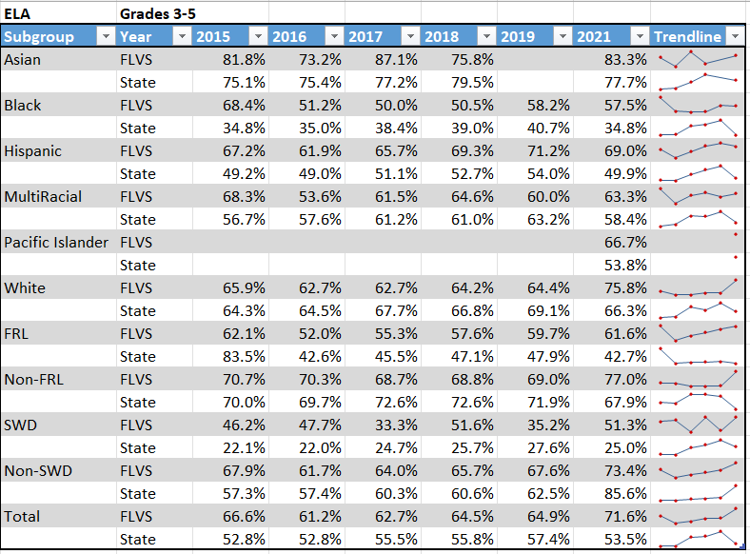
Areas of Strength
In every race/ethnicity, FLVS showed an increase except for Hispanic and Black, but the decreases were very minimal, especially compared to the State drops.
The FRL subgroup has seen a steady increase since 2016 and is nearly 20% higher than the State.
The SWD subgroup increased by 16 percentage points. There were 117 in the subgroup.
Areas for Growth
The Hispanic subgroup decreased 2.2%- although this is not much, it is the only real area of drop. There were 435 students in this group.

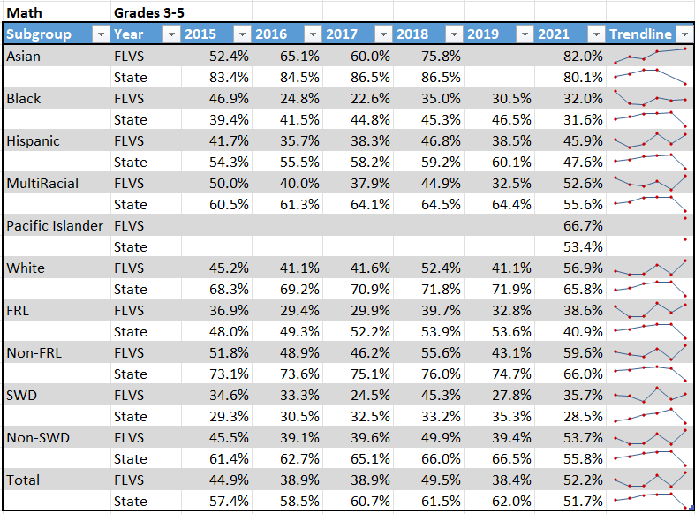
Areas of Strength
Every race/ethnicity subgroup improved.
The FRL subgroup increased nearly 6% points, whereas the same group statewide dropped nearly 13% points.
Students with disabilities increased and is above the State.
Areas for Growth
The Black subgroup is the lowest performing group and although higher than the State and demonstrating an increase, it's still at 32%, which is 20% lower than the total.
The SWD subgroup increased and is above the State, but is still 16.5% lower than the total.
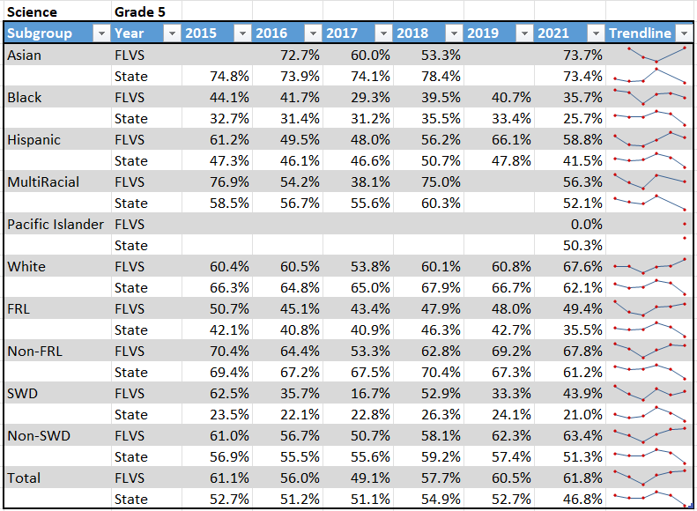
Areas of Strength
FRL performance is above the State by almost 14% points and is nearly 50%.
SWD performance rose 10% points and is 22% above the State.
Areas for Growth
The Black and Hispanic group dropped in performance, although still higher than the State.

Full Time Middle School subgroup data analysis:
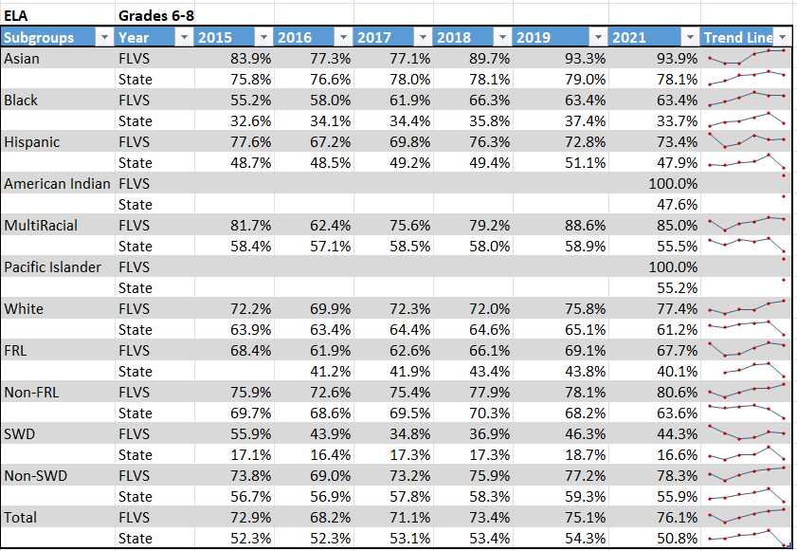
Areas of Strength
White students improved 3.4% to 77.4%, which is 16.2% higher than the State.
Areas for Growth
Most race subgroups made very little or no growth.
SWD and FRL performance dropped
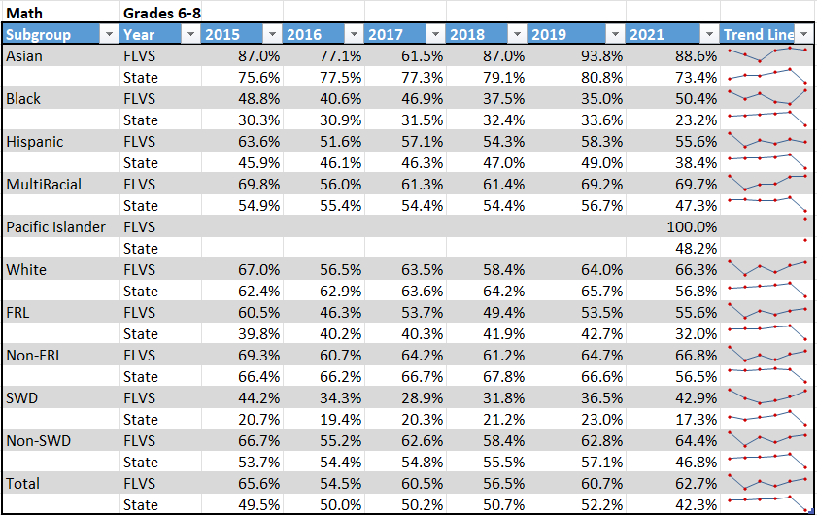
Areas of Strength
The Black subgroup increased 15% points.
The SWD subgroup increased 6.4%.
The FRL rose slightly, is above the State, and is above 50%.

Areas for Growth
The Hispanic and Asian subgroups dropped in performance; however, both are still above the State.
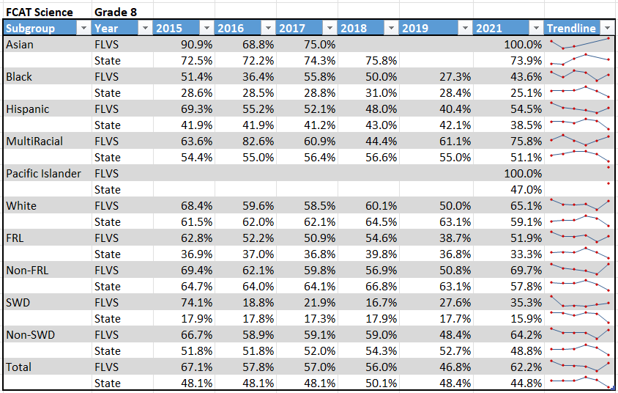
Areas of Strength
Every subgroup increased.
Every subgroup is above the State.
The FLVS overall performance is 17.4% above the State.
Areas for Growth
Although Black and SWD are above the State and increasing, they are both below 50%.

Full Time High School subgroup data analysis:
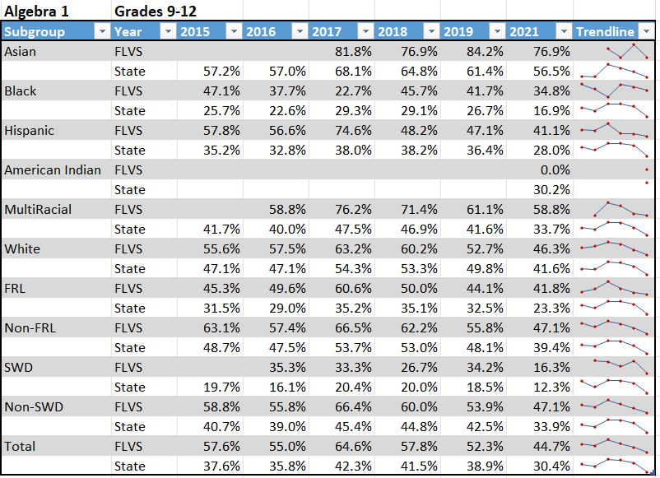
Areas of Strength
All subgroups are above the State.
Areas for Growth
All subgroups declined.
The SWD subgroups had the largest decline of 17.91%.
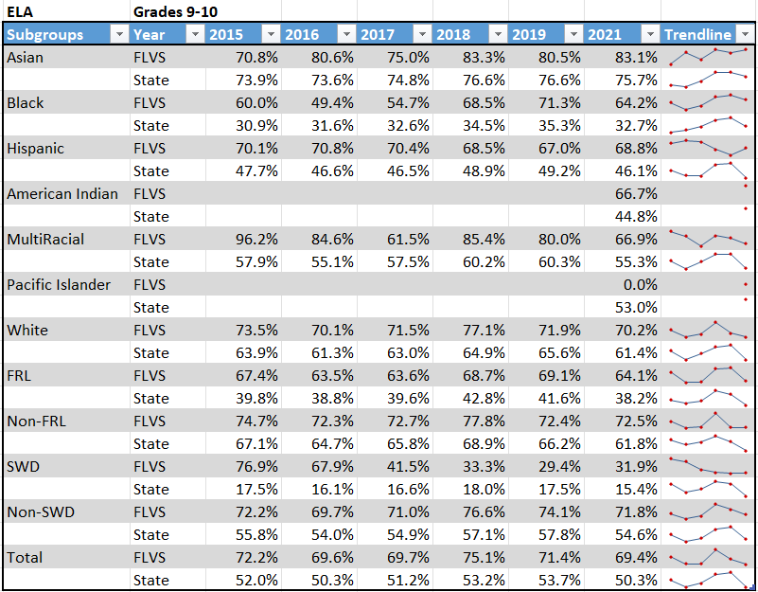
Areas of Strength
All subgroups are above the State.
SWD performance is nearly double the State performance, but still low relative to other subgroups.
Areas for Growth
The Black and Hispanic subgroups dropped the most of all the subgroups.
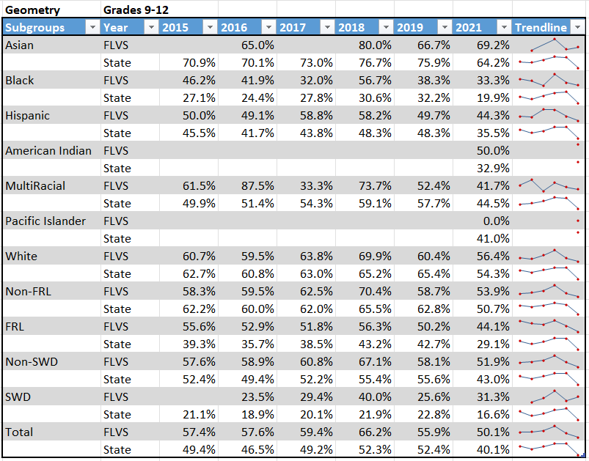
Areas of Strength
SWD improved almost 6% (to 31.3%)
Areas for Growth
Nearly all subgroups dropped in performance (except Asian and SWD).
The Multiracial subgroup dropped nearly 11% and is the only subgroup below the State.
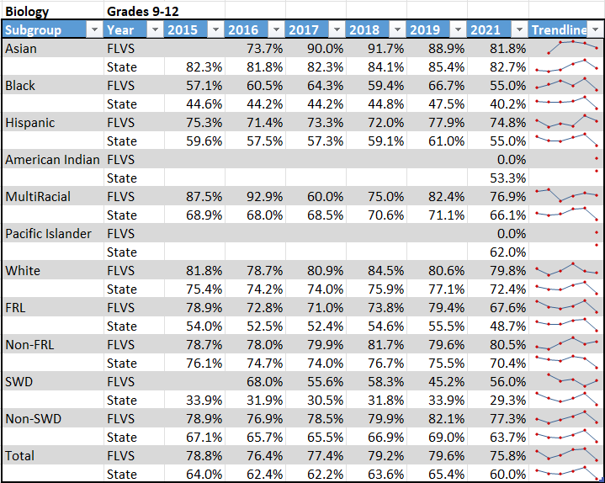
Areas of Strength
The non-FRL subgroup is the only subgroup that increased.
All subgroups (except Asian) are above the State average.
The SWD subgroup increased nearly 11% and is over 50%.
Areas for Growth
All subgroups (except non-FRL) decreased in performance.
The Black and FRL subgroups dropped nearly 12%.
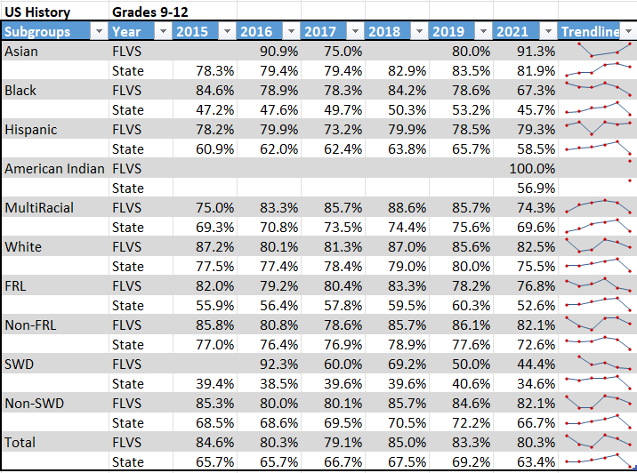
Areas of Strength
All subgroups performed above the State.
Areas for Growth
The Multiracial and Black subgroup dropped nearly 12%.
All subgroups (except Asian) dropped.

ELA Intervention Plan:
The Elementary school currently uses iReady for all tier 1 students, Lexia for K-2 tier 2 students and iReady for 3-5 tier 2 students, and Leveled Literacy Intervention for all tier 3 students. The Middle School currently uses NewsELA for all tier 2 students, iReady for all tier 2 students, and iReady, Rewards, or Orton Gillingham for tier 3 students. The High School currently uses Achieve 3000 for all tier 2 students and Achieve 3000 and USA Test Prep for 11th and 12th-grade tier 3 students.

Math Intervention Plan:
The Elementary currently uses iReady instruction for all K-5 students regardless of their tier. The Middle School currently uses MathNation for tier 1 students and iReady instruction for tier 2 and 3 students. The High School currently uses IXL for all tier 2 students and IXL and USA Test Prep for all tier 3 students. USA Test Prep, an evidence-based intervention, will be used for tier 3 9th – 12th graders in math.

FLVS will be utilizing iReady to assess student achievement for baseline, mid-year, and end-of-year progress monitoring.

Elementary School:
At the time of this application, the Full-time Elementary School will be using iReady diagnostic assessments three times/year for all students in grades K-5.

Middle School:
At the time of this application, the Full-time Middle School will be using iReady diagnostic assessments for all Tier 2 and Tier 3 students. These students are identified by scoring a 1 or 2 on the 2021 FSA or if they were in intensive courses in the 2020-21 school year. Additionally, students who did not participate in the 2021 FSA will take one initial diagnostic for placement and academic skill gap identification.

High School:
At the time of this application, the Full-time High School will use iReady to assess every 9th and 10th grader or 11th or 12th graders who have not met their assessment graduation requirement. Based on their initial diagnostic, if they are below grade level (tier 2 or 3), they will also be assessed mid-year and end-of-year to track progress.
Math Learning Gains and Learning Gains of the Lowest 25th percentile are amongst the weakest areas of student performance at the Full-time High School. To supplement instruction and target specific areas of weakness, teachers utilize iReady data, which provides math diagnostic tools with user-friendly dashboards and reports. Actionable data gives teachers a foundational understanding of students’ strengths and areas of need. This tool will enable educators to confidently determine each student’s on-grade level proficiency based on state and national standards. Skills gaps identified will be addressed through targeted, personalized instruction in order to respond to the COVID 19 impact on learning.

The Full-Time Elementary School will be using iReady diagnostics and instructional program for all students K-5.

The tier 2 and tier 3 intervention teachers for K-3 students collect progress monitoring data on each student to make decisions. DIBELS and the Florida Kindergarten Readiness Screener are used to make instructional decisions for Kindergarten students; DIBELS is also used for 1st and 2nd grade decision making, and iReady diagnostics are used for 2nd grade instructional decisions as well. Prior to the beginning of the 2020-21 school year, baseline skill assessments were administered to all Kindergarten and new 1st, 2nd, and 3rd grade FLVS students to plan for intervention strategies (as needed) beginning the first day students returned from summer. End of year diagnostic data was used for previously enrolled students. Classroom teachers also conducted a DIBELS assessment for K-2 students to assess letter phonological awareness and fluency.

For 2nd and 3rd grade students, the iReady program provides summary data that is used to identify gaps and provide differentiated instruction. These summary reports are reviewed regularly by the teachers and administration to make decisions on the appropriate intervention program/practice to be used. FLVS will also administer iReady diagnostics to K-1 students in Spring 2021.

For grades K-2 tier 2 students, Lexia® Core5® Reading (Core5) is a blended learning program that aims to accelerate the development of fundamental literacy skills for students of all abilities in grades pre-K-5. Core5 provides explicit, systematic instruction through personalized learning paths. Core5 adapts to target skill gaps as they emerge and equips teachers with the data and instructional resources, they need to personalize instruction for every student. Embedded assessment provides ongoing, actionable data to help teachers prioritize and plan offline instruction. The online student dashboard encourages students to take ownership of their learning, for an experience that’s motivating and engaging for students and teachers alike.

For grades K-5 tier 3 students, Leveled Literacy Intervention (LLI) is used as designed to help struggling readers achieve grade-level competency. LLI is delivered through explicit, direct instruction in a small-group format. Fast paced lessons aim to engage students and promote rapid processing. Intervention teachers use LLI to match students to books that they can read without difficulty (referred to as “student’s independent level” by the developer) and to books that provide more challenging text (referred to as “student’s instructional level”); the LLI Primary Systems focus on phonemic awareness, letters, phonics, comprehension, fluency, vocabulary, and writing about reading. Lessons include rereading books from the previous day, assessing reading comprehension, instructing on phonics and letters, assigning a writing task about the book that was read, and reading a new book.

The Middle School will be utilizing Math Nation for Algebra I, and Geometry students. Math Nation is a comprehensive, interactive math resource that is aligned to the Florida Math Standards and will be used to supplement instruction and target specific areas of weakness for students in the areas of middle school math classes as well as Algebra 1 and Geometry that will lead to increased student achievement and close academic gaps in order to respond to the COVID 19 impact on learning.

The Middle School will use REWARDS® Secondary. It is both an evidence-based and research-validated program. REWARDS (Reading Excellence: Word Attack & Rate Development Strategies) is a specialized reading program that uses direct instruction to teach students highly transferable word attack and decoding strategies for multisyllabic words, and builds fluency, comprehension, and automaticity. REWARDS is designed as a six-week intensive course with daily lessons of 50-60 minutes each, and uses the model of "I do, we do, you do" to deliver explicit, teacher-led instruction.
For grades 9-12, the following online programs will be utilized for ELA and Math interventions and are funded by Title I and other ESSER II grants.:
Achieve 3000
- 9th & 10th grade students who scored a Level 2 on FSA ELA and/or below 1-2 grade levels on the iReady diagnostic will use this as a part of their T2 instruction.
- 9th & 10th grade students who scored a Level 1 on FSA ELA and/or below 3 or more grade levels on iReady diagnostic
USA Test Prep
- 9th-12th grade students who scored a Level 1 on FSA ELA and/or below 3 or more grade levels on iReady diagnostic
Algebra 1/Geo
- IXL math for Tier 2 and Tier 3 instruction
- USA Test Prep for Tier 3 instruction
MobyMax
A complete K-8 curriculum including math, fact fluency, reading, early-reading, language, writing, science & social studies is used with 450 middle school students receiving Special Education Services.
The High School utilizes a Graduation Coach to assess student learning gaps and work with students to develop a graduation and achievement plan to include the best program to meet academic and post-secondary goals; collaborate with feeder middle school to utilize the components of a profile of characteristics of potential dropouts to identify middle school students with the high probability of not graduating; collaborate with teachers, counselors, and resource teachers to implement transition processes for rising/incoming 9th graders; coordinate transitions and monitor schedules for identified ninth-graders to help them successfully adapt to the rigor of high school; identify students in need of additional support and partner with appropriate stakeholders (staff, parents, community resources, etc.) to ensure they achieve academic and social success; provide training and/or support to teachers on strategies that work with at-risk youth; and conduct analysis of formative and summative data (to include but not limited to, grade distribution, EOC passing rates, and credit retrieval information) as a way to evaluate program effectiveness.
The following chart depicts the promotion rates of each 9th grade cohort at the end of SY 2021-22:
9th Grade Cohort | Total in Cohort | Retained | Promoted | Percentage Promoted
2017-18 | 1075 | 8 | 1028 | 95.63%
2018-19 | 1095 | 31 | 1064 | 97.17%
2019-20 | 1003 | 25 | 978 | 97.51%
2020-21 | 994 | 19 | 975 | 98.09%

Measurement of Effectiveness:
FLVS school improvement teams set goals for each grant funded activity to measure the effectiveness of the interventions. During progress monitoring meetings, the goals are reviewed and at the end of the year, the teams analyze the data, and an evaluation report is created that outlines each goal, the data, and if the goal has been met. This report is shared with all stakeholders at the end-of-year evaluation meeting.

Part III LEA Plan for Safe Return of In-Person Instruction

Each LEA developed and made publicly available on the LEA’s website a plan for the safe return of in-person learning in the Fall of 2020. This was before the enactment of the ARP Act. This plan must be updated to address the requirements of the U.S. Department of Education’s Interim Final Rule, 88 FR 21195. The Interim Final Rule “does not mandate that an LEA adopt the CDC guidance, but only requires that the LEA describe in its plan the extent to which it has adopted the key prevention and mitigation strategies identified in the guidance.” 88 FR at 21200. Any updated LEA plan must be consistent with state law, including any applicable executive order, any agency emergency order, or any agency regulation or rule. Note specifically that LEA policies must comply with section 381.00316, Florida Statutes, and that any policies implemented after August 9, 2021 must comply with Florida Department of Health Rule 64DER21 -12, F.A.C., and any policies implemented after September 22, 2021 must comply with Florida Department of Health Rule 64DER21-15, F.A.C.

Each LEA must seek public comment on the plan and take such comments into account prior to submission of the final plan to the Department within 60 days of the award. Upon the Department’s approval, the LEA shall post this updated plan on the LEA’s website within 90 days of the award.

☒ By checking this box, the LEA acknowledges the requirement that each LEA shall update its Plan for Safe Return of In-Person Instruction to reflect the requirements stated above, shall seek public comment on the updated plan and take such comments into account prior to the submission of the final plan to the Department within 60 days of the award. Upon the Department’s approval, the LEA shall post this updated plan on the LEA’s website within 90 days of the award.
Part IV: Assurances

The district must agree to ALL of the assurances by checking the corresponding boxes.

☒ Assurance 1: LEA Periodic Plan Update with Public Comment. As required in the U.S. Department of Education’s Interim Final Rule, 88 FR 21195, the LEA must regularly, but no less frequently than every six months, review and as appropriate, revise its plan for the safe return to in-person instruction and continuity of services. In determining whether revisions are necessary, and in making any revisions, the LEA must seek public input and take such input into account. If at the time the LEA revises its plan the CDC has updated its guidance on reopening schools, the revised plan must address the extent to which the LEA has adopted policies, and describe any policies, for each of the updated safety recommendations. Significantly, the Interim Final Rule “does not mandate that an LEA adopt the CDC guidance, but only requires that the LEA describe in its plan the extent to which it has adopted the key prevention and mitigation strategies identified in the guidance.” 88 FR at 21200. Any updated LEA plan must be consistent with state law, including any applicable executive order, any agency emergency order, or any agency regulation or rule. Specifically, LEA policies must comply with section 381.00316, Florida Statutes, and any policies implemented after August 9, 2021 must comply with Florida Department of Health Rule 64DER21 -12, F.A.C., and any policies implemented after September 22, 2021 must comply with Florida Department of Health Rule 64DER21-15, F.A.C.

☒ Assurance 2: Continue progress monitoring and interventions. The district agrees to provide robust progress monitoring and requisite interventions must be extended to all students with tiered support for students who are performing below grade level and are not making adequate progress. Students who are receiving instruction through innovative teaching methods must transition to another teaching method if they fail to make adequate progress. The district agrees to provide monthly progress monitoring reports to parent/guardians for students identified as performing below grade level and/or demonstrating decline on the district’s progress monitoring system.

☒ Assurance 3: Allowable Uses of Funds. The LEA will use funds for activities allowable under section 2001(e) of the CRRSA Act.

☒ Assurance 4: Maintenance of Equity. The LEA will comply with all requirements relating to Maintenance of Equity, in accordance with section 2004(c) of the ARP Act.

☒ Assurance 5: Reporting. The LEA will comply with all reporting requirements, and submit required reports to the Florida Department of Education at such time and in such manner and containing such information as the department may subsequently require.

☒ Assurance 6: Audits, Inspections or Examinations. The LEA will cooperate with any examination of records with respect to such funds by making records available for inspection, production, and examination, and authorized individuals available for interview and examination, upon the request of (i) the Florida Department of Education, the Florida Auditor General; (ii) the Department and/or its Inspector General; or (iii) any other federal or state agency, commission, or department in the lawful exercise of its jurisdiction and authority.

Acknowledgement

Local Educational Agency Chief Executive Officer or Authorized Representative

Name and title of person responsible for completion and submission
Dr. Jenny McDonough, Entitlement Grants Administrator
Contact information: email, phone number
jmcdonough@flvs.net; 386.679.2481
Superintendent signature (or authorized representative)

