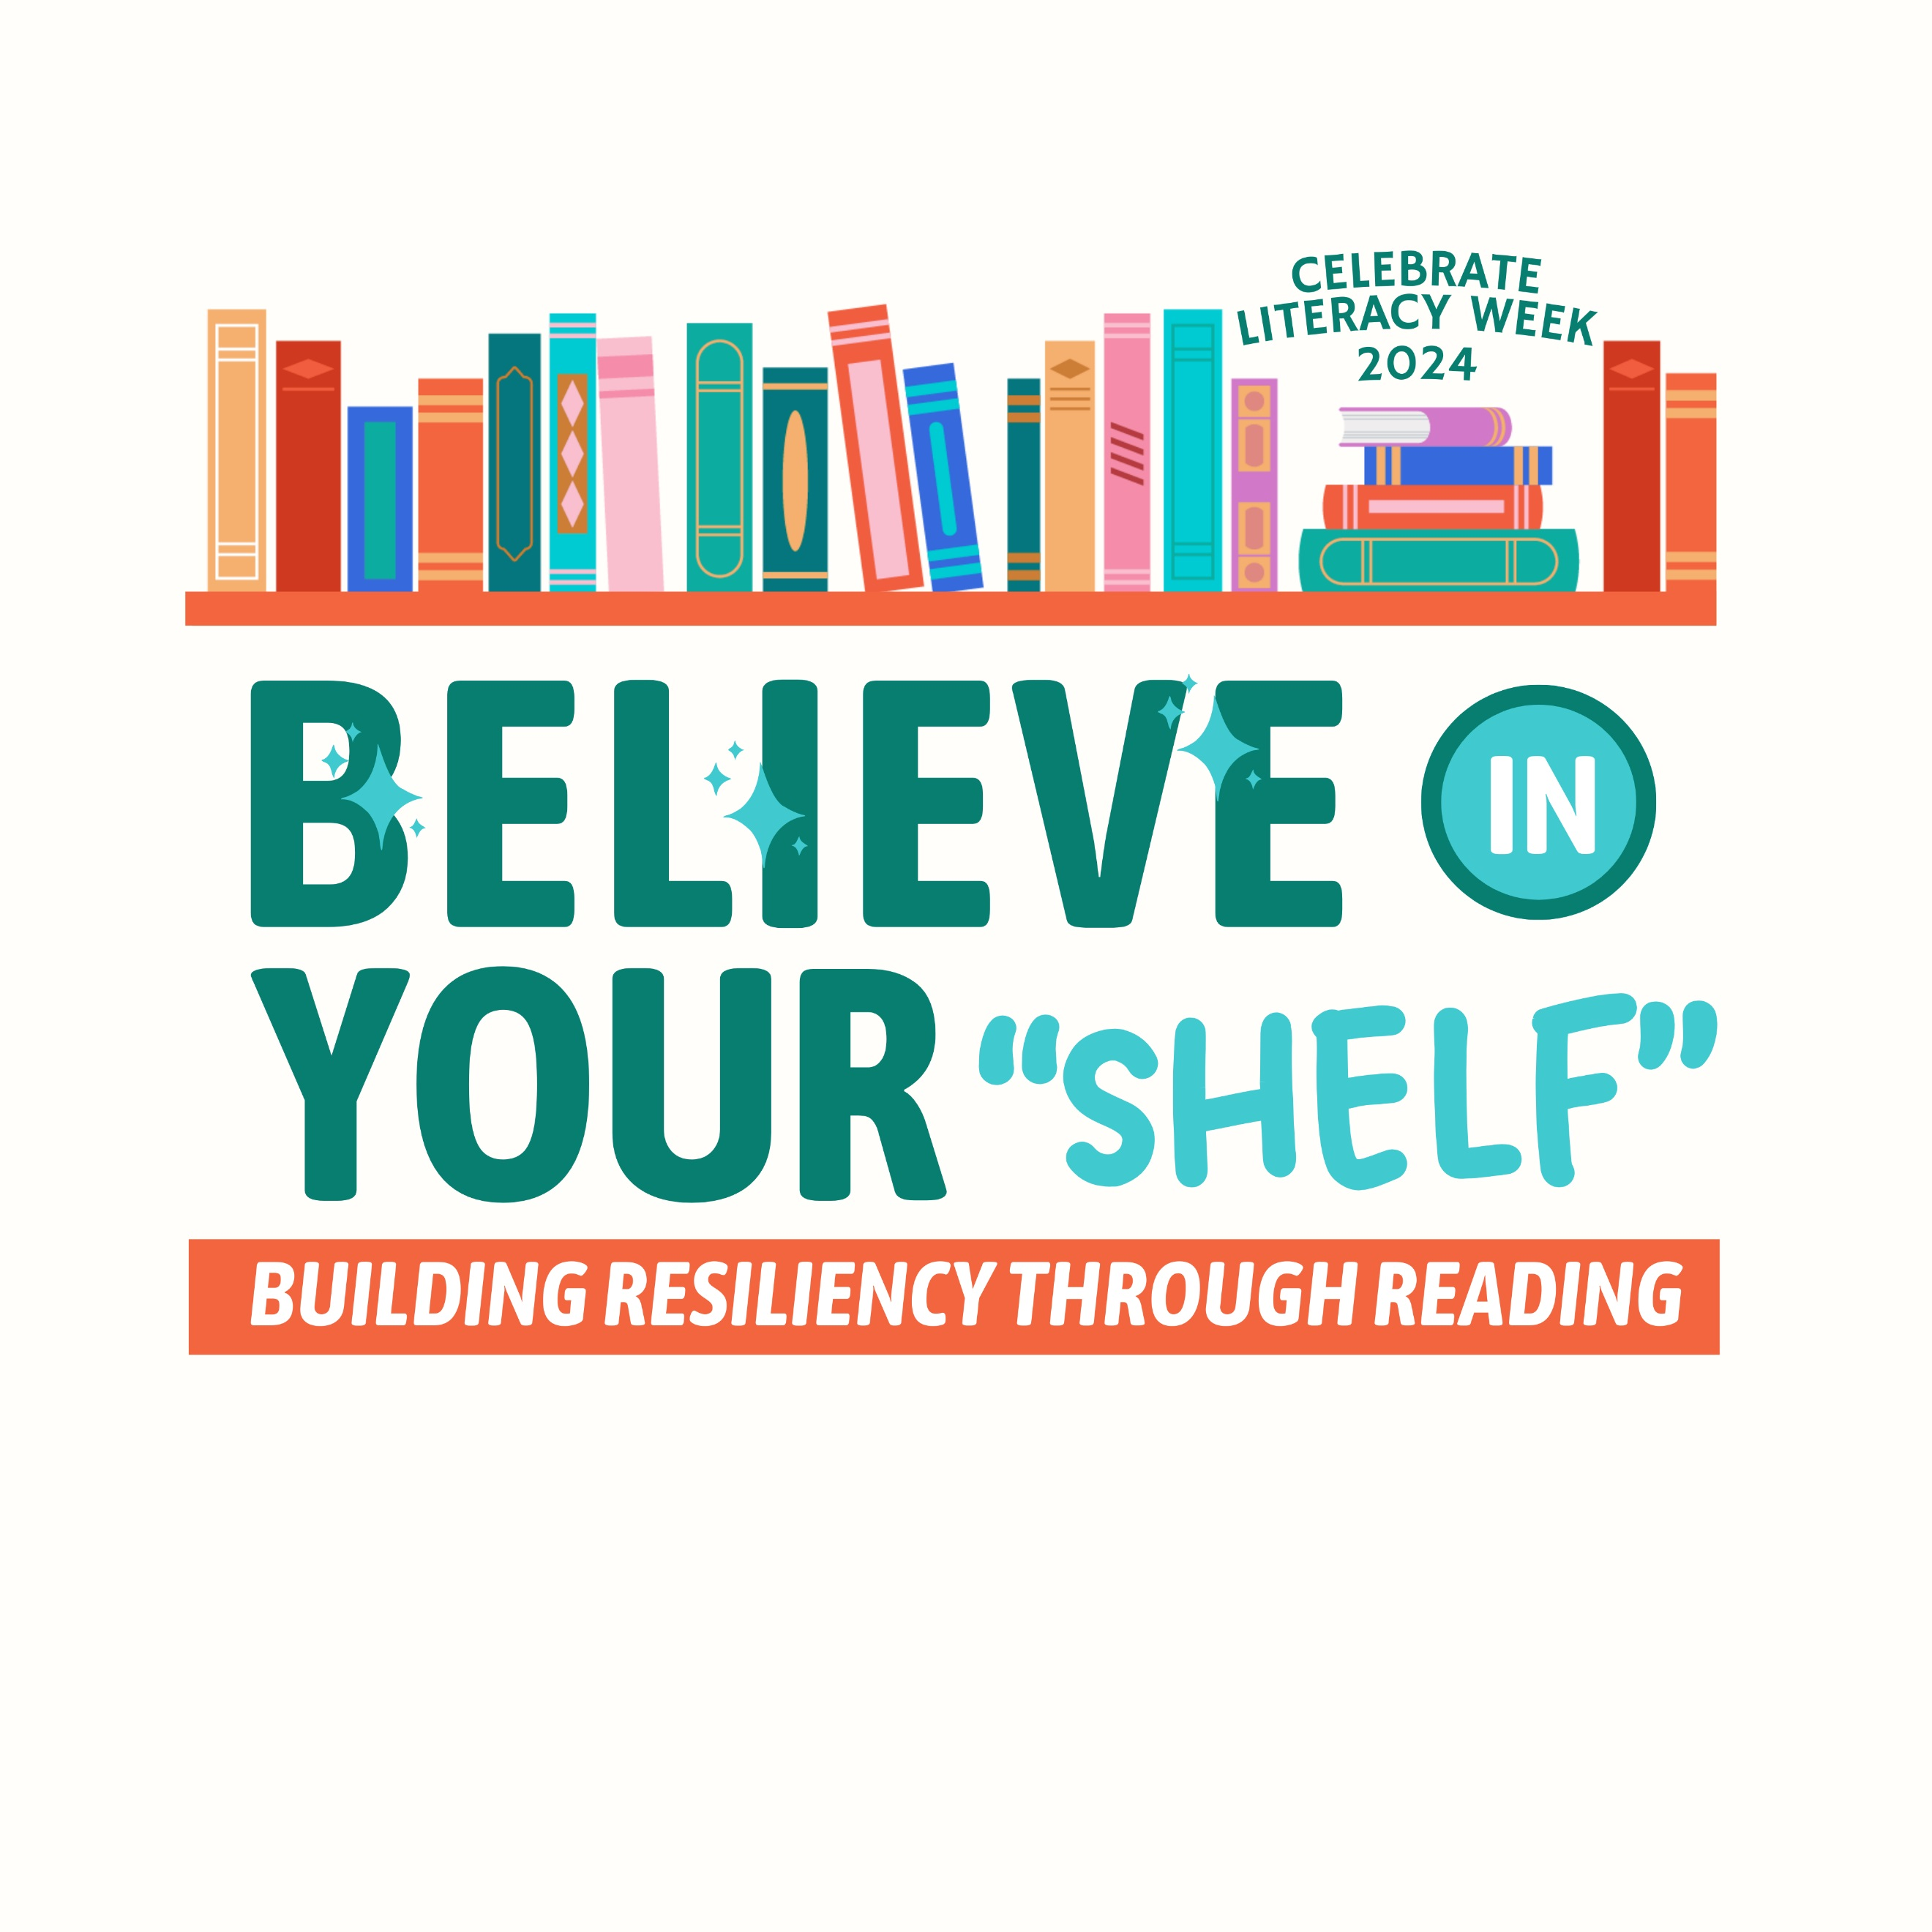
Celebrate Literacy Week, Florida!

January 22-26, 2024

District:

Monday,
January 22nd
Tuesday,
January 23rd
Wednesday,
January 24th
Thursday,
January 25th
Friday,
January 26th

