Excel Workbooks for Open Door Grant
- Open Door Grant Program Excel Workbook – Full Application with Budget Narrative Form (Excel)
- Open Door Grant Program Excel Workbook – Increase Funds (Excel)
Please contact Mallory.Martinez@fldoe.org for technical assistance with the Excel worksheets.
NOTE: Many of the cells in the workbooks contain formulas. Do not overwrite formulas with text entry.
The following screenshots provide guidance on how to complete the Excel workbook. The workbook for increased funds is nearly identical to the Full Application with the exception of the budget information. Tab C is not a DOE 101S; it is an increased funds request form since agencies applying for increased funds will be completing an amendment to their current grant award.
TITLE
Enter Agency Grant Number (see tab labeled “Agency Grant Numbers” if you don’t know this number).
Agency Name and TAPS# should populate.
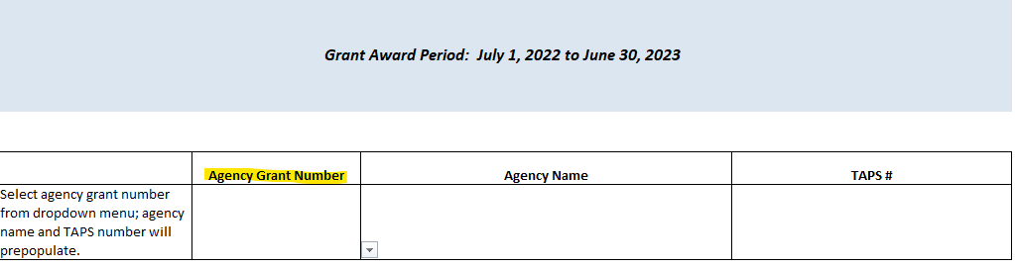

Tab A - Assurances
Only completed for the Full Application.
Tab B1 – Clock-Credit
Complete if you intend to use funds for Clock Hour or Credit Hour program enrollment. Otherwise, leave blank.
Read directions at the top of the worksheet.
Columns A and B must be completed which will auto-populate columns E and F. Pre-approved eligible programs and linkages are listed in “Approved Clock-Credit Linkages” tab. Only college credit programs of up to 30 credit hours and clock hour programs up to 1350 hours with a program linkage to an industry certification on the Master Credentials List are included in the dropdown for Column B.
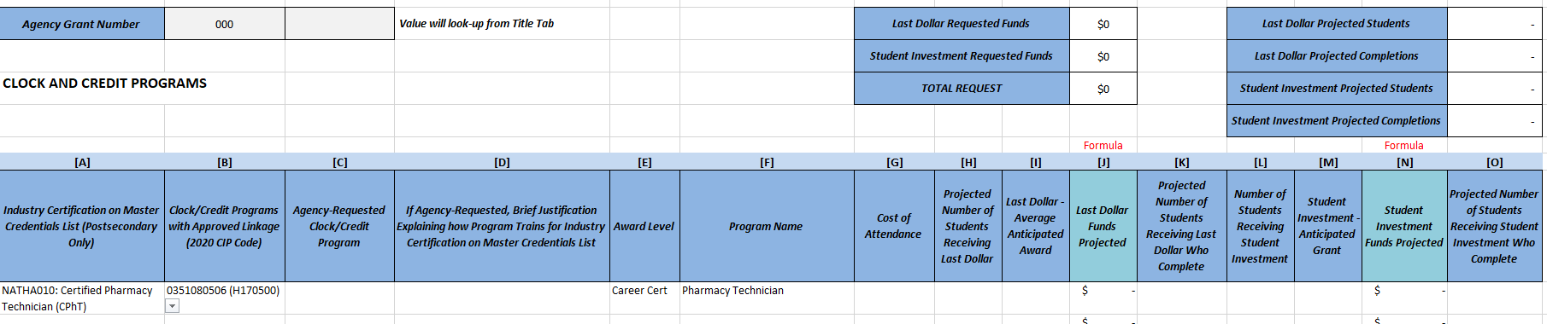
If you want to request a certification to program linkage that is not on the Approved Clock-Credit Linkages tab, provide information in C and D. For clock hour programs longer than 1350 hours, partial programs may be requested and will be reviewed for linkage to industry certifications with postsecondary funding eligible certifications on the Master Credentials List.

NOTES:
For Last Dollar, cost of attendance must be more than the Average Anticipated Award in Column I. Students must have federal or state aid that will offset a portion of the cost of attendance.
For Student Investment, Anticipated Grant award cannot exceed 2/3 of the Cost of Attendance in Column G.
Program Completers in Columns K and O cannot exceed the projected students in Columns H and L, respectively.

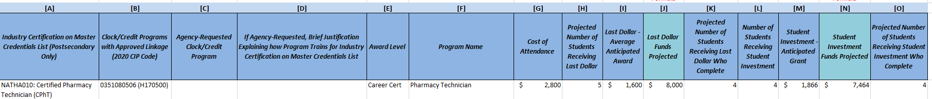
EXAMPLE:

Tab B2 – Non-Credit
Complete if you intend to use funds for the non-state fundable activity offered through non-credit courses. Otherwise, leave blank.
Read directions at the top of the worksheet.
See yellow highlighted columns for required data entry.

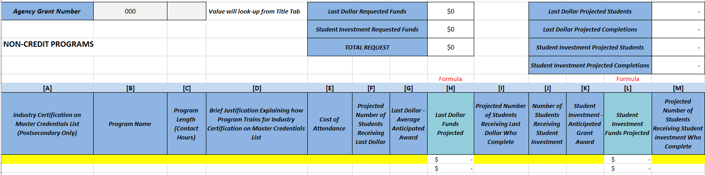

Tab B3 - IET Programs
Complete if you intend to use funds for Integrated Education and Training (IET) programs. Otherwise, leave blank.
Read directions at the top of the worksheet.
See yellow highlighted columns for required data entry.
Columns A and B are dropdowns. Only IET programs are allowed to use postsecondary and secondary approved credentials on the Master Credentials List. Currently approved IET program numbers are available in the dropdown in column B and column C will auto-populate based upon the number provided.
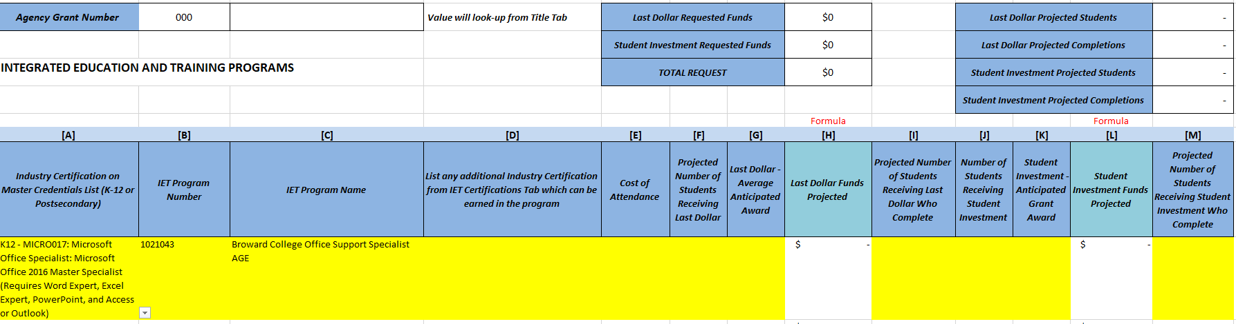
See tab “Approved IET Programs” for the IET program numbers. Only approved IET programs can be included in the application. See direction in RFA (page 5) for information on how to get a new IET approved.

Tab C – DOE 101S
Due to the limited allowable expenses for cost of attendance, most applications have one to three function/object codes. Items A) and C) should auto-populate based on the title page. The example in the workbook provides the most common areas for expenses. The amount on the budget must match the calculated totals generated by the information provided in Tabs B1 to B3. See “Request Totals” tab for this amount.
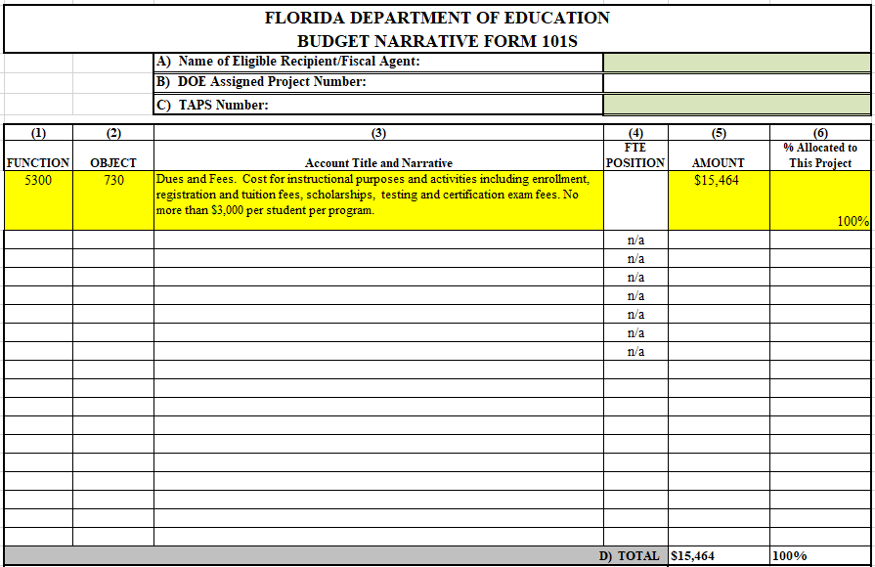

Examples for Tab C – DOE 101S
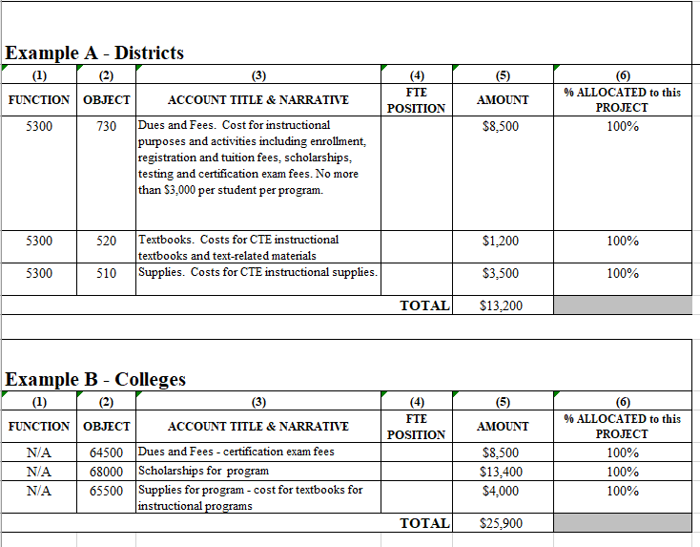

Grant Request Totals Summary
This tab is a formula generated summary of the funds requested. All cells should populate based upon the amounts reported in Tabs B1, B2, and B3.
In cell G9, a message will show if the Request Totals does not currently match the Tab C – 101S Total.

