2021-24 American Rescue Plan
Elementary and Secondary School Emergency Relief Fund
Local Educational Agency ARP ESSER Plan,
Application and Assurances

[LEA and Number]

Purpose
Florida must subgrant not less than 90 percent of its total ARP ESSER allocation to local educational agencies (LEAs) (including charter schools that are LEAs) to help meet a wide range of needs arising from the coronavirus pandemic, including reopening schools safely, sustaining their safe operation, and addressing students’ social, emotional, mental health, and academic needs resulting from the pandemic. The State must allocate these funds to LEAs on the basis of their respective shares of funds received under Title I, Part A of the Elementary and Secondary Education Act of 1965 (ESEA) in fiscal year (FY) 2020.

The purpose of this document is to guide districts to plan for the continued implementation of reopening and recovery through the utilization of the 2021-24 ARP ESSER and to assure federal requirements are met. Florida utilized the 2020-21 District Reopening Plan and the Spring 2021 Education Plan to respond to and mitigate the impact of the emergency and to promote the health, safety, and welfare of persons connected with Florida’s educational system.

The Department recognizes that the safe return to in-person instruction must be accompanied by a focus on meeting students’ academic, social, emotional, and mental health needs, and by addressing the opportunity gaps that existed before – and were exacerbated by – the pandemic. In this document, districts will describe how they will support the development of high-quality plans for the use of ARP ESSER funds to achieve these objectives for the following student groups: students from low-income families, from each racial or ethnic background, by gender, English Language Learners, students with disabilities, experiencing homelessness, in foster care, migratory students and other student groups.

Directions
Districts shall submit its ARP ESSER application to the Office of Grants Management via ShareFile on or before November 12, 2021. ShareFile access has been established for the ARP ESSER Lump Sum program for each LEA. The complete application shall include:

- LEA ARP ESSER Plan, Application and Assurances utilizing this template;
- DOE 100A Project Application Form; and
- DOE 101 Budget Narrative Form.

Each LEA developed and made publicly available on the LEA’s website a plan for the safe return of in-person learning in the Fall of 2020. This was before the enactment of the ARP Act. This plan must be updated to address the requirements of the U.S. Department of Education’s Interim Final Rule, 88 FR 21195. The requirements of the Interim Final Rule are summarized in Appendix A. Each LEA shall seek public comment on the updated plan and take such comments into account prior to the submission of the final plan to the Department. Updated plans must comply with state law, including any applicable executive order, any agency emergency action, or any agency regulation or rule. No later than 60 days from receipt of its DOE 200, Project Award Notice, each LEA shall email its updated final plan to recoveryplan@fldoe.org. The subject line of the email must include district name and Plan for the Safe Return of In-person Instruction. Upon the Department’s approval, the LEA shall post this plan on the LEA’s website within 90 days of the award.

Part I: Implementation Plan

The LEA will submit an implementation plan, outlining planned activities for each of the following uses of funds under section 2001(e) of the ARP Act. The description must be adequate to ascertain that the proposed use of funds is necessary to prevent, prepare for, or respond to the COVID-19 pandemic, including its impact on the social, emotional, mental health, and academic needs of students.
Activities should be numbered consecutively. If the LEA does not plan any activities for one or more authorized uses, please indicate that there are no planned activities. School district LEAs shall include the activities identified for charter schools within the LEA, aggregated at the district/LEA level.

Activity 1: Addressing Learning Loss (at least 20% of total allocation). Of the total amount allocated to an LEA, the LEA must reserve at least 20 percent of funds to address learning loss through the implementation of evidence-based interventions such as summer learning or summer enrichment, extended day, comprehensive afterschool programs, or extended school year programs, and ensure that those interventions respond to students’ social, emotional, and academic needs and address the disproportionate impact of COVID-19 on underrepresented student subgroups (each major racial and ethnic group, children from low-income families, children with disabilities, English learners, gender, migrant students, students experiencing homelessness, and children and youth in foster care).

NOTE: MHES stands for Moore Haven Elementary School
MHMHS stands for Moore Haven Middle High School
WG stands for West Glades School

1 Homework Help and Tutoring

A review of some of the test scores for Glades County reveals the following disaggregated results.

Statewide ELA test results School Years 2014-2021 (percent scoring a 3 or higher)

 | 14-15 | 15-16 | 16-17 | 17-18 | 18-19 | 20-21
3rd | 52.9 | 54.4 | 57.8 | 56.9 | 57.6 | 54.4
5th | 51.8 | 51.9 | 52.6 | 54.7 | 56.2 | 53.9
8th | 55.2 | 56.4 | 54.7 | 57.5 | 56.3 | 52.4
10th | 51.2 | 49.5 | 49.9 | 53.0 | 52.5 | 50.9

Glades County ELA test results by year

 | 14-15 | 15-16 | 16-17 | 17-18 | 18-19 | 20-21
3rd | 51.8 | 47.5 | 57.5 | 54.9 | 61.6 | 38.3
5th | 42.3 | 30.9 | 37.3 | 38.0 | 53.3 | 43.5
8th | 53.0 | 51.1 | 41.9 | 45.9 | 37.3 | 38.9
10th | 52.9 | 34.8 | 32.8 | 36.5 | 29.1 | 33.9

Each highlighted score in the table above represents a score lower than the state average and those in red are at least ten points below the state average. Clearly, there is need for interventions. The Mathematics and other test data follows this pattern.

Grade 3 ELA results by subgroup

A review of Glades County student test data shows the following results by subgroup:

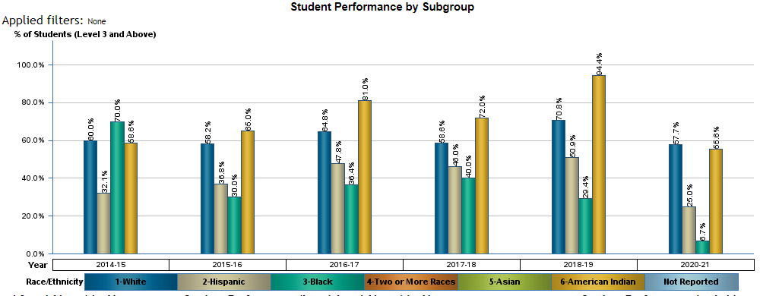

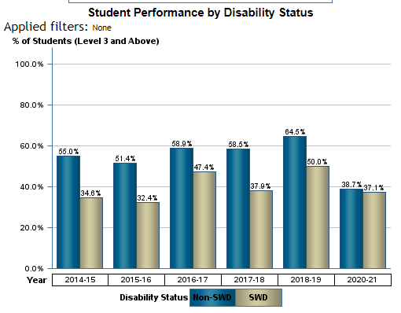
Focusing on the 2020-21 data, there are clear losses among all ethnic groups and White, Hispanic and Black subgroups scored well below the state averages for those groups. Most Native American students attend Pemayetv Emahakv Charter School (PECS) located on the Brighton Seminole Reservation and do not attend a traditional public school until 9th grade.

This data shows SWD scoring at approximately the same level as non-SWD, but this is misleading. SWD did not increase reading scores but instead lost less than Non-SWD to make the scores comparable.
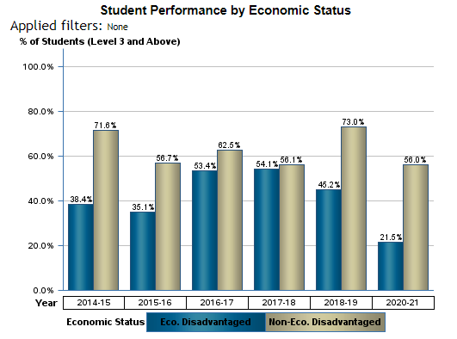

Glades County is a rural and low-income area that now provides all students free lunch. The scores took a dramatic drop in 2021-21.

Grade 5 ELA Results
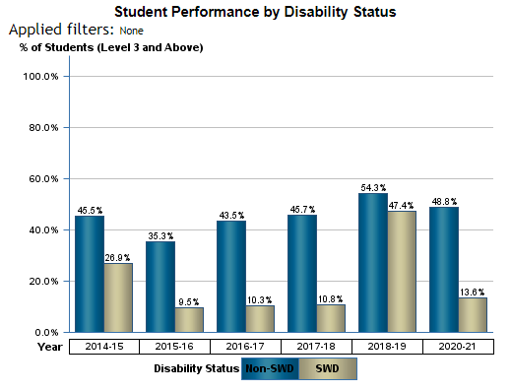

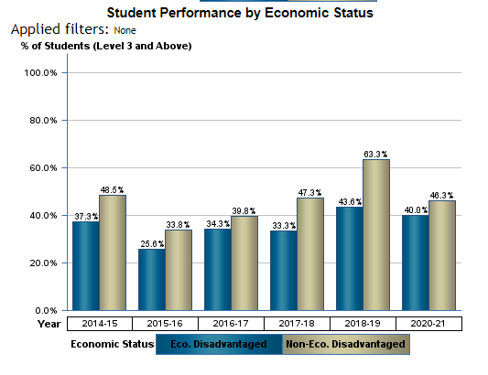
These results, as the reults that follow, provide evidence that our economically disadvantaged students do not fare as well as their peers. However, this is a bit misleading as in Gades County there are more students considered economically disadvantaged than others. In Florida the median household income is $59,227 whereas in Glades County the same statistic is $40,997, about 1/3 below the state median. Glades County is a 100% free and reduced lunch district.

ELA Grade 8
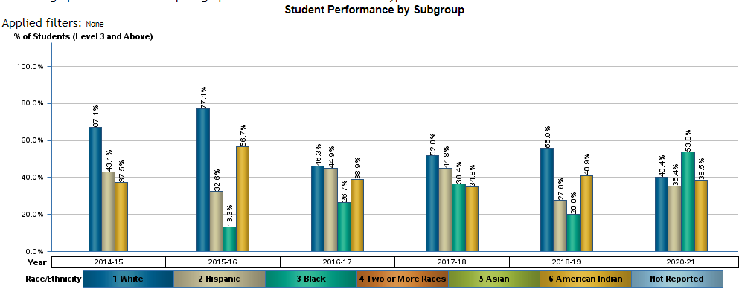
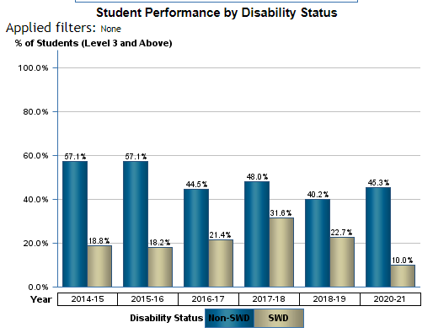
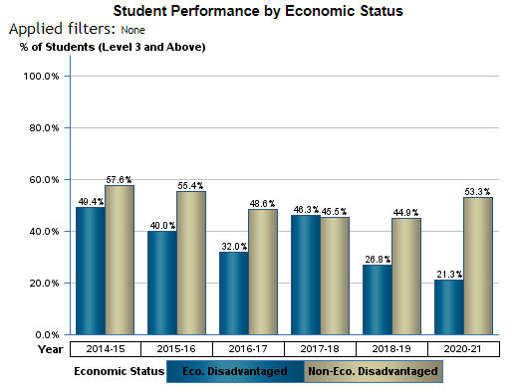

ELA Grade 10

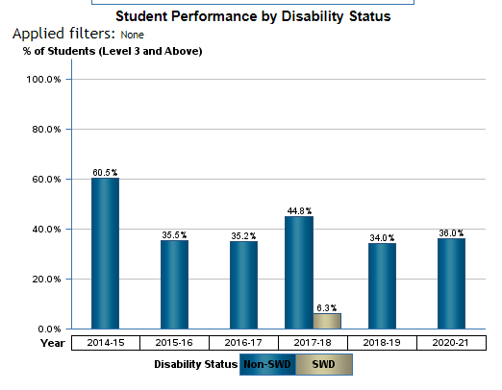
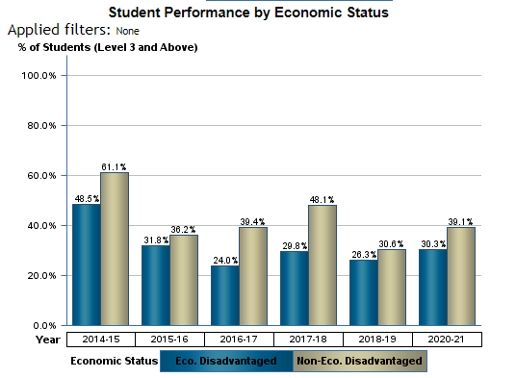

Overall, the data clearly shows the need for interventions for practically every sub-group as they are all performing below their peers across the state. As an intervention, Glades County will contract with Okin to provide homework help online. They provide live homework help by certified teachers and this help will be available to every student at West Glades, MHES and MHMHS. This service will be available to all students each day (including weekends). The contract will run for three years at a cost of $5/student each month.

Three-year cost: 1300 students x $5 x 36 months = $234,000

2 Pemayetv Emahakv Charter School (PECS) Professional development

PECS will contract with Catapult Literacy First, a company that provides intensive reading professional development. Due to CoVID, PECS was unable to teach in person and there are now learning gaps to address. Catapult provides live and in-class professional development and coaching to assist teachers in their teaching techniques as well as implementing strategies to close learning gaps that exist in the classroom. This is taking place during the 2022-23 and 2023-24 school years.

Two-year contract: $128,000 ($64,000 each year based on previous contracts)

3 Summer Pre-K

In addition to the traditional school year Pre-K program, Glades County will offer a summer Pre-K program. This will run from 8:00 AM to 3:00 PM for eight weeks during the summer. This program will be held at two schools, MHES in Moore Haven and West Glades in Muse. This program will take place each summer in 2022, 2023 and 2024.

Each school will be staffed with a teacher and a paraprofessional, which should be sufficient given historical enrollment umbers. We expect the costs to be as follows:

Teacher Salary 2 teachers x 41 days x 7.5 hours per day x $38/hr = $ 29,370
Para salary 2 paras x 41 days x 7.5 hours per day x $15/hr = $ 9,225
FICA Calculated @ 7.65% $ 2,494
Retirement Calculated @10.82% $ 3,527

Salary and Benefits $ 38,615

Supplies $1500 per school $ 1,500

Annual cost for Summer Pre-K program $ 41,615

The total for this program for three years is $ 124,846

4 Traditional Pre-K

In order to ensure that students get the necessary foundation that they did not get during CoVID shutdowns, Glades County is hosting a pre-K program at MHES. Glades Pre-K program runs through the full year from 8:00 AM to 3:00 PM. Excluding lunch, there are 6.5 hours of academics each day of which the state funds only 3 hours. To pay for the remainder of the program, Glades County pays for the extra 3.5 hours per day.

As the state only funds 540 hours of Pre-K per year and our program is for 1170 hours of instruction, the state funds 46.2% of the program and the county pays the remaining 53.8%.

Glades County is funding this program for FY21, FY22, FY23 and FY24. As this grant is retroactive March 22, 2020, this application includes 43 school days from FY20.

The table below shows the total salary and benefits expense to the district to pay for the extra classroom time for Pre-K students. This is based upon the following:

- Three teachers averaging $55,000 per year
- Three paras making an average of $19,280 per year
- 43 classroom days in FY20 (23% of the school year)
- Insurance is $8400 per employee per year
- FICA is 7.65% and Retirement is calculated at 10.82%

 | Annual cost | Four years | 19-20 portion | Total cost for 4.23 years | Unfunded 53.8%
Teacher salary | $ 165,000 | $ 660,000 | $ 36,199 | $ 696,199 | $ 374,555
Para Salary | $ 57,840 | $ 231,360 | $ 12,642 | $ 244,002 | $ 131,273
FICA | $ 17,047 | $ 68,189 | $ 3,736 | $ 71,925 | $ 38,696
Ret | $ 24,111 | $ 96,445 | $ 5,285 | $ 101,730 | $ 54,731
Ins | $ 50,400 | $ 201,600 | $ 11,057 | $ 212,657 | $ 114,410
Total | $ 314,399 | $ 1,257,594 | $ 68,919 | $ 1,326,513 | $ 713,664

Glades County will spend $713,664 from this grant to fund this program to accelerate pre-K learning.

5. After-school tutoring

Glades County will provide tutoring after school twice a week for 1.5 hours each day. This time will be spent focusing on grade-specific standards each day and homework help after tutoring. The cost for the tutors is based on having six teachers at MHES, seven at MHMHS and eight at WG each for each tutoring session.

Teachers will use materials from the curriculum as well as other supports for review, enrichment and extension as appropriate. Each school will have $3000 per year to purchase supplies for the after-school programs.

Costs are based upon this program starting in Spring 2022 and continuing through FY23 and FY24 for a total of 2.5 school years.

Salary: 21 teachers x 1.5 hrs x 2 days per week x 36 weeks x $38/hr $ 86,184
Retirement at 10.82% $ 6,593
FICA at 7.65% $ 9,325

Annual salary $102,102

Supplies: $3000 x 3 schools $ 9,000

Annual program total $111,102
The program will operate for 2.5 school years, so the program total cost is $111,102 x 2.5 = $277,755

6 Extending learning opportunities during the school day

At MHMHS, students have fallen behind on credits as a result of CoVID. While the district offered virtual learning, many students did not find success learning in that manner. Others became ill and fell behind. Some did not have Internet access while at home (Glades County has many remote pockets without internet access). No matter the reason, CoVID played a role in many students being behind in their academics. In order to assist students to get caught up academically, they need access to more flexibility in the school master schedule to accommodate courses necessary for graduation.

To accomplish this, the district will pay some teachers to teach an additional class during their planning period. With more classes available, it is much easier to schedule students into courses they need rather than having them take a class that is counted as an elective instead of a required course.

For the FY23 and FY24 school years, the costs will be as follows:

Salary: 21 teachers x 55 minutes (11/12 of an hour) x 180 days x $38/hr: $131,670

FICA on $131,670 at 7.65% $ 10,073

Retirement of $131,670 at 10.82% $ 14,220

Annual total: $115,963

For two years, the total will be $115,963 x 2 = $311,926

Activity 2 (A) Any activity authorized by the Elementary and Secondary Education Act of 1965.

No activities planned

Activity 2 (B) Any activity authorized by the Individuals with Disabilities Education Act.

No activities planned

Activity 2 (C) Any activity authorized by the Adult Education and Family Literacy Act.

No activities planned

Activity 2 (D) Any activity authorized by the Carl D. Perkins Career and Technical Education Act of 2006.

7 CTE Nursing

Due to CoVID, students did not get opportunities to participate in hands-on experiential learning. Students at Moore Haven Middle High School (MHMHS) have missed out on the experiences necessary not only for academics but also for earning industry certifications. Glades County will accelerate student learning by providing the needed tools to learn the necessary skills in vocational programs but also earn the certifications that lead to college and career success.

The Nursing program needs a classroom lab where students can learn and practice all of the skills needed to become certified as a CNA. This program will become a feeder to I-Tech Glades, a local vocational school opening in January. Students with a CNA certification will qualify for enrollment in the LPN program.

To accomplish this, the District will purchase the following for the CNA program:

Hospital beds |  | 3 |  | $ 2,000.00 |  | $ 6,000.00
Over bed nursing tables |  | 3 |  | $ 600.00 |  | $ 1,800.00
Bed-side cabinets (required for practicing nursing techniques) |  | 3 |  | $ 600.00 |  | $ 1,800.00
Bedside stands (required for practicing nursing techniques) |  | 3 |  | $1,000.00 |  | $ 3,000.00
 |  |  |  | Total |  | $ 12,600.00

8 CTE Agriculture

As in the Nursing program, due to CoVID, students did not get opportunities to participate in hands-on experiential learning. Students at Moore Haven Middle High School (MHMHS) have missed out on the experiences necessary not only for academics but also for earning industry certifications.

In the Agriculture program, students will be working this year to earn a certificate in Agricultural Communications and in future years, students will earn certificates in Agricultural Mechanics and Agritechnology. Students will also be participating in FFA and the many activities and competitions that are part of that organization. To prepare students for these industry certifications, the following will be purchased:

Item | Quantity | Price | Subtotal
Dewalt 14in. 15 Amp Chop Saw | 2 | $183 | $366
Lincoln AC/DC 225/125 Arc Welders | 2 | $900 | $1800
Hypotherm Powermax45 XP | 1 | $2236 | $2236
Echo PW-4200 PSI Pressure Washer | 1 | $1300 | $1300
Stihl FS 131 R 16.5 inch Gas Brushcutter | 1 | $449 | $449
Stihl 391 20 inch 64.1cc Chainsaw | 1 | $589 | $589
Stihl Bar & Chain | 1 | $80 | $80
Stihl Bar & Chain | 1 | $68 | $68
Pyramex WHAM10 Welding Helmets | 15 | $50 | $750
Deko Welding Gloves | 20 | $11 | $220
Miller Bobcat 50 feet Weld Leads | 1 | $471 | $471
Goose Neck Drop Away Hitch 1994 Ford F-250 Single Cab Long Bed 4x4 | 1 | $790 | $790
Central Machinery Drill Press | 1 | $160 | $160
Central Forge 6 inch Cross Slide Vise | 1 | $90 | $90
Earthquake 16 inch Victory Rear Tine Gas Viper Tiller | 1 | $813 | $813
Victor Journeyman Edge Torch Kit | 1 | $650 | $650
Plasma Cam Software and Parts Upgrade | 1 | $3660 | $3660
2”x10”x20’ Pressure Treated Lumber | 10 | $38.60 | $386
Power King Super Hwy Tires R-8 7.50-16LT | 4 | $150 | $600
Ridgid 6.5 amp 3"x18" Variable Speed Belt Sander | 2 | $119 | $238
Makita 13 Amp 4-1/2 in. SJS High-Power Angle Grinder | 2 | $159 | $318
Makita 15 Amp 7-1/4 in. Corded Lightweight Circular Saw | 1 | $199 | $199
Makita 6 Amp 5/8 in. Corded Hammer Drill | 2 | $100 | $200
Makita 3-1/4 HP Plunge Router with Variable Speed | 1 | $329 | $329
BKT TR135 Front Tractor Tire | 2 | $315 | $630
BKY TR135 Rear Tractor Tire | 2 | $685 | $1370
Tractor Seat Kit | 2 | $199 | $397
Heavy Duty Front End | 1 | $303 | $303
Tractor Shock absorbers | 2 | $209 | $418
 |  | Total | $19,880

Activity 2 (E) Coordination of preparedness and response efforts of local educational agencies with State, local, Tribal, and territorial public health departments, and other relevant agencies, to improve coordinated responses among such entities to prevent, prepare for, and respond to coronavirus.

No activities planned

Activity 2 (F) Activities to address the unique needs of low-income children or students, children with disabilities, English learners, racial and ethnic minorities, students experiencing homelessness, and foster care youth, including how outreach and service delivery will meet the needs of each population.

9 Providing Equity for Remote and Low-Income students

In response to CoVID, Glades County Schools will provide access to programs for students that live in remote areas. This district is unique in terms of population it is one of the smallest in the state but one of the largest in terms of land mass. From the eastern edge of the district to the western edge is 58 miles (on two-lane roads). There is a lot of distance between some of the remote areas of the district and the school.

In addition to the population sparsity of the district, there are many areas without internet access. With ARP funds (and other approved grants), there are many opportunities for students to participate in learning activities outside of the traditional school day, including after-school and summer programs. However, the district is unable to use school buses to serve every part of the district except for the morning and afternoon routes. It is not feasible to have a bus driver make an additional run with a full-sized school bus for two or three students.

Glades County will purchase three vans to expand the opportunities for student participation in educational activities. One will be located in the Muse area for transporting students living in the migrant work camps and other remote areas when no other option is available for students to get home after tutoring and other activities. The other two will be located in Moore Haven to transfer students to Lakeport and Palmdale (opposite directions but 25 miles from the schools).

The estimated cost for a van is $43,000 for a total of $144,000 for the three.

This additional transportation is critical to provide equitable opportunity for students living in the remotest parts of the district to access educational opportunities. Students in these areas were exceptionally hit hard by the pandemic. While some remote students were able to get access to online activities through hotspots, there were others that did not and fell behind their peers. To improve internet access to the remotest areas of the district, Glades County Schools will purchase an additional 35 hotpots for students to check out and take home as well as pay for the data plans for the hotspots.

Each mobile hotspot is $50 with a data plan that costs an additional $45 per month.

Hotpots: 35 @ $50 = $ 1,750
Data plan: 35 units @ $45/month for 30 months $47,250

Total $49,000

Activity 2 (G) Developing and implementing procedures and systems to improve the preparedness and response efforts of local educational agencies.

10 Increased social distancing on school transportation

Prior to CoVID, Glades County compressed bus routes to decrease the number of buses needed to transport students to and from school. Since then, the number of students on those combined routes has grown. To provide more space for social distancing, the district will revert to the original routes and reduce the number of students on each route. On the two routes formed by combining routes, there are 58 and 61 students respectively. The new buses will allow us to drop those routes to 28, 30, 31 and 30. This provides for each student to have a seat to themselves with increased social distancing to prevent another outbreak. To accomplish this, the district needs two additional school buses as the district does not have vehicles to complete the recreated routes. Based upon current costs, each bus will cost approximately $130,000 (currently varies based upon supply logistics)

Cost: $260,000

Activity 2 (H) Training and professional development for staff of the local educational agency on sanitation and minimizing the spread of infectious diseases.

No activities planned

Activity 2 (I) Purchasing supplies to sanitize and clean the facilities of a local educational agency, including buildings operated by such agency.

11 Clean and sanitize floors

Glades County needs machines to clean and sanitize floors. As a result of CoVID, the district is working diligently to respond to and prevent future outbreaks of illness. While we do our best to wipe and sanitize everything on a regular basis throughout the day, the floors need special equipment to be cleaned and sanitized. Having both tiled floors and carpeted floors in each school, we will purchase the following:

Six carper cleaners/sanitizers $2499 each $ 14,994

Six hard floor cleaner/sanitizers $2490 each $ 14,994

Total: $29,988

12 Clean and sanitize schools

Glades County Schools used CARES funds to purchase cleaning and sanitizing products to prevent or at a minimum minimize the spread of CoVID. The district is now very low on these supplies. For the three schools, school buses and the County Office the district will spend $41,496 over the next three years to replenish gloves, sanitizers, floor cleaning solutions, carpet cleaning solutions, etc…

Activity 2 (J) Planning for, coordinating, and implementing activities during long-term closures, including providing meals to eligible students, providing technology for online learning to all students, providing guidance for carrying out requirements under the Individuals with Disabilities Education Act and ensuring other educational services can continue to be provided consistent with all Federal, State,
and local requirements.

13 Prepare for remote operations

In order to prepare for current or future situations in which staff are unable to report to work and working virtually is required, the district will upgrade technology for all central office staff and school-based essential employees (Admin, Guidance, Confidential Secretaries, Bookkeepers, etc…) for potential remote operations. Each station will have a laptop connected to monitors in each office via a docking station. Should remote work be necessary, staff can grab their laptops and work remotely without interruptions.

Each station includes the following:

Laptop: $1250

Monitors ($300x2): $ 600

Monitor stand: $ 59

Docking stations: $ 90

Cables: $ 20

Station total $2019

There is a need for 42 stations between the District Office and the three school Leadership Teams

Total: 42 stations @ $2019 = $ 84,798

Supplies for remote work (flash drives, Kensington locks, etc…) $ 1,220

Total: $ 86,018

Activity 2(K) Purchasing educational technology (including hardware, software, and connectivity) for students who are served by the local educational agency that aids in regular and substantive educational interaction between students and their classroom instructors, including low-income students and children with disabilities, which may include assistive technology or adaptive equipment.

14 Prepare for students to be remote in case of school shutdown

Glades County Schools began a 1-1 Chromebook program a few years ago. This has been beneficial when fighting CoVID during school shutdowns and when students are ill or quarantining. In order to continue to be ready for such an occasion, technology must be as current as possible to work with newer applications. Older Chromebooks must be replaced when they reach the end of their life span. The district has already begun to replace the oldest items and many more will reach the end of their life-span by August 2024. Therefore, the district will spend money to replace Chromebooks as follows (based on $285 per Chromebook):

Summer 2023: 300 Chromebooks @ $285 $ 85,500

Fall 2023: 300 Chromebooks @ $285 $ 85,500

Spring 2021: 450 Chromebooks @ $285 $128,250

Total: $299,250

Activity 2(L) Providing mental health services and supports, including through the implementation of evidence-based full-service community schools.

No activities planned

Activity 2(M) Planning and implementing activities related to summer learning and supplemental afterschool programs, including providing classroom instruction or online learning during the summer months and addressing the needs of low-income students, children with disabilities, English learners, migrant students, students experiencing homelessness, and children in foster care.

No activities planned

Activity 2(N) Addressing learning loss among students, including low-income students, children with disabilities, English learners, racial and ethnic minorities, students experiencing homelessness, and children and youth in foster care, of the local educational agency, including by—
(i) administering and using high-quality assessments that are valid and reliable, to accurately assess students’ academic progress and assist educators in meeting students’ academic needs, including through differentiating instruction;
(ii) implementing evidence-based activities to meet the comprehensive needs of students;
(iii) providing information and assistance to parents and families on how they can effectively support students, including in a distance learning environment; and
(iv) tracking student attendance and improving student engagement in distance education.

15 Attendance Officer

As stated above, Glades County is a large district in terms of land size but is sparsely populated. For comparison purposes, below is a table showing the population and population densities for districts in SW Florida:

District | Population | Population Density (per Sq. mile)
Lee | 802,791 | 534.1
Charlotte | 197,032 | 190.1
Collier | 398,304 | 145.1
Hendry | 43,394 | 32.3
Glades | 14,061 | 13.4

Glades County has the sixth smallest population in the state and the third lowest population density. Compared to districts in the same region, it is the least populated and by far the most spread out. In part because of this population dispersion, it makes it difficult to monitor all students and their whereabouts when not attending school. Excessive absenteeism has been an issue but since CoVID it has grown significantly.

To assist students and families in getting to school on a regular basis, Glades County Schools will hire an Attendance Officer to monitor student attendance, locate unenrolled students, and work with students, parents, families and faculties to ensure that students are attending their school without excessive absences. This individual will make home visits when necessary and assist in monitoring students attending via virtual school. (This position is already funded through June 2023. This is for FY24.)

Salary: $40,000
Soc. Sec $ 3,060
Retirement: $ 4,328
Insurance: $ 8,800

Mileage: $ 2,400
Supplies: $ 1,000

Total: $59,588

Activity 2(O) School facility repairs and improvements to enable operation of schools to reduce risk of virus transmission and exposure to environmental health hazards, and to support student health needs.

16 PECS roof repairs

Due to CoVID, Pemayetv Emahakv Charter School (PECS) was closed for the entire 2020-2021 school year. There was nobody allowed into the buildings for over four months. During this time, extensive roof damage from water and mold occurred and had to be repaired prior to students returning from the CoVID shutdown. The total cost for this project is $469,000, of which this grant will pay for $354,806.

Activity 2(P) Inspection, testing, maintenance, repair, replacement, and upgrade projects to improve the indoor air quality in school facilities, including mechanical and nonmechanical heating, ventilation, and air conditioning systems, filtering, purification and other air cleaning, fans, control systems, and window and door repair and replacement.

17 Replace Air Conditioning Units

West Glades school has old and poorly functioning air conditioning and heating units. In order to respond and potentially prevent CoVID or other airborne viruses from spreading throughout the school, these units must be replaced. There are 100 units that must be replaced at an estimated cost of $3400 each. The district is using other funding sources to pay for part of this upgrade (expected to be $340,000 total). The district has roughly $165,000 from other sources for this project and will use $174,868 from this funding source to complete the process.

Activity 2(Q) Developing strategies and implementing public health protocols including, to the greatest extent possible and not inconsistent with state law, policies in line with guidance from the Centers for Disease Control and Prevention for the reopening and operation of school facilities to effectively maintain the health and safety of students, educators, and other staff.

No activities planned

Activity 2(R) Other activities that are necessary to maintain the operation of and continuity of services in local educational agencies and continuing to employ existing staff of the local educational agency.

18 Staff recruitment

Due to the location and rural nature of Glades County, it is difficult to recruit teachers to come teach in the “country.” Glades County Schools relies on teachers to commute from larger areas such as Ft. Myers or to relocate to the Lake Okeechobee area. With the pandemic, many have chosen not to travel due to fears of getting the virus. We currently need several highly qualified teachers at this point as we are using Administrators as teachers and we are contracting with external vendors to provide virtual classroom instruction. Neither of these are viable or sustainable options.

In order to prepare each school with the staff needed to handle not only instruction but also to be in class and assist in measures to prevent another CoVID outbreak, we will create a marketing campaign to promote our schools, the school district and the local area. It is essential to show that there is much more to Glades County than a job in a remote location.

As part of this, we will create videos to place on our website and to use when attending job fairs and events around the state. These will provide a visual perspective on the area and promote the lifestyle and activities available. We will have brochures printed as well as business cards for distribution.

We will use these videos as part of the campaign that includes the county office, the digital video display near US 27 in Moore Haven (the main traffic artery), and the main offices in all three schools. Each will have a large display that cycles through recruitment videos as well as school news promoting the benefits of working for Glades County Schools. For recruitment purposes, the district will obtain and use the following:

Laptop (video for job fairs and county office demonstration): $1500
Monitor (for job fairs, etc…) $ 300
Large screen displays for four (4) permanent digital displays $6000
Mounting brackets for four (4) permanent digital displays $ 600
Drone for videos $1200
Business cards $ 100
Brochures $ 200
Travel (to job fairs and other recruiting events $3000
Supplies $ 200

Total: $13,100

Activity 2 (S) Administration. LEAs may take reasonable and necessary administrative costs, to include direct and indirect costs. Indirect costs may be taken up to the negotiated, unrestricted indirect cost rate. However, to ensure that the total administrative costs are reasonable, the total direct and indirect costs may not exceed five percent (5%) of the LEA’s total award.

19 Calculated at 5% of eligible costs of $2,273,273 = $113,662

Part II: Ensuring Effectiveness of Interventions

Please describe how the LEA will ensure that the interventions it implements, including but not limited to the interventions under section 2001(e)(1) of the ARP Act to address the academic impact of lost instructional time, will respond to the academic, social, emotional, and mental health needs of all students, and particularly those students disproportionately impacted by the COVID-19 pandemic, including students from low-income families, students of color, English learners, children with disabilities, students experiencing homelessness, children and youth in foster care, and migratory students. In your response, please include a description of interventions and strategies that are aligned to the LEA’s data (disaggregated by subgroup), and describe how the LEA will measure the effectiveness of the selected interventions.

Interventions are based upon student data disaggregated from edstats.fldoe.org and from other internal data (absences, CoVID data, etc..). Please refer to the scores from earlier in this application. The activities identified in this applications are specifically designed to target areas in which data has demonstrated a need for the district.

These interventions will be reviewed by district leadership once per month. The district leadership team will consist of the Superintendent (or designee), Director of Academic Services and Coordinator of Grants/Federal Programs. The team will monitor each activity for effectiveness as follows:

Activity Number | Activity Description | Data Monitored
1 | Online homework help | Student usage of the homework help from Oken (disaggregated by subgroup);  Student progress monitoring data and assessment results (disaggregated by subgroup);
2 | PECS Catapult professional development | Lessons for implementation of Catapult training;  Student assessment data;
3 | Summer Pre-K | Attendance (including completion rate of enrollees);  Assessment data;  Long-term tracking of student achievement
4 | Traditional Pre-K (full-year) | Attendance (including completion rate of enrollees);  Assessment data;  Long-term tracking of student achievement
5 | After-school tutoring | Attendance;  Student grades;  Assessment data
6 | Extended opportunities during the school day | Student grades;  Credits earned;  Student assessment data
7 | Nursing program | Student assessments;  Enrollment numbers;  Industry certifications
8 | Ag program | Student assessments;  Enrollment numbers;  Industry certifications
9 | Providing equitable services | Hot spot usage;  Passengers transported after extra learning activities;  Student assessment data
10 | Social distance on transportation | Number of CoVID cases
11 | Floor/Carpet cleaning | Machine usage;  Number of CoVID cases
12 | School cleaning/sanitizing | Number of CoVID cases
13 | Leadership technology | Acquisition and Implementation
14 | Student computer replacement | Acquisition and Implementation
15 | Attendance Officer | Number of unexcused absences in each school (disaggregated);  Reduction in Truancy petitions
16 | PECS Roof Repair | Completed
17 | Ventilation repair | Implementation
18 | Teacher recruitment | Number of applications/new hires
19 | Indirect Costs | N/A

Should there be an issue identified by the committee, the Coordinator for Grants will investigate to determine the cause of the issue and provide options for how to resolve the problem. This will be on the agenda for the next meeting and each meeting thereafter until we have improved our processes so the intervention is effective (done with fidelity) or possibly changing interventions if needed.

Part III LEA Plan for Safe Return of In-Person Instruction

Each LEA developed and made publicly available on the LEA’s website a plan for the safe return of in-person learning in the Fall of 2020. This was before the enactment of the ARP Act. This plan must be updated to address the requirements of the U.S. Department of Education’s Interim Final Rule, 88 FR 21195. The Interim Final Rule “does not mandate that an LEA adopt the CDC guidance, but only requires that the LEA describe in its plan the extent to which it has adopted the key prevention and mitigation strategies identified in the guidance.” 88 FR at 21200. Any updated LEA plan must be consistent with state law, including any applicable executive order, any agency emergency order, or any agency regulation or rule. Note specifically that LEA policies must comply with section 381.00316, Florida Statutes, and that any policies implemented after August 9, 2021 must comply with Florida Department of Health Rule 64DER21 -12, F.A.C., and any policies implemented after September 22, 2021 must comply with Florida Department of Health Rule 64DER21-15, F.A.C.

Each LEA must seek public comment on the plan and take such comments into account prior to submission of the final plan to the Department within 60 days of the award. Upon the Department’s approval, the LEA shall post this updated plan on the LEA’s website within 90 days of the award.

☒ By checking this box, the LEA acknowledges the requirement that each LEA shall update its Plan for Safe Return of In-Person Instruction to reflect the requirements stated above, shall seek public comment on the updated plan and take such comments into account prior to the submission of the final plan to the Department within 60 days of the award. Upon the Department’s approval, the LEA shall post this updated plan on the LEA’s website within 90 days of the award.

Part IV: Assurances

The district must agree to ALL of the assurances by checking the corresponding boxes.

☒ Assurance 1: LEA Periodic Plan Update with Public Comment. As required in the U.S. Department of Education’s Interim Final Rule, 88 FR 21195, the LEA must regularly, but no less frequently than every six months, review and as appropriate, revise its plan for the safe return to in-person instruction and continuity of services. In determining whether revisions are necessary, and in making any revisions, the LEA must seek public input and take such input into account. If at the time the LEA revises its plan the CDC has updated its guidance on reopening schools, the revised plan must address the extent to which the LEA has adopted policies, and describe any policies, for each of the updated safety recommendations. Significantly, the Interim Final Rule “does not mandate that an LEA adopt the CDC guidance, but only requires that the LEA describe in its plan the extent to which it has adopted the key prevention and mitigation strategies identified in the guidance.” 88 FR at 21200. Any updated LEA plan must be consistent with state law, including any applicable executive order, any agency emergency order, or any agency regulation or rule. Specifically, LEA policies must comply with section 381.00316, Florida Statutes, and any policies implemented after August 9, 2021 must comply with Florida Department of Health Rule 64DER21 -12, F.A.C., and any policies implemented after September 22, 2021 must comply with Florida Department of Health Rule 64DER21-15, F.A.C.
☒ Assurance 2: Continue progress monitoring and interventions. The district agrees to provide robust progress monitoring and requisite interventions must be extended to all students with tiered support for students who are performing below grade level and are not making adequate progress. Students who are receiving instruction through innovative teaching methods must transition to another teaching method if they fail to make adequate progress. The district agrees to provide monthly progress monitoring reports to parent/guardians for students identified as performing below grade level and/or demonstrating decline on the district’s progress monitoring system.

☒ Assurance 3: Allowable Uses of Funds. The LEA will use funds for activities allowable under section 2001(e) of the CRRSA Act.

☒ Assurance 4: Maintenance of Equity. The LEA will comply with all requirements relating to Maintenance of Equity, in accordance with section 2004(c) of the ARP Act.

☒ Assurance 5: Reporting. The LEA will comply with all reporting requirements, and submit required reports to the Florida Department of Education at such time and in such manner and containing such information as the department may subsequently require.

☒ Assurance 6: Audits, Inspections or Examinations. The LEA will cooperate with any examination of records with respect to such funds by making records available for inspection, production, and examination, and authorized individuals available for interview and examination, upon the request of (i) the Florida Department of Education, the Florida Auditor General; (ii) the Department and/or its Inspector General; or (iii) any other federal or state agency, commission, or department in the lawful exercise of its jurisdiction and authority.

Acknowledgement

Local Educational Agency Chief Executive Officer or Authorized Representative

Name and title of person responsible for completion and submission
Gary Breakfield, Coordinator, Grants/Federal Programs
Contact information: email, phone number
(863) 946-2083; gary.breakfield@glades-schools.org
Superintendent signature (or authorized representative)

