

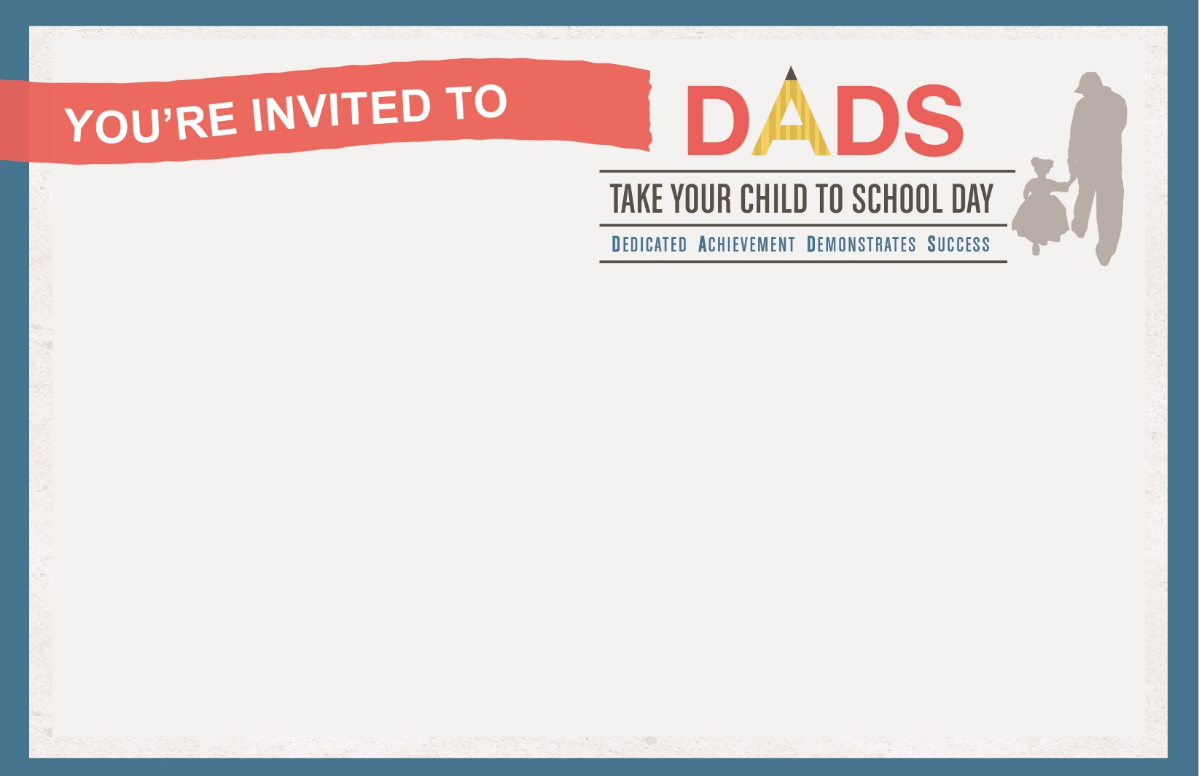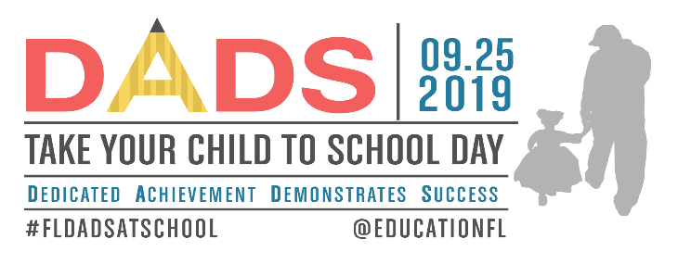

**WHO:** Fathers, stepfathers, grandfathers, uncles, big brothers, foster fathers and other significant male role models in our schools and classrooms

**WHEN:** **September 25, 2019**

**WHERE:**

**CONTACT/RSVP:**

**NOTES:**

s

**WHO:** Fathers, stepfathers, grandfathers, uncles, big brothers, foster fathers and other significant male role models in our schools and classrooms

**WHEN:** **September 25, 2019**

**WHERE:**

**CONTACT/RSVP:**

**NOTES:**

s

